Performance of mild acetone organosolv fractionation on lignocellulosic feedstocks from new cropping systems for production of advanced bioethanol

Supplementary materials

Table of contents

Performance of mild acetone organosolv fractionation on lignocellulosic feedstocks from new cropping systems for production of advanced bioethanol 1
Analytical methods 2
Performance indicators of pre-extraction and fractionation 4
Sulphuric acid dose determination 7
Estimation of water-soluble lignin (WSL) concentration in hydrolysates 9
Enzymatic hydrolysis 14
Bibliography 15

Analytical methods

Dried solid biomass samples were milled using a Fritz pulverisette equipped with a 0.2 mm sieve before analysis. Extractives content in solid biomass samples was determined using a solvent extraction system (Dionex ASE350) using demineralised water, 50wt% acetone and 100wt% acetone, following a protocol adapted from literature (Sluiter et al., 2008). Shortly, 6 g of sample was weighed in a 34 mL extraction cell containing two glass fibre filters (Whatman GF/D). Samples were extracted at 100 °C and 10 bar with cycles programmed to take 5 min heating time, 7 min static time, flush volume of 150% the cell volume and 2 min purge time. Extractives were removed with water in 3 cycles, with 50% wt acetone in water in 2 cycles, and 100% wt acetone in 2 cycles successively. Liquid sub-samples from the water extractives were analysed for sugar content after post hydrolysis in 1 M sulfuric acid at 100 °C for 2 h before quantification of saccharides. Each extract was dried to remove the solvent and weighed to determine the amount of extractives removed from the biomass sample.
Extracted solids were further dried and milled (IKA laboratory mill) for acid hydrolysis analysis using an adapted version of the NREL standard biomass analytical procedure (Sluiter et al., 2012). Shortly, the extracted sample was hydrolysed in two steps: first, using 12 M H₂SO₄ at 30 °C for 1 h; and subsequently, after dilution to give an acid concentration of 1.2 M H₂SO₄, at 99.5 °C for 3 h. The acid-insoluble lignin (AIL) content was determined gravimetrically as the residue after hydrolysis (ash-free basis), and the acid-soluble lignin (ASL) was measured using UV–VIS absorption at 205 nm. Finally, the hydrolysate was analysed for quantification of saccharides. Biomass ash content was determined gravimetrically by placing the solid biomass sample in a furnace at 550 °C overnight. Analyses were performed in duplicate. Experimentally-derived degradation factors for sugar degradation during hydrolysis were used to correct the data. Furthermore, oligomeric sugars in liquor samples were measured by treating the sample with 1 M H₂SO₄ at 100 °C for 2 h and further quantification of saccharides.

Monomeric saccharides were measured using a high-performance anion exchange chromatography with pulsed amperometric detection (HPAEC-PAD). The chromatography system (ICS3000, Dionex) was equipped with a CarboPac PA1 main and guard column. An eluent flow of 0.25 mL min⁻¹ was used in a gradient as follows: (1) 15 mM NaOH, 0–1 min; (2) 0 mM NaOH, 1–21 min; (3) 0 to 187.5 mM NaOH, 21–37 min; (4) 250 mM NaOH, 37–42 min; (5) 250 to 15 mM NaOH, 42.0-42.1 min; and (6) 15 mM NaOH, 42.1-50 min. A post column addition of 0.2 mL min⁻¹ 0.25 M NaOH was used. Lactose was used as an internal standard. Samples containing sulfuric acid were neutralised with barium carbonate and centrifuged before analysis.

The concentrations of organic acids (formic, acetic and levulinic acid) and furanics (furfural and 5-hydroxymethyl-2-furaldehyde) were measured in a High Performance Liquid Chromatography system (HPLC, Thermo Scientific Vanquish) equipped with a refractive index analyser, UV detector and a Rezex™ ROA-Organic Acid H+ (8%) LC column and guard. An eluent flow of 0.60 mL min⁻¹ of 5 mM H₂SO₄ was used with a column temperature of 65 °C.

The concentrations of phenolics were measured in a HPLC system (Thermo Scientific Vanquish) equipped with a diode array detector at 210, 254 and 280 nm and an Accucore C30 (150 x 4.6 mm, 2.6 μm particle size) LC column and guard. An eluent flow of 1.0 mL min⁻¹ is used with a gradient of 10% to 25% wt acetonitrile over 35 min where the remaining eluent is a 0.05% wt trifluoroacetic acid solution. A database with the UV absorbance of phenolic standards was built for this characterisation, where assignment of detected peaks was confirmed with the known spectra of the database compounds across the various wavelengths used in the method.
The fraction of water-soluble lignin and extractives, referred here to as “water soluble lignin” in the liquor after lignin precipitation was determined via an empirical estimation based on UV absorbance (see section on WSL determination). Samples of the recovered dry matter of the water-soluble lignin fraction of wheat straw liquors was used as reference for the calibration of the method. Stock solutions of 1 g kg⁻¹ of water-soluble lignin in 35 mM NaOH were prepared and diluted to obtain UV spectra and determine the maximum absorbance at 239, 297 and 335 nm. Calibration curves of the absorbance of other components (furfural, 5-hydroxymethylfurfural, syringaldehyde, and vanillin) found in the liquors were used to subtract the contribution of such components at the selected wavelengths for water-soluble lignin.

In fermentation tests, cell growth was measured as optical density at 600 nm (OD₆₀₀). Fermentation substrates and products were analysed by HPLC. Sugars, organic acids and ethanol were measured in a Waters HPLC system equipped with a refractive index detector (Waters model 2414) and a Shodex KC-811 300 × 8 mm column at 65 °C with 3 mM H₂SO₄ as mobile phase and a flow rate of 1.0 mL min⁻¹. Samples were mixed with an equal volume of 1 M H₂SO₄ containing 100 mM valeric acid as the internal standard. For measurement of sugars in fermentation samples, an ICS-5000+ ion Chromatography HPAEC system equipped with a CarboPac PA-1 column (250 × 2 mm) and guard column (25 × 2 mm) and a pulsed electrochemical detector in pulsed amperometric detection mode were used (Thermo Fischer Scientific). A flow rate of 0.25 mL min⁻¹ was used, the column was equilibrated with 21 mM NaOH at 30 °C and elution was performed 21 mM NaOH for 40 min. Sample preparation was by dilution with pure water and pH adjustment above 4.6 with barium carbonate. The solution was filtrated using an 0.45 μm PTFE filter before analyses.

Performance indicators of pre-extraction and fractionation

Equation S1:
Feedstock recovery (% dw) = dry mass of pre-extracted feedstock / dry mass of untreated feedstock × 100
Equation S2:
Ash removal (%) = (1 – Feedstock recovery × (ash content in pre-extracted feedstock / ash content in untreated feedstock)) × 100
Equation S3:
Organic extractives removal (%) = (1 – Feedstock recovery × (organic extractives content in pre-extracted feedstock / organic extractives content in untreated feedstock)) × 100
Equation S4:
Pulp yield (% dw) = dry mass product pulp / dry mass of pre-extracted feedstock × 100
Equation S5:
C6 recovery (%) = (dry mass product pulp × content of C6 saccharides in product pulp) / (dry mass of pre-extracted feedstock × content of C6 saccharides in pre-extracted feedstock) × 100
Equation S6:
C5 recovery (%) = (weight of product liquor × concentration of C5 monomeric and oligomeric sugar in liquor / 1.14) / (dry mass of pre-extracted feedstock × content of C5 saccharides in pre-extracted feedstock) × 100
Equation S7:
Delignification (%) = (1 – (dry mass product pulp × total lignin content in pulp) / (dry mass pre-extracted feedstock × total lignin content in pre-extracted feedstock)) × 100
Equation S8:
Lignin yield (%) = dry mass of precipitated lignin / ((dry mass pre-extracted feedstock × total lignin content in pre-extracted feedstock) – (dry mass product pulp × total lignin content in pulp)) × 100

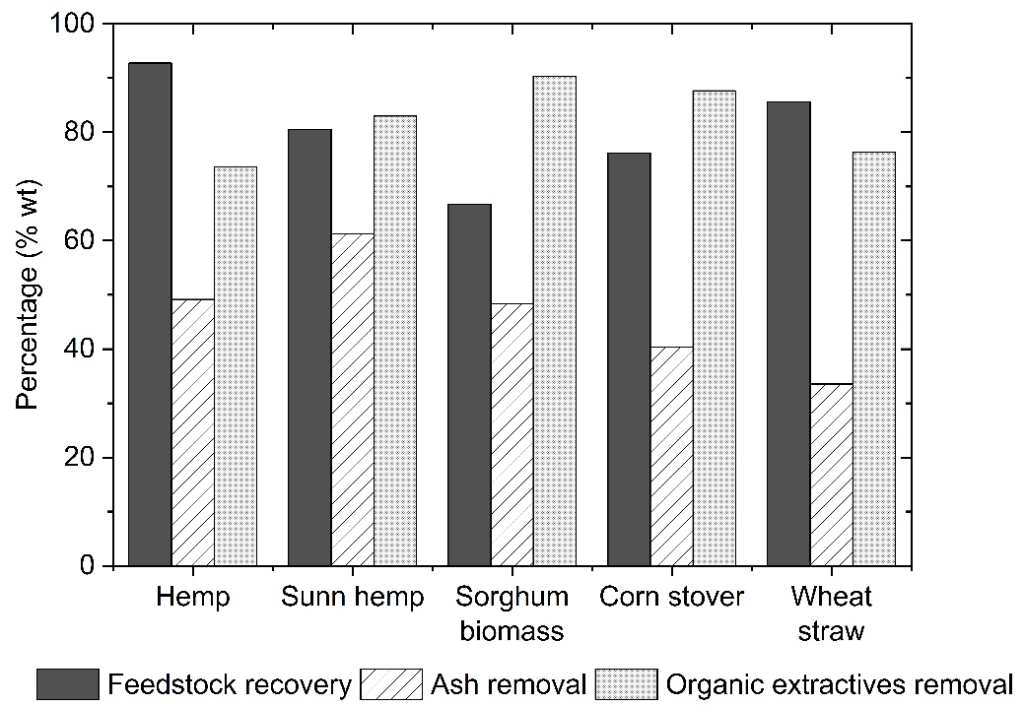
Figure S1: Feedstock recovery and removal of organic extractives and ash from biomass feedstocks following pre-extraction via water-acetone gradient.

Table S1: Outcomes of screening of the various pre-extracted feedstocks through Organosolv acetone fractionation.
Biomass | Acid dose  (mM H₂SO₄) | pH* | Pulp yield**  (% dw) | C6 recovery in pulp (%) | Glucan recovery in pulp (%) | C5 recovery in hydrolysate† (%) | Delignification (%) | Lignin yield (%)
Hemp straw | 61 | 1.78 | 59.6 | 83.4 (3.32) | 86.7 (3.18) | 80.6 | 79.7 | 72.6
Sunn hemp | 93 | 1.80 | 53.5 | 88.7 (0.51) | 94.4 (0.45) | 75.8 | 74.6 | 72.0
Sorghum biomass | 40 | 1.75 | 44.5 | 84.7 (0.07) | 87.0 (0.07) | 83.2 | 85.2 | 83.9
Corn stover | 42 | 1.79 | 46.7 | 96.6 (0.29) | 99.5 (0.62) | 90.0 | 89.3 | 79.3
Wheat straw | 50 | 1.73 | 49.6 | 100.5 (0.16) | 103.3 (0.16) | 85.7 | 84.0 | 80.6
* pH of the liquor after fractionation. **Based on the dry weight of pre-extracted biomass. †Monomeric and oligomeric.

Sulphuric acid dose determination

Prior to fractionation, small scale experiments were performed to determine the amount of sulphuric acid needed to achieve a pH of 1.8 described elsewhere (Smit et al., 2022). Shortly, the pre-extracted biomass was mixed with 50wt% acetone and various amounts of sulphuric acid to give acid concentrations between 0.035 and 0.095 M H₂SO₄ with a liquid-to-solid ratio of 6 L kg⁻¹. These mixtures were treated in 125 ml Parr (4748) digestion bombs heated to reach an internal temperature of 140 °C for 1 h. A second order polynomial regression was applied to determine the relationship between the product slurry pH and the sulphuric acid concentration (Fig. S2). The required sulphuric acid dose to obtain a liquor pH of 1.8 was estimated using the polynomial regressions build for each feedstock.

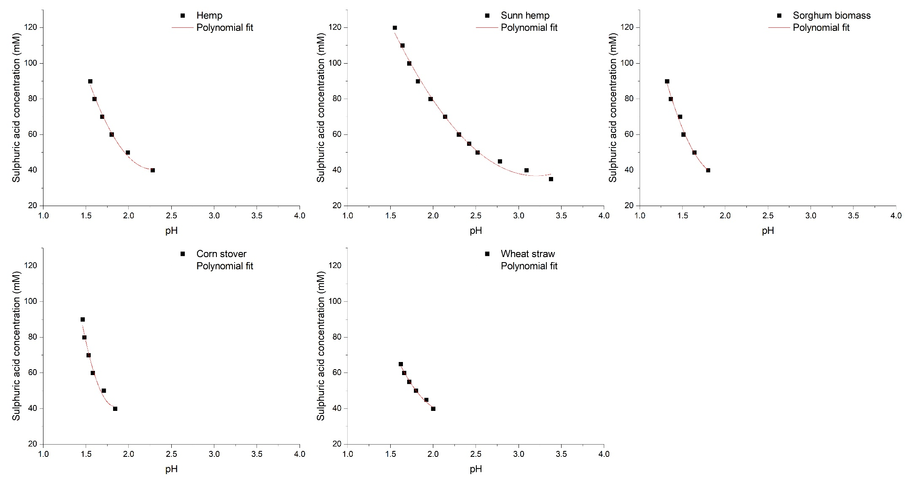
Figure S2: pH as a function of sulphuric acid concentration in the mild acetone organosolv fractionation of pre-extracted lignocellulosic feedstocks.

Estimation of water-soluble lignin (WSL) concentration in hydrolysates

In order to estimate the concentration of WSL in a hydrolysate sample, a dilution of the sample was made before measuring the absorbance at the three ranges selected in the method (range 1: 239-248 nm, range 2: 285-297 nm and range 3: 335-356 nm). The dilution must be such that the absorbance is in the linear range, i.e. absorbance is between 0.2 and 1.0 AU. The known concentrations of furfural, HMF, vanillin and syringaldehyde in the hydrolysate, as well as the corresponding extinction coefficients for these substances in the absorbance ranges, are used then to calculate the contribution of these components to the absorbance measured in the hydrolysate. These contributions are further subtracted from the measured absorbance and the extinction coefficient determined for WSL further used to estimate the concentration of this fraction:

C_{WSL, range i} = (ABS_{Range i} - Σ (ε_{j,range i} × C_{j}))/ ε_{WSL,range i}

Where C_{WSL, Range i} corresponds to the estimated WSL concentration at range i; Range i corresponds to either range 1 (239-248 nm), range 2 (285-297 nm) or range 3 (335-356 nm); ABS corresponds to the measured absorbance; ε_{j,range i} corresponds to the extinction coefficient for component j; C_{j} corresponds to the concentration of component j; and j refers to components furfural, HMF, vanillin, and syringaldehyde.

WSL was isolated from wheat straw hydrolysate produced via acetone Organosolv fractionation using powder activated carbon, desorbing the WSL by back-washing of the carbon with acetone and evaporation, as follows:
- 10 g of granular activated carbon (HYDRAFFIN CC 1240 SPEZIAL, Donau Carbon) was applied to 1 kg of hydrolysate obtained from the acetone Organosolv fractionation of wheat straw. These were gently mixed at 30 °C for 24 h. After this, the spent carbon was separated via centrifugation and further washed as follows:
  - Water washing: 150 g demineralised water were added to the wet spent carbon, mixed gently for 1 h at 30 °C and further centrifuged to recover the wet carbon.
  - Acetone washing: 40g of 100wt% acetone were added to the wet carbon recovered in the previous step, and mixed gently at 30 °C for 1 h. The acetone phase was separated by centrifugation. The recovered wet carbon was further washed with 110 g of 60wt% acetone, and mixed gently at 60 °C for 24 h. The acetone-water phase was recovered through centrifugation.
- The two acetone washings were mixed and 60% of the mass evaporated to remove acetone. The residue from evaporation was left overnight after which a precipitate was formed and separated by centrifugation. The precipitate was further dried at 105 °C overnight. The recovered solid is referred in this report as water-soluble lignin.

Its characterization (data not shown) indicated the presence of various aromatic functionalities (guaiacyl and syringyl groups) as well as fractions from sugar degradation (furanic groups). Stock solutions of the WSL sample were prepared in 35 mM NaOH and their UV absorbance characterized. Three different high absorbance ranges were identified, being within 239-248 nm (range 1), 285-297 nm (range 2) and 335-356 nm (range3). Other inhibitors present in the hydrolysates obtained from acetone Organosolv fractionation, such as the sugar degradation products furfural and HMF, and lignin derived monomers such as vanillin and syringaldehyde, also absorb UV light at those ranges, therefore calibrations of their possible contribution in such ranges were done using stock solutions. The extinction coefficients of the selected inhibitors and of WSL were then determined from the collected data of the stock solutions at five different dilutions where absorbance had a linear response. Table S2 presents the extinction coefficients of these calibrations, the lower and upper limits of the calibrations and the R2 coefficient as an indication of the goodness of fit of the calibrations. In principle, the measurement of WSL in the three absorbance ranges should result in similar estimations of the concentration of this component in the hydrolysates. Figure S3 shows the UV absorbance spectrum of the reference wheat straw WSL.

Figure S3: UV absorbance spectra of water soluble lignins isolated from wheat straw. Stock solutions of 1 mg WSL/mL 35 mM NaOH and diluted further 30 times.

Table S2: Extinction coefficients of the absorbance of water-soluble lignin from beech wood and from wheat straw, furfural, HMF, vanillin and syringaldehyde at the selected absorbance ranges for WSL.
 | Beech wood |  |  |  |  | Wheat straw
 | WSL | FUR | HMF | VAN | SYR | WSL | FUR | HMF | VAN | SYR
Correlation Range 1
Wavelength (nm) | 247-248 |  |  |  |  | 239
Extinction coefficient ε (kg/mg-cm) | 31.24 | 24.95 | 13.94 | 59.09 | 58.43 | 34.04 | 22.65 | 15.87 | 42.33 | 39.39
Lower limit (mg/kg) | 7.1 | 1.6 | 1.9 | 1.6 | 2.7 | 10.1 | 2.6 | 1.7 | 2.1 | 2.7
Upper limit (mg/kg) | 25.4 | 6.7 | 7.6 | 8.6 | 7.1 | 25.0 | 6.8 | 7.8 | 8.7 | 7.1
R² coefficient | 0.999 | 0.996 | 0.989 | 0.999 | 0.997 | 0.999 | 0.986 | 0.970 | 0.999 | 0.995
Correlation Range 2
Wavelength (nm) | 285-286 |  |  |  |  | 297
Extinction coefficient ε (kg/mg-cm) | 18.83 | 114.62 | 125.08 | 16.60 | 4.24 | 25.50 | 38.91 | 86.34 | 21.63 | 6.58
Lower limit (mg/kg) | 12.3 | 2.6 | 1.9 | 1.6 | 3.9 | 12.0 | 1.6 | 2.2 | 1.6 | 4.0
Upper limit (mg/kg) | 49.1 | 6.7 | 7.3 | 5.9 | 7.3 | 33.6 | 6.7 | 7.3 | 8.6 | 7.2
R² coefficient | 1.000 | 0.998 | 0.999 | 0.999 | 0.964 | 1.000 | 0.994 | 0.999 | 1.000 | 0.981
Correlation Range 3
Wavelength (nm) | 354-356 |  |  |  |  | 335
Extinction coefficient ε (kg/mg-cm) | 14.59 | na | na | 153.76 | 116.65 | 26.31 | na | na | 136.60 | 55.80
Lower limit (mg/kg) | 17.4 |  |  | 1.6 | 2.7 | 9.8 |  |  | 1.6 | 2.7
Upper limit (mg/kg) | 65.5 |  |  | 5.9 | 7.1 | 33.6 |  |  | 5.9 | 7.1
R² coefficient | 1.000 |  |  | 1.000 | 0.999 | 1.000 |  |  | 1.000 | 0.998

Hydrolysate from wheat straw from the batches from which the WSL was isolated were used to validate the estimation method of the WSL concentration. Table S3 presents the estimated concentrations at the three absorbance ranges and the average concentration from these. For the reference hydrolysates (Wheat straw ref. lab), the determination of the WSL concentration had relatively low standard deviations corresponding to coefficient of variations of 15 and 6%, respectively. The method was further applied to the hydrolysates produced from pre-extracted feedstocks in the present study.

The variation coefficient for the WSL determination from the pre-extracted wheat straw feedstock was similar to that of the reference wheat straw, suggesting that the WSL fragments were comparable. However, for sunn hemp and hemp, the coefficients of variation were higher and therefore the WSL fractions may be significantly different. The estimated WSL concentrations were further used in the lignin mass balance to check whether the WSL fraction could improve/close the mass balance. The variability of the data, and therefore part of its reliability, was not correlated to a “good or bad” mass balance closure, meaning for instance, that for hemp or sunn hemp, which gave relatively higher coefficient of variations, the lignin mass balance was not significantly high or low. It must be noted that the WSL estimation method is intended herein to be used as a semi-quantitative estimation of a rather complex and difficult to characterise fraction of the organics in the biomass hydrolysate. The method is not intended to be used for any type of hydrolysate since it is highly dependent on the type of biomass (matrix of organic compounds) and on the fractionation method. For instance, woody biomasses would contain extractives with certain tannins, saccharides and phenolics such as catechin; while wheat straw extractives are rather rich in fatty acids, sterols and other types of phenolics, such as coniferyl alcohol, 4-hydroxycinnamic acid and ferulic acid (Piccand et al., 2019; Qin et al., 2009; Vek et al., 2018). Furthermore, the formation of pseudo-lignin components, that is condensed forms of other degradation products, from e.g. furfural and acetone, onto the lignin molecules, can also alter significantly the composition and therefore the absorbance of the WSL. Limitations are to be expected specially when the calibration for WSL from herbaceous biomasses was derived from a single type of feedstock (wheat straw). At best, this method is indicative and not accurate in terms of the amount of lignin present in the hydrolysate product.

Table S3: Estimated water soluble lignin concentration in the reference hydrolysate from wheat straw, and from the hydrolysates obtained from pre-extracted feedstocks.
 |  | Range 1 |  | Range 2 |  | Range 3 |  | Average WSL concentration (g/kg)  [Variation coefficient**]
Hydrolysate sample | Cal.* | Estimated WSL (g/kg) | Relative absorbance of inhibitors | Estimated WSL (g/kg) | Relative absorbance of inhibitors | Estimated WSL (g/kg) | Relative absorbance of inhibitors | Average WSL concentration (g/kg)  [Variation coefficient**]
Beech wood (ref pilot) | BW | 35.05 | 5% | 38.3 | 15% | 28.2 | 16% | 33.8 [15%]
Eucalyptus wood | BW | 14.3 | 7% | 13.1 | 23% | 12.4 | 18% | 13.3 [7%]
Beech wood | BW | 12.9 | 7% | 13.6 | 26% | 11.6 | 13% | 12.7 [8%]
Wheat straw (ref lab) | WS | 10.4 | 22% | 9.29 | 43% | 9.96 | 4% | 9.89 [6%]
Giant reed | WS | 20.1 | 8% | 18.1 | 17% | 17.5 | 4% | 18.6 [7%]
Sorghum biomass | WS | 10.7 | 10% | 11.3 | 20% | 13.2 | 2% | 11.7 [11%]
Sunn hemp | WS | 12.6 | 6% | 11.3 | 15% | 6.52 | 4% | 10.1 [32%]
Sugarcane straw | WS | 16.1 | 10% | 16.4 | 21% | 14.4 | 1% | 15.6 [7%]
Hemp | WS | 11.8 | 6% | 10.1 | 15% | 6.90 | 5% | 9.59 [26%]
Corn stover | WS | 10.2 | 5% | 11.8 | 10% | 13.3 | 1% | 11.7 [13%]
Wheat straw | WS | 12.4 | 7% | 12.9 | 15% | 11.6 | 1% | 12.3 [6%]
* Calibration used for the estimation: BW = WSL isolated from beech wood, WS = WSL isolated from wheat straw. ** Coefficient variation = standard deviation/average x 100.

Enzymatic hydrolysis

Table S4: Composition of pulps after mild acetone organosolv fractionation.
Components, % dw | Ash | C5 sugarsª | C6 sugarsª | Glucan | Total lignin^{b}
Hemp pulp | 1.8 (0.06) | 3.0 (0.10) | 79.6 (2.08) | 77.4 (2.01) | 6.2 (0.05)
Sunn hemp pulp | 5.7 (0.01) | 3.9 (0.02) | 72.2 (0.83) | 70.4 (0.76) | 9.7 (0.01)
Sorghum pulp | 7.5 (0.06) | 5.8 (0.00) | 69.6 (0.09) | 69.6 (0.10) | 5.9 (0.02)
Corn stover pulp | 11.1 (0.11) | 5.3 (0.09) | 83.7 (0.38) | 83.5 (0.56) | 4.1 (0.27)
Wheat straw pulp | 11.9 (0.02) | 4.4 (0.02) | 81.2 (0.43) | 80.7 (0.39) | 6.0 (0.05)
ª C5 sugars corresponded only to xylan, C6 sugars included glucan, mannan and galactan. ^{b} Total lignin corresponded to both acid-insoluble lignin and acid-soluble lignin.

Figure S4: Glucose yields at various hydrolysis times for the pulps using three enzyme doses: a) 5 g/100 g glucan; b) 10 g/100 g glucan; c) 15 g/100 g glucan.

Bibliography

Piccand, M., Bianchi, S., Halaburt, E.I., Mayer, I., 2019. Characterization of extractives from biomasses of the alpine forests and their antioxidative efficacy. Industrial Crops and Products 142, 111832, doi:https://doi.org/10.1016/j.indcrop.2019.111832.
Qin, M.H., Xu, Q.H., Shao, Z.Y., Gao, Y., Fu, Y.J., Lu, X.M., Gao, P.J., Holmbom, B., 2009. Effect of bio-treatment on the lipophilic and hydrophilic extractives of wheat straw. Bioresource Technology 100, 3082-3087, doi:https://doi.org/10.1016/j.biortech.2009.01.055.
Sluiter, A., Hames, B., Ruiz, R., Scarlata, C., Sluiter, J., Templeton, D., Crocker, D., 2012. NREL/TP-510-42618 Determination of Structural Carbohydrates and Lignin in Biomass, Laboratory Analytical Procedure (LAP). National Renewable Energy Laboratory,
Sluiter, A., Ruiz, R., Scarlata, C., Sluiter, J., Templeton, D., 2008. NREL/TP-510-42619 Determination of Extractives in Biomass, Laboratory Analytical Procedure (LAP). National Renewable Energy Laboratory,
Smit, A.T., van Zomeren, A., Dussan, K., Riddell, L.A., Huijgen, W.J.J., Dijkstra, J.W., Bruijnincx, P.C.A., 2022. Biomass Pre-Extraction as a Versatile Strategy to Improve Biorefinery Feedstock Flexibility, Sugar Yields, and Lignin Purity. ACS Sustainable Chemistry & Engineering 10, 6012-6022, doi:10.1021/acssuschemeng.2c00838.
Vek, V., Oven, P., Poljanšek, I., 2018. Comparison of two extraction and two chromatographic methods in analysis of beech wood extractives. European Journal of Wood and Wood Products 76, 389-392, doi:10.1007/s00107-017-1216-5.

