Supplementary Material

Supplementary Figures
Fig. S1 (A) Temporal trends in the number of fishing vessels and (B) annual landings of anchovy (ANE) and sardine (PIL) from Ancona (red) and Chioggia (light blue) harbors.
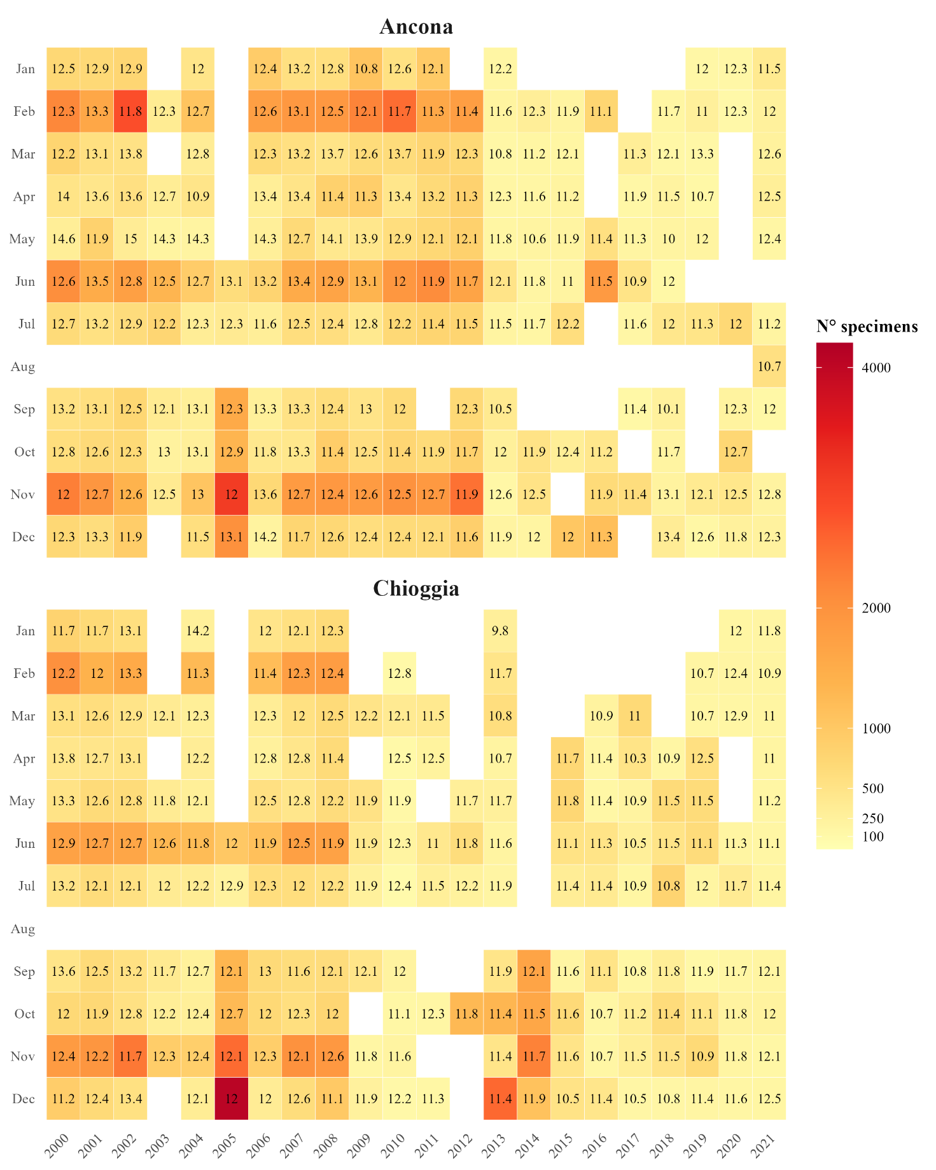
Fig. S2 Monthly and annual distribution of the weighted mean length (wML, numbers within cells) and the number of specimens examined (color scale) of anchovy in the ports of Ancona and Chioggia. Warmer colors indicates a higher number of measured specimens.
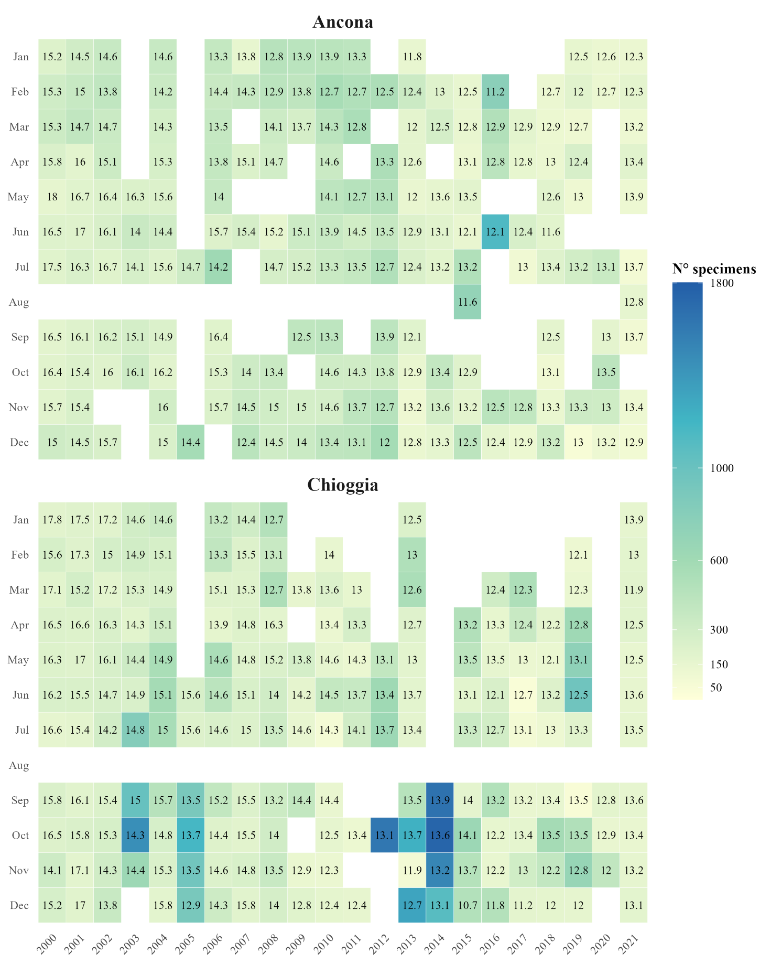
Fig. S3 Monthly and annual distribution of the weighted mean length (wML, numbers within cells) and the number of specimens examined (color scale) of sardine in the ports of Ancona and Chioggia. Warmer colors indicates a higher number of measured specimens.

Fig. S4 Temporal trends of the environmental variables. Linear regression lines, correlation coefficients (R) and significance levels (p-values) are displayed.
Fig. S5 T-test boxplot for (A) temperature, (B) Sea Surface Height, (C) chlorophyll-a concentration and (D) salinity that shows spatial differences between Ancona (blue) and Chioggia (yellow). P-values are shown.

Figure S6 Kendall’s rank correlation matrix among temporal, environmental, and anthropogenic variables used in the GAM analysis. Color scale represents the strength and direction of correlations, from negative (purple) to positive (orange) values. Correlation coefficients above 0.49 (in absolute value) are considered significant.

Fig. S7 GAM diagnostic for anchovy.

Fig. S8 GAM diagnostic for sardine.
Fig. S9 Observed versus predicted weighted mean length (wML) for anchovy (ANE, left panel) and sardine (PIL, right panel) from the best GAM models. The solid line represents the fitted linear regression, while the dashed line is the 'fitting of the observed data. Model performance is summarized by root mean squared error (RMSE) and coefficient of determination (R²).

Supplementary Tables
Table S1 Results of variable selection procedure for GAMs applied to anchovy (ANE) and sardine (PIL). Each row represents a model tested at different temporal lags (0–12 months) for environmental and anthropogenic predictors. The column Factors lists the covariates included in each model, and the corresponding Akaike Information Criterion (AIC) values are reported and ranked by lowest to highest for each lag. Lower AIC values indicate better model performance.
ANE |  |  | PIL
Lag | Factors | AIC | Factors | AIC
0 | Time, Harbor, Fleet, Ssh, Temp | 531.884 | Time, Temp, Fleet, Season, Po, Sal, Chla | 572.835
0 | Time, Harbor, Fleet, Ssh, Temp, Po | 533.323 | Time, Temp, Fleet, Season, Po | 573.636
0 | Time, Harbor, Fleet, Ssh, Temp, Po, Season | 534.844 | Time, Temp, Fleet, Season, Po, Sal | 573.679
0 | Time, Harbor, Fleet, Season | 534.875 | Time, Temp, Fleet, Season | 574.393
0 | Time, Harbor, Fleet | 535.059 | Time, Temp, Fleet | 583.032
0 | Time, Harbor | 541.692 | Time, Temp | 591.910
0 | Time | 567.281 | Time | 633.629
1 | Time, Harbor, Fleet, Chla, Po | 516.205 | Time, Season, Fleet, Po, Chla, Harbor | 560.786
1 | Time, Harbor, Fleet, Chla, Po, Temp | 516.482 | Time, Season, Fleet, Po, Chla, Harbor, Sal | 562.017
1 | Time, Harbor, Fleet, Chla, Po, Temp, Sal | 518.328 | Time, Season, Fleet, Temp, Chla | 564.186
1 | Time, Harbor, Fleet | 518.656 | Time, Season, Fleet, Temp | 564.770
1 | Time, Harbor, Fleet, Chla | 520.380 | Time, Season, Fleet | 569.553
1 | Time, Harbor | 541.692 | Time, Season | 602.062
1 | Time | 567.281 | Time | 633.629
2 | Time, Harbor, Po, Fleet, Temp, Ssh, Sal | 505.188 | Time, Season, Fleet, Po, Sal | 554.608
2 | Time, Harbor, Po, Fleet, Temp, Ssh | 507.239 | Time, Season, Fleet, Po, Sal, Chla | 554.853
2 | Time, Harbor, Po, Fleet, Temp | 507.411 | Time, Season, Fleet, Po, Sal, Harbor, Temp | 555.404
2 | Time, Harbor, Po, Fleet | 509.389 | Time, Season, Fleet, Po | 556.390
2 | Time, Harbor, Po | 538.588 | Time, Season, Fleet | 561.178
2 | Time, Harbor | 541.692 | Time, Season | 602.062
2 | Time | 567.281 | Time | 633.629
3 | Time, Harbor, Fleet, Chla, Temp, Ssh | 513.265 | Time, Season, Fleet, Chla, Sal, Po | 562.569
3 | Time, Harbor, Fleet, Chla, Temp, Ssh, Po | 513.728 | Time, Season, Fleet, Chla, Sal | 563.491
3 | Time, Harbor, Fleet, Chla, Temp | 513.920 | Time, Season, Fleet, Chla, Sal, Po, Temp | 564.397
3 | Time, Harbor, Fleet, Chla | 518.942 | Time, Season, Fleet, Chla | 565.043
3 | Time, Harbor, Fleet | 519.910 | Time, Season, Fleet | 567.671
3 | Time, Harbor | 541.692 | Time, Season | 602.062
3 | Time | 567.281 | Time | 633.629
4 | Time, Fleet, Ssh, Harbor, Temp, Sal | 484.653 | Time, Season, Fleet | 567.091
4 | Time, Fleet, Ssh, Harbor, Temp | 485.274 | Time, Season, Fleet, Temp | 567.522
4 | Time, Fleet, Ssh, Harbor | 485.278 | Time, Season, Fleet, Temp, Chla | 568.320
4 | Time, Fleet, Ssh, Harbor, Temp, Sal, Po | 486.521 | Time, Season, Fleet, Temp, Chla, Po | 568.981
4 | Time, Fleet, Ssh | 508.048 | Time, Season, Fleet, Temp, Chla, Ssh, Sal | 571.284
4 | Time, Fleet | 517.371 | Time, Season | 602.062
4 | Time | 567.281 | Time | 633.629
5 | Time, Fleet, Harbor, Sal | 498.104 | Time, Temp, Fleet, Season, Sal | 541.621
5 | Time, Fleet, Harbor | 499.348 | Time, Temp, Fleet, Season, Sal, Ssh | 542.041
5 | Time, Fleet, Chla, Sal, Temp | 502.709 | Time, Temp, Fleet, Season, Sal, Ssh, Chla | 542.350
5 | Time, Fleet, Chla, Sal, Temp, Season | 502.977 | Time, Temp, Fleet, Season | 543.639
5 | Time, Fleet, Chla, Sal, Temp, Season, Ssh | 503.952 | Time, Temp, Fleet | 555.890
5 | Time, Fleet | 520.846 | Time, Temp | 601.076
5 | Time | 567.281 | Time | 633.629
6 | Time, Fleet, Sal, Harbor, Season | 512.285 | Time, Temp, Fleet, Po, Sal, Chla | 539.038
6 | Time, Fleet, Sal, Harbor | 512.364 | Time, Temp, Fleet, Po, Sal, Chla, Harbor | 539.895
6 | Time, Fleet, Sal, Harbor, Season, Po | 513.592 | Time, Temp, Fleet, Po, Sal | 540.302
6 | Time, Fleet, Sal, Harbor, Season, Po, Ssh | 514.484 | Time, Temp, Fleet, Po | 544.626
6 | Time, Fleet, Sal | 523.391 | Time, Temp, Fleet | 551.010
6 | Time, Fleet | 529.779 | Time, Temp | 584.316
6 | Time | 567.281 | Time | 633.629
7 | Time, Fleet, Harbor, Season, Ssh | 502.052 | Time, Season, Fleet, Po, Chla, Temp | 567.199
7 | Time, Fleet, Harbor, Season | 503.958 | Time, Season, Fleet, Po, Chla, Temp, Harbor | 568.645
7 | Time, Fleet, Harbor, Temp, Ssh, Chla, Season | 504.867 | Time, Season, Fleet, Po, Chla | 571.775
7 | Time, Fleet, Harbor | 508.611 | Time, Season, Fleet, Po | 574.768
7 | Time, Fleet, Harbor, Po, Ssh, Chla | 511.871 | Time, Season, Fleet | 575.310
7 | Time, Fleet | 526.938 | Time, Season | 602.062
7 | Time | 567.281 | Time | 633.629
8 | Time, Fleet, Chla, Harbor, Season, Po, Ssh | 479.331 | Time, Season, Temp, Fleet, Chla, Harbor, Sal | 580.845
8 | Time, Fleet, Chla, Harbor, Season | 479.521 | Time, Season, Temp, Fleet, Chla, Harbor | 581.113
8 | Time, Fleet, Chla, Harbor, Season, Po | 479.600 | Time, Season, Temp, Fleet | 581.970
8 | Time, Fleet, Chla, Harbor | 481.414 | Time, Season, Temp, Fleet, Chla | 582.151
8 | Time, Fleet, Chla | 495.028 | Time, Season, Temp | 599.863
8 | Time, Fleet | 518.650 | Time, Season | 602.062
8 | Time | 567.281 | Time | 633.629
9 | Time, Fleet, Chla, Temp, Harbor, Po, Season | 484.231 | Time, Fleet, Sal, Temp, Season, Chla | 557.459
9 | Time, Fleet, Chla, Temp, Sal, Po | 485.654 | Time, Fleet, Sal, Temp, Season, Chla, Ssh | 558.350
9 | Time, Fleet, Chla, Temp | 486.880 | Time, Fleet, Sal, Temp, Ssh | 565.993
9 | Time, Fleet, Chla | 489.006 | Time, Fleet, Sal, Temp | 570.342
9 | Time, Fleet, Chla, Temp, Season | 489.197 | Time, Fleet, Season | 570.505
9 | Time, Fleet | 509.420 | Time, Fleet | 590.337
9 | Time | 567.281 | Time | 633.629
10 | Time, Fleet, Ssh, Harbor, Chla, Temp | 494.855 | Time, Season, Fleet, Temp | 548.685
10 | Time, Fleet, Ssh, Harbor, Chla, Temp, Sal | 496.737 | Time, Po, Fleet, Temp, Sal, Season | 550.864
10 | Time, Fleet, Po, Harbor | 499.166 | Time, Po, Fleet, Temp, Sal, Season, Harbor | 552.745
10 | Time, Fleet, Po, Harbor, Chla | 499.577 | Time, Season, Fleet | 559.195
10 | Time, Fleet, Po | 517.870 | Time, Harbor, Fleet, Temp, Sal | 563.982
10 | Time, Fleet | 526.479 | Time, Season | 602.062
10 | Time | 567.281 | Time | 633.629
11 | Time, Harbor, Po, Fleet, Temp | 502.752 | Time, Temp, Fleet, Season | 549.402
11 | Time, Harbor, Po, Fleet | 505.549 | Time, Temp, Fleet | 550.201
11 | Time, Harbor, Po, Fleet, Temp, Season | 507.147 | Time, Temp, Fleet, Season, Po | 550.837
11 | Time, Harbor, Po, Fleet, Temp, Season, Sal | 508.951 | Time, Temp, Fleet, Season, Po, Sal | 552.571
11 | Time, Harbor, Po | 527.247 | Time, Temp, Fleet, Season, Po, Sal, Chla | 554.254
11 | Time, Harbor | 541.692 | Time, Temp | 592.606
11 | Time | 567.281 | Time | 633.629
12 | Time, Chla, Harbor, Fleet, Temp, Ssh, Sal | 531.598 | Time, Temp, Season, Harbor, Fleet | 578.739
12 | Time, Chla, Harbor, Sal, Temp | 533.296 | Time, Temp, Season, Harbor, Fleet, Po | 579.612
12 | Time, Chla, Harbor, Sal | 534.475 | Time, Temp, Season, Harbor, Fleet, Po, Sal | 581.306
12 | Time, Chla, Harbor, Fleet, Temp, Po | 535.294 | Time, Temp, Season, Po | 586.487
12 | Time, Chla, Harbor | 536.997 | Time, Temp, Season | 587.408
12 | Time, Chla | 547.527 | Time, Temp | 593.876
12 | Time | 567.281 | Time | 633.629

