Web Appendix A. Journals
Table 1. Impact of journals by number of publications.
Journal | No. of articles
Journal of Cleaner Production | 56
Business Strategy and the Environment | 22
Small Business Economics | 11
Technological Forecasting and Social Change | 11
Journal of Business Research | 9
Organization & Environment | 4
Technovation | 4
Business & Society | 3
Journal of Industrial Ecology | 3
Journal of Service Research | 3

Table 2. Impact of journals by number of citations.
Journal | No. of citations
Journal of Cleaner Production | 1179
Business Strategy and the Environment | 348
Technological Forecasting and Social Change | 305
Research Policy | 254
Strategic Management Journal | 249
Journal of Business Research | 248
Small Business Economics | 245
Sustainability | 225
Academy of Management Review | 186
Academy of Management Journal | 173

Table 3. Conversion of the main academic journal rankings.
ABS Academic Journal Guide 2021 | Number of articles | Percentage
4* | 3 | 1.9%
4 | 7 | 4.3%
3 | 83 | 51.2%
2 | 69 | 42.6%
Total | 162 | 100%

Web Appendix B. Authors
Table 1. Impact of authors by number of publications.
Author | No. of articles
van Rijnsoever FJ | 4
Aarikka-Stenroos L | 3
Bocken N | 3
Fichter K | 3
Parida V | 3
Rajala R | 3
Zhang X | 3

Table 2. Impact of authors by number of citations.
Author | No. of citations
Neumeyer X | 15
Santos Sc | 15
Bocken N | 13
Hultink Ej | 13
Konietzko J | 13
Burstrom T | 11
Parida V | 11
van Rijnsoever FJ | 11
Visnjic I | 11
Wincent J | 11

Web Appendix C. Themes analysis by phase
After outlining the main phases of the research evolution in Section 4.2 and discussing the main literature sub-domains in Sections 5, we conducted an additional themes analysis to explore more deeply the intersection between temporal dynamics and these sub-domains.

First, we grouped articles according to the phases identified in our earlier analysis.
Second, we organized the research across the temporal phases. To do so, we performed a themes analysis which resulted in the outputs shown in Figures 1–3 below.

Figure 1. Themes emerging from Phase 1.
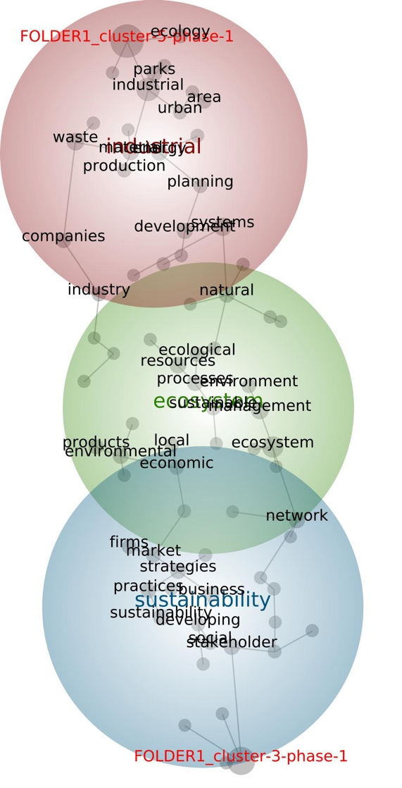

Figure 2. Themes emerging from Phase 2.
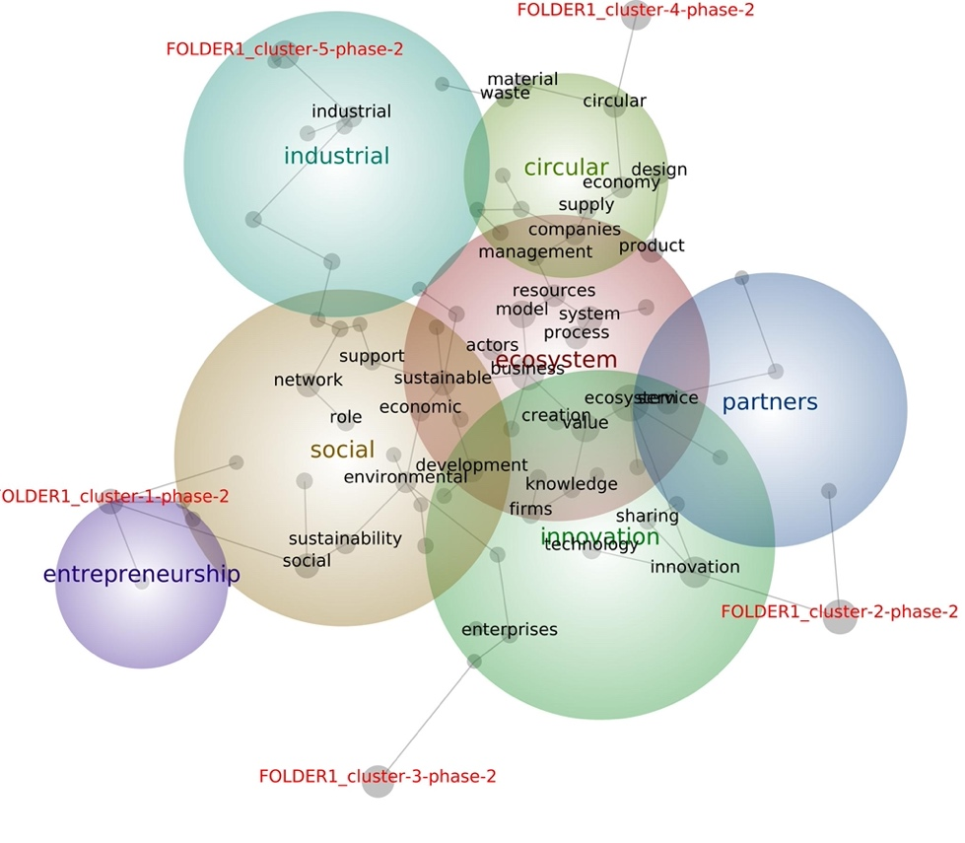

Figure 3. Themes emerging from Phase 3.
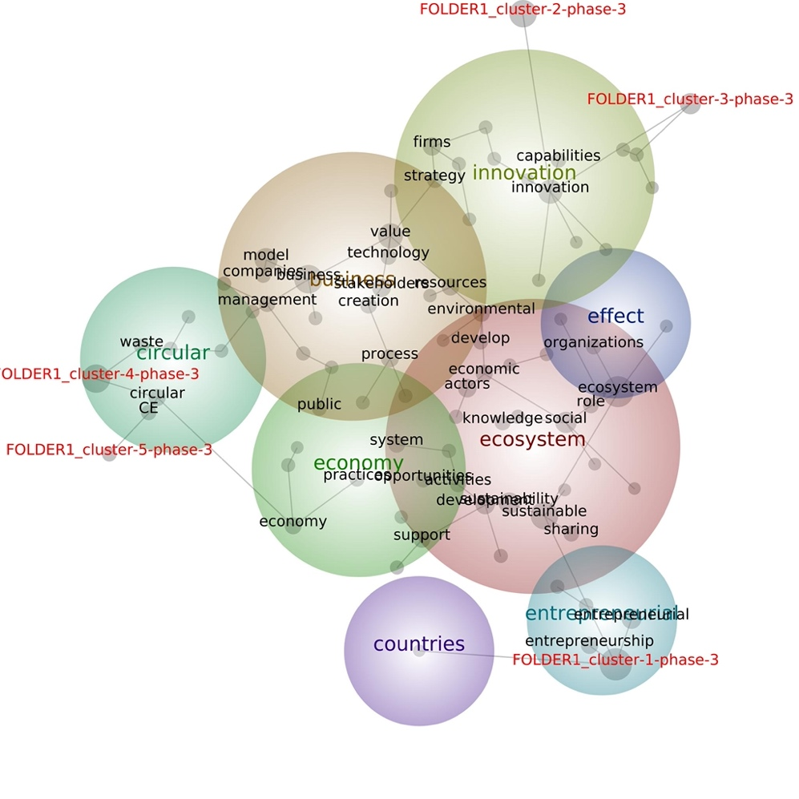
Theme categories were then derived from the terms associated with each theme, as identified by the software, and from the content of the papers. We refined the software output by removing cognates (e.g., sustainability/sustainable; entrepreneurship/entrepreneurial/entrepreneur) to enhance precision. Key terms — also provided by the software — were identified as core concepts related to each theme. Finally, the selection of references was based on both the software's suggestions and our domain expertise. The results are presented in Table 1.

Table 1. Research across the temporal phases
Phase | Theme Category | Key-terms | Selected References
1 | Natural Ecosystems and Resource Management Networks | ecosystem, management, resources, network, processes, sustainable, ecological, products, economic, environment, local | Desrochers, 2002; Nielsen, 2007; Manring, 2007
1 | Urban and Industrial Symbiotic Systems | industrial, systems, waste, material, energy, development, natural, parks, companies, ecology, industry, production, urban | Leduc & Van Kann, 2013; Yang & Lay, 2004; Zamorano et al., 2011
1 | Inter-Stakeholder Collaboration for Sustainability | sustainability, stakeholder, strategies, business, practices, market, firms, social | Heuer, 2011; Sharma & Henriques, 2005; Stead & Stead, 2013
2 | Urban and Industrial Symbiotic Systems | industrial, local, regional, symbiosis, ecology, time, China, water | Susur et al., 2019; Shi & Li, 2019; Zaoual & Lecocq, 2018
2 | Circular Resource Management | circular, economy, companies, supply, material, design, waste management | Batista et al., 2019; Whicher et al., 2018; Zucchella & Previtali, 2019
2 | Collective Value Creation | ecosystem, business model, value, system, sustainable, development, product, process, service, resources, actors, creation | Matinheikki et al., 2017; Matthies et al., 2016; Trischler et al., 2020
2 | Platform Solutions for Sustainability Partnerships | partners, platform, strategy, manufacturing | Ding et al., 2019; Konietzko et al., 2020; Wei et al., 2020
2 | Dynamics between Firms and Knowledge Sharing for Innovation | innovation, technology, firms, knowledge, sharing, enterprises | Madsen, 2020; Planko et al., 2019; Romanelli 2018
2 | Support for Socially-Oriented Firms | social, network, environmental, sustainability, economic, support, role | Bank et al., 2017; Bozhikin et al., 2019; Theodoraki et al., 2018
2 | Policy Frameworks for Social Entrepreneurship | entrepreneurship, social, entrepreneurs, role, policy, capital | Martinez‐Fierro et al, 2020; Lamine et al., 2018; Tiba et al., 2020
3 | Capabilities for Sustainable Urban Innovation | innovation, firms, strategy, capabilities, urban, partners, smart, green | Linde et al., 2021; Parente et al., 2021; Santa-Maria et al., 2022
3 | Circular Resource Management | circular, CE, waste, supply, material, production, construction | Valve et al., 2021; Zerbino et al., 2021; Yu et al., 2022
3 | Opportunities and Challenges in Building Future Economic Systems | economy, system, practices, opportunities, public, market, future, design, challenges, work, food | Averina et al., 2022; Chirumalla et al., 2022; Moggi & Dameri, 2021
3 | Collective Value Creation | business, model, value, stakeholders, process, resources, environmental, creation, management, technology, companies | Boldrini & Antheaume, 2021; Bonfanti et al., 2023; Tapaninaho & Heikkinen, 2022
3 | Performance of Sustainable Ventures | effect, collaboration, partners, green, open, performance, ventures | Acebo et al., 2021; Kroh, 2021; Lee & Roh, 2023
3 | Sustainable Development Through Knowledge Sharing and Collaboration | ecosystem, sustainability, social, sustainable development, actors, economic, support, activities, sharing, knowledge, role, organizations | Bertello et al., 2022; Ho & Yoon, 2022; Kanda et al., 2021
3 | Regional Sustainability Through Social Entrepreneurial Ventures | entrepreneurial, ventures, sustainable, regional, factors, social | Bischoff, 2021; O'Shea et al., 2021; Wagner et al., 2021
3 | Cross-Country Collaboration for Global Goals Achievement | countries, sector, global, institutional, practices | Canestrino et al., 2023; George 2021; Sebhatu & Enquist, 2022

Third, we examined how the theme categories relate to each sub-domain. During the themes analysis setup in the software, we assigned a “tag” to each article folder, with each folder representing a specific literature sub-domain. In the resulting output (Figures 1–3), the proximity of a term to a folder tag indicates a strong conceptual association with that sub-domain. To validate these associations, we analysed the terms linked to each folder tag, along with their corresponding co-counts and likelihoods. Moreover, while defining theme categories, key-terms, and selected references, we closely examined the content of the underlying articles to ensure alignment with the themes labels and to verify their relevance for specific literature sub-domains. Although a theme category may include articles from various sub-domains, there is always a dominant sub-domain within that category (i.e., most of the articles belong to the same sub-domain). This rigorous procedure, combined with our comprehensive understanding of the articles, ensured a minimally biased analysis.
This process yielded a set of clearly defined theme categories and their connections to specific literature sub-domains. The final output of this analysis is presented in Figure 9 in the main text. Inter-theme connections were established through qualitative content analysis of the relevant articles, allowing us to map the conceptual structure of the literature with greater granularity.
In what follows, we briefly discuss the content of each theme category across the different research phases as presented in Table 1.
Phase 1
The first phase, foundational in nature, is structured around the following three theme categories:
1) Natural Ecosystems and Resource Management Networks: The concept of ecosystems in managerial literature stems from studies of natural ecosystems (Nielsen, 2007). Early research introduced the idea of firms interconnected through resource recovery links, highlighting collaborative relationships to enhance sustainability (Desrochers, 2002; Manring, 2007).
2) Urban and Industrial Symbiotic Systems: Building on the idea of recycling firm linkages, this theme explores the application of these principles in local contexts. It emphasizes creating interconnected systems where materials, energy, and by-products are exchanged and reused across industrial and urban settings (Yang and Lay, 2004). Strategies such as eco-industrial parks and integrated urban planning are proposed to bridge industrial and natural environments (Leduc and Van Kann, 2013; Zamorano et al., 2011).
3) Inter-Stakeholder Collaboration for Sustainability: This theme takes a broader perspective, focusing on cooperation among businesses, governments, non-profits, and local communities to address sustainability challenges (Sharma and Henriques, 2005). Scholars emphasize the importance of trust, shared goals, and innovative governance structures to overcome power imbalances and conflicting priorities, fostering collective action for sustainable development across sectors and national borders (Heuer, 2011; Stead and Stead, 2013).
Phase 2
The second phase builds on the foundational principles of the first, emphasizing systemic strategies for sustainability through innovation, collaboration, and institutional transformation. This phase comprises the following seven theme categories:
1) Urban and Industrial Symbiotic Systems: This theme builds on topics developed in the first phase but shifts the focus toward regulatory, organizational, and operational barriers. It emphasizes shared governance, resilient networks, and technical and social learning to scale these systems (Shi et al., 2019; Zaoual and Lecocq, 2018). By fostering innovation within urban-industrial ecosystems, symbiotic practices not only close resource loops but also drive regional sustainability and economic development (Susur et al., 2019).
2) Circular Resource Management: This theme focuses on circular supply chains, innovative business models, and ecosystems that close resource loops (Batista et al., 2019). It emphasizes waste reduction, lifecycle extension, and upcycling, supported by policy frameworks, technological advancements, and stakeholder collaboration to drive systemic change toward circular models (Whicher et al., 2018; Zucchella and Previtali, 2019).
3) Collective Value Creation: This theme redefines value creation as a shared, co-creative process, that enables businesses, communities, and ecosystems to deliver societal and environmental benefits while reducing material consumption (Matinheikki et al., 2017). By leveraging ecosystem approaches and service-dominant logic, collective value creation fosters innovation, systemic cooperation, and resource efficiency (Matthies et al., 2016; Trischler et al., 2020).
4) Platform Solutions for Sustainability Partnerships: This theme examines platforms as integrative mechanisms that coordinate resources, services, and technologies among stakeholders (Wei et al., 2020). Platforms foster experimentation, co-creation, and modular innovation, enabling scalable solutions and supporting servitization and circular practices (Ding et al., 2019; Konietzko et al., 2020).
5) Dynamics Between Firms and Knowledge Sharing for Innovation: This theme explores the complexities of collaboration in innovation ecosystems. It highlights the role of digital tools and technologies in facilitating knowledge sharing while addressing challenges such as knowledge leakage and power imbalances in competitive environments (Madsen, 2020; Planko et al., 2019; Romanelli, 2018).
6) Support for Socially-Oriented Firms: This theme highlights the role of incubators, mentorship programs, and resource networks in fostering socially-driven ventures (Bank et al., 2017; Theodoraki et al., 2018). Collaborative ecosystems involving governments, universities, and business networks provide essential resources to support these ventures’ growth and innovation (Bozhikin et al., 2019).
7) Policy Frameworks for Social Entrepreneurship: This theme explores the role of policies and financial mechanisms in scaling socially-oriented enterprises. By aligning policies with regional contexts and facilitating partnerships, these frameworks reduce administrative burdens, attract resources, and enable sustainable development (Lamine et al., 2018; Martínez-Fierro et al., 2020; Tiba et al., 2020).
Phase 3
The third phase adopts a more granular perspective, delving into specific and operational topics related to knowledge and capabilities, opportunities and challenges of the ecosystem approach, and performance outcomes. This phase comprises the following eight theme categories:
1) Capabilities for Sustainable Urban Innovation: This theme focuses on the dynamic and innovation capabilities needed to build and orchestrate ecosystems that support sustainable and smart solutions in urban contexts (Linde et al., 2021; Parente et al., 2021; Santa-Maria et al., 2022).
2) Circular Resource Management: This theme, emerged in the second phase, here explores roles, business models, and tools for collective circular value creation, focusing on resource recovery and material flow optimization (Valve et al., 2021; Zerbino et al., 2021). Digital decision-support tools are highlighted for improving traceability and collaboration in construction and demolition waste management (Yu et al., 2022).
3) Opportunities and Challenges in Building Future Economic Systems: This theme examines the importance of identifying business opportunities that create multidirectional value for stakeholders (Chirumalla et al., 2022). Key dimensions for evaluating sustainability-related opportunities include assessing capabilities, aligning ecosystems, and ensuring value-capture viability to deliver economic and social benefits (Averina et al., 2022). Essential conditions for fostering sustainable ecosystems include identifying sustainable opportunities, mobilizing resources, and building mutual trust among stakeholders (Moggi and Dameri, 2021; DiVito and Ingen-Housz, 2021).
4) Collective Value Creation: This theme, already developed in the second phase, highlights the importance of aligning stakeholders’ expectations and business models in the joint value creation process to achieve sustainability and circularity (Boldrini and Antheaume, 2021; Tapaninaho and Heikkinen, 2022). It underscores the collaborative nature of sustainable practices as a crucial dimension for achieving the SDGs (Bonfanti et al., 2023).
5) Performance of Sustainable Ventures: This theme examines the outcomes of collaboration, focusing on how stakeholder interactions shape sustainable performance (Acebo et al., 2021; Kroh, 2021). It highlights that coopetition – simultaneous cooperation and competition – can yield varying results depending on actors’ capabilities (Lee and Roh, 2023).
6) Sustainable Development Through Knowledge Sharing and Collaboration: This theme emphasizes the creation of ecosystems where diverse actors co-develop sustainable solutions by sharing knowledge, aligning roles, and coordinating activities to address social and economic challenges (Bertello et al., 2022; Kanda et al., 2021). Intermediaries and digital platforms play a pivotal role in fostering collaboration, resource integration, and stakeholder engagement to drive systemic innovation and sustainability transitions (Ho and Yoon, 2022).
7) Regional Sustainability Through Social Entrepreneurial Ventures: This theme underscores the role of entrepreneurial ecosystems in addressing local challenges by integrating stakeholders and fostering collaboration (Bischoff, 2021; O'Shea et al., 2021). Institutions play a critical role in facilitating knowledge spillovers, building entrepreneurial capabilities, and supporting venture creation through dedicated programs and partnerships (Wagner et al., 2021).
8) Cross-Country Collaboration for Global Goal Achievement: This theme emphasizes the importance of cross-border partnerships that align public and private sector efforts to tackle global challenges and support the United Nations SDGs (Sebhatu and Enquist, 2022). Digital innovations enable collaboration across geographic and institutional boundaries, promoting knowledge sharing and coordinated action (George et al., 2021). The success of sustainable initiatives depends on shared values, local adaptation, and effective governance structures (Canestrino et al., 2023).

Additional references
DiVito, L., & Ingen-Housz, Z. (2021). From individual sustainability orientations to collective sustainability innovation and sustainable entrepreneurial ecosystems. Small Business Economics, 56, 1057–1072. doi:10.1007/s11187-019-00254-6
Parente, R., Melo, M., Andrews, D., Kumaraswamy, A., & Vasconcelos, F. (2021). Public sector organizations and agricultural catch-up dilemma in emerging markets: The orchestrating role of Embrapa in Brazil. Journal of International Business Studies, 52, 646-670. doi:10.1057/s41267-020-00325-x
Romanelli, M. (2018). Towards sustainable ecosystems. Systems Research and Behavioral Science, 35(4), 417-426 doi:10.1002/sres.2541

