Electronic Supplementary Information

LiNi_{0.5}Mn_{1.5}O₄ from aqueous slurry and chitosan-based binder: when high performance meets sustainability

Francesco Falcianiª, Denise Gregucciª, Luca Bargnesi^{a, c}, Antonio De Marco^{b}, Andrea Chiatto^{b}, Giampaolo Lacarbonara^{a, b*}, Catia Arbizzani^{a, b*}
ªNational Interuniversity Consortium of Materials Science and Technology (INSTM), via G. Giusti, 9, 50121 Firenze (Italy)
^{b}University of Bologna, Department of Chemistry “Giacomo Ciamician”, via P. Gobetti 85, 40129 Bologna (Italy)
^{c}Present affiliation: Centre for Cooperative Research on Alternative Energies (CICenergiGUNE), Basque Research and Technology Alliance (BRTA), Alava Technology Park, Albert Einstein 48, 01510 Vitoria-Gasteiz (Spain)

*Corresponding Authors
Catia Arbizzani, University of Bologna, Department of Chemistry “Giacomo Ciamician”, via P. Gobetti 85, 40129 Bologna (Italy), catia.arbizzani@unibo.it
Giampaolo Lacarbonara, University of Bologna, Department of Chemistry “Giacomo Ciamician”, via P. Gobetti 85, 40129 Bologna (Italy), giampaol.lacarbonar2@unibo.it

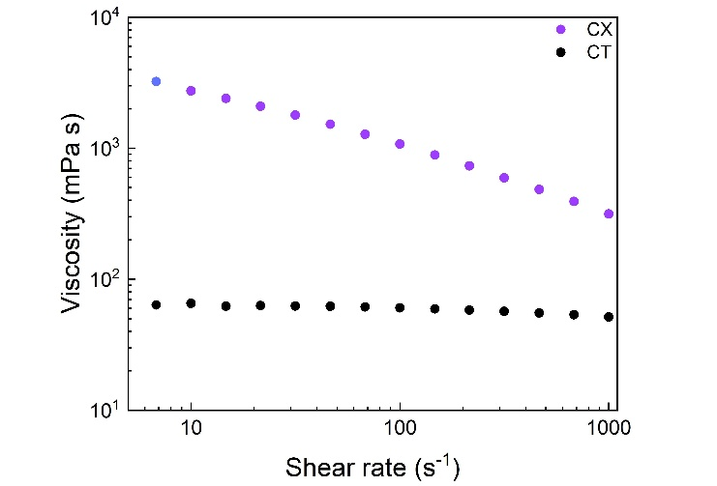
Figure S1. (a) Flow curves at 25°C of chitosan-tragacanth gum (CT) and chitosan-xanthan gum (CX) aqueous solutions prepared as described in part 2.2 of the Experimental Section.

Figure S2a shows the flow curves of two LNMO-based electrode slurries. Both slurries exhibit the shear-thinning behavior typical of concentrated suspensions and electrode slurries, where the particle orientation and the breakdown of agglomerates reduce flow resistance under shear. At low shear rates (< 1 s⁻¹), the LNMO-CT slurry shows a significantly higher initial viscosity (ca. 10⁵ mPa s) compared to LNMO-CX (ca. 10⁴ mPa s). As shear increases, the two curves converge to similar values (ca. 10³ mPa s) at shear rates > 100 s⁻¹. This suggests that LNMO-CT forms a more rigid structural network or stronger particle–particle interactions, which are progressively disrupted under shear. The higher viscosity of LNMO-CT can be beneficial because it indicates greater resistance to sedimentation, but it may also cause processing challenges (e.g., poor fluidity) at low shear rates. At high shear (> 100 s⁻¹), both formulations reach comparable viscosities, which were targeted for coating process of the electrode manufacturing. The 3-interval thixotropy test (3ITT) on the LNMO-CT slurry in Figure S2b shows a high viscosity at rest, a strong drop under high shear (1000 s⁻¹) due to structural breakdown, and a good recovery once the shear rate is reduced back to 0.1 s⁻¹. In this latter step, the viscosity progressively increases, and the slurry fully recovers its initial structure within ca. 100 s, highlighting a good structural resilience. The same measurement could not be performed on the LNMO–CX slurry due to insufficient stability at high shear rates. Even across five replicates, wall slip occurred during the 1000 s⁻¹ step.
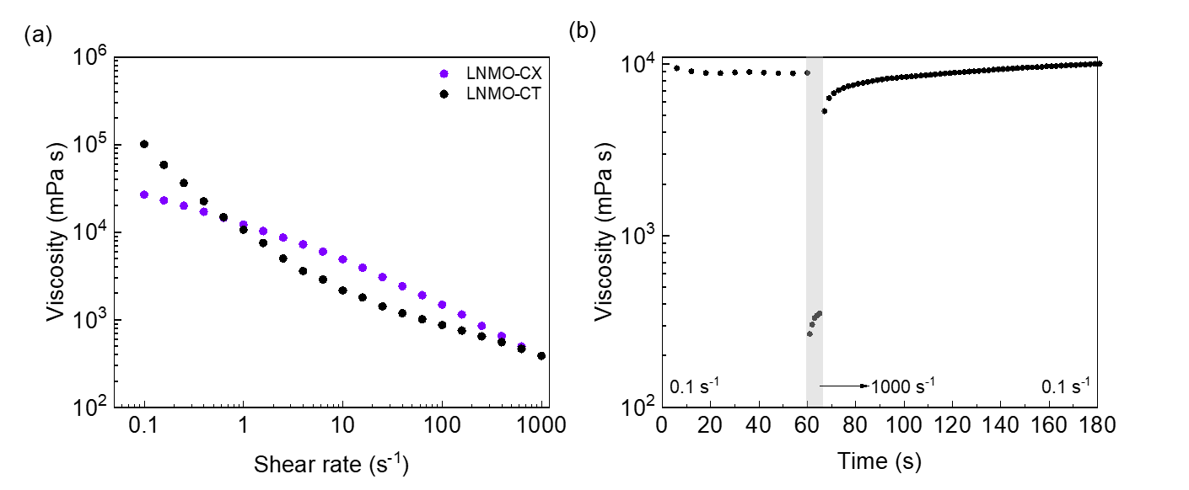
Figure S2. (a) Flow curves of LNMO-CT and LNMO-CX slurries at 25°C; (b) 3ITT on LNMO-CT slurry 25°C.

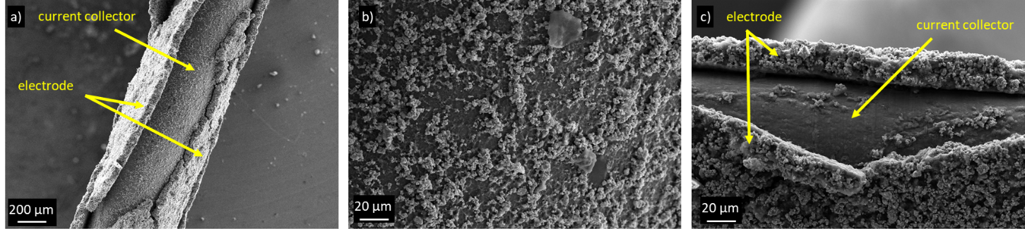
Figure S3. (a) SEM image of LNMO-CT electrode cross-section and current collector; (b) magnification of a portion of the current collector from which LNMO-CT electrode has been detached (see Figure S3a); (c) SEM image of LNMO-CX electrode cross-section and current collector.

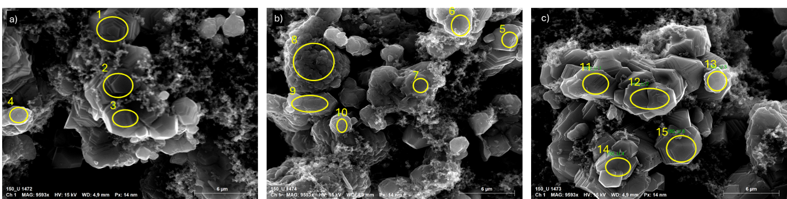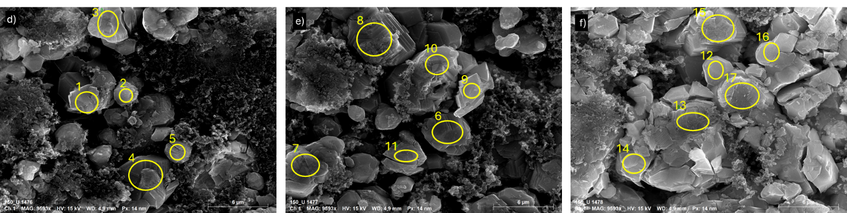
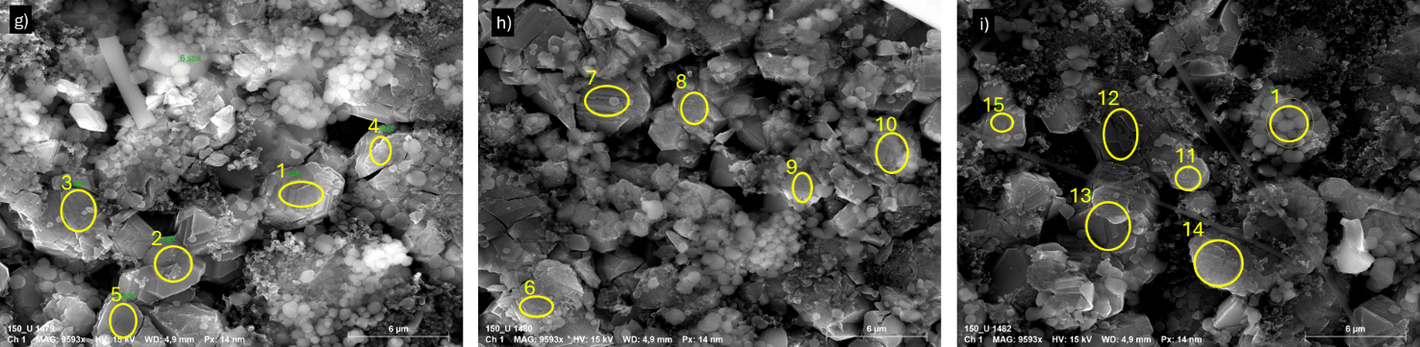
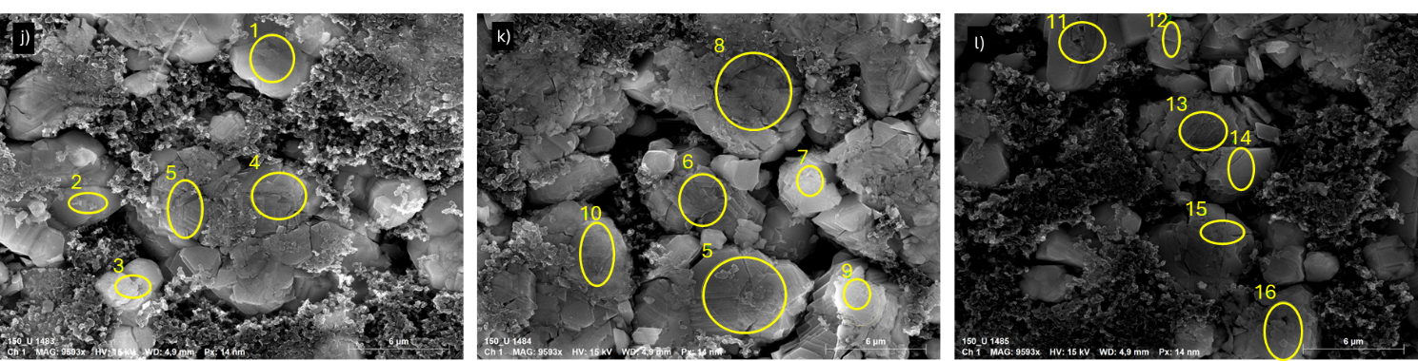
Figure S4. SEM images used for the EDS analyses of (a-c) pristine LNMO-CT electrode, (d-f) LNMO-CT after 100 cycles without additive, (g-i) LNMO-CT after 100 cycles in presence of the TEAPF₆, and (j-l) LNMO-CT after 100 cycles with pDOL.

Table S1. EDS quantification (atomic %) of the areas indicated in Figure S4 for pristine LNMO-CT, LNMO-CT after 100 cycles without additive, LNMO-CT after 100 cycles in presence of the TEAPF₆, and LNMO-CT after 100 cycles with pDOL.
LNMO-CT pristine
Spot | Carbon (%) | Oxygen (%) | Manganese (%) | Nickel (%) | Aluminum (%) | Fluorine (%)
1 | 11.52 | 62.92 | 20.03 | 5.53 | / | /
2 | 11.02 | 63.18 | 20.25 | 5.55 | / | /
3 | 6.78 | 63.40 | 23.28 | 6.54 | / | /
4 | 23.30 | 47.28 | 22.37 | 7.05 | / | /
5 | 12.16 | 64.00 | 18.63 | 5.21 | / | /
6 | 10.15 | 64.40 | 19.62 | 5.83 | / | /
7 | 23.35 | 54.60 | 16.73 | 5.33 | / | /
8 | 11.19 | 60.68 | 21.80 | 6.34 | / | /
9 | 14.98 | 50.97 | 26.48 | 7.58 | / | /
10 | 18.58 | 50.90 | 23.54 | 6.98 | / | /
11 | 18.22 | 58.33 | 18.56 | 4.90 | / | /
12 | 16.31 | 60.94 | 17.59 | 5.17 | / | /
13 | 7.65 | 64.97 | 21.03 | 6.34 | / | /
14 | 11.22 | 62.04 | 20.12 | 6.62 | / | /
15 | 9.84 | 64.36 | 19.32 | 5.75 | 0.73 | /
LNMO-CT No Additive
Spot | Carbon(%) | Oxygen (%) | Manganese (%) | Nickel (%) | Aluminium (%) | Fluorine (%)
1 | 15.14 | 60.04 | 19.28 | 5.54 | / | /
2 | 22.40 | 54.51 | 17.24 | 5.34 | / | /
3 | 14.18 | 59.57 | 20.33 | 5.91 | / | /
4 | 12.79 | 62.41 | 19.34 | 5.46 | / | /
5 | 33.50 | 49.14 | 13.31 | 4.05 | / | /
6 | 9.49 | 60.87 | 23.08 | 6.55 | / | /
7 | 8.38 | 63.51 | 20.97 | 6.02 | 1.12 | /
8 | 10.67 | 61.71 | 17.66 | 9.95 | / | /
9 | 18.43 | 57.77 | 18.50 | 5.30 | / | /
10 | 9.51 | 62.28 | 18.08 | 10.13 | / | /
11 | 11.55 | 63.15 | 18.75 | 5.16 | 1.39 | /
12 | 12.04 | 63.73 | 18.70 | 5.53 | / | /
13 | 11.10 | 62.74 | 20.18 | 5.98 | / | /
14 | 8.47 | 60.99 | 23.51 | 7.02 | / | /
15 | 10.89 | 60.89 | 21.67 | 5.96 | 0.58 | /
16 | 12.97 | 63.52 | 18.19 | 5.32 | / | /
17 | 5.87 | 63.98 | 23.05 | 7.10 | / | /
LNMO-CT TEAPF₆
Spot | Carbon (%) | Oxygen (%) | Manganese (%) | Nickel (%) | Aluminium (%) | Fluorine (%)
1 | 6.91 | 65.01 | 21.44 | 6.25 | 0.39 | /
2 | 8.78 | 62.11 | 19.85 | 9.26 | / | /
3 | 7.77 | 62.50 | 22.84 | 6.90 | / | /
4 | 5.89 | 66.66 | 21.49 | 5.96 | / | /
5 | 6.90 | 66.48 | 20.82 | 5.80 | / | /
6 | 9.65 | 60.81 | 22.33 | 7.21 | / | /
7 | 4.55 | 64.71 | 25.10 | 5.64 | / | /
8 | 8.06 | 67.60 | 19.71 | 4.63 | / | /
9 | 9.90 | 63.12 | 20.75 | 6.23 | / | /
10 | 10.47 | 61.97 | 21.00 | 6.06 | / | /
11 | 19.50 | 52.84 | 16.58 | 5.12 | / | 5.97
12 | 6.49 | 59.41 | 24.70 | 6.82 | / | 2.58
13 | 5.58 | 64.13 | 23.55 | 6.74 | / | /
14 | 11.52 | 62.81 | 19.45 | 5.36 | 0.86 | /
15 | 17.26 | 61.16 | 16.55 | 5.03 | / | /
LNMO-CT pDOL
Spot | Carbon (%) | Oxygen (%) | Manganese (%) | Nickel (%) | Aluminium (%) | Fluorine (%)
1 | 12.68 | 60.62 | 20.53 | 5.49 | 0.68 | /
2 | 22.14 | 46.62 | 23.86 | 7.38 | / | /
3 | 26.53 | 53.84 | 15.21 | 4.42 | / | /
4 | 14.24 | 59.17 | 20.69 | 5.90 | / | /
5 | 11.58 | 60.21 | 21.97 | 6.24 | / | /
6 | 9.58 | 60.88 | 23.22 | 6.32 | / | /
7 | 8.66 | 62.84 | 22.26 | 6.24 | / | /
8 | 8.14 | 66.14 | 20.30 | 5.41 | / | /
9 | 7.67 | 60.98 | 24.40 | 6.95 | / | /
10 | 11.54 | 62.87 | 20.33 | 5.25 | / | /
11 | 14.30 | 59.65 | 20.07 | 5.97 | / | /
12 | 12.14 | 60.33 | 21.47 | 6.06 | / | /
13 | 12.36 | 58.13 | 23.05 | 6.46 | / | /
14 | 8.49 | 61.33 | 23.20 | 5.09 | 1.90 | /
15 | 22.92 | 50.99 | 19.97 | 4.53 | 1.59 | /
16 | 13.01 | 59.89 | 20.71 | 6.39 | / | /

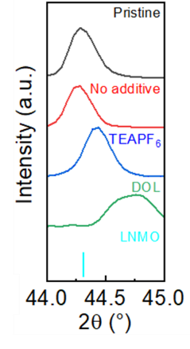

Figure S5. Comparison of the 4 0 0 diffraction peak of the pristine LNMO electrode and the electrodes cycled at 2C for 100 cycles. These shifts are observed for all the peaks.

