Enhanced recovery pathway and survival after elective surgery for colorectal cancer.

Marco Catarci^{1,α}, MD, FACS, Stefano Guadagni², MD, Marco Scatizzi³, MD, Raffaele De Luca⁴, MD, Paolo Delrio⁵, MD, Giacomo Ruffo⁶, MD, Felice Borghi⁷, MD, Francesco Masedu⁸, PhD; the Italian ColoRectal Anastomotic Leakage (iCral) study group*.
From the ¹General Surgery Unit, Sandro Pertini Hospital, ASL Roma 2, Roma; ²General Surgery Unit, Università degli Studi dell’Aquila, L’Aquila; ³General Surgery Unit, Santa Maria Annunziata & Serristori Hospital, Firenze; ⁴Department of Surgical Oncology, IRCCS Istituto Tumori “Giovanni Paolo II”, Bari; ⁵Colorectal Surgical Oncology, Istituto Nazionale per lo Studio e la Cura dei Tumori, “Fondazione Giovanni Pascale IRCCS-Italia”, Napoli; ⁶General Surgery Unit, IRCCS Sacro Cuore Don Calabria Hospital, Negrar di Valpolicella (VR); ⁷Oncologic Surgery Unit, Candiolo Cancer Institute, FPO-IRCCS, Candiolo (TO); ⁸Department of Biotechnological and Applied Clinical Sciences, Università degli Studi dell’Aquila, L’Aquila; Italy . ^{α}iCral study group coordinator.

Online Supplemental material:
Page 2: Supplemental Figure 1
Page 3: Supplemental Table 1
Page 4: Statistical Appendix

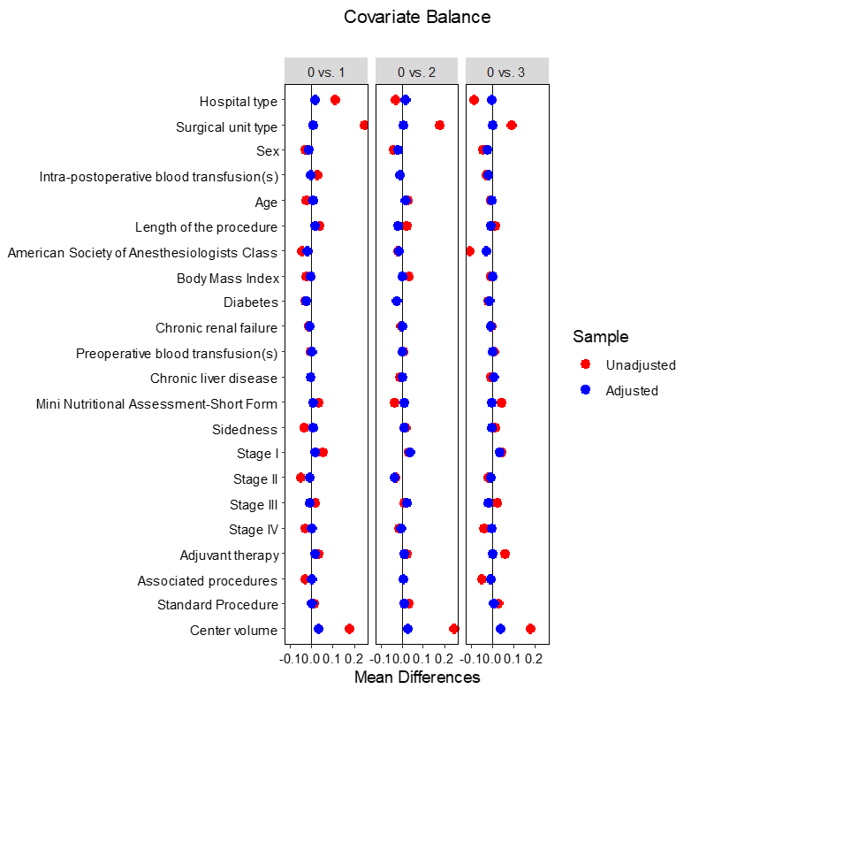
Supplemental Figure 1: Love plot of Kolmogorov-Smirnov covariates’ mean differences before and after adjustment using a machine-learning technique, comparing the reference treatment (1st quartile of ERP adherence, <57.7 %, named “0” in the figure) with the other 3 treatments (2nd quartile, ≥57.7% to <69.2 %, named “1”; 3rd quartile, ≥69.2% to <80.8%, named “2”; 4th quartile, ≥80.8%, named “3”).

Supplemental Table 1: 60-day outcomes according to quartiles of ERP adherence rates before and after Generalized Boosted Model (GBM) weighting.

60-day outcomes | ªERP adherence rates (%) quartiles | Logistic regression before ^{b}GBM weighting |  |  |  | Logistic regression after ^{b}GBM weighting
60-day outcomes | ªERP adherence rates (%) quartiles | Rate (%) | Events | ^{c}OR (95% CI) | p | Rate (%) | Events | ^{c}OR (95% CI) | p
Overall morbidity | Q1; <57.7 | 26.8 | 175 | reference |  | 26.8 | 175 | reference
Overall morbidity | Q2; ≥57.7 to <69.2 | 26.3 | 226 | 1.06 (0.83 - 1.35) | .650 | 18.0 | 154.8 | 0.97 (0.75 - 1.27) | .835
Overall morbidity | Q3; ≥69.2 to <80.8 | 27.8 | 136 | 1.07 (0.82 - 1.41) | .610 | 32.1 | 156.8 | 1.02 (0.75 - 1.39) | .898
Overall morbidity | Q4; ≥80.8 | 27.0 | 233 | 1.06 (0.83 - 1.34) | .656 | 17.8 | 153.6 | 0.98 (0.76 - 1.28) | .900
Major morbidity | Q1; <57.7 | 7.7 | 50 | reference |  | 7.7 | 50 | reference
Major morbidity | Q2; ≥57.7 to <69.2 | 6.6 | 57 | 0.89 (0.59 - 1.34) | .573 | 4.1 | 35.6 | 0.77 (0.49 - 1.22) | .265
Major morbidity | Q3; ≥69.2 to <80.8 | 6.5 | 32 | 0.83 (0.51 - 1.33) | .432 | 8.1 | 39.8 | 0.88 (0.52 - 1.47) | .617
Major morbidity | Q4; ≥80.8 | 7.9 | 68 | 1.06 (0.71 - 1.57) | .785 | 4.4 | 37.6 | 0.84 (0.55 - 1.27) | .402
Mortality | Q1; <57.7 | 0.6 | 4 | reference |  | 0.6 | 4 | reference
Mortality | Q2; ≥57.7 to <69.2 | 0.4 | 3 | 0.69 (0.15 - 3.23) | .641 | 0.2 | 1.7 | 0.47 (0.08 - 2.59) | .385
Mortality | Q3; ≥69.2 to <80.8 | 0.4 | 2 | 0.75 (0.13 - 4.24) | .743 | 0.3 | 1.7 | 0.46 (0.05 - 3.91) | .479
Mortality | Q4; ≥80.8 | 1.4 | 12 | 2.39 (0.74 - 7.74) | .146 | 0.9 | 7.9 | 2.24 (0.64 - 7.80) | .206
Anastomotic leakage | Q1; <57.7 | 5.8 | 38 | reference |  | 5.8 | 38 | reference
Anastomotic leakage | Q2; ≥57.7 to <69.2 | 4.0 | 34 | 0.68 (0.41 - 1.12) | .128 | 2.5 | 21.1 | 0.61 (0.36 - 1.04) | .068
Anastomotic leakage | Q3; ≥69.2 to <80.8 | 3.5 | 17 | 0.54 (0.30 - 0.99) | .050 | 3.7 | 18.0 | 0.50 (0.26 - 0.97) | .042
Anastomotic leakage | Q4; ≥80.8 | 3.8 | 33 | 0.64 (0.39 - 1.05) | .075 | 2.1 | 18.4 | 0.52 (0.28 - 0.96) | .036
 | ªERP adherence rates (%) quartiles | Linear regression before ^{b}GBM weighting |  |  |  | Linear regression after ^{b}GBM weighting
 | ªERP adherence rates (%) quartiles | mean | β coefficient |  | p | mean | β coefficient |  | p
Comprehensive Complication Index (CCI) | Q1; <57.7 | 6.76 | reference |  |  | 6.76 | reference
Comprehensive Complication Index (CCI) | Q2; ≥57.7 to <69.2 | 5.95 | - 0.37 |  | .634 | 5.74 | - 1.05 |  | .165
Comprehensive Complication Index (CCI) | Q3; ≥69.2 to <80.8 | 6.54 | - 0.09 |  | .922 | 6.57 | - 0.18 |  | .850
Comprehensive Complication Index (CCI) | Q4; ≥80.8 | 7.45 | 0.89 |  | .245 | 7.11 | 0.29 |  | .734
ªERP: enhanced recovery pathway; ^{b}GBM: Generalized Boosted Model; ^{c}OR (95% CI): odds ratio (95% confidence interval).

Statistical Appendix

The choice of a ML method, i.e. gradient boosted algorithm, instead of providing weights for covariates balance using the multinomial or the logistic regression comes from two main reasons: 1) Ensemble methods, like other ML algorithms, suffers from interpretability, but in our case we do not need to interpret weights but just use them in balancing; 2) GBM, using a sequential learning architecture, is sensitive to non-linearities and interactions among the potential confounders, preventing under or over-estimation of the weights, that could affect the probability to belong to each of the treatment categories.

The issue of overfitting was managed stopping the number of trees (30000 trees for each group comparison, despite computationally intensive, allowed us to reach stable results for KS.mean metrics. Covariate balance after weighting was a major concern of the analysis carried out. The balance was checked in tabular form comparing the KS.mean values for each comparison of the covariates in the treatment groups. Given the huge amount of computations, the tables were unfeasible to be reported on the manuscript so that the balancing results after GBM weighting have been reported using a Love-plot (Figure 1 of supplementary material), which gives an understandable and readable summary of the balancing achieved.

