Supplementary materials
Elemental content and radionuclide activity of bottom and fly ashes from Municipal Solid Waste Incineration: a time series analysis
Junaid GHANI^{1,2}, Katerina RODIOUCHKINA³, Ilia RODUSHKIN^{3,4}, Enrico DINELLI^{1*},Silvia GIULIANI², Luca Giorgio BELLUCCI², Thomas AIGLSPERGER³, Emma ENGSTRÖM^{3,4}, Valerio FUNARI^{1,5*}
¹University of Bologna, Department of Biological, Geological and Environmental Sciences (BiGeA), Piazza di Porta San Donato, 1 Bologna, Italy
²National Research Council of Italy, Department of Scienze Del Sistema Terra e Tecnologie per l'Ambiente (ISMAR-CNR), Bologna Research Area, via P. Gobetti, 101 Bologna, Italy
³Department of Civil, Environmental and Natural Resources Engineering, Division of Geosciences and Environmental Engineering, Luleå University of Technology, 97187, Luleå, Sweden
⁴ALS Scandinavia AB, ALS Laboratory Group, 97775, Luleå, Sweden
⁵National Research Council of Italy, Department of Scienze Del Sistema Terra e Tecnologie per l'Ambiente (ISMAR-CNR), Napoli Research Area, via Calata Porta di Massa - Porto Di Napoli, 80, 80133 – Napoli, Italy

*Corresponding author email: valerio.funari@cnr.it
*Corresponding author email: enrico.dinelli@unibo.it

- Elemental content and radionuclide activity of bottom and fly ashes from Municipal Solid Waste Incineration: a time series analysis

1.1 Overview of MSWI plants
The FE MSWI facility was built in 1993 and then renovated in 2007, whereas the FC plant was built in 1976 and renovated in 2008 (Bianchi et al., 2014). The two MSWI facilities are WtE systems that handle over 90% of domestic household solid waste (unsorted municipal solid waste) and ~10% of special waste (automobile residues, industrial, pharmaceutical/hospital waste) (Funari et al., 2016). The FC MSWI plant can process and operate the maximum capacity of 60 to 120 kilo tons of urban waste annually, while the FE incinerator unit is capable of processing 142 kilo tons of waste each year.

1.2 Role of FA additives (Lime and Soda addition)
The hot fluid smoke, which is heated at up to 1100 °C during the incineration process, flows through a heat exchanger that produces electricity through the Brayton cycle. The cooled smoke (180 °C) contains acids, metallic compounds, dioxines, and other volatilized substances, and these are strictly treated before the exhaust gas is released in the atmosphere. A two-stage technology of acid gas removal is used to clean FA smoke. The flue gas (untreated) flows in a reactor where calcium hydroxide in dry powder form, commonly known as hydrated/slaked lime, is injected. This alkaline material (Ca(OH)₂) serves as a sorbent towards the acid gases, causing the gas-solid reaction (“first stage”). Subsequently, the flue gas is transmitted through a fabric filter where the reactions take place, and residual/re-condensed powders deposit by gravity in the bags. Here, the solid wastes products (calcium-based FA) are obtained after reactions and eventually removed from the flue gas stream (Dal Pozzo et al., 2016). In the second stage, the soda additive is used similarly (“second stage”). The second stage involves the injection of sodium bicarbonate (NaHCO₃) in another reactor (a vertical Venturi-shaped pipe section).
First stage: a Ca(OH)₂ stream is thoroughly mixed with freshly produced FA fumes and passed through a bag filter. Ca(OH)₂ allows the removal of acid pollutants, such as HCl, Sox, and HF, which react with acids to form salts. For example:
HCl (gas) + Ca(OH)₂ (solid) → CaOHCl (solid) + H₂O (1)
The solid salts (e.g., CaOHCl) are deposited and separated with air jets in the so-called big bags. The solid residue of lime-doped fly ash (FAL) is obtained.
Second stage: a Na₂HCO₃ stream is thoroughly mixed with remaining FA fumes and passed through another bag filter. Following the MSWI systems’ temperature profiles for ashes, Na₂HCO₃ allows the removal of other acid pollutants and dangerous carbon-based substances forming sodium carbonate (Na₂CO₃) at 145 °C.
2NaHCO₃ → Na₂CO₃ + CO₂ + H₂O (2)
Again, the solid salts are separated and gathered in the big bags. This solid residue is soda-doped fly ash (FAS) because of reacted sodium bicarbonate. After these processes, the cleaned smoke streams from the smokestack into the atmosphere (Dal Pozzo et al., 2016).

1.3 Sampling and sample preparation to determine the chemical concentration in the solid samples
In both FE and FC plants, the primary FA samples (about 5 kg each) were collected on a constant basis in summer and winter seasons during 2013, 2020, 2021, and 2022 from full big bags. The primary sample is taken across different seasons (summer and winter) in fixed periods of the year (see Table 1 of the main text), depending on MSWI system’s duty, by blending the materials of a much higher volume (order of 50 kg FA and 200 kg BA) with many increments. Similarly to previous works (e.g., Morf et al., 2013; Funari et al., 2015), it is sufficient to represent the diversity of ash characteristics. This activity was only possible thanks to the company managers. FA are very finely grained samples containing very low content of moisture (i.e., < 1 wt. %). All the homogenized FA samples were dried overnight in oven at 40°C and were stored in plastic bags. The primary samples of each batch of FA and BA were split into four portions in quartering method, the opposite sides were thoroughly mixed and again split three times and mixed, to homogenize for representativeness. The stockpile of BA contains different melted phases with other non-combustible materials, and the pile is dry if it cools at the outlet and wet if water quenched. In both MSWI plants considered, the BA is quenched before stockpiling in open storage sites. For pre-treatment, all the BA samples were oven-dried overnight at 40°C. Wooden fragments were removed, then samples were grounded and milled by an agate vibratory disc mill and milled again with an agate mortar to reach a fine powder form (i.e., >40 μm).
Samples were multi-acid digested, followed by ICP-MS analysis. During the chemical determination, the residual sample solution was centrifuged at 2500 rpm for 5 min and the supernatant was decanted into acid washed 100 ml Teflon beakers for matrix separation, following the procedure explained elsewhere (Rodushkin et al., 2018). Samples and blanks were evaporated on a 100 °C hot plate until dry. Residuals were re-dissolved in 5 ml conc. HCl and 10 µl H₂O₂ (30 w/w %) was added. An aliquot of the sample was diluted to 0.24 M HCl in 2 ml. These diluted samples were then loaded onto columns filled with strong cation-exchange resin AG 50W-X8 (2 ml wet volume, 200-400 mesh, Bio-Rad Laboratories AB, Sweden) that had previously been cleaned (Rodushkin et al., 2018), and pre-conditioned with 8 ml 0.24 M HCl. In a dilute HCl matrix, cations in the sample solutions retained by the resin, while PGE and Au form anionic chloro-complexes, which can pass through the resin. Thus, the eluate contain PGE and Au isolated from interfering cations (Whiteley and Murray, 2005). The sample load (2 ml 0.24 M HCl) and matrix wash (4 ml 0.24 M HCl) were collected and diluted 20 times with ultrapure water and HNO₃ prior to elemental analysis. Individual single element stock standards (1000 mg l⁻¹, Ultra Scientific, Analytical Solutions, N. Kingstown, USA) were used to prepare a multi-element calibration by gradual dilution in 1.57 M HNO₃ matrix. Single element stock standards from another producer (1000 mg l⁻¹, Inorganic Ventures, Christiansburg, USA) were used to assess accuracy.

1.4 Radionuclide measurements
²¹⁰Po was extracted from selected BA and FA samples with HNO₃ and H₂O₂ on a hot plate at 110 °C, in the presence of ²⁰⁹Po as a yield monitor, to account for extraction and counting efficiencies. The leached solution was separated from the residue by centrifugation at 2500 rpm for 10 minutes, and then evaporated to near dryness. The remaining HNO₃ was eliminated by adding small quantities of concentrated HCl in several steps until red fumes completely disappeared. The solution was then evaporated to dryness, and the residue was dissolved in 1.5 M HCl and iron was reduced using ascorbic acid to avoid interference during Po adsorption. A silver disk was then placed at the bottom of the beaker containing the solution, and Po was left to spontaneously self-adsorb overnight on the disk’s surface, at room temperature.
Natural (²¹⁰Pb, ⁴⁰K, ²²⁶Ra, and ²³²Th) and artificial radionuclides (¹³⁷Cs and ²⁴¹Am) were measured in new dry samples using standard vessels of suitable geometries by non-destructive gamma spectrometry using Ortec high-purity germanium detectors connected to Ortec DSPEC multi-channel analyzers. In gamma spectrometry, ²¹⁰Pb was determined from the 46.5 keV peak, ²⁴²Am from the 59.5 keV peak, ¹³⁷Cs from the 661.7 keV peak, and ⁴⁰K from the 1460.8 keV peak. ²²⁶Ra was determined as a weighted average of the radon progeny, ²¹⁴Bi (609.3, 1764.5, and 1120.3 keV peaks), and ²¹⁴Pb (351.9, 295.2, and 242 keV peaks). ²³²Th was determined as a weighted average of ²²⁸Ac (911.2 and 338.3 keV peaks), and ²¹²Pb (238.6 keV peak) since these decay products representing ²²⁸Ra and ²²⁸Th were in or close to equilibrium.
The software used for peak search, peak area determination, baseline and background subtraction, nuclide identification and activity calculations was GammaVision (version 8.10.02 for Windows). The analytical accuracy was periodically checked by counting the certificate multiple gamma ray emitting solution 7501 by Eckert & Ziegler, and the results were within the standard uncertainties. Precision, estimated by repeated analyses of the same sample, ranged between 1.2 % (²²⁶Ra) and 16 % (²³²Th). Efficiencies on 20 ml geometries (0.25-0.50 %) were calculated through a series of standards obtained by spiking old sample with a known amount of the Eckert & Ziegler 7501 multi-peak standard solution. The analytical detection limit ranged from 0.8 (¹³⁷Cs) and 4.1 Bq kg⁻¹ (²³²Th). Precision, calculated from two sets of independent extraction procedures and analyses of the same sample, was 17 % on average.

1.5 Mass balance calculation
First lime and soda elemental concentrations were subtracted from the FAL and FAS elemental concentrations, respectively, under the assumption that all Ca precent in the FAL samples were due to lime addition and all Na precent in the FAS samples were due to soda addition. These values were then used for the mass balance calculations. The mass fractions together with the determined elemental concentration data in each ash type (C_{ash_type}) can then be used to calculate mass of an element in each ash type (M_{ash_type}$×$C_{ash_type}). Relative % mass of an element in each ash type (R_{ash_type}) can then be calculated as a ratio of M_{ash_type}$×$C_{ash_type} and the total mass of an element in all ash types (M_{BA}$×$C_{BA}+M_{FA_FAL}$×$C_{FA_FAL}+M_{FA_FAS}$×$C_{FA_FAS}) times 100 %. The elemental concentration in the feeding material can then be calculated by multiplying the relative % mass of an element with the determined elemental concentration data in each ash type followed by a summation of all ash types (R_{BA}$×$C_{BA}+R_{FA_FAL}$×$C_{FA_FAL}+R_{FA_FAS}$×$C_{FA_FAS}). The data of elemental concentrations in all feeding materials for annual flow are converted into t/a, and the results are presented in t/a as shown in Table S5 and Figure 7.
Mass balance calculations in this study assume that the inorganic elements of interest in the input waste are fully retained within the solid residues of the incineration process, i.e. in BA, FAL, and FAS, in accordance with the principle of mass conservation, under the premise that the system is effectively closed with respect to these elements. This approach assumes efficient flue gas cleaning and negligible elemental loss to emissions, enabling the estimation of elemental concentrations in the input waste stream based on the measured concentrations in ash and known annual mass flows (Table S1). The contributions from lime and soda were subtracted from the ash data to isolate the element concentrations originating from the waste itself (Table S7). The elemental concentrations in the additives (Tab. S4) were subtracted from the output waste of FAL and FAS from incineration plants and used to estimate the elemental content in the input feeding material (compare Tab. S1) through mass balance calculations. The assumption that all Ca in FAL and all Na in FAS originated from the added lime and soda, respectively, can be rejected because Ca and Na are still present as an output flow of element in FAL and FAS samples, according to their measured concentrations. It is obvious that Na and Ca can be sourced from both additives and input MSW.
Although this method simplifies complex incineration behavior, it provides a practical framework for tracking element flows and assessing material recovery potential at the facility level. However, it is important to recognize that these mass balance calculations are subject to uncertainties related to sampling representativeness, analytical variability, and complete element retention in the solid fractions. Seasonal fluctuations, operational differences between incinerators, and potential element losses through gaseous emissions or unaccounted residues could introduce non-accounted deviations. While these factors do not invalidate the mass balance approach, they highlight the need for cautious interpretation when extrapolating results beyond the studied systems.
1.6 Assessment of elemental enrichment and radiation hazard
Titanium was selected as the reference element for the normalization purposes in EF calculation. The ACI is computed considering the combined impact of three naturally occurring radionuclides, including thorium (²³²Th) derived from ²³²Th decay series, radium (²²⁶Ra) from the ²³⁸U decay series, and potassium (⁴⁰K). If the ACI is less than 1, then the materials don’t require further radiological assessments (EU, 1999).
In Total Emission Factor (TEF), total annual emission of ²¹⁰Pb, ²¹⁰Po, ⁴⁰K, ²²⁶Ra, ²³²Th, ¹³⁷Cs, ²⁴¹Am, and ¹³¹I was quantified from BA and FA data and annual output of substance corresponding to these waste categories at a single incinerator and regional level.
Table S1 Amount of MSW treated (expressed in t a⁻¹) during 2013, 2020, 2021 and 2022 in FE and FC plants.
Year | Incinerator | Waste treated
2013 | FE | 71.558
2013 | FC | 119.824
2020 | FE | 69.597
2020 | FC | 134.978
2021 | FE | 81.309
2021 | FC | 119.898
2022 | FE | 65.929
2022 | FC | 119.694
Data was obtained from annual reports of FE and FC incinerator plants. See the main text.
Note: The incineration service provider primarily acts on the territory of Emilia Romagna, collecting waste from the region itself and eventual outflows from other regions.

Table S2 Descriptive statistics of selected elements (mg kg⁻¹), analysed by ICP-SFMS in waste categories: BA (n = 11), FAL (n = 13), and FAS (n = 6). The Upper Continental Crust (UCC) average values are also reported (Rudnick and Gao, 2014).
 | BA |  |  |  |  |  | FAL |  |  |  |  |  |  |  |  | FAS
Variables | Mean | Median | Min | Max | S.D |  | Mean | Median | Min | Max | S.D |  |  |  | Mean |  | Median | Min | Max |  | S.D |  | UCC
Industrial base metals and valuable elements
Ca | 189000 | 193600 | 159700 | 211500 | 18800 |  | 197000 | 197000 | 80300 | 283000 | 67100 |  |  |  | 2700 |  | 2100 | 1150 | 6520 |  | 2000 |  | 3.6
Na | 13400 | 13700 | 9900 | 15900 | 1800 |  | 84600 | 33400 | 10301 | 188000 | 77200 |  |  |  | 306000 |  | 305800 | 283135 | 339500 |  | 19200 |  | 3.3
S | 5500 | 5200 | 4800 | 7300 | 750 |  | 35800 | 31189 | 8600 | 78600 | 19750 |  |  |  | 33600 |  | 27700 | 20000 | 52500 |  | 14410 |  | 62
K | 8900 | 8700 | 7100 | 13300 | 1700 |  | 31400 | 28500 | 9700 | 53700 | 11600 |  |  |  | 400 |  | 274 | 160 | 800 |  | 200 |  | 23245
Si | 56100 | 55700 | 48900 | 65500 | 4800 |  | 19300 | 10600 | 6400 | 49000 | 13100 |  |  |  | 1200 |  | 1300 | 940 | 1500 |  | 200 |  | 66.6
Zn | 4100 | 3300 | 1900 | 8300 | 1900 |  | 11700 | 9700 | 5700 | 30000 | 6700 |  |  |  | 83 |  | 42 | 9 | 270 |  | 100 |  | 67
Al | 35300 | 33000 | 27400 | 47700 | 6400 |  | 9900 | 5564 | 3400 | 29000 | 7300 |  |  |  | 530 |  | 545 | 290 | 760 |  | 200 |  | 81512
Fe | 47600 | 36400 | 28500 | 78200 | 18400 |  | 6500 | 5200 | 2000 | 21400 | 5100 |  |  |  | 5090 |  | 760 | 380 | 27000 |  | 10700 |  | 34970
Cu | 3500 | 2900 | 1100 | 7600 | 2000 |  | 700 | 500 | 300 | 2060 | 500 |  |  |  | 18 |  | 8 | 3 | 67 |  | 20 |  | 28
Mn | 920 | 900 | 680 | 1300 | 180 |  | 320 | 230 | 120 | 600 | 180 |  |  |  | 49 |  | 22 | 12 | 180 |  | 60 |  | 0.1
Se | 0.2 | 0.2 | 0.09 | 0.5 | 0.1 |  | 3.3 | 2.5 | 1.5 | 9.8 | 2.3 |  |  |  | 0.3 |  | 0.1 | 0.05 | 1.2 |  | 0.4 |  | 0.1
Critical Raw Materials (CRMs)
Mg | 16100 | 15600 | 11600 | 22400 | 3500 |  | 8600 | 7600 | 1800 | 19000 | 4600 |  |  |  | 350 |  | 300 | 200 | 500 |  | 100 |  | 15077
P | 6800 | 6100 | 4700 | 12700 | 2300 |  | 2800 | 2500 | 1000 | 6500 | 1500 |  |  |  | 50 |  | 50 | 28 | 80 |  | 20 |  | 872
Ti | 3500 | 3300 | 2700 | 4800 | 630 |  | 2700 | 2100 | 900 | 6700 | 1600 |  |  |  | 50 |  | 40 | 26 | 100 |  | 30 |  | 3597
Sb | 100 | 100 | 70 | 200 | 50 |  | 800 | 800 | 400 | 1150 | 240 |  |  |  | 8 |  | 6 | 2 | 20 |  | 7 |  | 0.4
Ba | 1400 | 900 | 700 | 4600 | 1150 |  | 500 | 200 | 200 | 1700 | 450 |  |  |  | 20 |  | 15 | 12 | 24 |  | 5 |  | 628
Sr | 500 | 500 | 400 | 600 | 60 |  | 200 | 200 | 60 | 500 | 100 |  |  |  | 20 |  | 15 | 12 | 37 |  | 9.2 |  | 320
B | 200 | 170 | 100 | 500 | 120 |  | 100 | 70 | 34 | 250 | 70 |  |  |  | 9 |  | 9 | 5.2 | 12 |  | 2.5 |  | 17
Bi | 3.3 | 2.1 | 1 | 7.3 | 2 |  | 40 | 22 | 10 | 100 | 30 |  |  |  | 1 |  | 0.4 | 0.2 | 4.3 |  | 1.6 |  | 0.2
Li | 25 | 24 | 21 | 31 | 4 |  | 20 | 13 | 8.8 | 30 | 7 |  |  |  | 0.8 |  | 0.8 | 0.5 | 1 |  | 0.2 |  | 24
V | 33 | 33 | 30 | 40 | 3 |  | 10 | 4.4 | 32 | 10 | 8.5 |  |  |  | 0.9 |  | 0.9 | 0.5 | 1.7 |  | 0.4 |  | 97
Co | 65 | 67 | 22 | 150 | 40 |  | 10 | 3.8 | 24 | 10 | 6 |  |  |  | 0.6 |  | 0.4 | 0.3 | 1.5 |  | 0.4 |  | 17.3
W | 16 | 6 | 3 | 100 | 30 |  | 4 | 1.3 | 13 | 4 | 3.2 |  |  |  | 0.09 |  | 0.07 | 0.05 | 0.1 |  | 0.03 |  | 1.9
Nb | 6 | 6 | 5 | 7 | 0.7 |  | 4.5 | 0.9 | 8.8 | 4.5 | 2 |  |  |  | 0.15 |  | 0.1 | 0.1 | 0.3 |  | 0.07 |  | 1
Ga | 7 | 7 | 6 | 10 | 1 |  | 3 | 2.1 | 7.4 | 3 | 1.8 |  |  |  | 0.2 |  | 0.2 | 0.1 | 0.4 |  | 0.1 |  | 17.5
In | 0.07 | 0.03 | 0.01 | 0.3 | 0.08 |  | 0.6 | 0.06 | 10.5 | 0.6 | 3 |  |  |  | 0.02 |  | 0.02 | 0.01 | 0.03 |  | 0.01 |  | 0.1
Sc | 3.2 | 3 | 2.7 | 3.7 | 0.3 |  | 0.8 | 0.3 | 2.6 | 0.8 | 0.6 |  |  |  | 0.1 |  | 0.1 | 0.06 | 0.20 |  | 0.04 |  | 14
Hf | 2.2 | 1.8 | 1.5 | 3.4 | 0.6 |  | 0.5 | 0.3 | 2.3 | 0.5 | 0.6 |  |  |  | 0.03 |  | 0.03 | 0.02 | 0.04 |  | 0.008 |  | 5.3
Be | 1 | 0.91 | 0.7 | 1 | 0.1 |  | 0.4 | 0.08 | 1 | 0.4 | 0.2 |  |  |  | 0.07 |  | 0.08 | 0.04 | 0.09 |  | 0.01 |  | 2.1
Ta | 0.3 | 0.3 | 0.2 | 0.5 | 0.05 |  | 0.3 | 0.07 | 0.7 | 0.3 | 0.2 |  |  |  | 0.01 |  | 0.01 | 0.01 | 0.02 |  | 0.004 |  | 0.9
Ge | 0.2 | 0.2 | 0.1 | 0.4 | 0.05 |  | 0.2 | 0.03 | 0.5 | 0.2 | 0.1 |  |  |  | 0.01 |  | 0.01 | 0.01 | 0.02 |  | 0.009 |  | 1.4
Rare Earth Elements (REEs)
Ce | 48 | 33 | 26 | 127 | 30 |  | 11 | 8 | 2.2 | 38 | 10 |  |  |  | 0.9 |  | 0.9 | 0.6 | 1.3 |  | 0.3 |  | 63
La | 17 | 16 | 13 | 25 | 3.2 |  | 5.6 | 5.8 | 1.4 | 11 | 3 |  |  |  | 0.5 |  | 0.53 | 0.3 | 0.7 |  | 0.2 |  | 31
Y | 12 | 11.5 | 9 | 20 | 3.2 |  | 5 | 6 | 1.3 | 9.3 | 2.6 |  |  |  | 0.4 |  | 0.41 | 0.2 | 0.5 |  | 0.1 |  | 21
Nd | 20 | 12 | 8 | 53 | 16.5 |  | 3.7 | 3.6 | 0.9 | 8 | 2 |  |  |  | 0.4 |  | 0.38 | 0.2 | 0.5 |  | 0.1 |  | 27
Yb | 0.8 | 0.8 | 0.70 | 1.2 | 0.1 |  | 1.4 | 0.3 | 0.07 | 15 | 4 |  |  |  | 0.03 |  | 0.03 | 0.02 | 0.04 |  | 0.01 |  | 2
Pr | 5 | 3 | 2.27 | 14 | 4.2 |  | 1 | 1 | 0.2 | 2 | 0.5 |  |  |  | 0.1 |  | 0.1 | 0.05 | 0.1 |  | 0.03 |  | 7.1
Gd | 4.15 | 1.91 | 1.31 | 15 | 5.2 |  | 0.6 | 0.7 | 0.2 | 1.3 | 0.3 |  |  |  | 0.07 |  | 0.07 | 0.03 | 0.09 |  | 0.02 |  | 4
Sm | 1.84 | 1.87 | 1.56 | 2.00 | 0.1 |  | 0.6 | 0.7 | 0.2 | 1.4 | 0.3 |  |  |  | 0.07 |  | 0.07 | 0.03 | 0.09 |  | 0.02 |  | 4.7
Dy | 1.59 | 1.62 | 1.27 | 1.80 | 0.1 |  | 0.5 | 0.6 | 0.1 | 1.1 | 0.3 |  |  |  | 0.06 |  | 0.07 | 0.03 | 0.08 |  | 0.02 |  | 3.9
Er | 1.02 | 1 | 0.90 | 1.26 | 0.1 |  | 0.3 | 0.4 | 0.08 | 0.6 | 0.15 |  |  |  | 0.03 |  | 0.04 | 0.02 | 0.04 |  | 0.01 |  | 2.3
Eu | 0.45 | 0.5 | 0.30 | 0.80 | 0.1 |  | 0.2 | 0.2 | 0.03 | 0.4 | 0.09 |  |  |  | 0.02 |  | 0.02 | 0.01 | 0.02 |  | 0.01 |  | 1
Tb | 0.3 | 0.3 | 0.23 | 0.40 | 0.05 |  | 0.1 | 0.1 | 0.03 | 0.3 | 0.07 |  |  |  | 0.01 |  | 0.01 | 0.01 | 0.01 |  | 0.003 |  | 0.7
Ho | 0.32 | 0.29 | 0.24 | 0.50 | 0.08 |  | 0.1 | 0.1 | 0.03 | 0.2 | 0.06 |  |  |  | 0.01 |  | 0.01 | 0.01 | 0.01 |  | 0.004 |  | 0.8
Tm | 0.12 | 0.12 | 0.1 | 0.14 | 0.01 |  | 0.04 | 0.05 | 0.01 | 0.08 | 0.02 |  |  |  | 0.01 |  | 0.01 | 0.01 | 0.01 |  | 0.001 |  | 0.3
Lu | 0.13 | 0.13 | 0.11 | 0.14 | 0.01 |  | 0.04 | 0.05 | 0.01 | 0.08 | 0.02 |  |  |  | 0.01 |  | 0.01 | 0.01 | 0.01 |  | 0.002 |  | 0.3
ΣLREE | 95.2 | 67.9 | 52.3 | 236 | 8 |  | 23 | 20 | 5 | 62 | 2.4 |  |  |  | 2 |  | 2.03 | 1.2 | 2.8 |  | 0.1 |  | -
ΣHREE | 16.6 | 15.7 | 12.4 | 25.4 | 1 |  | 7.5 | 7.6 | 1.7 | 26 | 1 |  |  |  | 0.5 |  | 0.59 | 0.3 | 0.7 |  | 0.02 |  | -
Platinum Group Metals (PGMs) (μg kg⁻¹)
Rh | 2.1 | 0.01 | 0.3 | 9.6 | 0.003 |  | 1.5 | 0.01 | 0.2 | 13 | 0.003 |  |  |  | 0.3 |  | 0.01 | 0.2 | 0.8 |  | 0.0002 |  | -
Pd | 0.5 | 0.01 | 0.03 | 1.2 | 0.0004 |  | 1.8 | 0.01 | 0.01 | 7.6 | 0.002 |  |  |  | 0.8 |  | 0.01 | 0.01 | 4.3 |  | 0.002 |  | 0.5
Ru | 0.5 | 0.01 | 0.2 | 0.8 | 0.0002 |  | 0.9 | 0.01 | 0.02 | 4.4 | 0.001 |  |  |  | 0.3 |  | 0.01 | 0.07 | 0.7 |  | 0.0002 |  | 0.3
Os | 0.3 | 0.01 | 0.2 | 0.5 | 0.0001 |  | 0.4 | 0.01 | 0.04 | 1.4 | 0.001 |  |  |  | 1.3 |  | 0.01 | 0.6 | 2.6 |  | 0.001 |  | 0.03
Pt | 0.2 | 0.01 | 0.02 | 0.6 | 0.0002 |  | 0.06 | 0.01 | 0.01 | 0.4 | 0.001 |  |  |  | 0.06 |  | 0.01 | 0.03 | 0.1 |  | 0.0001 |  | 0.5
Ir | 0.01 | 0.01 | 0.08 | 0.04 | 0.0001 |  | 0.01 | 0.01 | 0.05 | 0.02 | 0.0001 |  |  |  | 0.01 |  | 0.01 | 0.02 | 0.02 |  | 0.0001 |  | 0.02
Potentially Toxic Elements (PTEs)
Pb | 6150 | 1380 | 620 | 51200 | 15000 |  | 3040 | 1850 | 1080 | 11800 | 2900 |  |  |  | 19 |  | 11 | 2 | 58 |  | 20 |  | 1
Cr | 200 | 200 | 110 | 280 | 50 |  | 250 | 180 | 86 | 800 | 230 |  |  |  | 18 |  | 3 | 2 | 89 |  | 35 |  | 92
Cd | 12 | 5 | 1.6 | 60 | 20 |  | 140 | 160 | 57 | 250 | 50 |  |  |  | 1.4 |  | 0.5 | 0.1 | 5 |  | 1.9 |  | 0.1
Ni | 180 | 120 | 76 | 660 | 170 |  | 60 | 67 | 16 | 100 | 30 |  |  |  | 7 |  | 2 | 1 | 33 |  | 12.7 |  | 47
As | 7.9 | 7.6 | 5 | 14 | 2.6 |  | 16 | 13 | 7.4 | 30 | 6.5 |  |  |  | 0.5 |  | 0.4 | 0.3 | 1.1 |  | 0.3 |  | 4.8
Mo | 14 | 11 | 6.7 | 8 | 9.0 |  | 13 | 13 | 3.5 | 31 | 7.3 |  |  |  | 1.6 |  | 0.5 | 0.2 | 7.3 |  | 2.8 |  | 1.1
Hg | 0.1 | 0.09 | 0.04 | 0.2 | 0.1 |  | 12 | 10 | 0.2 | 51 | 12.6 |  |  |  | 21 |  | 23 | 2.7 | 40 |  | 14.0 |  | 0.1
Continue
Tl | 0.1 | 0.08 | 0.07 | 0.3 | 0.1 |  | 0.7 | 0.5 | 0.3 | 1.4 | 0.4 |  |  |  | 0.01 |  | 0.01 | 0.01 | 0.03 |  | 0.0 |  | 0.9
U | 1.4 | 1.4 | 1 | 1.6 | 0.2 |  | 0.7 | 0.6 | 0.4 | 1.2 | 0.3 |  |  |  | 0.09 |  | 0.08 | 0.03 | 0.2 |  | 0.1 |  | 2.7
Precious and other elements
Sn | 250 | 135 | 75 | 740 | 220 |  | 500 | 440 | 220 | 1000 | 230 |  |  |  | 3.8 |  | 1.8 | 0.6 | 12 |  | 4.4 |  | 2.1
Rb | 27 | 28 | 21 | 34 | 3.70 |  | 72 | 64 | 29 | 110 | 27 |  |  |  | 1 |  | 0.7 | 0.4 | 2 |  | 0.6 |  | 84
Br | 19 | 20 | 14 | 24 | 2.96 |  | 65 | 57 | 43 | 100 | 21 |  |  |  | 100 |  | 66 | 42 | 190 |  | 67 |  | 1.6
I | 21 | 11 | 7 | 91 | 25.0 |  | 57 | 56 | 14 | 130 | 31 |  |  |  | 300 |  | 280 | 160 | 425 |  | 102 |  | 1.4
Zr | 88 | 75 | 60 | 14 | 27.3 |  | 34 | 20 | 12 | 95 | 25 |  |  |  | 1.3 |  | 1.3 | 1 | 1.7 |  | 0.3 |  | 193
Ag | 6.3 | 4.8 | 2.4 | 17 | 4.39 |  | 16 | 15 | 8.3 | 27 | 4.8 |  |  |  | 0.1 |  | 0.08 | 0.03 | 0.4 |  | 0.2 |  | 53
Cs | 1.4 | 1.5 | 1.02 | 1.7 | 0.23 |  | 4 | 3.5 | 1.6 | 6.4 | 1.5 |  |  |  | 0.06 |  | 0.06 | 0.03 | 0.1 |  | 0.02 |  | 4.9
Re | 0.04 | 0.01 | 0.01 | 0.1 | 0.0001 |  | 1.7 | 0.01 | 0.2 | 6.8 | 0.002 |  |  |  | 0.4 |  | 0.01 | 0.03 | 1.7 |  | 0.001 |  | 0.2
Au | 0.06 | 0.01 | 0.01 | 0.1 | 0.0001 |  | 1.5 | 0.01 | 0.01 | 16 | 0.004 |  |  |  | 0.05 |  | 0.01 | 0.02 | 0.1 |  | 0.001 |  | 1.5
Th | 4.6 | 4.9 | 3.7 | 6 | 0.05 |  | 1.2 | 1 | 0.01 | 3.3 | 0.8 |  |  |  | 0.1 |  | 0.14 | 0.06 | 0.2 |  | 0.1 |  | 10.5
Te | 0.09 | 0.04 | 0.02 | 0.3 | 0.09 |  | 1 | 0.5 | 0.2 | 4.3 | 1.2 |  |  |  | 0.02 |  | 0.01 | 0.01 | 0.03 |  | 0.01 |  | -
Min: Minimum, Max: Maximum, S.D: Standard deviation, UCC: Upper Continental Crust mean values expressed in mg kg⁻¹ (data from Rudnick and Gao, 2014).

Table S3 Selected elements concentration (mg kg⁻¹), analysed by ICP-SFMS in BA, FAL, and FAS collected from FE and FC incinerators during 2013, 2020, 2021 and 2022.
Sample No. |  | Incinerator | Year | Ag | Al | As | Au | B | Ba | Be | Bi | Br | Ca | Cd | Ce | Cl | Co | Cr | Cs | Cu | Dy | Er | Eu | Fe | Ga | Gd | Ge | Hf | Hg | Ho | I | Ir | In | K | La | Li | Lu | Mg | Mn | Mo
2S | BA | FE | 2013 November | 9.49 | 31145 | 14.23 | 0.0001 | 486 | 4586 | 0.80 | 7.29 | 23.00 | 159662 | 5.58 | 32.86 | 11100 | 37.2 | 264 | 1.3 | 7583 | 1.54 | 0.88 | 0.54 | 78195 | 6.59 | 2.30 | 0.26 | 3.41 | 0.17 | 0.27 | 91.1 | 0.05 | 0.10 | 7186 | 15.4 | 31.1 | 0.12 | 15572 | 1064 | 38.2
4S | BA | FC | 2013 November | 7.99 | 47675 | 7.90 | 0.0001 | 187 | 1384 | 0.79 | 2.13 | 8.00 | 168689 | 2.55 | 27.34 | 5600 | 67.0 | 282 | 1.5 | 6894 | 1.56 | 1.26 | 0.37 | 68721 | 9.52 | 1.64 | 0.36 | 2.62 | 0.05 | 0.29 | 15.5 | 0.02 | 0.10 | 8145 | 12.6 | 21.2 | 0.13 | 12269 | 813 | 9.9
15S2 | BA | FE | 2020 July | 5.14 | 32621 | 9.43 | 0.0001 | 167 | 1494 | 1.02 | 2.24 | 0.00 | 207537 | 4.33 | 30.99 | N/A | 148.2 | 221 | 1.6 | 2949 | 1.62 | 1.00 | 0.29 | 33902 | 6.95 | 1.68 | 0.22 | 1.88 | 0.09 | 0.32 | 36.4 | 0.04 | 0.10 | 9338 | 17.1 | 28.7 | 0.14 | 17476 | 783 | 10.8
33S | BA | FE | 2020 December | 8.91 | 41873 | 9.96 | 0.0001 | 395 | 2424 | 0.83 | 6.17 | 23.00 | 193588 | 5.06 | 127.71 | 12900 | 28.5 | 259 | 1.0 | 3950 | 1.64 | 1.07 | 0.34 | 58307 | 8.13 | 1.91 | 0.21 | 2.73 | 0.09 | 0.29 | 21.8 | 0.08 | 0.10 | 7108 | 24.9 | 23.6 | 0.13 | 21497 | 1360 | 19.2
23S | BA | FC | 2020 July | 17.1 | 30751 | 8.18 | 0.0001 | 173 | 791 | 0.71 | 1.03 | 9.00 | 164243 | 62.0 | 33.02 | 7200 | 83.9 | 177 | 1.2 | 2161 | 1.27 | 1.26 | 0.53 | 73732 | 6.40 | 1.31 | 0.24 | 1.87 | 0.13 | 0.24 | 12.8 | 0.01 | 0.10 | 7547 | 15.2 | 20.9 | 0.11 | 11572 | 892 | 7.7
41S | BA | FC | 2020 November | 2.86 | 27355 | 5.20 | 0.0001 | 157 | 695 | 1.02 | 5.79 | 25.00 | 211522 | 17.1 | 25.87 | 10000 | 21.7 | 137 | 1.1 | 3116 | 1.42 | 0.83 | 0.37 | 41173 | 5.92 | 1.51 | 0.14 | 1.53 | 0.08 | 0.27 | 10.9 | 0.03 | 0.10 | 8373 | 15.0 | 22.3 | 0.12 | 16263 | 860 | 9.3
46S | BA | FE | 2021 December | 4.69 | 35918 | 7.04 | 0.0001 | 184 | 1193 | 1.12 | 2.12 | 29.00 | 196392 | 20.7 | 28.67 | 10600 | 43.7 | 209 | 1.7 | 2671 | 1.66 | 0.96 | 0.44 | 36437 | 7.60 | 1.92 | 0.17 | 2.65 | 0.13 | 0.32 | 9.14 | 0.02 | 0.16 | 13272 | 15.8 | 27.2 | 0.13 | 17840 | 907 | 13.4
49S | BA | FC | 2021 December | 2.81 | 28264 | 4.98 | 0.0001 | 130 | 881 | 0.88 | 3.42 | 17.00 | 211369 | 1.61 | 39.82 | 10700 | 69.3 | 226 | 1.5 | 2681 | 1.79 | 0.94 | 0.78 | 34478 | 6.66 | 2.52 | 0.29 | 1.84 | 0.23 | 0.33 | 6.81 | 0.06 | 0.10 | 8705 | 18.8 | 30.2 | 0.13 | 14866 | 944 | 15.6
76S | BA | FC | 2022 June | 2.42 | 39615 | 7.05 | 0.0001 | 101 | 742 | 0.91 | 1.97 | 0.00 | 178669 | 3.33 | 76.25 | N/A | 79.9 | 172 | 1.6 | 2337 | 1.75 | 1.09 | 0.47 | 34430 | 7.89 | 14.63 | 0.20 | 1.80 | 0.05 | 0.46 | 7.33 | 0.03 | 0.10 | 9779 | 19.1 | 23.7 | 0.14 | 13457 | 904 | 10.0
76S | BA | FC | 2022 June | 2.86 | 40452 | 7.61 | 0.0001 | 105 | 743 | 0.93 | 2.05 | 0.00 | 184990 | 4.97 | 72.57 | N/A | 100.2 | 201 | 1.6 | 2911 | 1.75 | 1.08 | 0.46 | 35986 | 8.36 | 14.54 | 0.22 | 1.75 | 0.04 | 0.46 | 6.71 | 0.03 | 0.10 | 9208 | 17.2 | 25.8 | 0.14 | 13564 | 956 | 10.8
64S | BA | FE | 2022 June | 4.79 | 32978 | 5.50 | 0.0001 | 129 | 933 | 0.94 | 1.69 | 0.00 | 198198 | 6.53 | 29.15 | N/A | 31.3 | 113 | 1.6 | 1120 | 1.47 | 0.83 | 0.31 | 28459 | 7.15 | 1.65 | 0.14 | 1.81 | 0.08 | 0.29 | 7.89 | 0.01 | 0.10 | 9436 | 15.8 | 24.4 | 0.12 | 22446 | 682 | 6.6
1S | FAL | FE | 2013 November | 27.1 | 15198 | 28.95 | 0.0006 | 253 | 1715 | 0.37 | 94.5 | 1708 | 235542 | 166 | 16.2 | 238750 | 17.5 | 188 | 5.4 | 2055 | 0.66 | 0.35 | 0.21 | 21462 | 5.61 | 0.76 | 0.27 | 1.52 | 13.52 | 0.13 | 16.0 | 0.03 | 0.84 | 32791 | 7.66 | 29.7 | 0.05 | 10142 | 606 | 30.7
3S | FAL | FC | 2013 November | 17.8 | 28217 | 24.76 | 0.0001 | 187 | 869 | 0.47 | 44.0 | 419 | 219142 | 110 | 17.7 | 74500 | 24.2 | 678 | 4.8 | 654 | 0.96 | 0.51 | 0.35 | 10270 | 7.27 | 1.10 | 0.37 | 2.22 | 0.19 | 0.18 | 38.2 | 0.05 | 0.16 | 53661 | 10.62 | 21.5 | 0.07 | 11407 | 543 | 18.4
10S | FAL | FE | 2020 July | 19.3 | 11898 | 16.37 | 0.0002 | 74 | 461 | 0.27 | 23.0 | 877 | 282637 | 173 | 9.4 | 170400 | 9.8 | 180 | 4.1 | 708 | 0.64 | 0.35 | 0.18 | 5851 | 4.83 | 0.67 | 0.19 | 0.89 | 9.17 | 0.12 | 0.0 | 0.01 | 0.31 | 28386 | 6.40 | 17.5 | 0.04 | 12723 | 319 | 8.9
26S | FAL | FE | 2020 December | 18.8 | 15141 | 16.81 | 0.0001 | 127 | 786 | 0.30 | 118 | 1326 | 269599 | 171 | 36.4 | 233200 | 14.0 | 181 | 4.0 | 1215 | 0.57 | 0.29 | 0.17 | 8050 | 6.34 | 0.73 | 0.37 | 1.13 | 7.71 | 0.11 | 46.4 | 0.01 | 0.78 | 32238 | 9.40 | 21.6 | 0.04 | 5958 | 499 | 12.4
62S | FAL | FE | 2020 June | 11.7 | 3218 | 8.95 | 0.0001 | 33.1 | 160 | 0.06 | 19.6 | 0 | 80206 | 57 | 1.76 | N/A | 3.8 | 126 | 1.6 | 413 | 0.08 | 0.05 | 0.02 | 1808 | 2.70 | 0.12 | 0.19 | 0.27 | 1.69 | 0.01 | 46.9 | 0.01 | 10.50 | 9699 | 1.11 | 8.4 | 0.01 | 1258 | 114 | 3.4
18S1 | FAL | FC | 2020 July | 15.3 | 4111 | 12.36 | 0.0001 | 49.9 | 203 | 1.04 | 17.09 | 2109 | 149399 | 166 | 4.26 | 186000 | 5.5 | 87 | 3.4 | 499 | 0.23 | 0.13 | 0.06 | 4772 | 2.66 | 0.23 | 0.07 | 0.42 | 11.00 | 0.04 | 49.6 | 0.01 | 0.10 | 29780 | 2.65 | 12.4 | 0.02 | 6310 | 153 | 19.2
18S2 | FAL | FC | 2020 July | 14.9 | 4080 | 11.86 | 0.0160 | 48.0 | 187 | 0.48 | 16.46 | 2109 | 148299 | 163 | 3.72 | 186000 | 4.6 | 89 | 3.2 | 471 | 0.21 | 0.12 | 0.06 | 2888 | 2.67 | 0.24 | 0.03 | 0.34 | 10.66 | 0.05 | 41.0 | 0.01 | 0.22 | 27902 | 2.35 | 11.9 | 0.02 | 6119 | 135 | 15.8
19S | FAL | FC | 2020 June | 14.4 | 3901 | 11.84 | 0.0001 | 47.8 | 180 | 0.47 | 15.97 | 1287 | 145708 | 158 | 2.98 | 173600 | 4.8 | 84 | 3.2 | 464 | 0.20 | 0.11 | 0.05 | 2918 | 2.49 | 0.22 | 0.03 | 0.35 | 10.24 | 0.04 | 37.3 | 0.01 | 0.11 | 27037 | 1.98 | 11.8 | 0.02 | 5988 | 130 | 14.7
35S | FAL | FC | 2020 November | 16.4 | 4168 | 8.60 | 0.0016 | 66.8 | 233 | 0.27 | 10.27 | 1619 | 152640 | 92 | 5.10 | 206700 | 7.0 | 124 | 2.6 | 377 | 0.26 | 0.15 | 0.11 | 3171 | 2.59 | 0.29 | 0.05 | 0.28 | 11.82 | 0.05 | 66.9 | 0.00 | 0.22 | 27482 | 3.09 | 11.7 | 0.02 | 8289 | 212 | 7.3
38S | FAL | FC | 2020 December | 9.3 | 4696 | 6.51 | 0.0011 | 53.0 | 201 | 0.31 | 15.99 | 1049 | 196914 | 66 | 6.75 | 173600 | 10.4 | 333 | 1.8 | 317 | 0.67 | 0.41 | 0.18 | 2762 | 2.00 | 0.84 | 0.00 | 0.44 | 50.92 | 0.13 | 52.9 | 0.01 | 0.10 | 19821 | 5.72 | 9.8 | 0.04 | 2922 | 210 | 5.7
47S | FAL | FC | 2021 December | 14.9 | 12105 | 15.15 | 0.0001 | 143.2 | 562 | 0.29 | 43.78 | 1156 | 282334 | 115 | 10.75 | 152700 | 12.7 | 811 | 6.0 | 753 | 0.60 | 0.34 | 0.15 | 5624 | 4.80 | 0.80 | 0.14 | 0.97 | 7.24 | 0.11 | 106.1 | 0.03 | 0.10 | 48096 | 6.49 | 25.6 | 0.04 | 17196 | 511 | 10.3
44S | FAL | FE | 2021 December | 8.3 | 5200 | 10.37 | 0.0001 | 52.2 | 191 | 0.12 | 22.46 | 2794 | 132092 | 87 | 3.60 | 232800 | 5.2 | 98 | 2.7 | 400 | 0.18 | 0.11 | 0.08 | 3193 | 2.41 | 0.22 | 0.04 | 0.41 | 3.34 | 0.03 | 3.5 | 0.01 | 6 | 26318 | 2.49 | 10.4 | 0.01 | 3098 | 161 | 5.0
74S | FAL | FC | 2022 June | 17.4 | 10375 | 18.86 | 0.0001 | 80.1 | 428 | 0.29 | 34.41 | 0 | 267978 | 250 | 8.34 | N/A | 10.1 | 205 | 6.4 | 698 | 0.44 | 0.26 | 0.16 | 4760 | 5.54 | 0.49 | 0.11 | 0.93 | 13.46 | 0.08 | 46.5 | 0.01 | 1 | 43803 | 4.87 | 21.6 | 0.03 | 6365 | 331 | 12.5
11S | FAS | FE | 2020 July | 0.43 | 441 | 0.71 | 0.0001 | 7.61 | 21.23 | 0.08 | 0.99 | 2085.80 | 6426 | 4.90 | 0.91 | 128000 | 0.5 | 5.6 | 0.1 | 18.9 | 0.07 | 0.04 | 0.01 | 379 | 0.19 | 0.07 | 0.00 | 0.04 | 23.09 | 0.01 | 388 | 0.01 | 0.10 | 792 | 0.62 | 0.76 | 0.00 | 337 | 19.2 | 0.31
29S | FAS | FE | 2020 December | 0.18 | 279 | 0.30 | 0.0001 | 11.68 | 13.33 | 0.04 | 4.28 | 2383.01 | 3046 | 2.42 | 0.58 | 118700 | 0.3 | 2.0 | 0.1 | 8.6 | 0.03 | 0.02 | 0.01 | 438 | 0.11 | 0.03 | 0.00 | 0.02 | 2.71 | 0.01 | 259 | 0.01 | 0.10 | 542 | 0.26 | 0.57 | 0.00 | 293 | 12.2 | 0.21
45S | FAS | FE | 2021 December | 0.03 | 698 | 0.29 | 0.0001 | 6.48 | 13.44 | 0.08 | 0.35 | 4182.00 | 1041 | 0.14 | 1.28 | 141200 | 0.3 | 1.9 | 0.1 | 3.8 | 0.07 | 0.04 | 0.02 | 719 | 0.15 | 0.08 | 0.00 | 0.03 | 31.94 | 0.01 | 417 | 0.02 | 0.10 | 161 | 0.66 | 0.92 | 0.00 | 317 | 25.6 | 0.22
63S | FAS | FE | 2022 June | 0.09 | 753 | 0.38 | 0.0001 | 9.58 | 16.35 | 0.08 | 0.48 | 0.00 | 1646 | 0.45 | 1.22 | N/A | 0.5 | 3.0 | 0.1 | 6.5 | 0.08 | 0.04 | 0.02 | 1208 | 0.17 | 0.09 | 0.00 | 0.04 | 23.18 | 0.01 | 219 | 0.02 | 0.10 | 219 | 0.67 | 1.01 | 0.01 | 327 | 44.5 | 0.70
48S | FAS | FC | 2021 December | 0.06 | 637 | 1.14 | 0.0001 | 10.44 | 23.96 | 0.09 | 0.19 | 1665.17 | 2410 | 0.48 | 0.84 | 238000 | 1.5 | 88.8 | 0.0 | 66.6 | 0.07 | 0.04 | 0.01 | 26999 | 0.42 | 0.06 | 0.00 | 0.04 | 39.40 | 0.01 | 150 | 0.02 | 0.10 | 326 | 0.43 | 0.78 | 0.01 | 477 | 178.6 | 7.31
75S | FAS | FC | 2022 June | 0.04 | 350 | 0.30 | 0.0001 | 4.78 | 11.87 | 0.05 | 0.17 | 0.00 | 1086 | 0.26 | 0.58 | N/A | 0.3 | 3.8 | 0.0 | 3.2 | 0.04 | 0.02 | 0.01 | 806 | 0.10 | 0.04 | 0.00 | 0.03 | 7.72 | 0.01 | 283 | 0.02 | 0.10 | 182 | 0.30 | 0.49 | 0.00 | 230 | 15.8 | 0.89

Continue
Sample No. |  | Incinerator | Year | Na | Nb | Nd | Ni | Os | P | Pb | Pd | Pr | Pt | Rb | Re | Rh | Ru | S | Sb | Sc | Se | Si | Sm | Sn | Sr | Ta | Tb | Te | Th | Ti | Tl | Tm | U | V | W | Y | Yb | Zn | Zr
2S | BA | FE | 2013 November | 14038 | 7.09 | 12.6 | 268 | 0.42 | 4837 | 4632 | 0.18 | 3.36 | 0.62 | 24.4 | 0.0001 | 9.62 | 0.76 | 5491 | 224 | 2.90 | 0.42 | 55667 | 1.87 | 330 | 573 | 0.36 | 0.37 | 0.15 | 3.72 | 4272 | 0.08 | 0.11 | 1.20 | 34.89 | 10.60 | 20.04 | 0.74 | 4520 | 142.6
4S | BA | FC | 2013 November | 12542 | 5.47 | 10.8 | 136 | 0.32 | 4673 | 1381 | 0.88 | 2.69 | 0.02 | 28.5 | 0.0001 | 0.48 | 0.60 | 5228 | 108 | 3.68 | 0.27 | 60730 | 1.86 | 587 | 404 | 0.35 | 0.29 | 0.02 | 4.02 | 3719 | 0.09 | 0.12 | 1.45 | 38.07 | 99.81 | 11.24 | 0.81 | 5082 | 121.6
15S2 | BA | FE | 2020 July | 13661 | 6.42 | 11.9 | 97 | 0.21 | 6834 | 1308 | 0.04 | 3.10 | 0.16 | 29.7 | 0.0001 | 0.50 | 0.25 | 7252 | 118 | 3.55 | 0.13 | 59587 | 1.90 | 110 | 535 | 0.30 | 0.30 | 0.08 | 5.04 | 3939 | 0.08 | 0.14 | 1.49 | 32.83 | 3.83 | 10.73 | 0.87 | 3936 | 74.9
33S | BA | FE | 2020 December | 11808 | 6.36 | 12.8 | 186 | 0.53 | 5162 | 1102 | 0.30 | 3.28 | 0.36 | 21.3 | 0.0001 | 1.74 | 0.66 | 6590 | 168 | 3.09 | 0.46 | 57748 | 1.78 | 218 | 541 | 0.51 | 0.32 | 0.08 | 4.18 | 4789 | 0.07 | 0.12 | 1.43 | 39.49 | 8.08 | 11.30 | 0.81 | 6454 | 109.8
23S | BA | FC | 2020 July | 15930 | 5.71 | 8.4 | 119 | 0.20 | 6110 | 2259 | 0.03 | 2.27 | 0.04 | 23.8 | 0.0001 | 0.34 | 0.36 | 5654 | 74 | 2.74 | 0.19 | 65531 | 1.56 | 240 | 398 | 0.27 | 0.34 | 0.03 | 3.81 | 3368 | 0.08 | 0.10 | 1.06 | 30.32 | 3.47 | 11.70 | 0.66 | 3136 | 74.8
41S | BA | FC | 2020 November | 9918 | 4.61 | 9.6 | 76 | 0.17 | 5843 | 1500 | 1.16 | 2.56 | 0.08 | 22.8 | 0.0001 | 0.57 | 0.38 | 5615 | 160 | 2.99 | 0.18 | 48945 | 1.68 | 741 | 520 | 0.23 | 0.25 | 0.34 | 3.92 | 3334 | 0.07 | 0.11 | 1.24 | 30.91 | 3.35 | 9.31 | 0.73 | 8349 | 59.9
46S | BA | FE | 2021 December | 14460 | 6.39 | 11.6 | 656 | 0.52 | 12668 | 618 | 0.63 | 3.07 | 0.03 | 34.4 | 0.0001 | 0.76 | 0.21 | 5236 | 153 | 3.51 | 0.21 | 53146 | 2.04 | 75 | 559 | 0.30 | 0.34 | 0.04 | 6.02 | 3334 | 0.07 | 0.13 | 1.61 | 33.16 | 5.89 | 11.46 | 1.17 | 2594 | 108.7
49S | BA | FC | 2021 December | 12164 | 4.98 | 17.3 | 134 | 0.33 | 5198 | 1821 | 0.05 | 4.82 | 0.07 | 27.5 | 0.0001 | 0.66 | 0.55 | 4810 | 84.8 | 3.53 | 0.10 | 49990 | 2.05 | 96 | 498 | 0.24 | 0.39 | 0.03 | 4.98 | 3066 | 0.09 | 0.13 | 1.42 | 34.22 | 5.43 | 16.76 | 0.86 | 2625 | 71.9
76S | BA | FC | 2022 June | 14508 | 5.69 | 53.1 | 106 | 0.23 | 7871 | 827 | 0.23 | 13.64 | 0.42 | 26.7 | 0.0001 | 3.24 | 0.58 | 5113 | 73.7 | 3.09 | 0.17 | 55675 | 1.87 | 119 | 433 | 0.27 | 0.23 | 0.03 | 4.85 | 2739 | 0.09 | 0.13 | 1.29 | 30.73 | 12.52 | 12.04 | 0.92 | 3252 | 71.0
76S | BA | FC | 2022 June | 15446 | 5.99 | 51.4 | 116 | 0.22 | 8261 | 979 | 0.39 | 13.21 | 0.45 | 27.5 | 0.0001 | 3.27 | 0.69 | 5198 | 76.3 | 3.18 | 0.17 | 56063 | 1.90 | 135 | 459 | 0.28 | 0.23 | 0.04 | 4.94 | 2861 | 0.09 | 0.13 | 1.29 | 30.50 | 14.43 | 12.11 | 0.80 | 3174 | 66.9
64S | BA | FE | 2022 June | 12429 | 5.84 | 10.4 | 76 | 0.17 | 7593 | 51223 | 0.01 | 2.82 | 0.01 | 29.3 | 0.0001 | 0.01 | 0.00 | 4841 | 69.4 | 3.00 | 0.00 | 54071 | 1.78 | 100 | 443 | 0.29 | 0.26 | 0.12 | 4.98 | 2979 | 0.25 | 0.12 | 1.59 | 31.75 | 3.15 | 8.99 | 0.79 | 1896 | 71.0
1S | FAL | FE | 2013 November | 33233 | 4.86 | 5.50 | 104 | 0.65 | 2943 | 11763 | 2.63 | 1.32 | 0.15 | 91.2 | 0.0016 | 12.8 | 0.52 | 27395 | 943 | 1.36 | 4.64 | 31837 | 0.91 | 1018 | 321 | 0.39 | 0.21 | 4.25 | 1.59 | 3646 | 1.11 | 0.05 | 0.85 | 22.34 | 6.58 | 7.62 | 0.32 | 30139 | 69.0
3S | FAL | FC | 2013 November | 30659 | 8.67 | 7.37 | 78.8 | 0.01 | 6487 | 4912 | 1.94 | 1.95 | 0.36 | 102 | 0.0022 | 0.74 | 4.35 | 78523 | 1150 | 2.45 | 2.52 | 47509 | 1.24 | 707 | 345 | 0.71 | 0.23 | 0.63 | 3.12 | 6649 | 0.72 | 0.07 | 0.02 | 25.98 | 8.44 | 8.22 | 14.61 | 12017 | 94.2
10S | FAL | FE | 2020 July | 24832 | 3.27 | 4.12 | 43.3 | 0.06 | 3028 | 2157 | 7.63 | 1.11 | 0.18 | 73.4 | 0.0022 | 1.20 | 0.06 | 24080 | 794 | 1.12 | 5.63 | 22916 | 0.72 | 484 | 120 | 0.23 | 0.12 | 0.46 | 1.47 | 2835 | 0.85 | 0.05 | 0.00 | 8.18 | 5.78 | 5.23 | 0.30 | 10699 | 37.2
26S | FAL | FE | 2020 December | 27439 | 4.32 | 4.95 | 72.7 | 0.09 | 3126 | 4637 | 3.24 | 1.30 | 0.01 | 77.0 | 0.0002 | 0.86 | 0.45 | 25064 | 1131 | 1.09 | 2.64 | 25876 | 0.63 | 705 | 140 | 0.31 | 0.13 | 1.14 | 1.53 | 3805 | 0.81 | 0.04 | 0.00 | 14.65 | 5.48 | 4.95 | 0.24 | 14985 | 46.5
62S | FAL | FE | 2020 June | 10295 | 0.88 | 0.67 | 15.5 | 0.26 | 1020 | 3349 | 0.01 | 0.18 | 0.01 | 28.3 | 0.0002 | 0.34 | 0.93 | 8604 | 526 | 0.19 | 9.74 | 5886 | 0.11 | 223 | 24 | 0.07 | 0.02 | 2.68 | 0.29 | 865 | 0.27 | 0.01 | 0.00 | 2.32 | 1.26 | 0.90 | 0.04 | 5716 | 12.3
18S1 | FAL | FC | 2020 July | 175167 | 5.76 | 1.42 | 91.5 | 0.50 | 1622 | 1917 | 1.02 | 0.35 | 0.01 | 63.5 | 0.0005 | 0.31 | 0.74 | 53954 | 642 | 0.43 | 1.89 | 7598 | 0.24 | 437 | 67 | 0.23 | 0.05 | 0.23 | 0.58 | 1492 | 0.53 | 0.02 | 0.00 | 2.98 | 4.34 | 1.93 | 0.20 | 9658 | 18.7
18S2 | FAL | FC | 2020 July | 183983 | 5.67 | 1.30 | 85.4 | 0.39 | 1587 | 1843 | 1.00 | 0.34 | 0.01 | 61.9 | 0.0017 | 0.33 | 0.63 | 54136 | 617 | 0.42 | 2.27 | 7602 | 0.21 | 413 | 63 | 0.20 | 0.05 | 0.22 | 0.55 | 1513 | 0.53 | 0.02 | 0.00 | 2.87 | 2.34 | 1.78 | 0.10 | 9310 | 15.3
19S | FAL | FC | 2020 June | 188382 | 4.93 | 1.28 | 82.1 | 0.27 | 1492 | 1806 | 0.23 | 1.20 | 0.01 | 59.1 | 0.0016 | 0.29 | 0.41 | 54799 | 588 | 0.37 | 1.46 | 7617 | 0.20 | 405 | 60 | 0.21 | 0.04 | 0.22 | 0.55 | 1438 | 0.47 | 0.02 | 0.00 | 2.81 | 2.23 | 2.07 | 0.11 | 9212 | 15.9
35S | FAL | FC | 2020 November | 182214 | 2.50 | 2.05 | 25.6 | 1.38 | 2433 | 1433 | 1.33 | 0.52 | 0.01 | 52.9 | 0.0034 | 0.35 | 0.87 | 31191 | 465 | 0.40 | 2.22 | 7775 | 0.33 | 318 | 123 | 0.21 | 0.07 | 0.16 | 0.65 | 2109 | 0.46 | 0.02 | 0.00 | 5.74 | 1.90 | 1.68 | 0.13 | 6601 | 11.8
38S | FAL | FC | 2020 December | 158775 | 2.55 | 3.76 | 26.0 | 0.34 | 2257 | 1075 | 1.76 | 0.91 | 0.01 | 37.8 | 0.0002 | 0.42 | 1.22 | 39438 | 416 | 0.65 | 1.60 | 9200 | 0.67 | 251 | 77 | 0.16 | 0.11 | 0.16 | 0.86 | 1561 | 0.31 | 0.05 | 0.00 | 3.78 | 2.14 | 6.61 | 0.30 | 5778 | 19.5
47S | FAL | FC | 2021 December | 33402 | 4.31 | 4.14 | 44.3 | 0.44 | 4379 | 1575 | 0.05 | 1.08 | 0.03 | 116.0 | 0.0068 | 0.75 | 0.79 | 31125 | 904 | 1.14 | 1.98 | 28353 | 0.72 | 514 | 237 | 0.32 | 0.12 | 0.47 | 1.37 | 4217 | 1.22 | 0.04 | 0.00 | 16.20 | 3.80 | 4.57 | 0.26 | 14284 | 40.8
44S | FAL | FE | 2021 December | 14974 | 1.54 | 1.35 | 19.0 | 0.34 | 2001 | 1237 | 0.84 | 0.35 | 0.01 | 52.0 | 0.0020 | 0.17 | 1.06 | 11779 | 916 | 0.40 | 2.60 | 9764 | 0.21 | 242 | 54 | 0.11 | 0.05 | 1.40 | 0.57 | 1317 | 0.49 | 0.02 | 0.00 | 4.35 | 1.85 | 1.89 | 0.08 | 5891 | 17.4
74S | FAL | FC | 2022 June | 37073 | 4.30 | 2.80 | 64.1 | 0.22 | 4107 | 1796 | 1.11 | 0.72 | 0.02 | 108.7 | 0.0003 | 0.75 | 0.02 | 24268 | 907 | 0.96 | 3.22 | 23420 | 0.53 | 649 | 163 | 0.35 | 0.11 | 0.32 | 1.21 | 3524 | 1.37 | 0.03 | 0.00 | 8.60 | 12.62 | 4.69 | 0.20 | 17286 | 38.5
11S | FAS | FE | 2020 July | 304792 | 0.17 | 0.39 | 1.80 | 0.59 | 79.9 | 57.80 | 4.34 | 0.10 | 0.10 | 2.04 | 0.0017 | 0.78 | 0.08 | 29978 | 20.5 | 0.11 | 1.16 | 1414 | 0.08 | 11.9 | 14.7 | 0.00 | 0.01 | 0.02 | 0.15 | 103 | 0.03 | 0.01 | 0.19 | 0.89 | 0.14 | 0.47 | 0.03 | 267 | 1.67
29S | FAS | FE | 2020 December | 292467 | 0.09 | 0.20 | 1.17 | 0.77 | 46.6 | 28.81 | 0.30 | 0.05 | 0.03 | 1.04 | 0.0000 | 0.17 | 0.07 | 19975 | 11.8 | 0.06 | 0.04 | 1059 | 0.03 | 5.78 | 23.1 | 0.00 | 0.01 | 0.01 | 0.06 | 52.5 | 0.01 | 0.00 | 0.03 | 0.45 | 0.08 | 0.21 | 0.01 | 120 | 0.85
45S | FAS | FE | 2021 December | 339502 | 0.10 | 0.50 | 0.99 | 0.67 | 36.1 | 2.06 | 0.13 | 0.14 | 0.03 | 0.58 | 0.0001 | 0.31 | 0.19 | 25448 | 6.81 | 0.15 | 0.15 | 1478 | 0.08 | 0.60 | 11.7 | 0.00 | 0.01 | 0.00 | 0.19 | 28.5 | 0.01 | 0.01 | 0.07 | 0.85 | 0.06 | 0.41 | 0.03 | 9.3 | 1.22
63S | FAS | FE | 2022 June | 310591 | 0.12 | 0.54 | 1.97 | 2.62 | 43.7 | 14.82 | 0.02 | 0.13 | 0.13 | 0.74 | 0.0003 | 0.38 | 0.28 | 22818 | 5.39 | 0.16 | 0.09 | 1330 | 0.09 | 1.71 | 15.0 | 0.00 | 0.01 | 0.02 | 0.18 | 37.6 | 0.01 | 0.01 | 0.08 | 0.97 | 0.06 | 0.45 | 0.03 | 47.1 | 1.43
48S | FAS | FC | 2021 December | 283135 | 0.28 | 0.35 | 32.99 | 1.65 | 56.3 | 7.06 | 0.01 | 0.09 | 0.03 | 0.64 | 0.0002 | 0.23 | 0.72 | 52510 | 2.59 | 0.14 | 0.24 | 1327 | 0.06 | 1.95 | 36.6 | 0.00 | 0.01 | 0.00 | 0.13 | 44.7 | 0.02 | 0.01 | 0.09 | 1.68 | 0.12 | 0.41 | 0.03 | 36.9 | 1.53
75S | FAS | FC | 2022 June | 306787 | 0.11 | 0.24 | 3.81 | 1.39 | 28.1 | 3.90 | 0.01 | 0.06 | 0.07 | 0.36 | 0.0001 | 0.19 | 0.22 | 50881 | 1.56 | 0.07 | 0.04 | 936 | 0.05 | 1.01 | 15.2 | 0.00 | 0.01 | 0.00 | 0.10 | 25.6 | 0.01 | 0.00 | 0.05 | 0.49 | 0.05 | 0.23 | 0.02 | 18.5 | 0.93

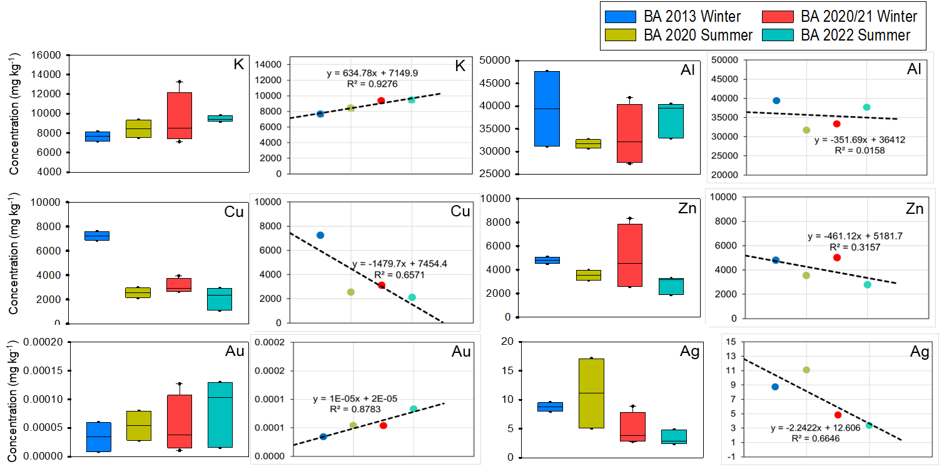
Figure S1 Box plots of selected elements in BA from summer (2020, and 2022) and winter (2013, 2020 and 2021) seasons for both FE and FC plants. Side plots show a trend (coefficient of linear regression) of mean concentrations with time in BA.
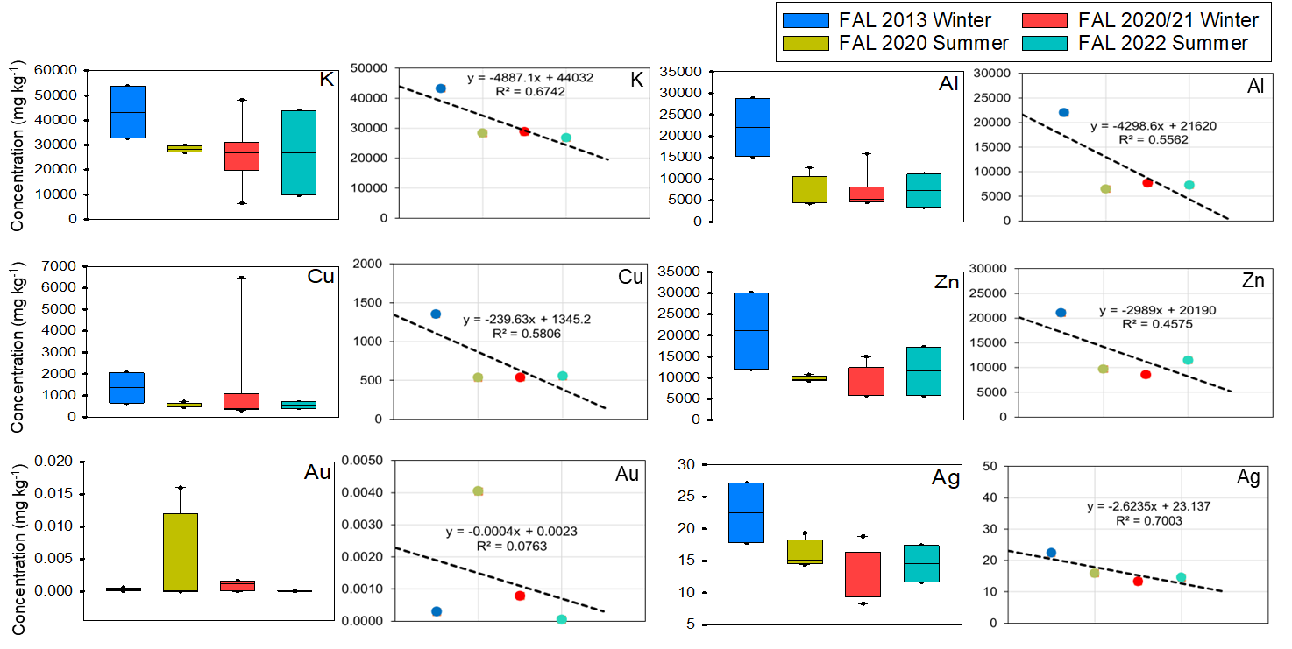
Figure S2 Box plots of selected elements in FAL from summer (2020, and 2022) and winter (2013, 2020 and 2021) seasons for both FE and FC plants. Side plots show a trend (coefficient of linear regression) of mean concentrations with time in FAL.
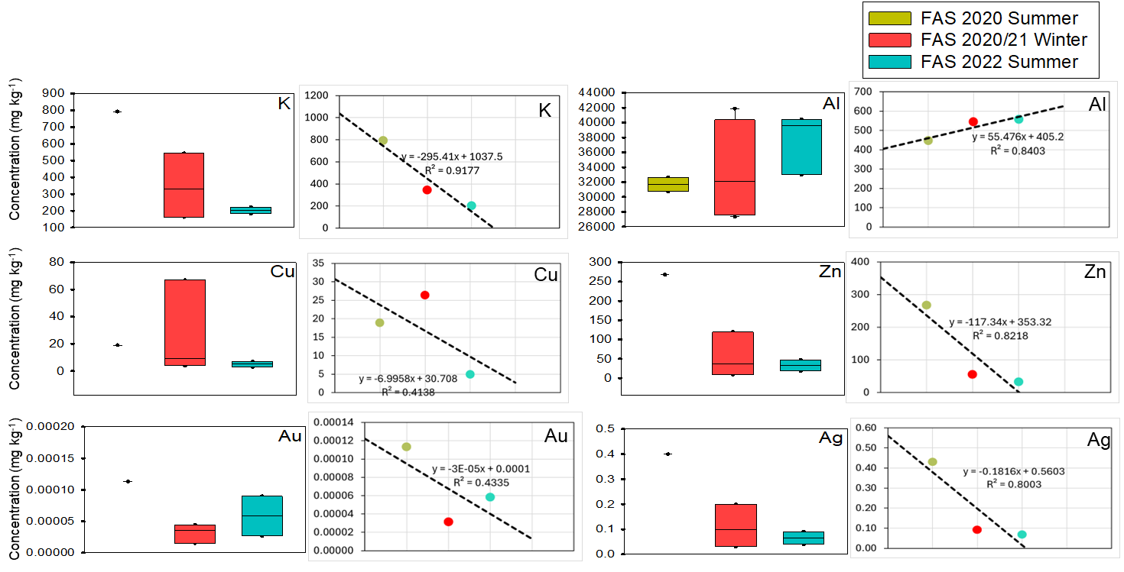
Figure S3 Box plots of selected elements in FAS from summer (2020, and 2022) and winter (2013, 2020 and 2021) seasons for both FE and FC plants. Side plots show a trend (coefficient of linear regression) of mean concentrations with time in FAS.

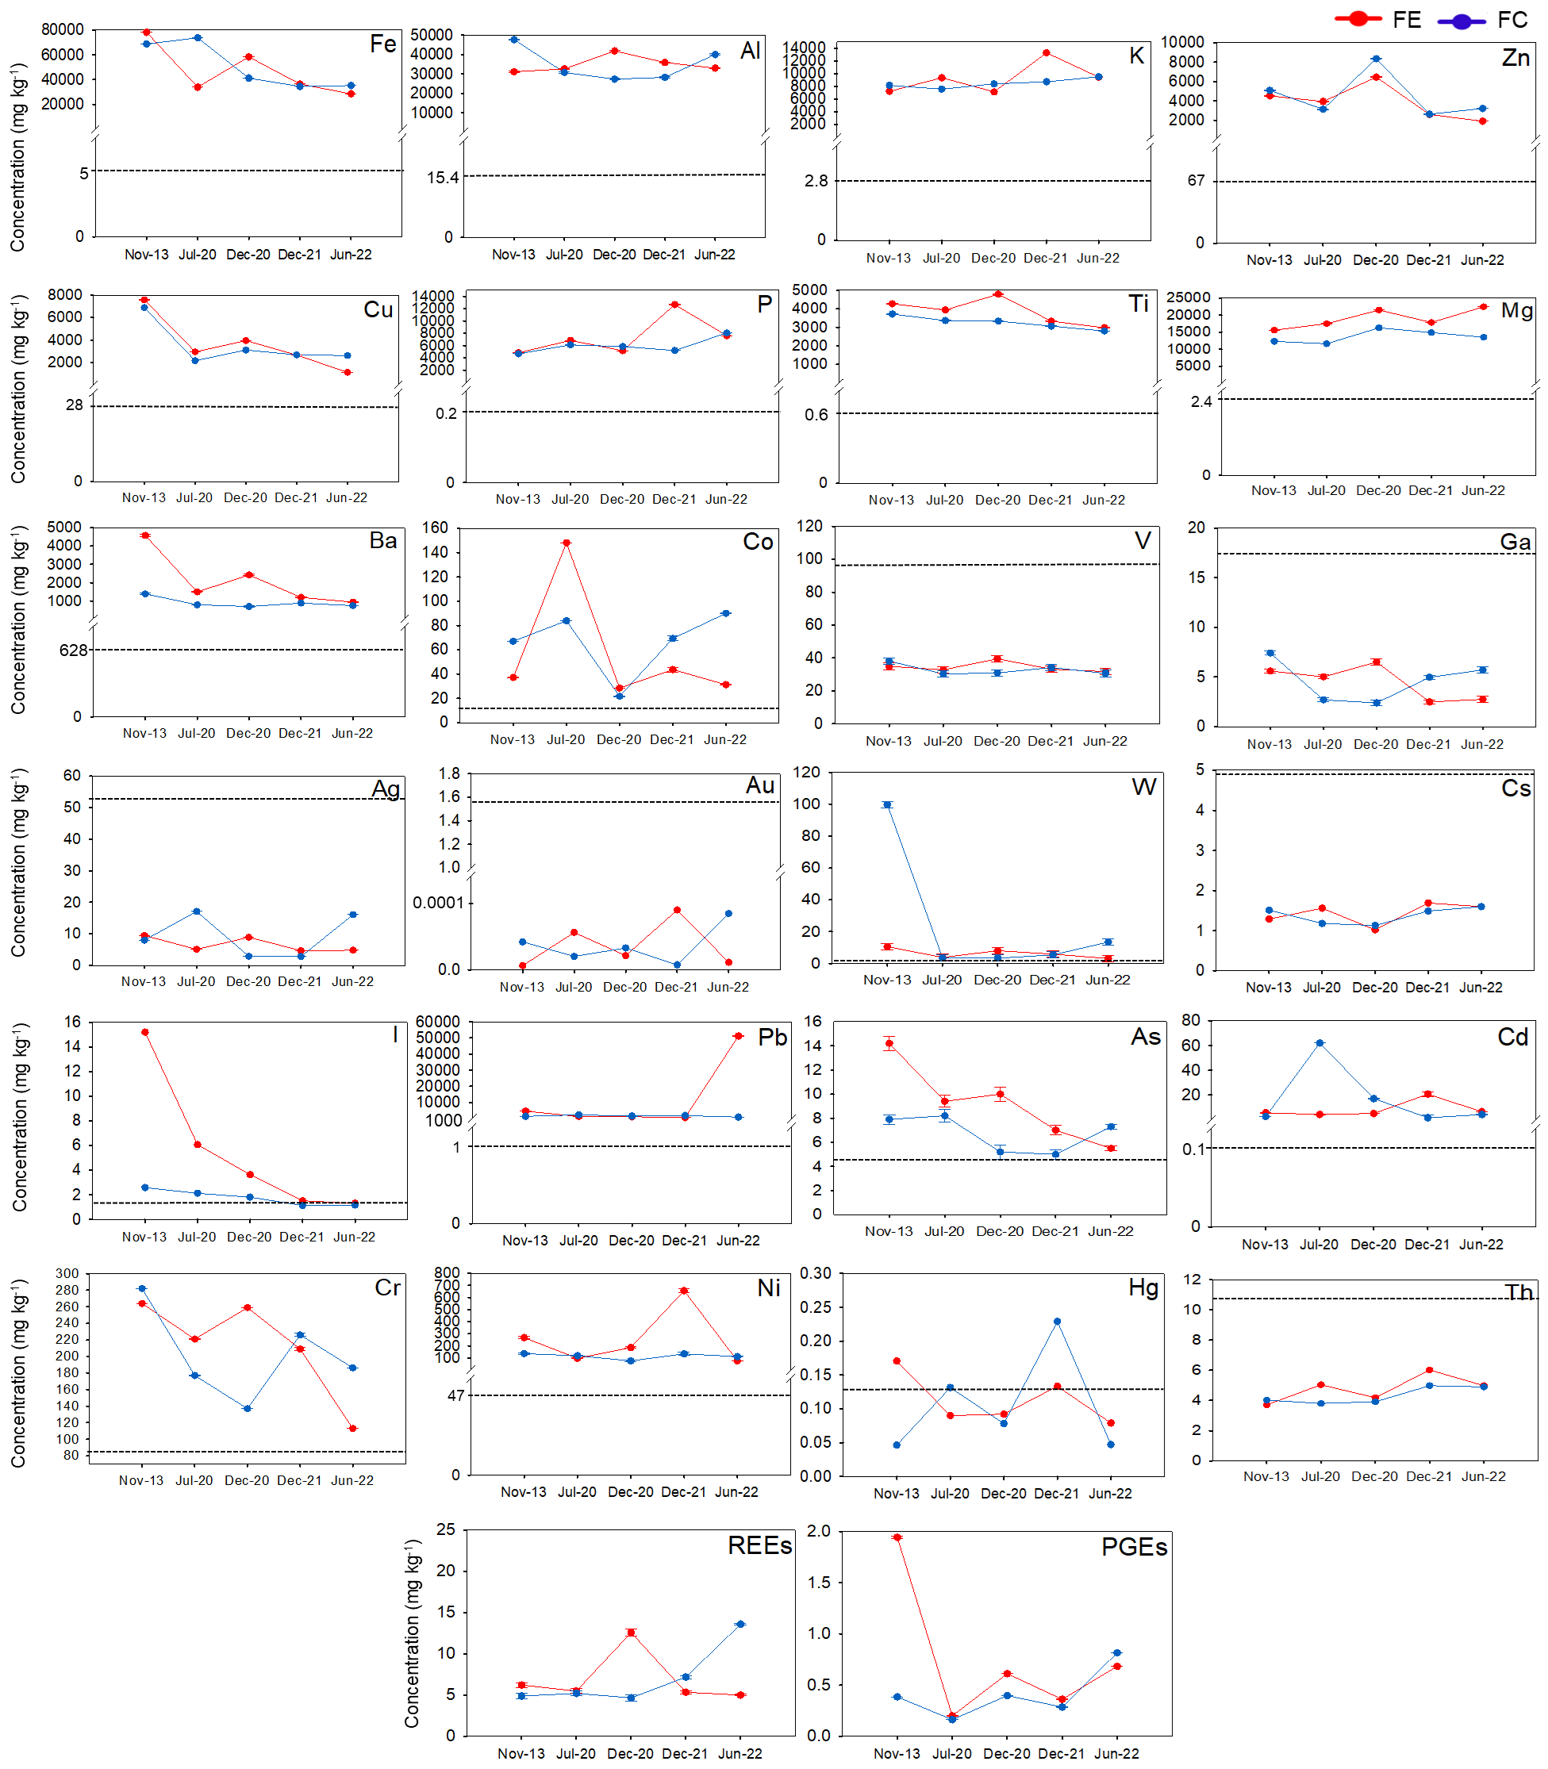
Figure S4 Mean concentration (mg kg⁻¹) of selected elements in BA from FE and FC plants. Dotted lines are UCC concentrations.
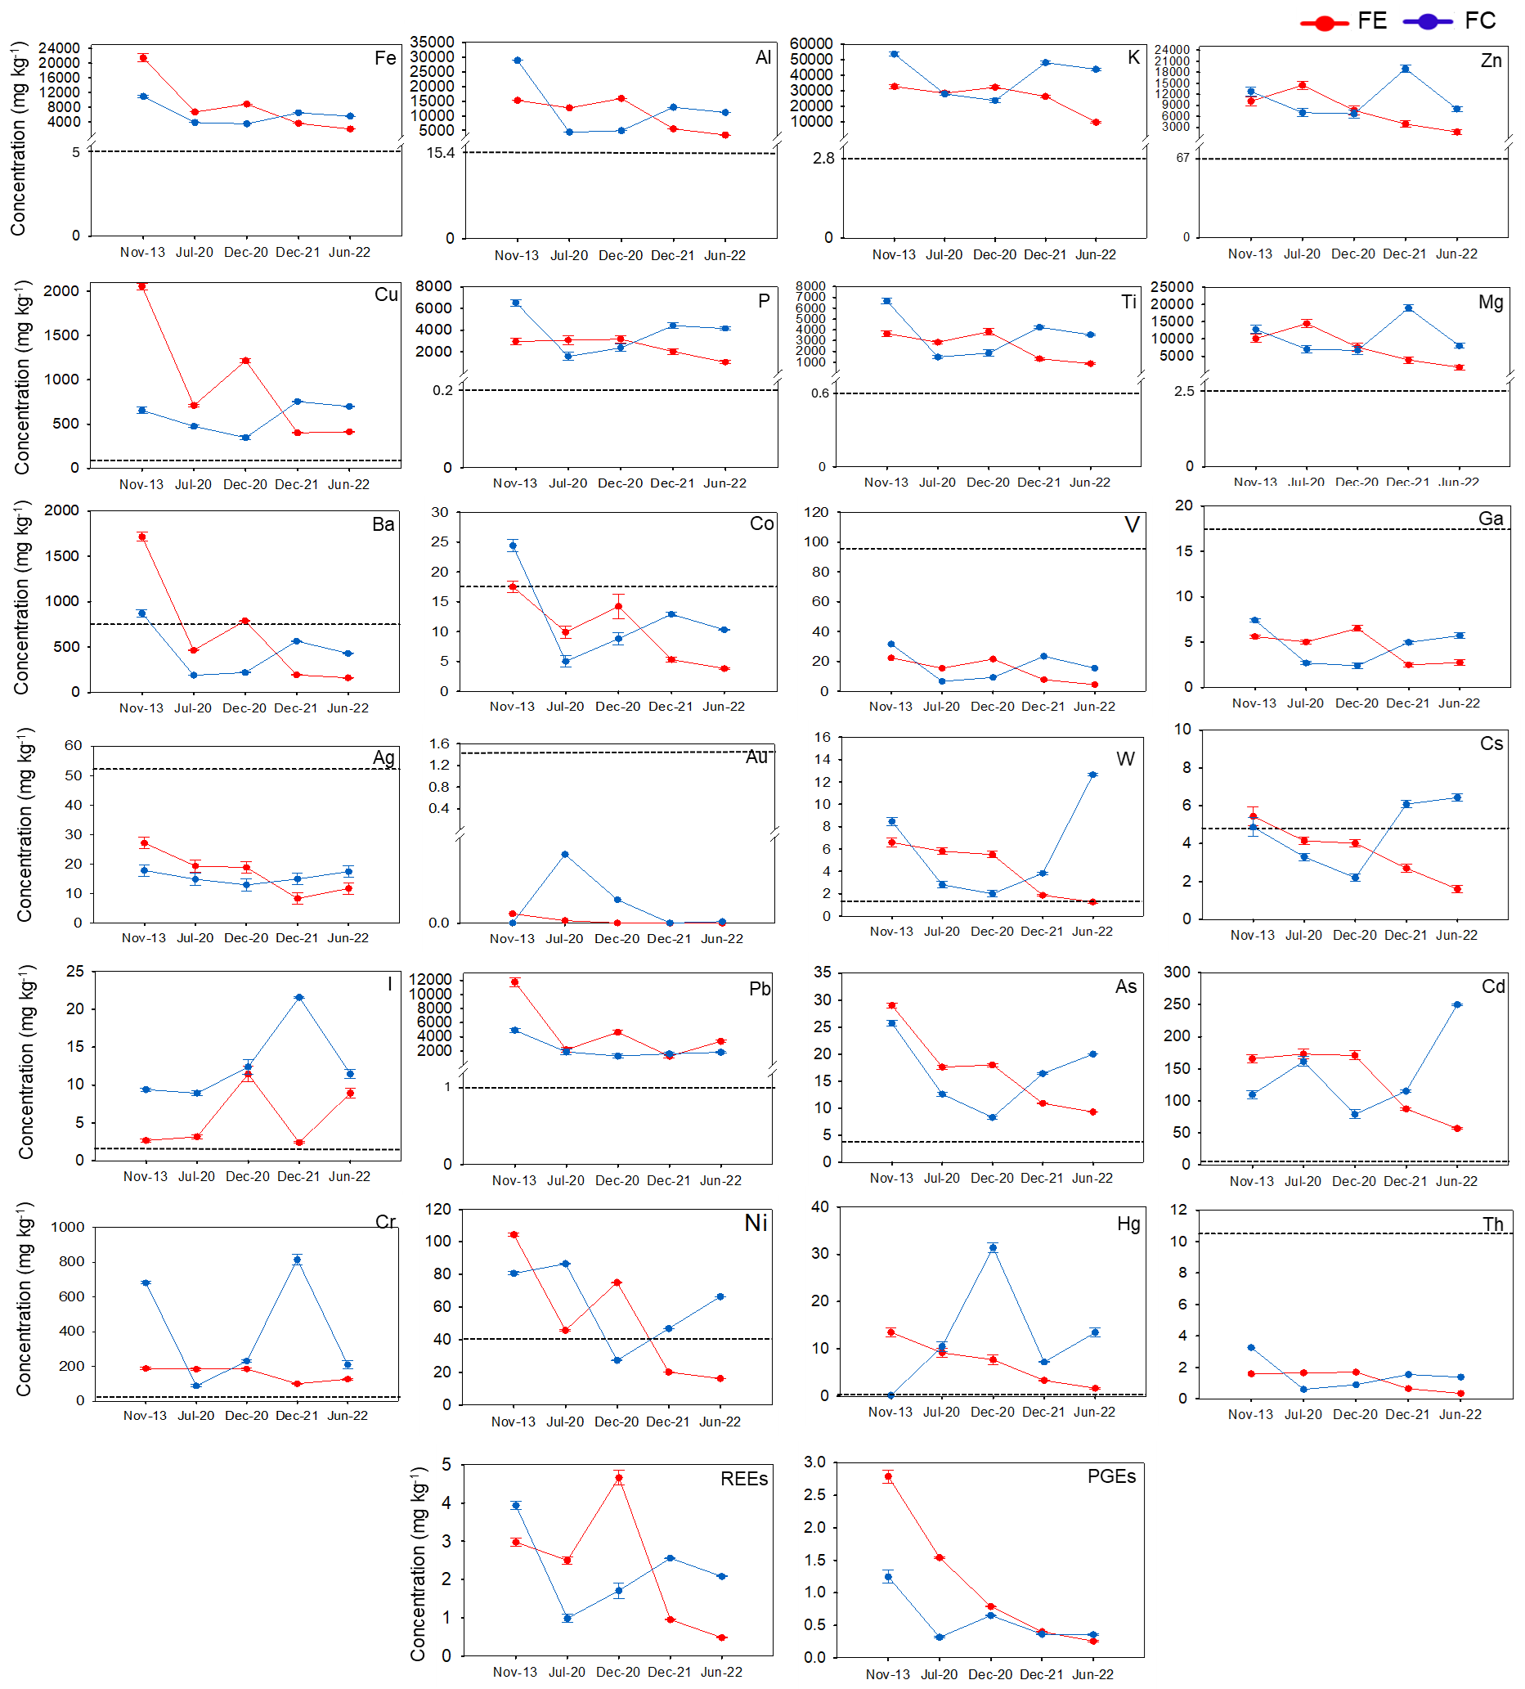
Figure S5 Mean concentration (mg kg⁻¹) of selected elements in FAL from FE and FC plants. Dotted lines are UCC concentrations.
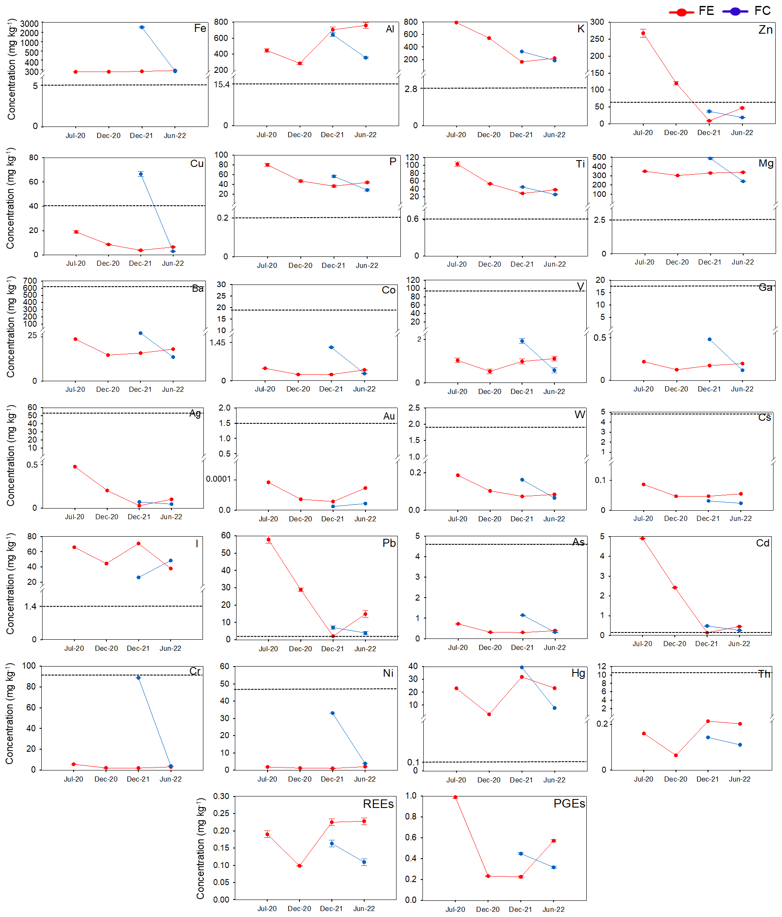
Figure S6 Mean concentration (mg kg⁻¹) of selected elements in FAS from FE and FC plants. Dotted lines are UCC concentrations.
Figure S4 Mean concentration (mg kg⁻¹) of selected elements in BA from FE and FC plants.
Figure S5 Mean concentration (mg kg⁻¹) of selected elements in FAL from FE and FC plants.
Table S4 Comparative analysis of elemental concentrations (as averages) in BA and FA collected from MSWI plants of different countries. Bold indicates concentrations higher than those determined in this study.
Analyte | FA concentration (mg kg⁻¹) | BA concentration (mg kg⁻¹) | Incinerator/Facility | Country/Region | Reference
Cu | 474 mg kg⁻¹ | 4787 mg kg⁻¹ | Maia MSWI plant | Portugal | Valentim et al., 2024
Zn | 5273 mg kg⁻¹ | 1009 mg kg⁻¹ | Maia MSWI plant | Portugal | Valentim et al., 2024
Pb | 1333 mg kg⁻¹ | 417 mg kg⁻¹ | Maia MSWI plant | Portugal | Valentim et al., 2024
As | 19.4 mg kg⁻¹ | 17 mg kg⁻¹ | Maia MSWI plant | Portugal | Valentim et al., 2024
Cu |  | 985 mg kg⁻¹ | Aradkouh waste incinerator | Iran | Beikmohammadi et al., 2023
Zn |  | 2343 mg kg⁻¹ | Aradkouh waste incinerator | Iran | Beikmohammadi et al., 2023
Pb |  | 155 mg kg⁻¹ | Aradkouh waste incinerator | Iran | Beikmohammadi et al., 2023
As |  | 11 mg kg⁻¹ | Aradkouh waste incinerator | Iran | Beikmohammadi et al., 2023
Cu | 340 mg L⁻¹ |  | Lujiashan MSWI plant | China | Zhao et al., 2021
Zn | 3488 mg L⁻¹
Pb | 760 mg L⁻¹
Cd | 133 mg L⁻¹
As | 87.4 mg L⁻¹
Mg |  | 756 mg kg⁻¹ | MSWI plant | United Kingdom | Gökelma et al., 2021
 |  | 495 mg kg⁻¹ | MSWI plant | United states | Gökelma et al., 2021
 |  | 1350 mg kg⁻¹ | MSWI plant | Denmark | Gökelma et al., 2021
Ti |  | 198 mg kg⁻¹ |  | United Kingdom | Gökelma et al., 2021
 |  | 255 mg kg⁻¹ |  | United States | Gökelma et al., 2021
 |  | 130 mg kg⁻¹ |  | Denmark | Gökelma et al., 2021
Ag |  | 0.0069 mg kg⁻¹ | Krakow Thermal Waste Treatment Plant | Poland | Chuchro et al., 2025
Au |  | 0.313 mg kg⁻¹
∑REE | 162 mg kg⁻¹ |  | Shanxi MSWI plant | China | Cui and Qin, 2023
Cu | 386 mg kg⁻¹ |  | MSWI plant | China | Zhao et al., 2023
Zn | 1670 mg kg⁻¹
Fe | 11000 mg kg⁻¹ |  | MSWI plants | Norway and Sweden | Nedkvitne et al., 2021
Al | 17300 mg kg⁻¹
Cu | 1200 mg kg⁻¹
Zn | 15900 mg kg⁻¹
Fe |  | 103000 mg kg⁻¹ | MSWI plants | Sweden | Tiberg et al., 2021
Al |  | 57000 mg kg⁻¹ | MSWI plants | Sweden | Tiberg et al., 2021
Cu |  | 6500 mg kg⁻¹ | MSWI plants | Sweden | Tiberg et al., 2021
Zn |  | 5900 mg kg⁻¹ | MSWI plants | Sweden | Tiberg et al., 2021
Cu |  | 5500 mg kg⁻¹ | MSWI plant | Japan | Back and Sakanakura, 2021
Zn |  | 2900 mg kg⁻¹ | MSWI plant | Japan | Back and Sakanakura, 2021
Fe |  | 11700 mg kg⁻¹ | MSWI plant | Japan | Back and Sakanakura, 2021
Al |  | 63500 mg kg⁻¹ | MSWI plant | Japan | Back and Sakanakura, 2021
Mg |  | 7900 mg kg⁻¹ | MSWI plant | Japan | Back and Sakanakura, 2021
P |  | 7800 mg kg⁻¹ | MSWI plant | Japan | Back and Sakanakura, 2021
Ti |  | 2300 mg kg⁻¹ | MSWI plant | Japan | Back and Sakanakura, 2021
K |  | 16400 mg kg⁻¹ | MSWI plant | Japan | Back and Sakanakura, 2021
Pb |  | 1200 mg kg⁻¹ | MSWI plant | Japan | Back and Sakanakura, 2021
Cd |  | 1.7 mg kg⁻¹ | MSWI plant | Japan | Back and Sakanakura, 2021
As |  | 28 mg kg⁻¹ | MSWI plant | Japan | Back and Sakanakura, 2021
Zn | 4035 mg kg⁻¹ |  | Jining MSWI plant | China | Yuan et al., 2023
Cd | 200 mg kg⁻¹
Pb | 342 mg kg⁻¹
Ni | 92.2 mg kg⁻¹
Cr | 85.7 mg kg⁻¹
Note: Italic values are lower than our present results. Bold values are higher than our present results. Non-Italic values are comparable with our present results.
Table S5 The independent sample t-test (for equality of the mean), performed for BA and FAs (FAL and FAS). Comparison of the p-value with elements mean content in MSWI residues from FE and FC plants for all years.
 | Mean FE | Mean FC | p-value | Mean FE | Mean FC | p-value | Mean FE | Mean FC | p-value
 | BA | BA |  | FAL | FAL |  | FAS | FAS
Ag | 6.60 | 6.01 | 0.84 | 17.04 | 15.05 | 0.37 | 0.18 | 0.05 | 0.37
Al | 34907 | 35685 | 0.85 | 10,131 | 8,957 | 0.08 | 543 | 494 | 0.81
As | 9.23 | 6.82 | 0.14 | 16.29 | 13.74 | 0.13 | 0.42 | 0.72 | 0.37
Au | 0.0001 | 0.0001 | 0.0001 | 0.0002 | 0.0024 | 0.318 | 0.0001 | 0.0001 | 0.0001
B | 272 | 142 | 0.08 | 108 | 84 | 0.17 | 8.84 | 7.61 | 0.64
Ba | 2126 | 873 | 0.07 | 663 | 358 | 0.09 | 16.09 | 17.92 | 0.71
Be | 0.94 | 0.87 | 0.37 | 0.22 | 0.45 | 0.17 | 0.07 | 0.07 | 1.00
Bi | 3.90 | 2.73 | 0.39 | 55.51 | 24.75 | 0.08 | 1.53 | 0.18 | 0.39
Br | 15.00 | 9.83 | 0.49 | 1341 | 1219 | 0.77 | 2163 | 833 | 0.39
Ca | 191075 | 186580 | 0.71 | 200015 | 195302 | 0.78 | 3040 | 1748 | 0.52
Cd | 8.44 | 15.26 | 0.55 | 130.80 | 140.00 | 0.60 | 1.98 | 0.37 | 0.38
Ce | 49.88 | 45.81 | 0.85 | 13.47 | 7.45 | 0.12 | 1.00 | 0.71 | 0.32
Cl | 11533 | 8375 | 0.09 | 218788 | 164729 | 0.74 | 129300 | 238000 | 0.0001
Co | 57.78 | 70.33 | 0.61 | 10.06 | 9.91 | 0.18 | 0.40 | 0.90 | 0.26
Cr | 213.20 | 199.17 | 0.68 | 155 | 301 | 0.97 | 3.13 | 46.30 | 0.17
Cs | 1.44 | 1.42 | 0.88 | 3.56 | 3.93 | 0.97 | 0.10 | 0.001 | 0.0001
Cu | 3655 | 3350 | 0.81 | 958 | 529 | 0.14 | 9.45 | 34.90 | 0.27
Dy | 1.59 | 1.59 | 0.97 | 0.43 | 0.45 | 0.36 | 0.06 | 0.06 | 0.71
Er | 0.95 | 1.08 | 0.17 | 0.23 | 0.25 | 0.48 | 0.04 | 0.03 | 0.63
Eu | 0.38 | 0.50 | 0.20 | 0.13 | 0.14 | 0.25 | 0.02 | 0.01 | 0.31
Fe | 47,060 | 48087 | 0.93 | 8073 | 4646 | 0.12 | 686 | 13903 | 0.17
Ga | 7.28 | 7.46 | 0.80 | 4.38 | 3.75 | 0.11 | 0.16 | 0.26 | 0.36
Gd | 1.89 | 6.03 | 0.20 | 0.50 | 0.53 | 0.40 | 0.07 | 0.05 | 0.44
Ge | 0.20 | 0.24 | 0.31 | 0.21 | 0.10 | 0.01 | 0.01 | 0.01 | 0.001
Hf | 2.50 | 1.90 | 0.09 | 0.84 | 0.74 | 0.10 | 0.03 | 0.04 | 0.76
Hg | 0.11 | 0.10 | 0.68 | 7.09 | 14.44 | 0.14 | 20.23 | 23.56 | 0.82
Ho | 0.30 | 0.34 | 0.35 | 0.08 | 0.09 | 0.39 | 0.01 | 0.01 | 0.001
I | 33.27 | 10.01 | 0.13 | 22.56 | 54.81 | 0.03 | 321 | 217 | 0.28
Ir | 0.04 | 0.03 | 0.47 | 0.01 | 0.02 | 0.26 | 0.02 | 0.02 | 0.31
In | 0.11 | 0.10 | 0.30 | 3.69 | 0.25 | 0.10 | 0.10 | 0.10 | 0.001
K | 9268 | 8626 | 0.56 | 25886 | 34698 | 0.83 | 429 | 254 | 0.48
La | 17.80 | 16.32 | 0.47 | 5.41 | 4.72 | 0.16 | 0.55 | 0.37 | 0.29
Li | 27.00 | 24.02 | 0.17 | 17.52 | 15.79 | 0.42 | 0.82 | 0.64 | 0.35
Lu | 0.13 | 0.13 | 0.96 | 0.03 | 0.03 | 0.34 | 0.00 | 0.01 | 0.63
Mg | 18966 | 13,665 | 0.001 | 6636 | 8075 | 0.95 | 319 | 354 | 0.67
Mn | 959.20 | 894.83 | 0.57 | 339.80 | 278.13 | 0.19 | 25.38 | 97.20 | 0.23
Mo | 17.64 | 10.55 | 0.20 | 12.08 | 12.99 | 0.83 | 0.36 | 4.10 | 0.13
Na | 13279 | 13418 | 0.90 | 22155 | 123707 | 0.001 | 311838 | 294961 | 0.37
Nb | 6.42 | 5.41 | 0.01 | 2.97 | 4.84 | 0.76 | 0.12 | 0.20 | 0.27
Nd | 11.86 | 25.10 | 0.20 | 3.32 | 3.02 | 0.17 | 0.41 | 0.30 | 0.40
Ni | 256.60 | 114.50 | 0.17 | 50.90 | 62.23 | 0.81 | 1.48 | 18.40 | 0.13
Os | 0.37 | 0.25 | 0.13 | 0.28 | 0.44 | 0.17 | 1.16 | 1.52 | 0.65
Continue Table S5 The independent sample t-test (for equality of the mean), performed for BA and FAs (FAL and FAS). Comparison of the p-value with elements mean content in MSWI residues from FE and FC plants for all years.
 | Mean FE | Mean FC | p-value | Mean FE | Mean FC | p-value | Mean FE | Mean FC | p-value
 | BA | BA |  | FAL | FAL |  | FAS | FAS
P | 7419 | 6326 | 0.46 | 2424 | 3046 | 0.53 | 51.58 | 42.20 | 0.61
Pb | 11777 | 1461 | 0.28 | 4629 | 2045 | 0.05 | 25.87 | 5.48 | 0.32
Pd | 0.23 | 0.46 | 0.36 | 2.87 | 1.06 | 0.11 | 1.20 | 0.01 | 0.49
Pr | 3.13 | 6.53 | 0.20 | 0.85 | 0.88 | 0.31 | 0.11 | 0.08 | 0.40
Pt | 0.24 | 0.18 | 0.69 | 0.07 | 0.06 | 0.07 | 0.07 | 0.05 | 0.60
Rb | 27.82 | 26.13 | 0.48 | 64.38 | 75.24 | 0.96 | 1.10 | 0.50 | 0.30
Re | 0.0001 | 0.0001 | 0.0001 | 0.001 | 0.002 | 0.53 | 0.0005 | 0.0002 | 0.56
Rh | 2.53 | 1.43 | 0.54 | 3.07 | 0.49 | 0.26 | 0.41 | 0.21 | 0.37
Ru | 0.38 | 0.53 | 0.32 | 0.60 | 1.13 | 0.38 | 0.16 | 0.47 | 0.14
S | 5882 | 5270 | 0.19 | 19384 | 45929 | 0.29 | 24555 | 51696 | 0.001
Sb | 146.48 | 96.13 | 0.10 | 862 | 711.13 | 0.05 | 11.13 | 2.08 | 0.15
Sc | 3.21 | 3.20 | 0.97 | 0.83 | 0.85 | 0.17 | 0.12 | 0.11 | 0.73
Se | 0.24 | 0.18 | 0.46 | 5.05 | 2.15 | 0.04 | 0.36 | 0.14 | 0.62
Si | 56044 | 56156 | 0.97 | 19256 | 17384 | 0.14 | 1320 | 1132 | 0.36
Sm | 1.87 | 1.82 | 0.56 | 0.52 | 0.52 | 0.25 | 0.07 | 0.06 | 0.51
Sn | 167 | 320 | 0.27 | 534 | 462 | 0.31 | 5.00 | 1.48 | 0.41
Sr | 530 | 452 | 0.03 | 132 | 142 | 0.37 | 16.13 | 25.90 | 0.26
Ta | 0.35 | 0.27 | 0.09 | 0.22 | 0.30 | 0.50 | 0.001 | 0.001 | 0.001
Tb | 0.32 | 0.29 | 0.40 | 0.11 | 0.10 | 0.19 | 0.01 | 0.01 | 0.001
Te | 0.09 | 0.08 | 0.84 | 1.99 | 0.30 | 0.02 | 0.01 | 0.001 | 0.16
Th | 4.79 | 4.42 | 0.42 | 1.09 | 1.11 | 0.16 | 0.15 | 0.12 | 0.54
Ti | 3863 | 3181 | 0.07 | 2494 | 2813 | 0.33 | 55.40 | 35.15 | 0.47
Tl | 0.11 | 0.09 | 0.45 | 0.71 | 0.70 | 0.96 | 0.02 | 0.02 | 1.00
Tm | 0.12 | 0.12 | 0.60 | 0.03 | 0.03 | 0.26 | 0.01 | 0.01 | 0.63
U | 1.46 | 1.29 | 0.09 | 0.17 | 0.00 | 0.29 | 0.09 | 0.07 | 0.69
V | 34.42 | 32.46 | 0.32 | 10.37 | 8.62 | 0.13 | 0.79 | 1.09 | 0.51
W | 6.31 | 23.17 | 0.35 | 4.19 | 4.73 | 0.72 | 0.09 | 0.09 | 1.00
Y | 12.50 | 12.19 | 0.88 | 4.12 | 3.94 | 0.31 | 0.39 | 0.32 | 0.57
Yb | 0.88 | 0.80 | 0.35 | 0.20 | 1.99 | 0.30 | 0.03 | 0.03 | 1.00
Zn | 3880 | 4270 | 0.76 | 13486 | 10518 | 0.45 | 111 | 27.70 | 0.39
Zr | 101 | 78 | 0.16 | 36.48 | 31.84 | 0.09 | 1.29 | 1.23 | 0.85

Table S6 The independent sample t-test (for equality of the mean), performed for BA and FAs (FAL and FAS). Comparison of the p-value with elements mean content in winter and summer seasons of MSWI residues from FE and FC plants for all years.
 | Mean FE | Mean FC | p-value | Mean FE | Mean FC | p-value | Mean FE | Mean FC | p-value
 | BA | BA |  | FAL | FAL |  | FAS | FAS
Ag | 6.13 | 6.46 | 0.91 | 16.09 | 15.50 | 0.84 | 0.09 | 0.19 | 0.50
Al | 35372 | 35283 | 0.98 | 12104 | 6264 | 0.15 | 538 | 515 | 0.90
As | 8.22 | 7.55 | 0.70 | 15.88 | 13.37 | 0.51 | 0.58 | 0.46 | 0.73
Au | 0.0001 | 0.0001 | 0.0001 | 0.0005 | 0.0028 | 0.38 | 0.0001 | 0.0001 | 0.0001
B | 257 | 135 | 0.11 | 126 | 55 | 0.05 | 9.53 | 7.32 | 0.35
Ba | 1861 | 941 | 0.21 | 651 | 270 | 0.13 | 16.91 | 16.48 | 0.93
Be | 0.91 | 0.90 | 0.95 | 0.30 | 0.44 | 0.35 | 0.07 | 0.07 | 1.00
Bi | 4.49 | 1.80 | 0.03 | 49.86 | 21.09 | 0.12 | 1.61 | 0.55 | 0.48
Br | 20.83 | 1.80 | 0.001 | 1,439 | 1,064 | 0.44 | 2743 | 695 | 0.12
Ca | 190204 | 186727 | 0.78 | 212609 | 179038 | 0.39 | 2166 | 3053 | 0.65
Cd | 8.77 | 16.23 | 0.51 | 115.29 | 161.17 | 0.13 | 1.01 | 1.87 | 0.64
Ce | 47.05 | 48.40 | 0.95 | 13.79 | 5.08 | 0.10 | 0.90 | 0.90 | 0.99
Cl | 10150 | 7200 | 0.001 | 187464 | 179000 | 0.79 | 165967 | 128000 | 0.001
Co | 44.57 | 88.70 | 0.05 | 13.00 | 6.43 | 0.04 | 0.70 | 0.43 | 0.55
Cr | 230 | 177 | 0.10 | 345 | 129 | 0.10 | 30.90 | 4.13 | 0.41
Cs | 1.35 | 1.52 | 0.26 | 3.90 | 3.65 | 0.78 | 0.07 | 0.07 | 1.00
Cu | 4483 | 2296 | 0.06 | 824 | 542 | 0.30 | 26.33 | 9.53 | 0.46
Dy | 1.60 | 1.57 | 0.77 | 0.56 | 0.30 | 0.08 | 0.06 | 0.06 | 0.73
Er | 0.99 | 1.05 | 0.53 | 0.31 | 0.17 | 0.08 | 0.03 | 0.03 | 1.00
Eu | 0.47 | 0.41 | 0.50 | 0.18 | 0.09 | 0.06 | 0.01 | 0.01 | 1.00
Fe | 52885 | 41302 | 0.32 | 7790 | 3833 | 0.18 | 9385 | 798 | 0.38
Ga | 7.40 | 7.35 | 0.94 | 4.43 | 3.48 | 0.36 | 0.23 | 0.15 | 0.51
Gd | 1.97 | 6.76 | 0.13 | 0.68 | 0.33 | 0.04 | 0.06 | 0.07 | 0.65
Ge | 0.24 | 0.20 | 0.41 | 0.18 | 0.10 | 0.32 | 0.01 | 0.01 | 0.001
Hf | 2.46 | 1.82 | 0.07 | 1.00 | 0.53 | 0.16 | 0.03 | 0.04 | 0.37
Hg | 0.13 | 0.08 | 0.19 | 13.53 | 9.37 | 0.57 | 24.68 | 18.00 | 0.62
Ho | 0.30 | 0.35 | 0.20 | 0.11 | 0.06 | 0.08 | 0.01 | 0.01 | 0.001
I | 25.88 | 14.23 | 0.47 | 47.14 | 36.88 | 0.52 | 275 | 297 | 0.83
Ir | 0.04 | 0.02 | 0.15 | 0.02 | 0.01 | 0.19 | 0.02 | 0.02 | 1.00
In | 0.11 | 0.10 | 0.39 | 1.17 | 2.04 | 0.64 | 0.10 | 0.10 | 1.00
K | 8798 | 9062 | 0.81 | 34344 | 27768 | 0.33 | 343 | 398 | 0.82
La | 17.08 | 16.88 | 0.92 | 6.50 | 3.23 | 0.05 | 0.45 | 0.53 | 0.65
Li | 25.93 | 24.70 | 0.59 | 18.61 | 13.93 | 0.24 | 0.76 | 0.75 | 0.99
Lu | 0.13 | 0.13 | 0.60 | 0.04 | 0.02 | 0.12 | 0.00 | 0.00 | 1.00
Mg | 16385 | 15703 | 0.77 | 8430 | 6461 | 0.45 | 362 | 298 | 0.39
Mn | 991.33 | 843.40 | 0.18 | 391.71 | 197.00 | 0.04 | 72.13 | 26.50 | 0.45
Mo | 17.60 | 9.18 | 0.12 | 12.83 | 12.42 | 0.93 | 2.58 | 0.63 | 0.46
Na | 12488 | 14395 | 0.07 | 68671 | 103289 | 0.44 | 305035 | 307390 | 0.90
Nb | 5.82 | 5.93 | 0.81 | 4.11 | 4.14 | 0.98 | 0.16 | 0.13 | 0.74
Nd | 12.45 | 27.04 | 0.15 | 4.16 | 1.93 | 0.04 | 0.35 | 0.39 | 0.76
Ni | 243 | 103 | 0.18 | 52.91 | 63.65 | 0.55 | 11.72 | 2.53 | 0.44
Os | 0.38 | 0.21 | 0.02 | 0.46 | 0.28 | 0.38 | 1.03 | 1.53 | 0.49
Continue Table S6 The independent sample t-test (for equality of the mean), performed for BA and FAs (FAL and FAS). Comparison of the p-value with elements mean content in winter and summer seasons of MSWI residues from FE and FC plants for all years.
 | Mean FE | Mean FC | p-value | Mean FE | Mean FC | p-value | Mean FE | Mean FC | p-value
 | BA | BA |  | FAL | FAL |  | FAS | FAS
P | 6397 | 7334 | 0.53 | 3375 | 2143 | 0.14 | 46.33 | 50.57 | 0.81
Pb | 1842 | 11319 | 0.32 | 3805 | 2145 | 0.32 | 12.64 | 25.51 | 0.52
Pd | 0.53 | 0.14 | 0.09 | 1.68 | 1.83 | 0.90 | 0.15 | 1.46 | 0.42
Pr | 3.30 | 7.01 | 0.16 | 1.06 | 0.65 | 0.16 | 0.09 | 0.10 | 0.92
Pt | 0.20 | 0.22 | 0.89 | 0.08 | 0.04 | 0.49 | 0.03 | 0.10 | 0.02
Rb | 26.48 | 27.40 | 0.70 | 75.56 | 65.82 | 0.54 | 0.75 | 1.05 | 0.61
Re | 0.0001 | 0.0001 | 0.0001 | 0.002 | 0.001 | 0.22 | 0.0001 | 0.0007 | 0.30
Rh | 2.31 | 1.47 | 0.65 | 2.30 | 0.54 | 0.38 | 0.24 | 0.45 | 0.30
Ru | 0.53 | 0.38 | 0.32 | 1.32 | 0.47 | 0.17 | 0.33 | 0.19 | 0.56
S | 5495 | 5612 | 0.81 | 34931 | 36640 | 0.88 | 32644 | 34559 | 0.89
Sb | 150 | 82 | 0.02 | 846 | 679 | 0.23 | 7.07 | 9.15 | 0.76
Sc | 3.28 | 3.11 | 0.39 | 1.07 | 0.58 | 0.16 | 0.12 | 0.11 | 0.94
Se | 0.27 | 0.13 | 0.08 | 2.60 | 4.04 | 0.28 | 0.14 | 0.43 | 0.48
Si | 54371 | 58185 | 0.20 | 22902 | 12507 | 0.16 | 1288 | 1227 | 0.76
Sm | 1.88 | 1.80 | 0.40 | 0.67 | 0.34 | 0.07 | 0.06 | 0.07 | 0.43
Sn | 341 | 141 | 0.14 | 536 | 435 | 0.45 | 2.78 | 4.87 | 0.61
Sr | 516 | 454 | 0.10 | 185 | 83 | 0.07 | 23.80 | 14.97 | 0.29
Ta | 0.33 | 0.28 | 0.31 | 0.32 | 0.22 | 0.28 | 0.0001 | 0.0001 | 0.0001
Tb | 0.33 | 0.27 | 0.10 | 0.13 | 0.07 | 0.06 | 0.01 | 0.01 | 0.0001
Te | 0.11 | 0.06 | 0.41 | 1.17 | 0.69 | 0.50 | 0.00 | 0.01 | 0.25
Th | 4.47 | 4.72 | 0.59 | 1.38 | 0.78 | 0.15 | 0.13 | 0.14 | 0.73
Ti | 3752 | 3177 | 0.14 | 3329 | 1945 | 0.13 | 41.90 | 55.40 | 0.62
Tl | 0.08 | 0.12 | 0.22 | 0.73 | 0.67 | 0.77 | 0.01 | 0.02 | 0.68
Tm | 0.12 | 0.12 | 0.60 | 0.04 | 0.03 | 0.09 | 0.01 | 0.01 | 1.00
U | 1.39 | 1.34 | 0.67 | 0.12 | 0.00 | 0.36 | 0.06 | 0.11 | 0.40
V | 35.12 | 31.23 | 0.03 | 13.29 | 4.63 | 0.05 | 0.99 | 0.78 | 0.62
W | 22.19 | 7.48 | 0.42 | 4.31 | 4.76 | 0.82 | 0.09 | 0.08 | 0.93
Y | 13.35 | 11.11 | 0.28 | 5.08 | 2.77 | 0.09 | 0.34 | 0.38 | 0.71
Yb | 0.85 | 0.81 | 0.60 | 2.28 | 0.16 | 0.36 | 0.02 | 0.03 | 0.68
Zn | 4937 | 3079 | 0.11 | 12814 | 10314 | 0.53 | 55.40 | 111 | 0.55
Zr | 102 | 72 | 0.06 | 42.74 | 22.98 | 0.16 | 1.20 | 1.34 | 0.65

Table S7 Chemical concentrations (mg kg⁻¹) of Calcium Hydroxide (Lime) and Sodium Bicarbonate (Soda) additives, added in FAL and FAS production, respectively.
Variables | Lime | Soda
Ag | 0.01 | 0.001
Al | 1100 | 8.0
As | 1.7 | 0.01
Au | 0.002 | 0.001
B | 2.7 | 0.6
Ba | 4.0 | 0.1
Be | 0.1 | 0.0003
Bi | 0.01 | 0.0002
Br | 15.9 | 6.6
Ca | 389200 | 120
Cd | 0.2 | 0.002
Ce | 2.2 | 0.001
Co | 0.3 | 0.003
Cr | 5.6 | 0.1
Cs | 0.1 | 0.002
Cu | 1.7 | 0.05
Dy | 0.2 | 0.001
Er | 0.1 | 0.001
Eu | 0.1 | 0.002
Fe | 1200 | 1.3
Ga | 0.3 | 0.008
Gd | 0.3 | 0.005
Ge | 0.2 | 0.02
Hf | 0.1 | 0.001
Hg | 0.01 | 0.007
Ho | 0.05 | 0.001
I | 30 | 10
Ir | 0.01 | 0.001
K | 150 | 2.2
La | 1.3 | 0.002
Li | 1.8 | 0.03
Lu | 0.03 | 0.002
Mg | 2400 | 10
Mn | 35.4 | 0.01
Mo | 0.5 | 0.003
Na | 30 | 389300
Nb | 0.2 | 0.001
Nd | 1.2 | 0.002
Ni | 3.5 | 0.1
Os | 0.01 | 0.0001
P | 40 | 0.4
Pb | 2.2 | 0.02
Pd | 0.01 | 0.002
Pr | 0.3 | 0.0004
Pt | 0.01 | 0.002
Rb | 1 | 0.005
Continue Table S7 Chemical concentrations (mg kg⁻¹) of Calcium Hydroxide (Lime) and Sodium Bicarbonate (Soda) additives, added in FAL and FAS production, respectively.
Variables | Lime | Soda
Re | 0.002 | 0.001
Rh | 0.003 | 0.002
Ru | 0.003 | 0.001
S | 90 | 2.7
Sb | 0.1 | 0.02
Sc | 0.3 | 0.004
Se | 0.03 | 0.02
Si | 2600 | 4.7
Sm | 0.3 | 0.001
Sn | 0.1 | 0.009
Sr | 200 | 0.4
Ta | 0.04 | 0.02
Tb | 0.04 | 0.0001
Te | 0.02 | 0.008
Th | 0.3 | 0.003
Ti | 27 | 0.07
Tl | 0.01 | 0.001
Tm | 0.02 | 0.0002
U | 1.9 | 0.0003
V | 10 | 0.02
W | 0.03 | 0.0001
Y | 2.0 | 0.0004
Yb | 0.2 | 0.009
Zn | 5.7 | 0.05
Zr | 1.2 | 0.03

Table S8 Estimated annual flow of elements (kg a⁻¹) of the entire output stream (BA + FAL + FAS) for 2013, 2020, 2021 and 2022 samplings.
 |  |  | FE |  |  |  |  |  | FC
Industrial base metals and valuable elements | Nov-13 | Jul-20 | Dec-20 | Dec-21 | Jun-22 |  | Nov-13 | Jul-20 | Dec-20 | Dec-21 | Jun-22
Fe | 3369900 | 1350900 | 2228600 | 3776300 | 1490500 |  | 2538900 | 2700800 | 1560000 | 2307900 | 1326200
Si | 2995500 | 2828500 | 2850900 | 3931400 | 2963700 |  | 3525200 | 2612800 | 2063500 | 2770000 | 2615800
S | 2117800 | 2023300 | 1704000 | 4826700 | 1077800 |  | 3609800 | 3111800 | 2108000 | 3006400 | 2563400
Al | 1576000 | 1578000 | 1913000 | 2731400 | 1870000 |  | 2441000 | 1232600 | 1126000 | 1419400 | 1642700
K | 1373400 | 1273300 | 1318300 | 2203000 | 1952000 |  | 1988700 | 1267200 | 1128800 | 1944000 | 1709000
Ca | 1353300 | 1637400 | 1537300 | 1382120 | 1644300 |  | 1251130 | 1101900 | 1347000 | 1685400 | 1438500
Na | 1186000 | 1131700 | 1093600 | 1155600 | 1903550 |  | 1104100 | 1740700 | 1635700 | 1116500 | 1144600
Zn | 1176600 | 491400 | 710900 | 606900 | 749500 |  | 551000 | 442700 | 507100 | 575700 | 654500
Cu | 325300 | 121200 | 170600 | 269700 | 121500 |  | 240100 | 91950 | 120100 | 118900 | 106000
Mn | 56900 | 37800 | 62500 | 55000 | 47000 |  | 44200 | 36800 | 38000 | 56400 | 41500
Se | 210 | 229 | 104 | 108 | 124 |  | 127 | 112 | 74 | 80 | 111
Critical Raw Materials (CRMs)
Mg | 877900 | 1065000 | 970400 | 903900 | 787600 |  | 805500 | 656500 | 804500 | 1165300 | 694900
Ti | 270200 | 227300 | 285600 | 369200 | 231800 |  | 332600 | 171600 | 181000 | 249600 | 203100
P | 264800 | 328800 | 275700 | 398000 | 446100 |  | 357400 | 268900 | 285500 | 328300 | 390200
Ba | 4500 | 1400 | 2300 | 1200 | 900 |  | 1300 | 800 | 700 | 900 | 700
Sb | 500 | 500 | 700 | 500 | 300 |  | 700 | 300 | 200 | 600 | 600
Sr | 600 | 500 | 500 | 550 | 400 |  | 400 | 400 | 500 | 500 | 400
B | 500 | 200 | 400 | 200 | 100 |  | 200 | 200 | 200 | 100 | 100
Co | 40 | 150 | 30 | 40 | 30 |  | 70 | 80 | 20 | 70 | 90
V | 30 | 30 | 40 | 30 | 30 |  | 40 | 30 | 30 | 30 | 30
Bi | 60 | 20 | 90 | 20 | 10 |  | 30 | 10 | 10 | 30 | 30
Li | 30 | 30 | 20 | 30 | 20 |  | 20 | 20 | 20 | 30 | 25
W | 10 | 4.3 | 8.0 | 6.0 | 3.0 |  | 100 | 3.0 | 3.0 | 5.0 | 10
Ga | 0.6 | 0.7 | 0.8 | 0.8 | 0.7 |  | 1 | 0.6 | 0.5 | 0.7 | 1
Nb | 7.0 | 6.0 | 7.0 | 7.0 | 6.0 |  | 6.0 | 6.0 | 4.5 | 5.0 | 5.0
Hf | 3.0 | 2.0 | 3.0 | 3.0 | 2.0 |  | 3.0 | 2.0 | 2.0 | 2.0 | 2.0
Be | 1.0 | 1.0 | 1.0 | 1.0 | 1.0 |  | 1.0 | 1.0 | 1.0 | 1.0 | 1.0
Ta | 0.5 | 0.3 | 0.5 | 0.3 | 0.3 |  | 0.5 | 0.3 | 0.2 | 0.3 | 0.3
Ge | 0.3 | 0.2 | 0.2 | 0.1 | 0.1 |  | 0.4 | 0.2 | 0.1 | 0.3 | 0.2
Rare Earth Elements (REE)
Ce | 1680 | 1410 | 5470 | 1660 | 3080 |  | 1500 | 320 | 1150 | 1800 | 2700
Y | 950 | 590 | 590 | 740 | 670 |  | 670 | 500 | 500 | 790 | 580
La | 790 | 830 | 1170 | 860 | 870 |  | 780 | 600 | 700 | 900 | 770
Nd | 620 | 570 | 620 | 680 | 1150 |  | 610 | 370 | 460 | 770 | 1110
Pr | 160 | 150 | 160 | 170 | 520 |  | 150 | 100 | 120 | 200 | 460
Sc | 150 | 170 | 150 | 230 | 160 |  | 200 | 120 | 130 | 170 | 140
Gd | 100 | 90 | 90 | 100 | 400 |  | 90 | 60 | 80 | 120 | 450
Sm | 90 | 90 | 80 | 120 | 90 |  | 100 | 70 | 80 | 100 | 80
Dy | 80 | 80 | 85 | 100 | 90 |  | 85 | 60 | 70 | 90 | 75
Er | 40 | 50 | 50 | 70 | 50 |  | 60 | 50 | 40 | 50 | 50
Yb | 35 | 40 | 40 | 60 | 40 |  | 60 | 30 | 35 | 40 | 40
Eu | 25 | 15 | 20 | 30 | 25 |  | 25 | 20 | 20 | 30 | 20
Tb | 20 | 15 | 15 | 20 | 10 |  | 15 | 10 | 10 | 20 | 10
Ho | 10 | 15 | 10 | 20 | 20 |  | 15 | 10 | 10 | 15 | 15
Lu | 5 | 6 | 6 | 8 | 7 |  | 7 | 5 | 5 | 7 | 6
Tm | 5 | 7 | 6 | 7 | 6 |  | 7 | 5 | 6 | 7 | 6
ΣREE (ave.) | 298 | 258 | 535 | 305 | 515 |  | 273 | 146 | 214 | 319 | 453
Platinum Group Elements (PGE)
Rh | 0.010 | 0.0007 | 0.002 | 0.001 | 0.000 |  | 0.001 | 0.0001 | 0.001 | 0.001 | 0.003
Pd | 0.002 | 0.0072 | 0.002 | 0.001 | 0.000 |  | 0.001 | 0.001 | 0.001 | 0.000 | 0.001
Ru | 0.001 | 0.0002 | 0.0006 | 0.0006 | 0.0009 |  | 0.0023 | 0.0004 | 0.0011 | 0.0006 | 0.0006
Continue
Pt | 0.001 | 0.0002 | 0.0004 | 0.0000 | 0.0001 |  | 0.0003 | 0.0000 | 0.0001 | 0.0001 | 0.0004
Os | 0.001 | 0.0002 | 0.0005 | 0.0005 | 0.0008 |  | 0.0004 | 0.0003 | 0.0136 | 0.0004 | 0.0003
Ir | 0.001 | 0.0369 | 0.08 | 0.02 | 0.01 |  | 0.0000 | 0.01 | 0.04 | 0.06 | 0.03
Re | 0.067 | 0.0674 | 0.06 | 0.08 | 0.08 |  | 0.07 | 0.08 | 0.08 | 0.06 | 0.06
Potentially Toxic Elements (PTE)
Pb | 6420 | 1510 | 2690 | 780 | 50630 |  | 2430 | 2230 | 1480 | 1790 | 1130
Cr | 260 | 220 | 250 | 200 | 110 |  | 370 | 170 | 190 | 420 | 190
Ni | 260 | 90 | 180 | 650 | 70 |  | 130 | 120 | 80 | 130 | 110
Cd | 130 | 150 | 150 | 50 | 40 |  | 90 | 80 | 40 | 100 | 230
Mo | 40 | 11 | 20 | 10 | 6.3 |  | 11 | 9.5 | 10 | 15 | 10
Hg | 15 | 12 | 7.0 | 20 | 15 |  | 19 | 12 | 281 | 15 | 12
As | 17.3 | 11.2 | 12.0 | 10.0 | 6.3 |  | 12.5 | 8.7 | 5.7 | 8.0 | 10.0
U | 1.2 | 1.5 | 1.4 | 1.0 | 1.6 |  | 1.5 | 1.1 | 1.2 | 1.4 | 1.3
Tl | 0.8 | 0.6 | 0.6 | 1.0 | 0.2 |  | 0.4 | 0.3 | 0.2 | 0.8 | 1.0
Precious and other elements
Br | 1640 | 1140 | 1410 | 2880 | 1800 |  | 430 | 1720 | 5620 | 1100 | 1510
Sn | 530 | 280 | 410 | 140 | 140 |  | 600 | 270 | 720 | 270 | 360
I | 120 | 110 | 70 | 210 | 80 |  | 40 | 40 | 2560 | 80 | 70
Zr | 140 | 70 | 100 | 110 | 70 |  | 120 | 70 | 60 | 70 | 70
Rb | 50 | 40 | 40 | 40 | 30 |  | 50 | 30 | 30 | 60 | 60
Ag | 14.3 | 10.0 | 10.0 | 5.6 | 7.0 |  | 10.0 | 17 | 6.4 | 7.9 | 10.0
Th | 3.6 | 4.8 | 4.0 | 5.9 | 4.9 |  | 3.9 | 4 | 4 | 5 | 5
Cs | 2.8 | 2.4 | 2.3 | 1.9 | 1.6 |  | 2.4 | 1.7 | 1.3 | 3.1 | 3.3
Te | 3.4 | 0.3 | 1.0 | 1.2 | 2.2 |  | 0.5 | 0.1 | 0.3 | 0.3 | 0.2
Au | 0.001 | 0.001 | 0.001 | 0.001 | 0.002 |  | 0.001 | 0.0001 | 0.0003 | 0.0003 | 0.0002

Table S9 Activity concentration of radionuclides, expressed in Bq kg ⁻¹, in BA, FAL, and FAS of FC plant from 2013 and 2022 samples.
Radionuclides | Extraction method | BA 2022 | FAS 2022 | FAL 2022 | BA 2013 | FAL 2013
²¹⁰Pb* | First extraction alpha | 12.3 ± 1.82 | 0.36 ± 0.43 | 428 ± 38 | 3.55 ± 0.97 | 282 ± 66.9
²¹⁰Pb* | Second extraction alpha | 8.18 ± 1.38 | 0.50 ± 0.33 | 349 ± 17.2 | 6.43 ± 1.66 | 223 ± 21.6
²¹⁰Pb | First gamma counting | 23.3 ± 0.10 | 17.1 ± 0.10 | 534 ± 11.9 | 28.0 ± 6.75 | 237 ± 11.3
²¹⁰Pb | Second gamma counting | 18.0 ± 0.10 | 14.9 ± 0.10 | 510 ± 10.9 | 48.1 ± 7.58 | 218 ± 8.92
²¹⁰Pb | Third gamma counting | 24.8 ± 7.26 | 24.0 ± 0.1 | 511 ± 14.0 | 26.6 ± 8.28 | 229 ± 12.7
⁴⁰K | First gamma counting | 693 ± 11.9 | 344 ± 15.2 | 2200 ± 19.4 | 660 ± 12.2 | 2189 ± 19.8
⁴⁰K | Second gamma counting | 673 ± 9.95 | 308 ± 12.1 | 2198 ± 17.2 | 688 ± 11.8 | 2170 ± 18.2
⁴⁰K | Third gamma counting | 685 ± 14.9 | 340 ± 12.6 | 2224 ± 22.8 | 728 ± 15.0 | 2134 ± 18.6
¹³⁷Cs | First gamma counting | 1.04 ± 0.30 | 0.78 ± 0.10 | 14.8 ± 0.79 | 3.43 ± 0.53 | 9.79 ± 0.74
¹³⁷Cs | Second gamma counting | 0.47 ± 0.00 | 0.58 ± 0.00 | 14.7 ± 0.70 | 2.40 ± 0.36 | 9.61 ± 0.76
¹³⁷Cs | Third gamma counting | 1.99 ± 0.61 | 0.63 ± 0.00 | 14.3 ± 0.68 | 2.72 ± 0.61 | 10.0 ± 0.74
²²⁶Ra | First gamma counting | 22.8 ± 1.00 | 6.6 ± 1.36 | 18.9 ± 1.31 | 31.2 ± 1.23 | 20.1 ± 1.07
²²⁶Ra | Second gamma counting | 22.0 ± 0.97 | 5.56 ± 1.05 | 18.2 ± 1.13 | 31.1 ± 1.13 | 20.8 ± 1.21
²²⁶Ra | Third gamma counting | 23.2 ± 1.41 | 7.0 ± 1.15 | 19.1 ± 1.42 | 31.2 ± 1.60 | 20.7 ± 1.13
²³²Th | First gamma counting | 28.2 ± 2.38 | 4.1 ± 0.01 | 10.2 ± 2.16 | 25.1 ± 1.49 | 16.5 ± 2.51
²³²Th | Second gamma counting | 15.5 ± 1.65 | 2.84 ± 0.01 | 12.4 ± 2.36 | 19.3 ± 1.23 | 9.59 ± 1.28
²³²Th | Third gamma counting | 25.2 ± 1.66 | 2.4 ± 0.10 | 10.6 ± 1.97 | 26.7 ± 1.86 | 16.7 ± 2.20
²⁴¹Am | First gamma counting | 1.6 ± 0.10 | 1.2 ± 0.10 | 1.6 ± 0.11 | 1.2 ± 0.01 | 1.5 ± 0.10
²⁴¹Am | Second gamma counting | 1.27 ± 0.001 | 1.03 ± 0.001 | 1.45 ± 0.001 | 1.17 ± 0.001 | 1.15 ± 0.001
²⁴¹Am | Third gamma counting | 1.21 ± 0.001 | 1.49 ± 0.001 | 1.60 ± 0.001 | 1.34 ± 0.001 | 1.65 ± 0.001
¹³¹I | First gamma counting | 0.44 ± 0.01 | 0.68 ± 0.01 | 0.52 ± 0.01 | 0.51 ± 0.01 | 0.55 ± 0.01
¹³¹I | Second gamma counting | 0.40 ± 0.01 | 0.54 ± 0.01 | 0.46 ± 0.01 | 0.46 ± 0.01 | 0.48 ± 0.01
¹³¹I | Third gamma counting | 0.62 ± 0.02 | 0.61 ± 0.02 | 0.64 ± 0.02 | 0.62 ± 0.02 | 0.54 ± 0.02
* Estimated through the analysis of ²¹⁰Po, assuming secular equilibrium between the two radionuclides.

Table S10 Total emission factor (TBq y⁻¹) of radionuclides of FC MSWI plant (FC estimation) and a regional estimation considering 6 incinerator plants of Emilia-Romagna region, Italy.
Activity | Sector | FAL 2013 | BA 2013 | FAL 2022 | FAS 2022 | BA 2022
²²⁶Ra | FC estimation | 92.3 | 840 | 74.3 | 1.94 | 626
 | Regional estimation | 2965 | 26206 | 2539 | 80 | 20493
²¹⁰Pb | FC estimation | 1025 | 923 | 2058 | 5.68 | 608
 | Regional estimation | 32915 | 28786 | 70257 | 234 | 19905
⁴⁰K | FC estimation | 9728 | 18653 | 8765 | 100 | 18878
 | Regional estimation | 312406 | 581700 | 299274 | 4143 | 617560
¹³⁷Cs | FC estimation | 44.1 | 76.8 | 57.9 | 0.20 | 32.3
 | Regional estimation | 1415 | 2395 | 1978 | 8.32 | 1056
²³²Th | FC estimation | 64.1 | 639 | 44.0 | 0.94 | 634
 | Regional estimation | 2060 | 19941 | 1501 | 38.8 | 20751
¹³¹I | FC estimation | 2.34 | 14.4 | 2.15 | 0.18 | 13.5
 | Regional estimation | 75.3 | 448 | 73.3 | 7.60 | 442
²⁴¹Am | FC estimation | 6.43 | 33.0 | 6.12 | 0.37 | 37.8
 | Regional estimation | 207 | 1028 | 209 | 15.3 | 1239

References
Bianchi, M., Branchini, L., De Pascale, A., Falchetti, M., Fiore, P., (2014). Advanced waste-to-energy steam cycles. Energy Procedia, 45, 1205-1214.
Dal Pozzo, A., Antonioni, G., Guglielmi, D., Stramigioli, C., Cozzani, V., (2016). Comparison of alternative flue gas dry treatment technologies in waste-to-energy processes. Waste Management, 51, 81-90.
Funari, V., Braga, R., Bokhari, S. N. H., Dinelli, E., and Meisel, T., 2015. Solid residues from Italian municipal solid waste incinerators: a source for “critical” raw materials. Waste Management, 45, 206–216.
Funari, V., Bokhari, S.N.H., Vigliotti, L., Meisel, T., Braga, R., 2016. The rare earth elements in municipal solid waste incinerators ash and promising tools for their prospecting. Journal of Hazardous Materials. 301, 471-479.
Morf, L.S., Gloor, R., Haag, O., Haupt, M., Skutan, S., Di Lorenzo, F., Boni, D., 2013. Precious metals and rare earth elements in municipal solid waste – sources and fate in a Swiss incineration plant. Waste Management, 33 (3), 634–644.
Rodushkin, I., Paulukat, C., Pontér, S., Engström, E., Baxter, D.C., Sörlin, D., Pallavicini, N., Rodushkina, K., (2018). Application of double-focusing sector field ICP-MS for determination of ultratrace constituents in samples characterized by complex composition of the matrix. Science of the total environment, 622, 203-213.
Rudnick, R.L., Gao, S., 2014. Composition of the Continental Crust. From: Treatise on Geochemistry, second ed., vol. 4. Elsevier Inc. Turekian, K. K., & Holland, H. D., pp. 1–51. doi: http://dx.doi.org/10.1016/b978-0-08-095975-7.00301-6.
Tiberg, C., Sjöstedt, C. and Fedje, K.K., 2021. Speciation of Cu and Zn in bottom ash from solid waste incineration studied by XAS, XRD, and geochemical modelling. Waste Manag. 119, 389-398.
Whiteley, J., Murray, F., (2005). Determination of platinum group elements (PGE) in environmental samples by ICP-MS: a critical assessment of matrix separation for the mitigation of interferences. Geochemistry: Exploration, Environment, Analysis, 5, 3-10.
Yuan, X.Y., Zhao, X.Y., Chen, Y.Z., Yang, Z.S. and Yang, J.Y., 2023. Stabilization effect of chelating agents on heavy metals in two types of municipal solid waste incineration fly ash. Process Saf. Environ. Prot. 180, 169-180.

