Supporting Information

Ultrafast Dynamics of Electronic and Structural Modifications Induced by Photoexcitation in Cerium Oxide

Samuele Pelatti,^{1,2} Eleonora Spurio,^{1,2} Daniele Catone,³ Patrick O’Keeffe,⁴ Stefano Turchini,³ Giuseppe Ammirati, ³ Fulvio Paleari,² Daniele Varsano,² Stefania Benedetti,² Alessandro di Bona,² Sergio D’Addato,^{1,2} Yifeng Jiang,⁵ Peter Zalden,⁵ Yohei Uemura,⁵ Hao Wang,⁵ Doriana Vinci,⁵ Xinchao Huang,⁵ Frederico Lima,⁵ Mykola Biednov,⁵ Dmitry Khakhulin,⁵ Christopher Jackson Milne,⁵ Federico Boscherini,^{6,7} Paola Luches^{2*}

¹ Dipartimento di Fisica Informatica e Matematica, Università di Modena e Reggio Emilia, Via G. Campi 213/a, 41121 Modena, Italy
² Istituto Nanoscienze, Consiglio Nazionale delle Ricerche, Via G. Campi 213/a, 41121 Modena, Italy
³ Istituto di Struttura della Materia – CNR, EuroFEL Support Laboratory (EFSL), 00133 Rome, Italy
⁴ Istituto di Struttura della Materia − CNR, EuroFEL Support Laboratory (EFSL), Monterotondo Scalo 00015, Italy
⁵ European XFEL, Holzkoppel 4, 22869 Schenefeld, Germany
⁶ Dipartimento di Fisica e Astronomia, Alma Mater Studiorum − Università di Bologna, 40127 Bologna, Italy
⁷ Istituto Officina dei Materiali – CNR, c/o AREA Science Park, Strada Statale 14, Km 163.5 – 34149 Trieste, Italy
* Corresponding author: e-mail paola.luches@nano.cnr.it

X-ray photoelectron spectroscopy characterization
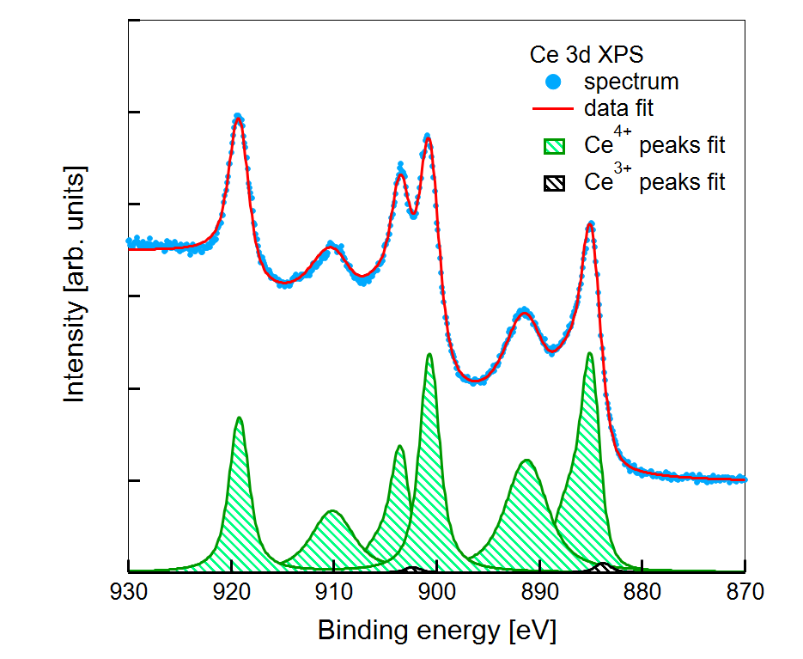
Figure S1: Ce 3d XPS spectrum of the cerium oxide film (blue dots) and fit (red line). The Ce⁴⁺-related (green) and Ce³⁺-related (black) fitting components are also shown.
X-ray photoelectron spectroscopy (XPS), using an Al K_{α} photon source and a hemispherical electron analyzer, provided information on the surface stoichiometry of the cerium oxide film. The Ce 3d spectrum, shown in Figure S1, shows a characteristic shape of Ce⁴⁺ ions.¹⁻² The fit was done following reference ¹, and the peaks used for the fitting are also shown in the figure. A Ce³⁺ concentration of 1 % was determined by the fit, a value comparable with the accuracy of the method.

UV-Vis spectrophotometry characterization
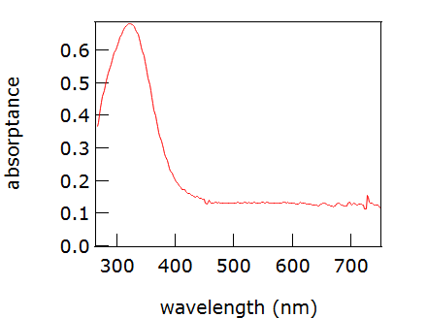
Figure S2: UV-Vis spectrum of the cerium oxide film.
UV-Vis spectrophotometry was carried out using a Xe lamp, a monochromator, a polarizer selecting s polarization, and a Si photodetector. The sample was measured at an incidence angle of 22˚ from surface normal. Figure S2 shows the absorptance (A=1-T-R), where T and R are the transmittance and the reflectance of the cerium oxide film. The shape of the spectrum is consistent with that observed for CeO₂ films.³⁻⁴
X-ray diffraction characterization
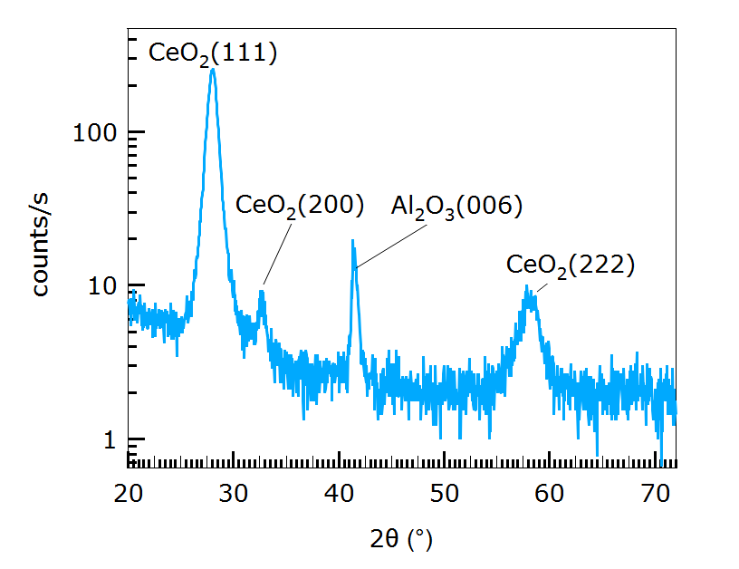
Figure S3: XRD profile of the cerium oxide film.

The X-ray diffraction (XRD) profile of the CeO₂ film shows a dominant peak at ∼ 28˚ related to (111) planes, a minor peak at ∼ 33˚ related to (200) planes and a peak at ∼ 58˚ related to (222) planes (POW COD open diffraction database, card 00-721-7887). The XRD suggests that the film is polycrystalline with a dominant (111) texture. The Scherrer coherence length estimated from the width of the (111) peak was 7.1 nm.⁵

XANES spectra of reference samples
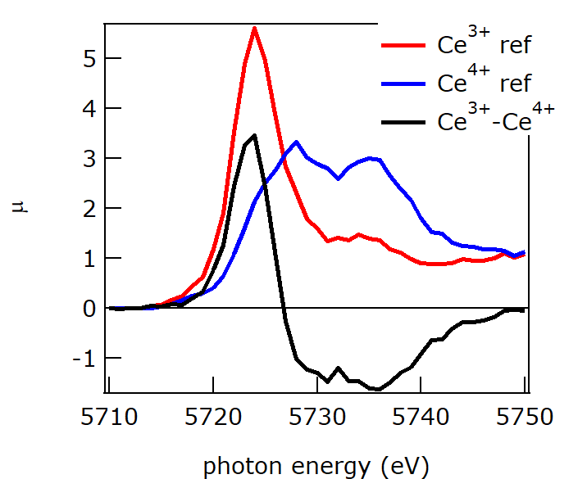
Figure S4: Ce L₃-edge XANES spectra of two reference samples for Ce⁴⁺ (CeO₂) and Ce³⁺ (Ce(NO₃)₃-6H₂O). The difference spectrum is also shown.

The Ce L₃-edge XANES spectra shown in Figure S4 were acquired on powders of CeO₂ and Ce(NO₃)₃-6H₂O, mixed with cellulose and pressed into pellets. The two compounds represent references for Ce⁴⁺ and Ce³⁺, respectively. The difference spectrum obtained by subtracting Ce³⁺ and Ce⁴⁺ reference spectra (black in Figure S4) was used for comparison with the pump-probe XANES difference spectra, as reported in the main text.

Fit of pump-probe XANES spectra
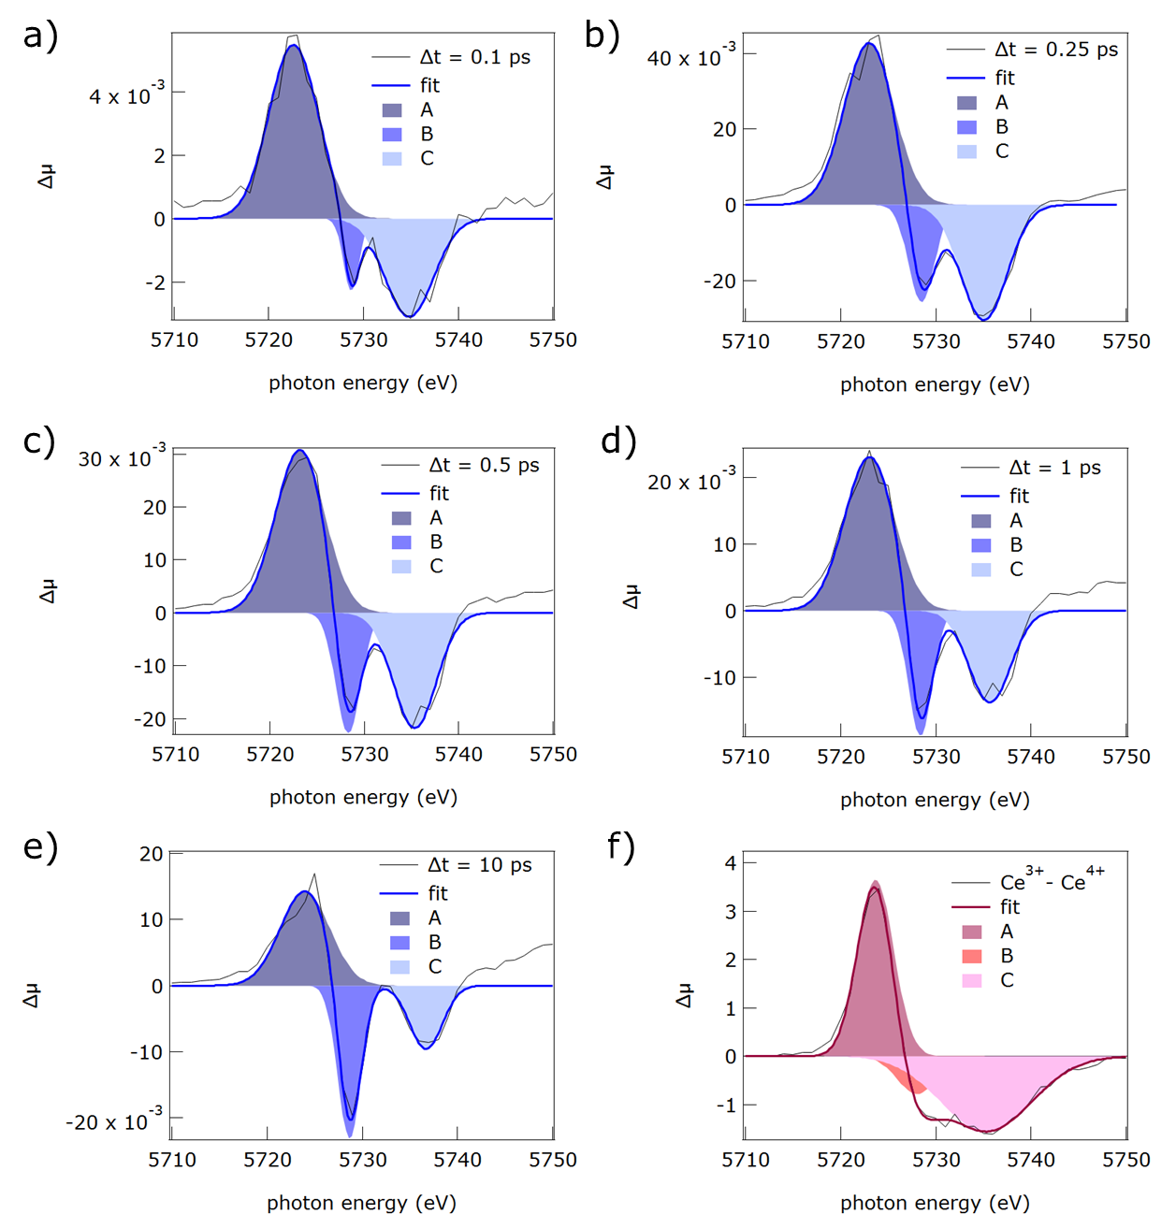
Figure S5: Pump-probe Ce L₃-edge XANES difference spectra at different delay times (a-e) and Ce³⁺-Ce⁴⁺ difference spectrum (f) and fit obtained using the sum of three peaks with gaussian shape. The A, B, and C gaussian components of the fit are also shown.

The pump-probe Ce L₃-edge difference spectra acquired on the CeO₂ film at different delay times were fit using the sum of three peaks with gaussian shape to identify the evolution of the position, intensity and width of the transient features A, B and C (Figure S5). Figure S6 summarizes the modifications of energy, width and intensity of the three features with delay time.

As shown in Figure S6, the energy of peak 1 shifts increases by 1 eV with increasing delay time, the energy of peak 2 stays constant, while the energy of peak 2 shows the most significant increase, by 2 eV. The energy position of the three peaks is close to the one in the Ce³⁺-Ce⁴⁺ difference spectrum at the shortest delay times. The width of peak 1 is almost constant and much higher than in the Ce³⁺-Ce⁴⁺ difference spectrum, while on the contrary, peak 2 and peak 3 are significantly narrower than in the Ce³⁺-Ce⁴⁺ difference spectrum. The relative intensities of the three peaks show values close to the Ce³⁺-Ce⁴⁺ difference spectrum at ultrashort delay times and they progressively deviate at increasing delay times.
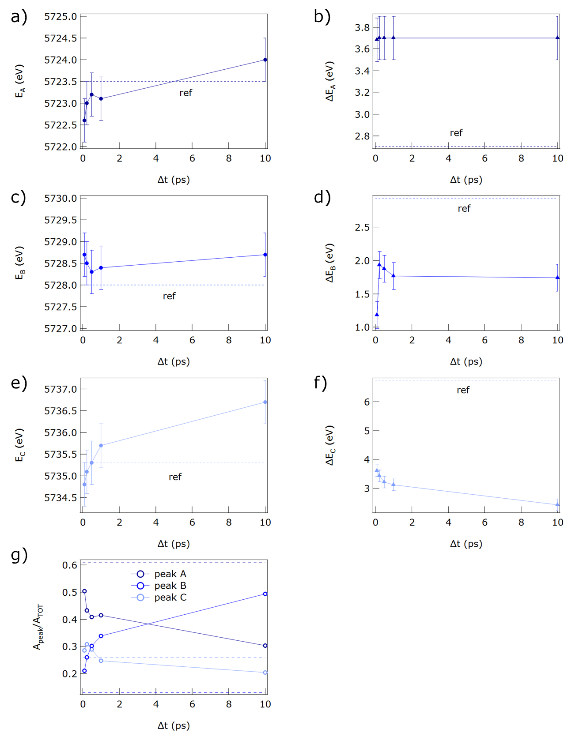
Figure S6: Evolution with delay time of the peak energy (a-c), of the width (d-f) and of the relative intensity (g) of the three components A, B and C used for the Gaussian fitting of pump-probe Ce L₃-edge XANES difference spectra reported in Figure S5. The parameters of the fit of Ce³⁺-Ce⁴⁺ difference spectrum measured on reference compounds, and shown in figure S5 f, are also reported as dashed lines.

Pump-probe EXAFS spectra
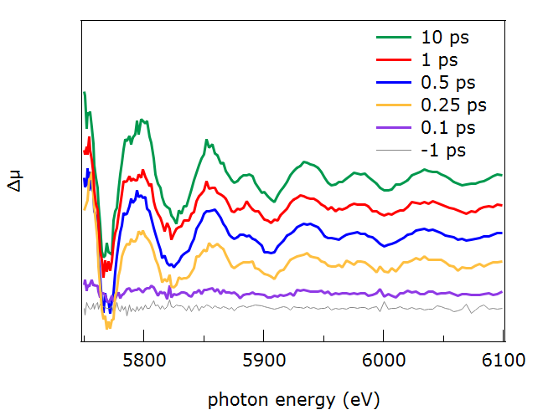
Figure S7: Δμ(E) pump-probe EXAFS spectra at different delay times.

Figure S7 shows the transient EXAFS spectra Δμ(E) spectra at different delay times. At negative delay times and at 0.1 ps delay the spectra appear flat. The transient signal sets in at 0.25 ps. The amplitude of the oscillations progressively incerases at increasing delay times.

Extraction of the first shell signal from pump-probe EXAFS spectra

To extract the first shell contribution to the experimental Δχ(k), we applied the Fourier transform to the experimental ∆χ(k) and back-transformed into k space only the first-shell contribution.
Figure S8 a-d show the Fourier transforms of Δχ(k) in R space and the window used for extracting the first shell contribution. Figure S8 e-h shows the Δχ(k) and the first-shell contribution obtained as the inverse-Fourier transform of the first shell of Δχ(R) shown in panels a-d. The first-shell contribution to Δχ(k) was used to extract information on the local atomic distortions, through the fitting procedure described in the main text.
Figure S8: a)-d) Magnitude of Fourier transform of k²χ(k) highlighting the first shell contribution and e)-h) Δχ(k) (red curve) and first-shell contribution to Δχ(k) (black line) – obtained as the inverse Fourier transform of the first-shell peak - at the different delay times.

Fit of the steady-state EXAFS signal
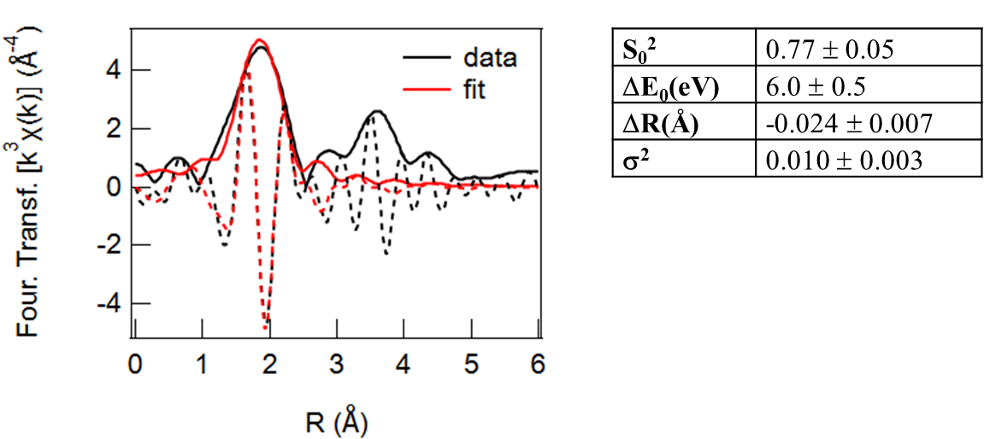
Figure S9: Left: Magnitude and imaginary part of the Fourier transform of the k³-weighted steady-state Ce L₃-edge χ(k) and first shell fit in the R=1-3 Å range. Right: fitting parameters: many-body amplitude reduction factor S₀², shift of the energy origin ΔE₀, modification of the interatomic Ce-O distance ΔR and Debye-Waller factor σ.
The first shell of the static EXFAS spectrum acquired without laser pumping was fit using feffit,⁶ leaving the many body amplitude reduction factor S₀², the energy origin E₀, the modification of the interatomic Ce-O distance dr and the Debye-Waller factor σ as free fitting parameters. The magnitude and imaginary part of the Fourier transform of the k³-weighted static χ(k), the first shell fit and the table with the coefficients that resulted from the fit are reported in Figure S9.

Schematic picture of photoinduced distortion

Figure S10: 2-D sketch of the distortion induced by photoexcitation. Ce ions are in grey and O atoms are in red.
Figure S10 shows a simplified 2-D sketch of the distortion induced by photoexcitation of the central Ce ion. The expansion of the distance between the central Ce ion and the O nearest neighbours leads also to a decrease of the distance between the corner O atoms and one of their O nearest neighbours.

Laser penetration depth and excited fraction

The laser penetration depth was used to estimate the thickness of the film to be investigated and in turn to evaluate the excited fraction. The penetration depth d is related to the absorption coefficient a by
$d=\frac{1}{a}$ (1)
where
$a=\frac{2}{}Im(n)$ (2)
For λ=267 nm (E=4.64 eV), Im(n)=0.75,⁷ we obtain a=0.017 nm⁻¹ and d=56 nm.
Considering that the laser is almost collinear with the X-ray beam with an incidence angle from sample normal θ_{in} (80˚ in our case), the effective film thickness excited within the laser penetration depth is D=d*cos(θ_{out}) where θ_{out} is the refraction angle of the photon beam.
Considering: $\frac{\sin{ϑ_{in}}}{\sin{ϑ_{out}}}=n$, where n is the refraction index of the material ($n_{CeO2}=$2.04 at 267 nm),⁷ we obtain:
$ϑ_{out}=\sin^{-1}\left(\frac{\sin{(80)}}{2.04}\right)=28.87˚$ and $d×cos(_{out})=49$ nm. The sample thickness was chosen to be 50 nm to optimize the excitation.

The excited fraction α can be written as: $=n_{ph}/n_{Ce}$, where $n_{ph}$ is the density of absorbed photons and $n_{Ce}$ is the density of Ce atoms. The density of absorbed photons can be written as:
$n_{ph}=\frac{A\left({}_{pump}\right)⋅F}{D⋅E_{pump}}$ , where $A\left({}_{pump}\right)$=0.35 is the sample absorptance at the pump wavelength, $F=$9.4 mJ/cm² is the laser fluence, $D$ is the sample thickness, $E_{pump}$ is the pump energy. By substituting the values we obtain $n_{ph}=$8.84 × 10²⁶ ph/m³.
Considering that the volume density of Ce atoms in CeO₂ is $n_{volCeO2}$=2.52 × 10²⁸ at/m³, we obtain $=n_{ph}/n_{Ce}$∼ 3.5 %, close to the value that was derived from the fit of the EXAFS spectra.

Fitting of XANES and EXAFS kinetic traces
The experimental data were fitted using a multi-exponential analytical function that combines different exponential decay/rise components convoluted with a Gaussian response function and an error function. This approach accounts for both the intrinsic dynamics of the system, represented by multiple characteristic time constants, and for the finite instrument response function (about 100 fs). This fitting strategy provides a flexible model, enabling the separation of distinct dynamical contributions.
Specifically, the kinetic traces in the XANES region (5723 eV) and in the EXAFS region (5825 eV) reported in Figure 4 were fit using the following functions:

XANES:
$A_{1}×\frac{\frac{τ_{1}}{τ_{2}-τ_{1}}}{2}×\left(e^{\left(\frac{\frac{{0.045}^{2}}{2}}{τ_{2} ^{2}}-\frac{c+x}{τ_{2}}\right)}×\left(1+erf\left(\frac{\frac{c+x}{\sqrt{2}}}{0.045}-\frac{\frac{0.045}{\sqrt{2}}}{τ_{2}}\right)\right)-e^{\left(\frac{\frac{{0.045}^{2}}{2}}{{τ_{1}}^{2}}-\frac{c+x}{τ_{1}}\right)}\right)×\left(1+erf\left(\frac{\frac{c+x}{\sqrt{2}}}{0.045}-\frac{\frac{0.045}{\sqrt{2}}}{τ_{1}}\right)\right)+A_{2}×e^{\left(\frac{-\left(c+x\right)}{τ_{3}}\right)}×e^{\left(\frac{\frac{{0.045}^{2}}{2}}{{τ_{3}}^{2}}\right)}×\left(1+erf\left(\frac{\frac{c+x}{\sqrt{2}}}{0.045}-\frac{\frac{0.045}{\sqrt{2}}}{τ_{3}}\right)\right)+A_{3}×\frac{\frac{τ_{4}}{τ_{2}-τ_{4}}}{2}×e^{\left(\frac{\frac{{0.045}^{2}}{2}}{τ_{2} ^{2}}-\frac{c+x}{τ_{2}}\right)}×\left(1+erf\left(\frac{\frac{c+x}{\sqrt{2}}}{0.045}-\frac{\frac{0.045}{\sqrt{2}}}{τ_{2}}\right)\right)-e^{\left(\frac{\frac{{0.045}^{2}}{2}}{{τ_{4}}^{2}}-\frac{c+x}{τ_{4}}\right)}×\left(1+erf\left(\frac{\frac{c+x}{\sqrt{2}}}{0.045}-\frac{\frac{0.045}{\sqrt{2}}}{τ_{4}}\right)\right)+offset;$ (3)

The times obtained by the fitting are reported in the table below.

XANES | τ (ps)
τ₁ | IRF
τ₂ | 0.46 ± 0.04
τ₃ | 8.6 ± 1.9
τ₄ | 600 ± 200

EXAFS:
$A_{1}×\left(1+erf\left(\frac{c+x}{\frac{\sqrt{2}}{0.045} }\right) \right)-\left(A_{1}×e^{-\frac{\left(c+x\right)}{τ_{1}}}×e^{\frac{{0.045}^{2}}{\frac{2}{τ_{1}^{2}}}}×\left(1+erf\left(\frac{c+x}{\frac{\sqrt{2}}{0.045}}-\frac{0.045}{\frac{\sqrt{2}}{τ_{1}}}\right)\right)\right)+A_{2}×\left(1+erf\left(\frac{c+x}{\frac{\sqrt{2}}{0.045}}\right)\right)-\left(A_{2}×e^{-\frac{\left(c+x\right)}{τ_{2}}}×e^{\frac{{0.045}^{2}}{\frac{2}{τ_{2}^{2}}}}×\left(1+erf\left(\frac{c+x}{\frac{\sqrt{2}}{0.045}}-\frac{0.045}{\frac{\sqrt{2}}{τ_{2}}}\right)\right)\right)+0.0002$ (4)

The times obtained by the fitting are reported in the table below.
EXAFS | τ (ps)
τ₁ | 0.3 ± 0.15
τ₂ | 2.0 ± 1.0
τ₃ | 1000 ± 400

Electronic structure and orbital character of the pristine system
Figure S11 shows the electronic structure of the pristine system including orbital composition. The valence band is primarily composed of oxygen 2p states (blue), with a small mixing of cerium 4f and 5d states. This band is separated from the Ce-4f unoccupied band by a 2.37 eV gap. In turn, the latter is separated from the Ce-5d manifold by another 5.27 eV gap. The unoccupied bands all present O-2p orbital mixing. In both occupied and unoccupied bands, the Ce/O orbital hybridization is stronger close to the W special point in the Brillouin zone (fcc structure).
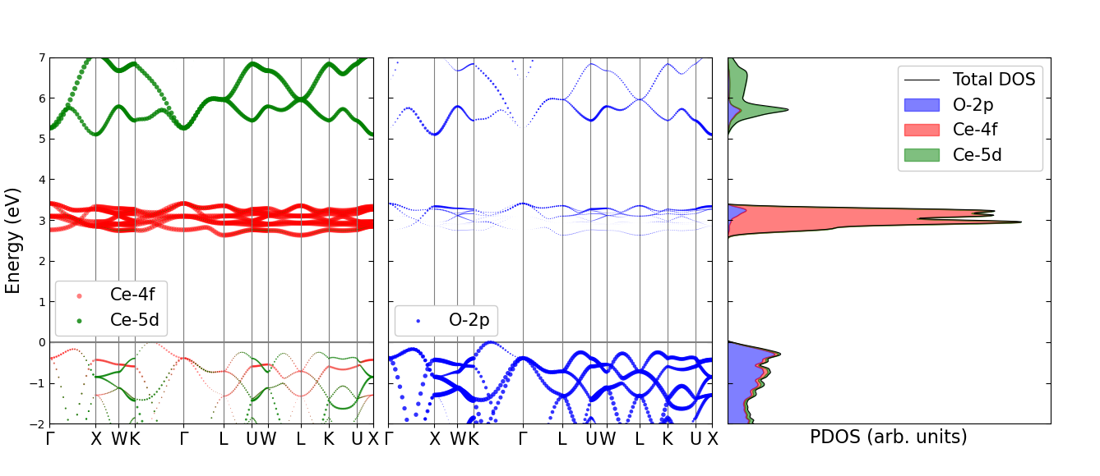
Figure S11: Band structure and DOS of undistorted CeO₂ structure, weighted with atomic orbital projections. Left: projection of electronic wave functions onto Ce-4f (red) and Ce-5d (green) atomic orbitals. The dot size indicates the relative weight per state, per momentum. Center: projections onto the O-2p atomic orbitals (blue). Right: partial DOS plot.

Analysis of polaronic distortion
Figure S12 shows the lattice distortion effects due to the presence of excess charges. On the left side, the case with an excess electron-hole pair is presented. The electron localizes on a Ce atom, pushing away the neighboring oxygens. We find that the average bond elongation of the first oxygen shell is 3.45% (corresponding to 0.08 Å). This elongation presents an anisotropy of 0.2%: however, as we argue below, the oxygen expansion is to be considered isotropic within the numerical accuracy of the simulation. The supercell is displaced in the same way if only the excess electron (and no hole) is added, as shown in the top right plot (this can be compared with the benchmarking done with VASP in Ref.⁸). Indeed, the excess hole has a negligible effect and remains delocalized over all oxygen atoms (instead of possibly forming a hole polaron like in anatase TiO₂⁹), with no lattice distortion being induced. This is shown in the bottom right plot (red data points) where only the excess hole was added. There is still a residual displacement (0.4% max) with respect to equilibrium positions: to provide a measure of the accuracy of our results, we repeated our calculation with the excess hole, this time without explicitly breaking the symmetry around one oxygen atom at the start of the relaxation process (blue data points), which significantly reduced the final residual displacements. Therefore, we take 0.4% as the numerical accuracy of our results for relative bond length distortions.
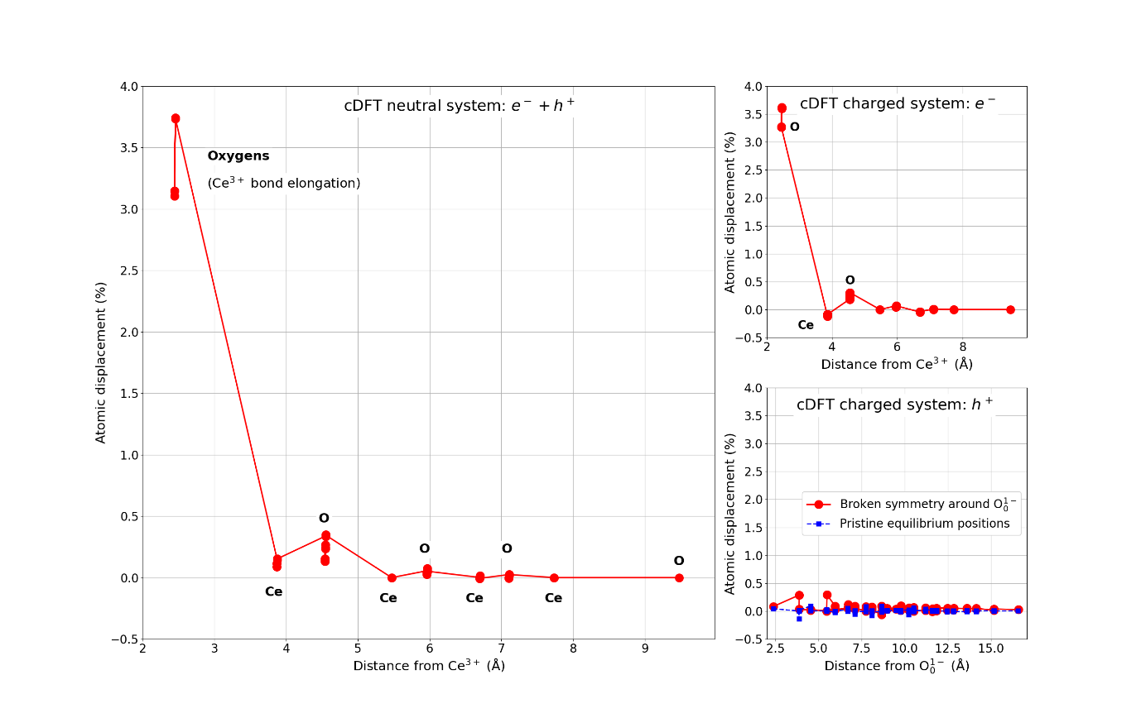
Figure S12: Changes in distance (%) from the polaron site of neighboring atomic shells with respect to pristine equilibrium positions. Left: distortion due to excess electron-hole pair. Top right: only excess electron. Bottom right: only excess hole (blue: local symmetry breaking not applied at start of atomic relaxation).

Analysis of Ce⁴⁺ and Ce³⁺ bands in the distorted structure
Figure S13 shows the band structure of the distorted supercell when an excess electron-hole pair is present. In panels (a) and (b), the wave function projections onto 4f+5d atomic orbitals for both Ce⁴⁺ and Ce³⁺ atoms, and for both spin up and down, are presented. The unoccupied bands due to Ce⁴⁺-5d remain essentially spin-degenerate (blue and teal colors) and the Ce⁴⁺ states are the only ones to mix with the O-2p-dominated valence band. In panels (c) and (d), only the 4f states are singled out for both Ce³⁺ and Ce⁴⁺ sites. It is clear that Ce³⁺ levels (orange and magenta) behave similarly to those of an isolated atom. The occupied Ce³⁺ spin-up “ground state” is the polaron level, while the unoccupied, spin-polarized Ce³⁺ levels accumulate at high energy within the Ce⁴⁺ 5d bands. It is worth noting that the energy of these additional Ce³⁺ levels is extremely sensitive not only to the chosen Hubbard-U value (larger values push them upwards), but also to the accuracy threshold of the self-consistent calculation.
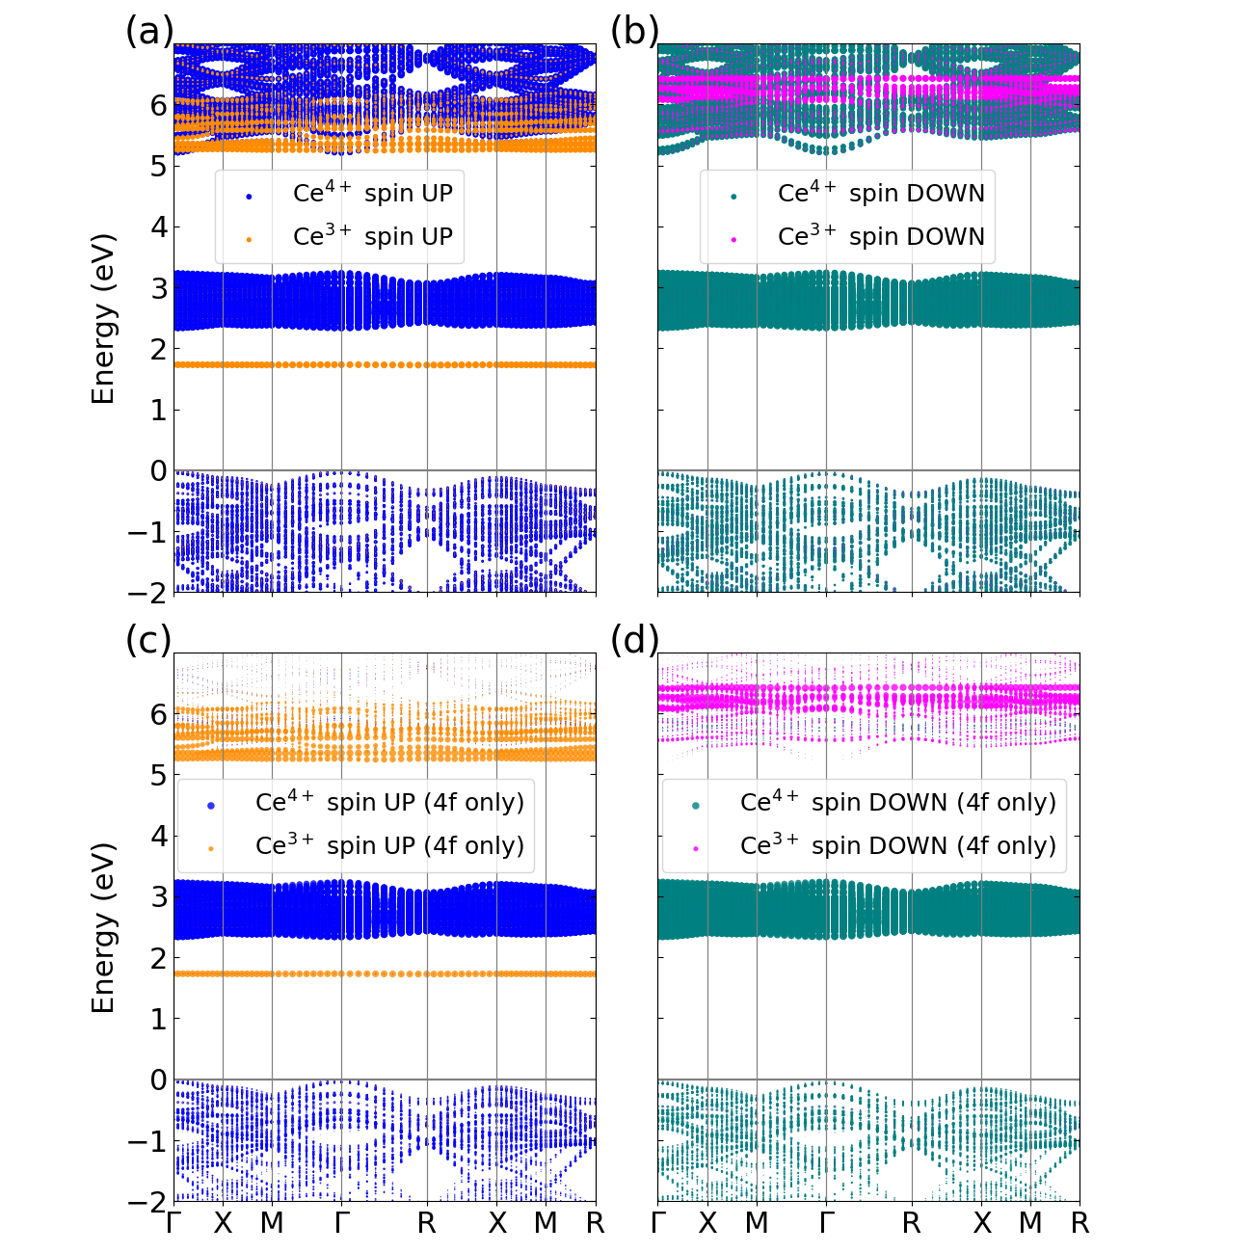
Figure S13: CeO₂ spin-polarized band structure in the presence of an excess electron-hole pair and polaronic distortion. (a) Projection of electronic wave functions corresponding to spin up 4f and 5d atomic orbitals on top of Ce⁴⁺ (blue), and on top of Ce³⁺ (orange). (b) Same as (a) for spin down states, with Ce⁴⁺ in teal and Ce³⁺ in magenta. (c-d) Same as (a-b), respectively, but this time omitting the contribution of 5d states and visualizing only 4f states.

References
1. Skála, T.; Šutara, F.; Škoda, M.; Prince, K. C.; Matolín, V., Palladium interaction with CeO 2 , Sn–Ce–O and Ga–Ce–O layers. Journal of Physics: Condensed Matter 2009, 21 (5), 055005.
2. Luches, P.; Pagliuca, F.; Valeri, S., Morphology, Stoichiometry, and Interface Structure of CeO₂ Ultrathin Films on Pt(111). J Phys Chem C 2011, 115 (21), 10718-10726.
3. Spurio, E.; Pelli Cresi, J. S.; Ammirati, G.; Pelatti, S.; Paladini, A.; D’Addato, S.; Turchini, S.; O’Keeffe, P.; Catone, D.; Luches, P., Injecting Electrons into CeO2 via Photoexcitation of Embedded Au Nanoparticles. ACS Photonics 2023, 10 (5), 1566-1574.
4. Pelli Cresi, J. S.; Di Mario, L.; Catone, D.; Martelli, F.; Paladini, A.; Turchini, S.; D’Addato, S.; Luches, P.; O’Keeffe, P., Ultrafast Formation of Small Polarons and the Optical Gap in CeO2. The Journal of Physical Chemistry Letters 2020, 11 (14), 5686-5691.
5. Patterson, A. L., The Scherrer Formula for X-Ray Particle Size Determination. Physical Review 1939, 56 (10), 978-982.
6. Newville, M., IFEFFIT : interactive XAFS analysis and FEFF fitting. Journal of Synchrotron Radiation 2001, 8 (2), 322-324.
7. Vangelista, S.; Piagge, R.; Ek, S.; Sarnet, T.; Ghidini, G.; Martella, C.; Lamperti, A., Structural, chemical and optical properties of cerium dioxide film prepared by atomic layer deposition on TiN and Si substrates. Thin Solid Films 2017, 636, 78-84.
8. Castleton, C. W. M.; Lee, A.; Kullgren, J., Benchmarking Density Functional Theory Functionals for Polarons in Oxides: Properties of CeO2. The Journal of Physical Chemistry C 2019, 123 (9), 5164-5175.
9. Di Valentin, C.; Selloni, A., Bulk and Surface Polarons in Photoexcited Anatase TiO2. The Journal of Physical Chemistry Letters 2011, 2 (17), 2223-2228.

