Supplementary Information to

A long-term ecological research data set from the genetic monitoring program ARMS- MBON 2020-2021

Corresponding author: Justine Pagnier, Department of Marine Sciences, University of Gothenburg, justine.pagnier@.gu.se

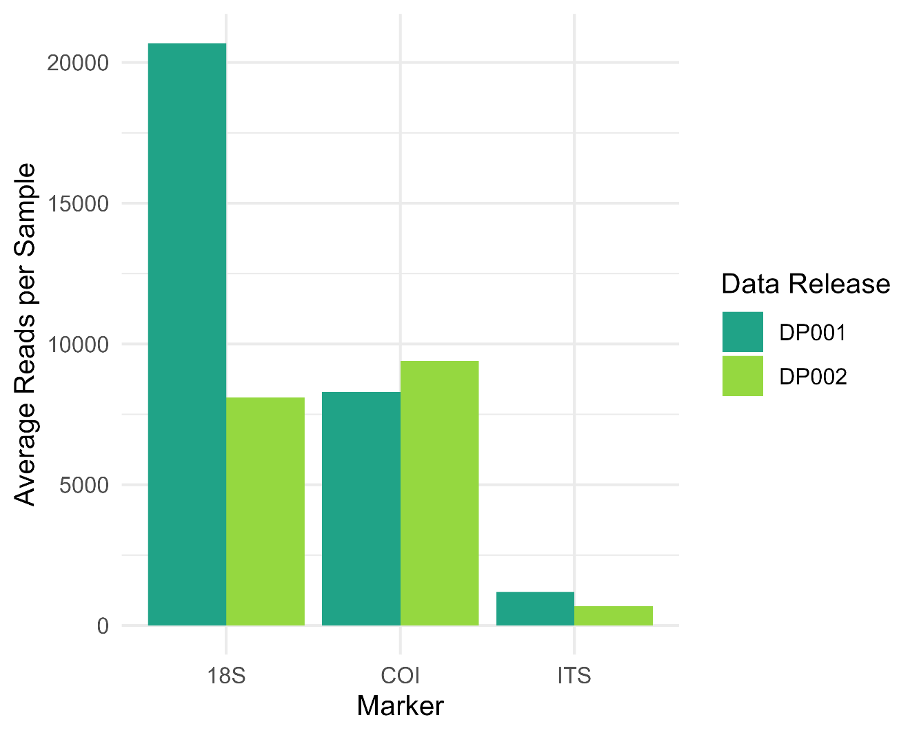
Supplementary Figure S2. Bar plot showing the mean number of reads per sample for each marker in both Data Paper 1 (dark green, Daraghmeh et al., 2024) and Data Paper 2 (light green, this present data release).

