Geophysical Research Letters
Supporting Information for
Underground Gas Storage as benchmark for seismic attenuation tomography in a tectonically complex region (north-eastern Italy)
D. Talone^{1,2}, M. A. Romano³, L. De Siena^{4,2}, M. Guidarelli³, M. Santulin³, L. Peruzza³, G. Lavecchia^{1,2}, and R. de Nardis^{1,2}
¹University of Chieti-Pescara "G. d'Annunzio", Chieti, Italy, Department of Sciences.
²CRUST-Interuniversity Center for 3D Seismotectonics with Territorial Applications, Chieti, Italy.
³National Institute of Oceanography and Applied Geophysics - OGS, Trieste, Italy.
⁴Dipartimento di Fisica e Astronomia (DIFA), Alma Mater Studiorum-Università di Bologna, Bologna, Italy.

Contents of this file
- Introduction to the supplementary material
- Figures S1 to S14

Introduction
This supplementary material provides additional information for the paper, particularly focusing on pre- and post-tomography analysis and tests. Figure S1 illustrates the extensive exploration conducted over the years in the Montello-Collalto area. Figures S2 and S3 focus on the main characteristics of the used seismic catalog and show examples of the records. The subsequent figures detail the preliminary analysis of the waveforms (S4 to S6), the testing procedure aimed at assessing the applicability of the methods at 12 Hz (S7 to S9), the results of the tomography represented as maps and sections (S10 to S12), and the spike tests useful for verifying the reliability of the anomalies (S13). The last figure details methodological approach to the diffusivity estimation (S14). For further information about the waveforms’ analysis procedure, refer to the Talone et al. (2023) supplementary material.
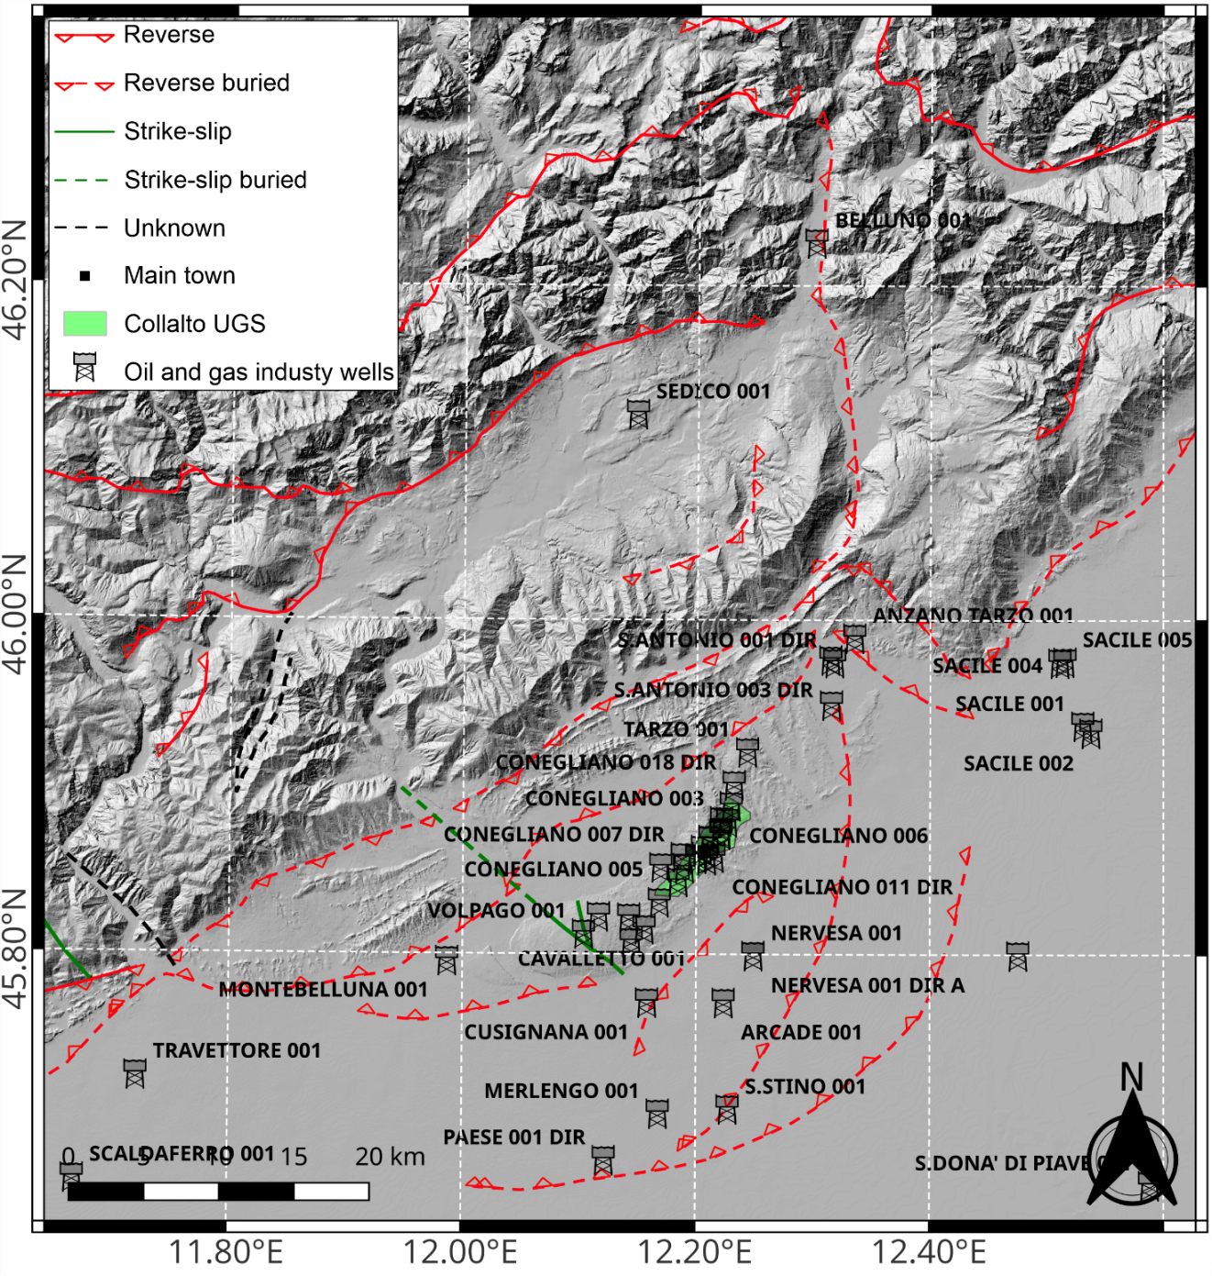Figure S1. Collalto UGS (green polygon). Wells drilled for oil and gas exploration that belong to closed permissions (SGI and UNMIG, 2010). Main tectonic structures from Picotti et al. (2022), extended outside the work’s area with Bigi et al. (1990), ITHACA Working Group (2019), and SGI and UNMIG (2010).

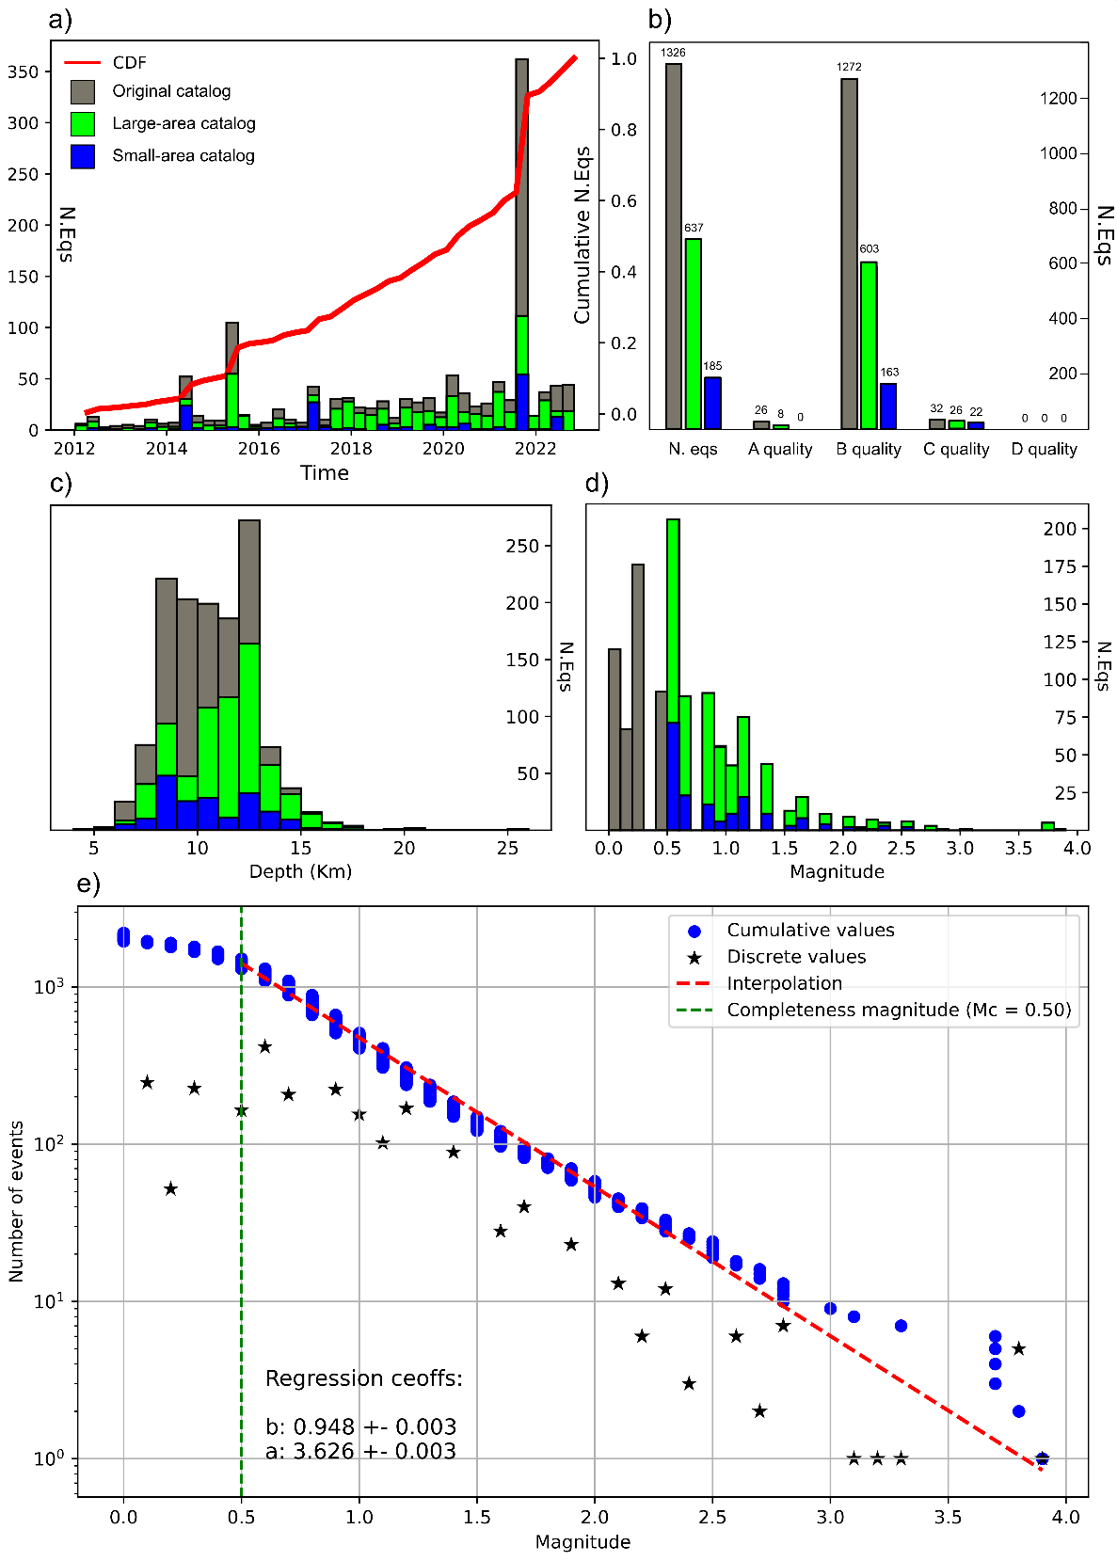

Figure S2. Main characteristic of the dataset used for the tomographic inversion. The entire seismic catalog is represented in gray, the earthquakes used in the large area are in green, and the data for the small area are in blue. a) the distribution over time of seismicity; b) the quality of the location calculated according to the method of Michele et al. (2019); c) number of earthquakes vs depth (1 km-bin); d) number of earthquakes vs magnitude (01-bin); e) Gutenberg-Richter distribution of the entire catalog.
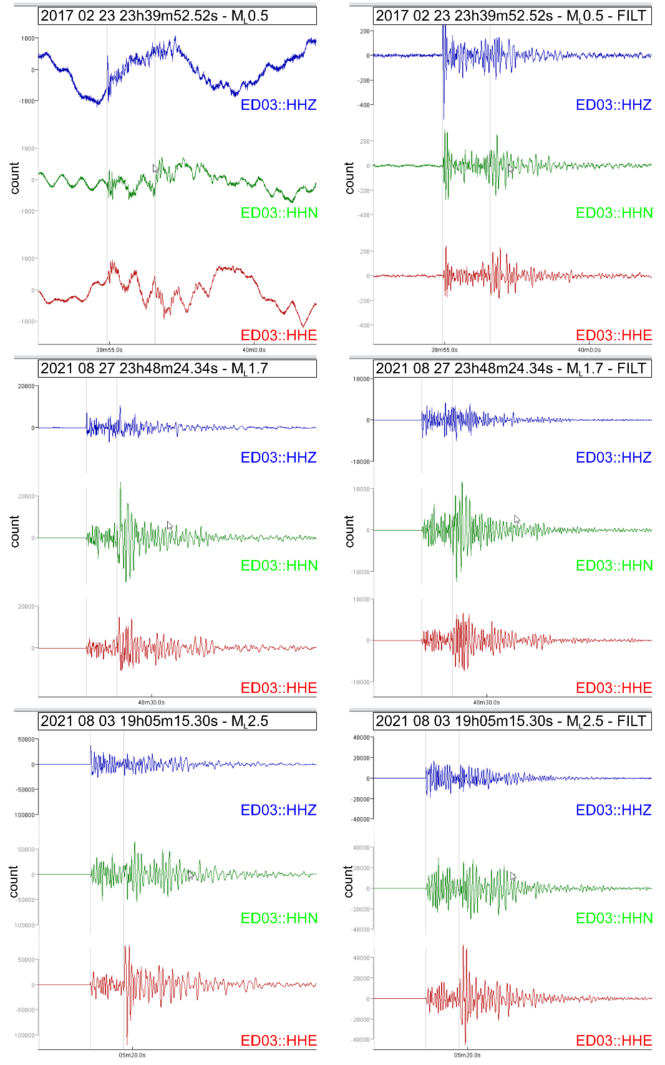
Figure S3. Continue…
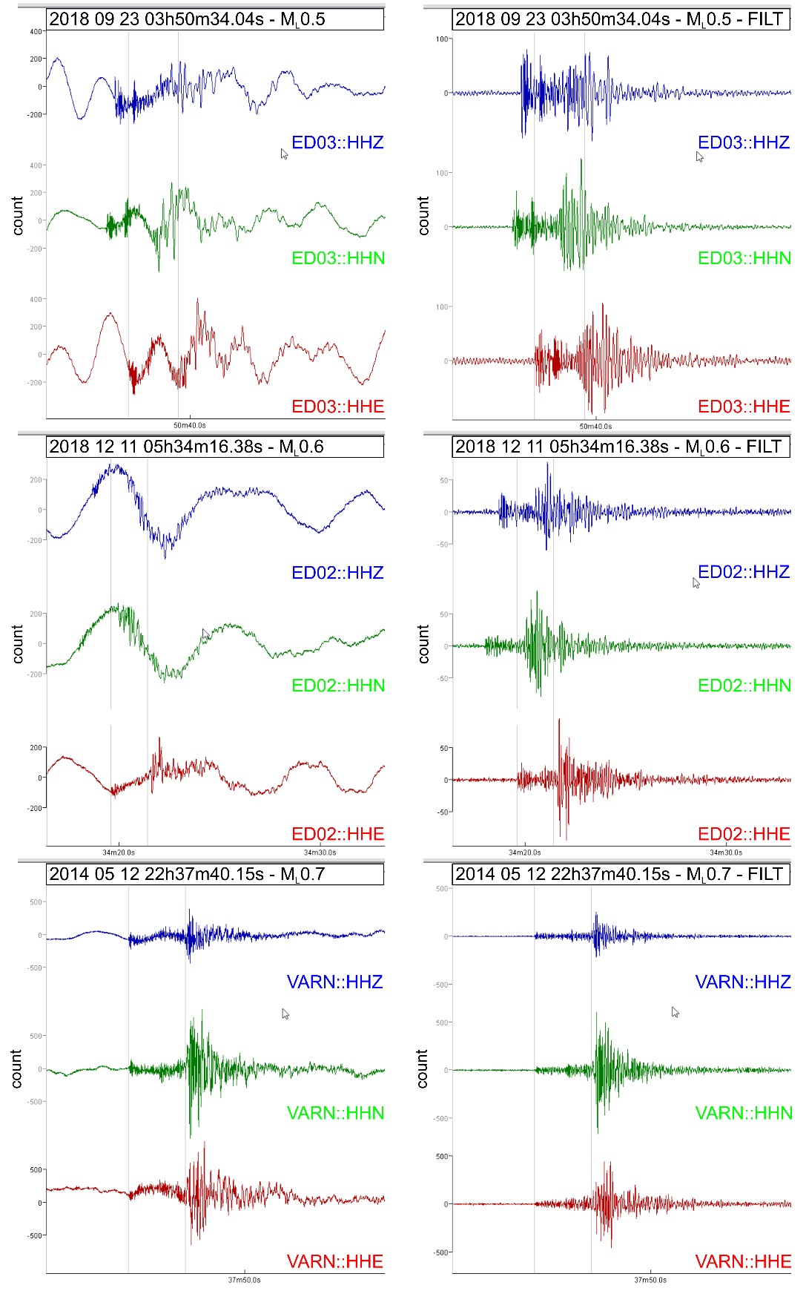
Figure S3. Waveform examples of earthquakes with different magnitudes used in the attenuation tomography. The first column shows the unfiltered components, while the last column displays the waveforms filtered between 8 and 16 Hz. Each row corresponds to one earthquake. Information about the earthquake and the stations is reported on each image.

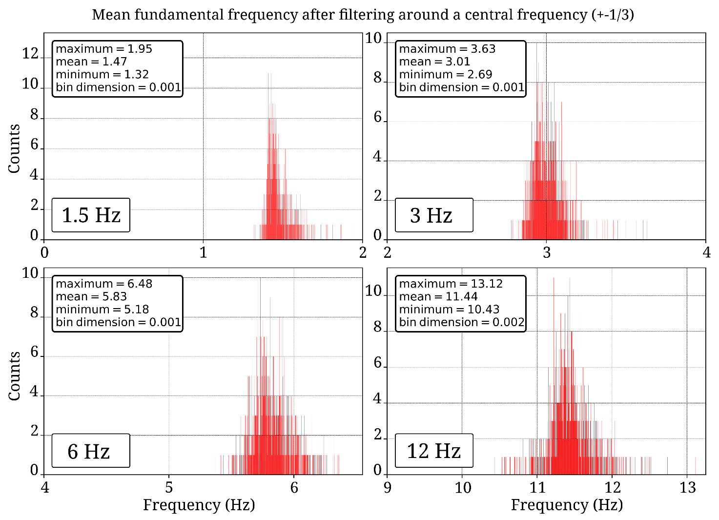
Figure S4. Waveforms’ fundamental frequencies. Histograms from the preliminary analysis showing the distribution of central frequencies after band-pass filtering the waveforms within ±1/3 of the central frequency (at 1.5 Hz, 3 Hz, 6 Hz, and 12 Hz, respectively).

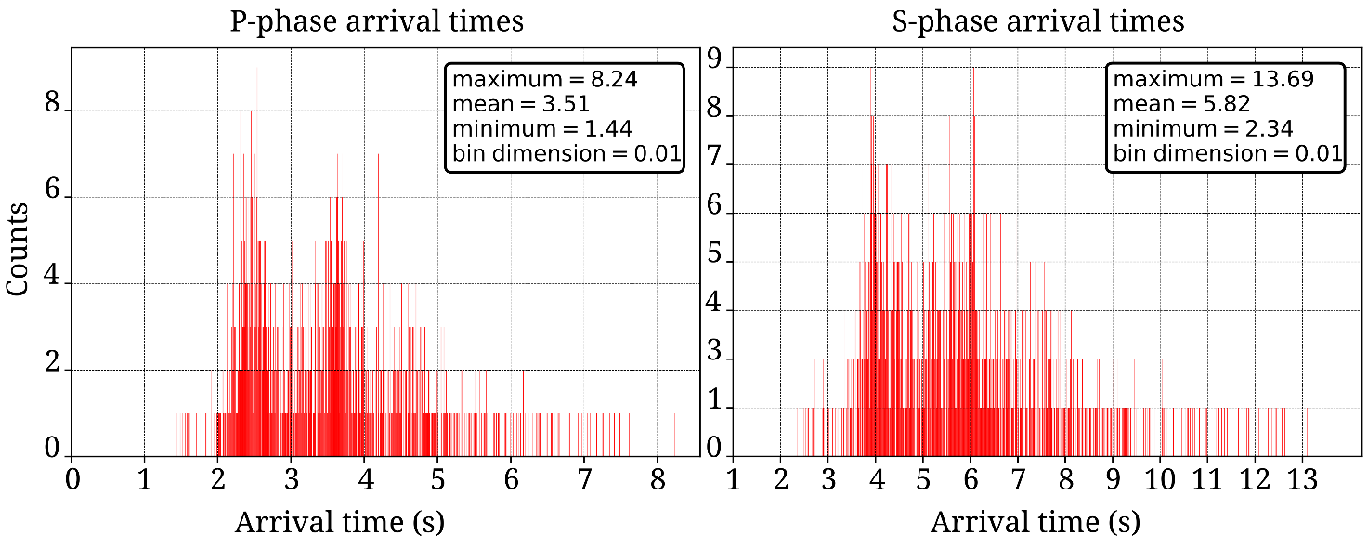
Figure S5. Body waves arrival times. Histograms of preliminary analysis showing the P-phase and the S-phase arrival times.

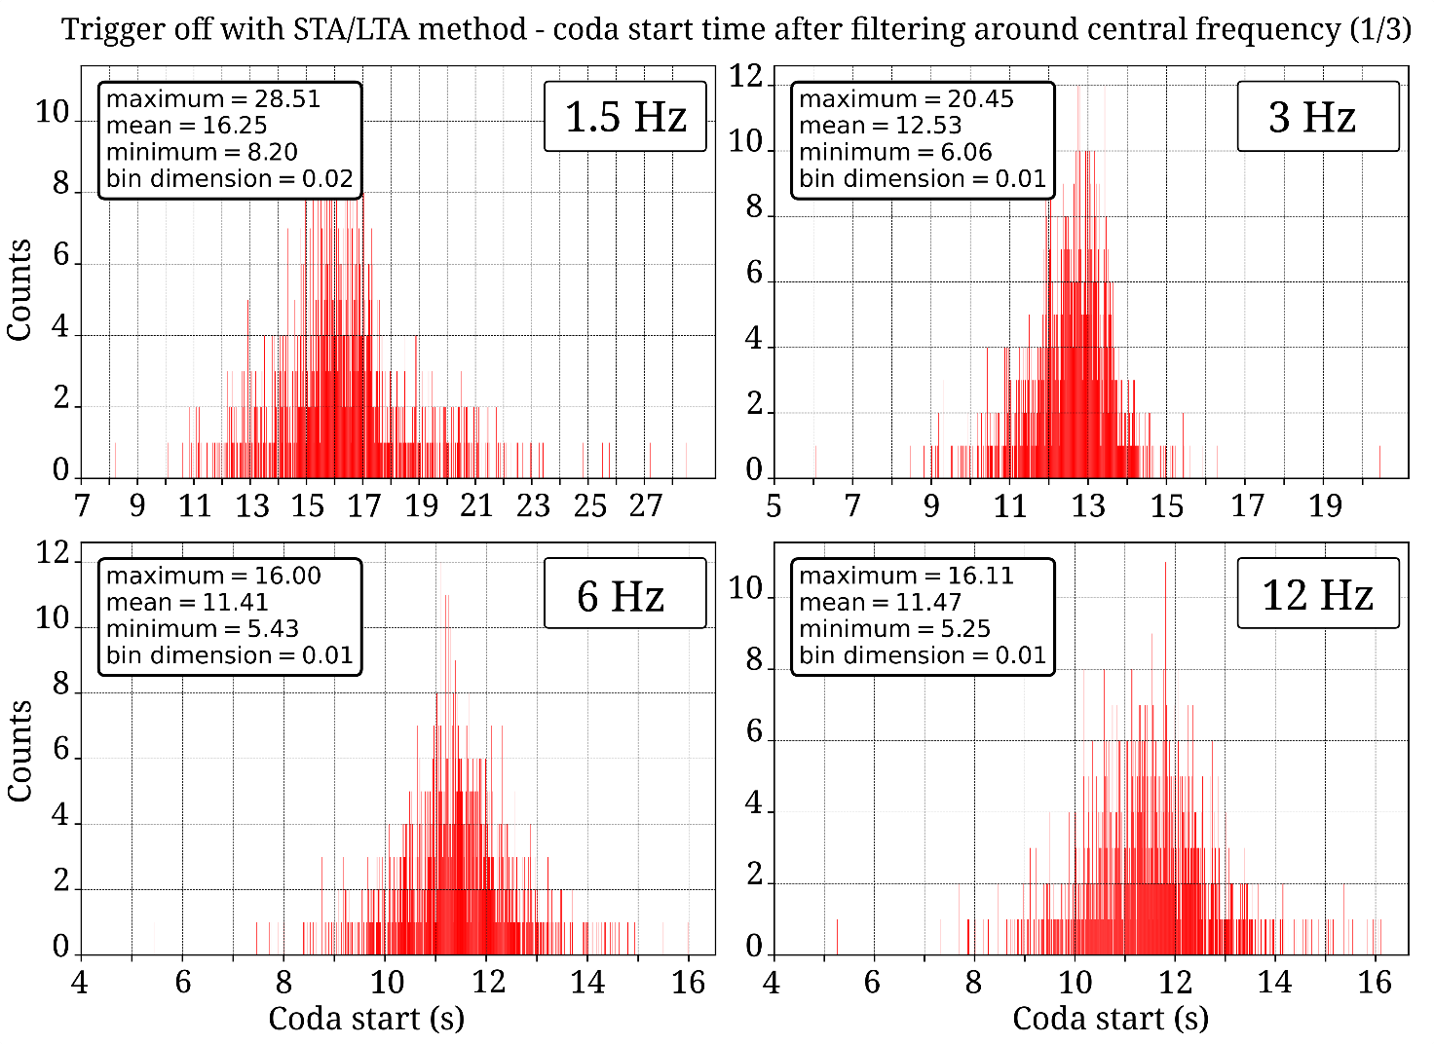
Figure S6. Coda starts time. Histograms of preliminary analysis showing the distribution of coda start time calculated as trigger off time using the STA/LTA method for waveforms filtered around 1.5 Hz, 3 Hz, 6 Hz, and 12 Hz, respectively.
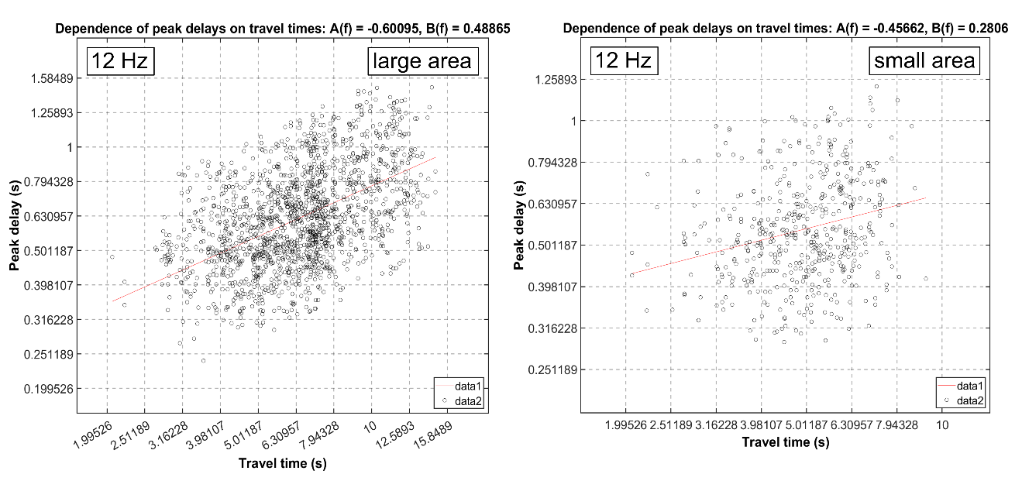
Figure S7. MuRAT test for waveforms filtered around 12 Hz in both tomographic inversions. The graphs show the increase in peak delays with the travel time. The images refer to the tomography performed at the large area (left) and the small area (right), respectively.
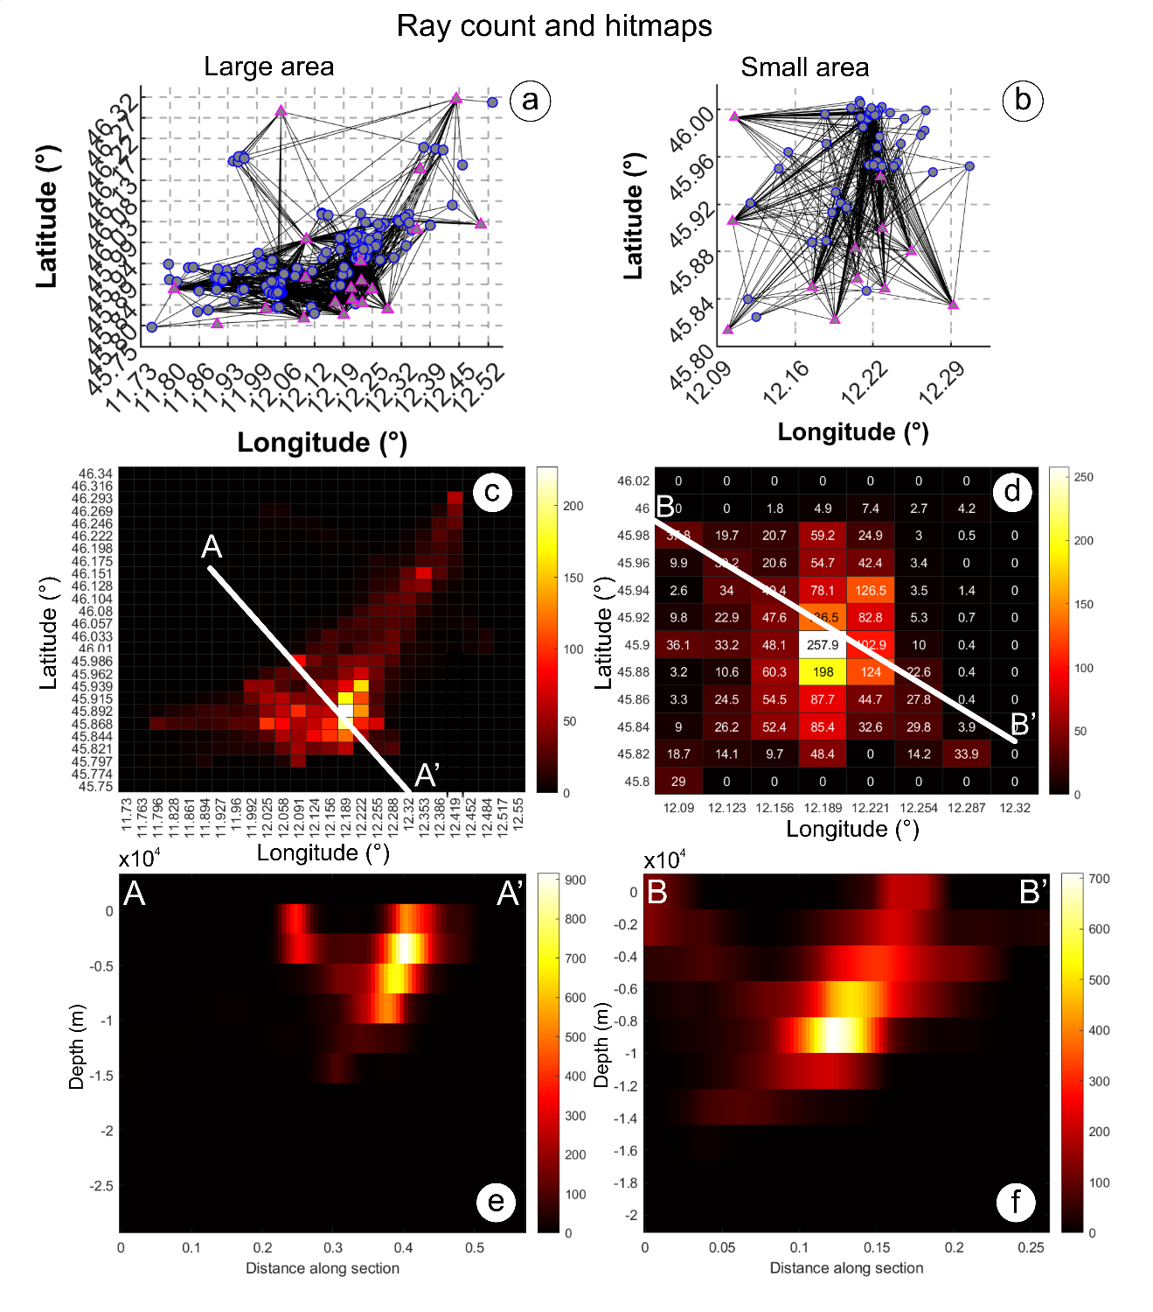
Figure S8. Coverage of the seismic rays connecting earthquakes to stations. On the left, the results are relative to the large area; on the right, the images refer to the small area. a-b) The ray coverage is represented as seismic rays. The circles represent earthquakes, and the triangles are seismic stations. c-d) Visual representation (hitmap) of the number of seismic rays passing through each cell. The colors are as in the legend. The white lines represent the trace of the cross-section in Fig. S8 e-f. e-f) hitmaps for vertical cross section.

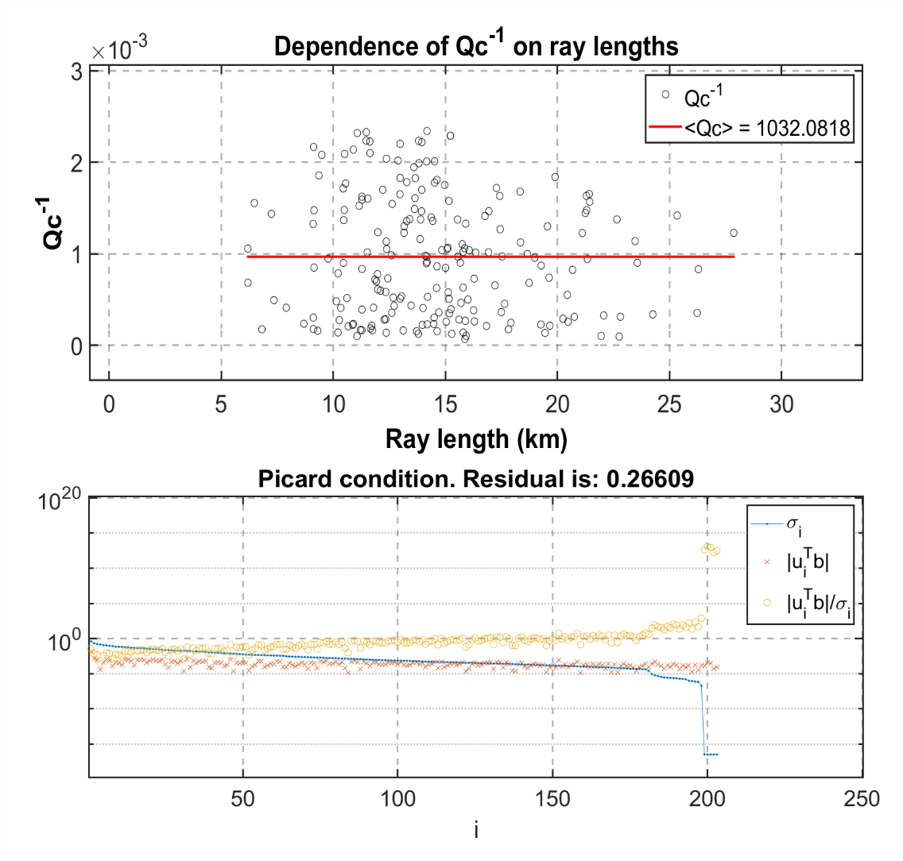
Figure S9. MuRAT test for waveforms filtered around 12 Hz. The images refer to the absorption tomography performed in the small area. The dependence of Qc⁻¹ on ray lengths and the Picard condition is tested (see MuRAT manual and Aster et al. (2005) for further details).
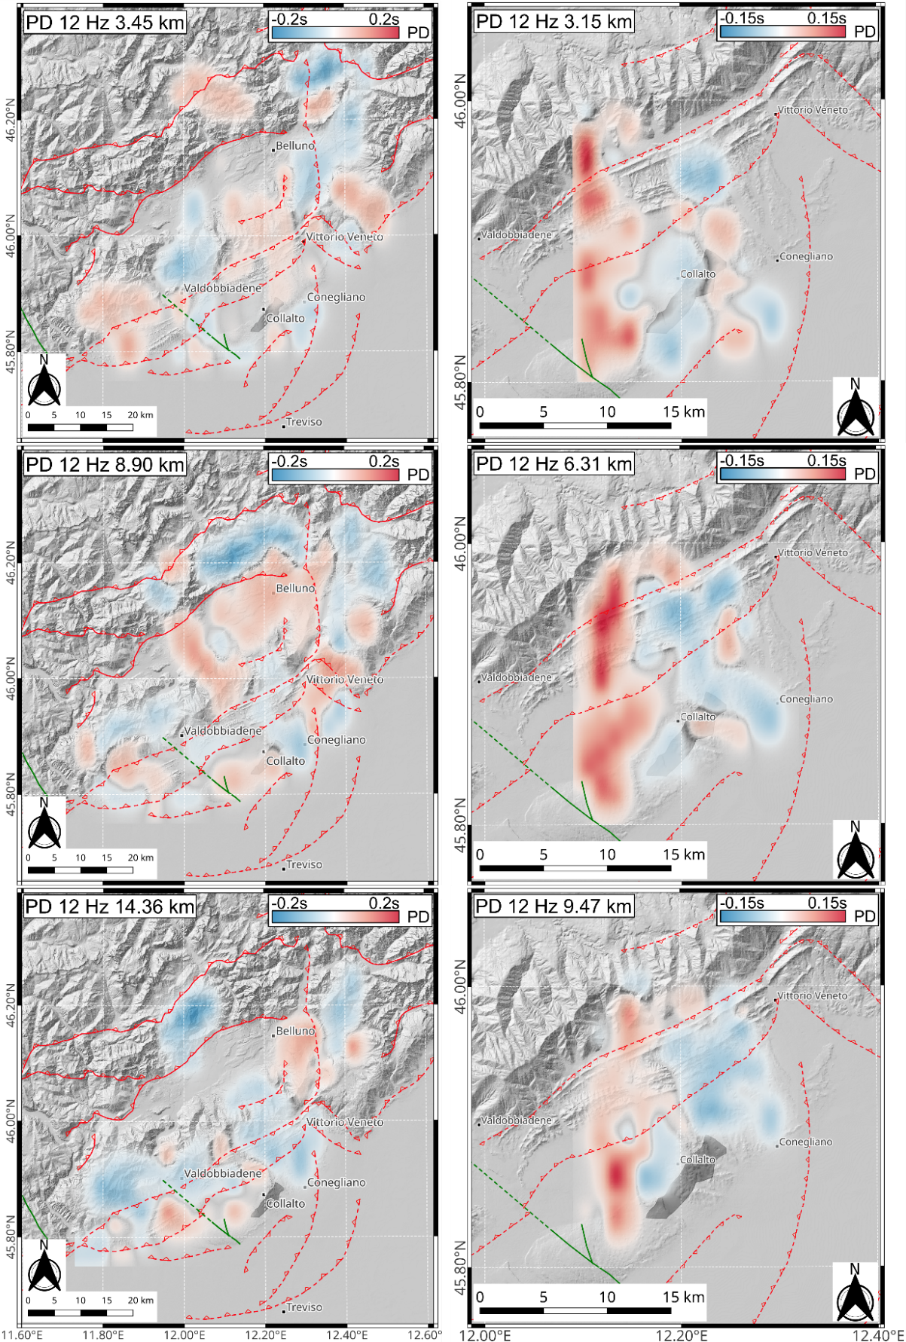
Figure S10. Peak delay slices at different depths for the central frequency of 12 Hz. On the left, the large-scale model; on the right, the small-scale model. Both tectonic structures and the location of the Collalto UGS are represented.

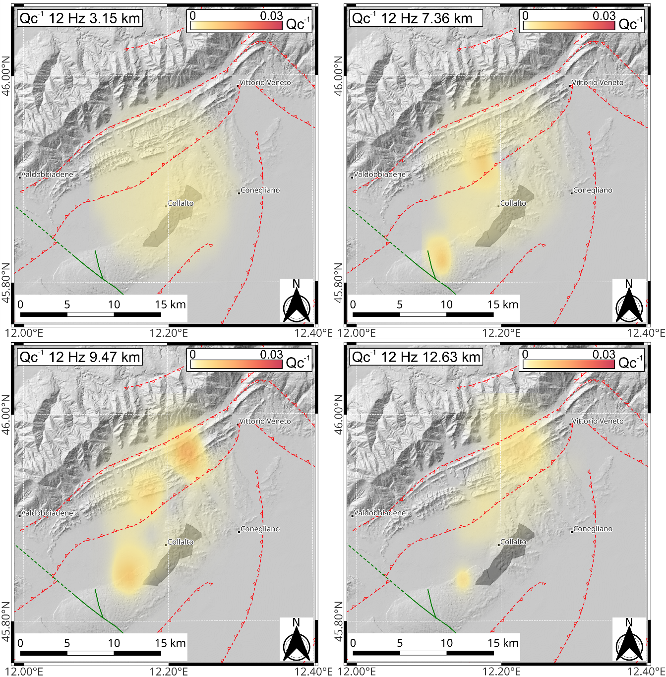
Figure S11. Absorption slices at different depths for the central frequency of 12 Hz. Both tectonic structures and the location of the Collalto UGS are represented.
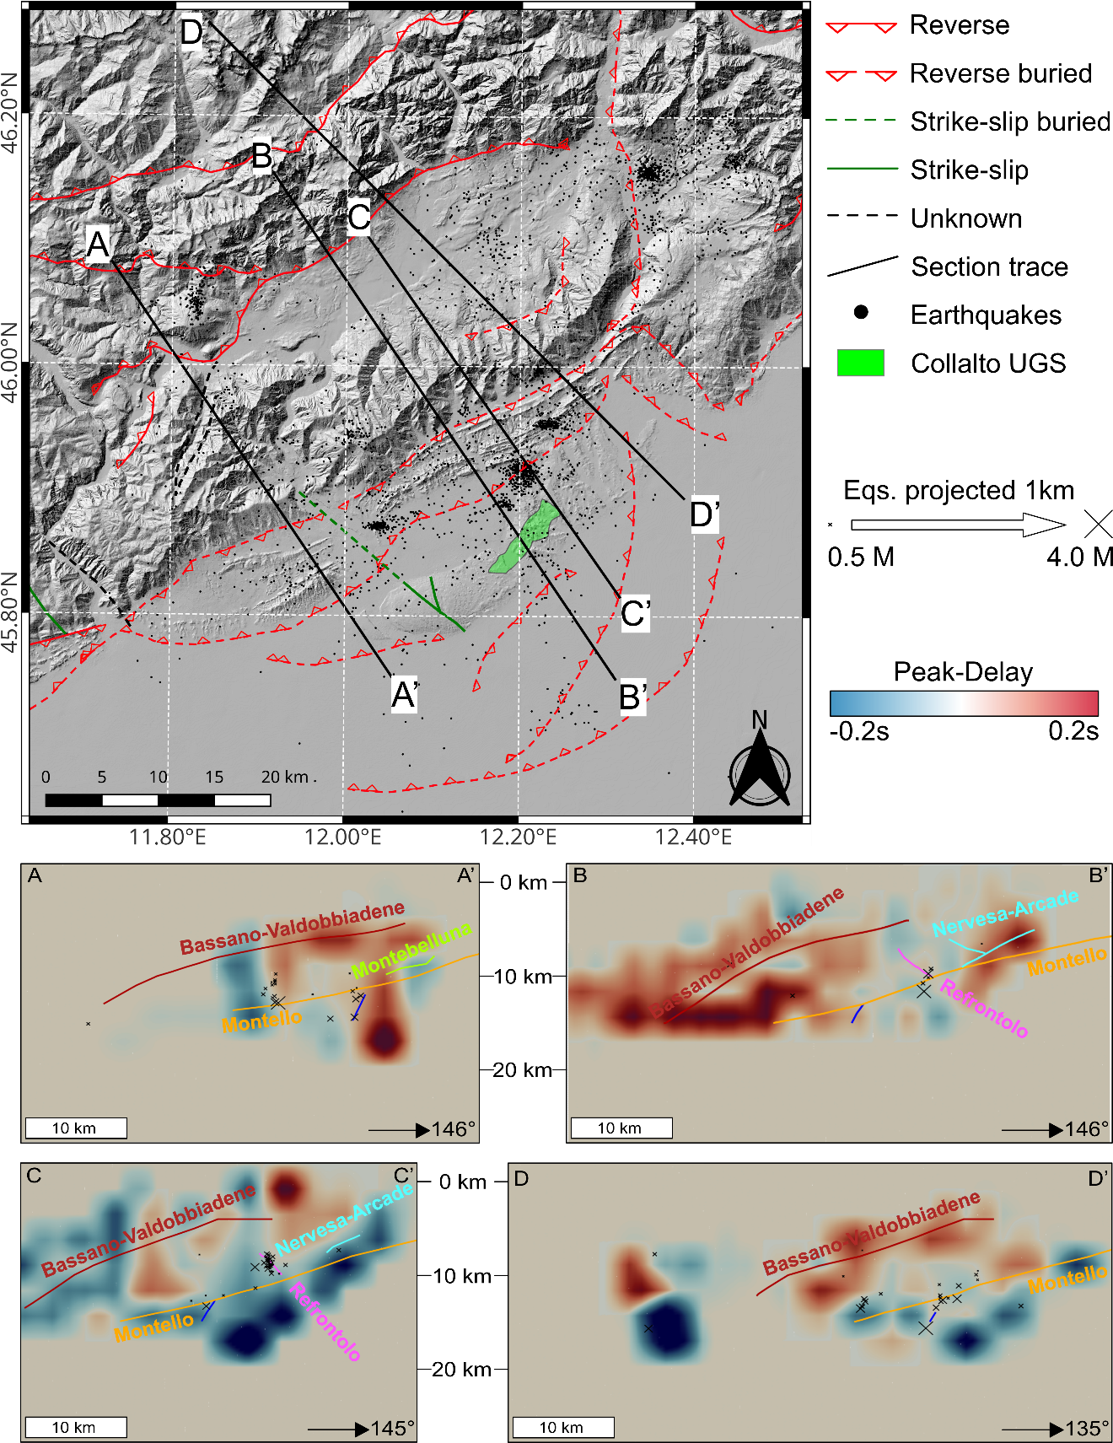
Figure S12. Attenuation sections at large scale. The four sections across the study area represent the peak delay (scattering) model. In the sections are overimpressed the intersections with the 3D reconstructed faults and the seismicity (selected for tomography). The latter is projected with a semi-width of 1 km (black crosses scaled according to magnitude). The section traces are from Picotti et al. (2022) (AA’, BB’), Galadini et al. (2005) (CC’), and Anselmi et al., (2011) (DD’).
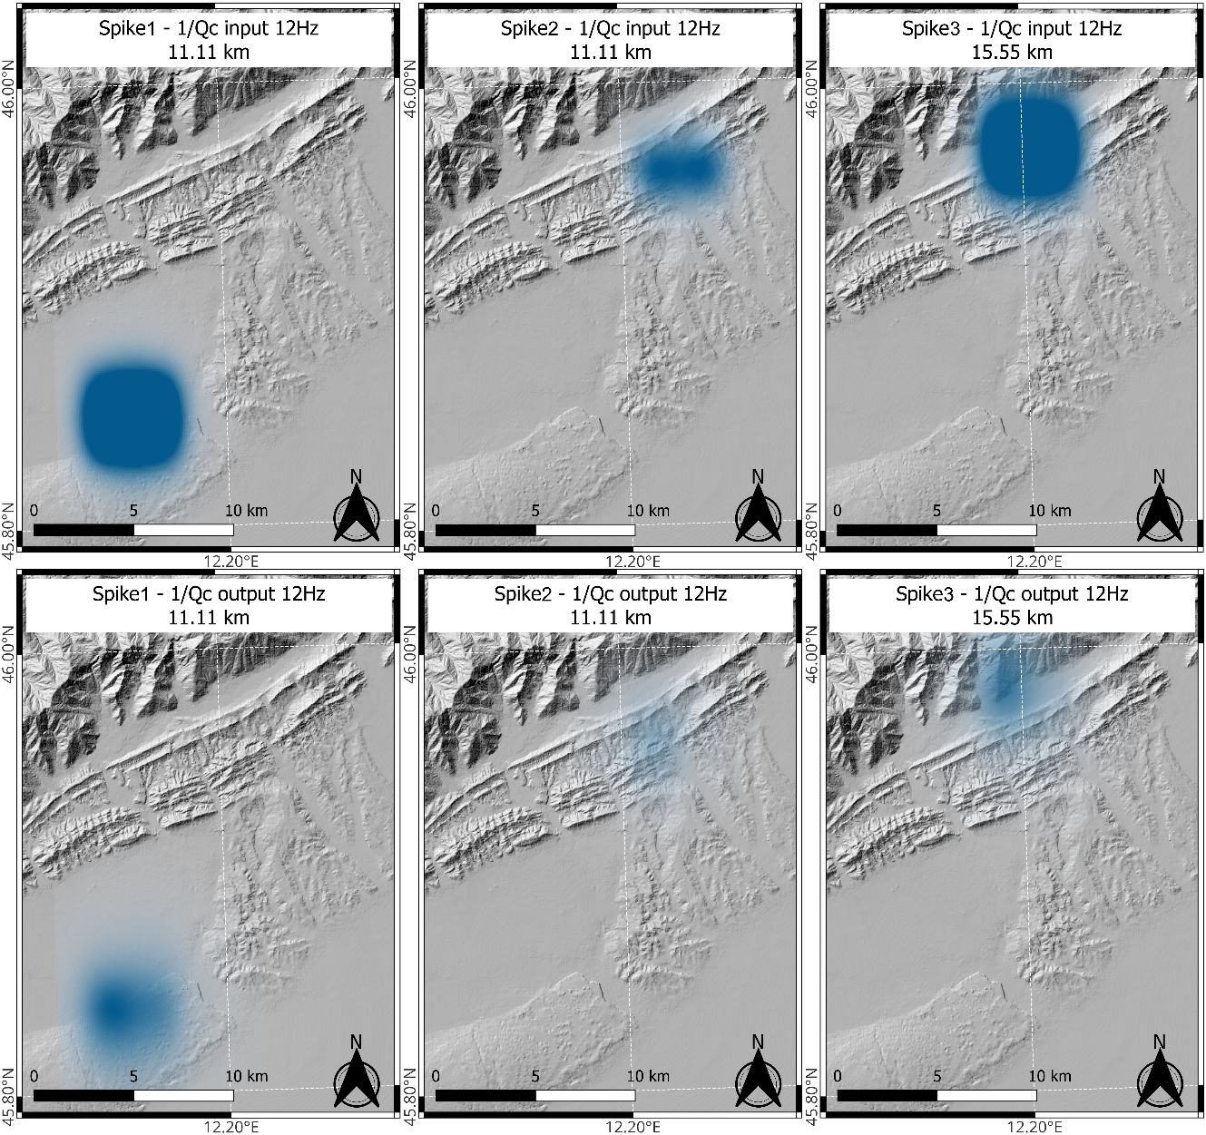
Figure S13. Spatial resolution evaluation (spike tests) for assessing the reliability of absorption anomalies. This synthetic test verifies resolution capability at a specific point. It is performed by introducing a synthetic anomaly (a spike) in the starting model. This anomaly is the only feature to be reconstructed in the output models. The top panels show three synthetic anomalies at different spatial positions and depths. The lower panels show the corresponding reconstructed models.
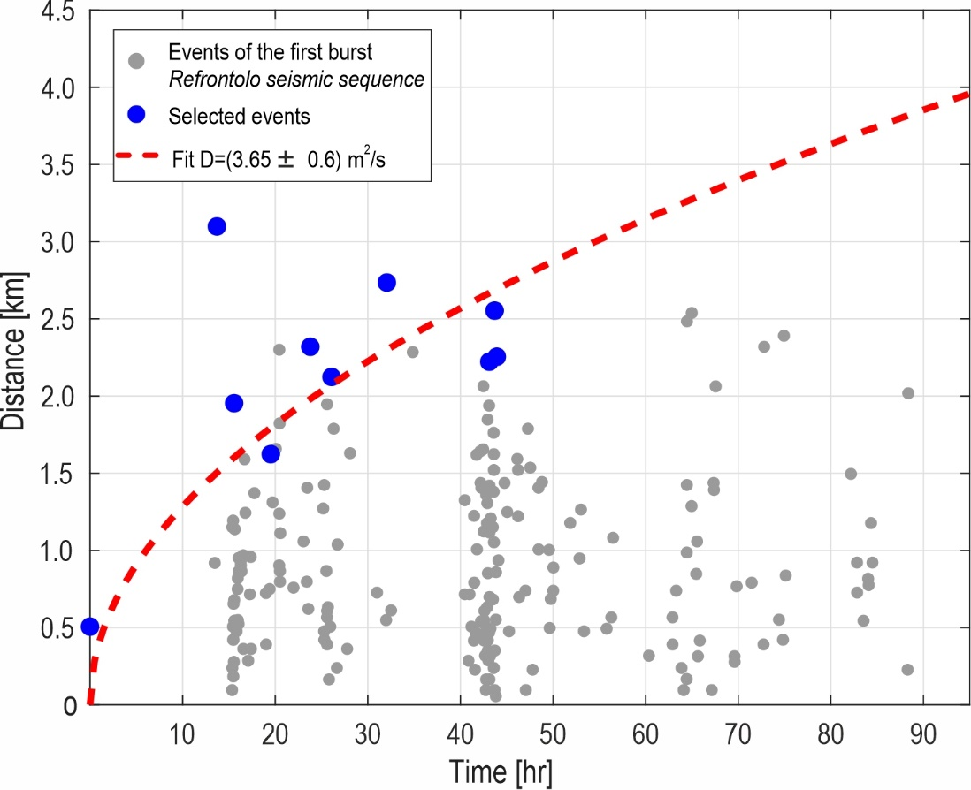
Fig S14. Space-time evolution of the first burst of the Refrontolo seismic sequence. In this R–T plot, the reference point is defined as the median spatial location of the first ten earthquakes in the catalog, following the method described in De Barros et al. (2024). Grey points represent the entire dataset, while blue points indicate the selected events, identified by using the approach after Amezawa et al. (2021). In this method, the diffusivity curve is computed by considering events with distances (R) above the 95th percentile within each 5-hour bin. The selection is restricted to the first 50% of the total duration of the seismic episode. Red dashed curves show the interpolation of the selected data assuming a homogeneous 3D diffusion model (Shapiro et al., 2002) obtained via L2 linear regression of R² vs time. The diffusivity value, along with its uncertainty, is reported in the legend.

References
Amezawa, Y., Maeda, T., Kosuga, M., 2021. Migration diffusivity as a controlling factor in the duration of earthquake swarms. Earth Planets Space 73, 148. https://doi.org/10.1186/s40623-021-01480-7
Anselmi, M., Govoni, A., De Gori, P., Chiarabba, C., 2011. Seismicity and velocity structures along the south-Alpine thrust front of the Venetian Alps (NE-Italy). Tectonophysics 513, 37–48. https://doi.org/10.1016/j.tecto.2011.09.023
Aster, R.C., Thurber, C.H., Borchers, B., 2005. Parameter estimation and inverse problems, International geophysics series. Elsevier Academic Press, Amsterdam Boston.
Bigi, G., Castellarin, A., Coli, M., Dal Piaz, G.V., Sartori, R., Scandone, P., Vai, G.B., 1990. Structural Model of Italy scale 1:500.000, sheet 1. C.N.R., Progetto Finalizzato Geodinamica, SELCA Firenze.
De Barros, L., Danré, P., Garagash, D., Cappa, F., Lengliné, O., 2024. Systematic observation of a seismic back-front during fluid injection in both natural and anthropogenic earthquake swarms. Earth and Planetary Science Letters 641, 118849. https://doi.org/10.1016/j.epsl.2024.118849
Galadini, F., Poli, M.E., Zanferrari, A., 2005. Seismogenic sources potentially responsible for earthquakes with M ≥ 6 in the eastern Southern Alps (Thiene-Udine sector, NE Italy). Geophysical Journal International 161, 739–762. https://doi.org/10.1111/j.1365-246X.2005.02571.x
ITHACA Working Group, 2019. ITHACA (ITaly HAzard from CApable faulting), A database of active capable faults of the Italian territory.
Michele, M., Latorre, D., Emolo, A., 2019. An Empirical Formula to Classify the Quality of Earthquake Locations. Bulletin of the Seismological Society of America 109, 2755–2761. https://doi.org/10.1785/0120190144
Picotti, V., Romano, M.A., Ponza, A., Guido, F.L., Peruzza, L., 2022. The Montello Thrust and the Active Mountain Front of the Eastern Southern Alps (Northeast Italy). Tectonics 41, e2022TC007522. https://doi.org/10.1029/2022TC007522
SGI, UNMIG, 2010. ViDEPI (Visibility of petroleum exploration data in Italy). Italian Journal of Geosciences 129, 3–3.
Shapiro, S.A., Rothert, E., Rath, V., Rindschwentner, J., 2002. Characterization of fluid transport properties of reservoirs using induced microseismicity. GEOPHYSICS 67, 212–220. https://doi.org/10.1190/1.1451597
Talone, D., De Siena, L., Lavecchia, G., De Nardis, R., 2023. The Attenuation and Scattering Signature of Fluid Reservoirs and Tectonic Interactions in the Central‐Southern Apennines (Italy). Geophys. Res. Lett. https://doi.org/10.1029/2023GL106074

