Supplementary Information
Amine- and hydroxyl-functionalized copolymers as lubricant additives on Si-doped DLC: a comparative experimental and computational study of their tribological performance
Takeru Omiya^{1, 2, 3*}, Enrico Pedretti⁴, Manuel Evaristo¹, Pooja Sharma¹, Sara Inocencio², Albano Cavaleiro^{1, 3}, Arménio C. Serra², Jorge F. J. Coelho^{2,3}, Fabio Ferreira^{1, 3} and Maria Clelia Righi^{4*}
¹University of Coimbra, CEMMPRE, ARISE, Department of Mechanical Engineering, Rua Luís Reis Santos, 3030-788 Coimbra, Portugal;
²University of Coimbra, CEMMPRE, ARISE, Department of Chemical Engineering, Rua Silvio Lima, 3030-790 Coimbra, Portugal;
³Laboratory for Wear, Testing & Materials, Instituto Pedro Nunes, Rua Pedro Nunes, 3030-199 Coimbra, Portugal.
⁴Department of Physics and Astronomy, University of Bologna, Bologna, 40127 Italy.
*Corresponding authors: takeru.omiya@student.dem.uc.pt, clelia.righi@unibo.it

Figure S1 shows the NMR spectrum of the block polymer PLMA-b-PHEMA.
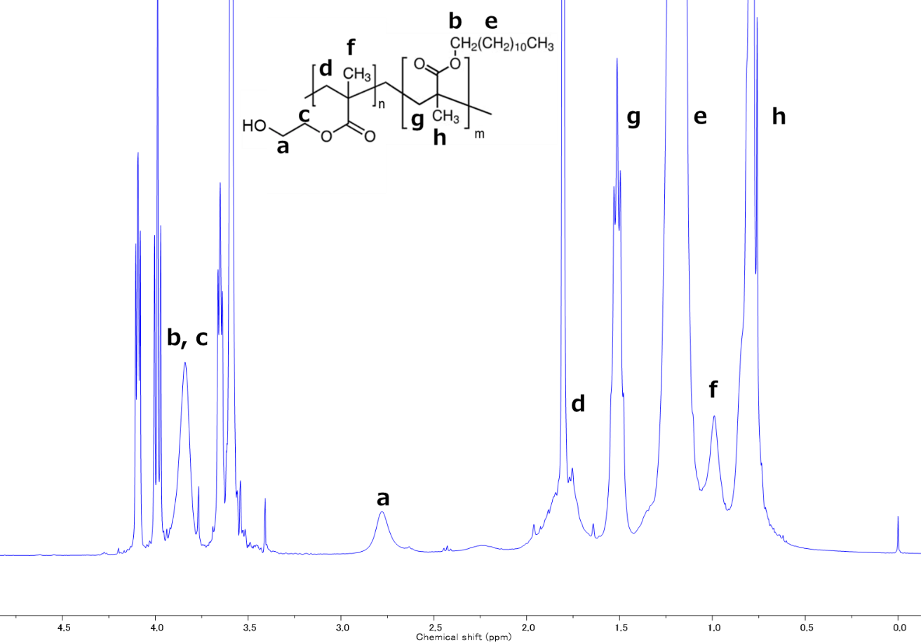
Figure S1. ¹H-NMR of block copolymer PLMA-b-PHEMA by SARA ATRP. Assignments: 2.78 ppm -CH₂- (PHEMA), 3.91 ppm -CH₂- (PLMA) and -CH₂- (PHEMA).

A wear test in high-load condition was conducted to assess the wear characteristics of functionalized polymers.The coefficient of friction (CoF) for the entire 20 minutes during the wear test is shown in Figure S2. During all tests, the friction decreased immediately after the start of the test, and the CoF stabilized after approximately 10 minutes. Similar to the friction test in low-load condition results shown in Figure 3, PLMA-b-PDMAEMA was found to exhibit a friction-reducing effect compared with PLMA and PLMA-b-PHEMA.

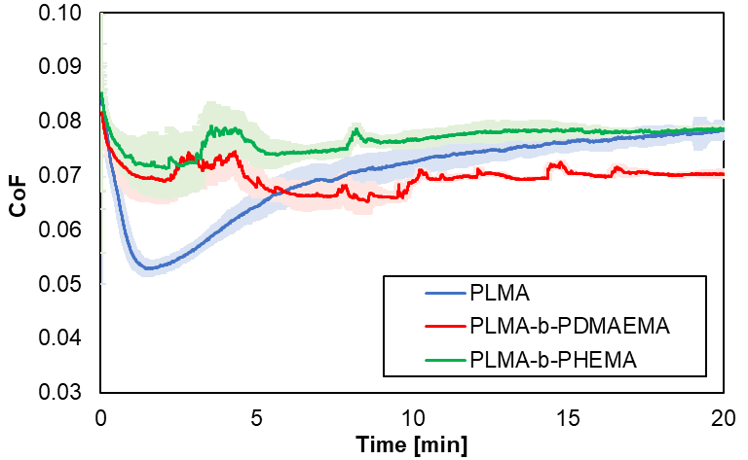
Figure S2. CoF during wear tests in high-load condition in the presence of PLMA and PLMA-b-PDMAEMA and PLMA-b-PHEMA. Light-colored areas indicate standard deviations for multiple testing.

