SUPPLEMENTARY MATERIAL

Recovered phosphorus for a more resilient urban agriculture: assessment of the fertilizer potential of struvite in hydroponics

Verónica Arcas-Pilz^{a,1}, Martí Rufí-Salís^{a,b,1}, Felipe Paradaª, Anna Petit-Boix^{c}, Xavier Gabarrell^{a,b,}*, Gara Villalba^{a,b}

ªSostenipra Research Group (SGR 01412), Institute of Environmental Sciences and Technology (MDM-2015-0552), Z Building, Universitat Autònoma de Barcelona (UAB), Campus UAB, 08193 Bellaterra, Barcelona, Spain
^{b}Department of Chemical, Biological and Environmental Engineering, Universitat Autònoma de Barcelona (UAB), Campus UAB, 08193 Bellaterra, Barcelona, Spain
^{c}Chair of Societal Transition and Circular Economy, University of Freiburg. Tennenbacher Str. 4, 79106 Freiburg i. Br. (Germany)
¹ These authors contributed equally to this research
Corresponding author: xavier.gabarrell@uab.cat
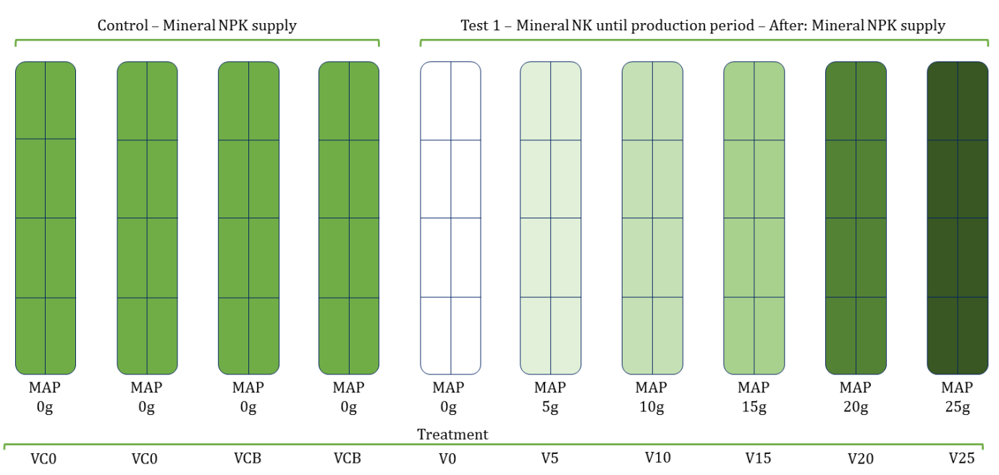
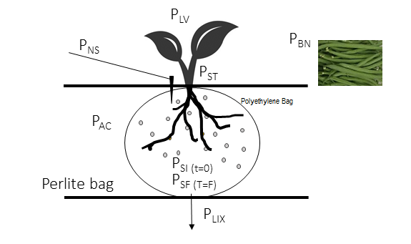
Figure SM1: Diagram of the perforated bag. PNS = mineral P in the nutrient solution; PSI = P in initial struvite; PLIX = P in leachates; PLV, PST, and PBN,= P in leaves, stem and beans, respectively; PSF = undissolved P (final struvite); PAC = dissolved P accumulated in the water retained in the substrate at the end of the crop.
Figure SM2: Distribution of growing lines in the validation test. Each growing table consisting on two irrigation lines, with four perlite bags each (eight perlite bags per growing table). From left to right: first four growing tables supplied with mineral P fertilizer as control treatment, VC0= without the perforated bag, VCB= with the perforated bag. Lines five to ten irrigated without mineral P and with the addition of 0, 5, 10, 15, 20 and 25g of struvite.

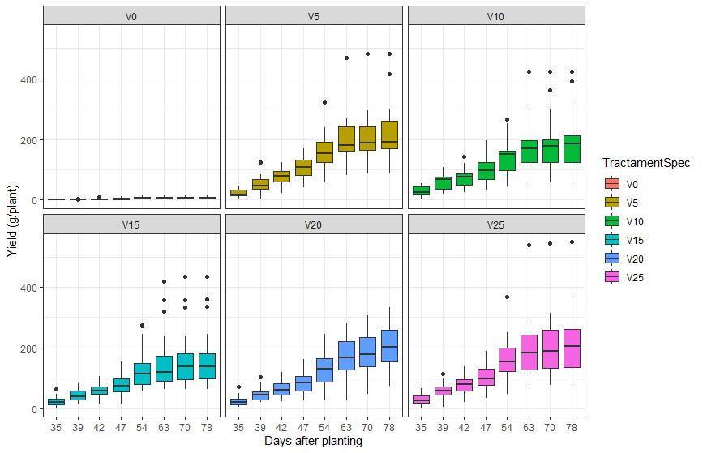
Figure SM3: Production (g/plant) of the struvite treatments in the validation test, with different amoints of struvite ranging from 0g to 25g (V0, V5, V10, V15, V20, V25) for each harvest. Sample size for harvests 1, 2, 3, 4 and 5 (35- 54 DAT) corresponds to n=28 plants, for harvests 6, 7 and 8 (63-78 DAT) n=24 plants per treatment.

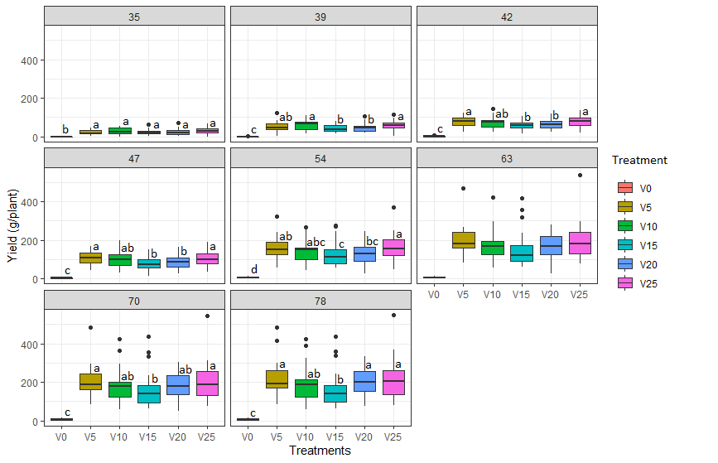
Figure SM4: Production (g/plant) of the struvite treatments in the validation test, with different amounts of struvite ranging from 0g to 25g (V0, V5, V10, V15, V20, V25) for each harvest. Same letters (a,b, c) indicate no significant difference (p>0.05) between treatment for each harvest time. Sample size for harvests 1, 2, 3, 4 and 5 (35- 54 DAT) corresponds to n=28 plants, for harvests 6, 7 and 8 (63-78 DAT) n=24 plants per treatment.

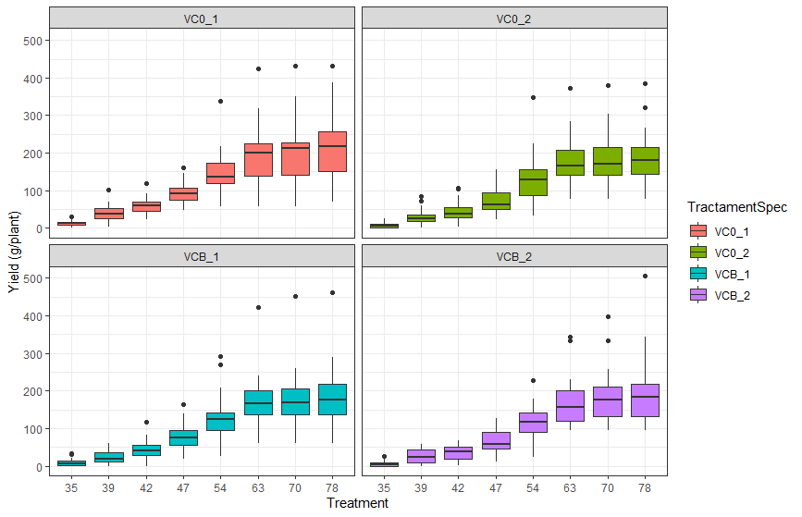
Figure SM5: Production (g/plant) of the control treatments in the validation test, with (VCB) and without (VC0) perforated bags for each harvest. Sample size for harvests 1, 2, 3, 4 and 5 (35- 54 DAP) corresponds to n=28 plants, for harvests 6, 7 and 8 (63-78 DAP) n=24 plants per treatment.

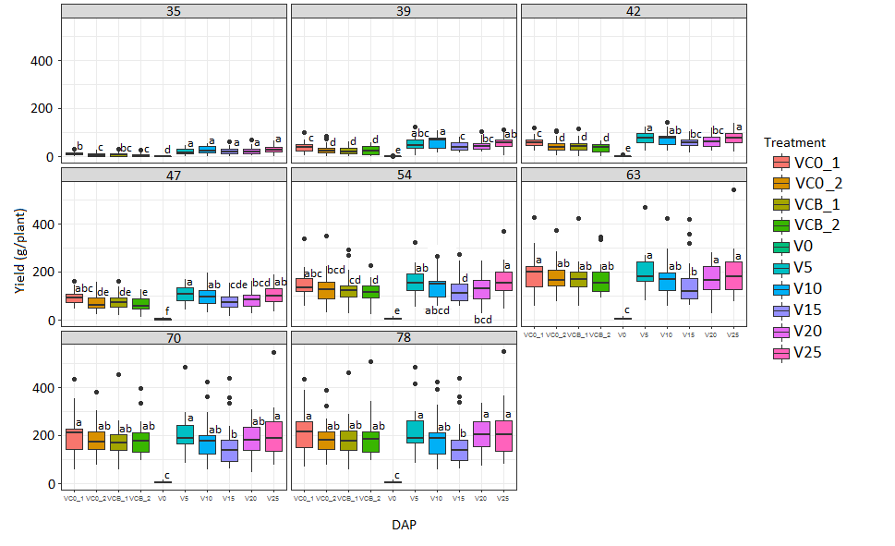
Figure SM6: Production (g/plant) in the validation test of the control treatments, with (VCB) and without (VC0) perforated bags and the struvite treatments, with different amounts of struvite ranging from 0g to 25g (V0, V5, V10, V15, V20, V25) for each harvest. Same letters (a, b, c, d, e, f) indicate no significant difference (p>0.05) between treatment for each harvest time. Sample size for harvests 1, 2, 3, 4 and 5 (35- 54 DAT) corresponds to n=28 plants, for harvests 6, 7 and 8 (63-78 DAT) n=24 plants per treatment.

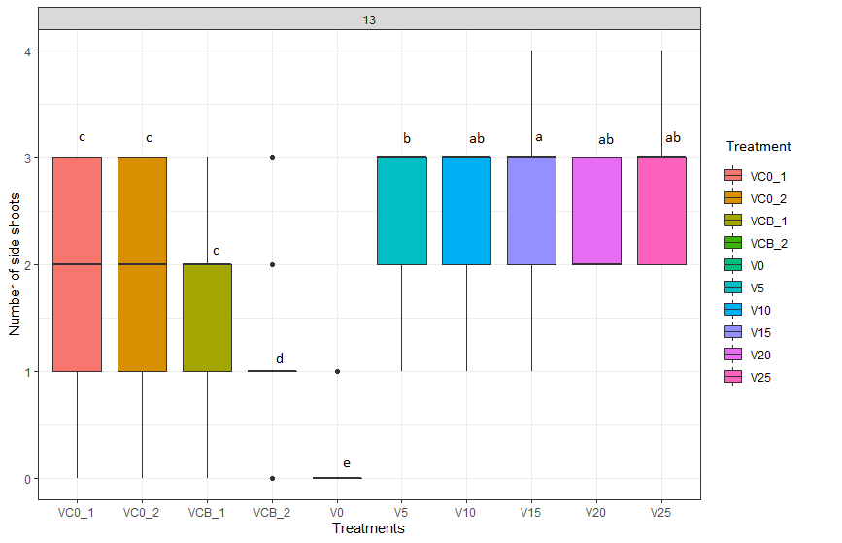
Figure SM7: Number of side shoots per plant per treatment and Days after Transplanting (DAP) in the validation test (13 DAP). Same letters (a, b, c, d, e) indicate no significant difference (p>0.05) between treatment for each counting time. Sample size n=32 for each treatment.
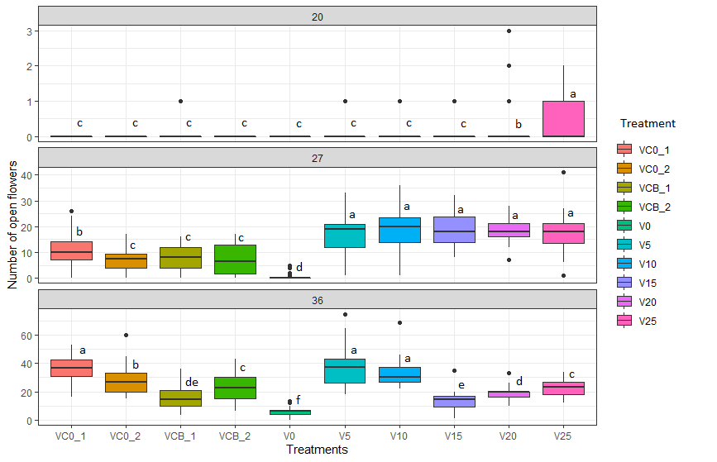
Figure SM8: Number of open flowers per plant per treatment and Days after Transplanting (DAP) in the validation test (20, 27, 36 DAP). Same letters (a, b, c, d, e, f) indicate no significant difference (p>0.05) between treatment for each counting time. Sample size n=32 for each treatment.

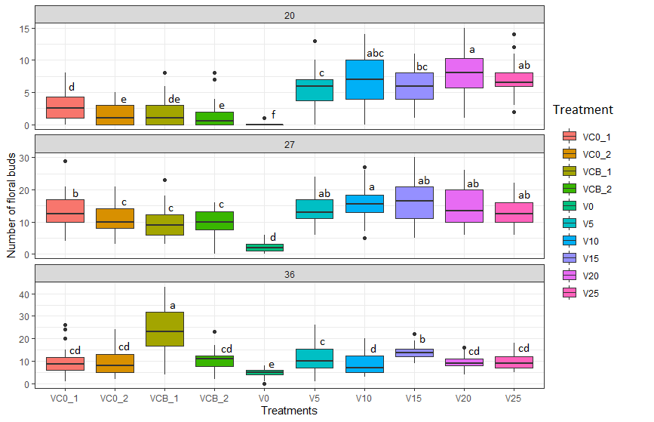
Figure SM9: Number of floral buttons per plant per treatment and Days after Transplanting (DAP) in the validation test (20, 27, 36 DAP). Same letters (a, b, c, d, e, f) indicate no significant difference (p>0.05) between treatment for each counting time. Sample size n=32 for each treatment.

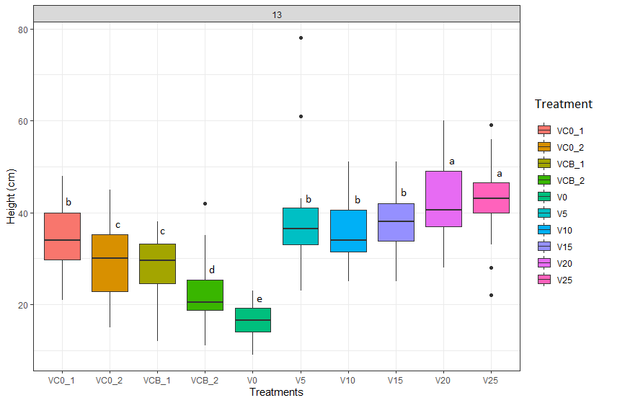
Figure SM10: Height (cm) plant per treatment and Days after Transplanting (DAP) in the validation test (13 DAP). Same letters (a, b, c, d, e) indicate no significant difference (p>0.05) between treatment for each counting time. Sample size n=32 for each treatment.

Figure SM11: Water irrigated (L) per plant in the validation test.
Figure SM12: Phosphorus concentrations in the multiple water streams in the validation test

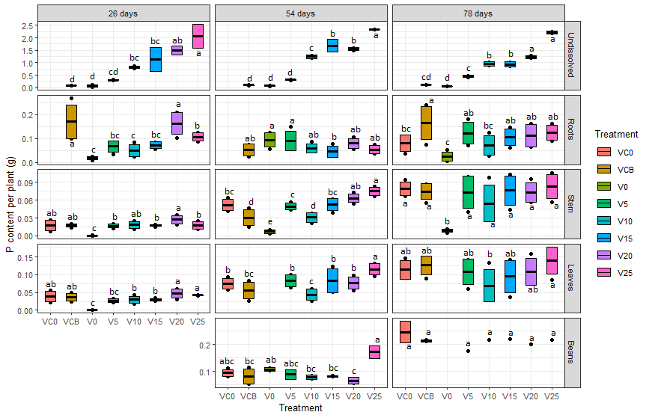
Figure SM13: P content per plant (g) of the struvite treatment in the validation test. Same letters (a, b, c, d, e) indicate no significant difference (p>0.05) between treatment for each harvest time. Sample size for all organs n=4. Undissolved P content n=2.

Figure SM14: Distribution of growing lines in the validation test

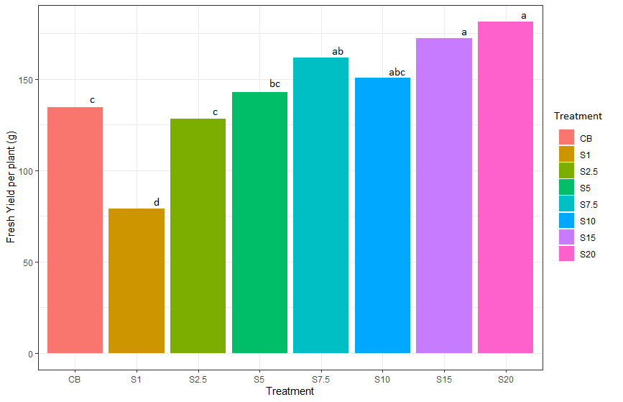
Figure SM15: Mean aggregated production per plant per treatment in the determination test

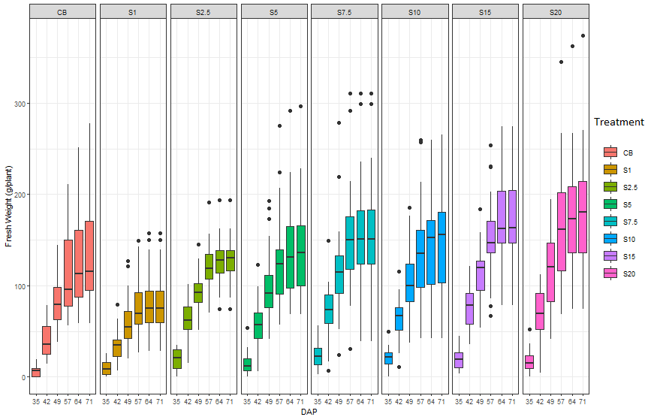
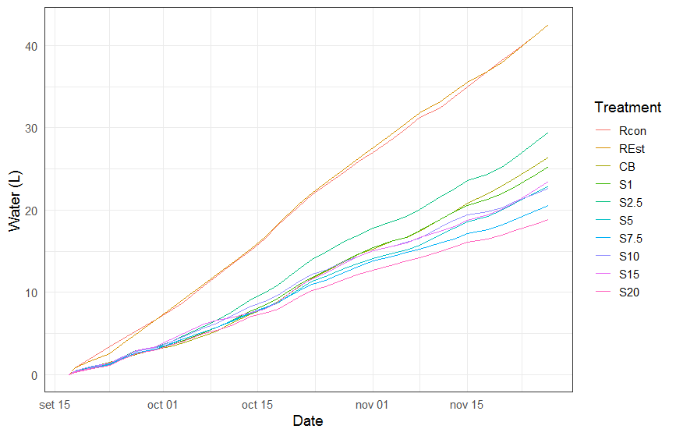
Figure SM16: Distribution of accumulated production per plant per harvest (DAP = days after plantin) of different treatments. Sample size for all harvests is n=24 plants per treatment.

Figure SM17: Water irrigated and drained per plant in the different treatments in the determination test

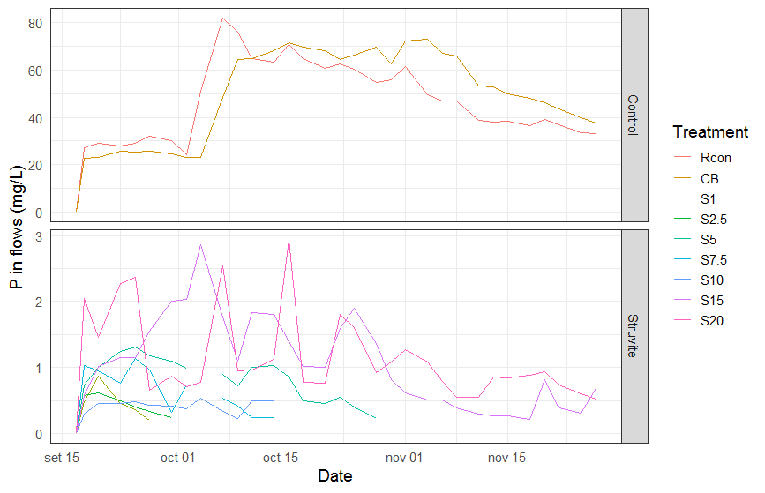
Figure SM18: Phosphorus concentrations in the multiple water streams in the determination test

