Supplementary Information
Hollow Fiber Flow Field-Flow Fractionation Enables High-Quality Extracellular Vesicle Isolation from Minimal Plasma Samples in Polycythemia Vera Liquid Biopsy
Ghazal Narimanfarª, Anna Placci^{bcd}, Filippo Maltoni^{e}, Stefano Giordani^{bcd}, Gianluca Storci^{f}, Barbara Roda^{bcd}, Andrea Zattoni^{bcd}, Pierluigi Reschiglian^{bcd}, Massimiliano Bonafè^{af}, Francesca Palandri^{e}, Valentina Marassi^{bcd}, Lucia Catani^{ae}
- Department of Medical and Surgical Sciences, University of Bologna, Bologna, Italy
- Department of Chemistry “G. Ciamician”, University of Bologna, Bologna, Italy
- byFlow srl, Bologna, Italy
- Biostructures and Biosystems National Institute (INBB), Rome, Italy
- IRCCS Azienda Ospedaliero-Universitaria di Bologna, Istituto di Ematologia “Seràgnoli”, Bologna, Italy
- IRCCS Azienda Ospedaliero-Universitaria di Bologna, Bologna, Italy
Corresponding Authors: Valentina Marassi valentina.marassi@unibo.it Lucia Catani lucia.catani@unibo.it
Table S1. Clinical and laboratory characteristics of PV patients and HDs. P <0.05 is considered significant. WBC (White Blood Cells), RBC (Red Blood Cells), HGB (Hemoglobin), HCT (Hematocrit), PLT (Platelets)

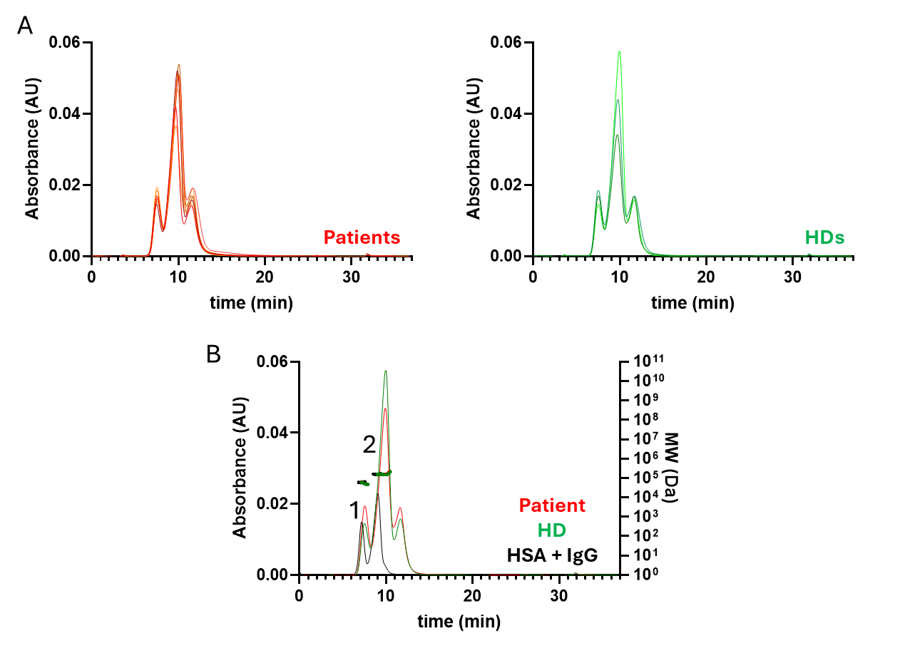
Figure S1. HF5-derived fractions analysis. (A) Patients (n=7) and HDs (n=3) UV fractograms at 280 nm overlay (each line is obtained from the HF5 analysis of the HF5-derived fractions from one patient or one HD. (B) Representative Patient and HD UV fractograms at 280 nm in overlay with a mix of HSA and IgG obtained with the same separative method.
3
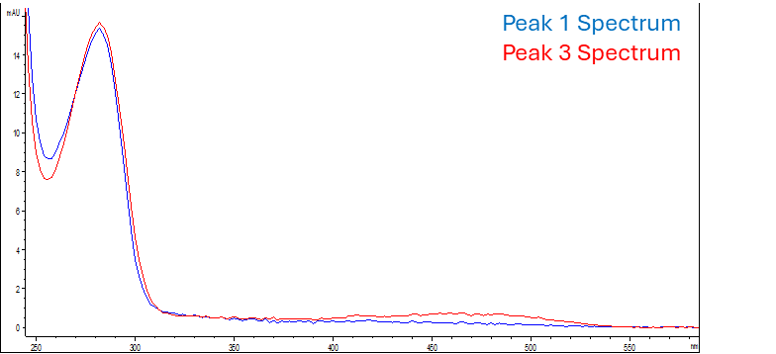
Figure S2. Representative UV spectrum, taken from an HD’s HF5-derived fraction, of Peak 1 (in blue) and Peak 3 (in red). Both Peak 1 and 3 spectra show a maximum absorbance at 280nm, characteristic signal of proteins, Peak 3 display also another maximum at 470 nm due to the β-carotene-binding protein in Low Density Lipoproteins (LDL)
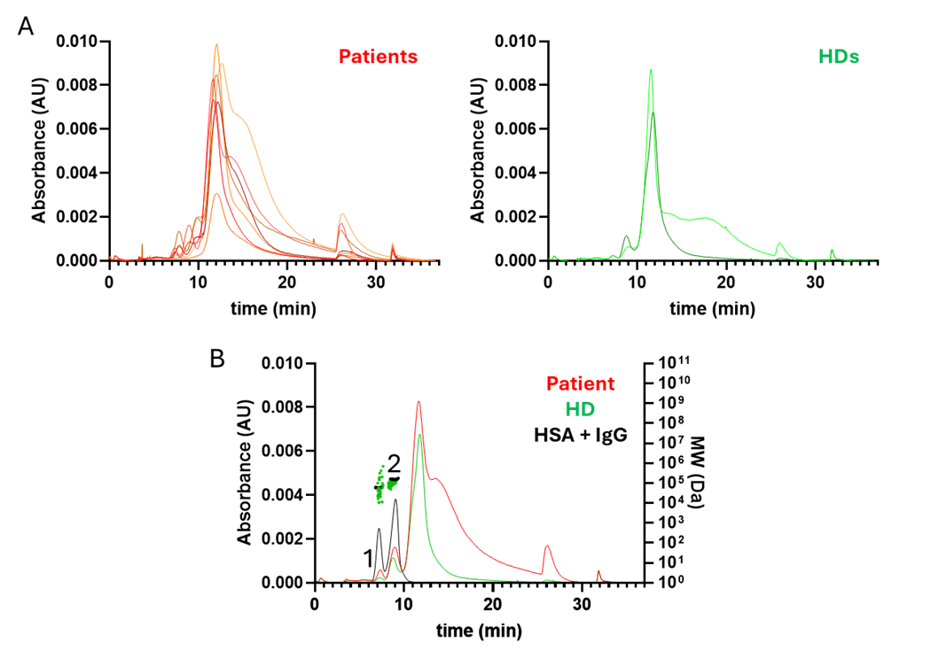
Figure S3. SEC-derived fractions analysis. (A) PV patients (n=7) and HDs (n=2) UV fractograms at 280 nm overlay (each line is obtained from the HF5 analysis of one Patient or HD SEC-derived fractions). (B) Representative UV fractograms of one PV patient and one HD at 280 nm in overlay with a mix of HAS and IgG obtained with the same separative method.

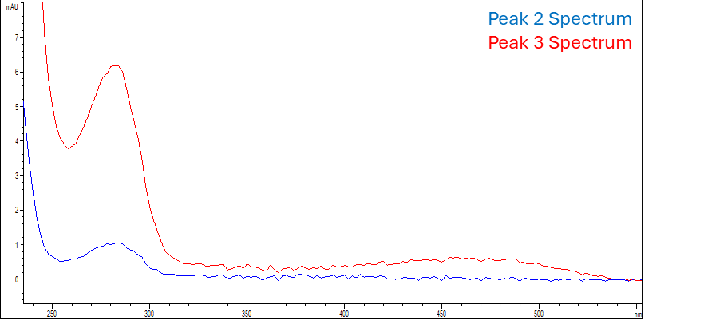
Figure S4. Representative UV spectrum, taken from an HD’s SEC-derived fraction, of Peak 2 (in blue) and Peak 3 (in red). Both Peak 2 and 3 spectra show a maximum absorbance at 280nm, characteristic signal of proteins, Peak 3 display also another maximum at 470 nm due to the β-carotene-binding protein in Low Density Lipoproteins (LDL)

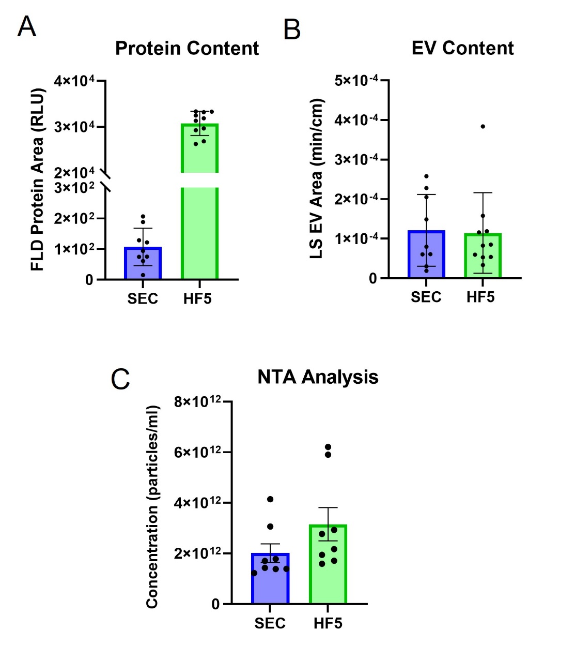
Figure S5. Quantitative comparison of (A) protein content, obtained by integrating Peaks 1 and 2 from fluorescence (FLD) fractograms, and (B) EV content, obtained by integrating Peak 4 from light scattering (LS) fractograms; all areas were scaled to an equal processed plasma volume (500ul), and C) concentration of particles obtained from NTA analysis scaled on the starting plasma volume.

