Supporting information for

Hybrid molecular photoanodes for water oxidation based on electropolymerized Cu macrocyclic complexes on BiVO₄-WO₃
Carlos G. Bellido,^{+,1} Michele Mazzanti,^{*,+,2} Koushik Ranu,^{+,1} Alberto Piccioni,³ Raffaello Mazzaro,³ Federico Boscherini,^{3,§} Fernando F. Salomón,¹ Sergi Grau,¹ Xavier Sala,⁴ Luca Pasquini,^{*,3} Antoni Llobet^{*,1} and Stefano Caramori²
1 - Institute of Chemical Research of Catalonia (ICIQ), Barcelona Institute of Science and Technology (BIST), Avda. Països Catalans, 16, 43007 Tarragona, Spain
2 - Department of Chemical, Pharmaceutical and Agricultural Sciences, University of Ferrara, Via Fossato di Mortara 17, 44121 Italy
3 - Department of Physics and Astronomy “Augusto Righi”, Alma Mater Studiorum Università di Bologna, viale Berti-Pichat 6/2, 40127 Bologna, Italy
4 - Departament de Química, Universitat Autònoma de Barcelona, Cerdanyola del Vallès, 08193 Barcelona, Spain

+ These authors contributed equally to this work
§ Present address: Consiglio Nazionale delle Ricerche (CNR) – Istituto Officina dei Materiali, c/o AREA Science Park, 34149 Trieste, Italy
* Corresponding authors: mzzmhl3@unife.it, allobet@iciq.cat, luca.pasquini@unibo.it

Contents
Materials 3
Instrumentation 3
Electrochemical measurements 3
Photoelectrochemical measurements 4
Preparation of photoanodes 4
Transient Absorption Spectroscopy (TAS) 5
Photoelectrochemical set-up 7
Photoelectrochemical experiments 8
Microscopy analysis 19
X-ray absorption spectroscopy 21
Raman spectroscopy 25
References 26

Materials
All chemicals used in this work were obtained from Sigma Aldrich and Alfa Aesar and have been used without further purification unless explicitly indicated. For further details, look at the preparative details reported below. The solvents were selected to be HPLC grade and high-purity water was acquired by passing distilled water through a Nanopure MilliQ water purification system. All the synthetic procedures were performed under argon atmosphere using vacuum-line techniques, if not stated otherwise. For other spectroscopic and electrochemical studies HPLC grade solvents were used.

Instrumentation
pH meter: The pH of all solutions was measured using a Mettler Toledo Seven Compact pH meter calibrated before measurements through standard solutions at pH 4.0, 7.0 and 9.2.
NMR spectroscopy: ¹H (400 MHz) and ¹³C (101 MHz) NMR spectra were recorded with a Bruker Avance 400 MHz spectrometer. All the measurements were carried out at room temperature in the corresponding deuterated solvent using residual protons as internal reference. NMR spectroscopic data were analyzed using MestreNova software.
Mass spectroscopy: Electrospray ionization mass spectra (ESI-MS) were performed on an Agilent Technologies 6130-Quadrupole LC/MS connected to an Agilent Technologies HPLC-1200 series. Samples were dissolved in the appropriate solvent and injected directly with an auto-sampler.
UV-vis spectrometry: A Cary 50 (Varian) UV-vis spectrophotometer was used to carry out the UV-vis spectroscopy. All the measurements were performed using a standard 1 cm pathway UV-vis cuvette.
Solar source: all photoelectrochemical experiments were performed by irradiation with a solar simulator LS-150 series.
Microscopy: SEM images and energy dispersive X-ray analysis (EDX) were recorded using a Quanta 600 from FEI company.
Resonance Raman spectroscopy was carried out with a Renishaw inVia Raman Microscope equipped with a 532 nm laser, coupled with a Leica DM-2500 microscope.

Electrochemical measurements
All electrochemical experiments were conducted using a Cambria CHI 730 or CHI 660 bi-potentiostat, using a one-compartment three-electrode home-made Teflon cell (Figure S1) for cyclic voltammetry (CV), linear sweep voltammetry (LSV) and chronoamperometry (CA) techniques. On the top, adaptive holes are located to seal the cell after placing all the different electrodes and the Ar purging system. The selected BiVO₄-WO₃ photoanode (composed by 1 cm² of bare FTO and 1cm² of FTO@BiVO₄-WO₃, see Figure S2, left) was employed as working electrode (WE), using copper tape as connection with the potentiostat on the bare FTO conductive layer (see Figure S2, right). The WE was placed between the outer and inner wall with the copper tape to the top, having the conductive layer of the photoanode facing the solution and the irradiation hole over the BiVO₄-WO₃ surface. A platinum mesh was used as counter electrode (CE), and a Hg/Hg₂SO₄ (sat. K₂SO₄) as reference electrode (RE). The CVs were iR compensated (85 %) unless stated otherwise. CVs were recorded at 50 mV·s⁻¹ and LSVs were recorded at 25 mV·s⁻¹ unless otherwise stated. All the potentials reported in this work were converted to NHE by subtracting 0.675 V to the measured potential on aqueous solutions (0.1 M phosphate buffer pH 7) or versus ferrocene for organic solvents (acetonitrile, MeCN) by addition of Ferrocene as internal standard at the end of the experiment. All experiments performed in organic solvents were done in oxygen-free conditions by a purging system with Ar.

Preparation of buffers
Phosphate buffer solution at pH 7.1 (I = 0.1 M) was prepared by dissolving NaH₂PO₄ (0.462 g, 3.8 mmol) and Na₂HPO₄ (0.754 g, 5.2 mmol) in 1 L of Mili-Q water.

Photoelectrochemical measurements
Photoelectrochemical measurements were performed in the same set-up as mentioned for electrochemical measurements but under 1 Sun back-illumination on the working electrode surface by a 150 W xenon lamp (LS-150, Abet Technologies) equipped with a AM1.5G filter, having the conductive side of the photoanode in contact with the solution. A 0.25 cm² hole on the external wall of the Teflon cell, in contact with the photoanode, is irradiated, extrapolating the results obtained to current density (mA/cm²). Chopped experiments were performed with a home-made programable shutter between the lamp and the photoelectrochemical cell. A platinum mesh was used as counter electrode (CE), and a Hg/Hg₂SO₄ (sat. K₂SO₄) as reference electrode (RE). JV curves were recorded at 50 mV·s⁻¹ and LSVs were recorded at 25 mV·s⁻¹ unless otherwise stated. All the potentials reported in this work were converted to NHE pH 7 by subtracting 0.675 V to the measured potential on aqueous solutions (0.1 M phosphate buffer pH 7) or versus ferrocene for organic solvents (acetonitrile, MeCN) by addition of Ferrocene as internal standard at the end of the experiment.

Preparation of photoanodes
FTO/WO₃ Electrodes: The preparation of spin-coated WO3 films constituted by WO₃ nanoparticles was accomplished according to previous works^{1,2} Briefly, the preparation of colloidal WO₃ was first accomplished by precipitating a H₂WO₄ gel by addition of concentrated HCl to aqueous Na₂WO₄ (Alfa Aesar, ≥ 99%). After several washings of H₂WO₄ carried out by redispersion/centrifugation, a stable H₂WO₄ sol was obtained by peptizing with oxalic acid (Alfa Aesar, ≥ 99.5 %) at 60 °C. The resulting colloidal was densified by adding 20% w/w Carbowax (Sigma-Aldrich) and a few drops of Triton X-100 (Fluka), to improve the spreading of the colloid during the subsequent FTO-coating process. Nanostructured photoanodes were obtained by spin coating the H₂WO₄ colloid onto well-cleaned FTO glass (Pilkington TEC7). Six WO₃ layers were sequentially deposited, each layer being thermally annealed at 550 °C for 30 min in air before the deposition of the next one. The total thickness of the electrode was ca. 1 μm.
Deposition of BiVO₄ on the WO₃ photoanodes described above was achieved according to a previously published procedure³ inspired by an electrochemical methodology developed by Seabold et al⁴. Briefly, 10 mM Bi(NO₃)₃ (Sigma Aldrich, ≥ 99%) was slowly added to a 10 mM VOSO₄ in the presence of HNO₃. After complete dissolution of Bi(NO₃) the pH of the solution was rapidly increased to 4.5 using 2M CH₃COONa (AlfaAesar, 99%). The resulting solution was quickly used as an electrolyte for two-electrode potentiostatic electrodeposition by applying 210 mV between FTO/WO₃ and a platinum foil at room temperature for 300 s. The typical distance between the FTO/WO₃ working electrode and the Pt foil was ≈ 3 mm. After deposition, the resulting FTO supported photoanode was abundantly rinsed with water, dried at room temperature, and finally annealed at 500 °C in air for 2 h.
Molecular photoanodes were prepared by photoelectropolymerization of the of [LCu]²⁻ monomer into BiVO₄-WO₃, to obtain p-[LCu]²⁻@BiVO₄-WO₃ electrodes. An acetonitrile solution of [LCu]²⁻ (3 mM) containing NH₄TfO (0.1 M) as supporting electrolyte was subjected to a chronoamperometric (CA) at E_{app} = 0.75 V vs Fc⁺/Fc under 1 sun illumination (100 mW/s) using the BiVO₄-WO₃ photoelectrodes (see Figure S3). After the polymerization process, the surface is rinsed with a few drops of MeCN and let dry under open atmosphere.

Transient Absorption Spectroscopy (TAS)
Transient absorption measurements in the 10⁻⁴ -1s time frame were performed with a a spectrometer comprising a Continuum Surelite II Nd:YAG laser (1064 nm, FWHM = 6-8 ns, 8 Hz) equipped with a frequency triplicator (355 nm) as excitation, and a monochromatized probe light generated by an Applied Photophysics Xenon lamp combined with an Applied Photophysics monochromator. A home-built selector disk shutter controlled by a National Instruments Board prevented sample and photomultiplier fatigue when operating the laser excitation within the 0.1 s time frame. For decay kinetics extending beyond 0.1 s, the selector was left open and the probe beam was further attenuated with neutral density filters (Edmund Optics). The transmitted light was focused on an Acton SpectraPro 2300i triple grating, dual output spectrograph. For fixed-wavelength kinetic studies, a Hamamatsu R3869 photomultiplier was used as a detector and the 600 lines/mm grating was selected. The signals generated by the photomultiplier (biased at 450±10V) were acquired using a TeledyneLeCroy 604Zi oscilloscope (400 MHz, 20 GS/s). For all the experiments, an oscilloscope input impedance of 1MΩ was used. The sample consisting of the transparent semiconductor working electrode was inserted at 45° with respect to the excitation beam, in order to reflect the unwanted excitation light away from the photomultiplier. Silver and platinum wires served as the quasi-reference and counter electrodes respectively and were carefully inserted in the cuvette at the sides of the photoanode, in order not to block the probe beam. The laser beam was defocused with a plano-concave lens in order to illuminate the entire active area of the working electrode at the energy of 5±1 mJ/cm²/pulse by choosing an appropriate combination of attenuating neutral filters, Q-switch (180 μs) and flash lamp (1.26 kV) supply voltage settings. The laser repetition rate was 1 Hz (for kinetic experiments extending up to 0.5 s) or 0.5 Hz for longer time scales. Typically, 100-150 shots were averaged in order to obtain an acceptable S/N ratio of the oscillographic traces. In general, we found that, by sampling a spectral bandwidth of ca. 10 nm, the region around 500 nm was the most stable and less noisy during these low signal (∆A < 1 mOD) measurements.
Decay kinetics were fitted with a stretched exponential function (Kohlrausch Williams Watts, KWW, eq -1):
$KWW=y_{0}+A\exp{{\left(-\frac{t}{τ}\right)}^{β}}$ (eq S1)
The average lifetime (expectation value or first order moment of KWW) was obtained as:
$〈τ〉= \frac{τ}{β}⋅Γ\left(\frac{1}{β}\right)$ (eq S2)
where $τ$ is the KWW time constant, $β$ is a stretching parameter (fixed at 0.5) in the fitting model, and $Γ$ is the gamma function (for integer $n, Γ(n)=(n-1)!$):
$Γ(z)=\int_{0}^{+∞}{t^{z-1}e^{-t}ⅆt}$ (eq S3)
The earliest part of the decay (${10}^{-4} - 5⋅{10}^{-4}$ s) was convolved with the instrumental response of the spectrometer, and was not included in the fitting.

Photoelectrochemical set-up

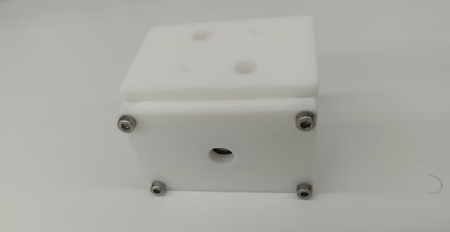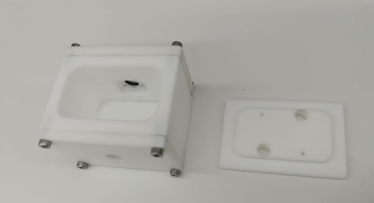
Figure S1. Home-made Teflon photoelectrochemical cell used in this work.¹¹

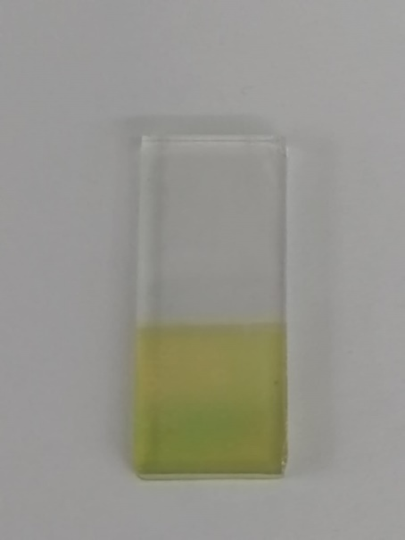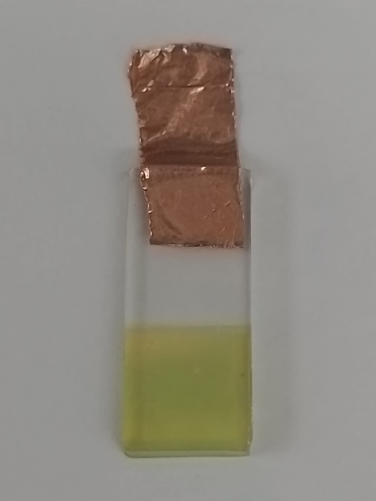

Figure S2. On the left, a BiVO₄-WO₃ sample (A = 0.5 cm x 0.5 cm = 0.25 cm²) used on this work. On the right, correct preparation of the BiVO₄-WO₃ photoanode with a copper tape connection.

Photoelectrochemical experiments
Figure S3. Chronoamperometry at E_{app} = 0.75 V vs. Fc⁺/Fc under 1 sun irradiation of a 3 mM [LCu]²⁻ solution in MeCN using a BiVO₄-WO₃ (A = 0.5 cm x 0.5 cm = 0.25 cm²) electrode.
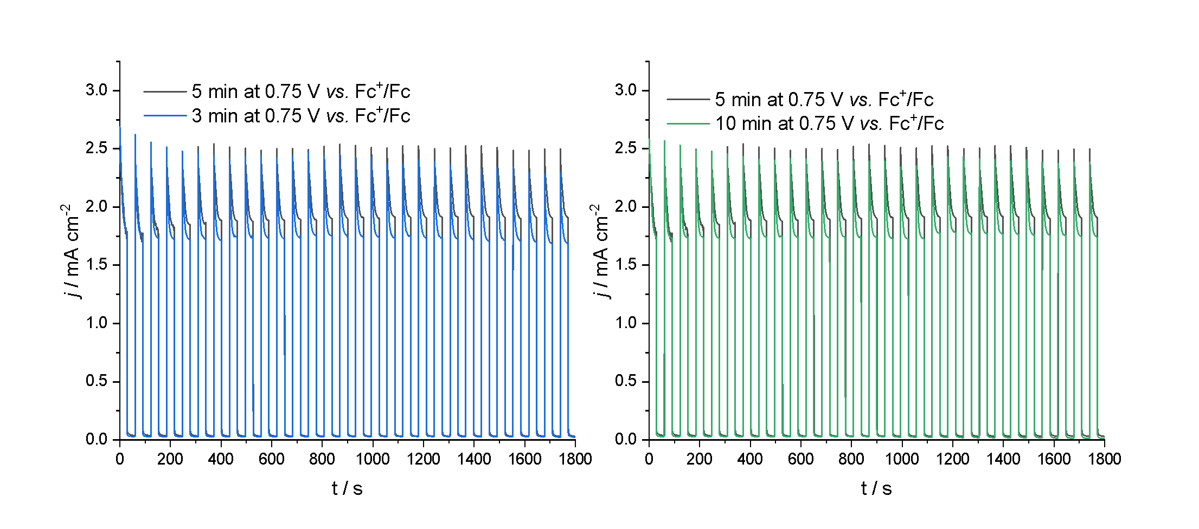
Figure S4. Chopped LSVs of p-[LCu]²⁻@BiVO₄-WO₃ electrodes in a phosphate buffer pH 7 0.1 M solution under 1 sun irradiation at E_{app} = 0.45 or 0.75 V vs. Fc/Fc⁺ (see label in the figure) for 3, 5 or 10 minutes.

Figure S5. Applied Bias Photocurrent Efficiency (APBE) under 1 sun irradiation at 25 mV/s of BiVO₄-WO₃ (blue) and p-[LCu]²⁻@BiVO₄-WO₃ (red) in a 0.1 M phosphate buffer pH 7 solution. ABPE = [j_{photo} (1.23 - V_{bias})]/P, where j_{photo} is the potocurrent density and P is the incident irradiance.

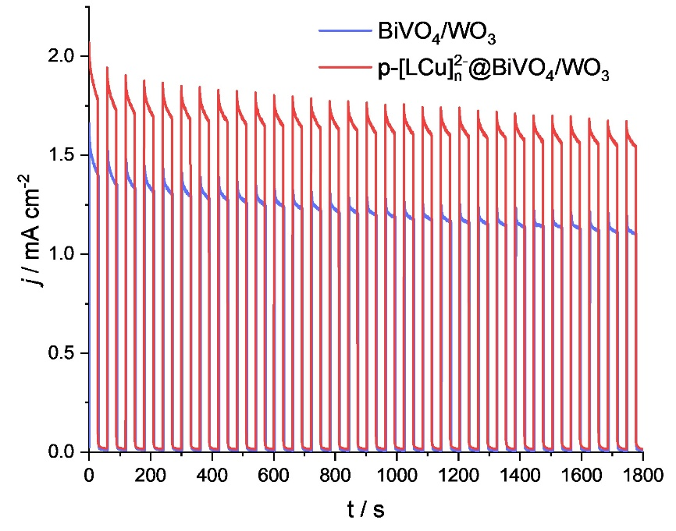
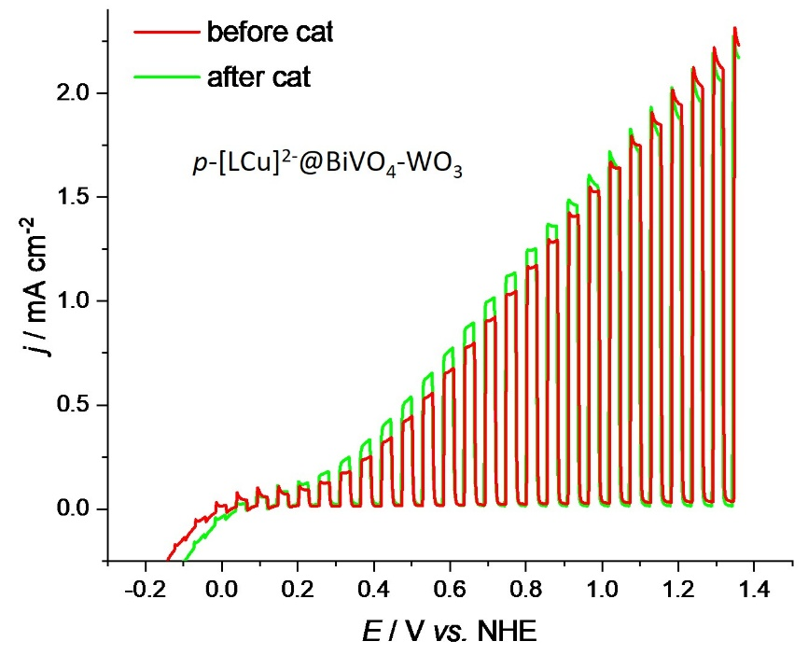
Figure S6. Top, chopped CA (30 min) of BiVO₄-WO₃ (blue) and p-[LCu]²⁻@BiVO₄-WO₃ (red) in a phosphate buffer pH 7 0.1 M solution under 1 sun at an E_{app} = 1.1 V vs. NHE. This gives 1.02 C (10.6 μmols of e-) and 1.58 C (16.4 μmols of e-; TON = 401) for BiVO₄-WO₃ and p-[LCu]²⁻@BiVO₄-WO₃ respectively. Bottom, chopped LSVs of p-[LCu]²⁻@BiVO₄-WO₃ in a phosphate buffer pH 7 0.1 M solution before (red) and after (green) the CA of the top panel.

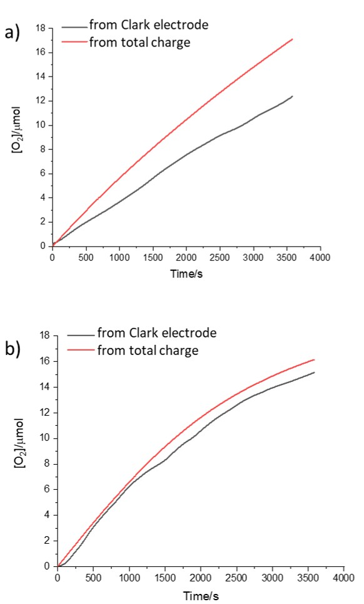
Figure S7. O₂ evolution measurements at 1.3V vs NHE in phosphate buffer 0.1M of a) bare BiVO₄-WO₃ and b) p-[LCu]²⁻@BiVO₄-WO₃ using Clark electrode (black line) and calculated using the total charge that passed through the cell (red line).

a)
b)
Figure S8. a) 500 nm kinetics in BiVO₄-WO₃ in the 0.54/1.15 V vs NHE interval, 0.1 M phosphate buffer b) 500 nm kinetics in p-[LCu]²⁻@BiVO₄-WO₃ in the 0.54/1.15 V vs NHE interval, 0.1 M phosphate buffer

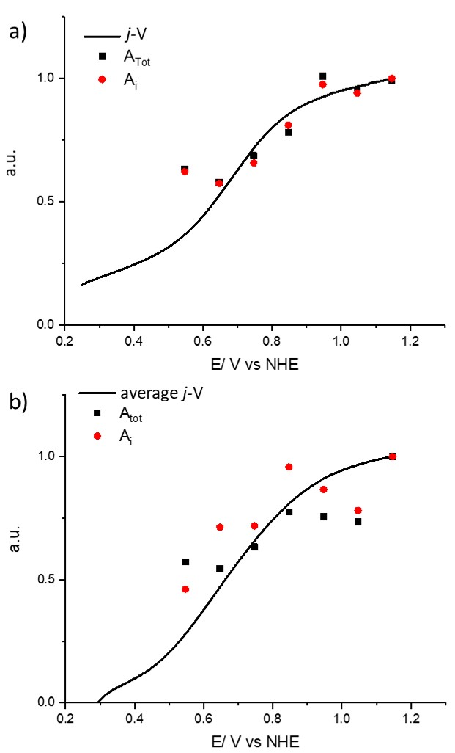
Figure S9. a) Normalized j-V curve vs. normalized 500 nm amplitude as a function of the applied voltage in p-[LCu]²⁻@BiVO₄-WO₃. b) Normalized j-V curve vs. normalized 500 nm amplitude as a function of the applied voltage in BiVO₄-WO₃. The averaged j-V curve was used in this case due to the quickly changing response of the photoelectrode.

Calculation of k_{bulk} and k_{rec}
It was not possible to decouple the true interfacial charge transfer rate constant, from bulk recombination and parasitic electrode photocorrosion. Nevertheless, given that at 0.64 V in Figure S9a the photocurrent value is half that of the limiting current, which comes from the integral of the IPCE spectrum multiplied by the photon flux, it can be assumed that at 0.64 V the value of the IPCE at 450 nm is ca. half of that at 1.15 V. Therefore, at 0.64V the IPCE of p-[LCu]²⁻@BiVO₄-WO₃ at 450 nm is ca. 25% (0.25) and is controlled by the factor k_{bulk}/(k_{bulk}+k_{rec}), where k_{bulk} assumes the meaning of an apparent charge separation rate constant:
k_{bulk}/(k_{bulk}+k_{rec}) =0.25 (eq S4)
TAS measurements yielded the photohole lifetime at 0.64V, which was found to be 0.3s (Figure 6c, red line). This lifetime is defined as follows:
<τ> = 1/(k_{bulk}+k_{rec}) ≈0.3 s (eq S5)
Upon multiplying both sides by k_{bulk}, the result is:
k_{bulk}/(k_{bulk}+k_{rec})= k_{bulk} $∙$0.3 s (eq S6)
from equation S4 we know that k_{bulk}/(k_{bulk}+k_{rec}) is equal to 0.25. Consequently:
k_{bulk}= $\frac{0.25}{0.3s}=0.83 s^{-1}$ (eq S7)
The value of k_{rec} is then calculated by replacing k_{bulk} with $0.83s^{-1}$ in equation S5, yielding:
k_{rec} = 2.5$s^{-1}$ (eq S8)
Similarly, it is possible to obtain the k_{bulk} and k_{rec} values for bare WO₃-BiVO₄ using the same reasoning. In this case, the maximum IPCE at 450 nm is ca. 40%, while the IPCE at half the photocurrent is ≈20%, therefore:
k_{bulk}/(k_{bulk}+k_{rec}) = 0.2 (eq S9)
TAS measurements yielded a maximum photohole lifetime of 0.2 s at 0.74V (Figure 6c, black line):
<τ> = 1/(k_{bulk}+k_{rec}) ≈0.2s (eq S10)
The comparison of equations S9 and S10 immediately shows that:
k_{bulk}= $\frac{0.2}{0.2}=1 s^{-1}$ (eq S11)
Insertion of this value in equation S10 finally gives:
k_{rec} = 4$s^{-1}$ (eq S12)

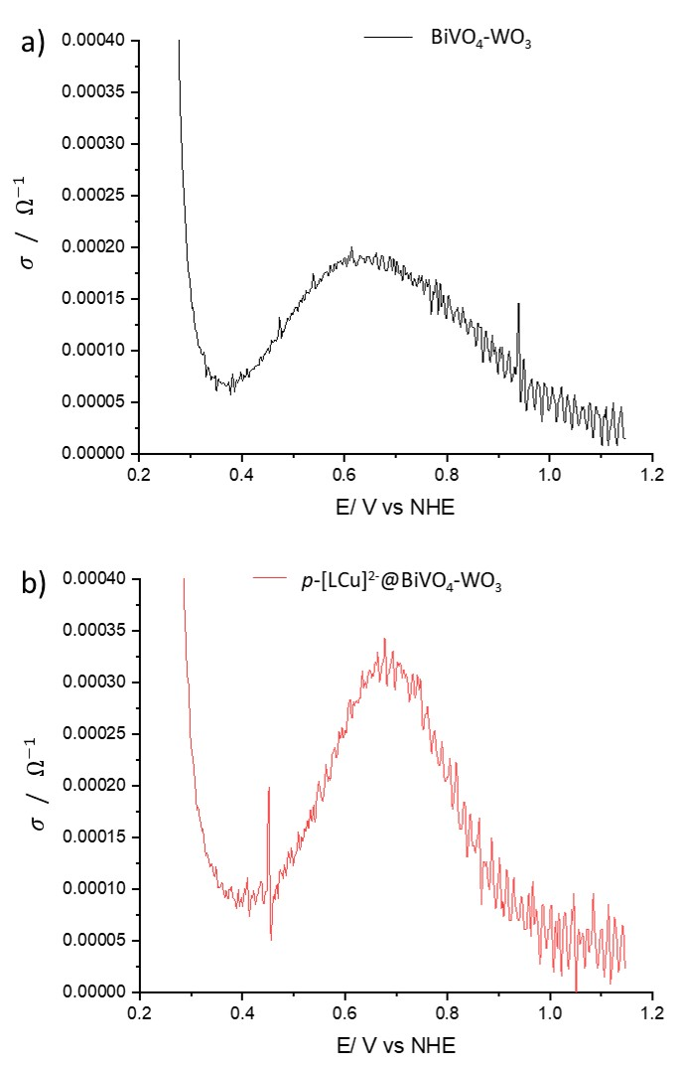
Figure S10. Conductivity of a) BiVO₄-WO₃ and b) p-[LCu]²⁻@BiVO₄-WO₃, as a function of V vs NHE, in 0.1 M phosphate buffer

a)

b)
Figure S11. Recombination transients of BiVO₄-WO₃ (red line) and p-[LCu]²⁻@BiVO₄-WO₃ (black line) at a)0.54V and b)0.74V vs NHE in 0.1 M phosphate buffer

a)

b)
Figure S12. Charge trapped in surface states of BiVO₄-WO₃ (red line) and p-[LCu]²⁻@BiVO₄-WO₃ (black line) at a) 0.54V and b) 0.74V vs NHE in 0.1 M phosphate buffer

Microscopy analysis
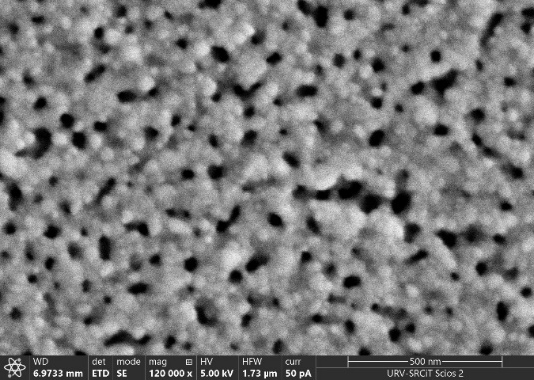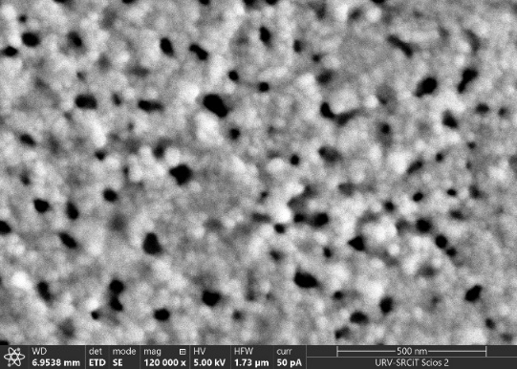
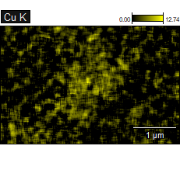
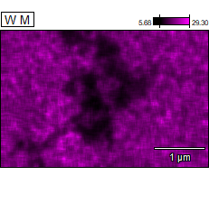
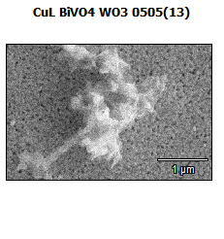
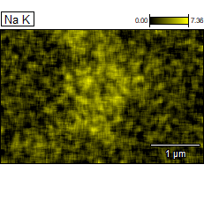
Figure S13. FESEM images of BiVO₄-WO₃ (left) and of p-[LCu]²⁻@BiVO₄-WO₃ (right).
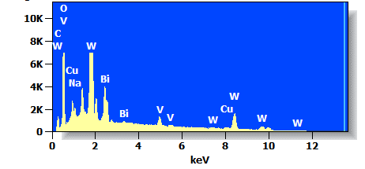
Figure S14a. Top, FESEM and EDX analysis of the p-[LCu]²⁻@BiVO₄-WO₃ surface before catalysis. The yellow and pink images indicate the presence of the different elements on the aggregation over the semiconductor surface. Bottom, EDX spectrum.

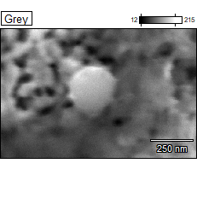 | 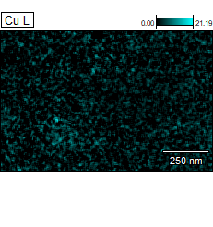
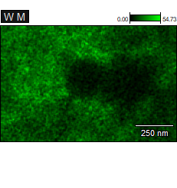 | 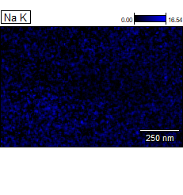
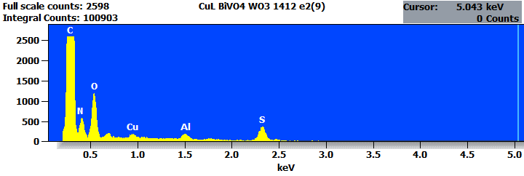

Figure S14b. Top, FESEM and EDX analysis of the p-[LCu]²⁻@BiVO₄-WO₃ surface after catalysis. The green and blue images indicate the presence of the different elements on the aggregation over the semiconductor surface. Bottom, EDX spectrum.

X-ray absorption spectroscopy
Cu K-edge X-ray Absorption Spectroscopy (XAS) measurements were conducted at the BM-08 LISA CRG beamline⁵ of the European Synchrotron Radiation Facility (ESRF) in Grenoble during experimental sessions CH6248 and A08-1-1078 (doi.org/10.15151/ESRF-ES-804822314). A sagittally focusing Si(111) Double Crystal Monochromator (DCM) was used to select the X-ray energy, yielding a beam spot of approximately 100 × 100 μm² on the sample and an energy resolution of ΔE/E ≈ 10⁻⁴. X-ray fluorescence at the Cu-Kα line was collected using a 12-element high-purity Ge detector and normalized to the incident beam intensity. To suppress low-energy fluorescence signals from foreign elements (e.g., Ca, Si, Sn), an aluminum filter was applied to the detector. Energy calibration was performed using a Cu reference foil. All measurements were carried out at room temperature under vacuum.
Quantitative analysis of the EXAFS signal wad performed using the ATHENA⁶ software. The structural model used to fit the EXAFS data was taken from a related system reported in the literature⁷ as cif file of [(Mac)Cu]²⁻ system (structure number 1959710). The calculation of the possible scattering paths that give a contribution to the EXAFS signal was performed using FEFF⁸ code built in ARTEMIS⁶ software. Both single scattering and multi-scattering paths were considered in order to have a reliable representation of the EXAFS spectrum.⁹ In this regard, only intra-molecule paths were considered, neglecting contributions coming from other molecules. In Table S1 we report the paths used for fitting the data and in Figure S9 their relative geometry.
The fit was performed considering the Fourier transform of the EXAFS signal between 3–10 Å⁻¹, adopting a Hanning window and using 10 parameters for the refining procedure: a common shift of the energy origin (∆E), independent variations of the path lengths (∆R) and Debye Waller factors (σ²), except for σ² for paths 2 and 3 which were constrained to be equal since they involve the same elements and in order to avoid too many fitting parameters. The amplitude reduction factor S₀² was set to 0.9 for all fits in order to reduce the errors on the Debye Waller factors and the number of free parameters. This choice is justified by the difficulty, especially when low Z atoms are present, in the determination of the amplitude reduction factor and the Debye Waller factors independently, since they are highly correlated in the fitting procedure. Models with different realistic values of the path degeneracies were tested, starting from those derived from the aforementioned cif file; we report in Table S1 the degeneracy values that give the best fit in terms of lowest R-factor. In Figure 5. of the main text, we display the best fit curves in real space while the numerical values of the parameters are reported in Table S2. In Table S2 we report also the results of the fit performed on a reference sample [LCu]²⁻ and already discussed in a previous work.¹⁰
The procedure adopted for EXAFS data fitting is described in detail in a previous work on the same macrocyclic system deposited on a glassy carbon substrate.¹⁰
The overall comparison between fit and experimental data is good, as supported by the low value of the R-factor reported in Table S2. The main feature of the Fourier transform of the EXAFS signal is the peak at around 1.5 Å, given by the contribution of the first coordination shell made by four N atoms around the absorber. The result of the fit shows that there is no significative displacement of the first shell after 30 minutes of photoelectrolysis, as indicated by the total interatomic distance R_{eff}+∆R which is 1.930 ± 0.018 Å in the fresh sample and 1.916 ± 0.011 Å after the catalysis. Smaller peaks are also present in the Fourier transform at higher distance, representing the contribution of the other scattering paths illustrated in Figure S15 (see Figure 5b in the main text). In this case there are no significative variations in the total interatomic distance, as reported in Table S2. This analysis suggests that the structure of the macrocyclic remains almost unchanged after 30 minutes of working time.
The comparison with the reference sample [LCu]²⁻ reveals a small expansion, from 1.877 Å to 1.930 Å, of the first shell after the deposition of the molecule on the BiVO₄-WO₃ substrate. The expanded value is close to the value 1.947 Å obtained for [LCu]²⁻ deposited on glassy carbon substrate and subjected to 24 h of constant potential electrolysis. ¹⁰ This result suggests that the interaction with the semiconductor induces a small distortion of the molecule.

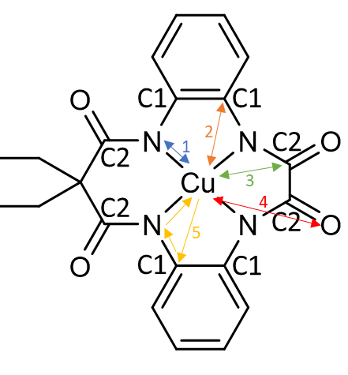
Figure S15: Geometry of the scattering paths.

Table S1: List of the scattering paths used for the fitting of experimental data.
Table S2: Fit parameters obtained from the EXAFS analysis.
Sample | Path code | R (Å) (Reff+∆R) | σ² | ∆E₀ | R-factor
Fresh | 1 | 1.930 (18) | 0.005 (1) | -2.0 (3.0) | 0.011
 | 2 | 3.310 (51) | 0.007 (5)
 | 3 | 2.485 (33) | 0.007 (5)
 | 4 | 4.199 (89) | 0.013 (12)
 | 5 | 2.545 (97) | 0.000 (5)
After | 1 | 1.916 (11) | 0.003 (1) | -3.5 (2.0) | 0.005
 | 2 | 3.267 (26) | 0.003 (3)
 | 3 | 2.477 (27) | 0.003 (3)
 | 4 | 4.094 (47) | 0.008 (5)
 | 5 | 2.517 (92) | 0.000 (5)
[LCu]²⁻ | 1 | 1.877 (4) | 0.07 (1) | 3.4 (8) | 0.008
 | 2 | 3.140 (28) | 0.006 (2)
 | 3 | 2.758 (17) | 0.006 (2)
 | 4 | 4.100 (15) | 0.000 (2)
 | 5 | 3.123 (60) | 0.014(25)

Table S3: Fit parameters obtained from the EXAFS analysis of a reference CuO powder.
Sample | Path | Degeneracy | R (Å) (Reff+∆R) | σ² | ∆E₀ | R-factor
CuO | $$Cu→O1$$ | 4 | 1.950 (7) | 0.004 (1) | 6.2 (0.7) | 0.007
 | $$Cu→Cu1$$ | 4 | 2.866 (13) | 0.007 (2)
 | $$Cu→Cu2$$ | 6 | 3.052 (14) | 0.009 (2)
 | $$Cu→O2$$ | 4 | 4.295 (35) | 0.003 (5)

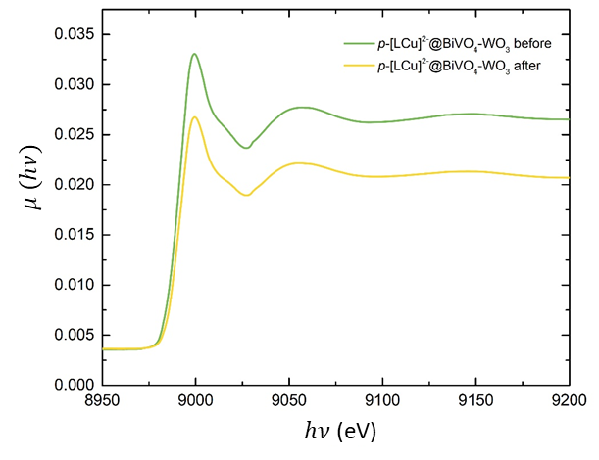
Figure S16: Cu K-edge XANES spectra of p-[LCu]²⁻@BiVO₄-WO₃ before (green trace) and after photoelectrolysis (yellow trace). The fluorescence signal was normalized to the incident beam intensity but, different from Figure 5b, was not normalized between 0 and 1. All experimental parameters (beam size, detector setup) are the same in the two measurements. Therefore, the lower jump observed for the sample after photoelectrolysis indicates a lower density of Cu atoms at its surface, which is attributed to partial de-anchoring of the catalysts from the electrode.

Raman spectroscopy
Figure S17. Left: resonance Raman (rR) spectra of CuO (powder, blue trace), [LCu]²⁻, (powder, black trace), bare BiVO₄-WO₃ (red trace), and p-[LCu]²⁻@BiVO₄-WO₃ both before catalysis (green trace) and after catalysis (cyan trace). Right: enlargement of the 250-750 cm⁻¹ zone. Vibrations at 295, 345 and 625 cm⁻¹ observed only in the CuO case, are associated with the Cu-O vibrations according to the literature.¹² Measurement were carried out with a Renishaw inVia Raman Microscope equipped with a 532 nm laser, coupled with a Leica DM-2500 microscope with an objective lens of 50x/0.75. Calibration was carried out with respect to Si standard. Spectra integration time was 30 seconds and spectra shown correspond to three to twenty accumulations. Laser power used was 1% of the nominal power (50 mW 532nm laser).

References
(1) Cristino, V.; Marinello, S.; Molinari, A.; Caramori, S.; Carli, S.; Boaretto, R.; Argazzi, R.; Meda, L.; Bignozzi, C. A. Some Aspects of the Charge Transfer Dynamics in Nanostructured WO ₃ Films. J Mater Chem A Mater 2016, 4 (8), 2995–3006. https://doi.org/10.1039/C5TA06887H.
(2) Meda, L.; Tozzola, G.; Tacca, A.; Marra, G.; Caramori, S.; Cristino, V.; Alberto Bignozzi, C. Photo-Electrochemical Properties of Nanostructured WO3 Prepared with Different Organic Dispersing Agents. Solar Energy Materials and Solar Cells 2010, 94 (5), 788–796. https://doi.org/10.1016/j.solmat.2009.12.025.
(3) Cristino, V.; Pasti, L.; Marchetti, N.; Berardi, S.; Bignozzi, C. A.; Molinari, A.; Passabi, F.; Caramori, S.; Amidani, L.; Orlandi, M.; Bazzanella, N.; Piccioni, A.; Kesavan, J. K.; Boscherini, F.; Pasquini, L. Photoelectrocatalytic Degradation of Emerging Contaminants at WO3/BiVO4 Photoanodes in Aqueous Solution. Photochemical & Photobiological Sciences 2019, 18 (9), 2150–2163. https://doi.org/10.1039/c9pp00043g.
(4) Seabold, J. A.; Choi, K.-S. Efficient and Stable Photo-Oxidation of Water by a Bismuth Vanadate Photoanode Coupled with an Iron Oxyhydroxide Oxygen Evolution Catalyst. J Am Chem Soc 2012, 134 (4), 2186–2192. https://doi.org/10.1021/ja209001d.
(5) d’Acapito, F.; Lepore, G. O.; Puri, A.; Laloni, A.; La Manna, F.; Dettona, E.; De Luisa, A.; Martin, A. The LISA Beamline at ESRF. J Synchrotron Radiat 2019, 26 (2), 551–558. https://doi.org/10.1107/S160057751801843X.
(6) Ravel, B.; Newville, M. ATHENA, ARTEMIS, HEPHAESTUS: Data Analysis for X-Ray Absorption Spectroscopy Using IFEFFIT. J Synchrotron Radiat 2005, 12 (4), 537–541. https://doi.org/10.1107/S0909049505012719.
(7) Garrido-Barros, P.; Moonshiram, D.; Gil-Sepulcre, M.; Pelosin, P.; Gimbert-Suriñach, C.; Benet-Buchholz, J.; Llobet, A. Redox Metal-Ligand Cooperativity Enables Robust and Efficient Water Oxidation Catalysis at Neutral PH with Macrocyclic Copper Complexes. J Am Chem Soc 2020, 142 (41), 17434–17446. https://doi.org/10.1021/jacs.0c06515.
(8) Zabinsky, S. I.; Rehr, J. J.; Ankudinov, A.; Albers, R. C.; Eller, M. J. Multiple-Scattering Calculations of x-Ray-Absorption Spectra. Phys Rev B 1995, 52 (4), 2995–3009. https://doi.org/10.1103/PhysRevB.52.2995.
(9) Rossi, G.; D’Acapito, F.; Amidani, L.; Boscherini, F.; Pedio, M. Local Environment of Metal Ions in Phthalocyanines: K-Edge X-Ray Absorption Spectra. Physical Chemistry Chemical Physics 2016, 18 (34), 23686–23694. https://doi.org/10.1039/c6cp04022e.
(10) Amthor, S.; Ranu, K.; Bellido, C. G.; Salomón, F. F.; Piccioni, A.; Mazzaro, R.; Boscherini, F.; Pasquini, L.; Gil‐Sepulcre, M.; Llobet, A. Robust Molecular Anodes for Electrocatalytic Water Oxidation Based on Electropolymerized Molecular Cu Complexes. Advanced Materials 2023, 2308392. https://doi.org/10.1002/adma.202308392.
(11) Grau, S.; Berardi, S.; Moya, A.; Matheu, R.; Cristino, V.; Vilatela, J. J.; Bignozzi, C. A.; Caramori, S.; Gimbert-Suriñach, C.; Llobet, A. A Hybrid Molecular Photoanode for Efficient Light-Induced Water Oxidation. Sustainable Energy Fuels 2018, 2 (9), 1979–1985. https://doi.org/10.1039/C8SE00146D.
(12) Xu, J. F.; Ji, W.; Shen, Z. X.; Li, W. S.; Tang, S. H.; Ye, X. R.; Jia, D. Z.; Xin, X. Q. Raman Spectra of CuO Nanocrystals. J. Raman Spectrosc. 1999, 30, 413–415. https://doi.org/10.1002/(SICI)1097-4555(199905)30:5%3C413::AID-JRS387%3E3.0.CO;2-N.

