Supporting Information

Comparing the performance of Electrostatic Repulsion-Reversed Phase chromatography approaches in the resolution of complex peptide mixture: Liraglutide as case study

Simone Manettoª, Giulia Mazzoccanti*ª, Michele Bassan^{b}, Marco Macis^{b}, Walter Cabri^{c}, Alessia Ciogliª, Antonio Ricci*^{b}, Francesco Gasparrini*ª
ª Department of Drug Chemistry and Technology, “Sapienza” University of Rome, 00185 Rome, Italy
^{b} Fresenius Kabi iPSUM, Via Roma 108, 20051 Cassina de Pecchi, Italy
^{c} Department of Chemistry, Alma Mater Studiorum-University of Bologna, Via Gobetti 84, 40129Bologna, Italy

S1. A) Column: ACQUITY Premier Glycan BEH-95A C18 AX, 150 x 2.1 mm (L.xI.D.), 1.7 μm,
B) column: ACQUITY Premier Glycan BEH-130A C18 CSH, 150 x 2.1 mm (L.xI.D.), 1.7 μm. Mobile phases A) water + 0.1 % DFA B) ACN + 0.1% DFA, T_{col} =40 °C. tG 60 minutes, from 20 % B to 60 % B.

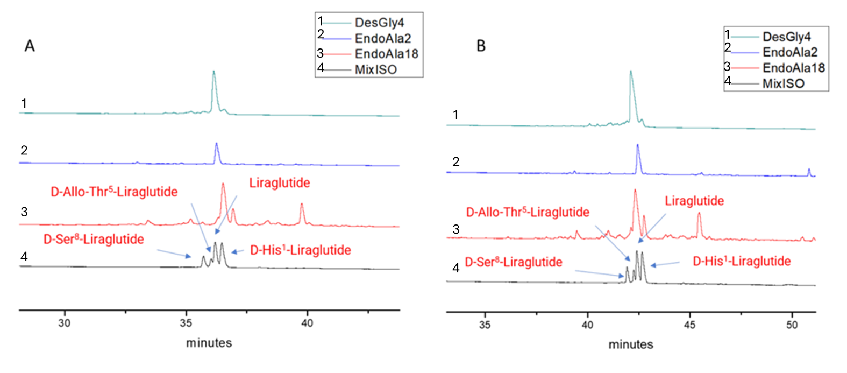

S2 Column: ACQUITY Premier Glycan BEH-95A C18 AX, 150 x 2.1 mm (L.xI.D.), 1.7 μm. Mobile phases A) water + 0.05 % FA and 0.01 % TFA B) ACN + 0.05 % FA and 0.01 % TFA, T_{col} =40 °C. tG 60 minutes, from 20 % B to 60 % B
