Supplementary Material

Use of isavuconazole in critically ill patients in intensive care units:
a prospective, observational, multicentre, cohort study

Daniele Roberto GIACOBBE^{1,2,}*, Claudia BARTALUCCI¹, Martina BAVASTRO^{1,2}, Riccardo SCHIAVONI^{1,2}, Vincenzo DI PILATO^{3,4}, Marco MUCCIO², Alessio SIGNORI⁵, Chiara ALDIERI⁶, Jacopo ANGELINI^{7,8}, Erika ASPERGES^{9,10}, Elisabetta BLASI VACCA¹¹, Nicoletta BOFFA¹², Enrica BONO¹⁰, Bruno CACOPARDO¹³, Alessandra CALABRESI¹⁴, Martina CASARINI¹⁵, Annamaria CATTELAN¹⁶, Silvia CORCIONE^{17,18}, Federica COSENTINO¹³, Gennaro DE PASCALE^{19,20}, Francesco Giuseppe DE ROSA¹⁷, Valerio DEL BONO⁶, Filippo DEL PUENTE¹¹, Chiara FANELLI²¹, Fiorenza FAVA²², Erica FRANCESCHINI²³, Nicholas GEREMIA^{24,25}; Maddalena GIANNELLA^{15,26}, Simone GIULIANO²⁷, Ivana MAIDA²¹, Andrea MARINO¹³, Maria MAZZITELLI^{16,28,29}, Maria Chiara MELONI²¹, Marco MERLI³⁰, Marianna MESCHIARI²³, Chiara MOREAL⁷, Chiara OLTOLINI³⁰, Rita PALLONE^{31,32}, Sandro PANESE^{24,25}, Emanuele PONTALI¹¹, Martina RICCIARDETTO²³, Matteo RINALDI^{15,26}, Alessandro RUSSO^{31,32}, Maurizio SANGUINETTI^{19,33}, Vincenzo SCAGLIONE¹⁶, Francesca SERAPIDE^{31,32}, Francesco Saverio SERINO³⁴, Nour SHBAKLO¹⁷, Carlo TORTI^{28,29}, Giovanna TRAVI³⁰, Laura MAGNASCO², Federica PORTUNATO², Federica BRIANO², Malgorzata MIKULSKA^{1,2}, Lorenzo BALL^{3,35}, Chiara ROBBA^{3,35}, Nicolò PATRONITI^{3,35}, Denise BATTAGLINI^{3,35}, Mauro GIACOMINI³⁶, Erika COPPO⁴, Anna MARCHESE^{3,4}, Antonio VENA^{1,2}, Matteo BASSETTI^{1,2}; on behalf of ISA-SITA investigators†

† ISA-SITA investigators (collaborators): Ylenia MURGIA; Gabriele DI MECO; Alice CAPPELLO; Sabrina GUASTAVINO; Cristina CAMPI; Michele PIANA; Sara MORA; Nicola ROSSO; Antonio DI BIAGIO; Giulia VIGLIETTI; Annaflavia LAMARINA; Stefano ANTOLA; Selene GALLONE; Pierluigi VIALE; Edoardo Antonio CAMPANELLA; Alessandro FRANZÒ; Chiara GULLOTTA; Davide COSTARELLA; Andrea BRUNI; Eugenio GAROFALO; Federico LONGHINI; Silvia BONI; Stefania TIGANO; Maddalena ALBERTINI; Davide CHEMELLO; Antonella SANTORO; Daniele MENGATO; Martina MUNARI; Paolo NAVALESI; Ivo TIBERIO; Ilaria DE BENEDETTO; Tommaso LUPIA; Simone MORNESE PINNA; Sara FERIN; Sarah FLAMMINI; Luca MARTINI; Luca MONTANARI; Stefania MUSSO; Federico D’AMICO; Serena SASSI; Elena SIMONCINI; Elena MOMESSO; Fabiola CAMMAROTA; Alessandro CAROLI; Daniel LIVANU; Angela Raffaella LOSITO.

¹ Department of Health Sciences (DISSAL), University of Genoa, Genoa, Italy
² Clinica Malattie Infettive, IRCCS Ospedale Policlinico San Martino, Genoa, Italy
³ Department of Surgical Sciences and Integrated Diagnostics (DISC), University of Genoa, Genoa, Italy
⁴ UO Microbiologia, IRCCS Ospedale Policlinico San Martino, Genoa, Italy
⁵ Section of Biostatistics, Department of Health Sciences (DISSAL), University of Genoa, Genoa, Italy
⁶ Infectious Diseases Unit, Santa Croce e Carle Hospital, Cuneo, Italy
⁷ Department of Medicine (DMED), University of Udine, Udine, Italy
⁸ Clinical Pharmacology and Toxicology Institute, University Hospital Friuli Centrale ASUFC, Udine, Italy
⁹ Department of Diagnostic, Paediatric, Clinical and Surgical Sciences, University of Pavia, Pavia, Italy
¹⁰ SC Malattie Infettive, Fondazione IRCCS Policlinico San Matteo, Pavia, Italy
¹¹ SC Malattie Infettive, EO Galliera, Genova, Italy
¹² UOC Anestesia e Rianimazione, ASL 4 Veneto Orientale, San Donà di Piave, Italy
¹³ Department of Clinical and Experimental Medicine, University of Catania, Catania, Italy
¹⁴ AOU “SS Antonio, Biagio e Cesare Arrigo”, Alessandria, Italy
¹⁵ Department of Medical and Surgical Sciences, Alma Mater Studiorum University of Bologna, Bologna, Italy
¹⁶ Infectious and Tropical Diseases Unit, Padua University Hospital, Padua, Italy
¹⁷ Infectious Diseases, Department of Medical Sciences, University of Turin, Turin, Italy
¹⁸ Tufts University School of Medicine, Boston, MA, USA
¹⁹ Dipartimento di Scienze Biotecnologiche di Base, Cliniche Intensivologiche e Perioperatorie, Università Cattolica del Sacro Cuore, Rome, Italy
²⁰ Dipartimento di Scienze dell'Emergenza, Anestesiologiche e della Rianimazione, Fondazione Policlinico Universitario A. Gemelli IRCCS, Rome, Italy
²¹ Department of Medicine, Surgery and Pharmacy, University of Sassari, Sassari, Italy
²² Anestesia e Terapia Intensiva Cardiotoracica, Fondazione IRCCS Policlinico San Matteo, Pavia, Italy
²³ Infectious Diseases Unit, Azienda Ospedaliera-Universitaria of Modena, University of Modena and Reggio Emilia, Modena, Italy
²⁴ Unit of Infectious Diseases, Department of Clinical Medicine, Ospedale “dell’Angelo”, Venice, Italy
²⁵ Unit of Infectious Diseases, Department of Clinical Medicine, Ospedale Civile “S.S. Giovanni e Paolo”, Venice, Italy
²⁶ Department for Integrated Risk Management, Infectious Disease Unit, IRCCS Azienda Ospedaliero-Universitaria di Bologna, Bologna, Italy
²⁷ Infectious Diseases Clinic, Azienda Sanitaria Universitaria Friuli Centrale, Udine, Italy
²⁸ Dipartimento di Scienze Mediche e Chirurgiche, UOC Malattie Infettive, Fondazione Policlinico Universitario Agostino Gemelli IRCCS, Rome, Italy
²⁹ Dipartimento di Sicurezza e Bioetica, Università Cattolica del Sacro Cuore, Sez. Malattie Infettive, Rome, Italy
³⁰ Infectious Diseases Clinic, ASST Grande Ospedale Metropolitano Niguarda, Milan, Italy
³¹ Department of Medical and Surgical Sciences, ‘Magna Graecia’ University of Catanzaro, Catanzaro, Italy
³² Infectious and Tropical Disease Unit, “Renato Dulbecco” Hospital, Catanzaro, Italy
³³ Dipartimento di Scienze di Laboratorio Ed Ematologiche, Fondazione Policlinico Universitario A. Gemelli IRCCS, Rome, Italy
³⁴ UOC Medicina, ASL 4 Veneto Orientale, Portogruaro, Italy
³⁵ Anesthesia and Intensive Care, IRCCS Ospedale Policlinico San Martino, Genoa, Italy
³⁶ Department of Informatics, Bioengineering, Robotics and System Engineering (DIBRIS), University of Genoa, Genoa, Italy

* Corresponding author:
Daniele Roberto Giacobbe, MD, PhD
Clinica Malattie Infettive, IRCCS Ospedale Policlinico San Martino
L.go R. Benzi, 10 – 16132 Genoa, Italy
Telephone: +39 010 555 4654; Fax: +39 010 5556712
Email address: danieleroberto.giacobbe@unige.it

Running title: Use of isavuconazole in critically ill patients

Table S1. Multivariable analysis of factors associated with 30-day mortality in critically ill patients with proven and probable invasive aspergillosis/mucormycosis treated with isavuconazole (model B including centre as shared frailty)

Variables | HR (95% CI) | P
SOFA score | 1.14 (1.03-1.26) | 0.010
Concomitant CABP, HABP, or VABP | 2.32 (1.17-4.59) | 0.016
Tables S1 legend. Analyses conducted after multiple imputation (for details, see study methods). CABP, community-acquired bacterial pneumonia; HABP, hospital-acquired bacterial pneumonia; VABP, ventilator-associated pneumonia.

Table S2. Multivariable analysis of factors associated with 90-day mortality in critically ill patients with proven and probable invasive aspergillosis/mucormycosis treated with isavuconazole (model D including centre as shared frailty)

Variables | HR (95% CI) | P
Prior hospitalization | 2.26 (1.19-4.27) | 0.013
SOFA score | 1.17 (1.07-1.28) | <0.001
Tables S2 legend. Analyses conducted after multiple imputation (for details, see study methods).

Figure S1. Flow-chart of the patient inclusion process

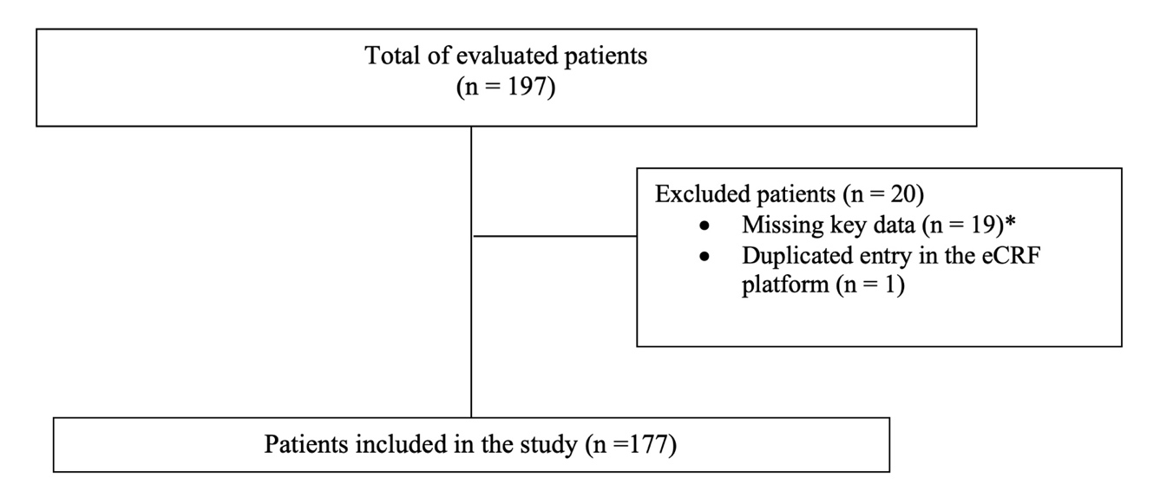

Figure S1 legend. eCRF, electronic case record form. * Lack of information on ICU admission.

Figure S2. Cumulative mortality up to day 90 in critically ill patients with proven and probable invasive aspergillosis/mucormycosis treated with isavuconazole

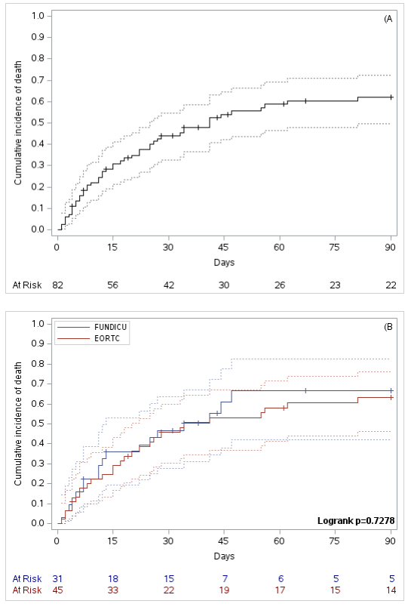

Figure S2 legend. Panel A. Cumulative mortality up to day 90 in ICU patients with proven or probable invasive mould disease treated with isavuconazole. Panel B. Cumulative mortality up to day 90 in ICU patients with probable invasive mould disease treated with isavuconazole, stratified for classification as probable according to EORTC/MSGERC versus FUNDICU definitions. For both panels, the time of origin was set at the day of isavuconazole initiation. Death was the event of interest and right-censoring was applied at the end of follow-up (loss to follow-up before day 90, e.g., for hospital discharge, or day 90, whichever came first). For further details, see methods. EORTC, European Organization for Research and Treatment of Cancer; FUNDICU, invasive FUNgal Diseases in adult patients in Intensive Care Unit; MSGERC, Mycoses Study Group Education and Research Consortium.

