Effect of faecal microbial transplantation on clinical outcome, faecal microbiota and metabolome in dogs with chronic enteropathy refractory to diet

CG Vecchiato^{1*}, MC Sabetti², CH Sung³, F Sportelli¹, C Delsante¹, C Pinna¹, M Alonzo⁴, D Erba⁴, JS Suchodolski³, R Pilla³, M Pietra¹, G Biagi¹, F Procoli⁴
¹Department of Veterinary Medical Sciences, University of Bologna, Italy
²Department of Veterinary Sciences, University of Parma, Via Taglio 8, 43100, Parma, Italy ³Gastrointestinal Laboratory, Texas A&M University, USA
⁴Anicura Ospedale Veterinario I Portoni Rossi, Bologna, Italy

*Corresponding author: carla.vecchiato2@unibo.it

Supplementary File

Table S1. Relevant data from healthy dogs (n=17) which were used to compare the microbial changes in faeces of CE dogs refractory to diet in response to FMT. Data are expressed as numbers or median and range.

Age (months) | 38 (12-84)
Body weight (kg, median (range) | 14.3 (1.3-35)
Sex  Castrated male  Spayed female  Intact female | n = 8  n = 6  n = 3
Breeds  Mixed breed  Chihuahua, Border collie, German Shepherd, Labrador Retriever, Poodle | n = 12  n = 1 (each)
Microbial data
Dysbiosis Index | -3.7 (-6.6 to -0.7)
P. hiranonis (Log DNA) | 6.3 (5.6-6.9)

Table S2. Faecal pH, NH₃ (µmol/g of fresh faeces) and sterols (µg/mg of dry faeces) in dogs with CE refractory to diet assessed before (T0) and 30 (T1), 60 (T2) and 90 (T3) days after FMT. Data are expressed as median and range.
 | T0 | T1 | T2 | T3
pH | 6.8 [5.9-7.5] | 6.9 [6-8.52] | 6.7 [5.7-7.9] | 6.7 [5.6-7.7]
NH₃ | 32 [10-71] | 33 [10-79] | 28 [9-65] | 28 [19-91]
Coprostanol | 0.01 | 0.02 | 0.01 | 0.02
RI [0.04-0.19] | [0.01-0.03] | [0.01-0.4] | [0.01-0.5] | [0.01-0.2]
﻿Cholesterol | 1.9 | 2.9 | 3.4 | 2.8
RI [0.81-8.83] | [0.9-8.7] | [0.9-20] | [0.8-24] | [0.9-8.6]
﻿﻿Cholestanol | 0.13 | 0.19 | 0.17 | 0.18
RI [0.05-0.42] | [0.03-0.5] | [0.03-0.5] | [0.04-0.3] | [0.04-0.5]
﻿﻿Lathosterol | 0.01 | 0.01 | 0.02 | 0.02
RI [0.02-0.06] | [0.01-0.06] | [0.01-0.11] | [0.01-0.09] | [0.01-0.07]
﻿﻿Total Zoosterols | 2.1 | 3.2 | 3.8 | 3.0
RI [0.93-9.24] | [1-9.6] | [0.9-20] | [0.8-25] | [0.9-9.1]
﻿Brassicasterol | 0.02 | 0.02 | 0.02 | 0.02
RI [0.04-0.23] | [0.01-0.17] | [0.01-0.06] | [0.01-0.11] | [0.01-0.15]
﻿﻿Campesterol | 0.3 | 0.3 | 0.3 | 0.5
RI [0.27-2.27] | [0.06-0.81] | [0.19-0.92] | [0.18-1.1] | [0.15-1.2]
﻿﻿Stigmasterol | 0.25 | 0.28 | 0.26 | 0.41
RI [0.08-1.06] | [0.1-0.83] | [0.12-0.57] | [0.09-0.53] | [0.08-0.6]
﻿﻿Fusosterol | 0.07 | 0.08 | 0.07 | 0.09
RI [0.03-0.22] | [0.02-0.48] | [0.04-0.68] | [0.02-0.64] | [0.04-0.66]
﻿﻿β-sitosterol | 1.43 | 1.53 | 1.58 | 2.11
RI [0.37-4.28] | [0.27-3.8] | [0.74-4.2] | [0.45-3.0] | [0.78-4.0]
﻿﻿Sitostanol | 0.08 | 0.09 | 0.06 | 0.08
RI [0.01-0.74] | [0.03-0.68] | [0.03-0.91] | [0.03-0.49] | [0.05-0.28]
﻿﻿Total Phytosterols | 2.40 | 2.64 | 2.52 | 3.35
RI [0.82-7.71] | [0.62-5.8] | [1.19-6.9] | [0.77-4.8] | [1.0-5.6]
﻿﻿Total sterols | 4.83 | 6.0 | 5.49 | 6.39
RI [2.31-20] | [2.53-15] | [2.87-23] | [2.17-26] | [2.32-13]
RI, reference intervals. Multiple comparisons among T0,T1, T2 and T3 did not differ (P > 0.05)

Table S3. Faecal volatile fatty acids (% of total VFA) in dogs with CE refractory to diet assessed before (T0) and 30 (T1), 60 (T2) and 90 (T3) days after FMT. Data are expressed as median and range.
 | T0 | T1 | T2 | T3
Acetic acid | 56.3 | 53.0 | 56.1 | 51.7
 | [46.8-86.9] | [37.5-82.3] | [39.6-69.1] | [43-83.3]
Propionic acid | 26.0 | 31.9 | 30.5 | 31.7
 | [5.5-47.3] | [3.5-47] | [6.1-54] | [3.5-46.7]
Isobutyric acid | 0.97 | 0.98 | 1.0 | 1.29
 | [0-3.0] | [0.33-4.0] | [0.11-1.9] | [0.13-3.6]
n-butyric acid | 8.42 | 8.36 | 9.20 | 9.56
 | [2.7-22] | [2.4-14] | [3.4-17] | [3.3-17]
﻿Isovaleric acid | 1.32 | 1.37 | 1.47 | 1.71
 | [0-6.5] | [0-6.8] | [0.4-3 | [0-5.4]

Figure S1.

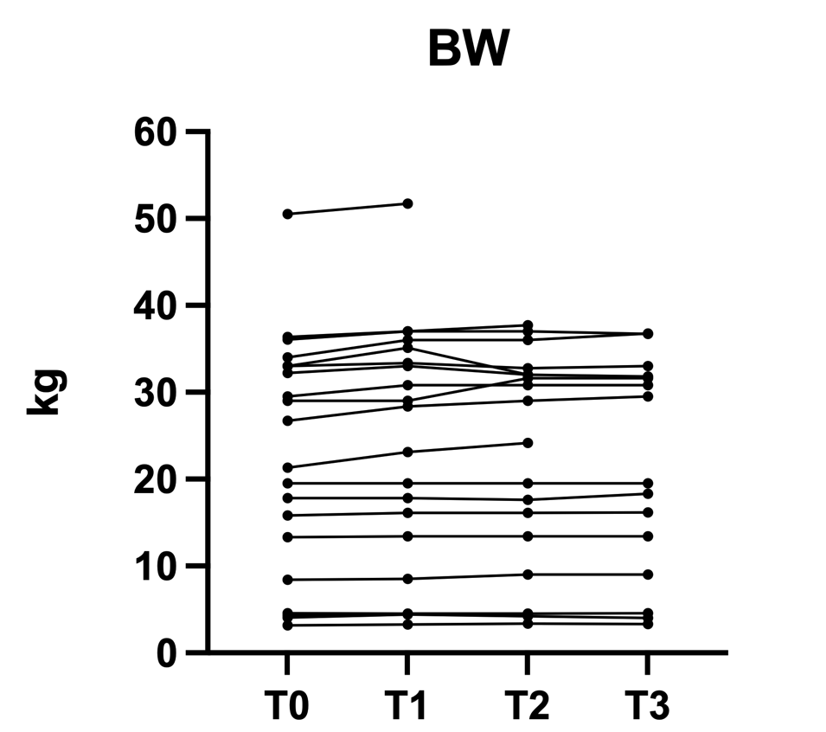

Body weight (kg) assessed in dogs with CE refractory to diet before (T0) and 30 (T1), 60 (T2) and 90 (T3) days after FMT. Missing values are due to patients excluded from the study or owner's lack of compliance, as explained in the manuscript (and in Figure 1).

