APPENDIX
Table 1: Descriptive Statistics

Variable | N | Mean | Std. Dev. | Min | Max | Survey question(s)/ values
Political trust |  |  |  |  |  | If there is a new pandemic in the future, to which extent would you trust following institutions to handle it?  - President  - Federal or National Government  - State or Local Government  Values: 1-10  1 - Do not trust at all (1)  2 - 2  3 - 3  4 - 4  5 - 5  6 - 6  7 - 7  8 - 8  9 - 9  10 - Definitely trust (10)
President | 4652 | 4.635 | 3.195 | 1 | 10
Federal/National Government | 4679 | 4.538 | 3.027 | 1 | 10
State/Local Government | 4692 | 4.672 | 2.913 | 1 | 10

Expert Trust |  |  |  |  |  | If there is a new pandemic in the future, to which extent would you trust following institutions to handle it?  - Public health authorities  - Scientists  - Medical professionals  Values: 1-10  1 - Do not trust at all (1)  2 - 2  3 - 3  4 - 4  5 - 5  6 - 6  7 - 7  8 - 8  9 - 9  10 - Definitely trust (10)
Public health authorities | 4757 | 5.842 | 2.939 | 1 | 10
Scientists | 4764 | 6.626 | 2.836 | 1 | 10
Medical professionals | 4779 | 6.83 | 2.748 | 1 | 10
Policy Support |  |  |  |  |  | We would now like to ask you about our opinions on specific measures that were adopted in your country at different times to mitigate the impact of the pandemic. In your opinion, do you disagree or agree that the authorities did the right thing to introduce:  - mandatory wearing of masks or face coverings in public  - requirements for social distancing, or staying 6 ft from others  - period of self-isolation for those testing positive  - temporary closure of schools, businesses and other areas of public life  - stay-at-home policies that discouraged people from gathering with others outside their households  - nationwide vaccination program  Values: 1-10  1 - Fully disagree (1)  2 - 2  3 - 3  4 - 4  5 - 5  6 - 6  7 - 7  8 - 8  9 - 9  10 – Fully agree (10)
S1 | 4926 | 7.316 | 3.067 | 1 | 10
S2 | 4932 | 7.327 | 2.897 | 1 | 10
S3 | 4925 | 7.935 | 2.642 | 1 | 10
S4 | 4912 | 6.588 | 3.143 | 1 | 10
S5 | 4901 | 6.073 | 3.241 | 1 | 10
S6 | 4896 | 6.996 | 3.289 | 1 | 10
Beliefs in Covid-19 misinformation |  |  |  |  |  | Ever since the beginning of the pandemic, various claims and arguments have been made in the public domain about Covid-19 or the vaccines, which some people believed in, while others considered them to be false. Can you tell us to what extent do you agree or disagree with following statements:
M1 | 5000 | .054 | .663 | -1 | 1 | - Covid-19 was purposefully created in a lab
M2 | 5000 | -.346 | .613 | -1 | 1 | - The U.S. military is behind the creation of the virus
M3 | 5000 | -.245 | .581 | -1 | 1 | - Covid-19 vaccines have been developed using human embryos
M4 | 5000 | -.448 | .62 | -1 | 1 | - Covid-19 vaccines contain microchips
M5 | 5000 | -.203 | .687 | -1 | 1 | - Face masks can make people ill
M6 | 5000 | -.038 | .707 | -1 | 1 | - The official numbers of deaths from Covid-19 have been grossly exaggerated
M7 | 5000 | .045 | .683 | -1 | 1 | - Natural immunity from Covid-19 is better than vaccines
M8 | 5000 | .102 | .665 | -1 | 1 | - Covid-19 vaccines are experimental, and their health risks are not properly known
M9 | 5000 | -.289 | .637 | -1 | 1 | - Covid-19 can change people’s DNA  Values: 1 to 1 scale:  -1 = fully disagree with false statement  -0.5 = rather disagree with false statement  0.5 = rather agree with false statement  1 = fully agree with false statement
News Access |  |  |  |  |  | Typically, how often do you access news? By news we mean national, international, regional/local news accessed via any platform (radio, TV, newspaper or online on computers or mobile devices).  Values: 1-9  1 - Never  2 - Less often than once a month  3 - At least once a month  4 - Once a week  5 - Several times a week  6 - Once a day  7 - 2-5 times a day  8 - 6-10 times a day  9 - 10 + times a day
 | 5000 | 5.62 | 1.941 | 1 | 9

Populist Vote | 5000 | .331 | .47 | 0 | 1 | In the last presidential election, who did you vote for?  - Brazil: 1 – Lula; 2 - Jair Bolsonaro; 3 - Não votei ou votei em branco/nulo  - Poland: 1 - Andrzej Duda; 2 - Rafał Trzaskowski; 3 - Nie głosowałam/łem lub oddałam/łem nieważny głos  - Serbia: 1 - Aleksandar Vučić; 2 - Zdravko Ponoš; 3 - Miloš Jovanović; 4 - Boško Obradović; 5 - Milica Đurđević Stamenkovski; 6 - Biljana Stojković; 7 – Drugo; 8 - Nisam glasao  - United States: 1 - Joe Biden; 2 - Donald Trump; 3 - Another candidate; 4 - I did not vote or voted blank"  Values: 1-4  1 - Voted for populist candidate  0 - Voted for challenger or did not vote/voted blank
Populist Attitudes |  |  |  |  |  | Can you tell us to what extent do you agree or disagree with the following statements:  - The people, not the politicians, should make our most important policy decisions  - The political differences between the people and the elite are larger than the differences among the people  - Elected officials talk too much and take too little action  - What people call "compromise" in politics is really just selling out on one's principles  - The particular interests of the political class negatively affect the welfare of the people  Values: -1 to 1 scale  -1 = fully disagree with false statement  -0.5 = rather disagree with false statement  0.5 = rather agree with false statement  1 = fully agree with false statement
Policy decisions | 5000 | .386 | .551 | -1 | 1
People vs elite | 5000 | .45 | .509 | -1 | 1
Action | 5000 | .574 | .498 | -1 | 1
Compromise | 5000 | .379 | .534 | -1 | 1
Interests | 5000 | .547 | .488 | -1 | 1
Age | 5000 | 45.032 | 16.207 | 18 | 91 | How old are you?  Values: 1-99
Sex | 5000 | Not meaningful | Not meaningful | 1 | 4 | Are you:  Values:  1 - Male  2 – Female  3 – Other  4 - Prefer not to answer
Education | 5000 | 3.306 | 1.06 | 1 | 6 | What is the highest level of education you attained?  Values:  Brazil: 1 - Ensino fundamental incompleto; 2 - Ensino fundamental completo; 3 - Ensino médio completo; 4 - Ensino superior completo  Poland: 1 - Wykształcenie podstawowe; 2 - Wykształcenie średnie bez matury lub wykształcenie zawodowe; 3 - Wykształcenie średnie z maturą; 4 - Wykształcenie wyższe lub wyższe podyplomowe  Serbia: 1 - Završena osnovna škola; 2 - Završena srednja škola, gimnazija, stručna škola; 3 - Završena viša škola; 4 - Završena visoka stručna sprema, fakultet;  United States: 1 - Some High School; 2 - High School Diploma; 3 - Trade School or Apprenticeship; 4 - Some College; 5 - Bachelor's Degree, or higher; 6 - Prefer not to say
Income | 5000 | 6.391 | 3.447 | 1 | 18 | What is your yearly gross household income?{montly - BR, PL, RS; annualy - US}  Values:  Brazil: 1 - Sem renda; 2 - Menos de R$ 600; 3 - De R$ 600 a R$ 1.199; 4 - De R$ 1.200 a R$ 1.799; 5 - De R$ 1.800 a R$ 2.399; 6 - De R$ 2.400 a R$ 2.999; 7 - De R$ 3.000 a R$ 4.499; 8 - De R$ 4.500 a R$ 5.999; 9 - De R$ 6.000 a R$ 8.999; 10 - De R$ 9.000 a R$ 11.999; 11 - De R$ 12.000 a R$ 17.999; 12 - De R$ 18.000 a R$ 23.999; 13 - Acima de R$ 24.000; 14 - Não sei; 15 - Não quero responder  Poland: 1 - Brak dochodu; 2 - Mniej niż 500; 3 - 500 - 1.000 zł; 4 - 1.001 - 1.500 zł; 5 - 1.501 - 2.000 zł; 6 - 2.001 - 2.500 zł; 7 - 2.501 - 3.000 zł; 8 - 3.001 - 3.500 zł; 9 - 3.501 - 4.000 zł; 10 - 4.001 - 5.000 zł; 11 - 5.001 - 6.000 zł; 12 - 6.001 - 7.000 zł; 13 - 7.001 - 8.000 zł; 14 - 8.001 - 9.000 zł; 15 - 9.001 - 10.000 zł; 16 - Powyżej 10.000 zł; 17 - Nie wiem; 18 - Nie chcę odpowiedzieć  Srbija:1 - Nemam prihoda; 2 - Manje od 18.000 Din; 3 - 18.001 - 28.000 Din; 4 - 28.001 - 37.000 Din; 5 - 37.001 - 46.000 Din; 6 - 46.001 - 57.000 Din; 7 - 57.001 - 69.000 Din; 8 - 69.001 - 80.000 Din; 9 - 80.001 - 92.000 Din; 10 - 92.001 - 115.000 Din; 11 - 115.001 - 138.000 Din; 12 - 138.001 - 184.000 Din; 13 - 184.001 - 230.000 Din; 14 - 230.001 - 345.000 Din; 15 - 345.001 - 1,586.000 Din; 16 - Preko 1586.000 Din.; 17 - Ne znam; 18 - Ne želim da odgovorim  United States: 1 - No income; 2 - Less than $ 20,000; 3 - $ 20,000 to $ 29,999; 4 - $ 30,000 to $ 39,999; 5 - $ 40,000 to 49,999; 6 - $ 50,000 to $ 59,999; 7 - $ 60,000 to $ 74,999; 8 - $ 75,000 to $ 84,999; 9 - $ 85,000 to $ 99,999; 10 - $ 100,000 to $ 124,999; 11 - $ 125,000 to $ 149,999; 12 - $ 150,000 to $ 199,999; 13 - $ 200,000 and over; 14 - I do not know; 15 - Prefer not to answer

Table 2: Frequency counts and summary statistics of key demographic variables

Sex:
Brazil | Freq. | Percent
Male | 715 | 47.67
Female | 782 |  | 52.13
Other | 3 | 0.20
Prefer not to answer | 1500 | 100.00
Total | 715 | 47.67

Poland | Freq. | Percent
Male | 480 | 48.00
Female | 518 |  | 51.80
Other | 1 | 0.10
Prefer not to answer | 1 | 0.10
Total | 1000 | 100.00

Serbia | Freq. | Percent
Male | Freq. | Percent
Female | 469 |  | 46.90
Other | 530 | 53.00
Prefer not to answer | 1 | 0.10
Total | 1000 | 100.00

USA | Freq. | Percent
Male | 723 | 48.20
Female | 774 |  | 51.60
Other | 3 | 0.20
Prefer not to answer | 1500 | 100.00
Total | 723 | 48.20

Age:
country | N | mean | sd | min | max
Brazil | 1500 | 41.569 | 14.351 | 18 | 74
Poland | 1000 | 45.954 | 15.308 | 18 | 86
Serbia | 1000 | 41.006 | 13.614 | 18 | 82
USA | 1500 | 50.565 | 18.34 | 18 | 91

Education:

Brazil | Freq. | Percent
Ensino fundamental incompleto [Incomplete fundamental education] | 54 | 3.60
Ensino fundamental completo [Complete fundamental teaching] | 100 |  | 6.67
Ensino médio completo [Completed high school] | 815 | 54.33
Ensino superior completo [Higher education completed] | 531 | 35.40
Total | 1500 | 100.00

Poland | Freq. | Percent
Wykształcenie podstawowe; [Elementary education;] | 28 | 2.80
Wykształcenie średnie bez matury lub wykształcenie zawodowe [Secondary education without high school diploma or vocational education] | 239 |  | 23.90
Wykształcenie średnie z maturą [Secondary education with a high school diploma] | 365 | 36.50
Wykształcenie wyższe lub wyższe podyplomowe [University or postgraduate education] | 368 | 36.80
Total | 1000 | 100.00

Serbia | Freq. | Percent
Završena osnovna škola [Completed elementary school] | 23 | 2.30
Završena srednja škola, gimnazija, stručna škola [Completed secondary school, gymnasium, vocational school] | 454 |  | 45.40
Završena viša škola [Completed high school] | 161 | 16.10
Završena visoka stručna sprema, fakultet [Completed higher professional education, faculty] | 362 | 36.20
Total | 1000 | 100.00

USA | Freq. | Percent
Some High School | 63 | 4.20
High School Diploma | 312 |  | 20.80
Trade School or Apprenticeship | 75 | 5.00
Some College | 399 | 26.60
Bachelor's Degree, or higher | 643 | 42.87
Prefer not to say | 8 | 0.53
Total | 1500 | 100.00

Income:

Brazil | Freq. | Percent | Cum.
No income | 68 | 4.53 | 4.53
Less than R$ 600 | 111 | 7.40 | 11.93
De R$ 600 a R$ 1.199 | 359 | 23.93 | 35.87
De R$ 1.200 a R$ 1.799 | 285 | 19.00 | 54.87
De R$ 1.800 a R$ 2.399 | 189 | 12.60 | 67.47
De R$ 2.400 a R$ 2.999 | 137 | 9.13 | 76.60
De R$ 3.000 a R$ 4.499 | 212 | 14.13 | 90.73
De R$ 4.500 a R$ 5.999 | 34 | 2.27 | 93.00
De R$ 6.000 a R$ 8.999 | 32 | 2.13 | 95.13
De R$ 9.000 a R$ 11.999 | 12 | 0.80 | 95.93
De R$ 12.000 a R$ 17.999 | 11 | 0.73 | 96.67
De R$ 18.000 a R$ 23.999 | 5 | 0.33 | 97.00
More than R$ 24.000 | 2 | 0.13 | 97.13
I don’t know | 8 | 0.53 | 97.67
I don’t want to answer | 35 | 2.33 | 100.00
Total | 1500 | 100.00

Poland | Freq. | Percent | Cum.
No income | 44 | 4.40 | 4.40
Less than 500 | 19 | 1.90 | 6.30
500 - 1.000 zł | 36 | 3.60 | 9.90
1.001 - 1.500 zł | 63 | 6.30 | 16.20
1.501 - 2.000 zł | 81 | 8.10 | 24.30
2.001 - 2.500 zł | 108 | 10.80 | 35.10
2.501 - 3.000 zł | 137 | 13.70 | 48.80
3.001 - 3.500 zł | 136 | 13.60 | 62.40
3.501 - 4.000 zł | 143 | 14.30 | 76.70
4.001 - 5.000 zł | 112 | 11.20 | 87.90
5.001 - 6.000 zł | 50 | 5.00 | 92.90
6.001 - 7.000 zł | 24 | 2.40 | 95.30
7.001 - 8.000 zł | 8 | 0.80 | 96.10
8.001 - 9.000 zł | 7 | 0.70 | 96.80
9.001 - 10.000 zł | 6 | 0.60 | 97.40
Above 10.000 zł | 9 | 0.90 | 98.30
I don’t know | 6 | 0.60 | 98.90
I don’t want to answer | 11 | 1.10 | 100.00
Total | 1000 | 100.00

Serbia | Freq. | Percent | Cum.
No income | 67 | 6.70 | 6.70
Less than 18.000 Din | 46 | 4.60 | 11.30
18.001 - 28.000 Din | 52 | 5.20 | 16.50
28.001 - 37.000 Din | 61 | 6.10 | 22.60
37.001 - 46.000 Din | 88 | 8.80 | 31.40
46.001 - 57.000 Din | 112 | 11.20 | 42.60
57.001 - 69.000 Din | 131 | 13.10 | 55.70
69.001 - 80.000 Din | 118 | 11.80 | 67.50
80.001 - 92.000 Din | 71 | 7.10 | 74.60
92.001 - 115.000 Din | 90 | 9.00 | 83.60
115.001 - 138.000 Din | 47 | 4.70 | 88.30
138.001 - 184.000 Din | 32 | 3.20 | 91.50
184.001 - 230.000 Din | 9 | 0.90 | 92.40
230.001 - 345.000 Din | 3 | 0.30 | 92.70
345.001 - 1,586.000 Din | 2 | 0.20 | 92.90
Above 1586.000 Din. | 3 | 0.30 | 93.20
I don’t know | 8 | 0.80 | 94.00
I don’t want to answer | 60 | 6.00 | 100.00
Total | 1000 | 100.00

USA | Freq. | Percent | Cum.
No income | 33 | 2.20 | 2.20
Less than $ 20,000 | 174 | 11.60 | 13.80
$ 20,000 to $ 29,999 | 148 | 9.87 | 23.67
$ 30,000 to $ 39,999 | 136 | 9.07 | 32.73
$ 40,000 to 49,999 | 137 | 9.13 | 41.87
$ 50,000 to $ 59,999 | 131 | 8.73 | 50.60
$ 60,000 to $ 74,999 | 143 | 9.53 | 60.13
$ 75,000 to $ 84,999 | 113 | 7.53 | 67.67
$ 85,000 to $ 99,999 | 179 | 11.93 | 79.60
$ 100,000 to $ 124,999 | 153 | 10.20 | 89.80
$ 125,000 to $ 149,999 | 60 | 4.00 | 93.80
$ 150,000 to $ 199,999 | 55 | 3.67 | 97.47
$ 200,000 and over | 25 | 1.67 | 99.13
I do not know | 2 | 0.13 | 99.27
Prefer not to answer | 11 | 0.73 | 100.00
Total | 1500 | 100.00

Table 3: Multivariate analysis of models with institutional trust as dependent and independent variable
 | Expert  Trust ~ | Political Trust ~ | Policy Support ~ | Misinfo. Belief ~ | News Access ~ | Populist Atts. ~ | Populist Vote ~
Expert Trust |  |  | 0.442 (0.043)*** | -0.567 (0.055)*** | 0.11 (0.084)* | 0.293 (0.042)*** | -0.139 (0.02)**
Political Trust |  |  | 0.162 (0.036)*** | 0.539 (0.049)*** | -0.005 (0.07) | -0.535 (0.036)*** | 0.272 (0.017)***
Policy Support | 0.861 (0.076)*** | 0.818 (0.041)*** |  | -0.334 (0.022)*** | -0.01 (0.038) | 0.133 (0.018)*** | -0.108 (0.009)***
Misinfo. Belief | 0.099 (0.023)*** | 0.436 (0.03)*** | -0.28 (0.019)*** |  | -0.228 (0.038)*** | 0.33 (0.019)*** | 0.143 (0.009)***
News Access | 0.158 (0.017)*** | 0.018 (0.01) | 0.137 (0.009)*** | -0.194 (0.009)*** |  | 0.112 (0.007)*** | -0.038 (0.004)*
Populist Atts. | -0.215 (0.026)*** | -0.408 (0.027)*** | 0.08 (0.015)*** | 0.237 (0.019)*** | 0.189 (0.03)*** |  | 0.007 (0.007)
Populist Vote | -0.07 (0.05)*** | 0.114 (0.039)*** | -0.136 (0.031)*** | 0.234 (0.034)*** | -0.036 (0.064)* | -0.02 (0.026)
R2 | 0.77 | 0.63 | 0.57 | 0.56 | 0.16 | 0.19 | 0.10
Chisq | 12927.1 | 12660.3 | 10506.6 | 8510.7 | 9979.9 | 11439.3 | 10195.6
Pooled data with all countries (N=5000). Regressions are controlled by Age, Sex, Education and Income. Values are standardized DWLS estimates based on both observed and latent variables with Standard Error in parenthesis; p values: *** (<.001), **(<.01),*(<.05)

Latent variables
Latent variables were estimated with diagonally weighted least squares. Paths show estimates for each country, by alphabetical order from left to right or from up to bottom: Brazil, Poland, Serbia and United States.

  - Political Trust
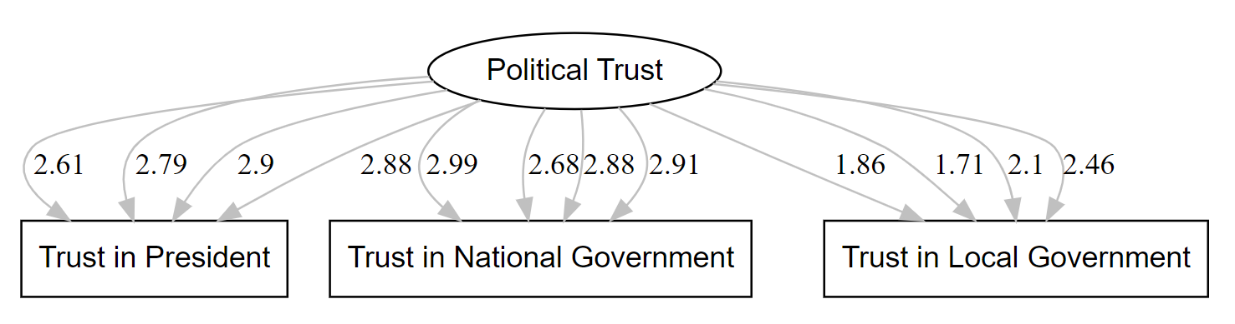

1.2 Expert Trust
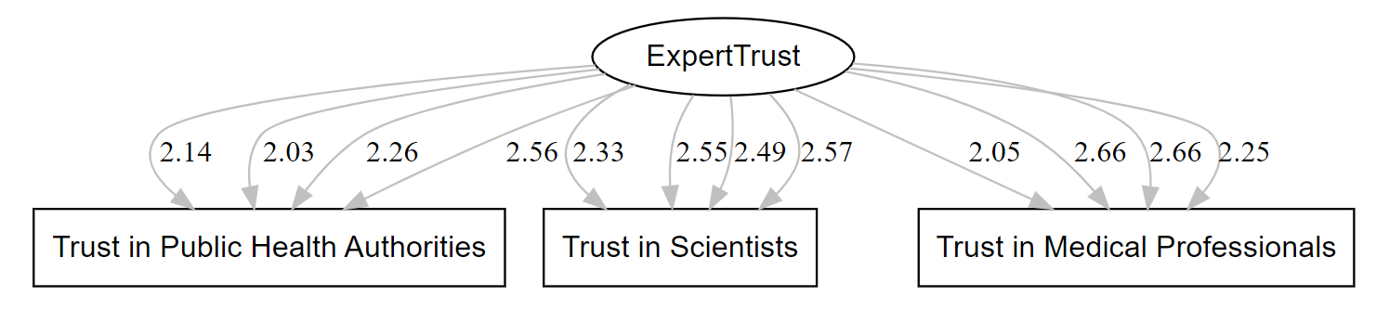

1.3 Misinformation
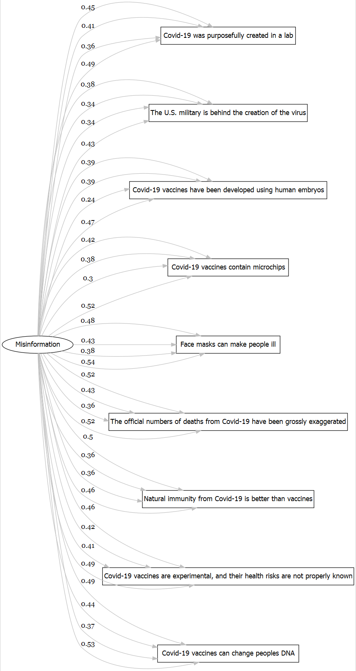
1.4 Populist attitudes
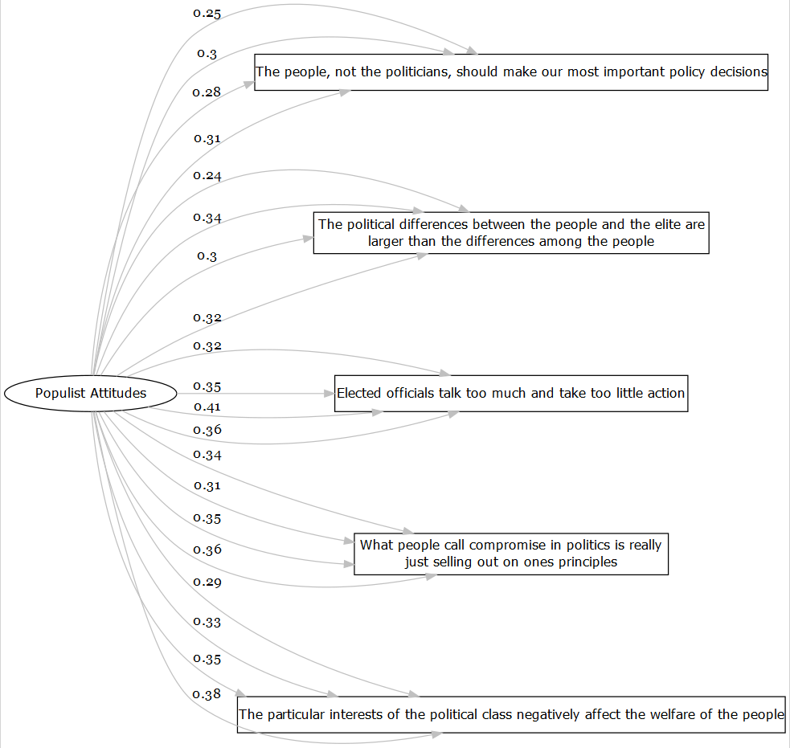

1.6 Policy Support
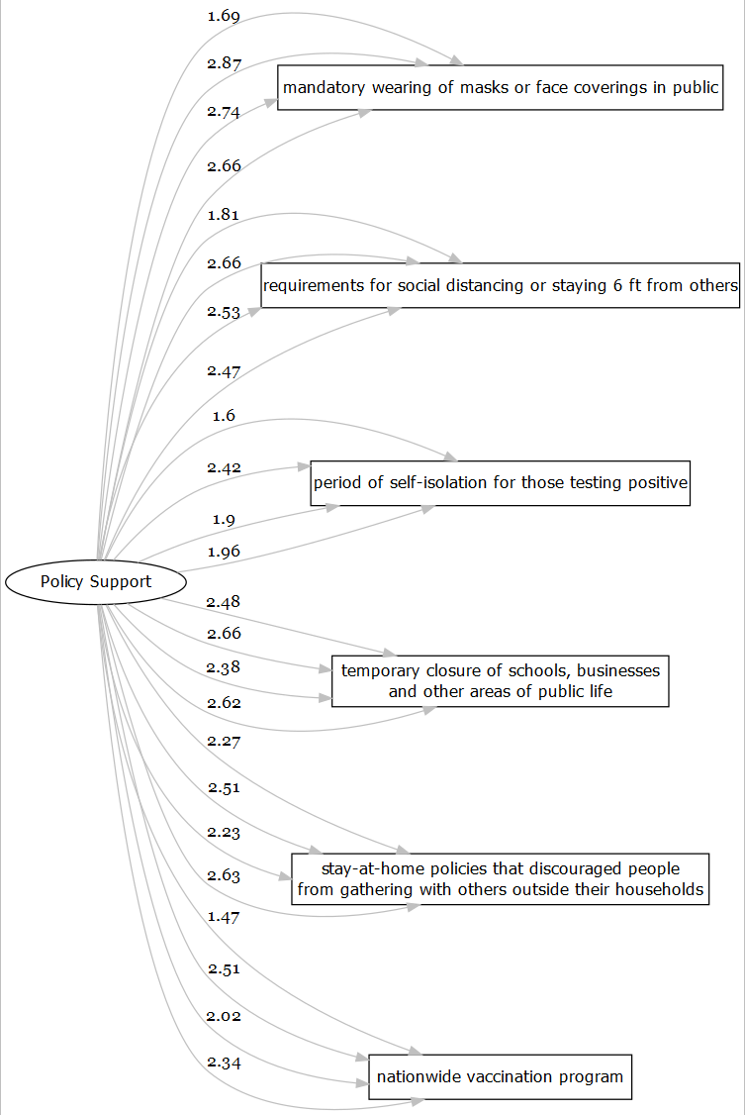

Table 4: Interactions
SEM model predicting institutional trust in countries with populist government with interaction between misinformation beliefs and populist attitudes
 | BR | PL | RS | US
Political Trust ~
Policy Support | 0.17 (0.01)*** | 0.51 (0.7)*** | 0.46 (0.06)*** | 0.63 (0.06)***
Misinformation | -0.02 (0.03) | -0.09 (0.05) | -0.01 (0.06) | -0.12 (0.03)
News Access | 0.00 (0.01) | 0.04 (0.03) | 0.05 (0.03) | 0.12 (0.03)***
Populist Vote | -0.01 (0.06) | 0.54 (0.21)*** | 0.52 (0.21)*** | -0.34 (0.13)***
Populist Attitude | -0.08 (0.03) | -0.23 (0.06)*** | -0.3 (0.06)*** | -0.13 (0.03)***
Misinf. x Populist Att. | 0.15 (0.01) | -0.02 (0.01) | -0.03 (0.02) | 0.1 (0.01)
Expert Trust ~
Policy Support | 0.52 (0.04)*** | 0.69 (0.14)*** | 0.59 (0.06)*** | 0.71 (0.16)***
Misinformation | -0.39 (0.05)** | -0.39 (0.06)** | -0.17 (0.05) | -0.28 (0.04)**
News Access | 0.06 (0.02)* | 0.09 (0.04)* | 0.08 (0.03)* | 0.18 (0.05)***
Populist Vote | -0.14 (0.08)*** | 0.24 (0.9)*** | 0.27 (0.13)*** | -0.29 (0.19)***
Populist Attitude | 0.05 (0.05) | -0.07 (0.06) | -0.17 (0.04)** | -0.04 (0.04)
Misinf. x Populist Att. | 0.06 (0.01) | -0.08 (0.02) | -0.18 (0.02) | 0.03 (0.01)
N used obs. | 1330 | 858 | 877 | 1324
CFI = 0.89, TLI = 0.89, RMSEA = 0.12, SRMR = 0.1
Regressions are controlled by Age, Sex, Education and Income. Values are standardized DWLS estimates based on both observed and latent variables with Standard Error in parenthesis;
p values: *** (<.001), **(<.01),*(<.05)

