SUPPLEMENTARY INFORMATION
Capping agent, solvent and nanoparticle interactions: driving selectivity for biomass transformations.
George F. Tierney,*^{[a,b]} Daniel Banks,^{[a]} Marina Carravetta,^{[a]} Alice E. Oakley,^{[a]} Shahram Alijani,^{[c]} Ilaria Barlocco, ^{[c]} Nikolaos Dimitratos,^{[d]} Alberto Villa,*^{[c]} and Peter P. Wells*^{[a,b,e]}
AUTHOR ADDRESS:
[a] Dr. G. F. Tierney, D. Banks, Dr. A. E. Oakley, Prof. M. Carravetta and Prof. P. P.Wells
School of Chemistry
University of Southampton, Southampton, SO17 1BJ, United Kingdom.
[b] Dr. G. F. Tierney and Prof. P. P. Wells
UK Catalysis Hub
Research Complex at Harwell, Rutherford Appleton Laboratory, Harwell, Didcot,
OX11 0FA, United Kingdom.
[c] Dr. S. Alijani, Dr. I. Barlocco and Prof. A. Villa
Dipartimento di Chimica
Universitá degli Studi di Milano, via Golgi 19, 20133, Milano, Italy.
[d] Prof. N. Dimitratos
Dipartimento di Chimica Industriale
“Toso Montanari” Alma Mater Studiorum Universitá di Bologna, Viale Risorgimento 4, 40136 Bologna, Italy.
[e] Prof. P. P. Wells
Diamond Light Source
Harwell Science and Innovation Campus, Chilton, Didcot, OX11 0DE, United Kingdom.
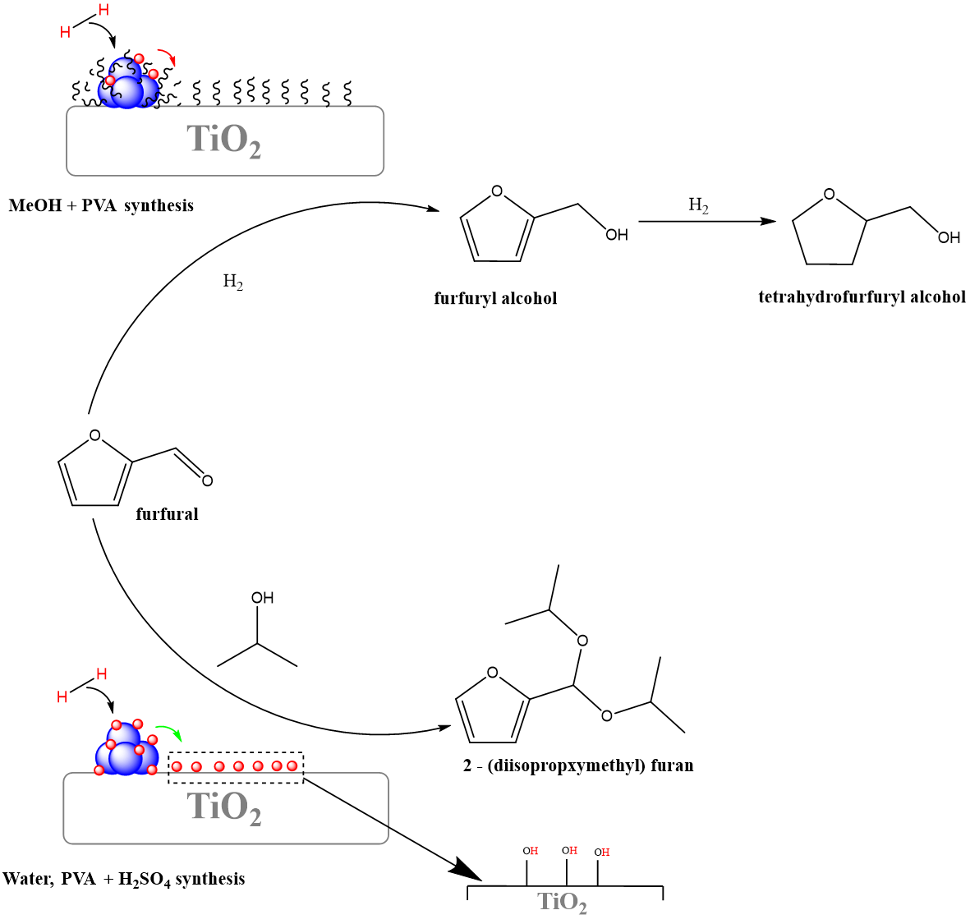
Figure S1. Schematic detailing the possible routes to furfural hydrogenation (above) and acetalization (below) over Pd/TiO₂ catalysts prepared using altered synthesis solvents, PVA and acidification procedures. Wherein, the complexation of PVA and MeOH during synthesis covers not only the NP surface, but also the support surface. This suppresses the potential for hydrogen spillover from the Pd NPs to the support, resulting in fewer Bronsted acid sites on Titania, and in turn selectivity only to the primary hydrogenation products. Schematic devised by incorporating results taken from our previous work on this, Tierney et al., ChemCatChem., 2021, 13, 5121-5133.¹
Supplementary Figures 2 and Tables for ¹³C NMR.
Fittings of the ¹³C Cross Polarization NMR signals for the prepared catalysts are listed below. Bruker data were processed in Mestrenova, then imported in Matlab for fitting, using a Gauss-Lorentz lineshape for each NMR peak.
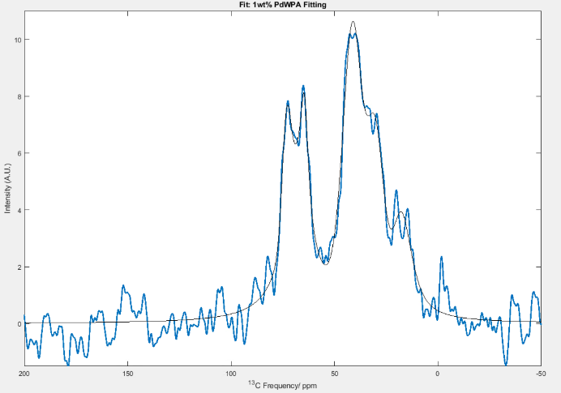
1 wt.% PdWPA

Amplitude (A.U) | Peak Position (ppm) | Linewidth (ppm) | Gauss – Lorentz Ratio
19.099 ± 22.973 | 73.234 ± 0.222 | 2.433 ± 0.545 | 0.007 ± 1.630
128.022 ± 36.565 | 67.965 ± 1.872 | 7.645 ± 0.970 | 1.000 ± 0.314
20.404 ± 23.633 | 64.514 ± 0.201 | 2.057 ± 0.706 | 0.816 ± 0.869
136.110 ± 17.053 | 41.160 ± 0.252 | 5.712 ± 0.255 | 0.348 ± 0.225
49.678 ± 24.529 | 30.211 ± 0.261 | 4.432 ± 0.467 | 0.001 ± 0.971
67.108 ± 13.256 | 17.672 ± 0.631 | 6.200 ± 0.783 | 0.880 ± 0.155
Number of scans = 56000
D1 = 3.5s
P15 = 500μs
Mestrenova settings:
Apodization = Exp 80 Hz. Phase 0th order = -21.53 Hz. Phase 1st order = 30 Hz. Baseline correction fit = Polynomial order 3
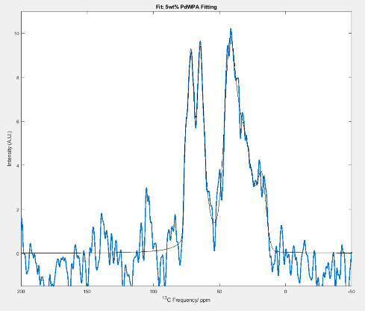
5 wt.% PdWPA

Amplitude (A.U) | Peak Position (ppm) | Linewidth (ppm) | Gauss – Lorentz Ratio
9.007 ± 3.391 | 75.716 ± 0.219 | 1.293 ± 0.251 | 3.401e-09 ± NaN
40.033 ± 9.250 | 71.881 ± 0.189 | 2.515 ± 0.281 | 3.393e-07 ± 0.427
102.316 ± 8.060 | 64.506 ± 0.151 | 3.499 ± 0.242 | 1.000 ± NaN
92.875 ± 34.717 | 42.399 ± 0.496 | 5.008 ± 0.500 | 0.305 ± 0.276
87.182 ± 42.751 | 32.113 ± 2.238 | 8.000 ± 1.767 | 6.178e-08 ± 0.409
23.658 ± 7.682 | 17.896 ± 0.453 | 3.749 ± 0.57 | 3.960e-09 ± NaN
Number of scans = 24000
D1 = 3.5s
P15 = 200μs
Mest re nova settings:
Apodization = Exp 80 Hz. Phase 0th order = -20.49 Hz. Phase 1st order = 30 Hz.
Baseline correction fit = Polynomial order 3
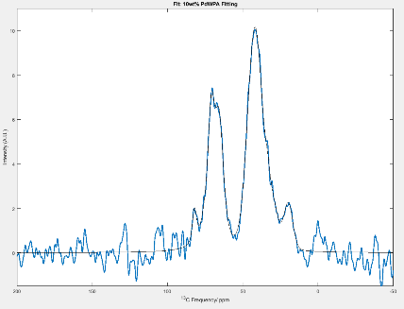
10 wt.% PdWPA

Amplitude (A.U) | Peak Position (ppm) | Linewidth (ppm) | Gauss – Lorentz Ratio
6.737 ± 6.369 | 82.067 ± 0.390 | 1.687 ± 0.607 | 0.652 ± 0.940
2.780 ± 44.321 | 75.557 ± 2.881 | 2.540 ± 11.133 | 0.967 ± 11.012
52.465 ± 74.396 | 70.940 ± 0.213 | 2.984 ± 1.399 | 0.942 ± 1.113
47.586 ± 29.291 | 65.640 ± 0.341 | 3.483 ± 0.408 | 0.664 ± 0.387
120.601 ± 23.414 | 41.949 ± 0.805 | 5.721 ± 0.585 | 0.038 ± 0.240
12.737 ± 93.743 | 33.469 ± 1.131 | 2.754 7.462 | 1.000 ± 4.886
18.787 ± 75.803 | 29.371 ± 2.810 | 4.168 ± 3.704 | 0.760 ± 2.953
14.986 ± 12.097 | 19.668 ± 0.641 | 3.461 ± 0.685 | 0.098 ± 0.972
Number of scans = 7000
D1 = 3.5s
P15 = 200μs
Mest re nova settings:
Apodization = Exp 80 Hz. Phase 0th order = -23.46 Hz. Phase 1st order = 30 Hz. Baseline correction fit = Polynomial order 3

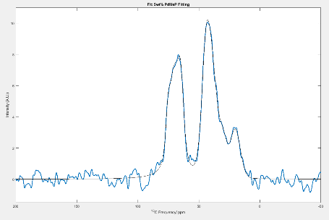
5 wt.% PdMeP

Amplitude (A.U) | Peak Position (ppm) | Linewidth (ppm) | Gauss – Lorentz Ratio
14.472 ± 16.987 | 75.177 ± 0.270 | 2.180 ± 0.829 | 0.751 ± 0.504
73.863 ± 31.333 | 70.449 ± 0.405 | 4.549 ± 1.463 | 0.695 ± 0.241
44.500± 13.024 | 64.933 ± 0.282 | 3.153 ± 0.268 | 0.679 ± 0.224
59.836 ± 160.342 | 44.266 ± 0.883 | 4.164 ± 1.729 | 0.379 ± 0.459
74.803 ± 176.799 | 39.197 ± 7.501 | 5.632 ± 5.675 | 0.021 ± 1.021
13.071 ± 25.234 | 29.791 ± 1.138 | 3.324 ± 1.456 | 0.005 ± 1.782
33.190 ± 6.711 | 20.250 ± 0.412 | 4.940 ± 0.365 | 0.042 ± 0.334

Number of scans = 22000
D1 = 3.5s
P15 = 200μs
Mest re nova settings:
Apodization = Exp 80 Hz. Phase 0th order = -8 Hz. Phase 1st order = 30 Hz. Baseline correction fit = Polynomial order 3

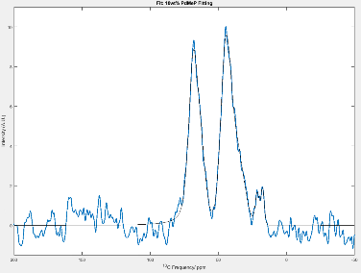
10 wt.% PdMeP

Amplitude (A.U) | Peak Position (ppm) | Linewidth (ppm) | Gauss – Lorentz Ratio
11.826 ± 14.677 | 76.242 ± 3.131 | 4.422 ± 2.265 | 5.652e-06 ± 1.513
52.464 ± 68.600 | 68.693 ± 1.600 | 3.494 ± 1.013 | 4.984e-11 ± NaN
39.521 ± 46.097 | 63.254 ± 6.034 | 4.493 ± 3.150 | 7.877e-05 ± 1.743
78.931 ± 25.835 | 44.642 ± 0.473 | 4.433 ± 0.350 | 1.984e-04 ± 0.477
49.288 ± 20.724 | 36.402 ± 2.131 | 6.159 ± 1.466 | 8.052e-05 ± 0.923
6.123 ± 5.923 | 21.372 ± 0.372 | 1.795 ± 0.446 | 9.6972e-07 ± 2.243
5.589 ± 3.209 | 17.522 ± 0.284 | 1.431 ± 0.296 | 4.290e-07 ± 1.299

Number of scans = 6700
D1 = 3.5s
P15 = 200μs
Mest re nova settings:
Apodization = Exp 80 Hz. Phase 0th order = -11.36 Hz. Phase 1st order = 30 Hz. Baseline correction fit = Polynomial order 3
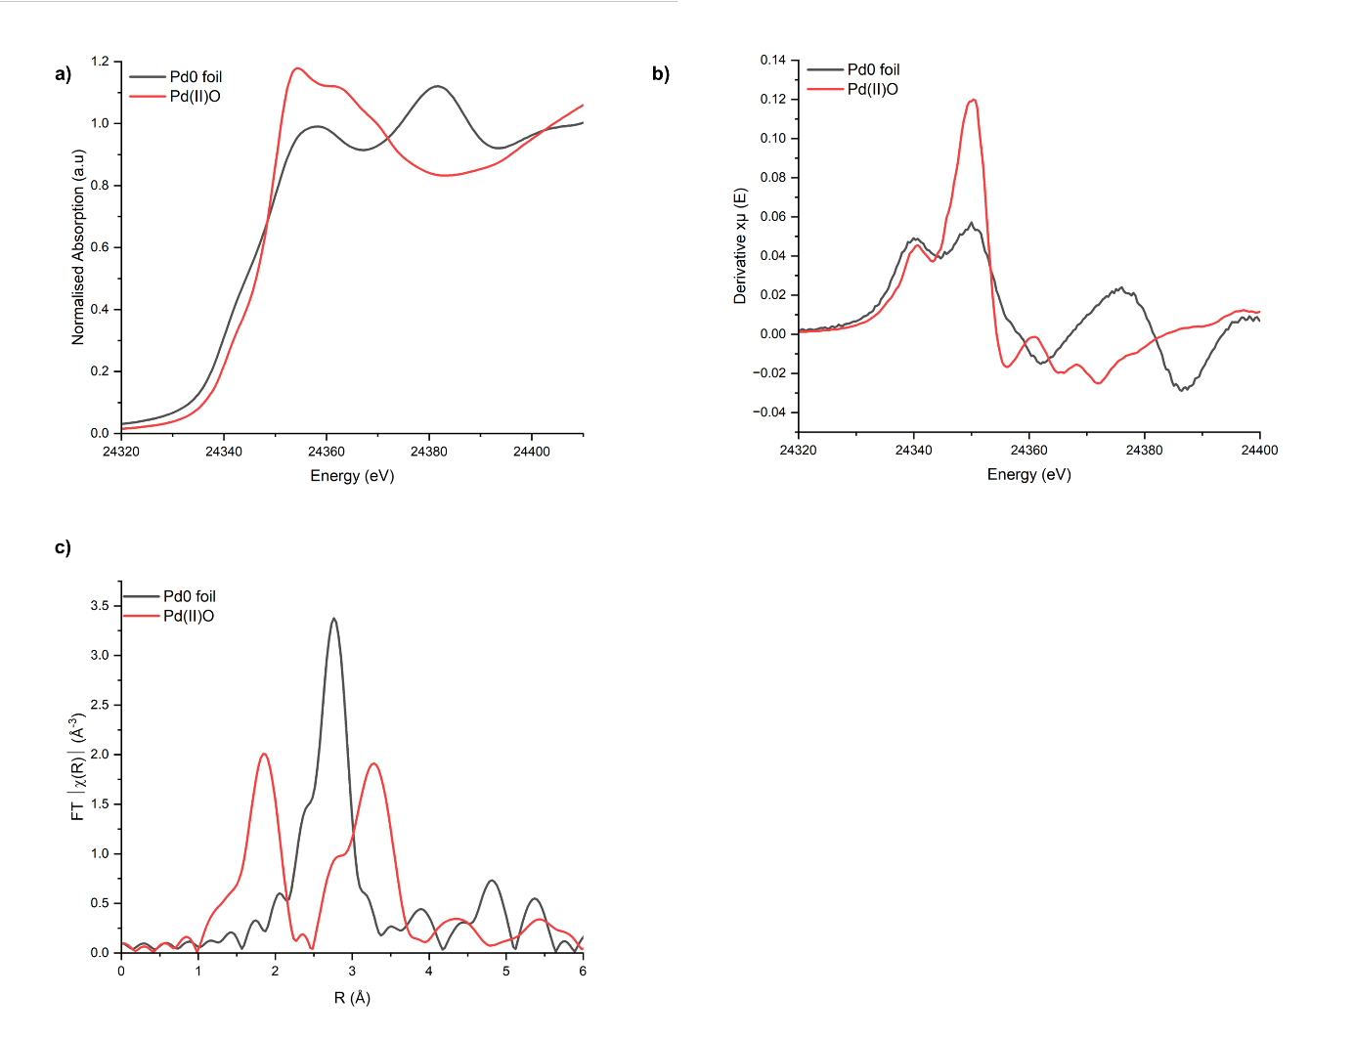
Figure S3. Pd K-edge ex situ XAS data acquired for Pd(0) foil and Pd(II)O reference materials. A) XANES region, b) 1st Derivative XANES, c) FT EXAFS data. Spectroscopic data was acquired during ex situ XAS measurements within the paper on the B18 beamline at the Diamond Light Source, U.K.

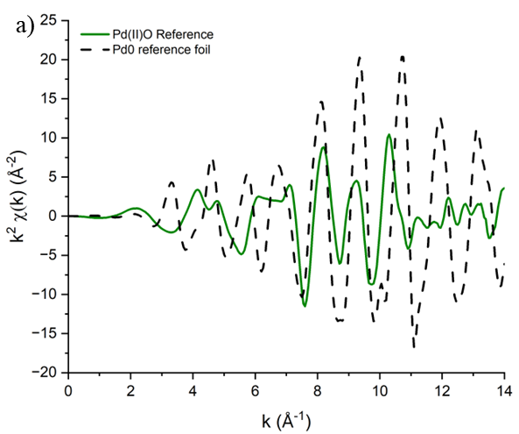 | 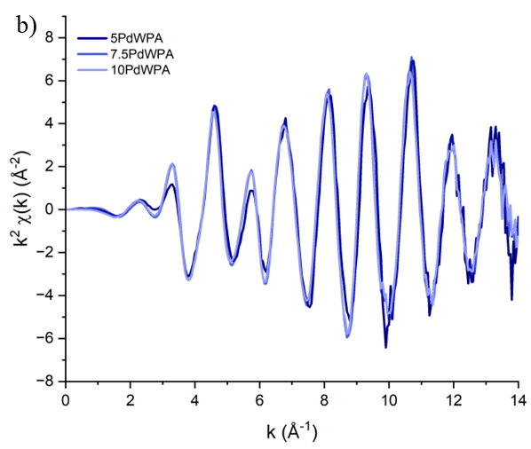
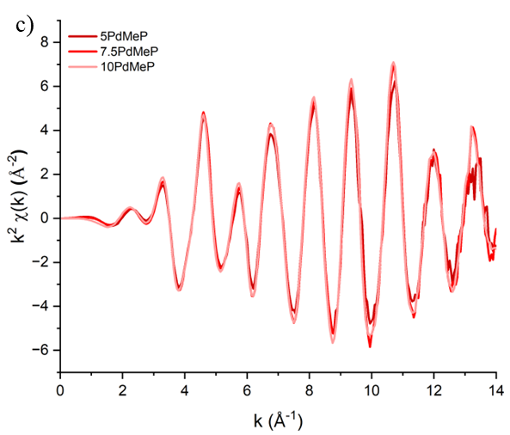
Figure S4. Pd K-edge Chi (Χ) EXAFS data acquired to k = 14 for the WPA and MeP series of Pd/TiO₂ catalysts. A) displays the chi EXAFS data for the Pd0 and Pd(II)O measured references, b) chi EXAFS data for the WPA series of catalysts, c) chi EXAFS data for the MeP series of catalysts. All references and samples were measured as ex-situ pellets on the B18 beamline at the Diamond Light Source, Harwell, U.K.

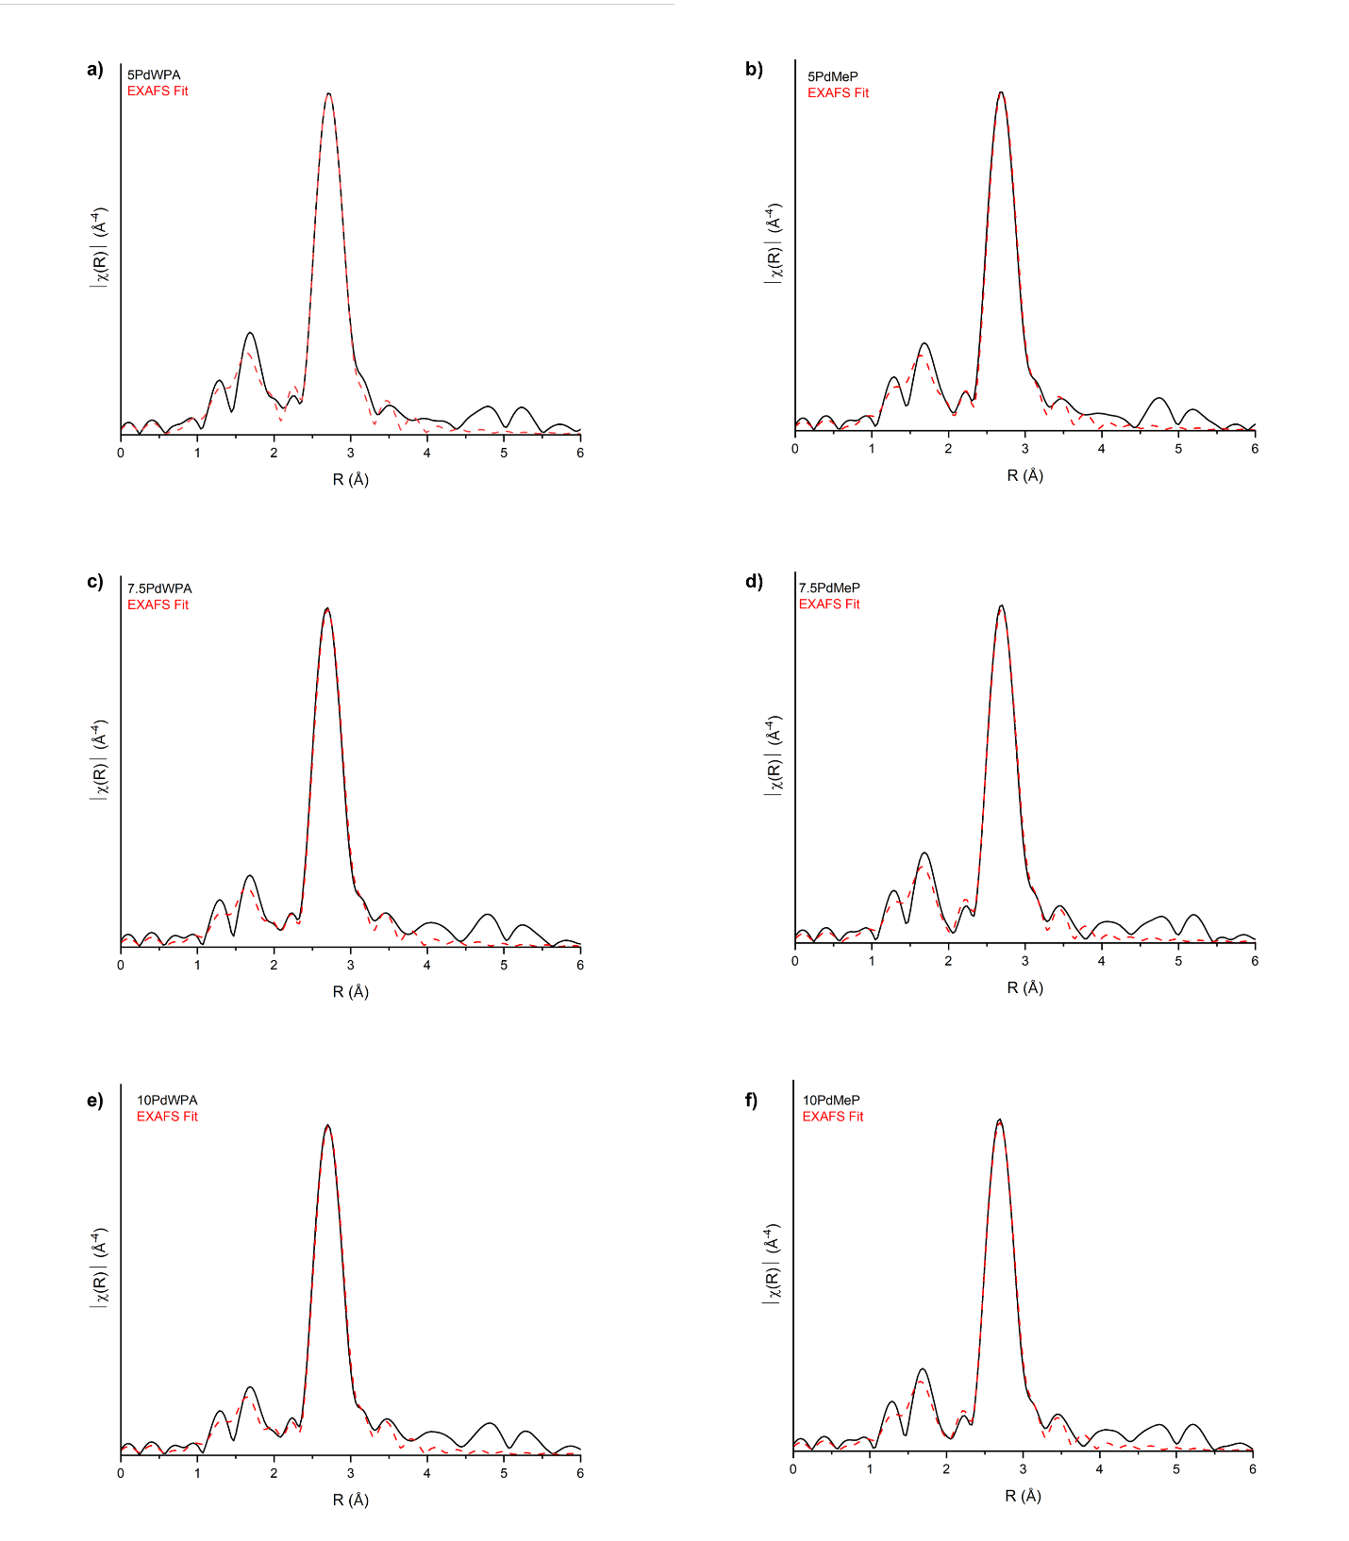
Figure S5. Fitting of the FT EXAFS data acquired for the WPA and MeP Pd/TiO₂ series of catalysts. 1st shell EXAFS fitting parameters were derived from the k² weighted Fourier transform data for the Pd K-edge EXAFS for fresh catalysts. The amplitude reduction factor ($S_{0}^{2}$) = 0.81, was determined through fitting of an acquired Pd metal reference foil using a crystallographic file. EXAFS fitting range: 3 < k < 13.5, 1< R < 3.5, number of independent points = 16.5.
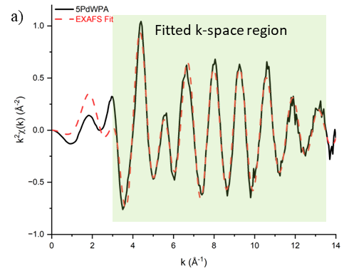 | 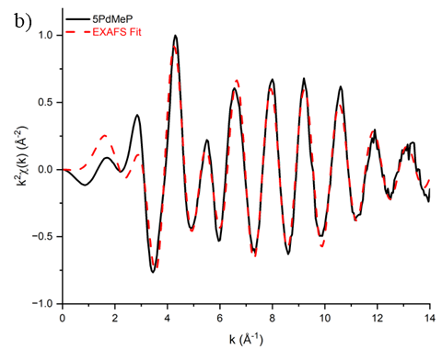
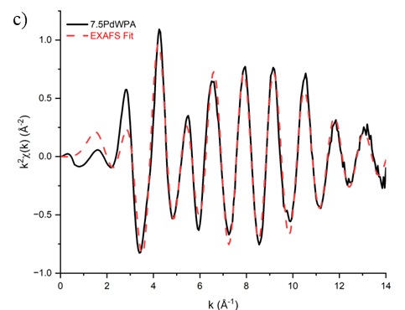 | 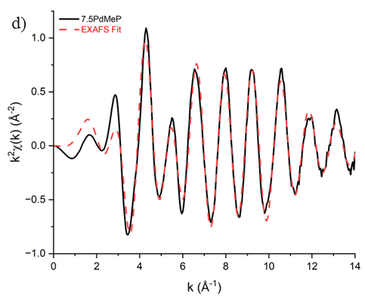
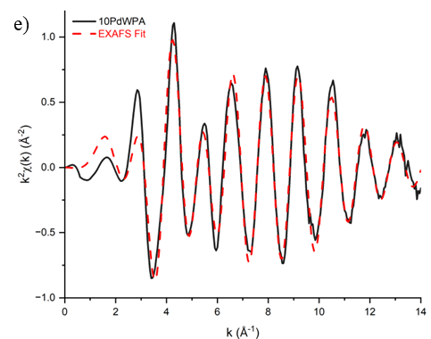 | 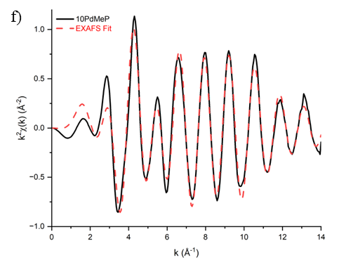
Figure S6. Fitting of the k-space EXAFS data acquired for the WPA and MeP Pd/TiO₂ series of catalysts. 1st shell EXAFS fitting parameters were derived from the k² weighted Fourier transform data for the Pd K-edge EXAFS for fresh catalysts. The amplitude reduction factor ($S_{0}^{2}$) = 0.81, was determined through fitting of an acquired Pd metal reference foil using a crystallographic file. EXAFS fitting range: 3 < k < 13.5, 1< R < 3.5, number of independent points = 16.5.
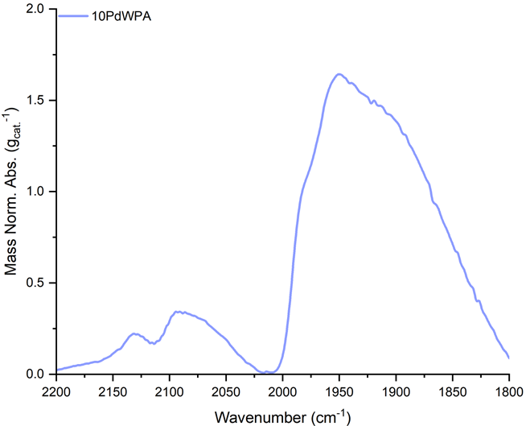
Figure S7. CO probe FTIR spectra of 10PdWPA.
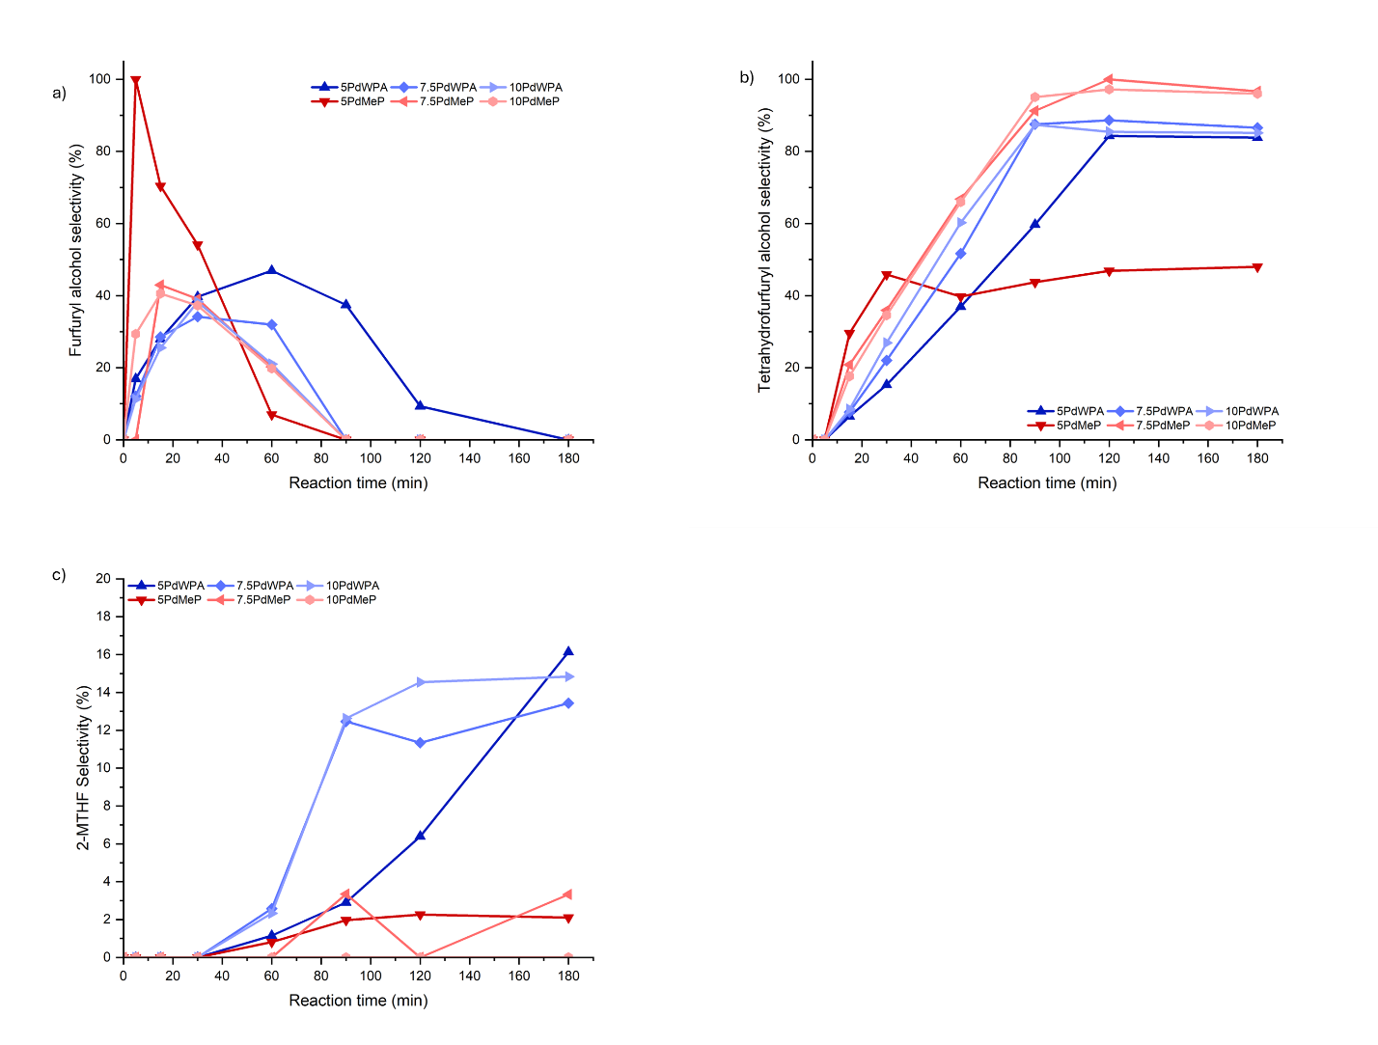
Figure S8. Schematic of reaction pathways in furfural hydrogenation to value added products.
Figure S9. Selectivity plots as a function of reaction time acquired during the hydrogenation of furfural over the prepared fresh catalysts. A) Selectivity to furfuryl alcohol, b) selectivity to hydrofurfuryl alcohol, c) selectivity to 2-methyltetrahydrofurfuryl (2-MTHF).

1. Tierney, G. F. et al. Controlling the Production of Acid Catalyzed Products of Furfural Hydrogenation by Pd/TiO2. ChemCatChem 13, 5121–5133 (2021).

