Supplementary Information

The OSCP subunit of ATP Synthase is a dimer in solution: strategy to induce the monomeric protein as a new tool for drug discovery

Simone Fabbian^{1,2}, Laura Gabbadore², Laura Morbiato², Marta De Zotti², Valentina Giorgio³, Roberto Battisutta^{2,4}, Gabriele Giachin², Alice Sosic¹ and Massimo Bellanda^{2,4}*.

¹Department of Pharmaceutical and Pharmacological Sciences, University of Padua, via Marzolo 5, 35131, Padova, Italy.

² Department of Chemical Sciences, University of Padua, via Marzolo 1, 35131, Padova, Italy.

³Department of Biomedical and Neuromotor Sciences, University of Bologna, Bologna, I-40126, Italy.

⁴Institute of Biomolecular Chemistry of CNR, Padua Unit, Padova, I-35131, Italy.

* Correspondence to Massimo Bellanda - MB (massimo.bellanda@unipd.it)

simone.fabbian@unipd.it
marta.dezotti@unipd.it
valentina.giorgio4@unibo.it
roberto.battistutta@unipd.it
gabriele.giachin@unipd.it
alice.sosic@unipd.it

Supplementary Figures

Supplementary Table

References
Fig S1: Structure and sequence of mature human OSCP subunit (full-length OSCP, here called OSCP-FL). A Surface representation of Cryo-EM structure of Homo sapiens ATP synthase (PDB ID 8H9S). F₁ and F_{O} indicate respectively the catalytic and the transmembrane regions of the enzyme. The Peripheral Stalks (PS), connecting the F₁ domain with the F_{O} region, is also reported. Black horizontal lines represent the Inner Mitochondrial Membrane (IMM). The OSCP subunit is highlighted on the top of the enzyme (cartoon representation, surface in transparency), with the N-terminal (OSCP-NT) and the C-terminal (OSCP-CT) domains coloured in light red and grey respectively. B Primary sequence of the OSCP-FL (F1-V190). Residues forming the N-terminal and the C-terminal domains of human OSCP subunit, named OSCP-NT (F1-G114) and OSCP-CT (G114-V190), are highlighted in light red and grey respectively. The cylinders and the arrows above the sequence indicate the positions of the α-helices (H1-H2-H3-H4-H5-H6-H7 and H8) and the parallel (β1– β2) and antiparallel (β3– β4) β-sheets respectively, as determined by the Cryo-EM structure of human ATP synthase (PDB ID 8H9S).

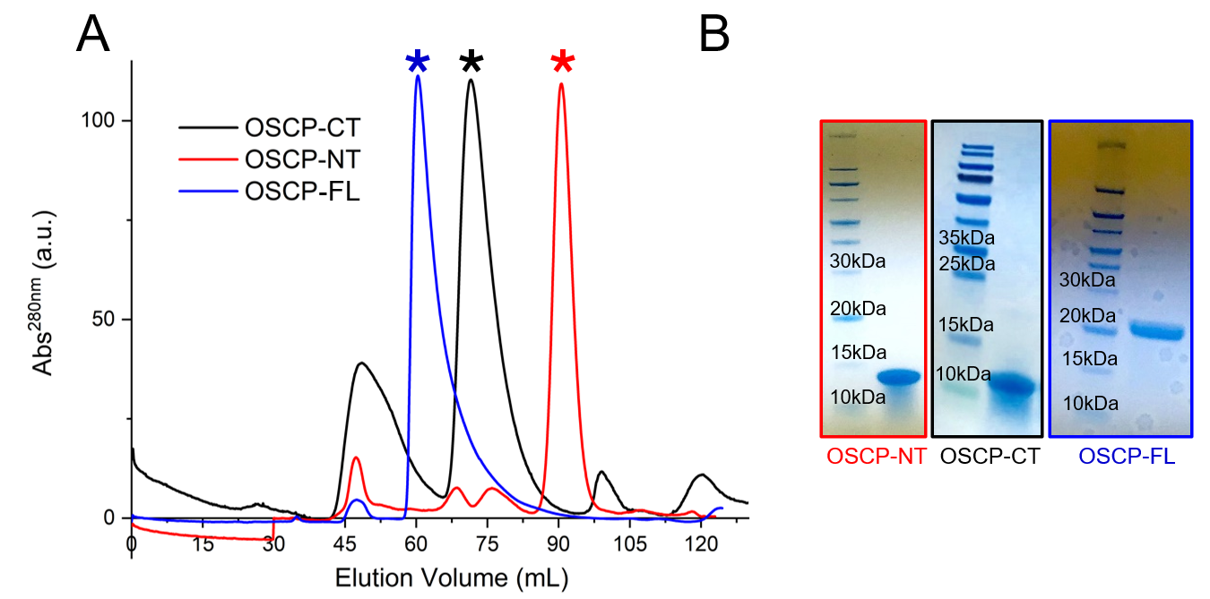
Fig S2: Chromatographic purification and mass validation of human OSCP and its N-terminal and C-terminal domains. A Size Exclusion Chromatography (SEC) elution profiles from the Superdex 75 PG HiLoad 16/60 column (GE Healthcare, Chicago, IL, USA) referring to the full-length OSCP subunit (OSCP-FL, blue curve), the C-terminal domain (OSCP-CT, black curve), and the N-terminal domain (OSCP-NT, red curve) of the OSCP subunit. In all three chromatograms, the main peak due to the elution of each protein species is starred with *. B SDS PAGE lanes showing the fractions collected from the main SEC peaks reported in Fig S2 A, for OSCP-NT, OSCP-CT and OSCP-FL. Each lane contains a unique protein species whose molecular weight is in good agreement with the expected values. The colour legend is the same used in Fig S2 A. C, D, E Representative ESI-MS spectra of purified OSCP-NT, OSCP-CT and OSCP-FL respectively, in water/acetonitrile 50:50 with 0.1% v/v formic acid. Each spectrum was acquired in positive mode. Experimental mass values calculated for OSCP-NT, OSCP-CT and OSCP-FL were 12042.1 Da, 8348.4 Da and 20874.9 Da respectively, in agreement with the expected values from protein sequence (12043.0 Da, 8348.9 Da and 20875.5 Da).

Fig S3: Normalized Kratky plots for OSCP-CT and OSCP-FL (blue and black circles respectively).

Fig S4: Determination of OSCP-CT dimensions in solution from amide ¹H-¹⁵N spin relaxation measurements, without and in presence of the peptide b-CT. A The experimental τ_{C} value determined for OSCP-CT (16.5 ns) is consistent with the trimeric state of OSCP-CT (“M₃”, MW ≈ 25 kDa), as indicated by the bigger green square. “M₁”, “M₂” and “M₄” refer to the molecular weight of monomeric, dimeric and tetrameric OSCP-CT respectively, with τ_{C} = 16.5 ns. B The τ_{C} value determined for OSCP-CT after the binding with b-CT (9.2 ns) is consistent the 1:1 monomeric complex between OSCP-CT and b-CT (“M”, MW ≈ 10.8 kDa). “M₂” and “M₃” refer to the molecular weight of 1:1 dimeric and trimeric complex between OSCP-CT and b-CT, with τ_{C} = 9.2 ns. The linear regression (red line in both panels A and B) between the correlation time (τ_{C}) and the molecular weight (MW) of several globular proteins¹ (black dots) was used to estimate the real dimensions of OSCP-CT in solution from its correlation time (τ_{C}).

Fig S5: Strategy for SAXS-guided modelling of OSCP-CT trimer. A Five models representing the OSCP-CT trimer were initially predicted by the AlphaFold2 tool, with a threefold C3 symmetry axis. B Each model was classified according to the χ² value arising from the comparison with the OSCP-CT SAXS profile. In this way a model was identified with excellent fitting to SAXS data (χ² =1.32). C. Schematic view of OSCP-CT secondary structure is drawn (α-helices and β-sheets represented as shown in Fig S1 and determined by the AlphaFold structure of human OSCP subunit). The residues of each OSCP-CT protomer which are interfaced in the model of the OSCP-CT trimer are highlighted in green (determined in PISA).

Fig S6: Strategy for SAXS-guided modelling of OSCP-FL dimer. A AlphaFold2 prediction was applied to obtain 5 models of the OSCP-CT dimerization unit, with a two-fold C2 symmetry axis. B The best model of dimeric OSCP-CT, with the highest score in terms of total interface area between the two monomeric units (evaluated by PISA) and percentage of residues with favoured backbone (φ;ψ) angles in Ramachandran plot (1027.8 Å² and 94%, respectively) was chosen to be the scaffold to guide the assembly of the full-length dimer, using the AlphaFold structure of human monomeric OSCP-FL as the two building blocks. The primary fitting with the SAXS profile showed a relatively high χ² value (2.27). Fitting was improved by introducing flexibility between the N-terminal and C-terminal domains of each OSCP-FL protomer (residues G114-E115) and the model was refined through a rigid body modelling guided by SAXS (see Materials and Methods). The final model is in excellent agreement with the scattering profile of the OSCP-FL in solution (χ² = 1.24). C Schematic view of OSCP-FL secondary structure is drawn (α-helices and β-sheets represented as shown in Fig S1 and determined by the AlphaFold structure of human OSCP subunit). The residues of each OSCP-FL protomer which are interfaced in the OSCP-FL dimer are highlighted in green (determined in PISA).

Fig S7: Structural details of the interaction between OSCP-FL subunit and the C-terminal helix of b-subunit (b-CT) in human ATP synthase (Cryo-EM structure, PDB ID 8H9S). (Left-hand side) Surface representation, coloured according to electrostatics, of OSCP-FL bound to the C-terminal helix of b-subunit (b-CT, cartoon representation coloured blue), from Cryo-EM structure of human ATP synthase (PDB ID 8H9S). The OSCP-CT domain is shown in transparency and with cartoon representation (alpha helices are coloured in purple, β-sheets are coloured in orange) to better visualize the structural elements forming the hydrophobic cleft (made by helix H7 and antiparallel β-sheet β3-β4) which is the binding site for b-CT. (Right-hand side) The schematic view of OSCP-CT secondary structure is drawn as already explained in Fig S1. The residues of OSCP-CT hydrophobic cleft which are interfaced with b-CT, are highlighted in green (determined in PISA). Notably, most of the residues of helix H7 and strands β3-β4 required for OSCP-FL or OSCP-CT oligomerisation (Fig S5 and Fig S6) are the same involved in the binding process with b-CT.

Fig S8: Characterization of peptide b-CT. A Primary sequence of the synthetic peptide b-CT, corresponding to the C-terminal helix of mitochondrial mature form of the human ATP synthase subunit b (residues 190-211), without the first 42 amino acids forming the mitochondrial targeting sequence (UniProtKB-P24539). B Representative ESI-MS spectrum of b-CT, in water/acetonitrile 50:50 with 0.1% v/v formic acid. The spectrum was acquired in positive ion mode. The experimental mass calculated from the spectrum was 2455.3 Da in accordance with the expected sequence mass of 2455.9 Da obtained from the peptide sequence. C CD spectrum of b-CT in solution, showing the typical profile of a disordered structure.

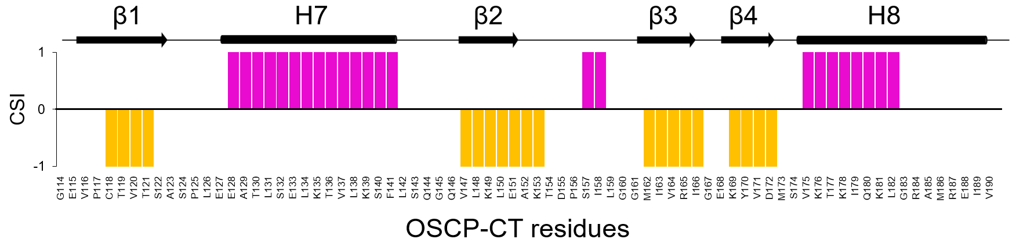
Fig S9: NMR assignment of the binding complex OSCP-CT•b-CT and secondary structure derived by NMR. Upper panel: ¹H-¹⁵N HSQC spectrum with assigned resonances of ¹⁵N-labelled human OSCP-CT (1mM) in presence of a 10-fold molar excess of unlabelled b-CT peptide in 50 mM sodium phosphate, 50 mM L-glutamic acid, 50 mM L-arginine, 2 mM DTT, pH 6.5, 25 °C. Lower panel: histogram showing OSCP-CT secondary structure in according to chemical shift index (CSI). CSI values of +1, 0, −1 indicate respectively α-helical structure (purple), random coil and β-strands (light orange). For comparison, secondary structure of OSCP-CT domain as determined by the Cryo-EM analysis of human ATP synthase (PDB ID 8H9S) is schematically represented above the graph.

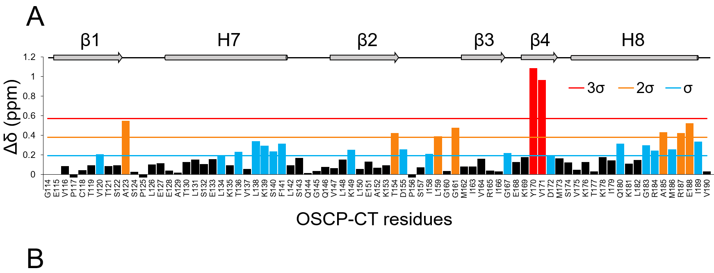
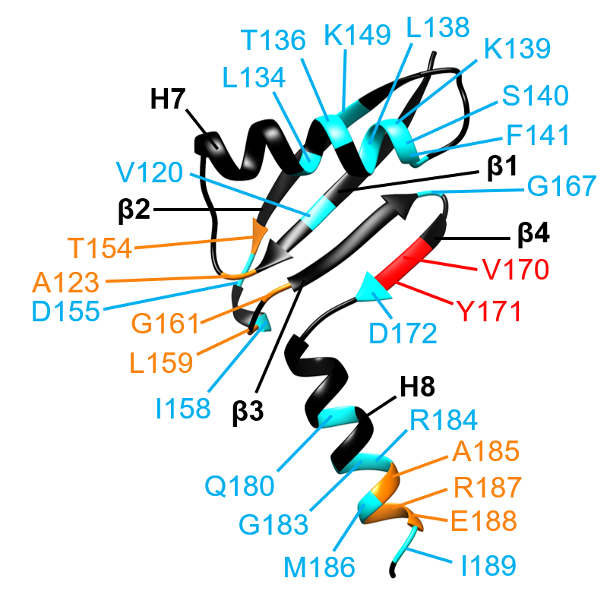

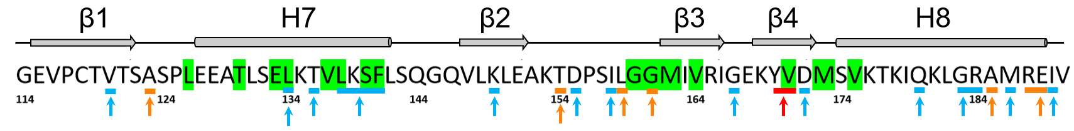
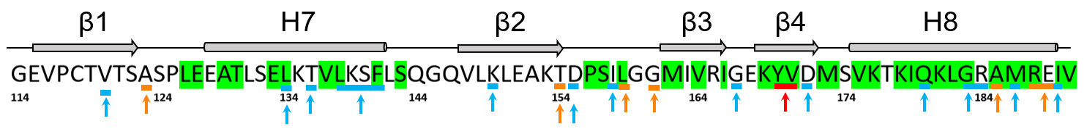
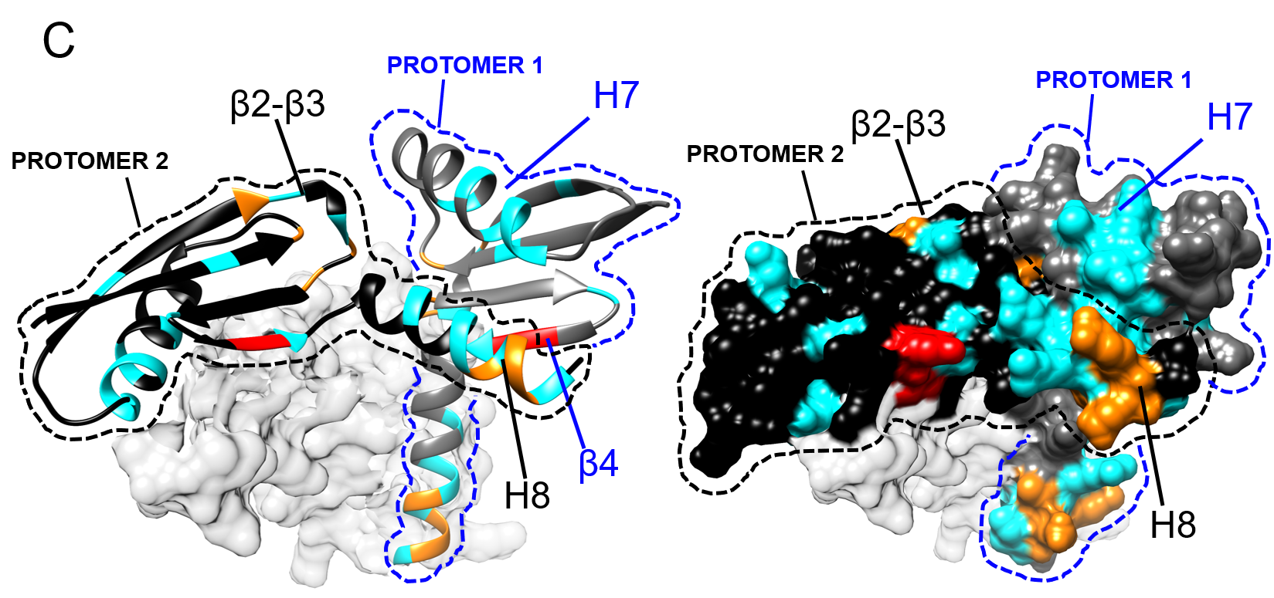
Fig S10: Analysis of NMR Chemical Shift Perturbations (Δδ) of OSCP-CT upon binding to the b-CT peptide. A Combined Chemical Shift Perturbations (Δδ) calculated from the analysis of ¹H-¹⁵N HSQC spectra of OSCP-CT domain in the absence and in the presence of 10-fold molar excess of b-CT peptide. Significantly perturbed residues are color-coded based on three Δδ intervals defined by standard deviation (σ) thresholds calculated across the entire sequence: σ < Δδ < 2σ (cyan), 2σ < Δδ < 3σ (orange), and Δδ > 3σ (red). Proline residues and residues with undetectable or very weak cross-peaks were not considered during the analysis, as indicated by negative bars and empty spaces, respectively. The schematic view of OSCP-CT secondary structure is drawn above the histogram as determined by the AlphaFold model of human OSCP subunit (ID entry P48047). B Cartoon representation of OSCP-CT domain derived from the AlphaFold model of human OSCP subunit and showing the residues with the largest Chemical Shift Perturbation, coloured according with panel A. The sequence of the human OSCP-CT domain, shown below the structural model, allows comparison between the residues exhibiting the largest Chemical Shift Perturbations (indicated by arrows) and those forming the OSCP-CT hydrophobic cleft interfacing with b-CT (highlighted in green), as identified in the Cryo-EM structure of human ATP synthase (PDB ID: 8H9S; see Fig S7). C Cartoon and surface representations of SAXS-validated model of OSCP-CT trimer. For the sake of clarity, only two protomers are shown, highlighted in black and blue respectively. Each displays the residues with the largest Chemical Shift Perturbations, coloured as in panel A The sequence of the human OSCP-CT domain shown below the structural model serves to compare the residues with the largest Chemical Shift Perturbation, indicated by arrows, and the residues of each OSCP-CT protomer which are interfaced in our SAXS validated model, highlighted in green (see Fig S5C).

Fig S11: Comparison of the ¹H-¹⁵N correlations between human OSCP-FL•b-CT complex and its individual N-terminal and C-terminal domains. Upper panel: superposition of the ¹H-¹⁵N HSQC spectra of the individual OSCP-NT domain (green spectrum), the OSCP-CT•b-CT complex (red spectrum), and the ¹H-¹⁵N BEST TROSY spectrum of the OSCP-FL•b-CT complex (black spectrum). The backbone NMR assignments of the individual domains are also reported, demonstrating that the spectrum of the full-length protein largely corresponds to the combined spectra of the isolated N-terminal and C-terminal domains. Lower panel: expanded plot showing the crowded central region of the spectra superposition.
Tab S1: Secondary structure estimation for human OSCP-NT, OSCP-CT and OSCP-FL determined by deconvolution analysis of CD spectra in comparison with the Cryo-EM analysis of human ATP synthase (PDB ID 8H9S)
Sample name | Circular Dichroism |  |  |  | Cryo-EM (PDB ID 8H9S)
Sample name | Helix (%) | Strand (%) | Turns (%) | Other (%) | Helix (%) | Strand (%) | Turns (%) | Other (%)
OSCP-NT | 55 | 7 | 11 | 27 | 72 | 0 | 9 | 19
OSCP-CT | 36 | 16 | 13 | 35 | 32 | 29 | 5 | 35
OSCP-FL | 42 | 14 | 13 | 31 | 55 | 12 | 9 | 24

Tab S2: SAXS analysis of OSCP-FL and OSCP-CT
(a) sample details
Sample name | OSCP-CT | OSCP-FL
Organism | Homo Sapiens
UniProt sequence ID  (residues in construct, without the first 23 residues forming the MTS) | OSCP (Oligomycin Sensitivity Conferral Protein or Complex V subunit O)-P48047
 | 114-190 | 1-190
Calculated exctinction coefficient at 280nm (M⁻¹ cm⁻¹) | 1490 | 7450
Calculated molecular weight (Da) | 8348.9 | 20875.5
Sample concentration (μM) | 300 | 70
Sample Volume (μL) | 50
Sample buffer | 50 mM Na₂HPO₄, 300 mM NaCl, pH = 7

(b) SAXS data collection parameters
Instrument | ESRF BM29
Wavelength (Å) | 0.99
q measurement range (nm⁻¹) | 0.0367-5.22
Sample-to-detector distance (m) | 2.867
Exposure time | 1 s/spectrum
Temperature (°C) | 20
Detector | Pilatus3 X 2M (Dectris)
Flux (protons/s) | 2 x 10¹²
Beam size (μm) | 100 x 100
Sample configuration | 1.8 mm quartz glass capillary
Absolute scaling method | Comparison to water in sample capillary
Normalization | To transmitted intensity by beam-stop counter

(c) structural parameters
Sample name | OSCP-CT | OSCP-FL
Guinier analysis
-I (0) (cm⁻¹) | 0.03411±0.00006 | 0.0364±0.0002
-R_{g} (nm) | 2.09±0.01 | 3.73±0.03
-q range (nm⁻¹), point range | 0.187-0.622,17-101 | 0.109-0.348,10-56
-qR_{g} max | 1.3 | 1.3
-M (from Bayesian Inference) (Da) / ratio to predicted | 21175 /2.5 | 44725 / 2.1
-Coefficient of correlation, R² | 0.998 | 0.989
P(r) analysis
-I (0) (cm⁻¹) | 0.0340 | 0.0361
-R_{g} (nm) | 2.07 | 3.77
-D_{max} (nm) | 6.5 | 12.0
-q range (nm⁻¹), point range | 0.187-3.04, 17-568 | 0.0109-3.14, 10-595
-Porod volume V_{p} (Å³) | 35683.40 | 64959.10
-M from V_{P} (Da) / ratio to predicted | 23789 / 2.9 | 43306/ 2.1
-χ² (total estimate by GNOM) | 0.86 | 0.82

(e) software employed for SAXS data reduction, analysis and interpretation
SAXS data reduction and data processing | Primus (ATSAS 3.0.3)
Shape/bead modelling | DAMMIF via ATSAS online 12(https://www.embl-hamburg.de/biosaxs/atsas-online/)
Extinction coefficient estimate | ProtParam via web server (https://web.expasy.org/protparam/)
OSCP-FL and OSCP-CT oligomerization tool | AlphaFold2_advanced via web server
Atomic structure modelling | Pepsi-SAXS via web server (https://pepsi.app.ill.fr/), CRYSOL via ATSAS online
Three-dimensional graphic models representations | UCSF-Chimera 1.15

(f) shape model – fitting results
Sample name | OSCP-CT | OSCP-FL
DAMMIF (default parameters, 20 calculation runs)
-q range for fitting (nm⁻¹) | 0.187-3.04 | 0.0109-3.14
-symmetry, anisotropy assumptions | P3, none | P1, none
-Normalized Spatial Discrepancy (NSD), standard deviation (σ) | 1.413, 0.144 |  | 1.303, 0.130
-resolution (from SASRES) (Å) | 40±3 |  | 37±3
-χ² range | 0.986-1.001 |  | 1.170-1.180

(g) atomistic modelling
Sample model | OSCP-CT trimer | OSCP-FL dimer
Atomic structures for rigid bodies | C3 trimer obtained by AlphaFold2_advanced tool | C2 dimer assembled on  OSCP-CT dimer  (obtained by AlphaFold2_advanced tool, C2 symmetry)
Rigid bodies (residues number without MTS) | 114-190 | 1-190
χ² value (CRYSOL) | 1.32 | 2.27
Flex-fit on dimeric OSCP-FL with Pepsi-SAXS (with default parameters)
Rigid blocks (residues in construct without MTS) | 1-113 (chain A, chain B), 116-190 (chains A + B)
q range for all modelling (nm⁻¹) | 0.0626-3.14
Final χ² value for the fitting  (Pepsi-SAXS) | 1.15
Final χ² value for the fitting  (CRYSOL) | 1.24
Small Angle Scattering Biological Data Bank (SASBDB)
SASBDB ID OSCP-CT trimer SASDVR9

SASBDB ID OSCP-FL dimer SASDVQ9

Tab S3: Geometrical validation of the final models representing the OSCP-CT trimer and OSCP-FL dimer and thermodynamics analysis
Sample model | OSCP-CT trimer | OSCP-FL dimer
Ramachandran statistics
Outliers (%) | 1.8 | 1.6
Favoured residues in Ramachandran plot (%) | 96 | 92.3
Allowed residues in Ramachandran plot (%) | 98.2 | 98.4
PISA analysis
P-value | 0.102 | 0.005
Solvation free energy ΔG (kcal/mol) | −13 | −24.9
Interface area (Å²) | 590.5 | 1015.2
*for trimeric OSCP-CT, mean values considering each couple of interacting subunits

Tab S4: DLS analysis of OSCP-FL
OSCP-FL  (μM) | Mean R_{S}  (nm) | Estimated MW (kDa)
OSCP-FL  (μM) | Mean R_{S}  (nm) | Globular proteins | Linear polysaccharides
130 | 5.32 | 168 | 42
280 | 5.45 | 179 | 44
350 | 5.05 | 149 | 38

Tab S5: Characterization of the peptide b-CT
Peptide | Purity (%) | t_{R}*  (min) | [M+H]⁺_{calc} (Da) |  | [M+H]⁺_{exp} (Da)
b-CT | 99.8 | 12.54 |  | 2456.9 | 2456.3
*elution gradient: 60-80% B in 20min

Tab S6: ITC analysis of the interaction between OSCP-FL and the peptide b-CT
OSCP-FL  (μM) | b-CT  (μM) | K_{D}  (μM) | N | T (K) | ΔH  (kJ /mol) | ΔG  (kJ /mol) | −TΔS  (kJ/mol)
30 | 900 | 10.3±1.0 | 1.000±0.024 | 298.35 | −23.3±1.0 | −28.5 | −5.2
30 | 900 | 12.9±2.4 | 1.16±0.05 | 298.25 | −18.9±1.7 | −27.9 | −9
20 | 450 | 9.5±2.7 | 0.96±0.07 | 298.35 | −25±4 | −29 | −4.0

References

(1) Rossi, P.; Swapna, G. V. T.; Huang, Y. J.; Aramini, J. M.; Anklin, C.; Conover, K.; Hamilton, K.; Xiao, R.; Acton, T. B.; Ertekin, A.; Everett, J. K.; Montelione, G. T. A Microscale Protein NMR Sample Screening Pipeline. J. Biomol. NMR 2010, 46 (1), 11–22.

