Supporting Information

Fast Neutron Detector based on Hybrid 2D Perovskite Thin Films

Ilaria Fratelli, Felix Pino, Laura Basiricò*, Giulia Napolitano, Jessica Calorina Delgado, Sara Cepić, Andrea Ciavatti, Sandra Moretto, Gianluigi Maggioni, Marco Cinausero, Sara Maria Carturan* and Beatrice Fraboni

Table T1: table comparing the density of hydrogen present in some fast neutron detector active materials
CLASS | ACTIVE MATERIAL | DENSITY  g cm⁻³ | HYDROGEN DENSITY  × 10²² cm⁻³ | CARBON DENSITY  × 10²² cm⁻³ | REF
SOLID STATE | MHyPbCl₃ | 3.242 | 3.79 | -- | (1)
SOLID STATE | Rubrene | 1.26 | 3.99 | -- | (2)
SOLID STATE | 4MHB | 1.46 | 4.62 | -- | (3)
LIQUID SCINTILLATOR | EJ301 | -- | 4.82 | 3.98 | (4)
LIQUID SCINTILLATOR | EJ309 | -- | 5.43 | 4.35 | (4)
LIQUID SCINTILLATOR | Stilbene | 1.15 | 4.61 | -- | (5)
PLASTIC SCINTILLATOR | EJ276D | 1.099 | 4.65 | 4.94 | (4)
PLASTIC SCINTILLATOR | EJ200 | 1.023 | 5.17 | 4.69 | (4)
THIS WORK | PEA₂PbBr₄ | 2.27 | 4.25 | 2.84

Figure S1: Interaction mechanisms of fast neutrons and 1 MeV Gamma rays with 2D hybrid perovskite thin film. The plots represent the Linear Energy Transfer of the byproducts due to the fast neutron elastic scattering (i.e. recoil protons and carbon ions) and the gamma ray Compton scattering (i.e. Compton electrons) for some specific energies in 4 µm of PEA₂PbBr₄.

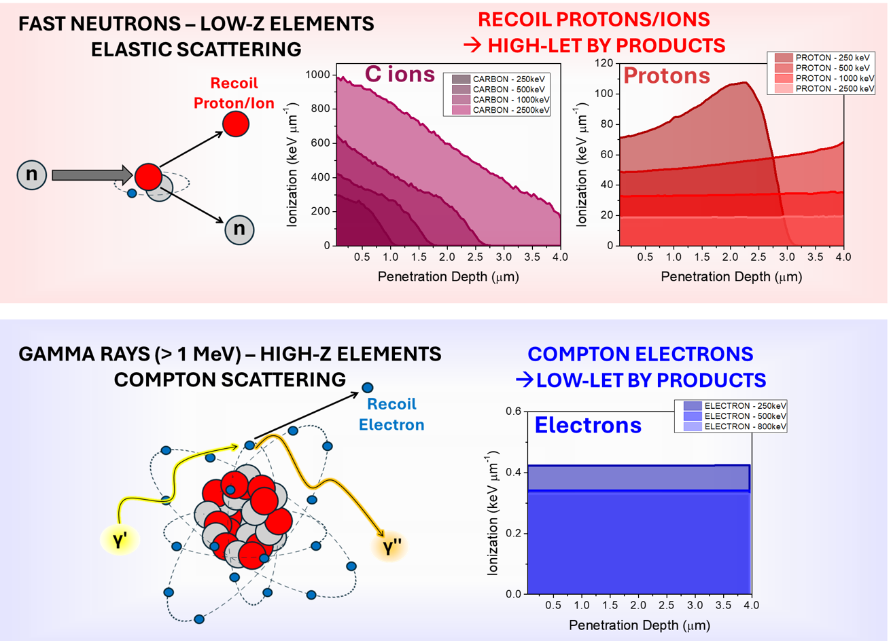

Figure S2: Mechanical Flexibility of the PEA₂PbBr₄ thin film based detector. The three different perovskite thicknesses devices have been exposed under X-rays (10s X-ray ON, 10 s X-ray OFF, 40 kVp, 2.8 mGy s⁻¹, bias 15 V) while they were kept flat or bent at different curvature radii in the range RC = [2.5 – 1] mm. The induced current for the (A) 1 µm, (B) 2µm and (C) 4 µm thick perovskites is reported for the different bending conditions. (D) Photocurrent variation at the different curvature radii. The photocurrent decrease is 10%, 13% and 20% at curvature radius of 2 mm for the 1 µm, 2 µm, 4 µm thick perovskites respectively. All the three samples show a 100% recovery when they return flat after the bending test.

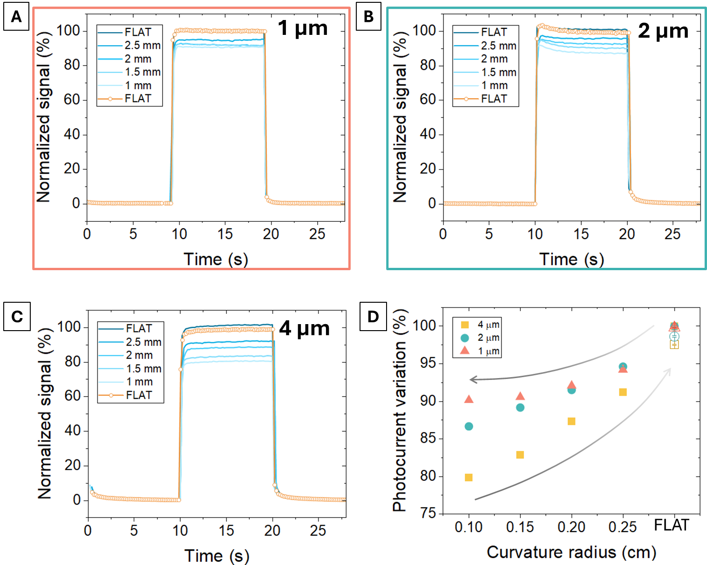

Figure S3: Thicknesses and Morphology of Perovskite layers deposited at different spin coating speeds. (A) Optical profilometer image of the edge between the perovskite layer deposited at 2000 rpm (orange) and the Kapton substrate below (blue). The white dashed line refers to the extracted profile. (B) Profiles of the perovskite layers deposited at different spin coating speed. (C) SEM images of the top-view (left) and cross-section (right) of the perovskite layers deposited at different spin coating speed
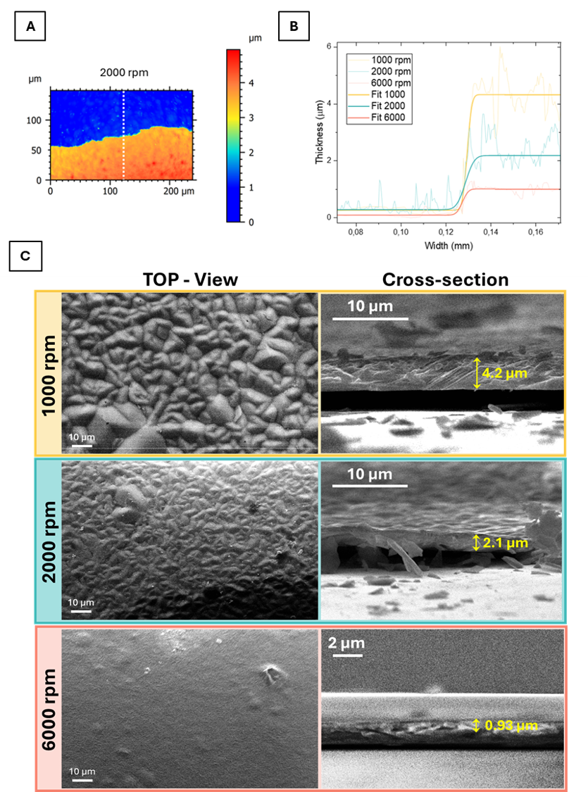

Figure S4: Electrical characterization in dark conditions. (A) Current-Voltage (IV) curve of the detectors, deposited at different spin coating speeds, in dark conditions. (B) Electrical Conductivity values for the samples deposited at different spin coating speeds and calculated as $σ=\frac{1}{R_{s}t}.$

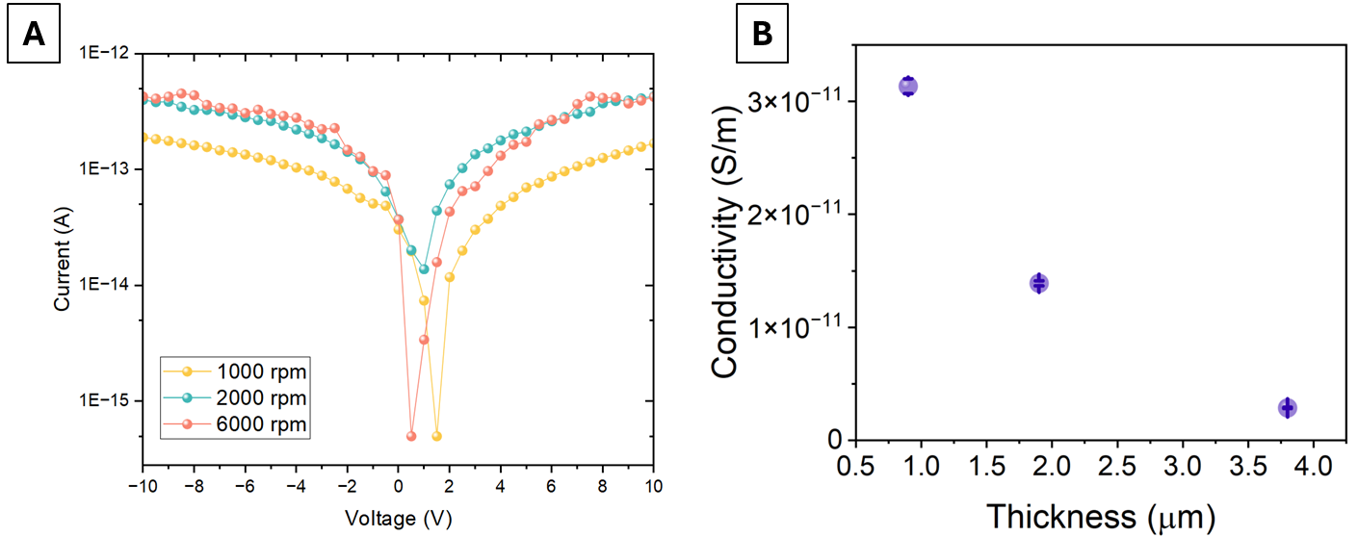

Figure S5: Long-term operational stability of PEA₂PbBr₄ based devices. (A) Current induced in a 2 µm thick PEA₂PbBr₄ based detector characterized as soon as fabricated and after 6 months of storage in ambient conditions (i.e. in air and at room temperature) under 5 MeV protons at different beam intensities (i.e. proton current). (B) Dynamic response of a 2 µm thick PEA₂PbBr₄ based detector irradiated by X-rays produced by a W-target X-ray tube over 40 consecutive cycles (each consisting of 50 seconds X-ray ON and 50 seconds X-ray OFF, at 40 kVp and 4.8 mGy/s dose rate, under a 15 V bias), for a total accumulated dose of 9.6 Gy.
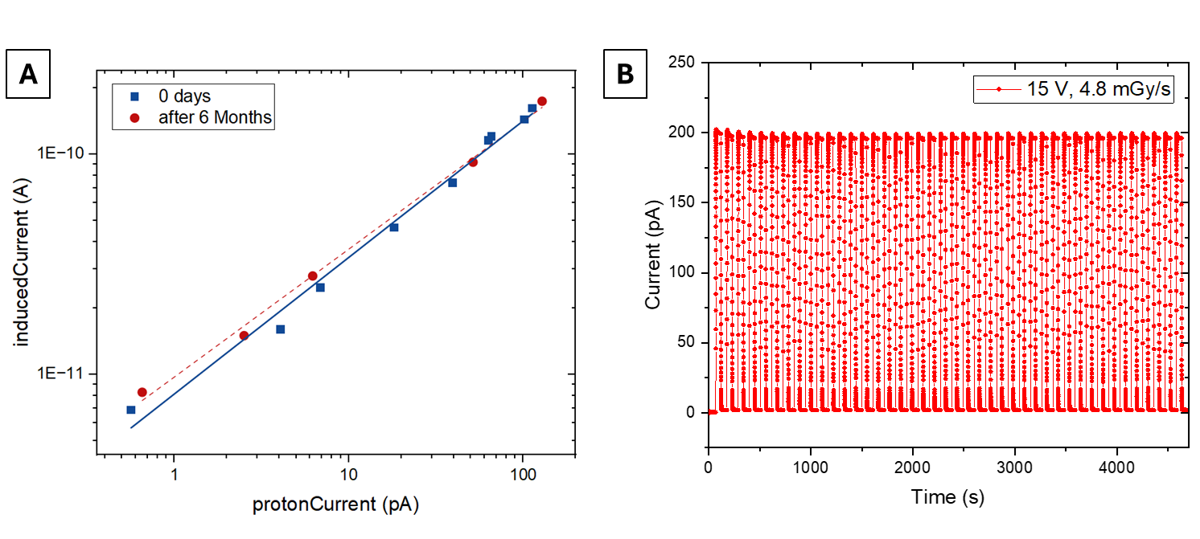

Figure S6: 1 MeV Gamma Ray exposure. Irradiation exposure under a ⁶⁰Co radioactive source (Activity = 1000 kBq). (A) Dynamic response of the thinnest (6000 rpm) and the thickest (1000 rpm) perovskite based detector biased at 15 V and exposed to 2 subsequent irradiation cycles (i.e. grey shadows) of 1 MeV Gamma Ray produced by the ⁶⁰Co source (10⁴ gamma rays s⁻¹ cm⁻²) (lines) and the mixed field present at the fast neutron beamline (i.e. 0.4 x 10⁵ n s⁻¹ cm⁻² + 10⁴ gamma rays s⁻¹ cm⁻²) (solid symbols). The radioactive source has been manually moved close (i.e. 3 cm) and far away (i.e. behind 10 cm of lead) from the sample to switch on and off the irradiation. (B) Dynamic response of the two samples and the blank (i.e. the interdigitated electrodes without the perovskite deposited on top) under the ⁶⁰Co radioactive source following the same experimental procedure. The spikes at the beginning and at the end of each irradiation cycle are due associated to the electronic noise due to the movement of the radioactive source.

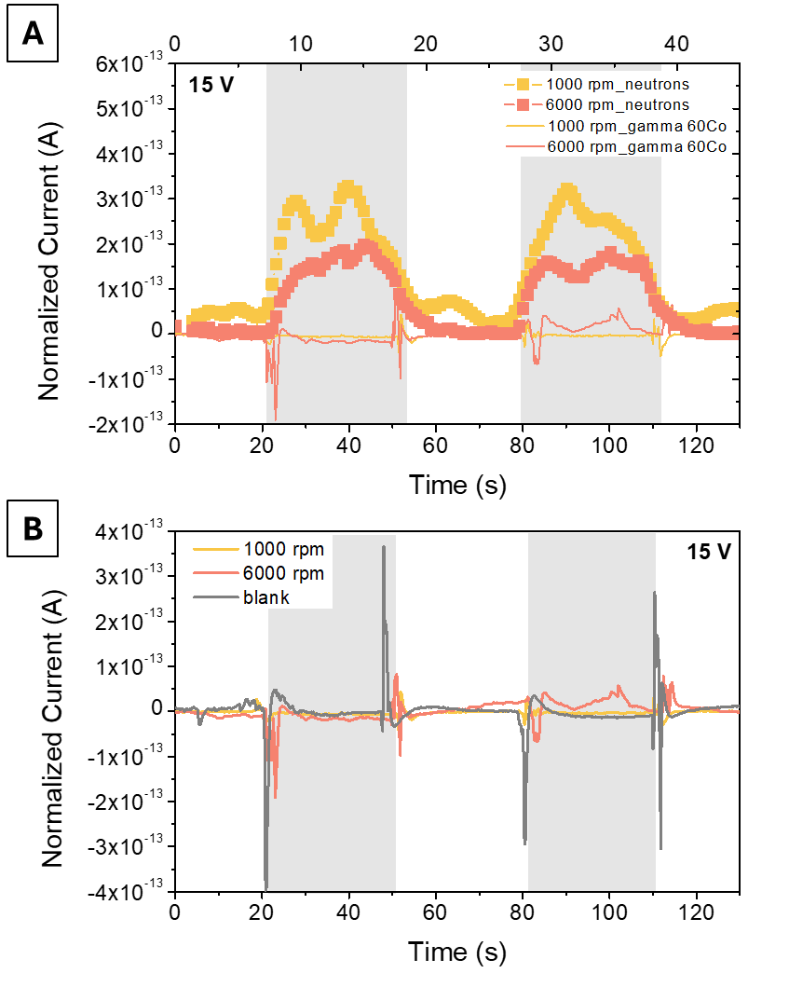

Table T2: table comparing the fast neutron detection efficiency in some direct and indirect detectors
CLASS | ACTIVE MATERIAL | HYDROGEN DENSITY  × 10²² cm⁻³ | Thickness (µm) | Efficiency (%) | REF
SOLID STATE | MHyPbCl3 | 3.79 | 330 | 0.44 | (1)
SOLID STATE | CVD diamond | 3.99 | 50 | 1 | (6)
SOLID STATE | 4MHB | 4.62 | 5000 | 40 | (3)
SCINTILLATOR | EJ410 | -- | 15900 | 1 | (4)
SCINTILLATOR | Mn-STA₂PbBr₄ | 9.51 | 1000 | 4.65 | (7)
SCINTILLATOR | Mn-DA₂PbBr₄ | 7.46 | 1000 | 3.90 | (7)
SCINTILLATOR | ZnS(Ag):PP | 15.47 | 1000 | 6.04 | (7)
SCINTILLATOR | Anthracene | 7.28 | 1000 | 8.19 | (7)
THIS WORK | PEA₂PbBr₄ | 4.25 | 1  1000 | 0.002  1.6 | Extracted

Figure S7: Sensitivity and simulated Neutron Detection Efficiency for different perovskite thickness and bias conditions.

Figure S8: Finite Element Simulation of the Electric Field Distribution in the perovskite co-plana device. Finite-element simulations using the ANSYS Maxwell 2D package to analyze the electric field distribution across the PEA₂PbBr₄ perovskite channel in our planar detector architecture. The simulation was run for three different perovskite thicknesses and simulating the real geometrical conditions of the semiconducting channel across one single pair of fingers of the interdigitated structures. The electrodes are formed by 40 nm of gold, the channel length is 30 µm, the electrical conductivity experimentally measured and in the order of 10⁻¹¹ S m⁻¹ and relative permittivity εr = 3 (8–12).

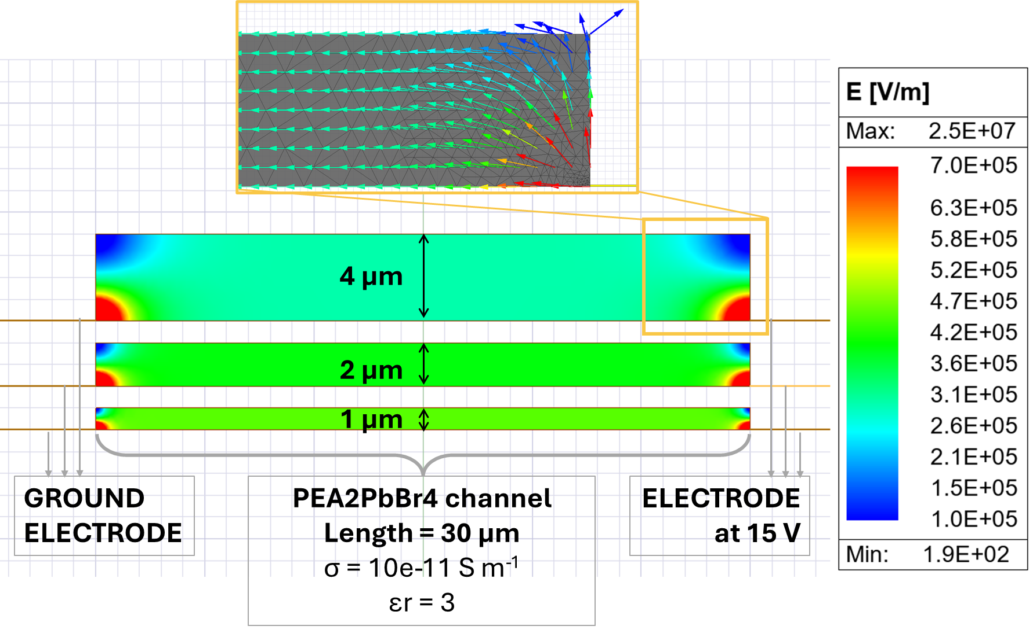

References
1. W. Panaccione, Z. Shi, P. Kandlakunta, T. Nichols, S. White, J. Huang, L. R. Cao, Testing of an Organic Metal Halide Perovskite for Fast Neutron Detection. Nucl Instrum Methods Phys Res A 1064, 169340 (2024).
2. L. Carman, H. Paul Martinez, L. Voss, S. Hunter, P. Beck, N. Zaitseva, S. A. Payne, P. Irkhin, H. H. Choi, V. Podzorov, Solution-Grown Rubrene Crystals as Radiation Detecting Devices. IEEE Trans Nucl Sci 64, 781–788 (2017).
3. D. Zhao, P. Cai, W. Cheng, W. Jia, B. Zhang, M. Zhu, L. Liu, X. Ouyang, P. Sellin, W. Jie, Y. Xu, Direct Detection of Fast Neutrons by Organic Semiconducting Single Crystal Detectors. Adv Funct Mater 32, 1–9 (2022).
4. https://eljentechnology.com/.
5. InradOptics, ScintinelTM Stilbene for Fast Neutron Detection.
6. Y. Lee, J. G. Kwak, Y. U. Nam, S. W. Yoon, H. S. Kim, G. Park, Diamond fast-neutron detector applied to the KSTAR tokamak. Fusion Engineering and Design 153 (2020).
7. J. Zheng, Y. Zeng, J. Wang, C. Sun, B. Tang, Y. Wu, Y. Zhang, Y. Yi, N. Wang, Y. Zhao, S. Zhou, Hydrogen-Rich 2D Halide Perovskite Scintillators for Fast Neutron Radiography. J Am Chem Soc 143, 21302–21311 (2021).
8. B. Chen, R. Yu, G. Xing, Y. Wang, W. Wang, Y. Chen, X. Xu, Q. Zhao, Dielectric Engineering of 2D Organic-Inorganic Hybrid Perovskites. American Chemical Society (2024). https://doi.org/10.1021/acsenergylett.3c02069.
9. D. Li, D. Li, A. Yang, H. Zhang, X. Lai, C. Liang, Electronic and Optical Properties of van der Waals Heterostructures Based on Two-Dimensional Perovskite (PEA)2PbI4 and Black Phosphorus. ACS Omega 6, 20877–20886 (2021).
10. R. Zheng, X. Gan, K. Li, S. Zhang, M. Xiang, L. Guo, H. Liu, High dielectric constant ethanolamine based two-dimensional perovskite thin films and their application in perovskite PSCs. Opt Mater (Amst) 147 (2024).
11. A. Forde, S. Tretiak, A. J. Neukirch, Dielectric Screening and Charge-Transfer in 2D Lead-Halide Perovskites for Reduced Exciton Binding Energies. Nano Lett 23, 11586–11592 (2023).
12. Z. Fang, G. Wang, C. Guan, J. Zhang, Q. Xiang, Reducing Dielectric Confinement Effect Enhances Carrier Separation in Two‐Dimensional Hybrid Perovskite Photocatalysts. Angewandte Chemie International Edition, doi: 10.1002/anie.202411219 (2024).

