SUPPLEMENTARY MATERIAL

Volumetric absorptive microsampling for in vitro metabolism of the recent synthetic cannabinoid receptor agonist 5F-PB-22

Michele Protti^{a,1}, Roberto Mandrioli^{b,1}, Sobia Noreenª, Antonio Leoneª,
Roccaldo Sardella^{c}, Jose González-Rodríguez^{d,}*, Laura Mercolini^{a,}*

ª Research Group of Pharmaco-Toxicological Analysis (PTA Lab), Department of Pharmacy and Biotechnology (FaBiT), Alma Mater Studiorum - University of Bologna, Via Belmeloro 6, 40126 Bologna (Italy)
^{b} Department for Life Quality Studies, Alma Mater Studiorum - University of Bologna, Corso d’Augusto 237, 47921 Rimini (Italy)
^{c} Department of Pharmaceutical Sciences, University of Perugia, Via Fabretti 48, 06123 Perugia (Italy)
^{d} School of Natural Sciences, Department of Chemistry, College of Health and Science, University of Lincoln, Brayford Pool, LN67TS Lincoln (United Kingdom)

¹ Equal contributors.

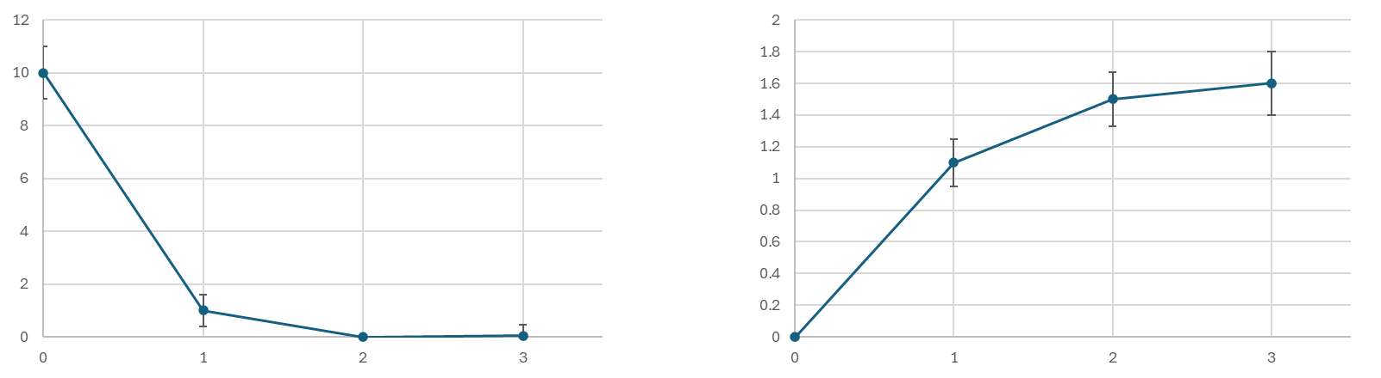
Figure S1. Average change in concentration of a) 5F-PB-22
Time (h)
Analyte conc. (µg/mL)
Analyte conc. (µg/mL)
Time (h)
a

b

and b) 5F-PB-22 3-carboxyindole in PII sample series.
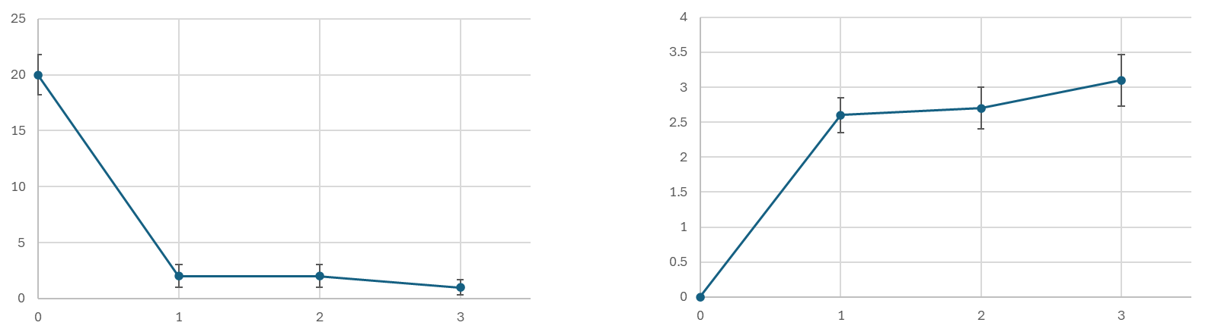
Analyte conc. (µg/mL)
Time (h)
Time (h)
Analyte conc. (µg/mL)
a

b

Figure S2. Average change in concentration of a) 5F-PB-22
and b) 5F-PB-22 3-carboxyindole in PIII series samples.
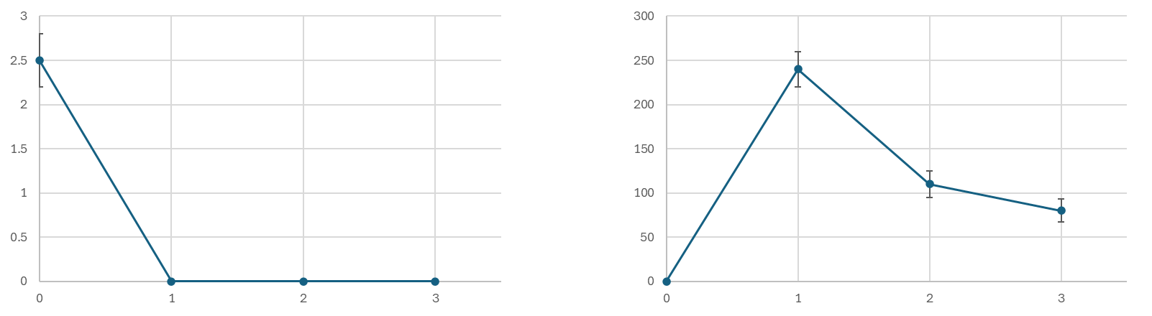
a

b

Analyte conc. (ng/mL)
Time (h)
Time (h)
Analyte conc. (µg/mL)

Figure S3. Average change in concentration of a) 5F-PB-22
and b) 5F-PB-22 3-carboxyindole in PIV series samples.

Table S1. Results of extraction procedure optimisation assays.
Conditions |  |  | Results
Technique | Solvent | Volume (µL) | Extraction yield (%)* | Purification
Vortex-Assisted Extraction (VAE) | MeOH | 500 | 62 | -
Vortex-Assisted Extraction (VAE) | MeOH | 1000 | 79 | ++
Vortex-Assisted Extraction (VAE) | MeOH | 1500 | 71 | +
Vortex-Assisted Extraction (VAE) | H₂O | 500 | 65 | -
Vortex-Assisted Extraction (VAE) | H₂O | 1000 | 75 | +
Vortex-Assisted Extraction (VAE) | H₂O | 1500 | 64 | +
Vortex-Assisted Extraction (VAE) | ACN | 500 | 47 | ++
Vortex-Assisted Extraction (VAE) | ACN | 1000 | 45 | ++
Vortex-Assisted Extraction (VAE) | ACN | 1500 | 49 | +
Vortex-Assisted Extraction (VAE) | MeOH/ACN 50/50 | 500 | 70 | -
Vortex-Assisted Extraction (VAE) | MeOH/ACN 50/50 | 1000 | 70 | +
Vortex-Assisted Extraction (VAE) | MeOH/ACN 50/50 | 1500 | 71 | ++

Conditions |  |  | Results
Technique | Solvent | Volume (µL) | Extraction yield (%)* | Purification
Microwave-Assisted Extraction (MAE) | MeOH | 500 | 53 | +
Microwave-Assisted Extraction (MAE) | MeOH | 1000 | 67 | ++
Microwave-Assisted Extraction (MAE) | MeOH | 1500 | 68 | +
Microwave-Assisted Extraction (MAE) | H₂O | 500 | 70 | -
Microwave-Assisted Extraction (MAE) | H₂O | 1000 | 72 | -
Microwave-Assisted Extraction (MAE) | H₂O | 1500 | 74 | -
Microwave-Assisted Extraction (MAE) | ACN | 500 | 54 | +
Microwave-Assisted Extraction (MAE) | ACN | 1000 | 55 | -
Microwave-Assisted Extraction (MAE) | ACN | 1500 | 54 | -
Microwave-Assisted Extraction (MAE) | MeOH/ACN 50/50 | 500 | 62 | +
Microwave-Assisted Extraction (MAE) | MeOH/ACN 50/50 | 1000 | 63 | +
Microwave-Assisted Extraction (MAE) | MeOH/ACN 50/50 | 1500 | 64 | -

Conditions |  |  | Results
Technique | Solvent | Volume (µL) | Extraction yield (%)* | Purification
Ultrasound-Assisted Extraction (UAE) | MeOH | 500 | 74 | +
Ultrasound-Assisted Extraction (UAE) | MeOH | 1000 | 88 | ++
Ultrasound-Assisted Extraction (UAE) | MeOH | 1500 | 85 | +
Ultrasound-Assisted Extraction (UAE) | H₂O | 500 | 45 | -
Ultrasound-Assisted Extraction (UAE) | H₂O | 1000 | 55 | -
Ultrasound-Assisted Extraction (UAE) | H₂O | 1500 | 61 | +
Ultrasound-Assisted Extraction (UAE) | ACN | 500 | 78 | +
Ultrasound-Assisted Extraction (UAE) | ACN | 1000 | 78 | +
Ultrasound-Assisted Extraction (UAE) | ACN | 1500 | 76 | +
Ultrasound-Assisted Extraction (UAE) | MeOH/ACN 50/50 | 500 | 72 | +
Ultrasound-Assisted Extraction (UAE) | MeOH/ACN 50/50 | 1000 | 76 | +
Ultrasound-Assisted Extraction (UAE) | MeOH/ACN 50/50 | 1500 | 77 | ++
* Results refer to 5F-PB-22.

Table S2. Results of matrix effect assays.
Level | Concentration (µg/mL) | Matrix Effect (% Bias)
Level | Concentration (µg/mL) | 5F-PB-22 | 5F-PB-22  3-carboxyindole
Low | 5 | -10 | -7
Middle | 500 | -4 | -5
High | 1000 | +3 | +7

