AR-A014418-based dual Glycogen Synthase Kinase 3β / Histone Deacetylases inhibitors as potential therapeutics for Alzheimer’s disease

Alan Santini,ª Elisa Tassinari,ª Alessandra Altomare,^{b} Manuela Loi,^{c} Elisabetta Ciani,^{c} Stefania Trazzi,^{c} Rebecca Piccarducci,^{d} Simona Daniele,^{d} Claudia Martini,^{d} Barbara Pagliarani,ª Andrea Tarozzi,ª Matteo Bersani,^{e} Francesca Spyrakis,^{e} Daniela Danková,^{f} Eleonora Poeta,^{g} Simone Raimondi,ª Lara Davani,^{b} Giancarlo Aldini,^{b} Vincenza Andrisano,ª Angela De Simone,^{e} and Andrea Milelliª*

ª Department for Life Quality Studies, Alma Mater Studiorum-University of Bologna, Corso d’Augusto 237, 47921 Rimini, Italy
^{b} Department of Pharmaceutical Sciences (DISFARM), University of Milan, Via Mangiagalli 25, 20133, Milan, Italy
^{c} Department of Biomedical and Neuromotor Science, Alma Mater Studiorum-University of Bologna, Piazza di Porta S. Donato, 2, 40126 Bologna, Italy
^{d} Department of Pharmacy, University of Pisa, Via Bonanno Pisano, 6, 56126 Pisa, Italy
^{e} Department of Drug Science and Technology, University of Turin, Via Pietro Giuria 9, 10125 Turin, Italy
^{f} Center for Biopharmaceuticals and Department of Drug Design and Pharmacology, Faculty of Health and Medical Sciences, University of Copenhagen, Jagtvej 160, DK-2100 Copenhagen, Denmark
^{g} Department of Pharmacy and Biotechnology, Alma Mater Studiorum-University of Bologna, Via Francesco Selmi 3, 40126 Bologna, Italy

Table of Content
1. Figure SI1. Mitotic index.
2. Figure SI2. Multiscatter plot depicting the distribution of LFQ intensities between two conditions.
3. Table SI1. List of UniProt protein names along with a brief description of their roles in the mitotic process.
4. Figure SI3. Protein-protein interaction network illustrating the relationships among the proteins associated with the mitosis phase.
5. Table SI3.
6. Figure SI2. Protein-protein interaction network illustrating the relationships among the proteins associated with the apoptotic execution phase.
7. Table SI3. List of antibodies used.
8. Representative copies of ¹H-NMR and ¹³C-NMR spectra.

1.
Figure SI1. Effect of treatments on cell proliferation. Number of mitotic cells over the total cell number (mitotic index) in SH-SY5Y cells treated with vehicle (0.1% DMSO) or increasing concentrations (0.1 μM, 1 μM, 10 μM, 25 μM, 50 μM, and 100 μM) of compounds 3 or 19 for 24 h. Values are represented as means ± SEM. *p < 0.05, *** p < 0.001. Two way-ANOVA Dunnett's multiple comparisons test.
2.

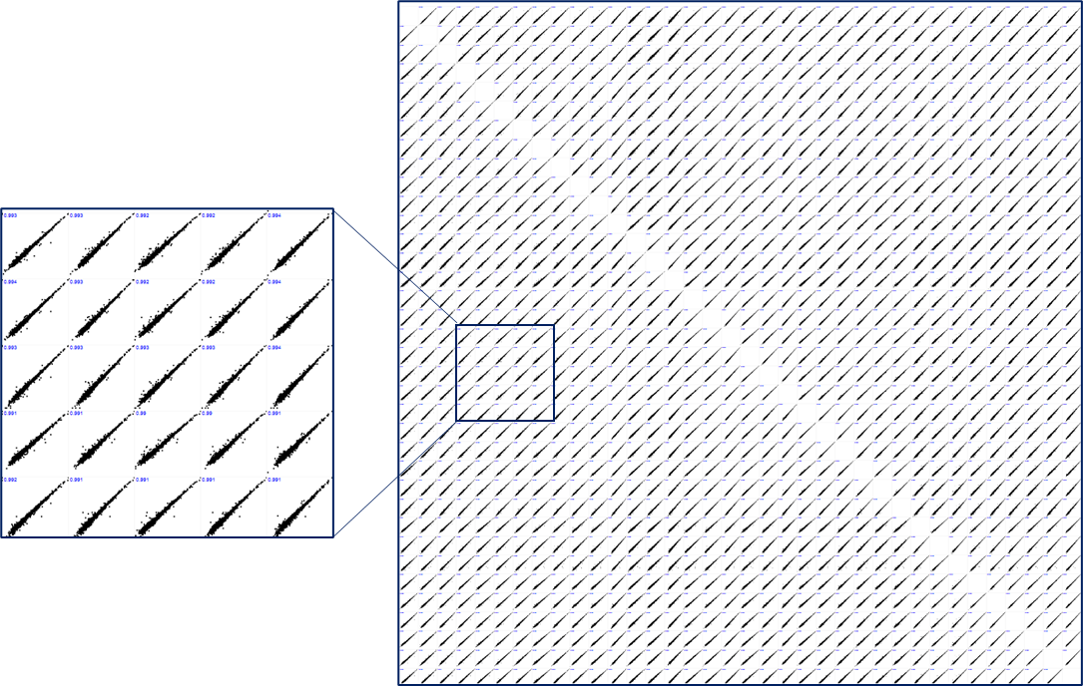

Figure SI2. Multiscatter plot depicting the distribution of LFQ intensities between two conditions (3 biological replicates for 3 technical replicates).

3. Table SI1. List of UniProt protein names along with a brief description of their roles in the mitotic process.

Mitosis Protein | UniProt Name | Function
AHCTF1 | Activating Signal Cointegrator 1 Complex Subunit 1 | Involved in nuclear pore complex assembly and mitotic progression.
CHMP4B | Charged Multivesicular Body Protein 4B | Part of the ESCRT-III complex, crucial for cytokinesis and membrane fission.
LMNA | Prelamin-A/C | Structural component of the nuclear envelope, involved in nuclear stability and chromatin organization.
PPP2R1B | Serine/threonine-protein phosphatase 2A 65 kDa regulatory subunit A beta isoform | Regulatory subunit of protein phosphatase 2A, involved in controlling mitotic exit.
PSME1 | Proteasome Activator Complex Subunit 1 | Facilitates the degradation of proteins during cell cycle transitions.
RCC2 | Protein Regulator of Cytokinesis 1 | Plays a role in chromosome condensation and the proper segregation of chromosomes.
UBE2S | Ubiquitin-Conjugating Enzyme E2 S | Catalyzes the elongation of ubiquitin chains on substrates, important for anaphase progression.
CETN2 | Centrin-2 | Involved in centrosome duplication and spindle formation during mitosis.
TPX2 | Targeting Protein for Xklp2 | Key player in spindle assembly by activating Aurora A kinase.
MAX | MYC-Associated Factor X | Regulates transcription of target genes during cell cycle progression.
TK1 | Thymidine Kinase 1 | Catalyzes the phosphorylation of thymidine, essential for DNA synthesis during cell division.
TYMS | Thymidylate Synthase | Catalyzes the conversion of dUMP to dTMP, a crucial step in DNA replication.
TOP2A | DNA Topoisomerase II Alpha | Controls the topological states of DNA during transcription and is essential for chromosomal segregation in mitosis.

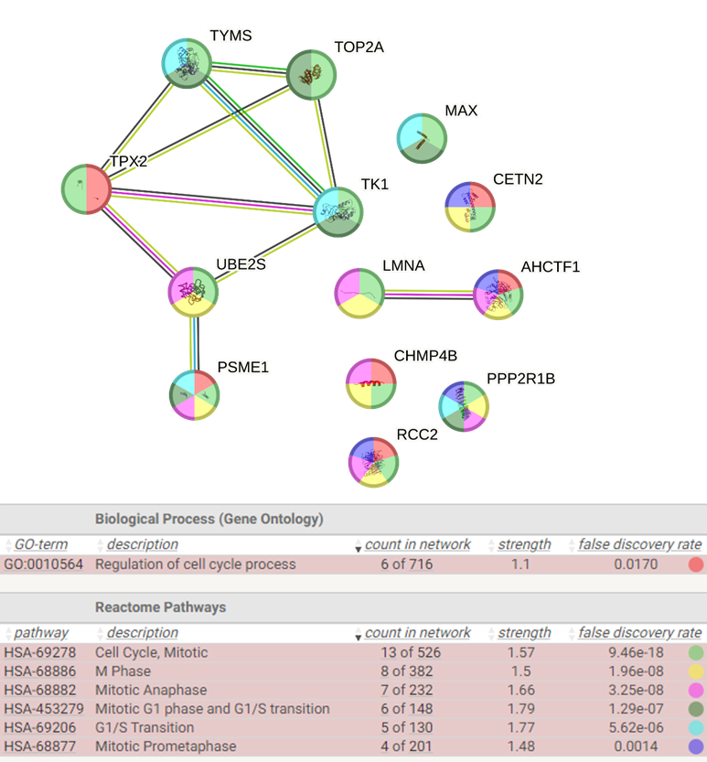
4. Figure SI3. Protein-protein interaction network illustrating the relationships among the proteins associated with the mitosis phase.

5. Table SI2. This table provides the UniProt names and highlights the role of these proteins during the apoptotic execution phase, focusing on their involvement in chromatin dynamics and nuclear integrity.

Apoptotic Execution Phase Protein | UniProt Name | Function
H1-0 | H10_HUMAN (P07305) | In apoptosis, H1-0 is involved in chromatin condensation and DNA fragmentation, a hallmark of the apoptotic execution phase.
H1-2 | H12_HUMAN (P16403) | Histone H1.2 is known to be released into the cytoplasm during apoptosis, where it can contribute to the activation of apoptotic pathways, particularly through the release of cytochrome c from mitochondria.
H1-4 | H14_HUMAN (P10412) | Histone H1.4 plays a role in chromatin condensation during the apoptotic execution phase, aiding in the structural reorganization of chromatin prior to DNA fragmentation.
LMNA | LMNA_HUMAN (P02545) | Lamin A/C is cleaved by caspases during apoptosis, leading to nuclear envelope breakdown and chromatin condensation, facilitating the progression of apoptosis.

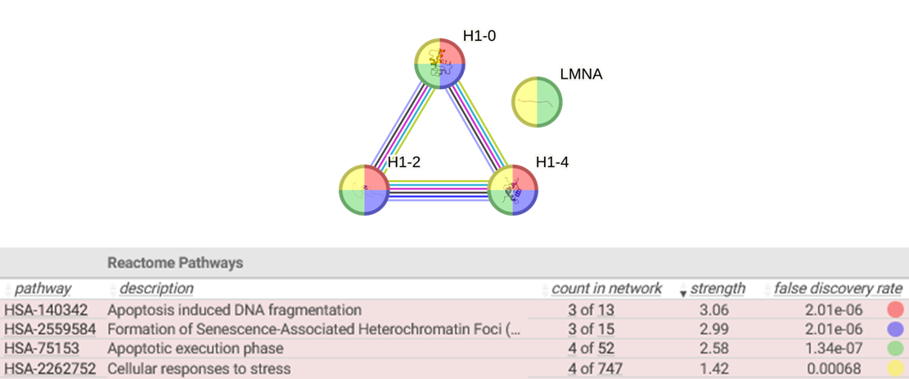
6. Figure SI4. Protein-protein interaction network illustrating the relationships among the proteins associated with the apoptotic execution phase.

7. Table SI3. List of antibodies used.
Antibody against | Description | Diluition | Product nr and Manufacturer
Phospho-GSK-3β (Ser9) | Rabbit polyclonal | 1:1000 | 5558, Cell Signaling Technology
GSK-3β | Rabbit polyclonal | 1:1000 | 9315, Cell Signaling Technology
Acetylated Tubulin | Mouse monoclonal | 1:1000 | T6793, Sigma-Aldrich
α-Tubulin | Mouse monoclonal | 1:1000 | T5168, Sigma-Aldrich
H3K9/14ac | Rabbit polyclonal | 1:500 | C15410005, Diagenode
Histone H3 | Rabbit monoclonal | 1:1000 | 05-928, Merck Millipore
GAPDH | Rabbit polyclonal | 1:5000 | G9545, Sigma-Aldrich
Secondary antibodies
Antibody | Conjugate | Diluition | Product nr and Manufacturer
Goat Anti-Rabbit IgG | HRP | 1:5000 | 111-035-144, Jackson ImmunoResearch Laboratories, Inc.
Goat Anti-Mouse IgG | HRP | 1:5000 | 115-035-146, Jackson ImmunoResearch Laboratories, Inc.
8. Representative copies of ¹H-NMR and ¹³C-NMR spectra.
Compound 3. ¹H-NMR (400 MHz) and ¹³C-NMR (100 MHz) in DMSO-d.

Compound 7. ¹H-NMR (400 MHz) and ¹³C-NMR (100 MHz) in DMSO-d.

Compound 10. ¹H-NMR (400 MHz) and ¹³C-NMR (100 MHz) in DMSO-d.

Compound 11. ¹H-NMR (400 MHz) and ¹³C-NMR (100 MHz) in DMSO-d.

Compound 13. ¹H-NMR (400 MHz) and ¹³C-NMR (100 MHz) in DMSO-d.

Compound 19. ¹H-NMR (400 MHz) and ¹³C-NMR (100 MHz) in DMSO-d.

Compound 21. ¹H-NMR (400 MHz) and ¹³C-NMR (100 MHz) in DMSO-d.

Compound 24. ¹H-NMR (400 MHz) and ¹³C-NMR (100 MHz) in DMSO-d.

Compound 26. ¹H-NMR (400 MHz) and ¹³C-NMR (100 MHz) in DMSO-d.

Compound 27. ¹H-NMR (400 MHz) and ¹³C-NMR (100 MHz) in DMSO-d.

Compound 28. ¹H-NMR (400 MHz) and ¹³C-NMR (100 MHz) in DMSO-d.

Compound 29. ¹H-NMR (400 MHz) and ¹³C-NMR (100 MHz) in DMSO-d.

Compound 30. ¹H-NMR (400 MHz) and ¹³C-NMR (100 MHz) in DMSO-d.

Compound 31. ¹H-NMR (400 MHz) and ¹³C-NMR (100 MHz) in DMSO-d.

Compound 32. ¹H-NMR (400 MHz) and ¹³C-NMR (100 MHz) in DMSO-d.

Compound 35. ¹H-NMR (400 MHz) and ¹³C-NMR (100 MHz) in DMSO-d.

