Supporting information/ Supplementary material

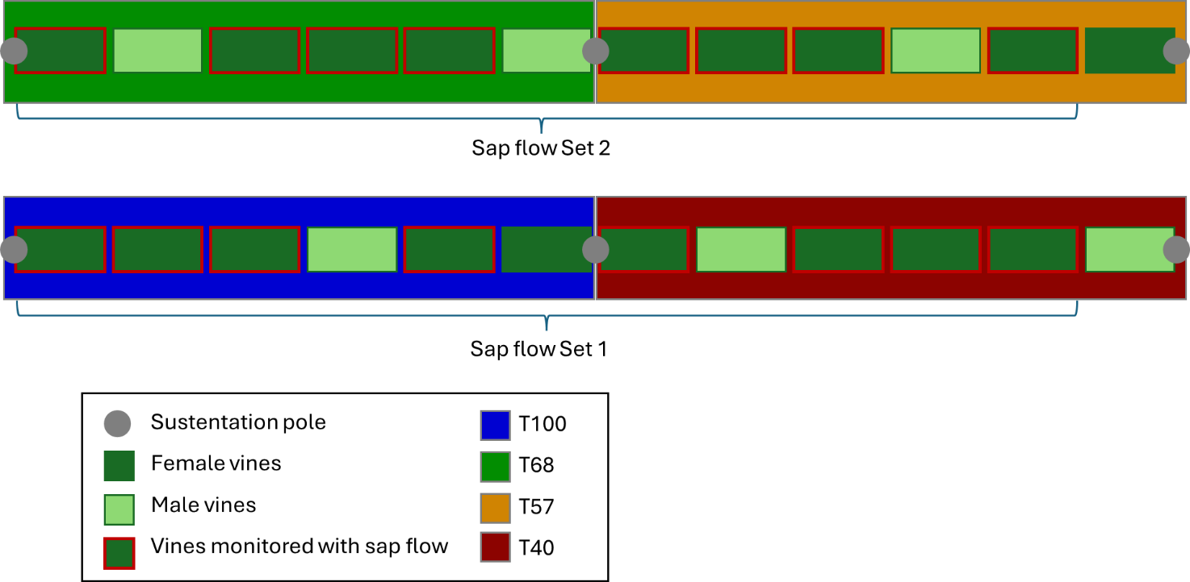
Figure S1. Experimental design.

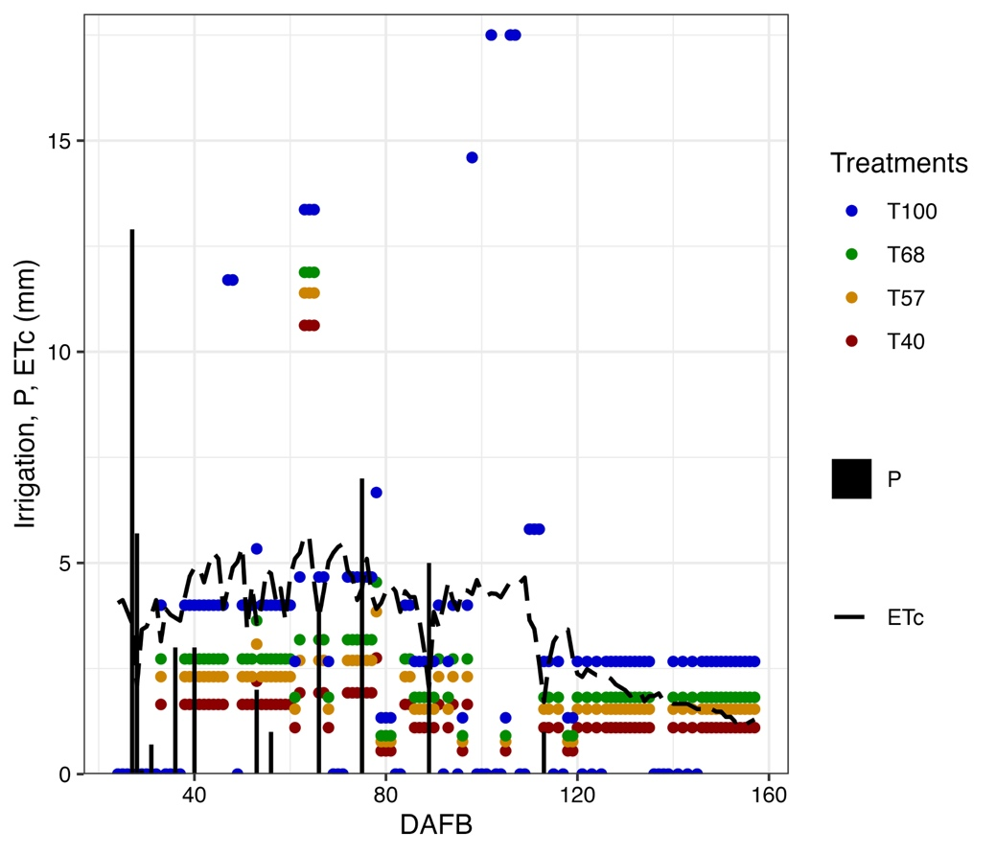
Figure S2. Irrigation doses according to the treatments, rainfall (P), and crop evapotranspiration (ETc) during 2023 fruit growing season when irrigation was more needed.

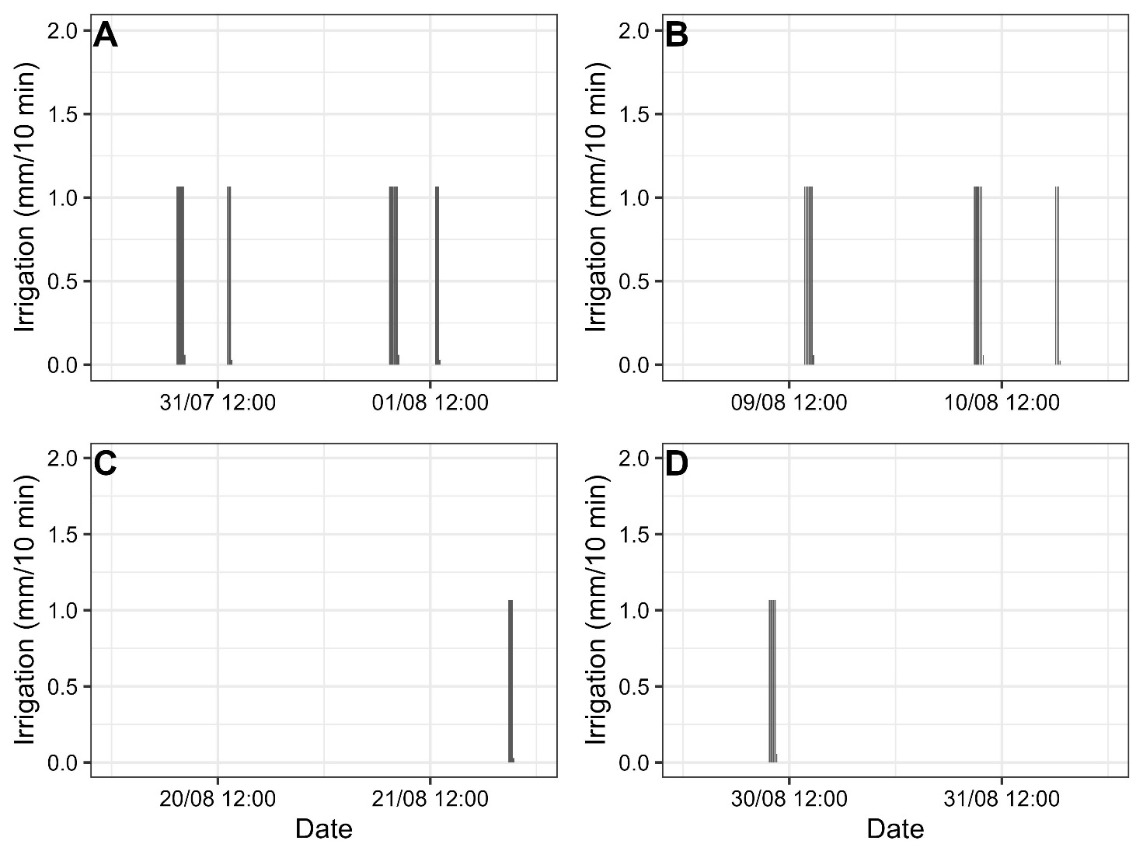
Figure S3. Irrigation volumes for the T100 treatment (100% ETc) at 84 to 85 (A), 104 to 105 (B), 114 to 115 (C) and 120 to 121 (D) DAFB. At 121 and 141 DAFB no irrigation was applied.

