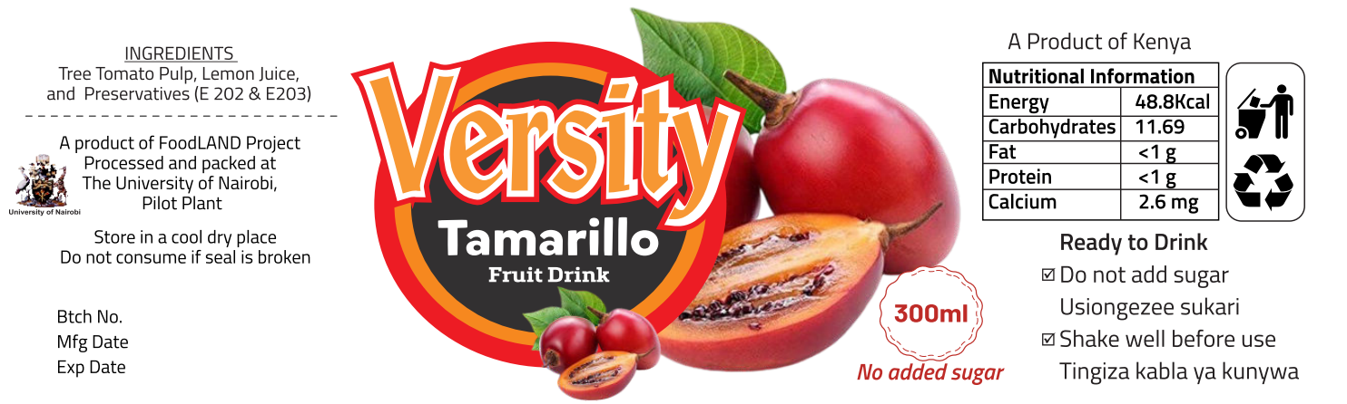
Figure S1. Pure tamarillo drink label, which reports: brand and product name, ingredients, information on the manufacturer, storage instructions, batch number, production/packaging date, expiry date, net weight, nutritional table, recycling symbol and consumption information.
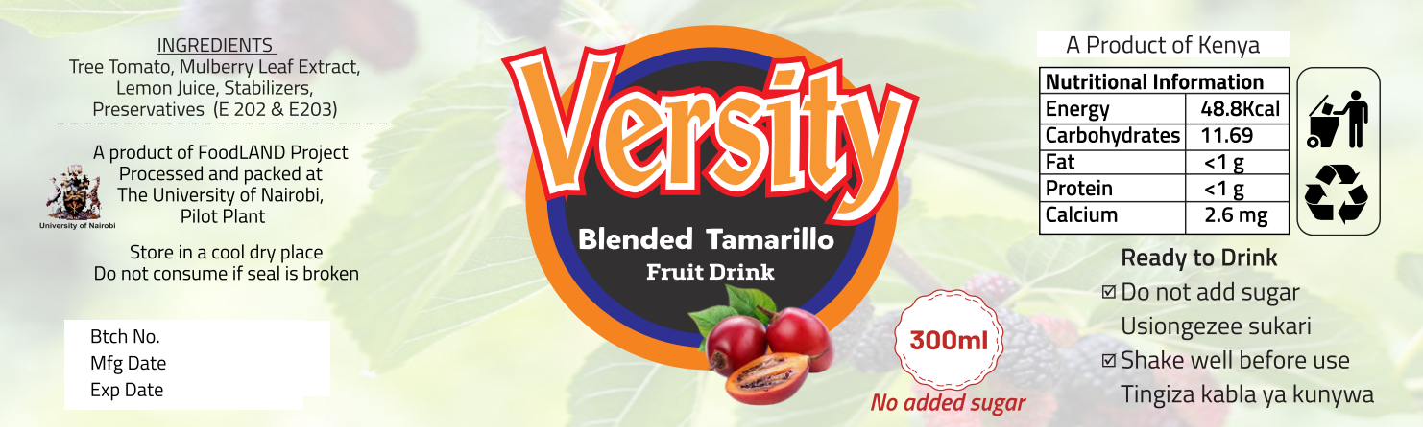
Figure S2. Tamarillo drink fortified with mulberry leaf extract label, which reports: brand and product name of the product, ingredients, information on the manufacturer, storage method, batch number, production/packaging date, expiry date, net weight, nutritional table, recycling symbol and consumption information.
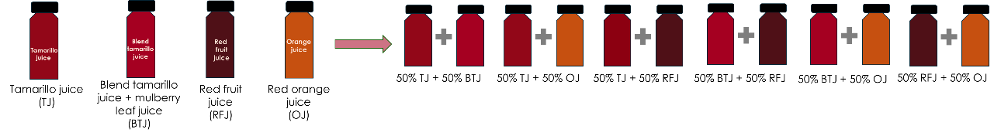
Figure S3. Composition of the samples analysed: the four pure fruit drinks are depicted on the left side of the image, while on the right their mixture (1:1 v/v) are represented.
Table S1. Volatile profile analysed by SPME-GC-MS of the ten samples. Results are expressed as area x 10⁻³ and as mean ± % coefficient of variation of three independent replicates. The compounds are listed according to their retention time (RT).

Compound | RT | TJ | BTJ | OJ | RFJ | TJ+BTJ | TJ+OJ | TJ+RFJ | BTJ+OJ | BTJ+RFJ |  | OJ+RFJ
Ethyl acetate | 2.35 | nd | nd | nd | 15343  ± 2.84 | nd | nd | nd | nd | 6253  ± 2.94 |  | nd
Ethanol | 2.82 | 10755  ± 6.04 | nd | 45738  ± 14.25 | nd | nd | 26386  ± 2.75 | nd | 23509  ± 15.53 | nd |  | 24302  ± 6.91
α-Pinene | 4.30 | 207584  ± 14.64 | 46691  ± 11.26 | 285369  ± 4.30 | nd | 237629  ± 4.13 | 289638  ± 6.76 | 136421  ± 34.18 | 170057  ± 5.33 | 27444  ± 4.28 |  | 165625  ± 11.81
Butanoic acid | 4.75 | 11067  ± 1.02 | nd | 24957  ± 9.74 | 327111  ± 3.10 | nd | 15697  ± 8.29 | 91444  ± 5.98 | 11750  ± 17.27 | 165012  ± 0.28 |  | 77334  ± 5.29
Canfene | 5.13 | 10720  ± 13.69 | 5243  ± 5.55 | nd | nd | 13723  ± 3.77 | nd | 6426  ± 18.78 | nd | nd |  | nd
Ethyl-2-methyl-butanoate | 5.25 | nd | nd | nd | 186409  ± 5.02 | nd | nd | 32567  ± 19.41 | nd | 73487  ± 2.10 |  | 26075  ± 10.54
Camphene (isomer 1) | 5.32 | 26565  ± 13.69 | 11722  ± 10.71 | nd | nd | 33325  ± 5.94 | 16841  ± 1.58 | 19476  ± 31.84 | nd | nd |  | nd
Pantanoic acid | 5.79 | nd | nd | nd | 899125  ± 3.87 | nd | nd | 246752  ± 11.64 | nd | 404329  ± 1.76 |  | 189895  ± 6.35
Ethyl isovalerate | 5.97 | nd | nd | nd | 116457  ± 4.52 | nd | nd | 19329  ± 32.75 | nd | nd |  | nd
Camphene (isomer 2) | 6.69 | 482886  ± 8.41 | nd | nd | nd | 454722  ± 21.42 | 316893  ± 13.18 | 304337  ± 29.87 | nd | nd |  | nd
3-Carene | 9.03 | nd | nd | 164536  ± 7.67 | nd | nd | nd | nd | 87088  ± 19.62 | nd |  | 103583  ± 3.36
β-Myrcene (isomer 1) | 10.66 | 172682  ± 19.58 | 76571  ± 13.35 | nd | nd | nd | nd | nd | nd | 20463  ± 3.32 |  | nd
β-Myrcene (isomer 2) | 10.86 | 96120  ± 6.76 | 34219  ± 6.24 | nd | nd | 321399  ± 5.72 | 1251286  ± 8.05 | 179453  ± 32.92 | 1025652  ± 6.81 | nd |  | nd
Carene | 11.03 | 105932  ± 12.41 | nd | nd | nd | nd | nd | nd | nd | nd |  | nd
β-Myrcene (isomer 1) + Carene | 11.05 | nd | nd | 1535875  ± 3.61 | nd | nd | nd | nd | nd | nd |  | 1026495  ± 8.05
Carene (isomer 1) | 11.24 | 78277  ± 6.48 | nd | nd | nd | 185437  ± 7.59 | nd | 89158  ± 37.22 | nd | nd |  | nd
Limonene + m-Mentha-4,8-diene | 12.69 | 4945278  ± 6.12 | 2550646  ± 0.14 | nd | nd | nd | 12171245  ± 3.92 | nd | nd | nd |  | nd
Limonene + m-Mentha-1,7,8-diene | 12.82 | nd | nd | nd | nd | 5030121  ± 4.25 | 12219125  ± 5.44 | 3219798  ± 25.28 | 11555479  ± 5.50 |  | 1925556  ± 1.12 | nd
Eucalyptol | 12.88 | nd | nd | nd | 468381  ± 2.69 | nd | nd | 224850  ± 0.88 | nd | 254492  ± 2.82 |  | nd
β-Phellandrene | 12.89 | 165455  ± 11.87 | nd | nd | nd | 137809  ± 12.11 | nd | nd | nd | nd |  | nd
Limonene + m-Mentha-1,7,8-diene + Eucalyptol | 13.58 | nd | nd | 15262642  ± 0.97 | nd | nd | nd | nd | nd | nd |  | 1191267  ± 4.48
m-Mentha-4,8-diene | 15.42 | 1243885  ± 7.20 | 510470  ± 22.99 | 213908  ± 0.18 | nd | 1277997  ± 2.76 | 804066  ± 6.54 | 890024  ± 19.16 | 236595  ± 3.89 | 294823  ± 3.71 |  | 141114  ± 6.76
β-cis-Ocimene | 16.19 | 177903  ± 10.42 | 36477  ± 16.81 | 31301  ± 2.73 | nd | 202214  ± 5.27 | 107560  ± 9.11 | 101021  ± 28.05 | 27123  ± 0.94 | 21898  ± 8.18 |  | 17956  ± 3.44
o-Cymene | 16.63 | 59882 ± 8.06 | 57835  ± 0.54 | 16303  ± 4.85 | nd | 95923  ± 5.14 | 35584  ± 13.34 | 44759  ± 33.59 | 18557  ± 6.29 | 29911  ± 7.46 |  | 9855  ± 19.16
p-Mentha-1,4(8)-diene | 17.43 | 627870  ± 7.23 | 201810  ± 13.99 | 97518  ± 1.35 | nd | 681010  ± 3.33 | 419091  ± 8.07 | 425799  ± 21.69 | 106165  ± 5.33 | 128390  ± 1.89 |  | 74064  ± 4.57
Acetic acid | 17.52 | nd | nd | nd | 25426  ± 5.21 | nd | nd | nd | nd | nd |  | nd
Octanal | 18.11 | nd | nd | 31091  ± 0.27 | nd | nd | 11654  ± 9.49 | nd | 22459  ± 4.19 | nd |  | 20015  ± 4.26
Ethyl octanoate | 25.81 | nd | nd | nd | nd | nd | nd | nd | 17472  ± 13.74 | nd |  | nd
α-Copaene | 27.72 | nd | nd | 7514  ± 5.96 | nd | nd | nd | nd | nd | nd |  | nd
Decanal | 28.32 | 32410 ± 6.22 | 69600  ± 0.10 | 82033  ± 1.23 | nd | 52013  ± 0.28 | 86753  ± 1.67 | 61418  ± 6.20 | 69715  ± 2.15 | 44534  ± 4.15 |  | 59466  ± 1.02
Linalool | 30.77 | 102180  ± 2.97 | 121107  ± 4.11 | 303440  ± 2.73 | 218838  ± 0.42 | 107309  ± 2.09 | 231357  ± 1.00 | 133134  ± 8.01 | 230881  ± 2.26 | 170574  ± 0.97 |  | 267625  ± 0.43
Menthol | 30.99 | nd | nd | nd | 535204  ± 2.05 | nd | nd | 90005  ± 2.25 | nd | 286713  ± 1.58 |  | 116806  ± 1.93
1-Octanol | 31.16 | nd | nd | 65110  ± 3.07 | nd | nd | 44855  ± 1.87 | nd | 47961  ± 3.45 | nd |  | 60164  ± 3.18
Fenchol | 31.77 | 236588  ± 2.37 | 230274  ± 4.89 | nd | nd | 235798  ± 3.68 | 93980  ± 1.29 | 180118  ± 7.82 | 58037  ± 0.41 | 136146  ± 1.60 |  | nd
α-Bergamotene | 31.92 | 542421  ± 9.92 | 578128  ± 0.80 | 30660  ± 3.04 | nd | 592544  ± 1.76 | 251741  ± 8.07 | 407719  ± 7.09 | 126789  ± 5.60 | 445758  ± 7.59 |  | 24475  ± 7.90
4-Terpineol | 32.40 | 447624  ± 0.28 | 445246  ± 4.40 | 110155  ± 1.83 | nd | 451626  ± 2.25 | 267897  ± 0.75 | 354386  ± 5.68 | 208559  ± 1.99 | 282007  ± 1.93 |  | 75154  ± 1.97
β-Terpineol | 33.75 | nd | 24553  ± 3.39 | nd | nd | 13910  ± 4.52 | nd | nd | 9889  ± 4.90 | 11975  ± 2.45 |  | nd
α-Caryophyllene | 34.71 | 36160  ± 10.75 | 39980  ±0.75 | nd | nd | 39962  ± 4.20 | 15313  ± 7.81 | 21994  ± 4.43 | nd | 26069  ± 5.53 |  | nd
β-Citronellyl acetate | 35.24 | nd | nd | 27042  ± 9.69 | nd | nd | nd | nd | nd | nd |  | 19989  ± 4.79
Elixene | 36.07 | nd | nd | nd | nd | nd | nd | nd | 12162  ± 20.89 | nd |  | nd
p-Mentha-1-en-8-ol | 36.25 | 1004711  ± 0.62 | 1064988  ± 1.85 | 100786  ± 4.66 | 179509  ± 3.80 | 1041201  ± 0.91 | 658997  ± 1.19 | 906171  ± 3.83 | 587475  ± 1.29 | 833146  ± 1.34 |  | 129180  ± 2.79
Eremophilene | 36.75 | nd | nd | 917796  ± 4.60 | nd | nd | 807583  ± 8.40 | nd | 879131  ± 4.41 | nd |  | 871874  ± 4.83
Eremophilene (isomer 1) | 36.86 | nd | nd | 176890  ± 5.13 | nd | nd | nd | nd | nd | nd |  | 137491  ± 11.80
β-Bisabolene | 37.46 | 307505  ± 17.68 | 441772  ± 2.08 | nd | nd | 332915  ± 10.96 | 121980  ± 17.69 | 220582  ± 4.13 | 63862  ± 10.92 | 327111  ± 10.70 |  | nd
β-Bisabolene (isomer 1) | 37.55 | 131366  ± 11.32 | nd | nd | nd | 128195  ± 5.59 | 62502  ± 4.24 | 83455  ± 3.21 | nd | nd |  | nd
α-Panasinsene | 38.18 | nd | nd | 73026  ± 8.27 | nd | nd | 43637  ± 13.13 | nd | 51810  ± 8.33 | nd |  | 60079  ± 7.21
Cadinene | 38.32 | nd | nd | 29279  ± 11.01 | nd | nd | 20275  ± 10.81 | nd | 21378  ± 5.64 | nd |  | 26274  ± 11.60
α-Farnesene | 38.54 | 175053  ± 19.29 | 126895  ± 1.15 | nd | nd | 165865  ± 10.58 | 79138  ± 3.01 | 119287  ± 3.78 | 39519  ± 17.58 | 99455  ± 10.68 |  | nd
Geranyl acetate | 38.71 | 155899  ± 9.57 | 50363  ± 5.32 | nd | nd | 148338  ± 8.15 | 70859  ± 4.05 | 91368  ± 3.91 | nd | 22323  ± 0.92 |  | nd
Geranyl butyrate | 43.69 | nd | nd | nd | 14391  ± 20.71 | nd | nd | nd | nd | nd |  | nd
Octanoic acid | 48.75 | nd | nd | 8276  ± 0.50 | 7272  ± 18.21 | nd | nd | nd | nd | nd |  | 14410  ± 51.43
E-Sorbic acid | 50.96 | 445696  ± 32.80 | 394136  ± 19.71 | nd | 21151  ± 28.73 | 508562  ± 0.16 | 367811  ± 0.30 | 383718  ± 0.57 | 368511  ± 6.08 | 355024  ± 12.55 |  | 22053  ± 42.37
Nonanoic acid | 52.10 | 26115  ± 6.62 | 49299  ± 1.06 | 29273  ±17.59 | 22292  ± 41.94 | nd | nd | nd | 34774  ± 57.95 | 22064  ± 42.15 |  | 38381  ± 91.25
Furanone | 54.28 | nd | nd | nd | 20370  ± 24.04 | nd | nd | nd | nd | nd |  | nd

