From Red to Green: Smart Thiol-Porphyrin Cryogels Combining High Mercury Efficiency Removal and Visual Material Saturation Alert

Giuseppe Proietto Salanitri ^{a, 1}, Tommaso Mecca ^{b, 1}, Sabrina C. Carroccio ^{c*}, Daniele Caretti ª, Francesca Cunsolo ^{b}, Giuliana Impellizzeri ^{d}, Sandro Dattilo ^{c}.
ª Department of Industrial Chemistry “Toso Montanari”, University of Bologna, Via Piero Gobetti 85, 40129 Bologna, Italy.
^{b} CNR-ICB, Via Paolo Gaifami 18, 95126, Catania, Italy.
^{c} CNR-IPCB, Via Paolo Gaifami 18, 95126, Catania, Italy.
^{d} CNR-IMM, Via S. Sofia 64, I-95123 Catania, Italy.
Keywords: Porphyrin; Cryogel; Mercury(II); Thiol; Saturation; Sensor
¹ These authors contributed equally to this work
*Correspondence to

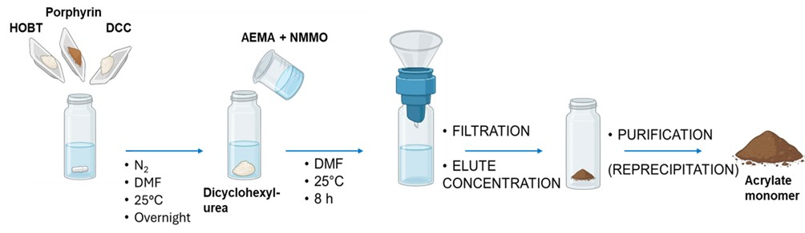
Fig. S1 Schematic representation of the synthesis of Acrylate PORPH monomer.

Synthesis of HEMA-PORPH cryogels

Depending on the desired ratio of HEMA: porph-acrylate (1.2-100 mg), 460 μL of HEMA, and 60.0 mg of MBAA were dissolved in 2.0 mL H₂O; then 2.4 mL of water were added to reach a total volume of 4.9 mL. The solution was then cooled at 0 °C, and 50 μL of a 10% w/v of TEMED and 50 μL of a 10% w/v of APS were added in sequence under stirring. The solution was poured into a small cylindrical glass reactor and cooled at T = -15 °C for 24 hours. The reactor was thawed, and the so-obtained cryogels were sequentially washed with H₂O, EtOH, and Et₂O, dried under nitrogen flux, then vacuumed. For each synthesis about 45 mg of polymer were obtained (yield ≈ 75%).
¹H-NMR spectrum of meso-tris(N-methyl-4-pyridyl) mono(4-carboxyphenyl) porphyrin

The ¹H-NMR spectrum of meso-tris(N-methyl-4-pyridyl) mono(4-carboxyphenyl) porphyrin trichloride, recorded in deuterated methanol, reveals characteristic chemical shifts. (Fig. S2) The aromatic pyridine protons resonate distinctly at δ=9.38 and δ=8.96 ppm; the aromatic protons on the phenyl ring bearing the carboxylate group are at δ=8.50 and 8.33 ppm; the methyl protons of the pyridinium salt appear as a singlet at δ=4.83 ppm, while a broad signal centered at δ=9.1 ppm is attributed to the pyrrole protons.

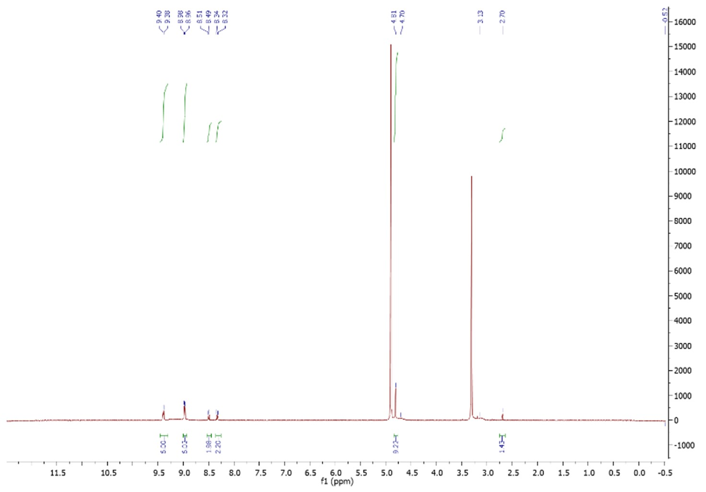
Fig. S2 ¹H-NMR spectra of meso-tris(N-methyl-4-pyridyl) mono(4-carboxyphenyl) porphine trichloride recorded in deuterated methanol

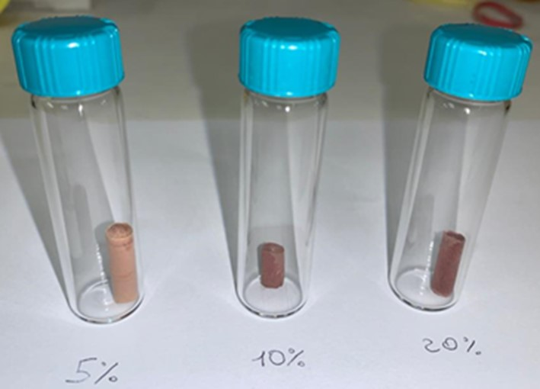
Fig. S3 HEMA-PORPH Cryopolymers containing different amounts of PORPH. Starting from the left side, the 5%, 10% and 20%.
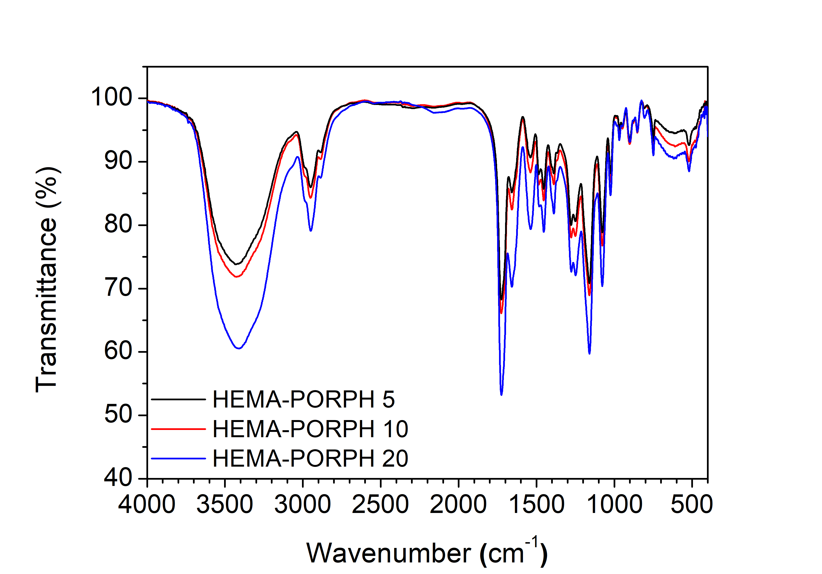
Fig. S4 ATR-IR spectra of HEMA-PORPH 5 (black line); HEMA-PORPH (red line); and HEMA-PORPH 20 (blue line)

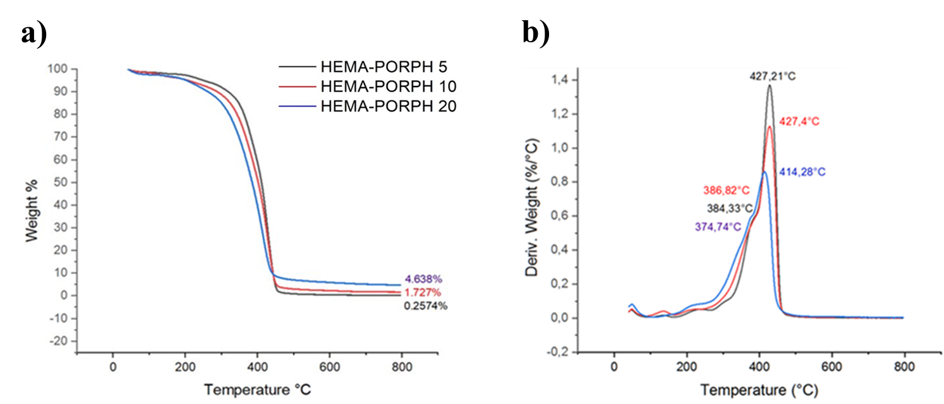
Fig. S5 a) TG and b) DTG profiles of HEMA-PORPH 5 (black line); HEMA-PORPH 10 (red line); and HEMA-PORPH 20 (blue line).

Table S1
TGA data (temperatures at a maximum rate of decomposition and residue) obtained from HEMA-PORPH as-prepared cryogels.

Sample | Tmax D (°C) | Residue at 800 °C (%)
HEMA | 429 ±1 | 0.19
HEMA-PORPH 5 | 427 ±1 | 0.26
HEMA-PORPH 10 | 427 ±1 | 1.73
HEMA-PORPH 20 | 414 ±1 | 4.64

Table S2
Initial concentration of Hg(II) (C₀), at the equilibrium (C_{e}) and equilibrium removal capacity (Q_{e}) after 24 h of contact using 1 mg of adsorbent material for each mL of solution. R(%) represents the removal percentage of metal ions from the solution (Equation 3).

Sample | C₀ (mg/L) | C_{e} (mg/L) | Q_{e} (mg/g) | R (%)
HEMA-PORPH 5 | 30.0 | 22.4 | 7.6 | 25.3 %
HEMA-PORPH 10 | 30.0 | 15.8 | 14.2 | 47,3 %
HEMA-PORPH 20 | 30.0 | 1.9 | 28.1 | 93.7 %

Adsorption Kinetics
To evaluate the adsorption kinetics, 3.0 mg of dry cryogel was placed into 3.0 mL of an aqueous mercury (II) solution at a concentration of 500 ppm. The system was stirred at 150 rpm at room temperature for predetermined time intervals. The adsorption capacity Q_{t} (mg g⁻¹) from each material at different time intervals was determined using the equation:
$Q_{t}=\left(C_{0}-C_{t}\right)x V/m$ (Equation S1)
Where C₀ and C_{t}​ represent the starting concentration and the concentration at time t of Hg(II) in solution, respectively. V (L) is the solution volume, and m (g) refers to the mass of cryogel. Concentrations were monitored at different time intervals by ICP-MS measurements. To describe the adsorption mechanism, pseudo-first-order, and pseudo-second-order kinetic models were applied using both linear and non-linear fitting approaches.
The non-linear forms of these models are as follows:
$Q_{t}= Q_{e}×\left(1-e^{-k_{1}t}\right)$ (Equation S2)
$Q_{t}= {(K}_{2}Q_{e}^{2}t)/(1+K_{2}Q_{e}t)$ (Equation S3)
The corresponding linearized forms of these Equations are:
$ln\left(Q_{e}-Q_{t}\right) = ln Q_{e}-k_{1}kt$ (Equation S4)
$t/Q_{t}=[1/(k_{2}Q_{e}^{2})]+(t/Q_{e})$ (Equation S5)
where Q_{e} and Q_{t} ​ (mg g⁻¹) are the adsorption capacity of cryogels at equilibrium and time (t), k₁ (min⁻¹) and k₂ ​ (g/(mg min)) are rate constants for the pseudo-first and pseudo-second-order models, respectively.

Adsorption Isotherm
To further interpret the adsorption data, Langmuir and Freundlich isotherm models were utilized.
The empirical Langmuir Equation is usually used to describe homogeneous systems:
$Q_{e}=(Q_{max}{k_{L}C}_{e})/(1+ {k_{L}C}_{e})$ (Equation S6)
where Q_{e} (mg g⁻¹) is referred to the contaminant sequesterd per unit weight of adsorbate, C_{e} (mg L⁻¹) is the concentration at the equilibrium, Q_{max} (mg g⁻¹) is the maximum adsorbtion capacity, and K_{L} (mg⁻¹ L) represent the Langmuir constant.
The empirical Freundlich sorption model is usually used to describe heterogeneous systems:
$Q_{e}=K_{F}{(C_{e})}^{\frac{1}{n}}$ (Equation S7)
where K_{F} (mg g⁻¹)/(mg L⁻¹)^{1/n} is the Freundlich constant associated with the adsorption capacity and 1/n is a parameter that allows obtaining indications about the heterogeneity of the system, and thus the intensity of the adsorption.

The corresponding linearized Equation form of Langmuir and Freundlich's model used were respectively:
$1/Q_{e}=[1/(k_{L}q_{m})×[1/C_{e}]+[1/Q_{max}]$ (Equation S8)
$\ln{Q_{e}}= \frac{1}{n}{\ln{C}}_{e}+ {\ln{k}}_{F}$ (Equation S9)

For HEMA-PORPH 20 tests were further corroborated at higher Hg(II) concentrations (18, 30, 50, and 100 ppm), along with varying immersion times. As visible in Fig. S6b, HEMA poorly contributes to the Hg(II) adsorption, due to its interaction with hydroxyl and amide groups of polymer structure, for this reason only adsorption tests at 1.5, 18.0, and 30.0 ppm were performed.
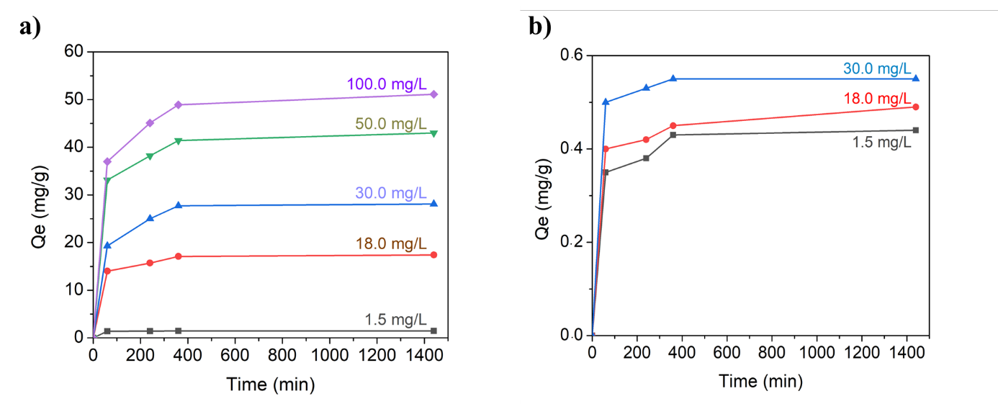
Fig. S6 Adsorption kinetics using solutions with varying Hg(II) concentrations: a) 1.5, 18, 30, 50, and 100 ppm for HEMA-PORPH 20 adsorption, and b) 1.5, 18, and 30 ppm for HEMA cryogel.

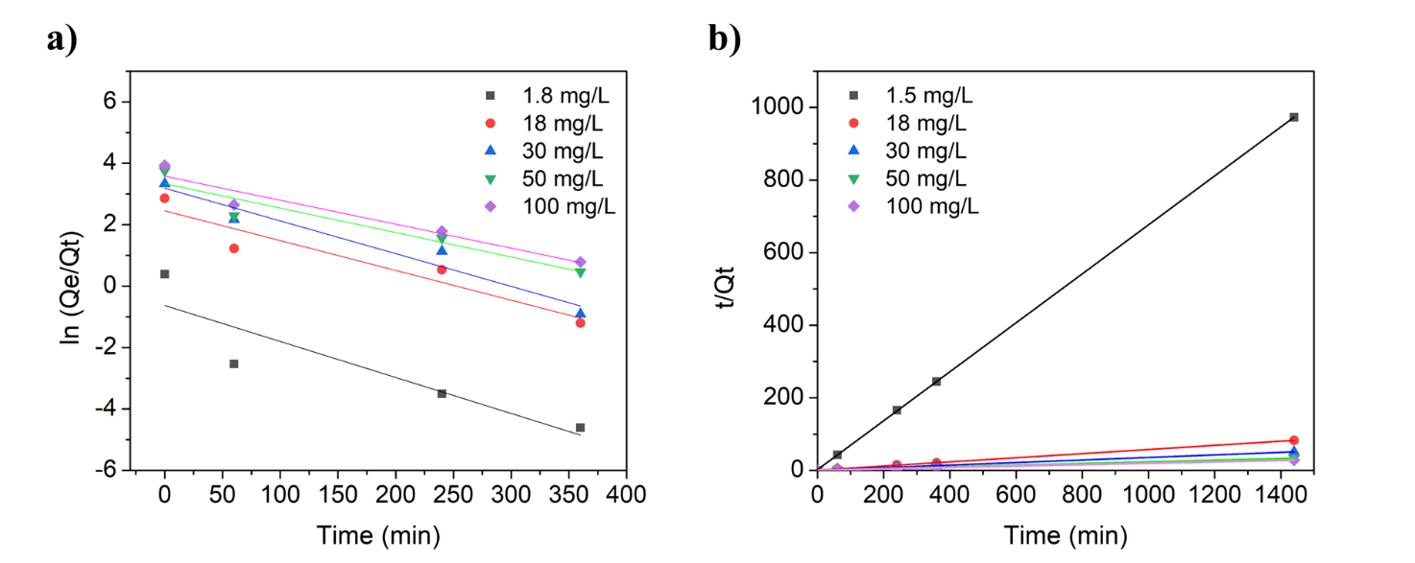
Fig. S7 Adsorption kinetics models (pH: 6.5) of HEMA-PORPH 20 fitted with a) pseudo I order and b) pseudo II order models

Table S3
Kinetic parameters for HEMA-20 calculated from pseudo-first order and pseudo-second order models
 | Pseudo I order |  | Pseudo II order
C₀ (mg L⁻¹) | k₁ (min⁻¹) | R² | k₂ (g/(mg min)) | R²
1.50 | 0.011 | 0.815 | 0.675 | 0.999
18.0 | 0.010 | 0.909 | 0.057 | 0.999
30.0 | 0.010 | 0.959 | 0.043 | 0.999

As it is possible to see from Table S4, all batch experiments showed highly efficient removal of mercury ions for all concentrations studied, except for the highest ones, due to the reaching of the material saturation limit. Freundlich and Langmuir's isothermal models were used to study the adsorption equilibrium data. From the regression coefficients (R²) reported in Table S5, it is possible to deduce that the Langmuir is the most suitable model to describe the Hg(II) adsorption process on HEMA-PORPH cryogels.

Table S4
Initial concentration of mercury ions (C₀), concentration at the equilibrium (C_{e}), equilibrium removal capacity (Q_{e}), and percentage of metal ions removal (R%) for HEMA PORPH 20 after 24 h of contact time at room temperature.

C₀ (mg/L) | C_{e} (mg/L) | Q_{e} (mg/g) | R (%)
1.5 | 0.02 | 1.48 | 98.7 %
18.0 | 0.6 | 17.4 | 96.7 %
30.0 | 1.9 | 28.1 | 93.7 %
50.0 | 7.0 | 43.0 | 86.0 %
100.0 | 48.9 | 51.1 | 41.1 %

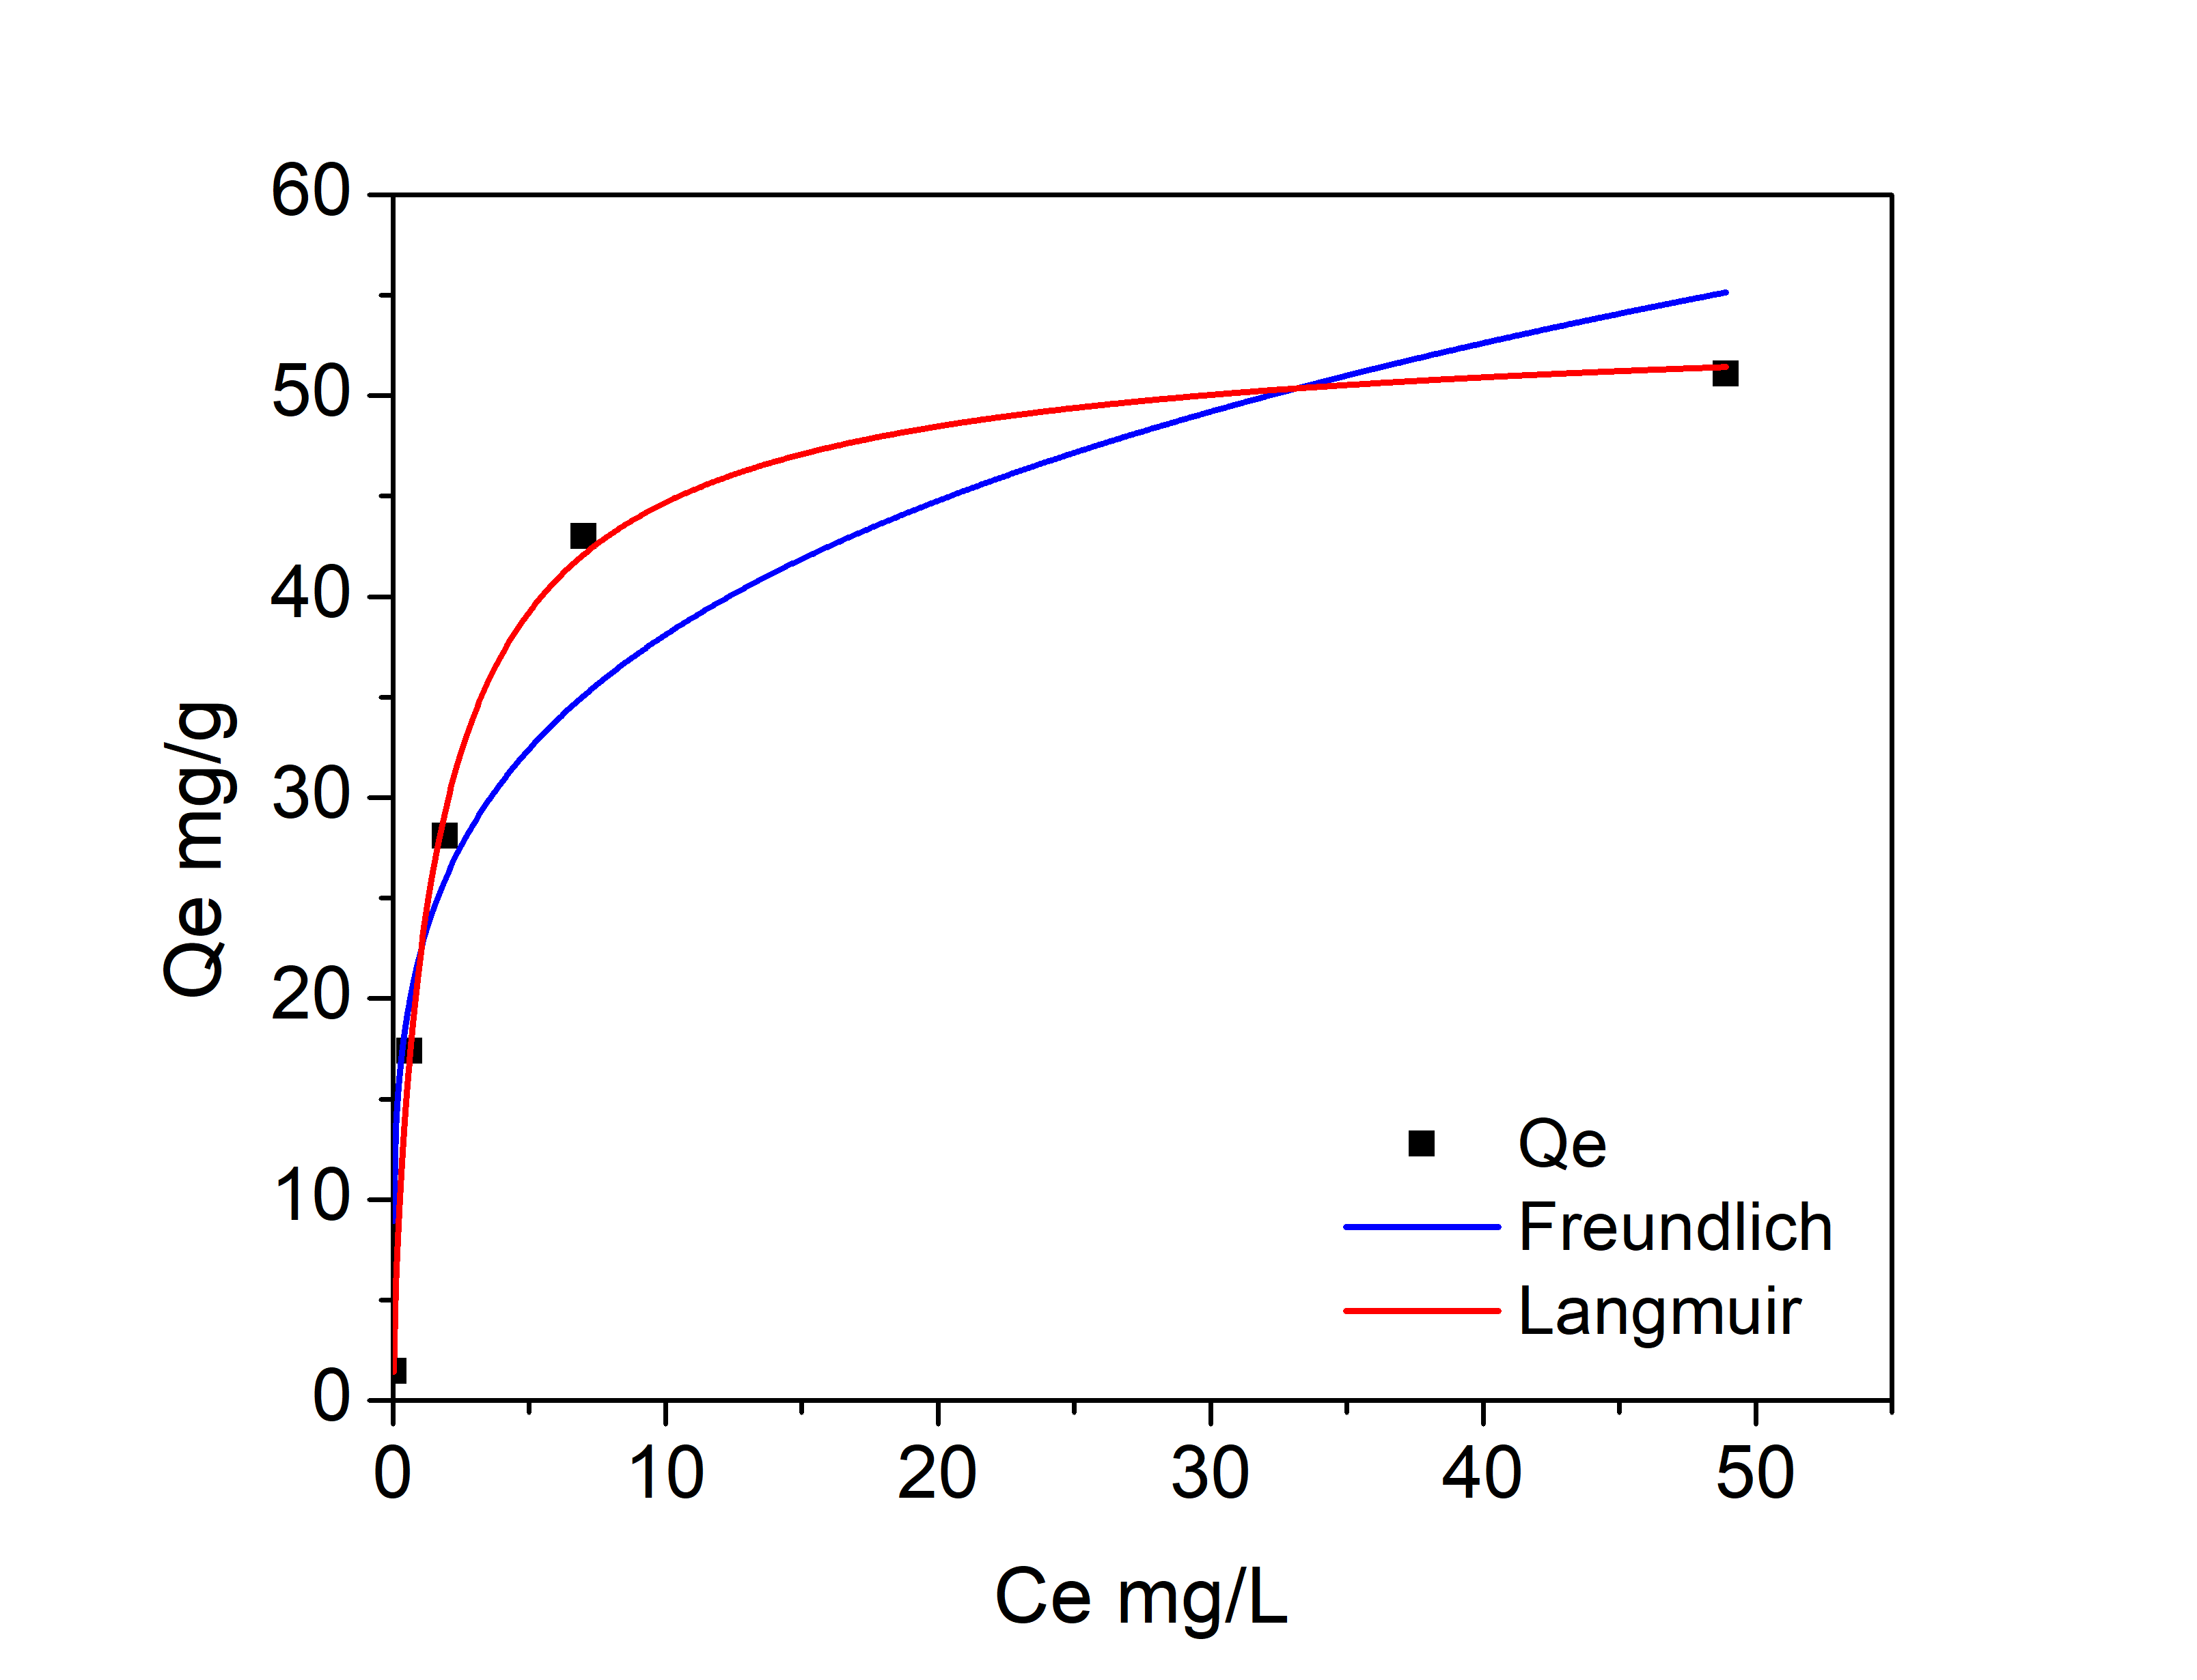
Fig. S8 Equilibrium adsorption Langmuir (red curve) and Freundlich (blue curve) isotherms by plotting Q_{e} versus C_{e} experimental data for Hg(II) adsorption by using HEMA-PORPH 20 cryogel.

Table S5
Parameters obtained by applying Langmuir and Freundlich isotherm models for mercury ions.
 | Langmuir Model |  |  | Freundlich Model
Sample | Q _{max} (mg g⁻¹) | K_{L} (L mg⁻¹) | R² | 1/n | K_{F} (mg g⁻¹)/(mg L⁻¹)^{1/n} |  | R²
HEMA PORPH 20 | 56.4 | 0.55 | 0,983 | 2,80 | 20.9 | 0,914
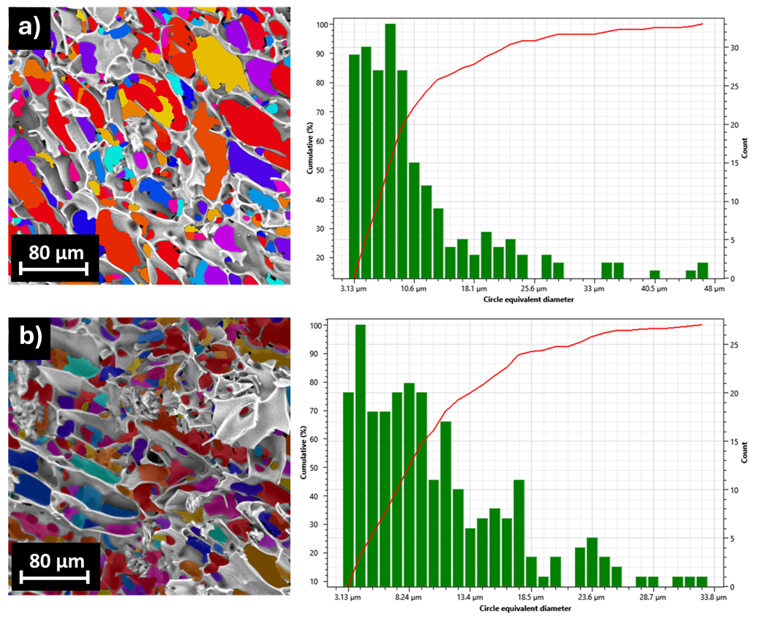
Fig. S9 Pore size and cumulative percentage of a) MAA-PORPH and b) CYS-PORPH calculated using Phenom Porometric 1.1.2.0 (PhenomWorld BV, Eindhoven, The Netherlands).

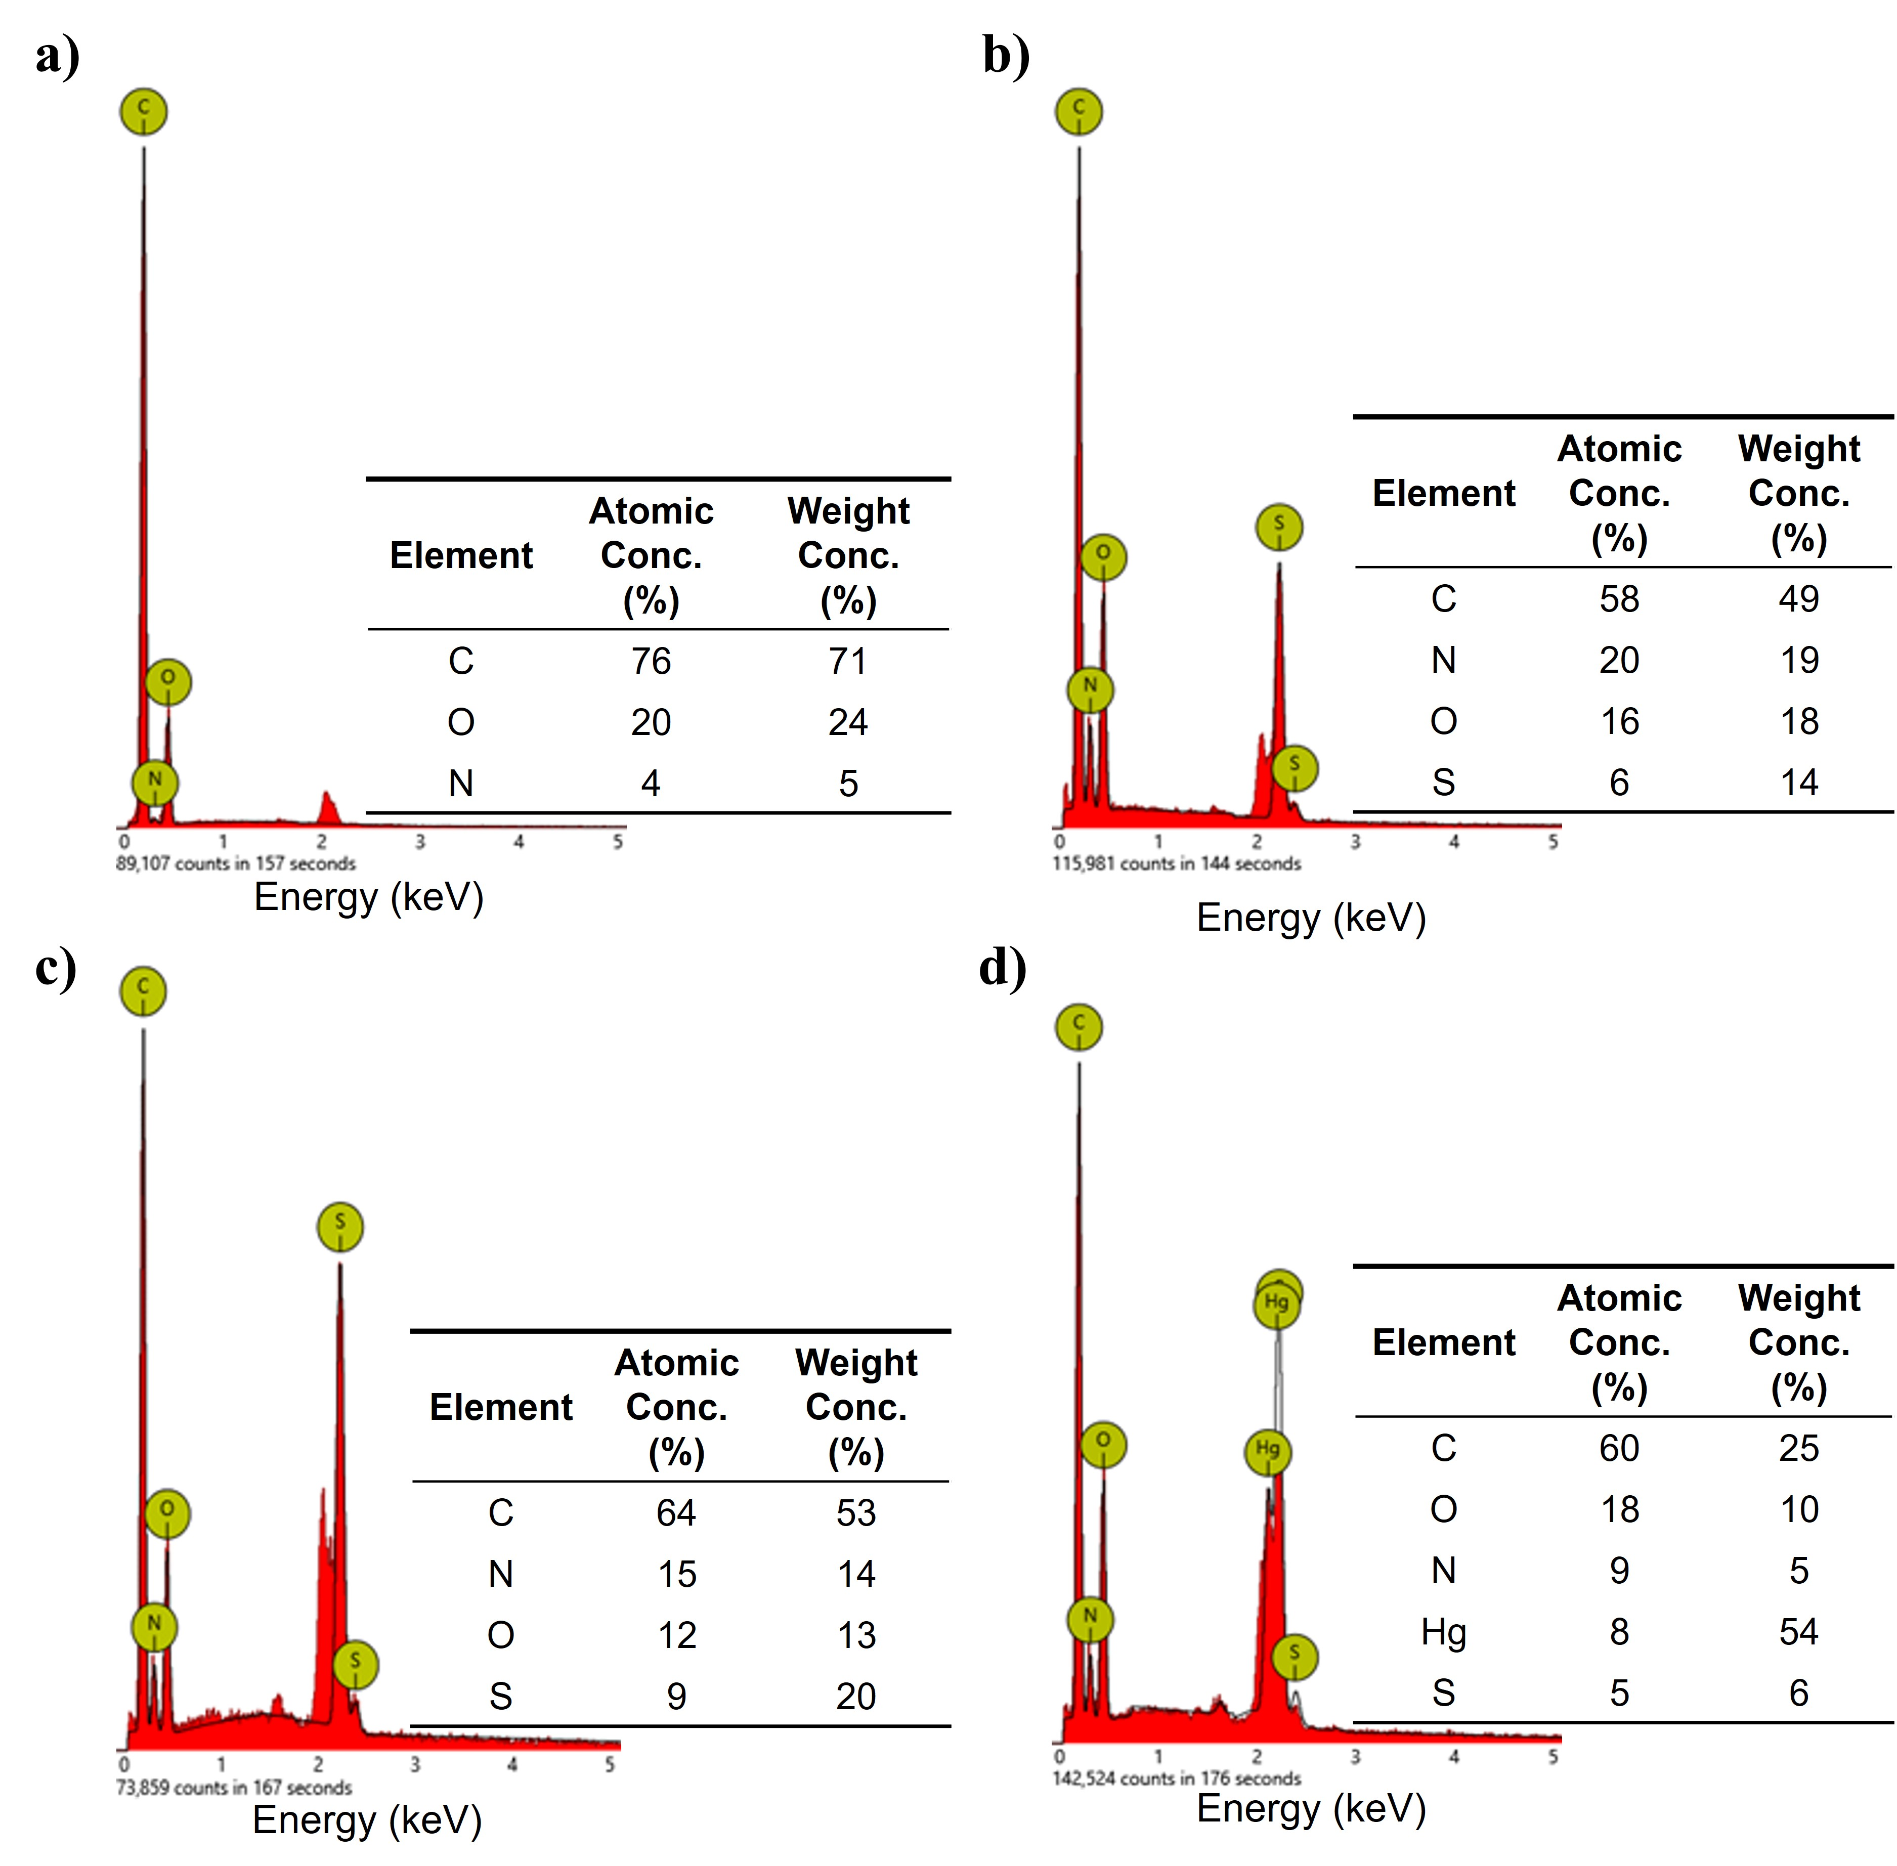
Fig. S10 EDX spectra of the samples: a) MAA-PORPH; b) CYS-PORPH; c) THIOL-PORPH ; d) THIOL-PORPH after adsorption tests. Mode: 10 kV - Image, Detector: BSD Full. Disabled elements: Au, used for sputtering the sample

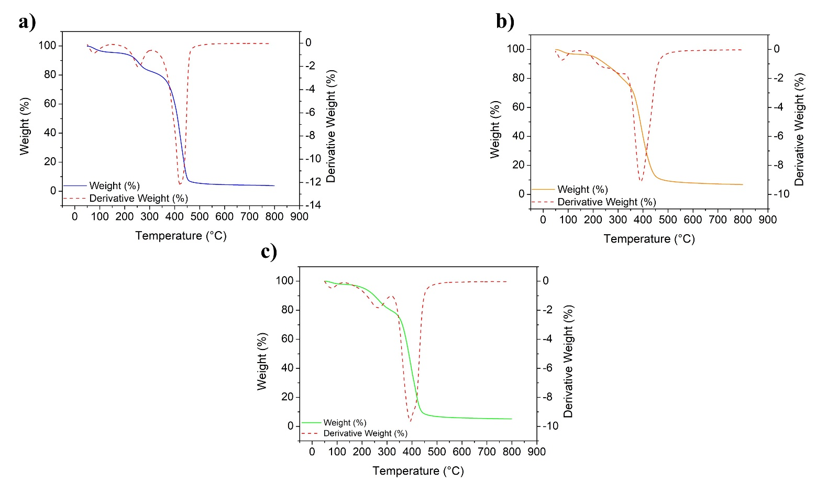
Fig. S11 Thermogravimetric analysis (TGA) and derivative thermogravimetric analysis (dTGA, red dotted line) of: a) MAA-PORPH (blue line); b) CYS-PORPH (orange line); and c) THIOL-PORPH (green line).

Table S6
Kinetic parameters for MAA-PORPH, CYS-PORPH and THIOL-PORPH calculated from pseudo-first order and pseudo-second order models.
 | Pseudo I order |  | Pseudo II order
C₀ ₌ 500 mg L⁻¹ | k₁ (min⁻¹) | R² | k₂ (g/(mg min)) | R²
MAA-PORPH | 0.005 | 0.988 | 0.002 | 0.999
CYS-PORPH | 0.005 | 0.997 | 0.002 | 0.999
THIOL-PORPH | 0.005 | 0.991 | 0.002 | 0.999

Fig. S12 ATR-IR spectra of THIOL-PORPH before (green line) and after (grey line) Hg(II) adsorption, highlighting spectral changes associated with mercury ions binding.

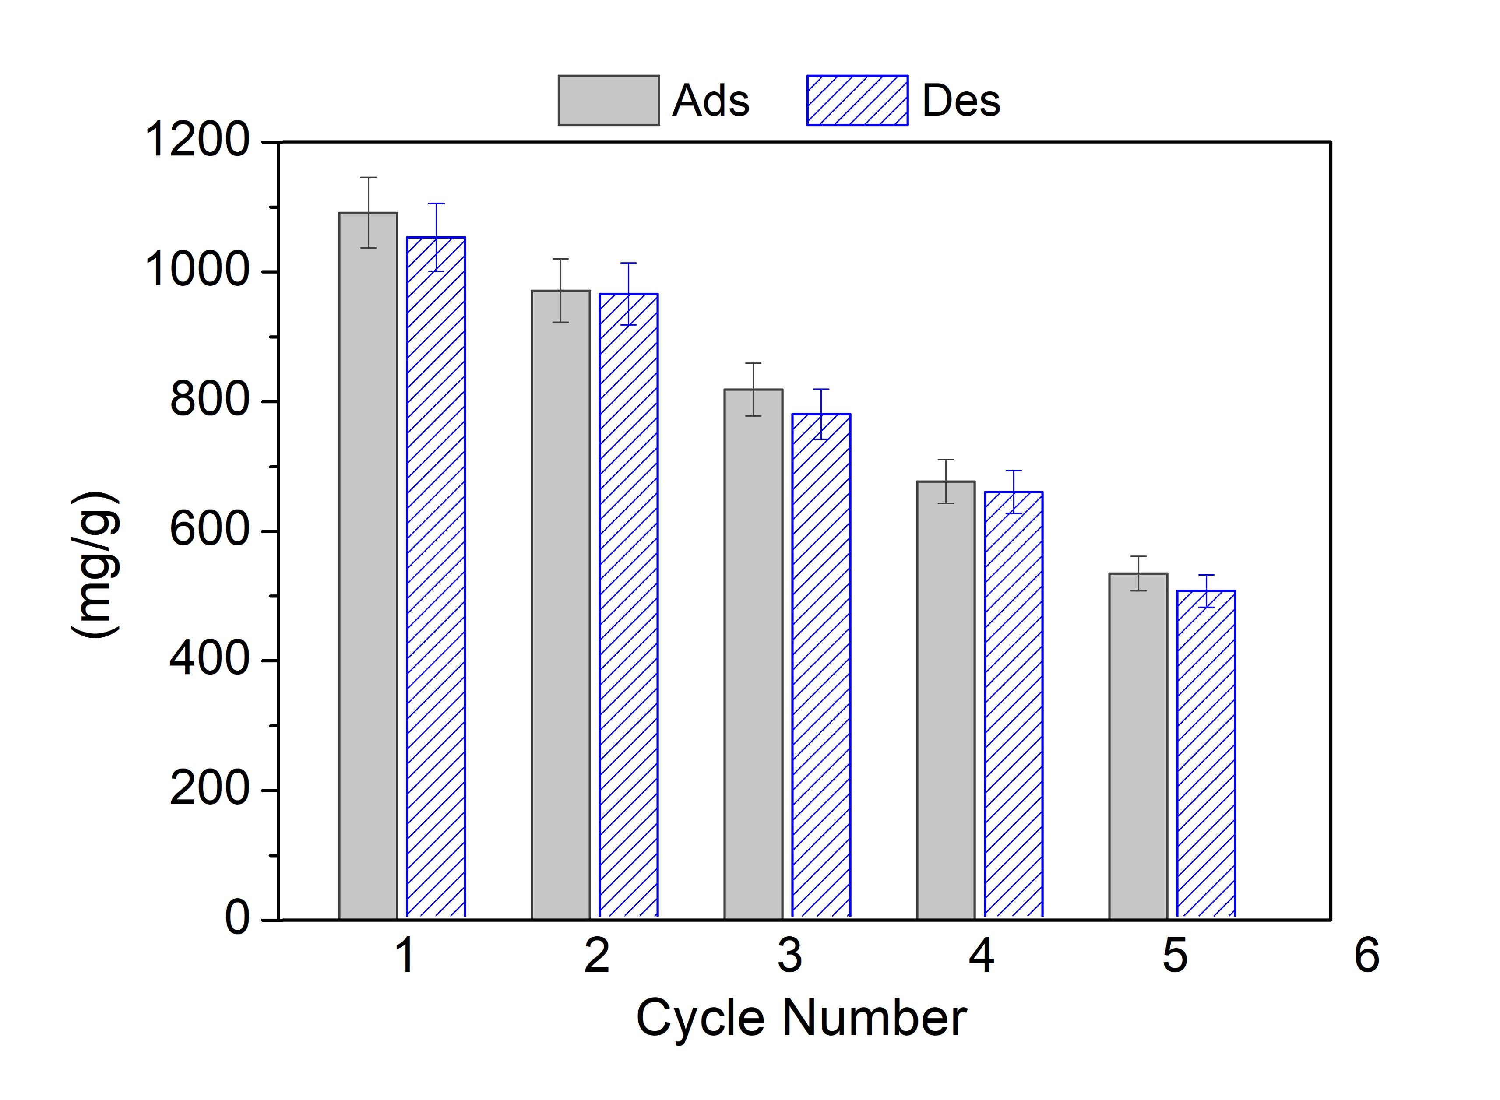
Fig. S13 Hg(II) adsorption (Ads) and desorption (Des) against cycles for the material THIOL-PORPH using HCl 37% as the regenerating agent

