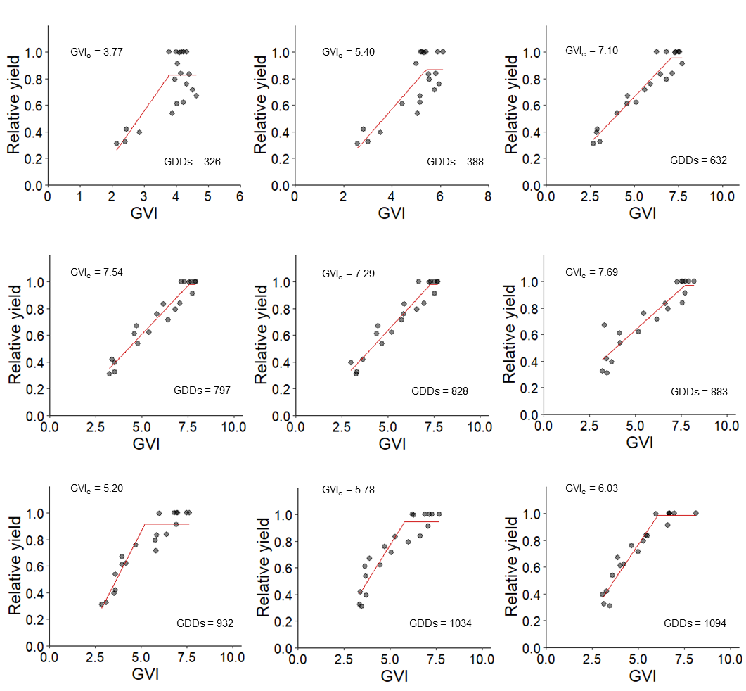
S1 Linear plateau relationship between the GVI and the relative yield developed in 2002 in Legnaro (Padova, Italy)

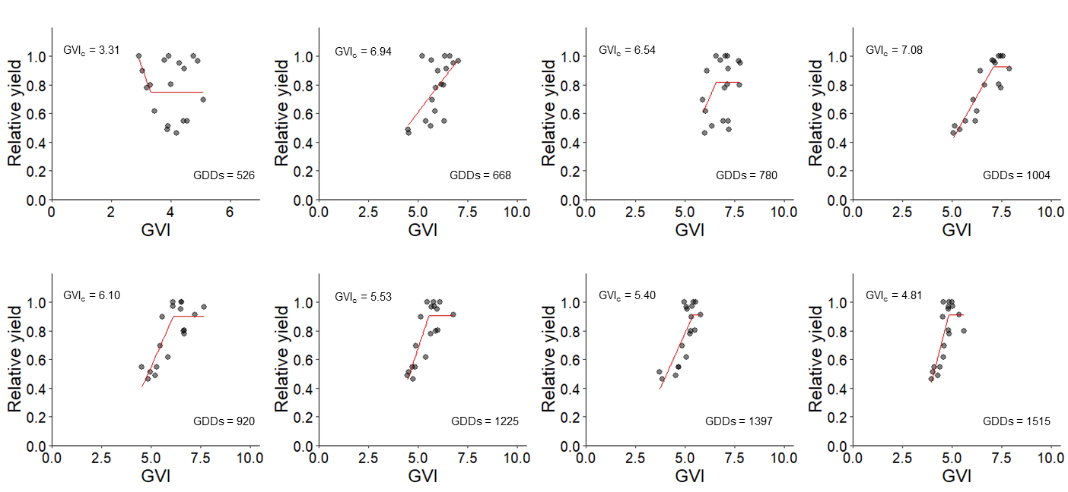
S2 Linear plateau relationship between the GVI and the relative yield developed in 2003 in Rosolina (Rovigo, Italy)

S3. Lycopene extraction and determination protocol
An extracting solution consisting of n-hexane, acetone, and methanol in a 2:1:1 ratio, with the addition of 0.5% butylated hydroxytoluene (all from Sigma Aldrich Chemie GmbH, Steinheim, Germany), was freshly prepared. 4 grams of fresh tomato fruit sample was weighed into 35 mL glass vials with PTFE-lined screw caps, followed by the addition of 20 mL of the extracting solution. Samples were individually stirred for 60 s on a vortex mixer and then allowed to sit for 15 min at room temperature in the dark. Subsequently, the samples were centrifuged at 453 RCF for 10 min. The supernatant was collected using a Pasteur pipette and transferred to a 25 mL volumetric flask. The extraction process was repeated twice more with 10 mL of extracting solution each time. Supernatants from the second and third extractions were combined in the same 25 mL volumetric flask containing the first aliquot. The combined hexane supernatants were brought to a final volume of 25 mL with hexane, frozen at -20°C, and stored until analysis. The bottom layer, containing discolored tomato tissues, acetone, and methanol was finally discarded. Absorbance at 503 nm was measured using a V-530 UV-VIS spectrophotometer (Jasco, Tokyo, Japan) against a hexane blank. Lycopene standards (Merck KGaA, Darmstadt, Germany) were used to construct a calibration curve for determining the limit of quantification (LOQ) and the concentration linearity range, which was found to be 0.5 to 8.75 mg L⁻¹. Tomato hexane extracts were hence diluted 1:20, and their absorbance at 503 nm was measured against a hexane blank. Full spectra of the samples were recorded beforehand to verify that the sample extract spectra were indistinguishable from the lycopene standard and that eventual beta-carotene content extracted alongside lycopene was negligible. The lycopene concentration in the tomato samples was calculated as reported in the equation below:

$$Lycopene \left({mg kg}^{-1}\right)=\frac{x}{y} ∙A∙ 3.12$$
Where x is the volume in mL, y is the weight of the fruit sample, A is the absorbance at 503 nm, and 3.12 is the extinction coefficient. Each tomato sample was extracted in duplicate, and the results were averaged. Analyses were repeated if the standard error of the two replicates exceeded a repeatability standard error calculated from ten extractions of the same sample

S4 ANOVA table of quantitative data monitored at harvest. When “-“ is present in the Sum of Square (SS) cell, the Kruskal-Wallis test was performed, and the Chi-square (X²) value is reported instead of the F-value. SE stands for Standard Error, Mkt for Marketable. ns stands for not significant, * p<0.05, ** p<0.01, and *** p<0.001. Empty cells mean that the respective measurement was not monitored
 |  | Healthy fruits | Minor lesions | Deep lesions | Sunscalded fruits | Rotten fruits | Green fruits | Blossom end rot | Total fruits n° | Mkt. fruits n° | Total fruit weight | Mkt fruit weight | Total yield | Mkt yield | Harvest Index
 | F or X² value | 4.938 | 1.358 | 2.016 | 6.066 | 3.757 | 2.15 |  | 12.24 | 14.8 | 17.78 | 19.19 | 7.735 | 7.291
 | p value | 0.0096 | 0.295 | 0.732 | 0.00414 | 0.0261 | 0.125 |  | 0.00012 | <0.0001 | <0.0001 | <0.0001 | 0.0014 | 0.0018
Exp | SS | 333 | 1.004 | - | 307 | 13.32 | 45.1 |  | 5245 | 4266 | 872 | 1261 | 10225 | 7590
1 | SE | 2.05 | 0.215 |  | 1.78 | 0.471 | 1.15 |  | 5.18 | 4.24 | 1.75 | 2.03 | 0.09 | 8.07
 | Significativity | ** | ns | ns | ** | * | ns |  | *** | *** | *** | *** | ** | **
 | F or X² value |  |  |  |  |  | 2.647 | 4.228 | 6.349 | 12.298 | 1.471 | 5.928 | 4.657 | 1.563 | 2.53
 | p value |  |  |  |  |  | 0.075 | 0.38 | 0.00339 | 0.02 | 0.831 | 0.2 | 0.32 | 0.23 | 0.084
Exp | SS |  |  |  |  |  | 150.2 | - | 1262 | - | - | - | - | 815 | 108.1
2 | SE |  |  |  |  |  | 1.88 | 0.469 | 3.53 | 3.26 | 2.46 | 2.91 | 2.91 | 5.71 | 1.63
 | Significativity |  |  |  |  |  | ns | ns | ** | ** | ns | ns | ns | ns | ns

S5 ANOVA table of qualitative and physiologic data monitored at harvest. When “-“ is present in the Sum of Square (SS) cell, the Kruskal-Wallis test was performed, and the Chi-square value is reported instead of the F-value. SE stands for Standard Error, Mkt for Marketable. Empty cells mean that the respective measurement was not monitored. A stands for net photosynthesis, E_{mm} for transpiration, g_{sw} for stomatal conductance, and WUE for water use efficiency at leaf level, ns not significant, and ** p<0.01. Empty cells mean that the respective measurement was not monitored
 |  | pH | EC | Brix | Dry matter | Lycopene | A | E_{mm} | g_{sw} | WUE_{L}
 | F or X² value | 4.571 | 2.04 | 1.348 | 0.453
 | p value | 0.339 | 0.140 | 0.298 | 0.769
Exp.1 | SS | - | 0.894 | 1.408 | 0.053
 | SE |  | 0.166 | 0.256 | 0.085
 | Significativity | ns | ns | ns | ns
 | F or X² value | 0.400 |  | 5.49 | 2.197 | 2.441 | 7.072 | 1.550 | 1.314 | 1.882
 | p value | 0.805 |  | 0.006 | 0.119 | 0.092 | 0.132 | 0.239 | 0.859 | 0.166
Exp. 2 | SS | 0.010 |  | 0.636 | 1.036 | 1568 | - | 0.898 | - | 0.205
 | SE | 0.040 |  | 0.008 | 0.179 | 6.34 |  | 0.190 |  | 0.0825
 | Significativity | ns |  | ** | ns | ns | ns | ns | ns | ns

