Additional file 1
Intrauterine growth restriction, defined by an elevated brain-to-liver weight ratio, affects faecal microbiota composition and, to a lesser extent, plasma metabolome profile at different ages in pigs
R. Ruggeri^{a, b}, G. Beeª, F. Correa ^{b}, P. Trevisi ^{b}, C. Ollagnierª
ª Swine Research Unit, Agroscope, Route de la Tioleyre 4, 1725 Posieux, Switzerland
^{b} Department of Agricultural and Food Sciences (DISTAL), University of Bologna, viale G Fanin 44, 40127 Bologna, Italy
Authors’ email: roberta.ruggeri@agroscope.admin.ch, giuseppe.bee@agroscope.admin.ch, paolo.trevisi@unibo.it, federico.correa2@unibo.it, catherine.ollagnier@agroscope.admin.ch
Corresponding author: Giuseppe Bee
Supplementary Table 1. Brain-to-liver weight ratio of pigs selected for the analysis. Brain-to-liver weight ratio (BrW/LW) of pigs affected by intrauterine growth restriction (IUGR) and normal pigs (NORM) that were used to compare the blood metabolome and faecal microbiota at different time points.
 | Category |  | Sex
Item | IUGR | NORM | Female | Castrate
T1 | 12 | 12 | 15 | 9
BrW/LW | 1.00 | 0.36 | 0.69 | 0.66
T2, T3, T4 | 12 | 12 | 12 | 12
BrW/LW | 1.00 | 0.40 | 0.72 | 0.68

Supplementary Table 2. Sequencing depth. Individual sample information regarding sequencing depth.
ID | Sow ID | Parity | Sex | BtW | BrW/LW | Category | Time point | Selected | Depth
9205 | 5262-FE4 | 3 | Female | 1.11 | 1.10 | IUGR | 4 | 1 | 28819
9069 | 7162-FE4 | 1 | Castrate | 1.95 | 0.42 | NORM | 2 | 1 | 26669
9124 | 5906-FE4 | 2 | Female | 1.61 | 0.41 | NORM | 1 | 1 | 49488
9092 | 1773-FE4 | 7 | Female | 1.18 | 0.99 | IUGR | 1 | 1 | 32163
9108 | 5953-FE4 | 2 | Castrate | 2.03 | 0.35 | NORM | 2 | 1 | 25222
9110 | 5953-FE4 | 2 | Female | 1.89 | 0.32 | NORM | 2 | 1 | 35540
9166 | 338-FE4 | 9 | Female | 2.16 | 0.38 | NORM | 2 | 1 | 54012
9266 | 709-FE4 | 8 | Castrate | 1.87 | 0.46 | NORM | 2 | 1 | 30261
9110 | 5953-FE4 | 2 | Female | 1.89 | 0.32 | NORM | 4 | 1 | 47032
9143 | 6076-FE4 | 1 | Female | 0.83 | 1.06 | IUGR | 4 | 1 | 29679
9166 | 338-FE4 | 9 | Female | 2.16 | 0.38 | NORM | 4 | 1 | 38775
9165 | 338-FE4 | 9 | Female | 2.15 | 0.41 | NORM | 4 | 1 | 41079
9093 | 1773-FE4 | 7 | Female | 1.08 | 0.94 | IUGR | 1 | 1 | 32841
9193 | 5262-FE4 | 3 | Castrate | 1.51 | 0.89 | IUGR | 1 | 1 | 31073
9236 | 7201-FE4 | 1 | Castrate | 1.94 | 0.46 | NORM | 2 | 1 | 31613
9239 | 7201-FE4 | 1 | Castrate | 1.95 | 0.44 | NORM | 2 | 1 | 29614
9059 | 3188-FE4 | 5 | Castrate | 1.76 | 0.46 | NORM | 3 | 1 | 28108
9006 | 7151-FE4 | 1 | Castrate | 1.03 | 1.12 | IUGR | 1 | 1 | 22955
9007 | 7151-FE4 | 1 | Castrate | 1.07 | 0.41 | NORM | 1 | 1 | 29748
9108 | 5953-FE4 | 2 | Castrate | 2.03 | 0.35 | NORM | 1 | 1 | 38794
9165 | 338-FE4 | 9 | Female | 2.15 | 0.41 | NORM | 1 | 1 | 8851
9236 | 7201-FE4 | 1 | Castrate | 1.94 | 0.46 | NORM | 4 | 1 | 1272
9239 | 7201-FE4 | 1 | Castrate | 1.95 | 0.44 | NORM | 3 | 1 | 56528
9059 | 3188-FE4 | 5 | Castrate | 1.76 | 0.46 | NORM | 2 | 1 | 44147
9048 | 4062-FE4 | 4 | Castrate | 1.57 | 0.40 | NORM | 1 | 1 | 28884
9282 | 709-FE4 | 8 | Female | 0.97 | 0.88 | IUGR | 2 | 1 | 56314
9016 | 7151-FE4 | 1 | Female | 0.99 | 0.96 | IUGR | 1 | 1 | 36803
9110 | 5953-FE4 | 2 | Female | 1.89 | 0.32 | NORM | 1 | 1 | 28746
9006 | 7151-FE4 | 1 | Castrate | 1.03 | 1.12 | IUGR | 2 | 1 | 45261
9284 | 3459-FE4 | 5 | Castrate | 1.31 | 0.88 | IUGR | 4 | 1 | 33257
9085 | 1773-FE4 | 7 | Castrate | 1.15 | 0.98 | IUGR | 2 | 1 | 1238
9205 | 5262-FE4 | 3 | Female | 1.11 | 1.10 | IUGR | 1 | 1 | 32393
9236 | 7201-FE4 | 1 | Castrate | 1.94 | 0.46 | NORM | 3 | 1 | 30554
9112 | 1684-FE4 | 7 | Female | 1.76 | 0.38 | NORM | 2 | 1 | 40088
9104 | 757-FE4 | 8 | Female | 1.49 | 0.90 | IUGR | 1 | 1 | 34718
9085 | 1773-FE4 | 7 | Castrate | 1.15 | 0.98 | IUGR | 4 | 1 | 31491
9205 | 5262-FE4 | 3 | Female | 1.11 | 1.11 | IUGR | 2 | 1 | 45294
9033 | 7146-FE4 | 1 | Castrate | 1.9 | 0.36 | NORM | 2 | 1 | 19047
9086 | 1773-FE4 | 7 | Castrate | 1.11 | 1.14 | IUGR | 2 | 1 | 41018
9006 | 7151-FE4 | 1 | Castrate | 1.03 | 1.12 | IUGR | 3 | 1 | 62877
9183 | 7202-FE4 | 1 | Castrate | 1.17 | 1.07 | IUGR | 2 | 1 | 40677
9166 | 338-FE4 | 9 | Female | 2.16 | 0.38 | NORM | 1 | 1 | 27838
9092 | 1773-FE4 | 7 | Female | 1.18 | 1.00 | IUGR | 2 | 1 | 41374
9093 | 1773-FE4 | 7 | Female | 1.08 | 0.94 | IUGR | 4 | 1 | 29702
9108 | 5953-FE4 | 2 | Castrate | 2.03 | 0.35 | NORM | 4 | 1 | 25700
9122 | 5906-FE4 | 2 | Female | 1.84 | 0.36 | NORM | 3 | 1 | 38052
9093 | 1773-FE4 | 7 | Female | 1.08 | 0.94 | IUGR | 2 | 1 | 41000
9013 | 7151-FE4 | 1 | Female | 1.05 | 0.87 | IUGR | 3 | 1 | 40499
9122 | 5906-FE4 | 2 | Female | 1.84 | 0.36 | NORM | 1 | 1 | 22663
9108 | 5953-FE4 | 2 | Castrate | 2.03 | 0.35 | NORM | 3 | 1 | 44204
9121 | 5906-FE4 | 2 | Female | 1.96 | 0.36 | NORM | 1 | 1 | 30670
9205 | 5262-FE4 | 3 | Female | 1.11 | 1.11 | IUGR | 3 | 1 | 32822
9122 | 5906-FE4 | 2 | Female | 1.84 | 0.36 | NORM | 2 | 1 | 32933
9143 | 6076-FE4 | 1 | Female | 0.83 | 1.06 | IUGR | 3 | 1 | 31782
9092 | 1773-FE4 | 7 | Female | 1.18 | 1.00 | IUGR | 3 | 1 | 41411
9016 | 7151-FE4 | 1 | Female | 0.99 | 0.96 | IUGR | 4 | 1 | 55016
9016 | 7151-FE4 | 1 | Female | 0.99 | 0.96 | IUGR | 3 | 1 | 6492
9016 | 7151-FE4 | 1 | Female | 0.99 | 0.96 | IUGR | 2 | 1 | 60599
9110 | 5953-FE4 | 2 | Female | 1.89 | 0.32 | NORM | 3 | 1 | 38896
9013 | 7151-FE4 | 1 | Female | 1.05 | 0.87 | IUGR | 2 | 1 | 57628
9165 | 338-FE4 | 9 | Female | 2.15 | 0.41 | NORM | 3 | 1 | 50687
9143 | 6076-FE4 | 1 | Female | 0.83 | 1.06 | IUGR | 2 | 1 | 43745
9086 | 1773-FE4 | 7 | Castrate | 1.11 | 1.13 | IUGR | 1 | 1 | 53553
9166 | 338-FE4 | 9 | Female | 2.16 | 0.38 | NORM | 3 | 1 | 69256
9069 | 7162-FE4 | 1 | Castrate | 1.95 | 0.42 | NORM | 3 | 1 | 23014
9033 | 7146-FE4 | 1 | Castrate | 1.9 | 0.36 | NORM | 4 | 1 | 44073
9266 | 709-FE4 | 8 | Castrate | 1.87 | 0.46 | NORM | 3 | 1 | 54524
9284 | 3459-FE4 | 5 | Castrate | 1.31 | 0.88 | IUGR | 2 | 1 | 47954
9112 | 1684-FE4 | 7 | Female | 1.76 | 0.38 | NORM | 3 | 1 | 37984
9282 | 709-FE4 | 8 | Female | 0.97 | 0.88 | IUGR | 1 | 1 | 30306
9282 | 709-FE4 | 8 | Female | 0.97 | 0.88 | IUGR | 4 | 1 | 42453
9165 | 338-FE4 | 9 | Female | 2.15 | 0.41 | NORM | 2 | 1 | 63679
9106 | 757-FE4 | 8 | Female | 1.08 | 0.92 | IUGR | 1 | 1 | 52217
9069 | 7162-FE4 | 1 | Castrate | 1.95 | 0.42 | NORM | 4 | 1 | 34925
9059 | 3188-FE4 | 5 | Castrate | 1.76 | 0.46 | NORM | 4 | 1 | 40414
9006 | 7151-FE4 | 1 | Castrate | 1.03 | 1.12 | IUGR | 4 | 1 | 39642
9143 | 6076-FE4 | 1 | Female | 0.83 | 1.06 | IUGR | 1 | 1 | 29546
9183 | 7202-FE4 | 1 | Castrate | 1.17 | 1.07 | IUGR | 3 | 1 | 50258
9093 | 1773-FE4 | 7 | Female | 1.08 | 0.90 | IUGR | 3 | 1 | 32798
9239 | 7201-FE4 | 1 | Castrate | 1.95 | 0.43 | NORM | 4 | 1 | 45838
9112 | 1684-FE4 | 7 | Female | 1.76 | 0.38 | NORM | 1 | 1 | 31543
9183 | 7202-FE4 | 1 | Castrate | 1.17 | 1.07 | IUGR | 4 | 1 | 39263
9033 | 7146-FE4 | 1 | Castrate | 1.9 | 0.35 | NORM | 3 | 1 | 43388
9119 | 5906-FE4 | 2 | Castrate | 1.68 | 0.29 | NORM | 1 | 1 | 27982
9086 | 1773-FE4 | 7 | Castrate | 1.11 | 1.13 | IUGR | 4 | 1 | 40526
9013 | 7151-FE4 | 1 | Female | 1.05 | 0.87 | IUGR | 4 | 1 | 22027
9160 | 338-FE4 | 3 | Castrate | 1.96 | 0.29 | NORM | 1 | 1 | 0
9183 | 7202-FE4 | 1 | Castrate | 1.17 | 1.07 | IUGR | 1 | 1 | 27679
9266 | 709-FE4 | 8 | Castrate | 1.87 | 0.46 | NORM | 4 | 1 | 28537
9085 | 1773-FE4 | 7 | Castrate | 1.15 | 0.97 | IUGR | 3 | 1 | 21369
9122 | 5906-FE4 | 2 | Female | 1.84 | 0.35 | NORM | 4 | 1 | 26619
9284 | 3459-FE4 | 5 | Castrate | 1.31 | 0.87 | IUGR | 3 | 1 | 27701
9086 | 1773-FE4 | 7 | Castrate | 1.11 | 1.13 | IUGR | 3 | 1 | 43488
9092 | 1773-FE4 | 7 | Female | 1.18 | 0.99 | IUGR | 4 | 1 | 41610
9112 | 1684-FE4 | 7 | Female | 1.76 | 0.38 | NORM | 4 | 1 | 31182
9282 | 709-FE4 | 8 | Female | 0.97 | 0.88 | IUGR | 3 | 1 | 2545

Supplementary Table 3. Metabolites analysed at T1. Metabolites analysed from plasma samples of 24 piglets to compare the blood metabolome profile between piglets affected by intrauterine growth restriction (IUGR = 12) and normal piglets (NORM = 12) at day 16 ± 0.6 (T1).
Item | Statistical analysis
2,3-Butanediol | Not included
2-Aminobutyrate | Included
2-Hydroxybutyrate | Not included
3-Aminoisobutyrate | Included
3-Hydroxybutyrate | Not included
3-Hydroxyisobutyrate | Included
3-Methyl-2-oxovalerate | Not included
3-Methylhistidine | Not included
Acetate | Included
Acetone | Included
Alanine | Included
Alpha-ketoisovalerate | Not included
Anserine | Not included
Arabinose | Included
Arginine | Included
Ascorbate | Included
Asparagine | Included
Aspartate | Included
Beta-alanine | Included
Betaine | Included
Carnosine | Not included
Choline | Included
Citramalate | Included
Citrate, glutamine | Included
Creatine | Included
Dimethylamine | Not included
Dimethyl-sulfone | Included
Ethanol | Not included
Formate | Included
Fumarate | Included
Glucose | Included
Glycerol | Included
Glycine | Included
Glyoxylate | Included
Histidine | Not included
Hypoxanthine | Not included
Isoleucine | Included
Isopropanol | Not included
Lactate | Included
Leucine | Included
Levulinate | Not included
Lysine, 2-oxoglutarate | Included
Mannose | Included
Methanol | Not included
Methionine | Included
Methylmalonate | Not included
Myo-inositol | Included
N,N-Dimethylglycine | Included
Phenylalanine | Included
Proline | Included
Pyroglutamate | Not included
Pyruvate | Not included
Sarcosine | Included
Serine | Included
Succinate, pyruvate | Included
Theophylline | Not included
Threonine | Included
TMAO (trimethylamine N-oxide) | Included
Trans-4-Hydroxy-L-proline | Included
Tyrosine | Included
UDP-glucose | Not included
Uridine | Not included
Valine | Included

Supplementary Table 4. Metabolites analysed at T2. Metabolites analysed from plasma samples of 24 piglets to compare the blood metabolome profile between piglets affected by intrauterine growth restriction (IUGR = 12) and normal piglets (NORM = 12) at day 63 ± 8.6 (T2).
Item | Statistical analysis
2,3-Butanediol | Not included
2-Aminobutyrate | Included
2-Hydroxybutyrate | Not included
3-Aminoisobutyrate | Included
3-Hydroxybutyrate | Not included
3-Hydroxyisobutyrate | Included
3-Methyl-2-oxovalerate | Not included
3-Methylhistidine | Not included
Acetate | Included
Acetone | Included
Alanine | Included
Alpha-ketoisovalerate | Not included
Anserine | Not included
Arabinose | Included
Arginine | Included
Ascorbate | Included
Asparagine | Included
Aspartate | Included
Beta-alanine | Included
Betaine | Included
Carnosine | Not included
Choline | Included
Citramalate | Included
Citrate, glutamine | Included
Creatine | Included
Dimethylamine | Not included
Dimethyl-sulfone | Included
Ethanol | Not included
Formate | Included
Fumarate | Included
Glucose | Included
Glycerol | Included
Glycine | Included
Glyoxylate | Included
Histidine | Not included
Hypoxanthine | Not included
Isoleucine | Included
Isopropanol | Not included
Lactate | Included
Leucine | Included
Levulinate | Not included
Lysine, 2-oxoglutarate | Included
Mannose | Included
Methanol | Not included
Methionine | Included
Methylmalonate | Not included
Myo-inositol | Included
N,N-Dimethylglycine | Included
Phenylalanine | Included
Proline | Included
Pyroglutamate | Not included
Pyruvate | Not included
Sarcosine | Included
Serine | Included
Succinate, pyruvate | Included
Theophylline | Not included
Threonine | Included
TMAO (trimethylamine N-oxide) | Included
Trans-4-Hydroxy-L-proline | Included
Tyrosine | Included
UDP-glucose | Not included
Uridine | Not included
Valine | Included
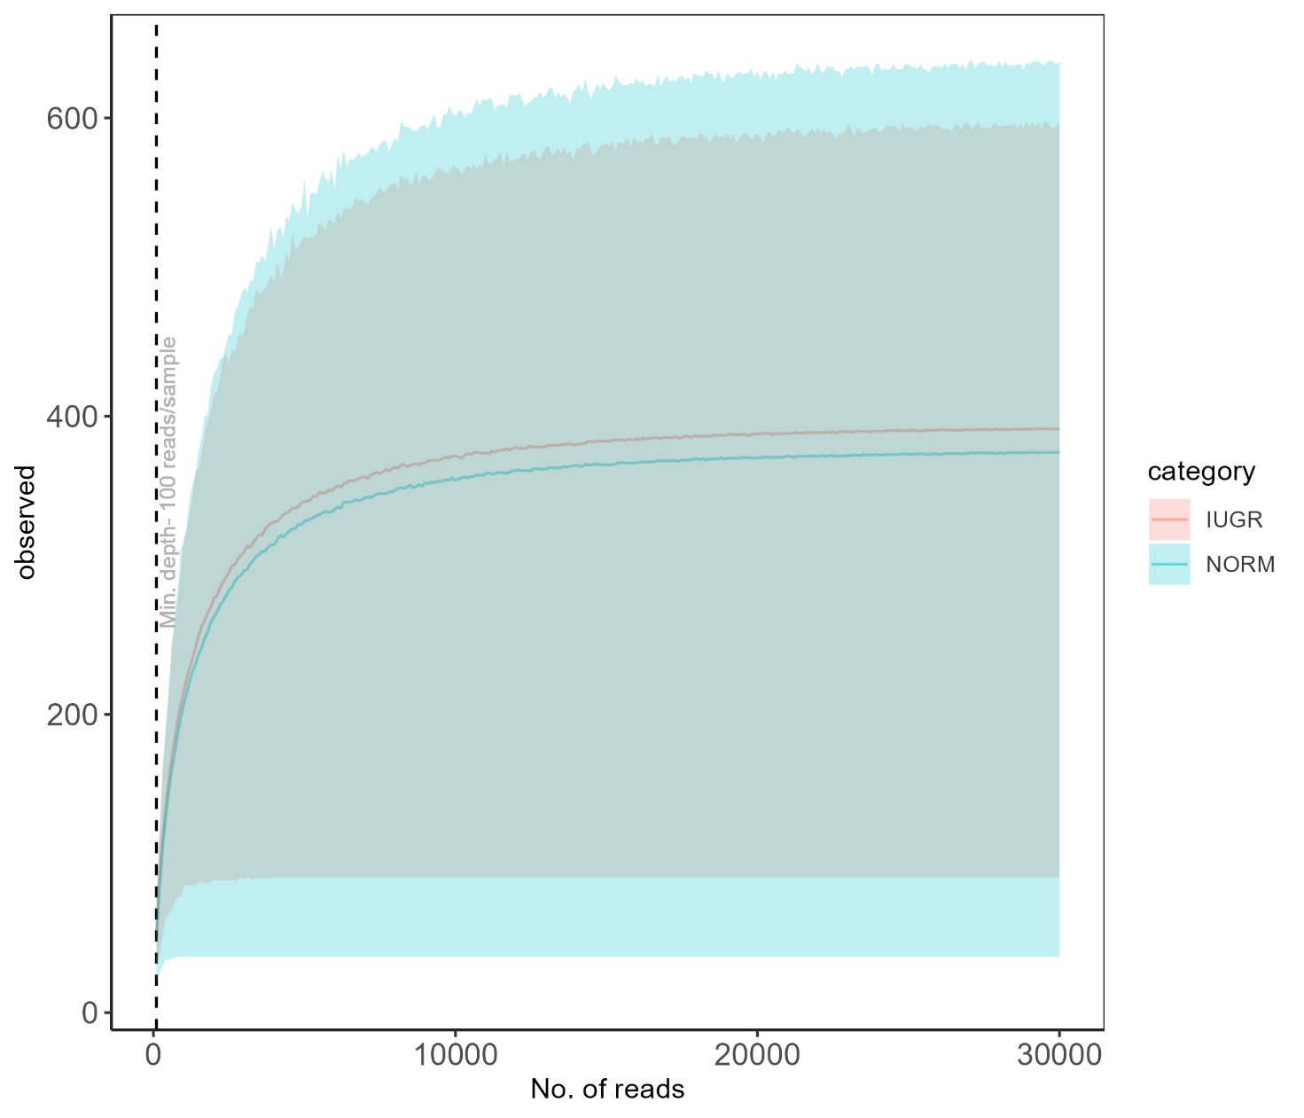
Supplementary Figure 1. MiSeq sequencing rarefaction curve. Rarefaction curve of faecal samples of piglets generated through sequencing the V3–V4 region of the 16s rRNA gene with the MiSeq platform (Illumina Inc., San Diego, CA, USA).

Category: IUGR: 12 pigs with the highest BrW/LW; NORM: pigs with the lowest BrW/LW.
T1 = blood and faeces collected before the administration of the pre-/early postweaning diet (day 16 ± 0.6); T2 = blood and faeces collected at the end of the starter period (day 63 ± 8.6); T3 = faeces collected at the beginning of the fattening period (day 119 ± 11.4); T4 = faeces collected at the end of the fattening period (day 162 ± 14.3). BrW/LW = mean BrW/LW in the IUGR and NORM groups.
ID = identification number of the pig.
Sow ID = identification number of the sow.
BtW = birth body weight.
BrW/LW = brain-to-liver weight ratio.
IUGR = 12 pigs with the highest BrW/LW; NORM = 12 pigs with the lowest BrW/LW.
T1 = blood and faeces collected before the administration of the pre-/early postweaning diet (day 16 ± 0.6); T2 = blood and faeces collected at the end of the starter period (day 63 ± 8.6); T3 = faeces collected at the beginning of the fattening period (day 119 ± 11.4); T4 = faeces collected at the end of the fattening period (day 162 ± 14.3).
Plasma metabolites analysed at day 16 ± 0.6 (T1) from 24 pigs (IUGR = 12, NORM = 12).
Included: metabolites with plasma concentration in the quantitation range for each sample, included in the statistical analyses; not included: metabolites with plasma concentration not detectable in any (2-hydroxybutyrate, 3-methyl-2-oxovalerate, 3-methylhistidine, alpha-ketoisovalerate, anserine, carnosine, dimethylamine, hypoxanthine, pyroglutamate, and UDP-glucose) or most (2,3 butanediol, 3-hydroxybutyrate, ethanol, histidine, isopropanol, levulinate, methanol, methylmalonate, pyruvate, theophylline, and uridine) of the samples after centrifugation, not included in the statistical analysis.
Plasma metabolites analysed at day 63 ± 8.6 (T2) from 24 pigs (IUGR = 12, NORM = 12).
Included: metabolites with plasma concentration in the quantitation range for each sample, included in the statistical analyses; not included: metabolites with plasma concentration not detectable in any (2-hydroxybutyrate, 3-hydroxybutyrate, 3-methyl-2-oxovalerate, anserine, carnosine, hypoxanthine, isopropanol, methanol, pyroglutamate, theophylline, UDP-glucose, and uridine) or most (2,3 butanediol, 3-methylhistidine, alpha-ketoisovalerate, dimethylamine, ethanol, histidine, levulinate, methylmalonate, and pyruvate) of the samples after centrifugation, not included in the statistical analysis.

