eFigure 1 (Supplement)
Cytoplasmic staining with membrane enhancement from plasma of a patient with high titer detection (1:2250) of anti-ALK antibodies

eFigure 2 (supplement)
Median Overall Survival (mOS): Kaplan-Meier Curves
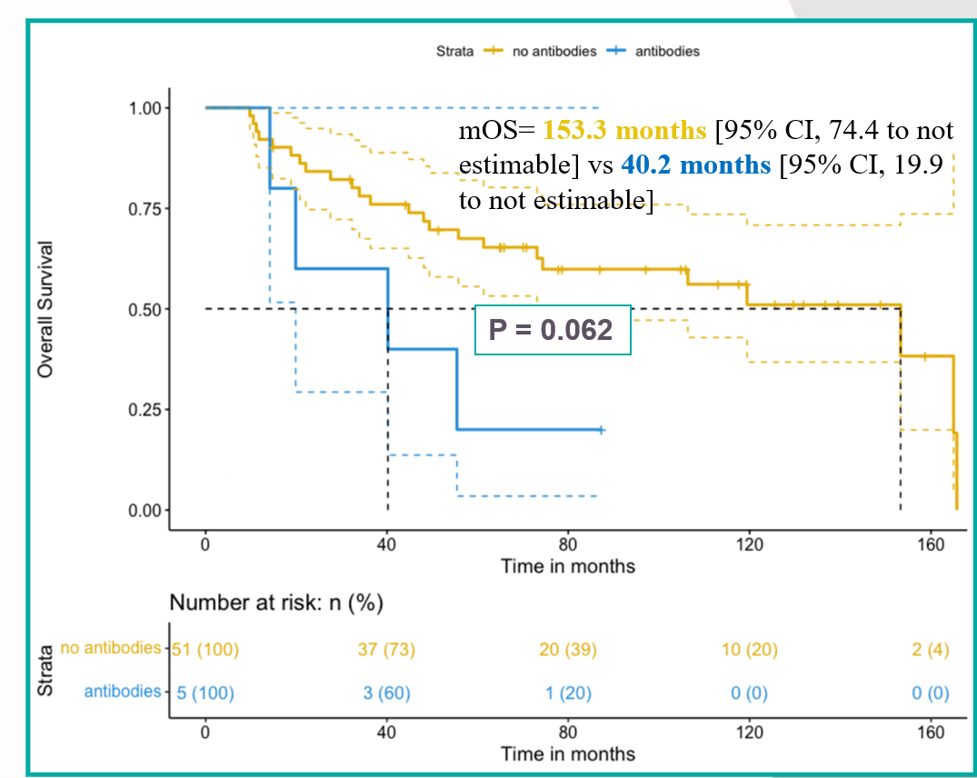

eFigure2 (Supplement)
Median Progression-Free Survival (mPFS): Kaplan-Meier Curves
