Supplementary Figures
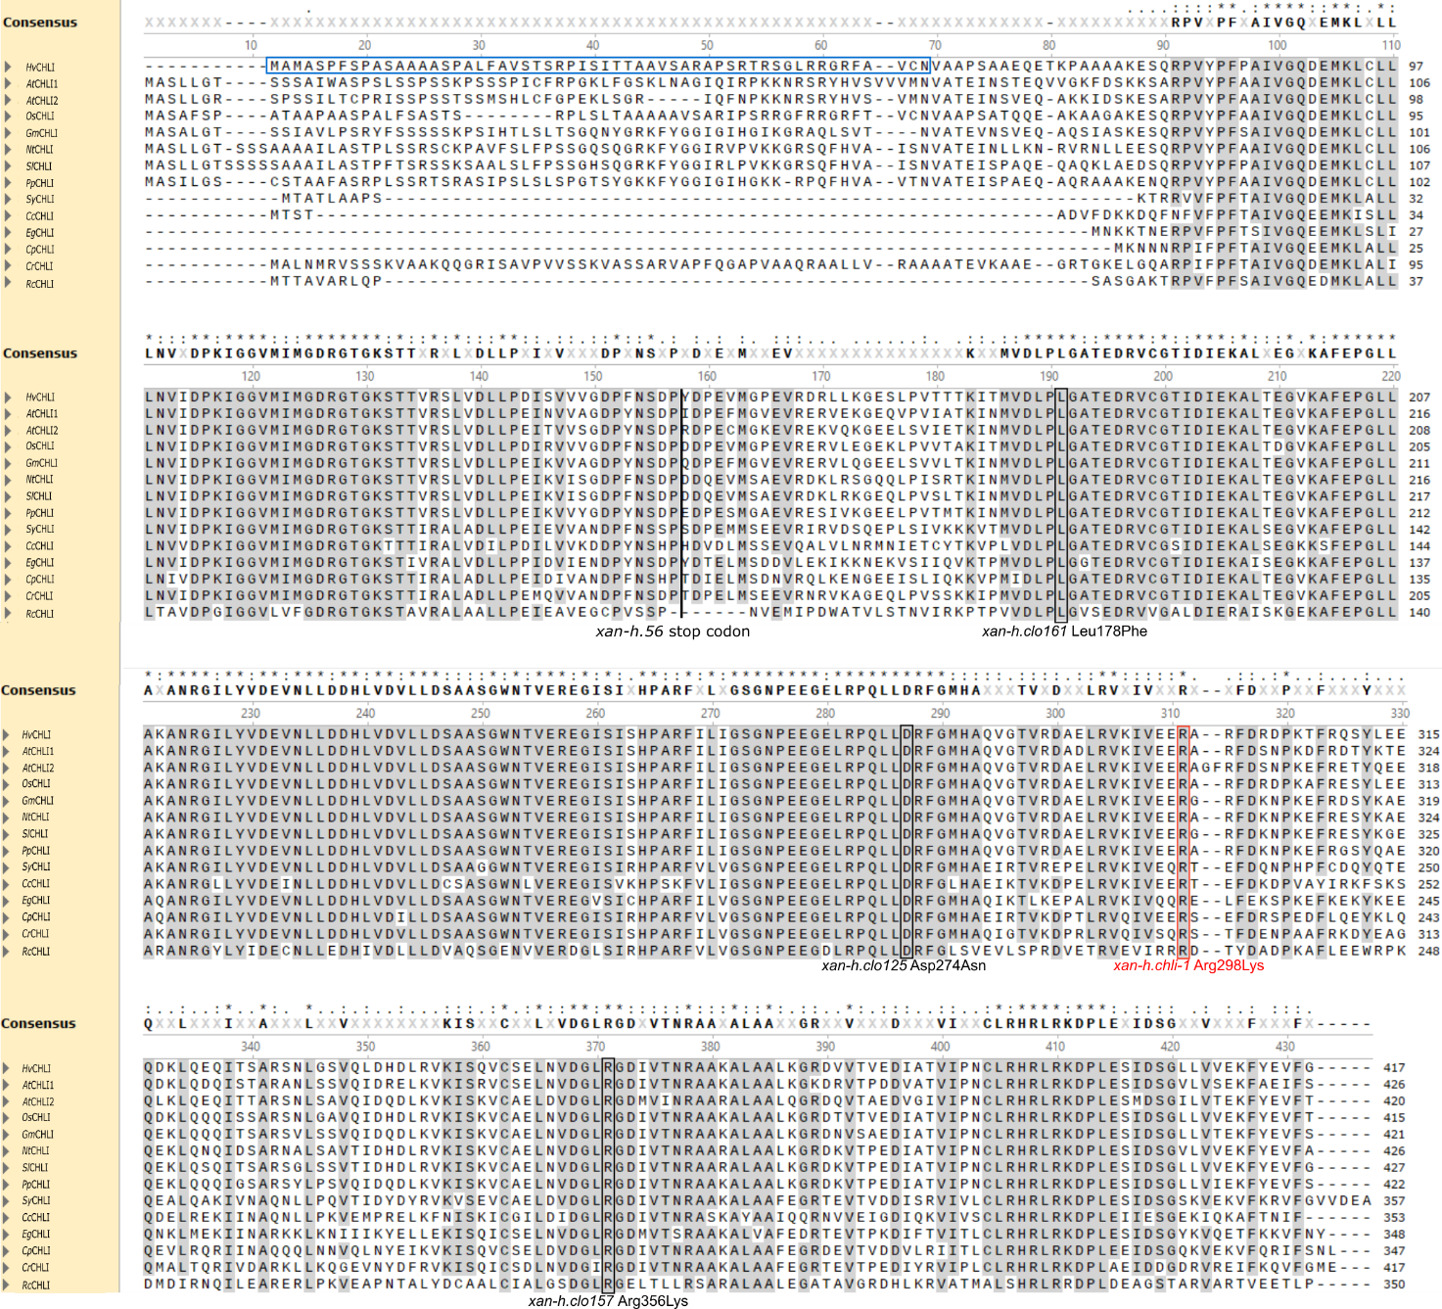
Figure S1. Alignment of CHLI sequences with Musclev5. The chloroplast transit peptide (cTP) of the HvCHLI protein, as predicted by TargetP-2.0 (services.healthtech.dtu.dk/services/TargetP-2.0), is highlighted with a light-blue box. Amino-acid substitutions reported as SNPs in barley mutants are indicated. Amino-acid positions refer to the barley sequence, including the R298K missense mutation as main candidate for the TM2490 pale green phenotype (in red). The degrees of identity between the Hordeum vulgare sequence and the analyzed sequences are the following: Arabidopsis thaliana AtCHLI1 78%; Arabidopsis thaliana AtCHLI2 81%; Oryza sativa subsp. Japonica OsCHLI 90%; Glycine max GmCHLI 77%; Nicotiana tabacum NtCHLI 76%; Solanum lycopersicum SlCHLI 78%; Prunus persica PpCHLI 78%; Synechocystis sp. (strain PCC 6803 / Kazusa) SyCHLI 73%; Cyanidium caldarium CcCHLI 62%; Euglena gracilis EgCHLI 69%; Cyanophora paradoxa CpCHLI 70%; Chlamydomonas reinhardti CrCHLI 66%; Rhodobacter capsulatus RcCHLI 49%. Amino acids showing 100% conservation among the sequences considered are indicated by asterisks, while dots and colons indicate degrees of amino-acid conservation greater than 40% and 60%, respectively.

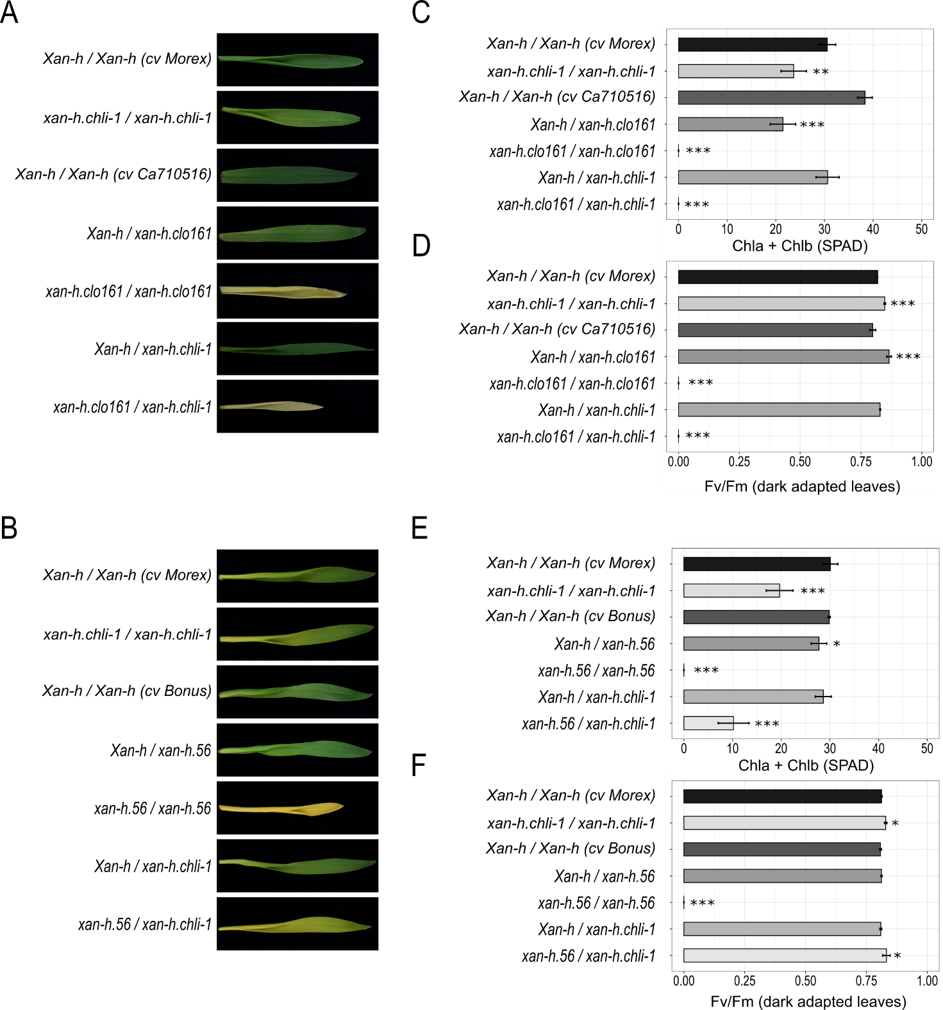
Figure S2. Validation of the TM2490 locus based on allelism tests. (A and B) First leaves of F1 plants obtained by crossing TM2490 (xan-h.chli-1/xan-h.chli-1) with xan-h.clo161 (genetic background cv Ca710516) and xan-h.56 (genetic background cv Bonus), grown for 10 days under controlled greenhouse conditions, together with cv Morex, Bonus, Ca710516, xan-h.chli-1, xan-h.56 and xan-h.clo161. (C and E) Measurements of total apparent chlorophyll contents expressed in SPAD units. (D and F) Leaf PSII functionality (Fv/Fm) in dark-adapted plants measured using the portable Handy PEA. Error bars on the histograms indicate standard deviations (Student’s t-test; *** P < 0.001, ** P < 0.01, * P < 0.05).
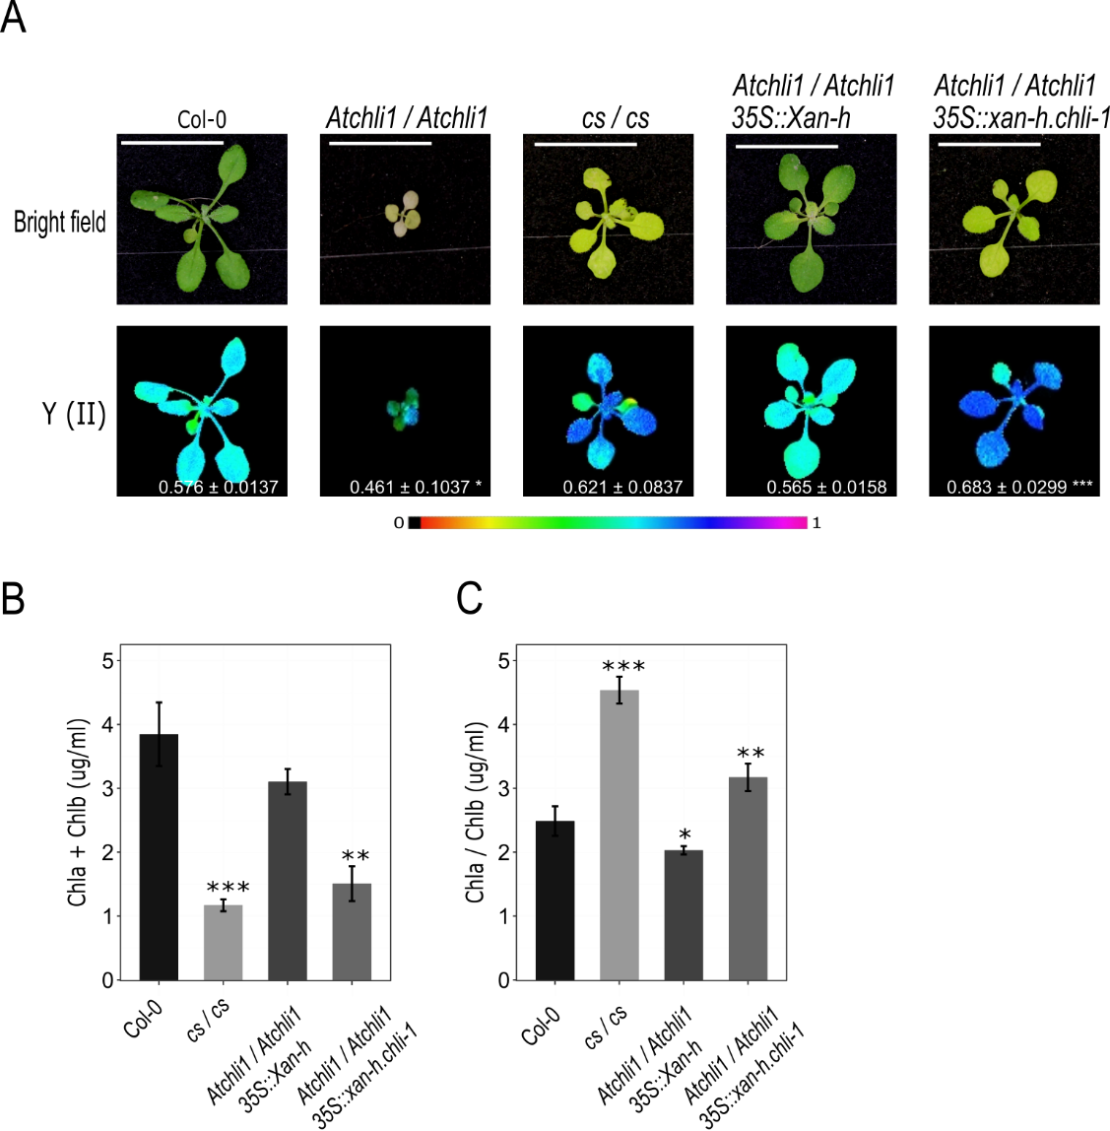
Figure S3. Complementation assays using the A. thaliana chli1 mutant (Atchli1/Atchli1) and the barley WT (Xan-h) or the barley mutant allele (xan-h.chli-1). (A) Visible phenotype and photosynthetic performance of Atchli1/Atchli1 rosette leaves compared to the same genotype crossed with either Xan-h or xan-h.chli-1, and the controls Col-0 and cs/cs. Photosynthetic performance was estimated by measuring the Y(II) values of plants that were exposed to light (56 µmol photons m⁻² s⁻¹) for 5 min. The data were recorded with the Imaging-PAM fluorometer and the results are displayed in false colours. The colour scale is shown below the images, where violet corresponds to 1 and black to 0. Scale bar = 1 cm. (B) Chla + Chlb content and (C) Chla/Chlb ratio determined by spectrophotometry (see Materials and Methods section). Data were analysed with Student’s t-test (*** P < 0.001, ** P < 0.01, * P < 0.05).

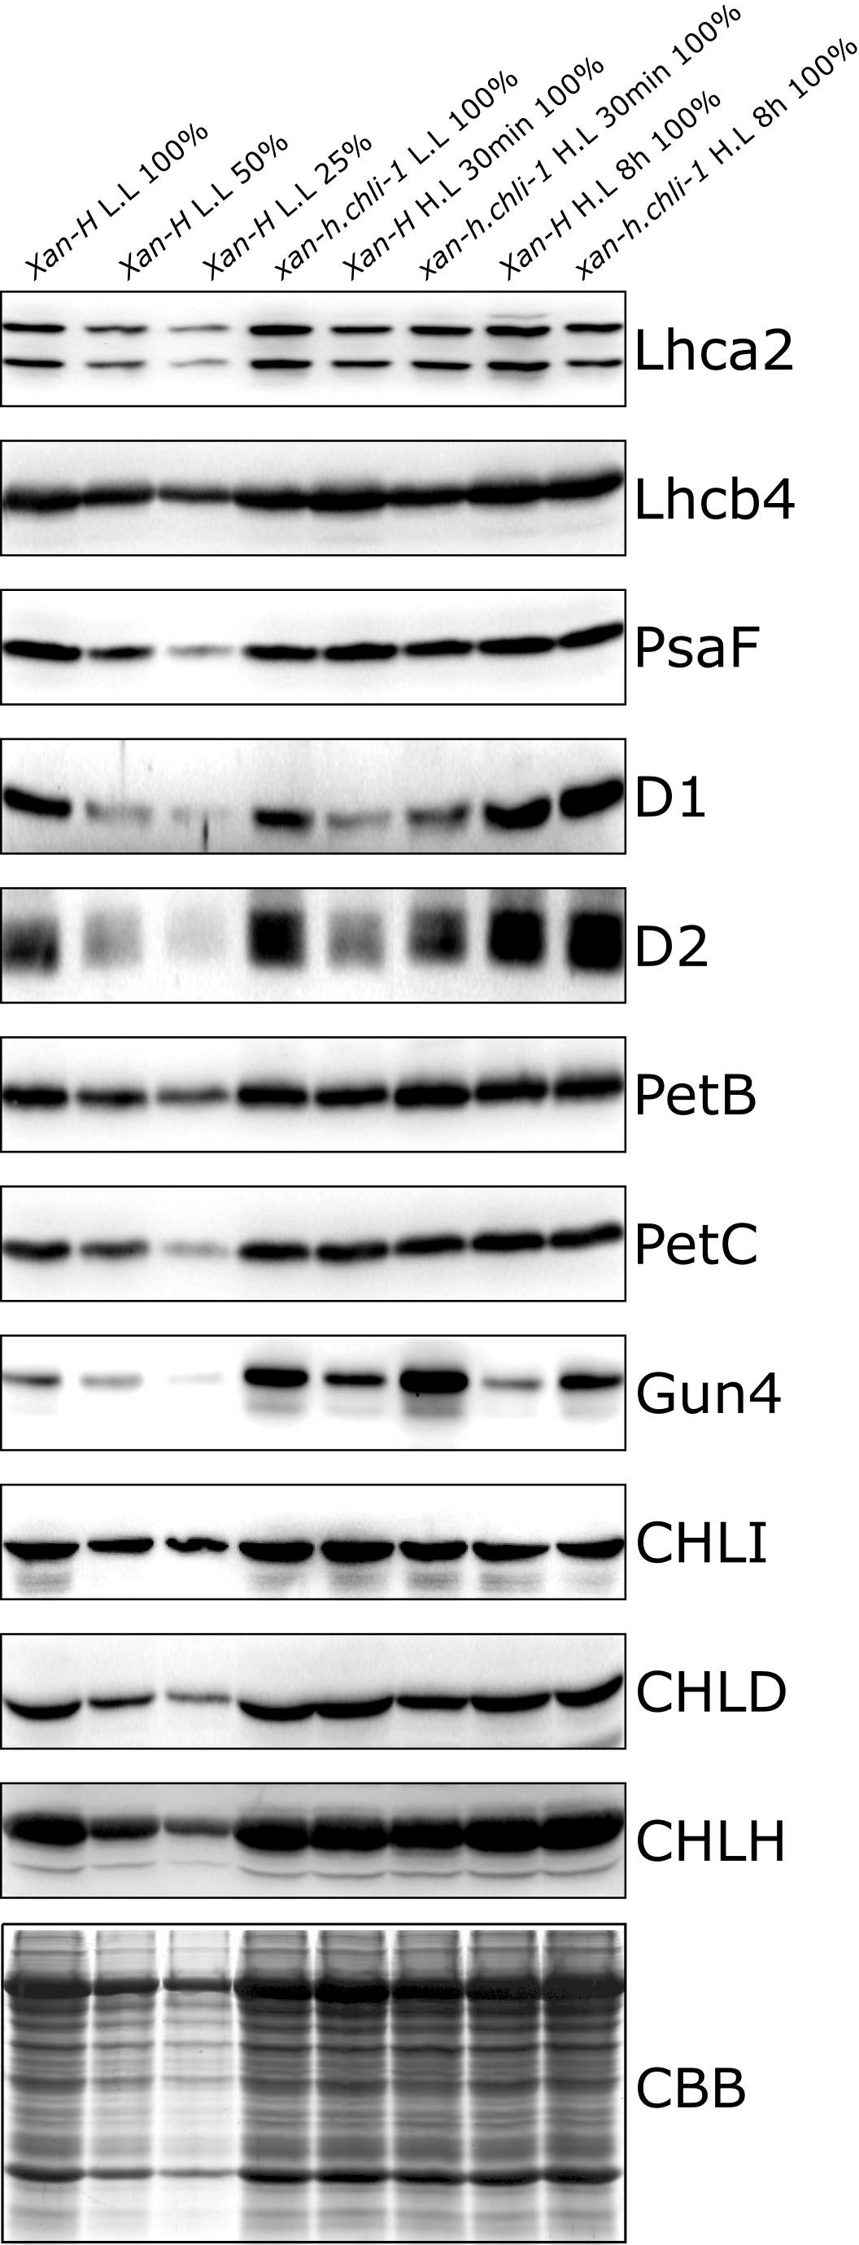

Figure S4. Immunoblot analyses on thylakoid and Mg-chelatase subunits to evaluate the effects of high-light exposure. Immunoblot analyses were performed on Xan-h and xan-h.chli-1 total protein extracted from plants grown under control conditions (Low light, L.L, around 400-500 µmol photons m ⁻² s ⁻¹) and exposed to high light (H.L, around 1200-1400 µmol photons m ⁻² s ⁻¹) for 0.5 (30 min) and 8 hours (h). An SDS-PA gel stained with Coomassie Brilliant Blue (CBB) is shown as loading control.

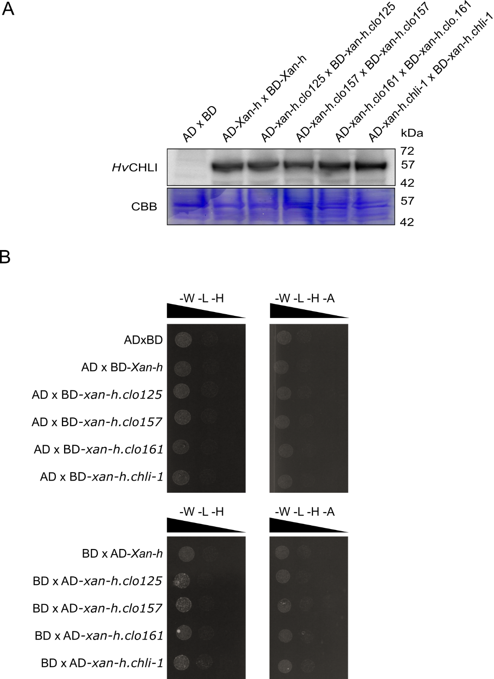
Figure S5. Western blots and negative controls to validate the yeast two-hybrid data. (A) Western blot analysis performed by using a HvCHLI-specific antibody on diploid yeast cells (AH109xY187) to confirm the expression of Gal4AD and Gal4BD fusions to Xan-h and its allelic variants xan-h.chli-1, xan-h.clo125, xan-h.clo157 and xan-h.clo161 (MW between 53 and 57 kDa). Empty plasmids expressing Gal4AD and Gal4BD (AD x BD) were used as controls. CBB, Coomassie Brilliant Blue staining of a replica SDS-PAGE. (B) To exclude possible growth on selective media due to non-specific interaction between the different variants and the Gal4 domains used for the assay, each yeast strain expressing wild-type and mutant variants of HvCHLI was alternatively mated and tested for interaction against either the Gal4BD or the Gal4AD alone. No interaction between HvCHLI and mutant variants with Gal4BD or Gal4AD could be detected, as shown by the lack of yeast growth on selective media, devoid of either Trp, Leu and His (-W -L -H) or Trp, Leu, His and Ade (-W -L -H -A).

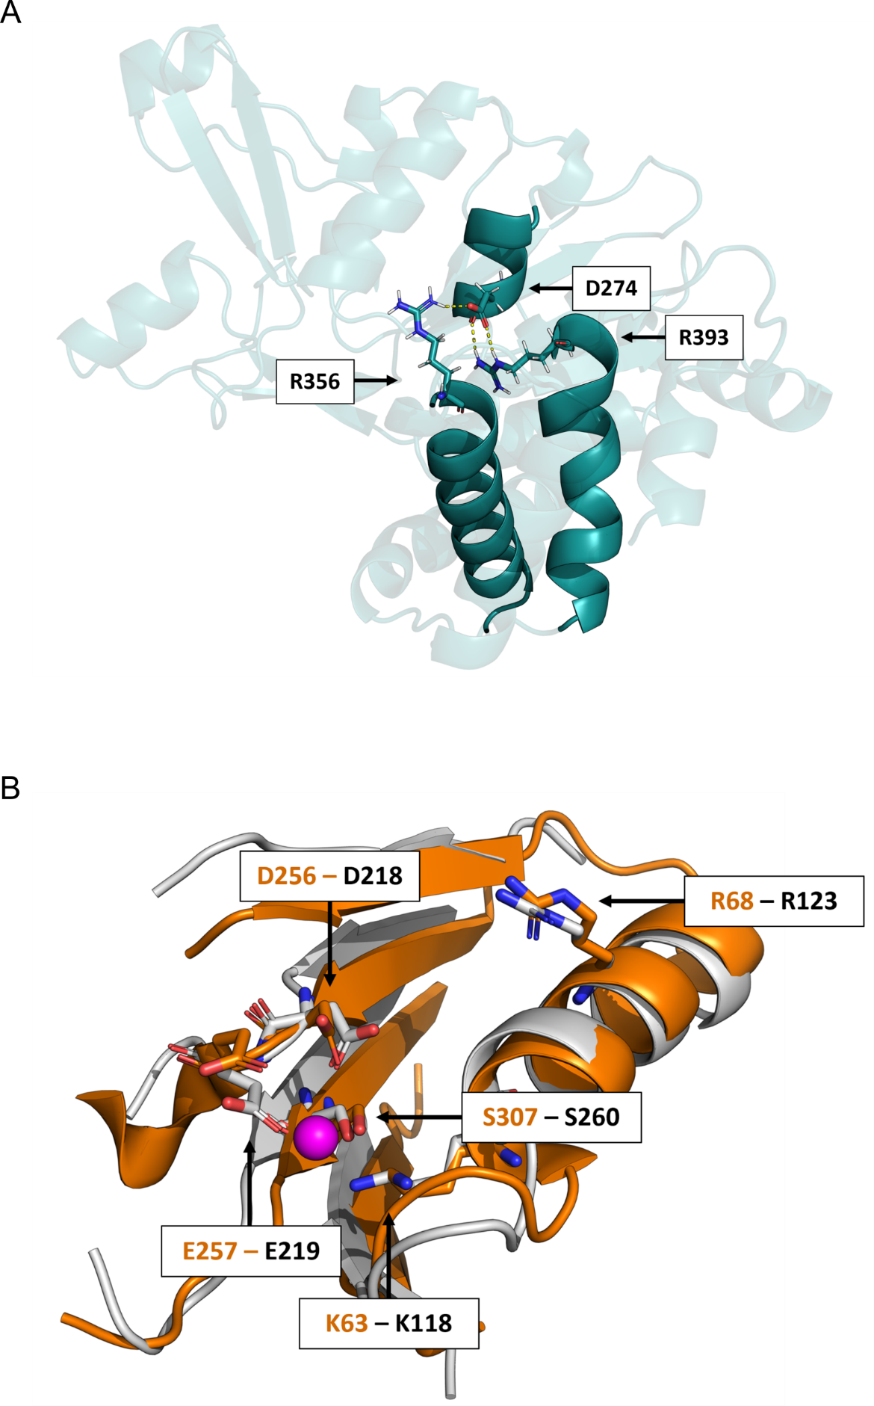
Figure S6. Details of specific properties of the HvCHLI monomer. (A) Detailed view of the D274- R356-R393 interaction within the barley HvCHLI monomer. The overall monomer structure is represented in transparent cyan cartoon, except for the alpha helices encompassing D274, R356 and R393, which are highlighted in solid cyan cartoon. D274, R356 and R393 are depicted as solid sticks and coloured: cyan for C atoms, blue for N, red for O, and white for H-. The hydrogen bond is represented as a dashed yellow line. (B) The ATP-binding domain from the protein Heat Shock Locus U [HSLU, PDB ID: 1DO0; (Bochtler et al. 2000)] superimposed on the barley HvCHLI model. The HSLU domain is presented in solid orange cartoon, whereas the domain from the barley HvCHLI model is in light grey. Selected conserved residues from HSLU are represented as solid sticks: C atoms are shown in orange, N atoms in blue, O atoms in red, and H atoms in white. Conserved residues of the barley model are depicted in the same colour scheme, except that C atoms are shown in light grey.

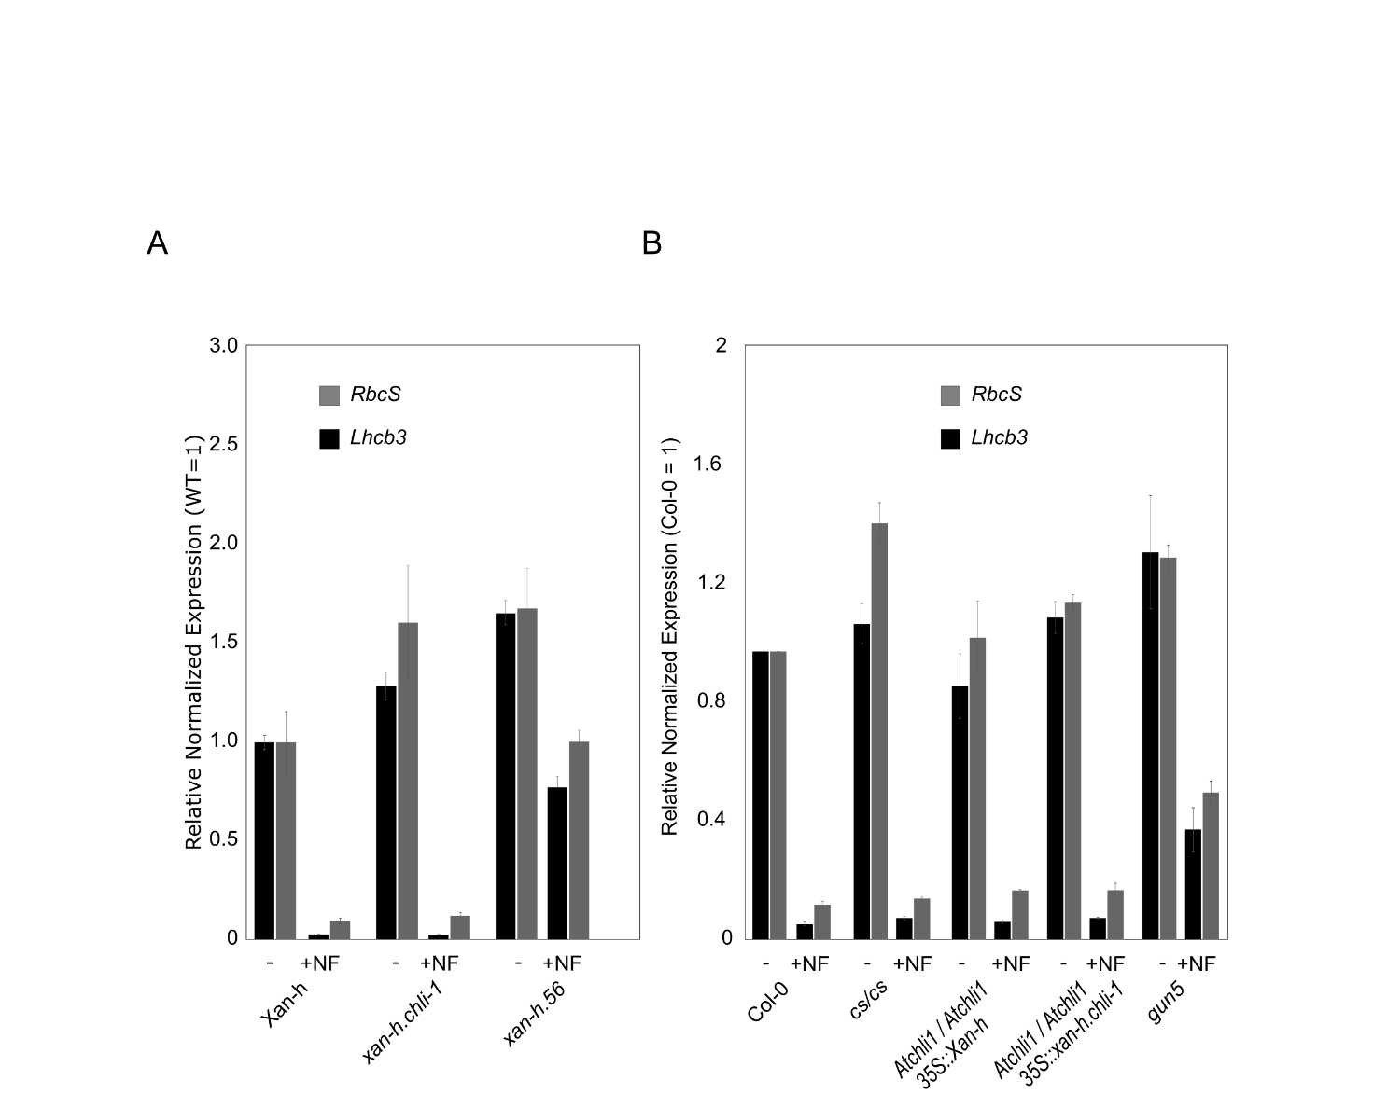
Figure S7. Assay for the genomes uncoupled (gun) phenotype in barley and Arabidopsis lines. (A) RT-qPCR expression analyses of the photosynthesis-associated nuclear genes Rbcs and Lhcb3 were performed on barley Xan-h, xan-h.chli-1 and xan-h.56 lines grown for 6 days under sterile conditions, either in the absence of Norflurazon (NF) or on NF-supplemented medium (5 µM) for 4 days. (B) The expression of the same genes was also monitored in Arabidopsis Col-0, cs/cs, Atchli1/Atchli1 + 35S::Xan-h and Atchli/Atchli + 35S::xan-h.chli-1 mutant lines under the same conditions in presence or absence of 5 µM Norflurazon. The retrograde-signalling-defective mutant gun5 (Arabidopsis) and xan-h.56 (barley) were used as controls for the gun phenotype.

