Supplementary Information

Disentangling the effects of sandy beach management on intertidal macrobenthic fauna: a path analysis approach.

Fabio Bozzeda^{1,2}, Lucia Fanini¹, Federica Costantini^{3,4}, Barbara Mikac^{4,5} and Marina Antonia Colangelo^{3,4}

1 Department of Biological and Environmental Sciences and Technologies (DiSTeBA), University of Salento, S.P. Lecce-Monteroni, 73100 Lecce, Italy
2 National Biodiversity Future Center (NBFC), 90133 Palermo, Italy
3 Department of Biological, Geological and Environmental Sciences, University of Bologna, UOS Ravenna, Italy
4 Interdepartmental Center for Industrial Research on Renewable Sources, Environment, Sea and Energy, University of Bologna, Ravenna, Italy
5 Department of Cultural Heritage, University of Bologna, Ravenna, Italy

Corresponding: Lucia Fanini; email address: lucia.fanini@unisalento.it

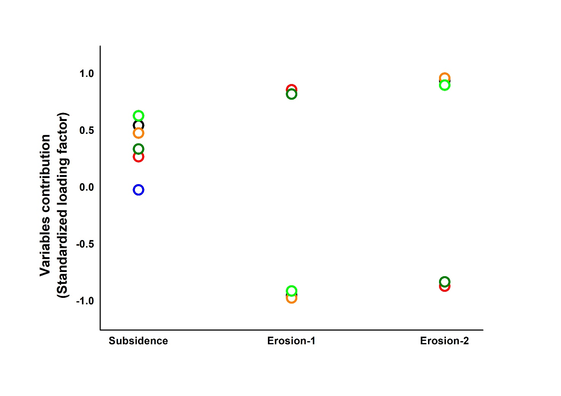

Figure S1: The path coefficients for each measured variable that compose the latent variable “physical processes” and for each independent variable. The colors of the symbols—black, red, orange, dark green, and light green—represent, respectively, the Taxa number and the abundances of Nemertea sp., Scolelepis (scolelepis) squamata, Polydora sp., and Lentidium mediterraneum.

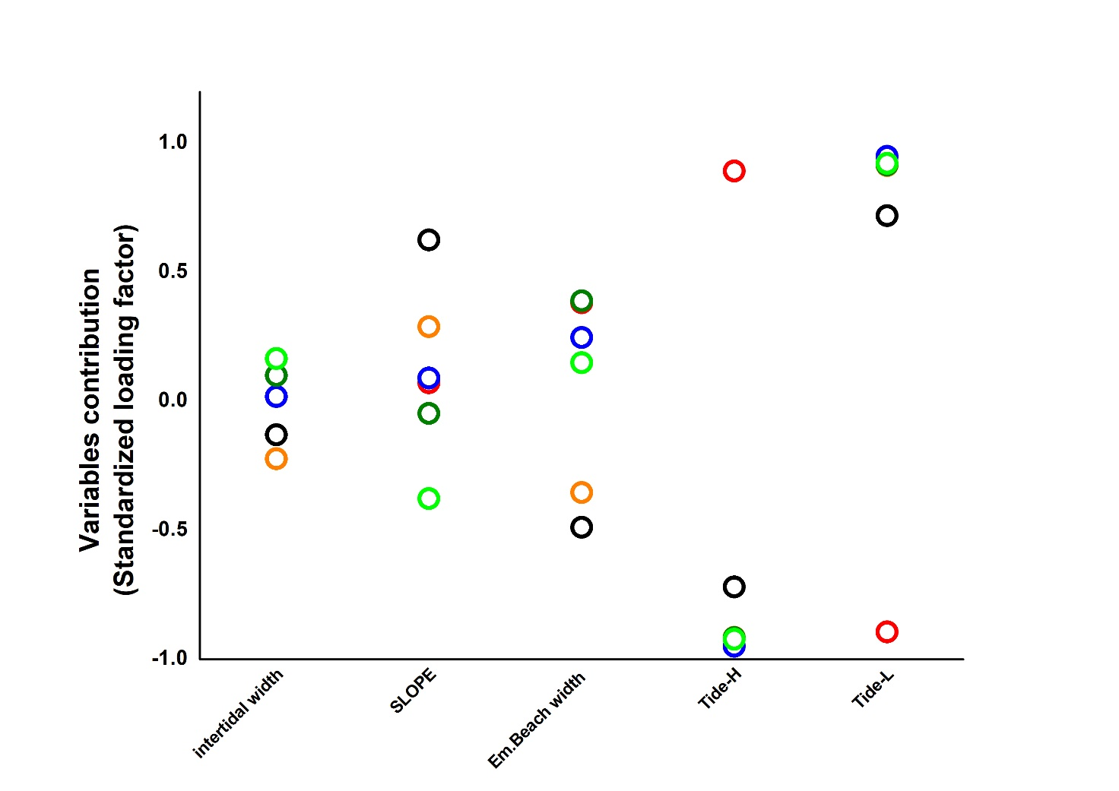
Figure S2: The path coefficients for each measured variable that compose the latent variable “physical state” and for each independent variable. The colors of the symbols—black, red, orange, dark green, and light green—represent, respectively, the Taxa number and the abundances of Nemertea sp., Scolelepis squamata, Polydora sp., and Lentidium mediterraneum.

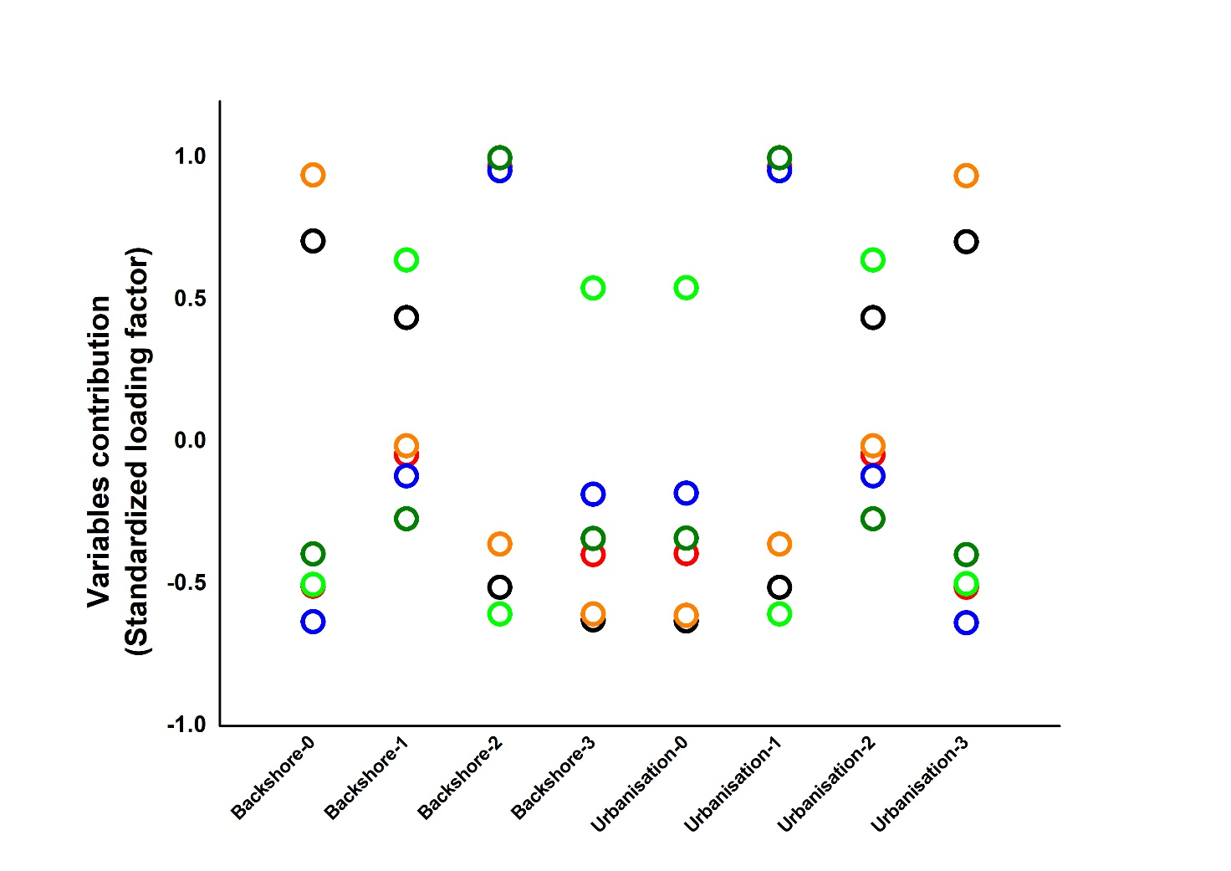
Figure S3: The path coefficients for each measured variable that compose the latent variable “beach backing” and for each independent variable. The colors of the symbols—black, red, orange, dark green, and light green—represent, respectively, the Taxa number and the abundances of Nemertea sp., Scolelepis (scolelepis) squamata, Polydora sp., and Lentidium mediterraneum.

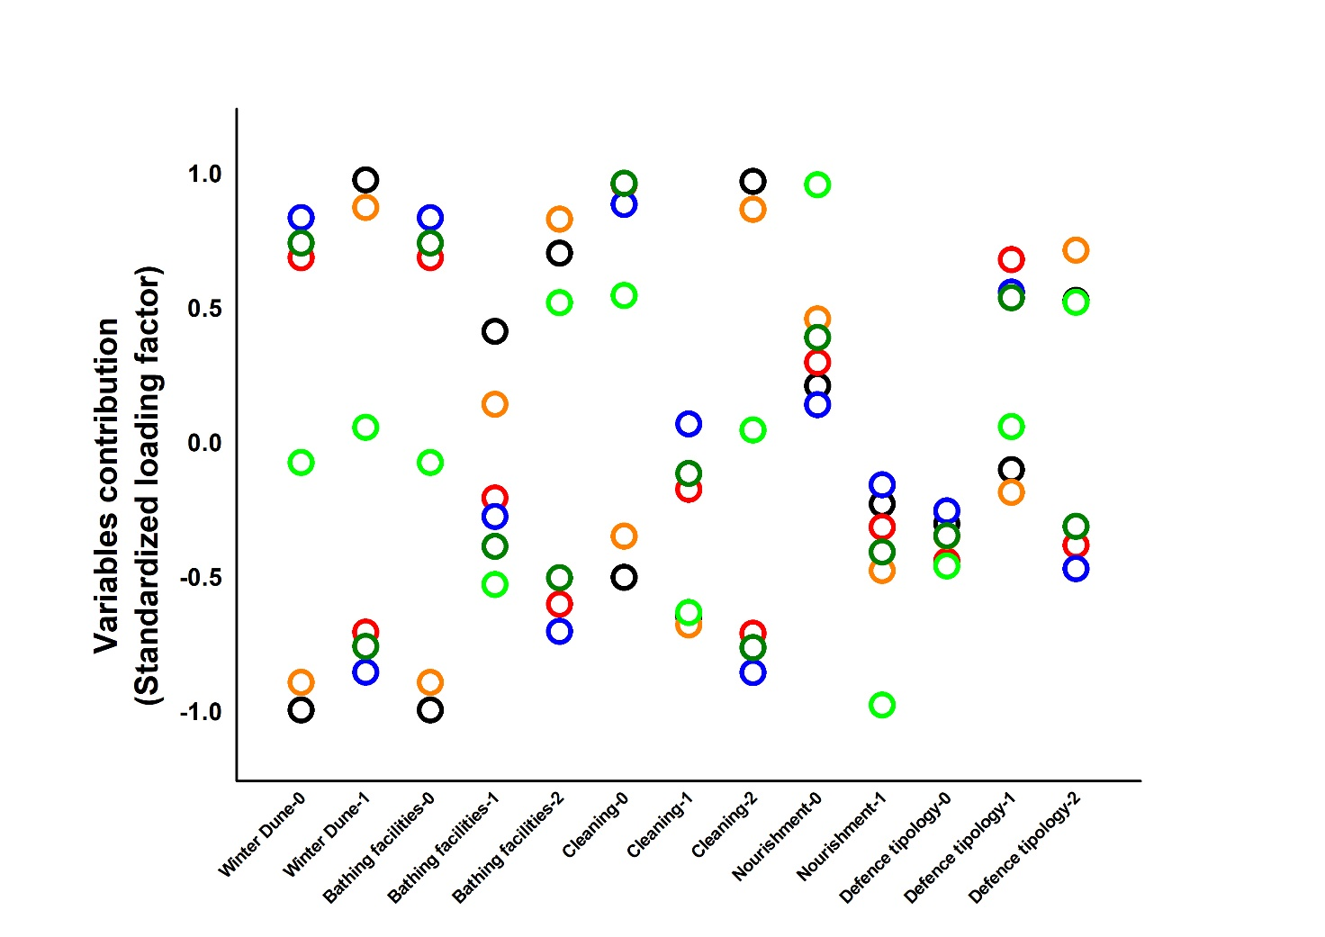
Figure S4: The path coefficients for each measured variable that compose the latent variable “management” and for each independent variable. The colors of the symbols—black, red, orange, dark green, and light green—represent, respectively, the Taxa number and the abundances of Nemertea sp., Scolelepis (scolelepis) squamata, Polydora sp., and Lentidium mediterraneum.

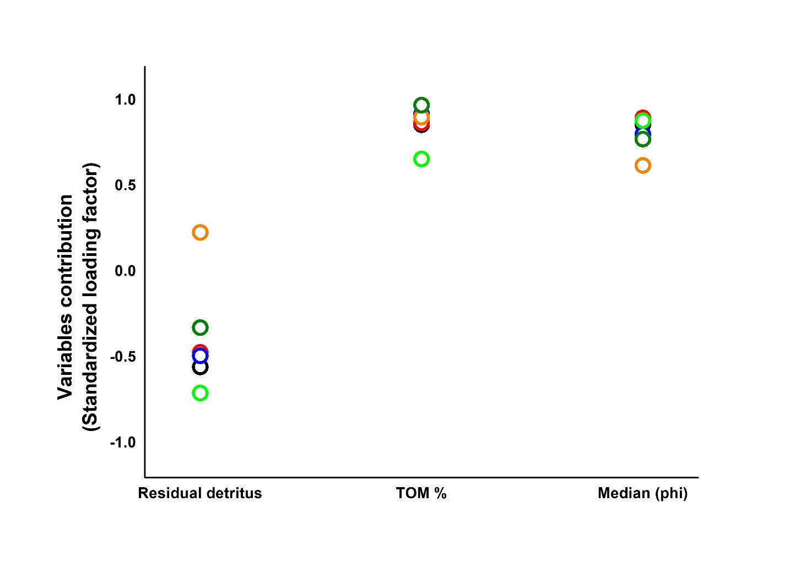

Figure S5: The path coefficients for each measured variable that compose the latent variable “sediment” and for each independent variable. The colors of the symbols—black, red, orange, dark green, and light green—represent, respectively, the Taxa number and the abundances of Nemertea sp., Scolelepis (scolelepis) squamata, Polydora sp., and Lentidium mediterraneum.

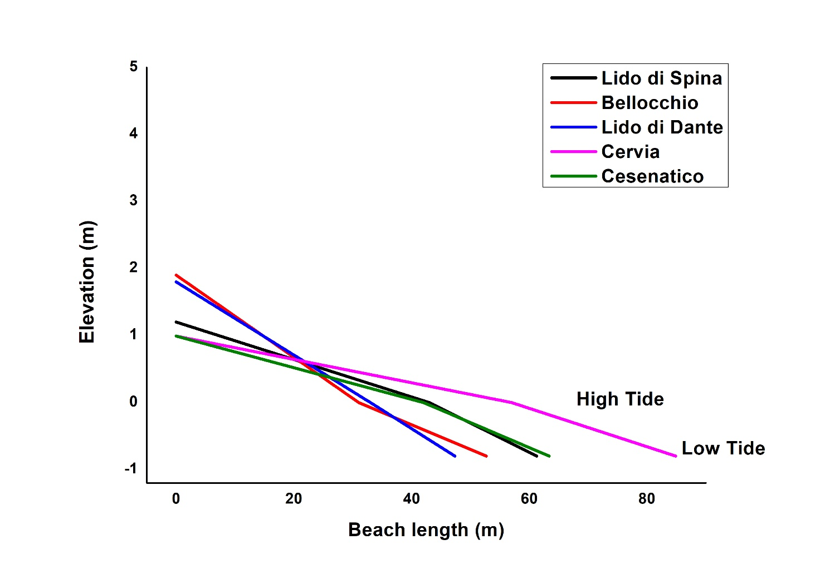
Figure S6: profiles of the 5 studied beaches, each profile describe the emerged beach until the low tide level.

About Path analysis procedure

Path analysis is applied to linear models with structural equations of the type:
- A y = B x + u (1)
in which A is a GxG matrix of coefficients, by hypothesis invertible, B is a GxK matrix of coefficients, y is a GxN matrix of endogenous variables, x is a KxN matrix of possibly non-deterministic exogenous variables, and u is a GxN matrix of terms disturbance, uncorrelated with the exogenous variables, with zero mean and covariance matrix Z. The variables that in a generic equation of model (1) have a coefficient other than zero (outside the main diagonal) belong to the group of direct causes of the dependent variable of that equation. The variables that through intermediate variables influence the dependent variable of an equation (direct causes of direct causes, for example) belong to the group of indirect causes. The structure of the Path model, within which the possible causal trajectories of the system are simulated, is graphically expressed as a system of ellipses (latent variables) and rectangles (measured variables) connected to each other according to the hypothesized causal links.

Figure captions:
Fig. 1. Map of the five sampling beaches along the coast of Emilia Romagna (North-East of Italy) (Source: Google Earth).
Fig. 2. Structure of Path model. Ellipses designate latent variables and rectangles designed measured variables.
Fig. 3. Principal Component Analysis (PCA) carried out on environmental variables in (A) H tide; (B) L tide appropriately transformed. Intertidal Weight (IW), Slope (Sl), Residual Detritus (RD), percentage of total organic matter (TOM), Median grain size (Md in phi) and Beach Deposit Index (BDI) in each beach. Vectors indicate the direction and strength of each group contribution. SPI: Lido di Spina; BEL: Bellocchio; LDD: Lido di Dante; CER: Cervia; CES: Cesenatico.

Fig. 4. Boxplot of Number of taxa at (a) H tide and (b) L tide and Abundance (Ind/m²) at (c) H tide and (d) L tide.

Fig. 5. Metric multidimensional scaling (mMDS) plot based on Bray-Curtis similarity matrix on abundance data (Ind/m²) after square root transformation in (a) H tide and (b) L tide. Ellipses indicate 95% confidence intervals and Avg for each beach were shown. SPI: Lido di Spina; BEL: Bellocchio; LDD: Lido di Dante; CER: Cervia; CES: Cesenatico.

Figure 6: Path coefficients of each latent variable for each dependent variable.

Table S1. Features of the 5 studied beaches.
Cesenatico (CES) | Cervia (CER) | Lido di Dante (LDD) | Bellocchio (BEL) | Lido di Spina (SPI)
Turistic | Turistic | Naturistic beach | Natural beach | Semi-turistic beach
Subemerged barriers -(0.8 km long, |  |  |  | Groins made with wooden piles in the south part
12 m wide, 250 m distant from the
beach)
Scraping sand from intertidal area to extend the beach
Winter dune | Winter dune
In summer daily grooming | In summer daily grooming | In summer sporadic groomic on volunteer basis | In summer sporadic groomic on volunteer basis | In summer daily grooming
Beach interrupted by bar/restaurant | Beach interrupted by bar/restaurant | Pinewood on backshore | Ponds on backshore | Sand dunes

Table S2. Sampling design informations.
 |  | time of sampling | Number of transects | tide levels | Number replicates/tide level | total samples/tide x beach
Cesenatico North |  | dry season 2010 | 3 | H; L | 2 | 24H; 24L
 |  | cold season 2010 | 3 | H; L | 2 | 24H; 24L
 |  | dry season 2011 | 3 | H; L | 2 | 24H; 24L
 |  | cold season 2011 | 3 | H; L | 2 | 24H; 24L
Cervia/Pinarella |  | early september 2010 | 3 | H; L | 2 | 24H; 24L
 |  | cold season 2010 | 3 | H; L | 2 | 24H; 24L
 |  | dry season 2011 | 3 | H; L | 2 | 24H; 24L
 |  | cold season 2011 | 3 | H; L | 2 | 24H; 24L
Lido di Dante/Bassona |  | cold seasonr 2010 | 3 | H; L | 2 | 42H; 42L
 |  | cold seasonr 2010 | 3 | H; L | 2 | 42H; 42L
 |  | dry season 2011 | 3 | H; L | 2 | 42H; 42L
 |  | cold seasonr 2011 | 3 | H; L | 2 | 42H; 42L
 |  | dry season 2013 | 6 | H; L | 3 | 42H; 42L
Bellocchio |  | dry season 2012 | 6 | H; L | 4 | 42H; 42L
 |  | cold season 2013 | 6 | H; L | 3 | 42H; 42L
Lido di Spina |  | dry season 2012 | 6 | H; L | 4 | 33H; 33L
 |  | cold season 2013 | 3 | H; L | 3 | 33H; 33L

Table S3. List of taxa found in each beach. SPI: Lido di Spina; BEL: Bellocchio; LDD: Lido di Dante; CER: Cervia; CES: Cesenatico
 |  |  |  |  | H tide |  |  |  |  | L tide
Phylum | Class | Order | Family | Species | SPI | BEL | LDD | CER | CES | SPI | BEL | LDD | CER | CES
Platyhelminthes | Turbellaria |  |  |  | * | * | * | * | * | * | * | * | * | *
Nemertea |  |  |  | Nemertea | * | * | * | * | * | * | * | * | * | *
Nematoda |  |  |  | Nematoda | * | * | * | * | * | * | * | * | *
Annelida | Clitellata |  |  | Oligochaeta | * |  | * | * |  |  |  | * | *
Annelida | Polychaeta | Phyllodocida | Phyllodocidae | Mysta picta |  | *
Annelida | Polychaeta | Spionida | Spionidae | Prionospio caspersi |  | * |  |  |  |  | * |  | *
Annelida | Polychaeta | Phyllodocida | Glyceridae | Glycera tridactyla | * | * |  | * | * | * | * | * | * | *
Annelida | Polychaeta | Terebellida | Cirratulidae | Cirratulidae |  |  |  |  |  |  | *
Annelida | Polychaeta | Phyllodocida | Nephtyidae | Nephtys hombergii |  | * |  |  |  |  | * |  |  | *
Annelida | Polychaeta |  | Nereididae | Alitta succinea |  |  |  |  |  |  |  | * | *
Annelida | Polychaeta |  | Sigalionidae | Sigalionidae |  |  |  |  |  |  |  |  |  | *
Annelida | Polychaeta |  | Saccocirridae | Saccocirrus |  |  | * |  |  |  |  | *
Annelida | Polychaeta | Eunicida | Lumbrineridae | Lumbrineris |  |  |  | *
Annelida | Polychaeta |  | Oweniidae | Oweniidae |  |  |  | * |  |  |  |  | *
Annelida | Polychaeta | Spionida | Spionidae | Malacoceros fuliginosus |  | *
Annelida | Polychaeta | Spionida | Spionidae | Scolelepis (Scolelepis) squamata | * | * | * | * | * | * | * | * | * | *
Annelida | Polychaeta | Spionida | Spionidae | Polydora | * | * |  |  |  | * | *
Annelida | Polychaeta | Spionida | Spionidae | Spionidae | * |  | * |  |  |  | * | * | * | *
Annelida | Polychaeta | Terebellida | Terebellidae | Terebellidae |  |  |  |  |  |  | *
Annelida | Polychaeta |  | Capitellidae | Heteromastus |  |  |  |  |  |  | *
Annelida | Polychaeta |  | Capitellidae | Capitellidae |  | * |  |  | * |  | * |  |  | *
Annelida | Polychaeta |  | Orbiniidae | Orbiniidae |  |  |  |  |  |  |  |  |  | *
Annelida | Polychaeta |  |  | Polychaeta | * |  | * | * |  | * |  |  |  | *
Mollusca | Bivalvia | Lucinida | Lucinidae | Lucinella divaricata |  |  |  |  | * |  |  |  |  | *
Mollusca | Bivalvia | Cardiida | Cardiidae | Cerastoderma glaucum |  | * |  |  |  |  | *
Mollusca | Bivalvia | Venerida | Mactridae | Mactra stultorum |  |  |  | * |  |  |  |  | * | *
Mollusca | Bivalvia | Cardiida | Donacidae | Donax semistriatus |  |  | * | * |  |  |  | * | * | *
Mollusca | Bivalvia | Cardiida | Donacidae | Donax trunculus | * |  | * |  |  |  |  |  |  | *
Mollusca | Bivalvia | Cardiida | Tellinidae | Macomangulus tenuis | * |  |  |  |  | * |  | * | * | *
Mollusca | Bivalvia | Cardiida | Tellinidae | Tellinidae | * |  |  |  |  | *
Mollusca | Bivalvia | Venerida | Veneridae | Chamelea gallina |  | * | * | * | * |  |  | * | * | *
Mollusca | Bivalvia | Venerida | Veneridae | Ruditapes philippinarum |  | * |  |  | * |  | * | *
Mollusca | Bivalvia | Venerida | Veneridae | Veneridae
Mollusca | Bivalvia | Mytilida | Mytilidae | Gregariella petagnae |  | *
Mollusca | Bivalvia | Mytilida | Mytilidae | Arcuatula senhousia |  | * |  |  |  |  | *
Mollusca | Bivalvia | Mytilida | Mytilidae | Musculus subpictus |  |  |  |  |  |  | *
Mollusca | Bivalvia | Mytilida | Mytilidae | Mytilus galloprovincialis | * | * | * |  |  | * | * | *
Mollusca | Bivalvia | Myida | Pholadidae | Barnea candida | * | * |  |  |  |  | *
Mollusca | Bivalvia | Myida | Corbulidae | Lentidium mediterraneum | * | * | * | * | * | * | * | * | * | *
Mollusca | Bivalvia | Arcida | Arcidae | Anadara inaequivalvis |  | * |  | * | *
Mollusca | Gastropoda | Neogastropoda | Nassariidae | Tritia neritea |  |  |  | * |  | * |  |  | * | *
Mollusca | Gastropoda | Neogastropoda | Nassariidae | Nassarius |  |  |  |  |  | *
Mollusca | Gastropoda |  |  | Gastropoda | *
Arthropoda | Copepoda | Cyclopoida | Taeniacanthidae | Taeniacanthidae |  | * |  |  |  |  | *
Arthropoda | Copepoda | Harpacticoida |  | Harpacticoida | * |  | * | * | * | * |  | *
Arthropoda | Ostracoda |  |  | Ostracoda | * | * |  |  |  | * | *
Arthropoda | Malacostraca | Mysida | Mysidae | Gastrosaccus | * | * |  |  |  | *
Arthropoda | Malacostraca | Isopoda | Idoteidae | Idotea balthica |  | * |  |  |  |  | * | *
Arthropoda | Malacostraca | Isopoda | Cirolanidae | Eurydice spinigera | * | * | * |  | * | * | * | * | *
Arthropoda | Malacostraca | Isopoda | Sphaeromatidae | Sphaeroma serratum | * | * | * |  |  | * | * | *
Arthropoda | Malacostraca | Amphipoda | Stenothoidae | Stenothoe tergestina |  |  | * |  |  |  |  | * |  | *
Arthropoda | Malacostraca | Amphipoda | Gammaridae | Gammarus aequicauda |  | * |  |  |  | * | *
Arthropoda | Malacostraca | Amphipoda | Gammaridae | Gammarus | * | * |  |  |  | * | * | *
Arthropoda | Malacostraca | Amphipoda | Atylidae | Nototropis massiliensis |  |  |  |  |  | * | *
Arthropoda | Malacostraca | Amphipoda | Atylidae | Nototropis swammerdamei |  |  |  |  |  |  | * | *
Arthropoda | Malacostraca | Amphipoda | Bathyporeiidae | Bathyporeia guilliamsoniana | * | * |  |  |  | * | * | *
Arthropoda | Malacostraca | Amphipoda | Aoridae | Microdeutopus gryllotalpa |  |  |  |  |  |  | *
Arthropoda | Malacostraca | Amphipoda | Melitidae | Melita hergensis |  | * |  |  |  |  | *
Arthropoda | Malacostraca | Amphipoda | Melitidae | Melita palmata |  |  |  |  |  |  | *
Arthropoda | Malacostraca | Amphipoda | Corophiidae | Monocorophium acherusicum | * | * |  |  |  | * | *
Arthropoda | Malacostraca | Amphipoda | Corophiidae | Monocorophium insidiosum | * | * |  |  |  |  | *
Arthropoda | Malacostraca | Amphipoda | Ischyroceridae | Jassa marmorata |  | * |  |  |  |  | *
Arthropoda | Malacostraca | Amphipoda | Caprellidae | Caprellidae |  |  |  |  |  |  | * | *
Arthropoda | Malacostraca | Amphipoda |  | Amphipoda | * |  | * |  | * | * |  |  |  | *
Arthropoda | Malacostraca | Anisopoda |  | Tanaidacea
Arthropoda | Malacostraca | Tanaidacea |  | Tanaidacea |  |  |  |  |  |  |  |  | *
Arthropoda | Malacostraca | Decapoda | Crangonidae | Crangonidae |  |  |  |  |  | *
Arthropoda | Malacostraca | Decapoda | Carcinidae | Carcinus aestuarii |  |  |  |  |  |  | *
Arthropoda | Malacostraca | Decapoda |  | Decapoda | * |  | * |  |  |  |  | *
Arthropoda | Malacostraca | Euphausiacea |  | Euphausiacea |  |  | * |  |  |  |  | *
Arthropoda | Malacostraca | Mysidacea |  | Mysida |  |  |  |  |  | *
Arthropoda | Malacostraca | Cumacea | Bodotriidae | Bodotria | * | * | * | * |  | * | * | * | * | *
Arthropoda | Malacostraca | Cumacea |  | Cumacea |  |  |  |  |  | * | * |  |  | *
Arthropoda | Malacostraca | Isopoda |  | Isopoda |  |  |  |  |  | *
Arthropoda | Pycnogonida | Pantopoda | Pycnogonidae | Pycnogonidae |  |  | *
Arthropoda | Arachnida | Trombidiformes | Halacaridae | Halacaridae |  | *

Table S4. Results of PERMANOVA and Pair-wise comparisons for the Number of taxa and Abundance (Ind/m2) of macrobenthos and Pair-Wise comparison tests at (a) H tide and (b) L tide. SPI: Lido di Spina; BEL: Bellocchio; LDD: Lido di Dante; CER: Cervia; CES: Cesenatico. Significant p-values (p < 0.05) are given in bold.
 |  | (a) H tide
 |  | Number of taxa |  |  | Abundance(Ind/m²)
Source | df | MS | Pseudo-F | P(perm) | MS | Pseudo-F | P(perm)
Beaches | 4 | 86.75 | 21.41 | 0.0001 | 6.14E+07 | 1.879 | 0.1113
Residual | 160 | 4.05 |  |  | 3.27E+07
Total | 164
 | Pair-wise | Beaches | t | P(perm)
 | Pair-wise | SPI, BEL | 3.717 | 0.001
 | Pair-wise | SPI, LDD | 2.322 | 0.0235
 | Pair-wise | SPI, CER | 3.019 | 0.0049
 | Pair-wise | SPI, CES | 3.437 | 0.0015
 | Pair-wise | BEL, LDD | 6.303 | 0.0001
 | Pair-wise | BEL, CER | 5.962 | 0.0001
 | Pair-wise | BEL, CES | 6.257 | 0.0001
 | Pair-wise | LDD, CER | 1.095 | 0.298
 | Pair-wise | LDD, CES | 1.79 | 0.0936
 | Pair-wise | CER, CES | 0.809 | 0.4815
 |  | (b) L tide
 |  | Number of taxa |  |  | Abundance(Ind/m²)
Source | df | MS | Pseudo-F | P(perm) | MS | Pseudo-F | P(perm)
Beaches | 4 | 113.37 | 24.61 | 0.0001 | 5.34E+09 | 10.59 | 0.0001
Residual | 160 | 4.61 |  |  | 5.04E+08
Total | 164
 | Pair-wise | Beaches | t | P(perm) | Beaches | t | P(perm)
 | Pair-wise | SPI, BEL | 5.612 | 0.0001 | SPI, BEL | 5.113 | 0.0001
 | Pair-wise | SPI, LDD | 1.737 | 0.0928 | SPI, LDD | 3.807 | 0.0002
 | Pair-wise | SPI, CER | 0.879 | 0.3811 | SPI, CER | 1.829 | 0.0615
 | Pair-wise | SPI, CES | 0.966 | 0.3525 | SPI, CES | 2.119 | 0.0364
 | Pair-wise | BEL, LDD | 7.841 | 0.0001 | BEL, LDD | 0.498 | 0.6177
 | Pair-wise | BEL, CER | 6.05 | 0.0001 | BEL, CER | 3.763 | 0.0002
 | Pair-wise | BEL, CES | 5.928 | 0.0001 | BEL, CES | 4.618 | 0.0001
 | Pair-wise | LDD, CER | 0.82 | 0.4101 | LDD, CER | 2.887 | 0.0039
 | Pair-wise | LDD, CES | 0.583 | 0.5876 | LDD, CES | 3.404 | 0.0013
 | Pair-wise | CER, CES | 0.174 | 0.9301 | CER, CES | 2.496 | 0.0019

Table S5. Results of PERMANOVA and Pair-wise comparisons testing for differences in community structure among beaches at H tide and L tide. SPI: Lido di Spina; BEL: Bellocchio; LDD: Lido di Dante; CER: Cervia; CES: Cesenatico.

 |  | H tide |  |  | L tide
Source | df | MS | Pseudo-F | P(perm) | MS | Pseudo-F | P(perm)
Beaches | 4 | 22947 | 7.13 | 0.0001 | 39565 | 14.928 | 0.0001
Residual | 160 | 3217.1 |  |  | 2650.4
Total | 164
 | Pair-wise | Groups | t | P(perm) | Groups | t | P(perm)
 | Pair-wise | SPI, BEL | 2.997 | 0.0001 | SPI, BEL | 4.628 | 0.0001
 | Pair-wise | SPI, LDD | 2.153 | 0.0005 | SPI, LDD | 2.751 | 0.0001
 | Pair-wise | SPI, CER | 2.087 | 0.0004 | SPI, CER | 3.16 | 0.0001
 | Pair-wise | SPI, CES | 2.654 | 0.0001 | SPI, CES | 3.374 | 0.0001
 | Pair-wise | BEL, LDD | 3.217 | 0.0001 | BEL, LDD | 4.52 | 0.0001
 | Pair-wise | BEL, CER | 2.744 | 0.0001 | BEL, CER | 4.588 | 0.0001
 | Pair-wise | BEL, CES | 3.31 | 0.0001 | BEL, CES | 5.202 | 0.0001
 | Pair-wise | LDD, CER | 1.453 | 0.0496 | LDD, CER | 2.667 | 0.0001
 | Pair-wise | LDD, CES | 3.002 | 0.0001 | LDD, CES | 3.601 | 0.0001
 | Pair-wise | CER, CES | 2.104 | 0.0002 | CER, CES | 2.083 | 0.0004

Table S6. Results of SIMPER analyses (cut-off 70%) at H tide, based on square root transformed data to identify taxa that contributed most to faunal similarity and dissimilarity within and between beaches. Av.Abund, mean abundance; Av.Sim, mean similarity, Sim/SD similarity/standard deviation ratio, Contrib%, contribution relative to single taxon; Cum%, cumulative contribution, Av.Diss, mean dissimilarity; Diss/SD, dissimilarity/standard deviation ratio. SPI: Lido di Spina; BEL: Bellocchio; LDD: Lido di Dante; CER: Cervia; CES: Cesenatico.
H tide
SPI - Avg similarity: 21.48
Taxa | Av.Abund | Av.Sim | Sim/SD | Contrib% | Cum.%
Nematoda | 7.19 | 7.75 | 0.53 | 36.07 | 36.07
Lentidium mediterraneum | 24.15 | 4.16 | 0.36 | 19.35 | 55.42
Nemertea | 5.59 | 3.23 | 0.42 | 15.06 | 70.48
BEL - Avg. Similarity: 19.46
Taxa | Av.Abund | Av.Sim | Sim/SD | Contrib% | Cum.%
Mytilus galloprovincialis | 17.24 | 4.68 | 0.54 | 24.05 | 24.05
Lentidium mediterraneum | 15.61 | 3.06 | 0.44 | 15.73 | 39.78
Nemertea | 9.09 | 2.96 | 0.36 | 15.22 | 55
Polydora sp. | 17.9 | 2.24 | 0.39 | 11.5 | 66.5
Ruditapes philippinarum | 7.14 | 1.79 | 0.45 | 9.19 | 75.7
LDD - Avg. Similarity: 20.48
Taxa | Av.Abund | Av.Sim | Sim/SD | Contrib% | Cum.%
Lentidium mediterraneum | 27.24 | 11.72 | 0.59 | 57.26 | 57.26
Turbellaria | 8.54 | 4.18 | 0.37 | 20.39 | 77.65
CER-Average similarity: 18.81
Taxa | Av.Abund | Av.Sim | Sim/SD | Contrib% | Cum.%
Lentidium mediterraneum | 28.76 | 13.12 | 0.56 | 69.74 | 69.74
Turbellaria | 4.26 | 2 | 0.28 | 10.65 | 80.39
CES-Average similarity: 18.66
Taxa | Av.Abund | Av.Sim | Sim/SD | Contrib% | Cum.%
Scolelepis (Scolelepis) squamata | 8.03 | 11.94 | 0.71 | 64 | 64
Lentidium mediterraneum | 3.18 | 3.63 | 0.38 | 19.45 | 83.45
Groups SPI & BEL
Average dissimilarity = 89.28
 | Group SPI | Group BEL
Taxa | Av.Abund | Av.Abund | Av.Diss | Diss/SD | Contrib% | Cum.%
Lentidium mediterraneum | 24.15 | 15.61 | 17.09 | 0.81 | 19.14 | 19.14
Nemertea | 5.59 | 9.09 | 9.87 | 0.68 | 11.06 | 30.2
Mytilus galloprovincialis | 0.17 | 17.24 | 9.69 | 0.87 | 10.86 | 41.05
Polydora sp. | 0.17 | 17.9 | 7.49 | 0.72 | 8.39 | 49.45
Nematoda | 7.19 | 1.05 | 7.09 | 0.69 | 7.94 | 57.39
Ruditapes philippinarum | 0 | 7.14 | 4.42 | 0.7 | 4.95 | 62.34
Ostracoda spp. | 0.17 | 6.72 | 3.94 | 0.39 | 4.42 | 66.76
Scolelepis (Scolelepis) squamata | 4.04 | 2.18 | 3.54 | 0.77 | 3.97 | 70.73
Groups SPI & LDD
Average dissimilarity = 84.12
 | Group SPI | Group LDD
Taxa | Av.Abund | Av.Abund | Av.Diss | Diss/SD | Contrib% | Cum.%
Lentidium mediterraneum | 24.15 | 27.24 | 29.17 | 1.06 | 34.67 | 34.67
Nematoda | 7.19 | 4.39 | 10.34 | 0.8 | 12.29 | 46.96
Turbellaria | 2.26 | 8.54 | 9.29 | 0.77 | 11.04 | 58.01
Nemertea | 5.59 | 4.58 | 7.95 | 0.74 | 9.45 | 67.45
Eurydice spinigera | 2.05 | 2.14 | 4.09 | 0.5 | 4.86 | 72.32
Groups BEL & LDD
Average dissimilarity = 90.54
 | Group BEL | Group LDD
Taxa | Av.Abund | Av.Abund | Av.Diss | Diss/SD | Contrib% | Cum.%
Lentidium mediterraneum | 15.61 | 27.24 | 20.12 | 0.89 | 22.22 | 22.22
Mytilus galloprovincialis | 17.24 | 0.13 | 9.23 | 0.84 | 10.2 | 32.42
Nemertea | 9.09 | 4.58 | 9.08 | 0.67 | 10.03 | 42.44
Polydora sp. | 17.9 | 0 | 7.23 | 0.71 | 7.99 | 50.43
Turbellaria | 0.65 | 8.54 | 6.58 | 0.65 | 7.27 | 57.7
Ruditapes philippinarum | 7.14 | 0 | 4.2 | 0.7 | 4.63 | 62.33
Ostracoda | 6.72 | 0 | 3.69 | 0.38 | 4.08 | 66.41
Nematoda | 1.05 | 4.39 | 3.64 | 0.6 | 4.02 | 70.44
Groups SPI & CER
Average dissimilarity = 85.87
 | Group SPI | Group CER
Taxa | Av.Abund | Av.Abund | Av.Diss | Diss/SD | Contrib% | Cum.%
Lentidium mediterraneum | 24.15 | 28.76 | 32.33 | 1.17 | 37.65 | 37.65
Nematoda | 7.19 | 0.47 | 11.46 | 0.75 | 13.34 | 50.99
Nemertea | 5.59 | 1.5 | 7.87 | 0.65 | 9.17 | 60.16
Turbellaria | 2.26 | 4.26 | 6.46 | 0.71 | 7.52 | 67.68
Scolelepis (Scolelepis) squamata | 4.04 | 2.26 | 6.06 | 0.76 | 7.05 | 74.73
Groups BEL & CER
Average dissimilarity = 90.69
 | Group BEL | Group CER
Taxa | Av.Abund | Av.Abund | Av.Diss | Diss/SD | Contrib% | Cum.%
Lentidium mediterraneum | 15.61 | 28.76 | 22.16 | 0.97 | 24.44 | 24.44
Mytilus galloprovincialis | 17.24 | 0 | 10.48 | 0.86 | 11.56 | 36
Nemertea | 9.09 | 1.5 | 9.48 | 0.61 | 10.45 | 46.45
Polydora sp. | 17.9 | 0 | 7.8 | 0.72 | 8.6 | 55.04
Ruditapes philippinarum | 7.14 | 0 | 4.72 | 0.7 | 5.21 | 60.25
Ostracoda | 6.72 | 0 | 4.07 | 0.38 | 4.48 | 64.73
Turbellaria | 0.65 | 4.26 | 3.93 | 0.57 | 4.34 | 69.07
Scolelepis (Scolelepis) squamata | 2.18 | 2.26 | 3.51 | 0.54 | 3.87 | 72.94
Groups LDD & CER
Average dissimilarity = 82.25
 | Group LDD | Group CER
Taxa | Av.Abund | Av.Abund | Av.Diss | Diss/SD | Contrib% | Cum.%
Lentidium mediterraneum | 27.24 | 28.76 | 34.69 | 1.25 | 42.17 | 42.17
Turbellaria | 8.54 | 4.26 | 11.03 | 0.83 | 13.41 | 55.58
Nemertea | 4.58 | 1.5 | 6.04 | 0.65 | 7.34 | 62.92
Nematoda | 4.39 | 0.47 | 4.61 | 0.55 | 5.61 | 68.53
Scolelepis (Scolelepis) squamata | 0.32 | 2.26 | 3.69 | 0.46 | 4.48 | 73.01
Groups SPI & CES
Average dissimilarity = 88.86
 | Group SPI | Group CES
Taxa | Av.Abund | Av.Abund | Av.Diss | Diss/SD | Contrib% | Cum.%
Lentidium mediterraneum | 24.15 | 3.18 | 20.18 | 0.81 | 22.71 | 22.71
Nematoda | 7.19 | 1.21 | 15.12 | 0.76 | 17.02 | 39.73
Scolelepis (Scolelepis) squamata | 4.04 | 8.03 | 12.61 | 0.93 | 14.19 | 53.92
Nemertea | 5.59 | 0.47 | 8.98 | 0.6 | 10.11 | 64.02
Turbellaria | 2.26 | 2.83 | 6.8 | 0.55 | 7.65 | 71.67
Groups BEL & CES
Average dissimilarity = 93.73
 | Group BEL | Group CES
Taxa | Av.Abund | Av.Abund | Av.Diss | Diss/SD | Contrib% | Cum.%
Mytilus galloprovincialis | 17.24 | 0 | 12.68 | 0.81 | 13.53 | 13.53
Lentidium mediterraneum | 15.61 | 3.18 | 12.04 | 0.71 | 12.85 | 26.38
Nemertea | 9.09 | 0.47 | 10.93 | 0.61 | 11.66 | 38.04
Polydora sp. | 17.9 | 0 | 8.65 | 0.74 | 9.23 | 47.26
Scolelepis (Scolelepis) squamata | 2.18 | 8.03 | 8.47 | 0.78 | 9.04 | 56.3
Ruditapes philippinarum | 7.14 | 0.57 | 5.64 | 0.75 | 6.02 | 62.32
Ostracoda spp. | 6.72 | 0 | 4.6 | 0.39 | 4.91 | 67.23
Monocorophium insidiosum | 4.35 | 0 | 3.72 | 0.61 | 3.97 | 71.2
Groups LDD & CES
Average dissimilarity = 91.72
 | Group LDD | Group CES
Taxa | Av.Abund | Av.Abund | Av.Diss | Diss/SD | Contrib% | Cum.%
Lentidium mediterraneum | 27.24 | 3.18 | 29.39 | 0.95 | 32.04 | 32.04
Turbellaria | 8.54 | 2.83 | 13.58 | 0.73 | 14.81 | 46.85
Scolelepis (Scolelepis) squamata | 0.32 | 8.03 | 11.22 | 0.83 | 12.23 | 59.08
Nemertea | 4.58 | 0.47 | 6.27 | 0.58 | 6.84 | 65.91
Nematoda | 4.39 | 1.21 | 6.1 | 0.61 | 6.65 | 72.57
Groups CER & CES
Average dissimilarity = 87.99
 | Group CER | Group CES
Taxa | Av.Abund | Av.Abund | Av.Diss | Diss/SD | Contrib% | Cum.%
Lentidium mediterraneum | 28.76 | 3.18 | 33.72 | 1.08 | 38.32 | 38.32
Scolelepis (Scolelepis) squamata | 2.26 | 8.03 | 15.4 | 0.87 | 17.51 | 55.83
Turbellaria | 4.26 | 2.83 | 9.39 | 0.68 | 10.67 | 66.5
Chamelea gallina | 0.71 | 1.82 | 4.84 | 0.54 | 5.5 | 71.99

Table S7. Results of SIMPER analyses (cut-off 70%) at L tide, based on square root transformed data to identify taxa that contributed most to faunal similarity and dissimilarity within and between beaches. Av.Abund, mean abundance; Av.Sim, mean similarity, Sim/SD similarity/standard deviation ratio, Contrib%, contribution relative to single taxon; Cum%, cumulative contribution, Av.Diss, mean dissimilarity; Diss/SD, dissimilarity/standard deviation ratio. SPI: Lido di Spina; BEL: Bellocchio; LDD: Lido di Dante; CER: Cervia; CES: Cesenatico.
L tide
Species | Av.Abund | Av.Sim | Sim/SD | Contrib% | Cum.%
Scolelepis (Scolelepis) squamata | 5.78 | 5.72 | 0.73 | 23.25 | 23.25
Nematoda | 6.88 | 5.56 | 0.56 | 22.62 | 45.86
Nemertea | 5.12 | 5.31 | 0.65 | 21.6 | 67.46
Lentidium mediterraneum | 19.52 | 3.97 | 0.31 | 16.14 | 83.6
BEL-Average similarity: 28.22
Species | Av.Abund | Av.Sim | Sim/SD | Contrib% | Cum.%
Polydora sp. | 50.51 | 7.95 | 1.27 | 28.18 | 28.18
Monocorophium insidiosum | 41.66 | 4.66 | 0.5 | 16.53 | 44.71
Lentidium mediterraneum | 21.36 | 4.63 | 0.44 | 16.4 | 61.11
Monocorophium acherusicum | 47.2 | 4.01 | 0.5 | 14.22 | 75.33
LDD-Average similarity: 23.84
Species | Av.Abund | Av.Sim | Sim/SD | Contrib% | Cum.%
Lentidium mediterraneum | 104.56 | 16.36 | 0.58 | 68.63 | 68.63
Turbellaria | 6.19 | 3.69 | 0.42 | 15.48 | 84.11
CER-Average similarity: 37.80
Species | Av.Abund | Av.Sim | Sim/SD | Contrib% | Cum.%
Lentidium mediterraneum | 42.28 | 21.24 | 1.17 | 56.21 | 56.21
Scolelepis (Scolelepis) squamata | 13.22 | 9.73 | 0.88 | 25.75 | 81.96
CES-Average similarity: 43.08
Species | Av.Abund | Av.Sim | Sim/SD | Contrib% | Cum.%
Scolelepis (Scolelepis) squamata | 10.6 | 19.89 | 1.55 | 46.18 | 46.18
Lentidium mediterraneum | 14.88 | 17.41 | 1.35 | 40.42 | 86.61
Groups SPI & BEL
Average dissimilarity = 93.63
 | Group SPI | Group BEL
Species | Av.Abund | Av.Abund | Av.Diss | Diss/SD | Contrib% | Cum.%
Polydora sp. | 0.17 | 50.51 | 13.23 | 1.51 | 14.12 | 14.12
Lentidium mediterraneum | 19.52 | 21.36 | 12.97 | 0.81 | 13.85 | 27.98
Monocorophium insidiosum | 0 | 41.66 | 12.21 | 0.82 | 13.05 | 41.02
Monocorophium acherusicum | 0.64 | 47.2 | 11.67 | 0.77 | 12.47 | 53.49
Mytilus galloprovincialis | 0.24 | 31.12 | 8.73 | 0.68 | 9.32 | 62.82
Barnea candida | 0 | 8.84 | 3.17 | 0.48 | 3.38 | 66.2
Taeniacanthidae | 0 | 8.16 | 2.93 | 0.54 | 3.13 | 69.32
Nematoda | 6.88 | 1 | 2.83 | 0.72 | 3.03 | 72.35
Groups SPI & LDD
Average dissimilarity = 85.26
 | Group SPI | Group LDD
Species | Av.Abund | Av.Abund | Av.Diss | Diss/SD | Contrib% | Cum.%
Lentidium mediterraneum | 19.52 | 104.56 | 39.41 | 1.24 | 46.22 | 46.22
Turbellaria | 1.74 | 6.19 | 6.67 | 0.65 | 7.82 | 54.03
Nematoda | 6.88 | 1.88 | 6.65 | 0.71 | 7.8 | 61.84
Nemertea | 5.12 | 2.08 | 5.42 | 0.66 | 6.36 | 68.19
Scolelepis (Scolelepis) squamata | 5.78 | 3.1 | 5.34 | 0.66 | 6.27 | 74.46
Groups BEL & LDD
Average dissimilarity = 93.38
 | Group BEL | Group LDD
Species | Av.Abund | Av.Abund | Av.Diss | Diss/SD | Contrib% | Cum.%
Lentidium mediterraneum | 21.36 | 104.56 | 25.47 | 1.15 | 27.28 | 27.28
Polydora sp. | 50.51 | 0 | 11.67 | 1.37 | 12.5 | 39.78
Monocorophium insidiosum | 41.66 | 0 | 10.67 | 0.78 | 11.43 | 51.21
Monocorophium acherusicum | 47.2 | 0 | 10.34 | 0.73 | 11.07 | 62.27
Mytilus galloprovincialis | 31.12 | 0.13 | 7.64 | 0.64 | 8.18 | 70.46
Groups SPI & CER
Average dissimilarity = 81.25
 | Group SPI | Group CER
Species | Av.Abund | Av.Abund | Av.Diss | Diss/SD | Contrib% | Cum.%
Lentidium mediterraneum | 19.52 | 42.28 | 29.58 | 1.45 | 36.4 | 36.4
Scolelepis (Scolelepis) squamata | 5.78 | 13.22 | 9.4 | 0.96 | 11.57 | 47.97
Nematoda | 6.88 | 0.47 | 6.23 | 0.83 | 7.67 | 55.64
Nemertea | 5.12 | 0.33 | 4.72 | 0.9 | 5.81 | 61.45
Glycera tridactyla | 1.1 | 4.13 | 4.01 | 0.93 | 4.93 | 66.38
Bathyporeia guilliamsoniana | 5.19 | 0 | 2.89 | 0.57 | 3.56 | 69.94
Turbellaria | 1.74 | 2.05 | 2.76 | 0.64 | 3.39 | 73.33
Groups BEL & CER
Average dissimilarity = 89.57
 | Group BEL | Group CER
Species | Av.Abund | Av.Abund | Av.Diss | Diss/SD | Contrib% | Cum.%
Lentidium mediterraneum | 21.36 | 42.28 | 14.08 | 1.05 | 15.72 | 15.72
Polydora sp. | 50.51 | 0 | 12.61 | 1.49 | 14.08 | 29.79
Monocorophium insidiosum | 41.66 | 0 | 11.57 | 0.82 | 12.92 | 42.71
Monocorophium acherusicum | 47.2 | 0 | 11.17 | 0.76 | 12.47 | 55.18
Mytilus galloprovincialis | 31.12 | 0 | 8.23 | 0.68 | 9.19 | 64.37
Scolelepis (Scolelepis) squamata | 0.27 | 13.22 | 4.69 | 1.01 | 5.23 | 69.6
Barnea candida | 8.84 | 0 | 2.99 | 0.48 | 3.34 | 72.94
Groups LDD & CER
Average dissimilarity = 79.42
 | Group LDD | Group CER
Species | Av.Abund | Av.Abund | Av.Diss | Diss/SD | Contrib% | Cum.%
Lentidium mediterraneum | 104.56 | 42.28 | 42.19 | 1.59 | 53.12 | 53.12
Scolelepis (Scolelepis) squamata | 3.1 | 13.22 | 8.51 | 0.83 | 10.72 | 63.84
Turbellaria | 6.19 | 2.05 | 5.49 | 0.71 | 6.91 | 70.75
Groups SPI & CES
Average dissimilarity = 80.64
 | Group SPI | Group CES
Species | Av.Abund | Av.Abund | Av.Diss | Diss/SD | Contrib% | Cum.%
Lentidium mediterraneum | 19.52 | 14.88 | 22.5 | 1.44 | 27.9 | 27.9
Scolelepis (Scolelepis) squamata | 5.78 | 10.6 | 8.97 | 0.9 | 11.12 | 39.03
Nematoda | 6.88 | 0 | 7.96 | 0.88 | 9.87 | 48.9
Nemertea | 5.12 | 0.47 | 5.96 | 0.91 | 7.39 | 56.29
Bodotria sp. | 2.16 | 2.37 | 3.44 | 0.75 | 4.26 | 60.56
Bathyporeia guilliamsoniana | 5.19 | 0 | 3.36 | 0.58 | 4.17 | 64.72
Cyclope neritea | 0.17 | 2.48 | 2.74 | 0.57 | 3.4 | 68.13
Macomangulus tenuis | 0.17 | 2.08 | 2.66 | 0.6 | 3.29 | 71.42
Groups BEL & CES
Average dissimilarity = 92.06
 | Group BEL | Group CES
Species | Av.Abund | Av.Abund | Av.Diss | Diss/SD | Contrib% | Cum.%
Polydora sp. | 50.51 | 0 | 13.78 | 1.57 | 14.97 | 14.97
Monocorophium insidiosum | 41.66 | 0 | 12.72 | 0.83 | 13.82 | 28.79
Monocorophium acherusicum | 47.2 | 0 | 12.1 | 0.77 | 13.14 | 41.93
Lentidium mediterraneum | 21.36 | 14.88 | 11.12 | 0.8 | 12.08 | 54.01
Mytilus galloprovincialis | 31.12 | 0 | 9.1 | 0.69 | 9.89 | 63.89
Scolelepis (Scolelepis) squamata | 0.27 | 10.6 | 4.5 | 1.28 | 4.89 | 68.78
Barnea candida | 8.84 | 0 | 3.31 | 0.48 | 3.6 | 72.38
Groups LDD & CES
Average dissimilarity = 84.14
 | Group LDD | Group CES
Species | Av.Abund | Av.Abund | Av.Diss | Diss/SD | Contrib% | Cum.%
Lentidium mediterraneum | 104.56 | 14.88 | 40.73 | 1.33 | 48.41 | 48.41
Scolelepis (Scolelepis) squamata | 3.1 | 10.6 | 9.15 | 0.82 | 10.87 | 59.28
Turbellaria | 6.19 | 0.24 | 6.84 | 0.7 | 8.13 | 67.41
Nemertea | 2.08 | 0.47 | 2.64 | 0.47 | 3.14 | 70.56
Groups CER & CES
Average dissimilarity = 64.78
 | Group CER | Group CES
Species | Av.Abund | Av.Abund | Av.Diss | Diss/SD | Contrib% | Cum.%
Lentidium mediterraneum | 42.28 | 14.88 | 25.19 | 1.31 | 38.89 | 38.89
Scolelepis (Scolelepis) squamata | 13.22 | 10.6 | 9.28 | 1.2 | 14.33 | 53.22
Glycera tridactyla | 4.13 | 0.9 | 4.36 | 1.06 | 6.74 | 59.95
Macomangulus tenuis | 2.48 | 2.08 | 3.42 | 0.81 | 5.28 | 65.24
Bodotria sp. | 2.17 | 2.37 | 2.78 | 0.83 | 4.29 | 69.53
Cyclope neritea | 1.51 | 2.48 | 2.72 | 0.71 | 4.21 | 73.74

Table S8. Results of correlation analysis between Number of taxa and Total abundance and environmental variables at H tide level and L tide level. Residual Detritus (RD), percentage of total organic matter (TOM), Median grain size (Md in phi), Beach Deposit Index (BDI), Intertidal width (IW), Slope (Sl). Results of DistLM fitting set of predictor variables to (S8a) macrobenthic communities at H tide level and (S8b) macrobenthic communities at L tide level. The best result is in bold.

 | H tide |  |  |  |  |  | L tide
 | Number of taxa |  | Total abundance |  |  |  | Number of taxa |  | Total abundance
 | rho value | P-value | rho value | P-value |  |  | rho value | P-value | rho value | P-value
RD | -0.107 | 0.173000 | -0.044 | 0.57139 |  | RD | -0.241 | 0.00185 | -0.262 | 0.0007
TOM | 0.362 | 0.000002 | 0.316 | 0.00003 |  | TOM | 0.524 | 5.37E-13 | 0.281 | 0.0003
Md (phi) | 0.155 | 0.047000 | 0.050 | 0.52542 |  | Md (phi) | 0.600 | 1.70E-17 | 0.199 | 0.0105
BDI | -0.039 | 0.618000 | -0.066 | 0.39870 |  | BDI | 0.501 | 7.26E-12 | 0.268 | 0.0005
IW | -0.02 | 0.801000 | -0.066 | 0.40132 |  | IW | 0.155 | 0.046117 | 0.130 | 0.0973
Sl | -0.143 | 0.067000 | 0.202 | 0.00935 |  | Sl | -0.159 | 0.041033 | 0.592 | 5.81E-17
(a) H tide
MARGINAL TESTS
Variable | SS(trace) | Pseudo-F | P | Prop.
sqr(RD) | 15963 | 4.406 | 0.001 | 0.029
sqr(TOM) | 30041 | 8.494 | 0.001 | 0.055
Md (phi) | 26175 | 7.352 | 0.001 | 0.039
sqr(BDI) | 14390 | 3.961 | 0.001 | 0.036
IW | 12810 | 3.517 | 0.001 | 0.021
Sl | 36862 | 10.547 | 0.001 | 0.061
BEST RESULT FOR EACH NUMBER OF VARIABLES
AIC | R^2 | No.Vars | Selections
1348.2 | 0.06 | 1 | Sl
1341.1 | 0.112 | 2 | sqr(TOM); Sl
1338.8 | 0.134 | 3 | sqr(TOM);Md(phi); Sl
1337.5 | 0.151 | 4 | sqr(RD);sqr(TOM); IW; Sl
1335.9 | 0.17 | 5 | sqr(TOM); Md (phi); sqr(BDI); IW; Sl
1335.3 | 0.182 | 6 | sqr(RD); sqr(TOM); Md (phi); sqr(BDI); IW; Sl
(b) L tide
MARGINAL TESTS
Variable | SS(trace) | Pseudo-F | P | Prop.
sqr(RD) | 41548 | 12.523 | 0.001 | 0.071
sqr(TOM) | 81735 | 26.614 | 0.001 | 0.14
Md (phi) | 75128 | 24.144 | 0.001 | 0.131
sqr(BDI) | 75241 | 24.186 | 0.001 | 0.135
IW | 16341 | 4.706 | 0.001 | 0.028
Sl | 61841 | 19.367 | 0.001 | 0.106
BEST RESULT FOR EACH NUMBER OF VARIABLES
AIC | R^2 | No.Vars | Selections
1326.9 | 0.14 | 1 | sqr(TOM)
1306.9 | 0.248 | 2 | sqr(TOM); Sl
1301.4 | 0.281 | 3 | sqr(RD); sqr(TOM); Sl
1294.2 | 0.32 | 4 | sqr(RD); sqr(TOM); sqr(BDI); Sl
1291.4 | 0.339 | 5 | sqr(RD); sqr(TOM); Md(phi); sqr(BDI); Sl
1289.3 | 0.356 | 6 | sqr(RD); sqr(TOM); Md(phi); sqr(BDI); IW; Sl

