Supplementary Material
Biomolecule-functionalized exfoliated-graphene and graphene oxide as heteronucleants of nanocrystalline apatites to make hybrid nanocomposites with varying mechanical, luminescent, and biological properties
ªFrancisco Javier Acebedo-Martínez, ^{b}Paula Alejandra Baldión, ^{c}Francesca Oltolina, ^{c}Antonia Follenzi, ^{d}Giuseppe Falini, ^{e}Jorge Fernando Fernández-Sánchez, ªDuane Choquesillo-Lazarte, ªJaime Gómez-Morales*

ªLaboratory of Crystallographic Studies. IACT- CSIC-University of Granada. Avda. Las Palmeras, 4, E-18100 Armilla, Spain.
^{b}Department of Oral Health, Faculty of Odontology, Universidad Nacional de Colombia. Cra 30 No. 45-03, Ed. 210. Bogotá, Colombia..
^{c}Dipartimento di Scienze della Salute, Università del Piemonte Orientale A. Avogadro, Via Solaroli, 17, 28100 Novara, Italy.
^{d}Dipartimento di Chimica “Giacomo Ciamician”, Alma Mater Studiorum Università di Bologna, via Selmi 2, 40126 Bologna, Italy.
^{e}Department of Analytical Chemistry, Faculty of Sciences, University of Granada, Avda. Fuentenueva s/n, 18071 Granada, Spain.

*Corresponding authors: jaime@lec.csic.es (Jaime Gómez-Morales), j.acebedo@csic.es (Francisco Javier Acebedo-Martínez)
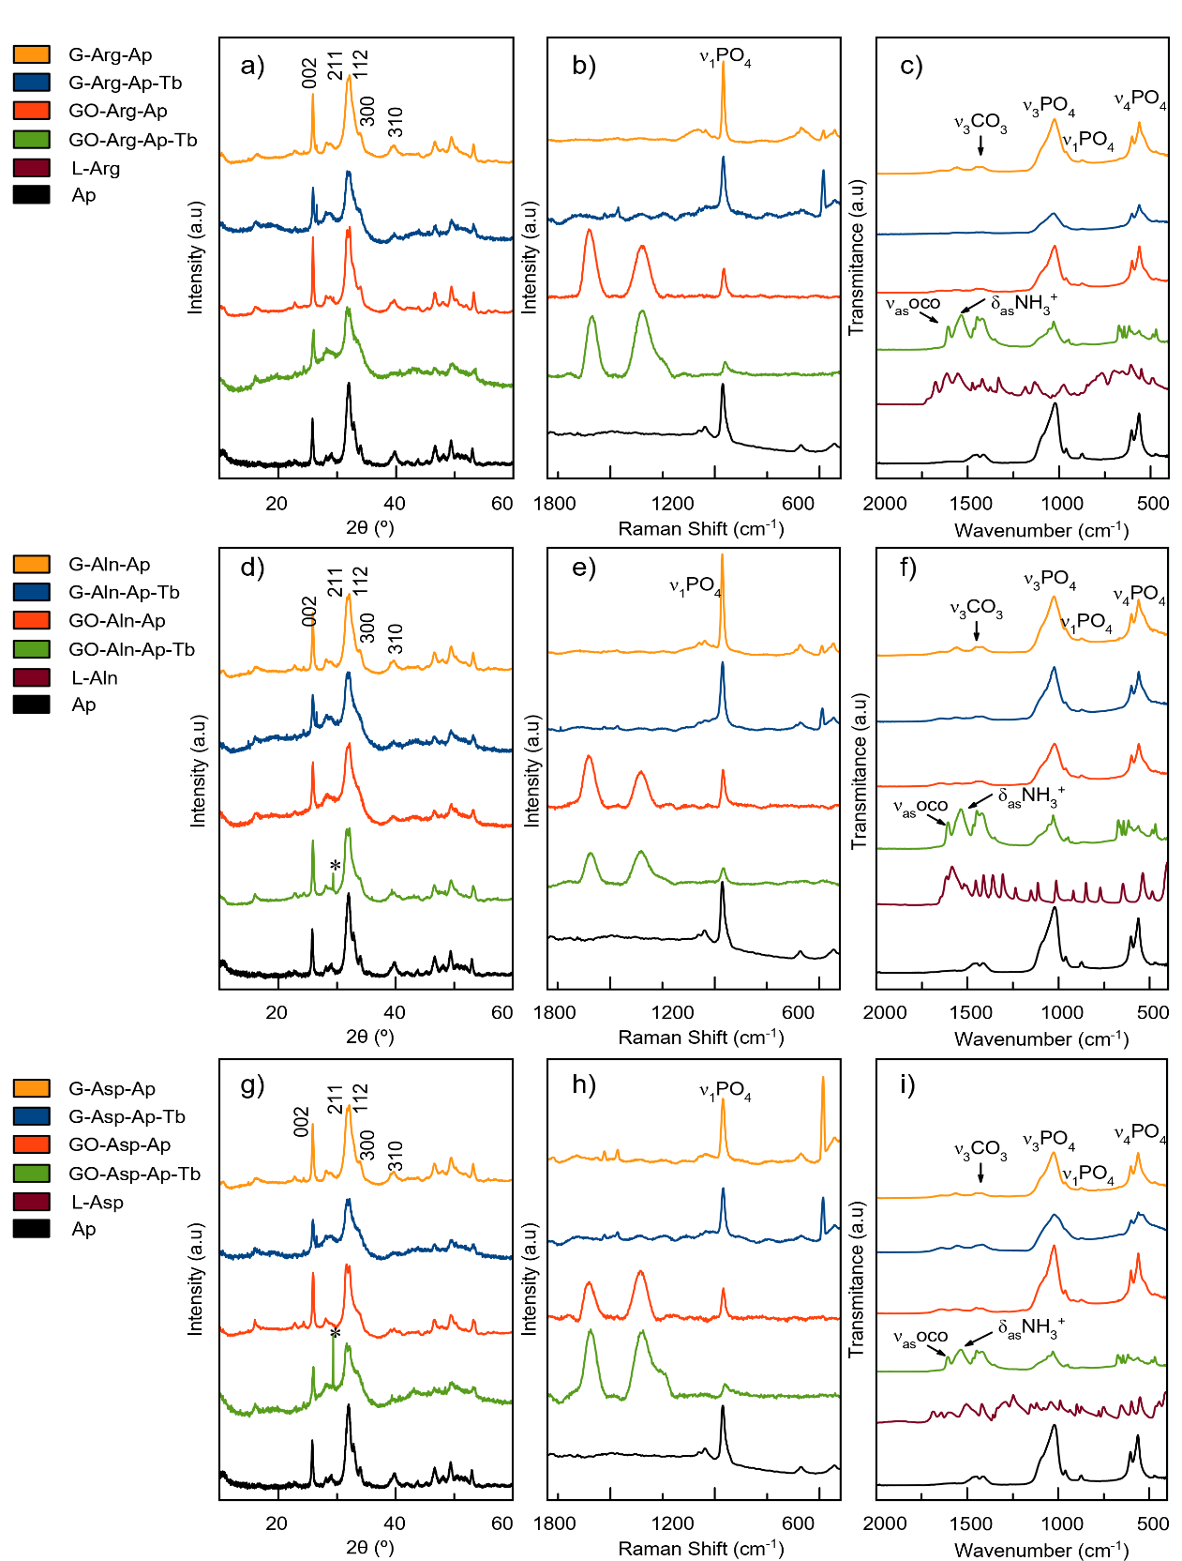

Figure S1. XRD patterns (a, d, g), Raman spectra (b, e, h), and FT-IR spectra (c, f, i) of the different G-Ap and GO-Ap nanocomposites prepared in presence of the amino acids L-Arg, L-Ala and L-Asp, and Tb³⁺. Apatite ASTM card file no. 9-432; graphite (ASTM card no. 41-1487); Tb₂O₃ (ASTM card no. 19-1326).
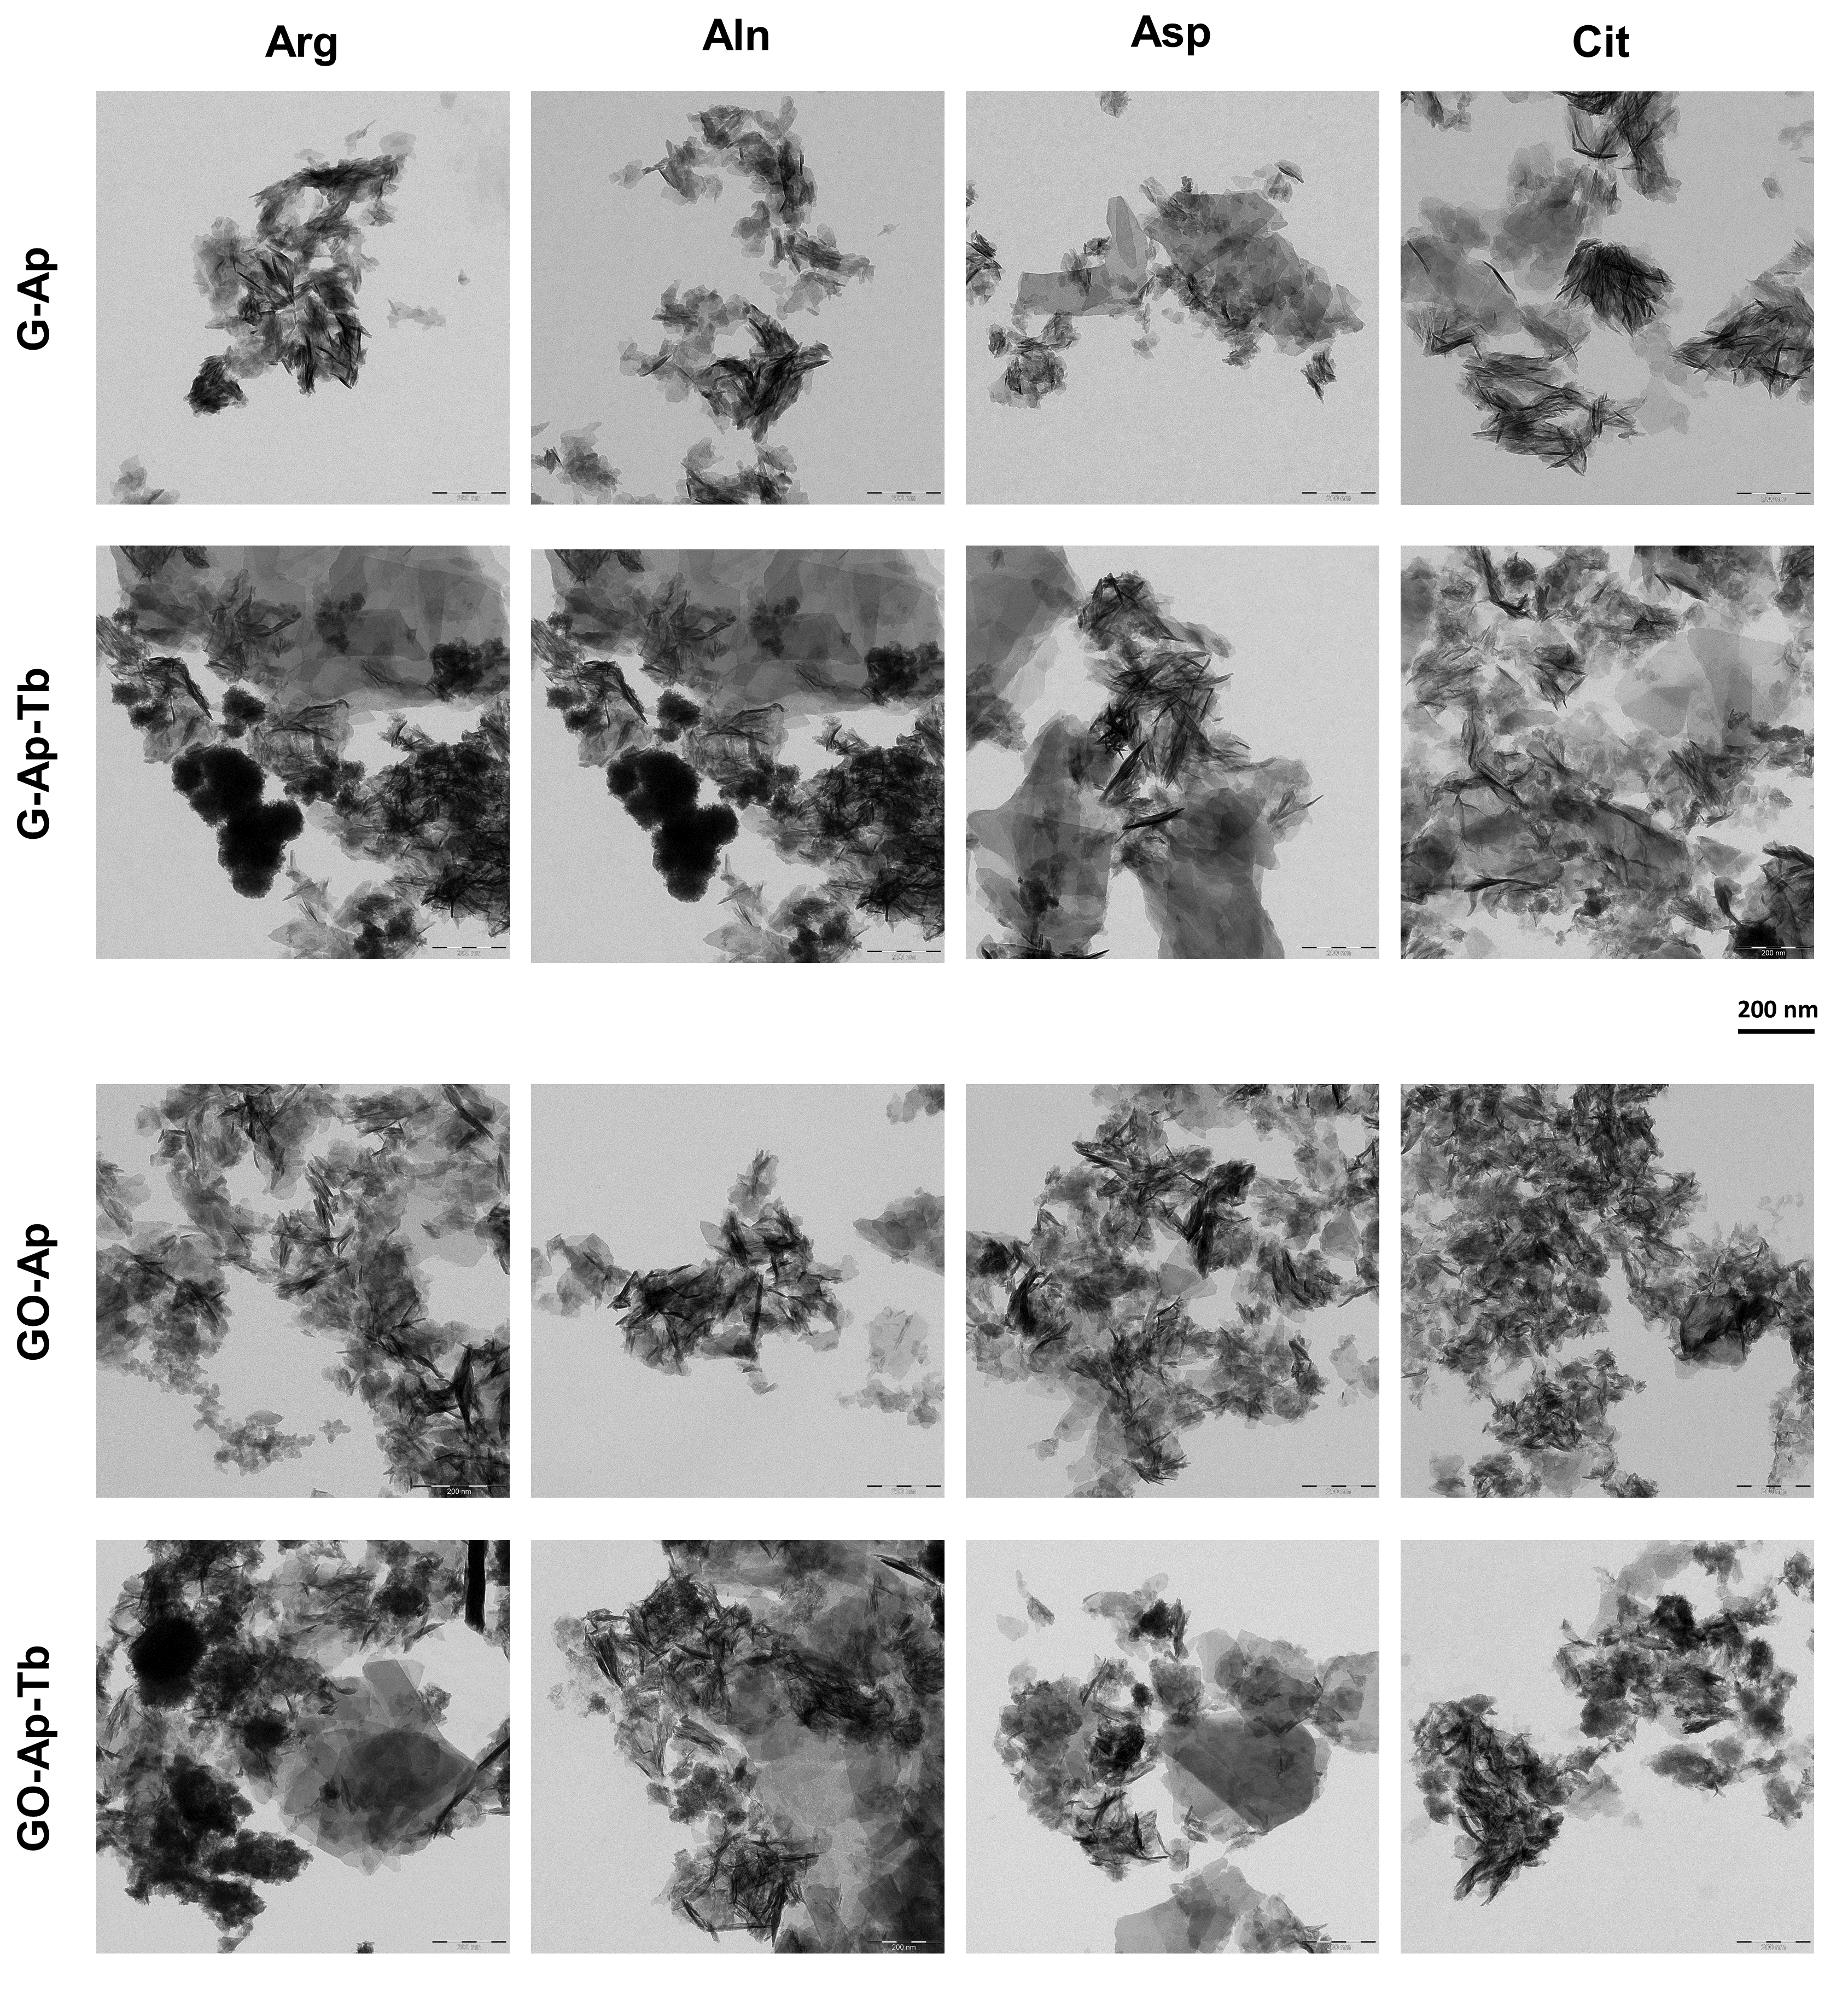
Figure S2. TEM microscopy of the nanocomposites. Scale bar is 200 nm.
Figure S3. Luminescence decay curve of graphene nanocomposites doped with Tb³⁺. λ_{exc/em} = 375/545 nm, slit-width_{sexc/em} = 20/20 nm, and detector voltage = 800 V. Circles correspond to experimental data and lines to the fitting equation
Figure S4. Luminescence decay curve of graphene-oxide functionalized materials doped with Tb³⁺. λ_{exc/em} = 375/545 nm, slit-width_{sexc/em} = 20/20 nm, and detector voltage = 800 V. Circles correspond to experimental data and lines to the fitting equation.
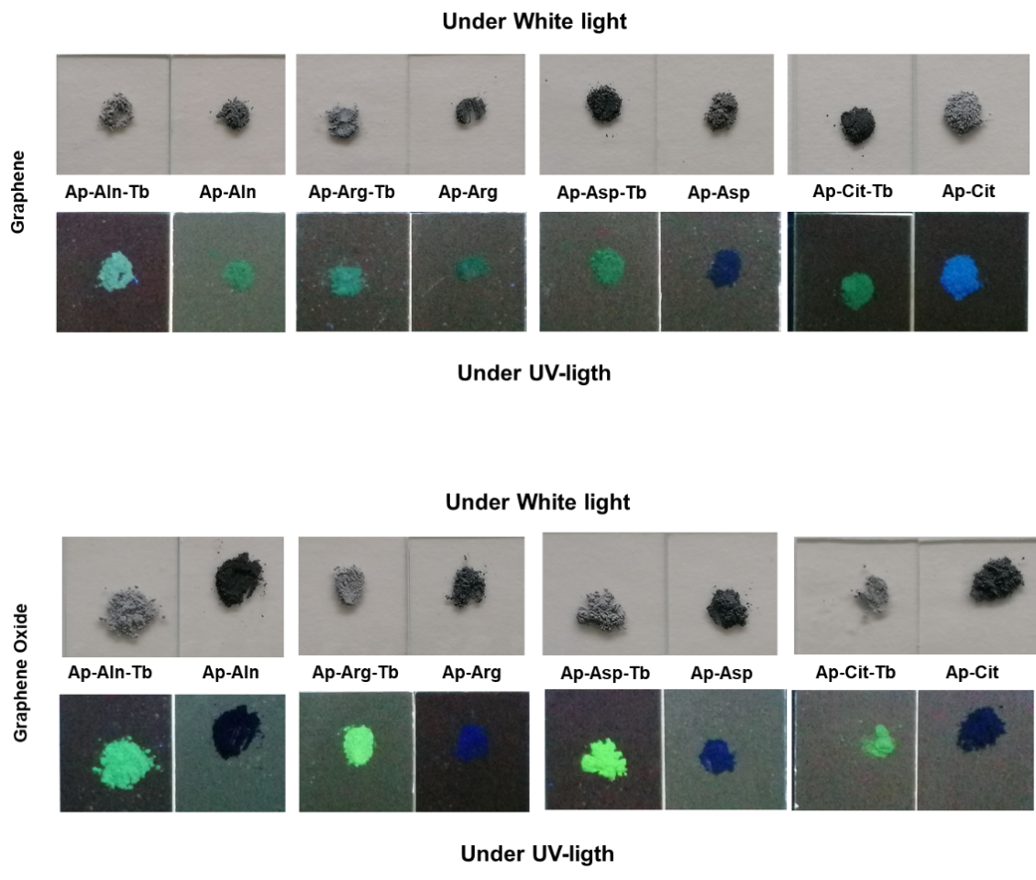
Figure S5. Pictures of the materials exposed to white (sun) and UV lights.

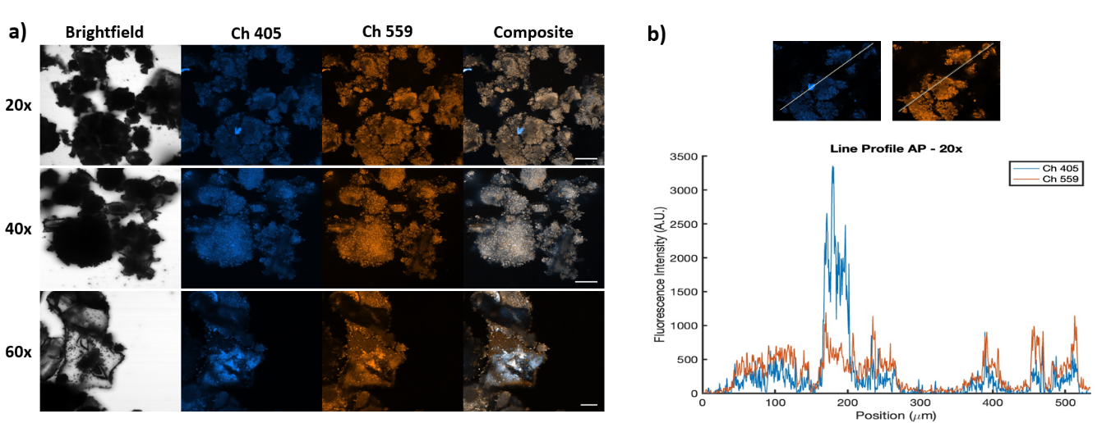
Figure S6. Intensity profile of the fluorescence of apatite particles. a) Intensity profile obtained by confocal microscopy in the blue channel at 405 nm (Ch 405) and in the red channel at 559 nm (Ch 559); b) Intensity profile obtained along the line shown in the images. Scale bar: 10 µm. The Pearson’s correlation coefficient was calculated from the signals of each channel using the Matlab function corrcoef. Pearson’ correlation coefficient (R value) = 0.8078. A value of 1 is highly correlated, -1 is anti-correlated and 0 means no correlation.

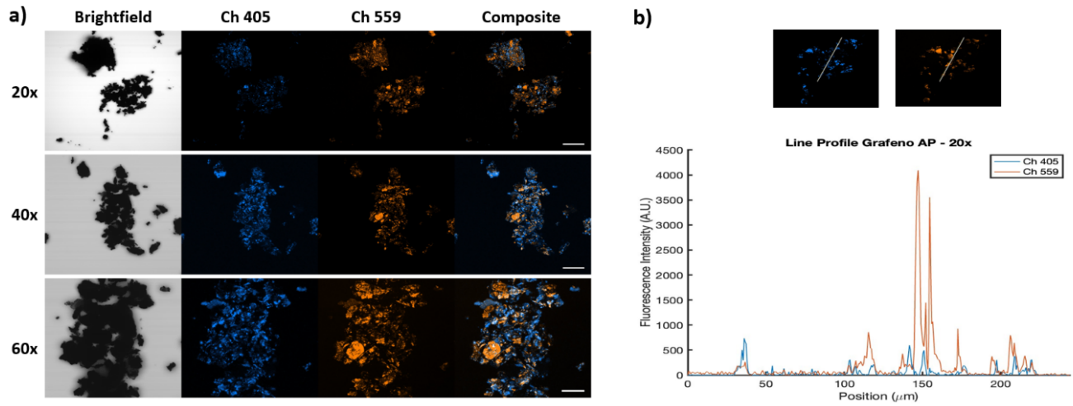
Figure S7. Intensity profile of the fluorescence of G/nAp nanocomposites. a) Intensity profile obtained by confocal microscopy in the blue channel at 405 nm (Ch 405) that shows apatite, and in the red channel at 559 nm (Ch 559) that shows other elements of Graphene-Arginine-Apatite-Terbium (G -Arg-Ap-Tb) particles. Scale bar: 10 µm; b) Intensity profile obtained along the line shown in the images. The Pearson's correlation coefficient was calculated from the signals of each channel using the Matlab function corrcoef. Pearson’ correlation coefficient (R value) = 0.1217. A value of 1 is highly correlated, -1 is anti-correlated and 0 means no correlation.
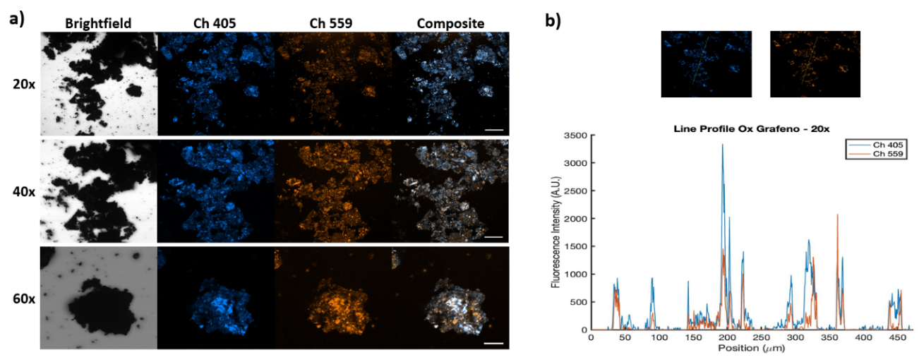
Figure S8. Intensity profile of the fluorescence of GO/nAp nanocomposites. a) Intensity profile obtained by confocal microscopy in the blue channel at 405 nm (Ch 405) that corresponds to the fluorescence of apatite, as well as in the red channel at 559 nm (Ch 559). Images corresponding to Graphene Oxide-Arginine-Apatite (GO-Arg-Ap) particles. Ap covers most of the surface of GO. Scale bar: 10 µm; b) Intensity profile obtained along the line shown in the images. Pearson’ correlation coefficient (R value) = 0.7871. A value of 1 is highly correlated, -1 is anti-correlated and 0 means no correlation.

Table S1. Carbonation degree in the composites in mass weight (%).
 |  |  |  | Ap
 |  |  | Wt %CO₃ | 3.32
G-Arg | G-Aln | G-Asp | G-Cit | G-Arg-Tb | G-Aln-Tb | G-Asp-Tb | G-Cit-Tb
0.97 | 1.07 | 1.00 | 1.31 | 0.86 | 1.12 | 1.55 | 1.37
GO-Arg | GOAln | GO-Asp | GO-Cit | GO-Arg-Tb | GO-Aln-Tb | GO-Asp-Tb | GO-Cit-Tb
1.17 | 1.70 | 0.83 | 1.44 | 2.05 | 2.08 | 1.75 | 2.41

Table S2. Elemental EDX composition (% atom) of G/Ap and GO/Ap composites prepared in presence of Arg, Aln, Asp, and Cit, both undoped and Tb³⁺-doped
Element (%) | G-Arg | G-Aln | G-Asp | G-Cit
C | 69.65 | 55.47 | 75.78 | 41.33
O | 17.97 | 20.95 | 13.52 | 29.96
P | 5.33 | 10.27 | 4.44 | 11.26
Ca | 7.04 | 11.46 | 6.25 | 17.45
N | — | — | — | —
Element (%) | G-Arg-Tb | G-Aln-Tb | G-Asp-Tb | G-Cit-Tb
C | 36.40 | 43.97 | 39.98 | 37.81
O | 38.10 | 39.25 | 38.32 | 40.24
P | 10.99 | 8.26 | 9.41 | 8.60
Ca | 11.22 | 4.67 | 9.57 | 11.35
N | — | — | — | —
Tb | 1.86 | 1.55 | 1.21 | 1.16
Element (%) | GO-Arg | GO-Aln | GO-Asp | GO-Cit
C | 20.12 | 28.62 | 44.48 | 38.31
O | 41.28 | 28.01 | 32.31 | 27.88
P | 11.43 | 12.17 | 3.05 | 11.80
Ca | 18.34 | 22.12 | 6.65 | 14.50
N | 8.80 | 9.08 | 10.02 | —
Element (%) | GO-Arg-Tb | GO-Aln-Tb | GO-Asp-Tb | GO-Cit-Tb
C | 30.87 | 31.03 | 25.52 | 28.46
O | 36.03 | 32.12 | 49.04 | 50.30
P | 10.63 | 11.22 | 3.99 | 8.82
Ca | 13.35 | 15.18 | 12.97 | 9.42
N | 9.07 | 8.73 | 6.74 | —
Tb | 3.28 | 1.68 | 1.49 | 1.26

