Supplementary Information

Sorbent-based dialysate regeneration for the wearable artificial kidney: advancing material innovation via experimental and computational studies
Thomas Fabianiª, Maryam Zarghamidehaghaniª, Cristiana Boi^{b}, Simone Dimartino^{c}, Sandra Kentish^{d}, Maria Grazia De Angelisª
ª Institute for Materials and Processes, School of Engineering, University of Edinburgh,
King's Buildings, Robert Stevenson Road, EH9 3FB, Edinburgh, Scotland, UK
^{b} Department of Civil, Chemical, Environmental and Materials Engineering, University of Bologna,
Via Terracini 28, 40131 Bologna (BO), Italy
^{c} Institute for Bioengineering, School of Engineering, University of Edinburgh,
King's Buildings, Colin Maclaurin Road, EH9 3DW, Edinburgh, Scotland, UK.
^{d} Department of Chemical Engineering, The University of Melbourne,
Parkville, VIC 3052, Australia

Table S1 Dialysate typical composition [11], [12], [13]
 | Dialysate | Plasma
Sodium (Na⁺) | 134–145 mM | 136–145 mM
Potassium (K⁺) | 1-4 mM | 3.5–5.5 mM
Calcium (Ca²⁺) | 1.25-1.75 mM | 2.0–2.6 mM
Magnesium (Mg²⁺) | 0.25-0.5 mM | 0.8–1.2 mM
Chloride (Cl⁻) | 99-115 mM | 95–106 mM
Bicarbonate (HCO₃⁻) | 30–40 mM | 21–28 mM
Glucose | 1-2 g L | 0.8–1.2 mM
pH | 7.1-7.3
Osmolarity | 300 ± 20 mOsm | 280 ± 20 mOsm

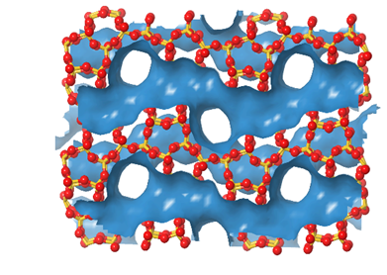 | 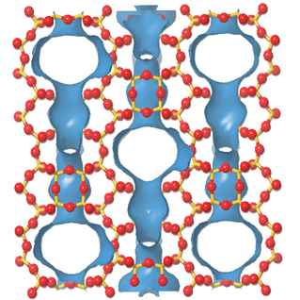
(a) | (b)
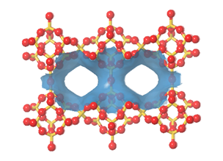 | 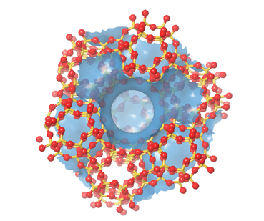
(c) | (d)
Figure S1 Ball and stick representation of purely silicious framework of zeolite structures a) MFI (5.3 Å x 5.6 Å, 5.1 Å x 5.5 Å) b) MOR (6.5 Å x 7.0 Å) c) STI (4.7 Å x 5.0 Å) d) FAU (7.4 Å x7.4 Å), in blue the cage surface. Zeolites are presented showing the biggest pore normal to the view. Silicon centres, in yellow; coordinate tetrahedrally oxygen atoms in red.

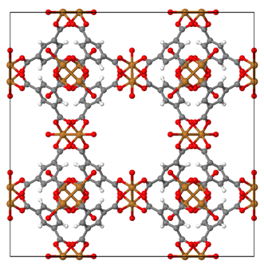 | 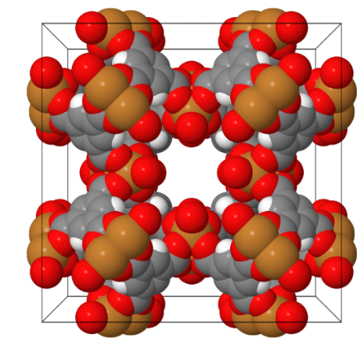 |  | 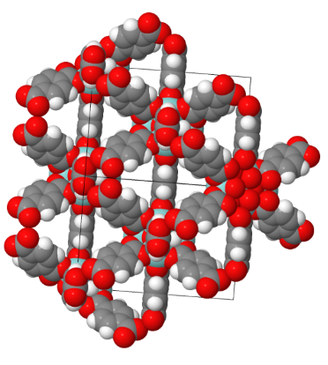
(a) | (b) |  | (c)
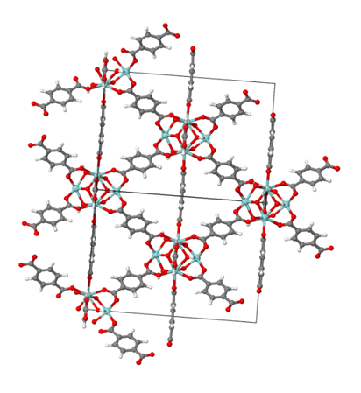 |  | 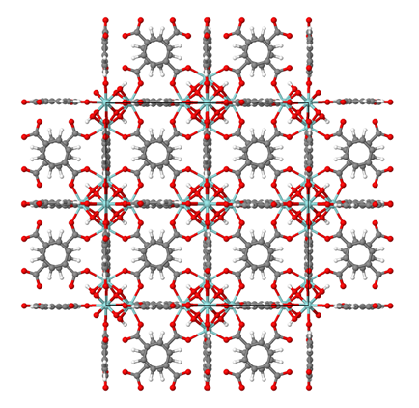
(d)
(e) |  | (f)
Figure S2 MOF structures and linkers : a,b,c) HKUST-1 (a=b=c=26.303 Å, α=β=γ=90°) [120] d) UiO-66 (a=b=c=20.978 Å, α=β=γ=90°) e) benzene-1,3,5-tricarboxylic acid f) benzene-1,4-dicarboxylic acid, in UiO-66 (R₁, R₂ = H), in UiO-66-NH₂ (R₁=H , R₂ = NH₂, in UiO-66-(COOH)₂ R₁, R₂ = COOH). Carbons are in grey, oxygen are in red, hydrogen in white, copper in light blue.

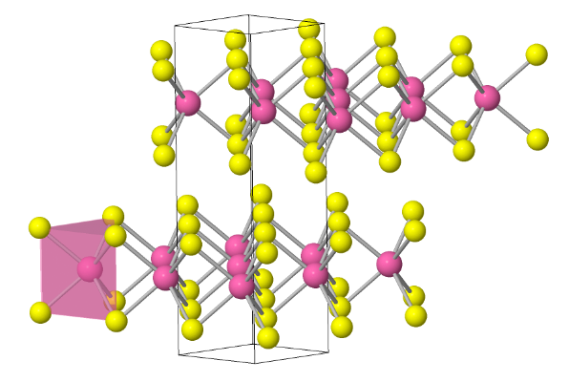
Figure S3 Crystal structure of MoS₂ (a=b=3.15 Å, c=12.3 Å α=β=90° γ=120°, molybdenum is in pink, sulphur is in yellow).

(a) | (b) | (c) | (d)
Figure S4 Chemical structures of a) chitosan, b) starch (amylose), c) starch (amylopectin), and d) cellulose.

(a) |  | (b)
Figure S5 Models of a) bridge and b) pendant for urea binding in Cu (II) complexed chitosan

Figure S6 Chemical reactions involved in functionalization of chitosan crosslinked glutaraldehyde a) reaction with epichlorohydrin to have a reactive epoxy group (CS), b) reaction with tetraethylenepentamine to obtain CS-TEPA, c) reaction with bromoacetic acid to obtain Ac-TEPA-CS

