Appendix A. Supplementary Materials

Efficacy of Psychosocial Interventions for Young Offspring of Parents with a Serious Physical or Mental Illness: Systematic Review and Meta-analysis

SM 1: Complete Query Strings used in the Search in Bibliographic Databases.
SM 2: Characteristics of the Publications of the Studies Included in the Systematic Review.
SM 3: Risk of Bias Assessment across Included Studies According to the Revised Cochrane Risk of Bias Tool.
SM 4: Forest Plots of Meta-analyses on Internalizing and Externalizing Problems at Post-intervention.
SM 5: Forest Plots of Meta-analyses on Global Well-being, Resilience, and Self-esteem at Post-intervention.
SM 6: Forest Plots of Meta-analyses on Family Functioning and Social Functioning at Post-intervention.
SM 7: Forest Plots of Meta-analyses at Short-term Follow-up.
SM 8: Forest Plots of Meta-analyses at Long-term Follow-up.
SM 9A: Results of Moderator Analyses: Subgroup Analyses.
SM 9B: Results of Moderator Analyses: Meta-regressions.
SM 10: Funnel Plots of Overall Adjustment Domains.

Supplementary Materials 1
Complete Query Strings Used in the Search in Bibliographic Databases.
1. Medline (ProQuest)
tiab(parent* or maternal* or paternal* or mother* or father*) AND tiab(disorder* or ill* or impair* or sick* or diagnos* or diseas* or chronic* or mental* or physical* or serious* or cancer* or neoplasm* or diabet* or HIV* or AIDS* or scleros* or Parkinson* or injur* or Lupus or cardiovascular* or stroke or damage* or ictus or infarct* or somatic* or pain*or depress* or anxiet* or psychiatric* or bipol* or shizophren* or psychopatol* or border* or PTSD* or trauma* or psychos* or alcohol* or substanc* or abus* or drug*) AND tiab(child* or adolescen* or teen* or offspring* or “young adult*” OR youth* or “young carer*” or “young adult carer*” or “young careg*”) AND tiab(intervent* or psychotherap* or therap* or treatment* or “peer* support*” or support* or program* or “prevent* intervent*”) AND tiab(rct* OR "randomized controlled trial*" OR “clinical trial*”)

2. Web of Science Core Collection
(TS=(parent* or maternal* or paternal* or mother* or father*) AND TS=(disorder* or ill* or impair* or sick* or diagnos* or diseas* or chronic* or mental* or physical* or serious* or cancer* or neoplasm* or diabet* or HIV or AIDS or scleros* or Parkinson* or injur* or Lupus or cardiovascular* or stroke or damage* or ictus or infarct* or somatic* or pain*or depress* or anxiet* or psychiatric* or bipol* or shizophren* or psychopatol* or border* or PTSD or trauma* or psychos* or alcohol* or substanc* or abus* or drug*) AND TS=(child* or adolescen* or teen* or offspring* or “young adult*” OR youth* or “young carer*” or “young adult carer*” or “young careg*”) AND TS=(intervent* or psychotherap* or therap* or treatment* or “peer* support*” or support* or program* or “prevent* intervent*”) AND TS=(rct* OR "randomized controlled trial*" OR “clinical trial*”)) AND (DT==("ARTICLE"))

3. EBSCO (PsycInfo, PScyArticle, Cinahl)
AB ( parent* or maternal* or paternal* or mother* or father* ) AND AB ( disorder* or ill* or impair* or sick* or diagnos* or diseas* or chronic* or mental* or physical* or serious* or cancer* or neoplasm* or diabet* or HIV* or AIDS* or scleros* or Parkinson* or injur* or Lupus or cardiovascular* or stroke or damage* or ictus or infarct* or somatic* or pain*or depress* or anxiet* or psychiatric* or bipol* or shizophren* or psychopatol* or border* or PTSD* or trauma* or psychos* or alcohol* or substanc* or abus* or drug* ) AND AB ( child* or adolescen* or teen* or offspring* or “young adult*” OR youth* or “young carer*” or “young adult carer*” or “young careg*” ) AND AB ( intervent* or psychotherap* or therap* or treatment* or “peer* support*” or support* or program* or “prevent* intervent*” ) AND AB ( rct* OR "randomized controlled trial*" OR “clinical trial*” )

4. ProQuest Dissertation and Theses databases
abstract(parent* or maternal* or paternal* or mother* or father*) AND abstract(disorder* or ill* or impair* or sick* or diagnos* or diseas* or chronic* or mental* or physical* or serious* or cancer* or neoplasm* or diabet* or HIV or AIDS or scleros* or Parkinson* or injur* or Lupus or cardiovascular* or stroke or damage* or ictus or infarct* or somatic* or pain*or depress* or anxiet* or psychiatric* or bipol* or shizophren* or psychopatol* or border* or PTSD or trauma* or psychos* or alcohol* or substanc* or abus* or drug*) AND abstract(child* or adolescen* or teen* or offspring* or ("young adult" OR "young adulthood" OR "young adults") OR youth* or ("young carers") or “young adult carer*” or “young careg*”) AND abstract(intervent* or psychotherap* or therap* or treatment* or “peer* support*” or program* or “prevent* intervent*”) AND abstract(rct* OR "randomized controlled trial*" OR “clinical trial*”)

Supplementary Materials 2
Characteristics of the Publications Included in the Systematic Review.
Study | Type of Publication | Journal Name | Subject Category | Ranking | Impact Factor | Language
Assarian et al. (2023) | Journal article | Iranian Journal of  Psychiatry and Behavioral Sciences | Psychiatry | Q4 | 1.00 | English
Beardslee, Versage, et al. (1997); Beardslee, Wright, et al. (1997) | Journal article | Development and Psychopathology: Journal of the American Academy of Child and Adolescent Psychiatry | Psychology, Developmental; Pediatrics | Q1;  Q1 | 3.19; 3.79 | English
Beardslee et al. (2003) | Journal article | Pediatrics | Pediatrics | Q1 | 3.78 | English
Brent et al. (2015) | Journal article | Jama Psychiatry | Psychiatry | Q1 | 14.42 | English
Catalano et al. (1997) | Journal article | Substance Use & Misuse | Psychiatry | Q4 | 0.73 | English
Clarke et al. (2001) | Journal article | Archives of General Psychiatry | Psychiatry | Q1 | 11.98 | English
Compas et al. (2009, 2011) | Journal article | Journal of Consulting and Clinical Psychology | Psychology, Clinical | Q1 | 4.46 | English
Forutannasab et al. (2024) | Journal article | International Journal of Community Based Nursing and Midwifery | n/a | n/a | n/a | English
Furlong et al. (2024) | Journal article | Frontiers in Psychiatry | Psychiatry | Q2 | 4.70 | English
Gance-Cleveland & Mays (2008) | Journal article | Journal of the American Psychiatric Nurses Association | Nursing | Q2 | 0.98 | English
Garber et al. (2009);  Beardslee et al. (2013); | Journal article | JAMA; JAMA Psychiatry | Medicine, General  & Internal; n/a | Q1; n/a | 28.90 | English
Goldstein et al. (2018) | Journal article | Journal of Affective Disorders | Psychiatry | Q1 | 4.08 | English
Hauken et al. (2018) | Journal article | Cancer Nursing | Nursing | Q1 | 1.84 | English
Hojjat et al. (2015) | Journal article | Global Journal of Health Science | n/a | n/a | n/a | English
Hyun et al. (2010) | Journal article | Archives of Psychiatric Nursing | Nursing | Q2 | 0.98 | English
Küçük et al. (2020) | Journal article | Issues in Mental Health Nursing | Nursing | Q3 | 1.84 | English
Mason et al. (2012) | Journal article | Journal of Child and Family Studies | Family Studies | Q2 | 1.42 | English
Maybery et al. (2022) | Journal article | Early Intervention in Psychiatry | Psychiatry | Q3 | 2.00 | English
Mon et al. (2016, 2017) | Journal article | Vulnerable Children and Youth Studies | Family Studies | Q3 | 0.49 | English
Omkarappa et al. (2021) | Journal article | Journal of Child and Adolescent  Psychiatric Nursing | Nursing | Q3 | 0.63 | English
Omkarappa et al. (2022) | Journal article | World Journal of Clinical Cases | Medicine, General,  & Internal | Q3 | 1.10 | English
Rasing et al. (2018) | Journal article | International Journal of Environmental Research  and Public Health | Public Environmental & Occupational Health | Q1 | 2.47 | English
Rotheram-Borus et al. (2004) | Journal article | The Archives of Pediatrics  & Adolescent Medicine | Pediatrics | Q1 | 2.89 | English
Rotheram-Borus et al. (2006) | Journal article | Journal of Adolescent Health | Pediatrics | Q1 | 2.71 | English
Rotheram-Borus et al. (2012) | Journal article | AIDS and Behavior | Social Sciences, Biomedical | Q1 | 2.98 | English
Tuttle et al. (2006) | Journal article | Journal of Pediatric Health Care | Health Policy & Services | Q3 | 0.94 | English
Wall et al. (2024) | Journal article | Journal of Medical Internet Research | Health Care Sciences  & Services | Q1 | 7.40 | English
Note. The data are extracted from Journal Citation Reports and are related to the publication year. Q = Quartile.

Supplementary Materials 3
Risk of Bias Assessment Across Included Studies According to the Revised Cochrane Risk of Bias Tool.
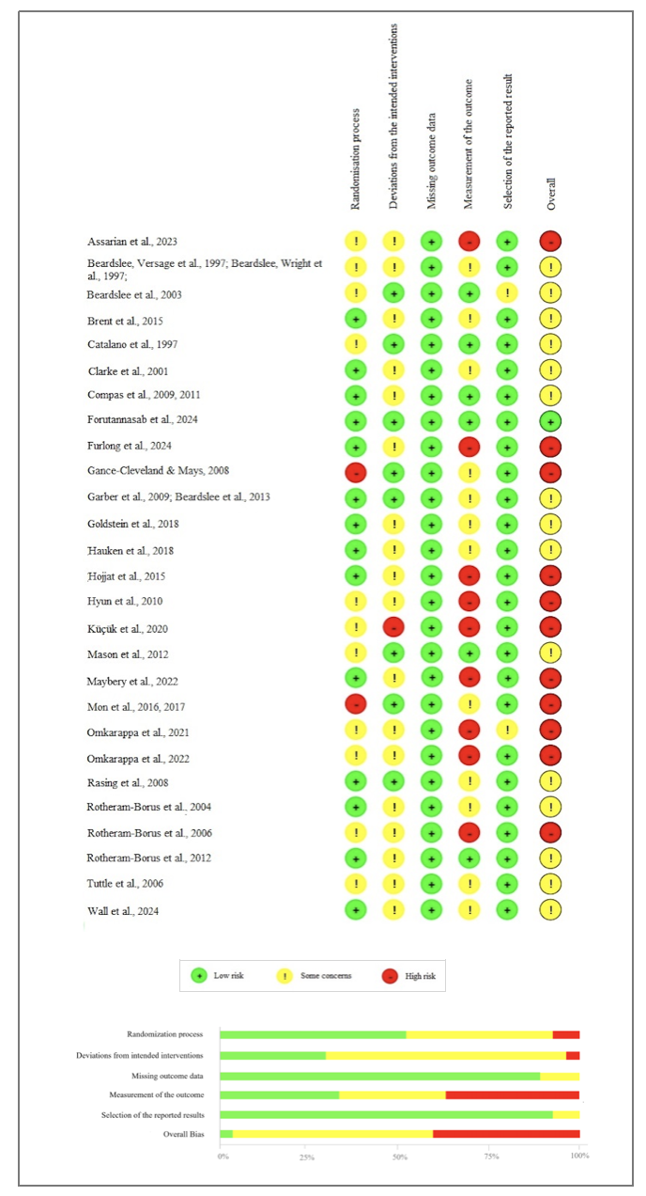
Supplementary Materials 4
Forest Plots of Meta-analyses on Internalizing and Externalizing Problems at Post-intervention.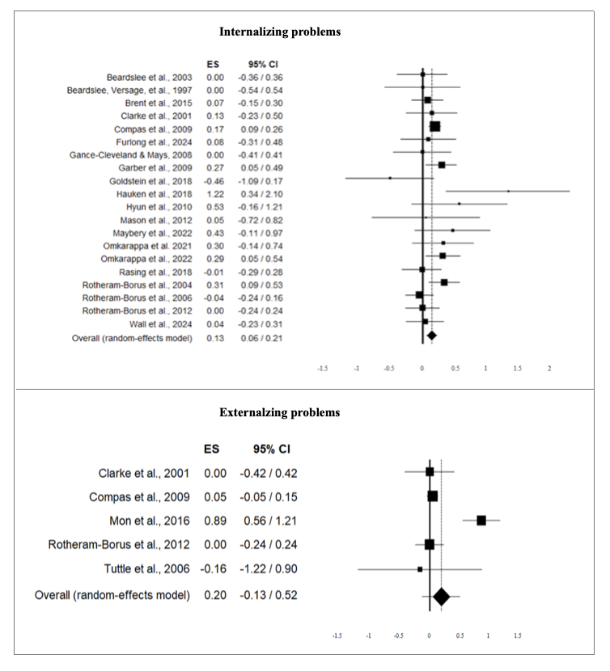

Supplementary Materials 5
Forest Plots of Meta-analyses on Global Well-being, Resilience, and Self-esteem at Post-intervention.
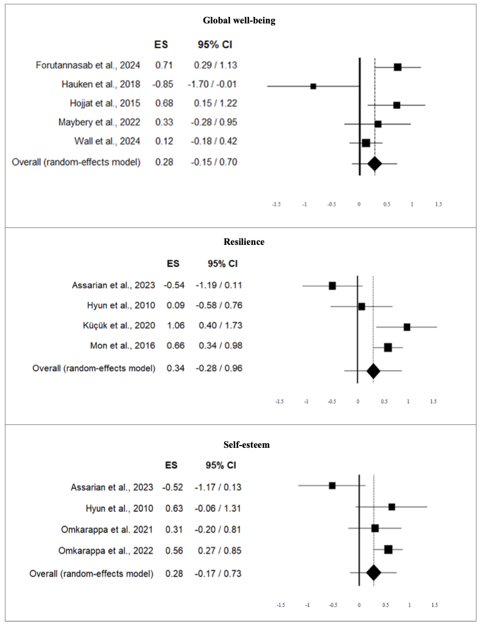

Supplementary Materials 6
Forest Plots of Meta-analyses on Family Functioning and Social Functioning at Post-intervention.
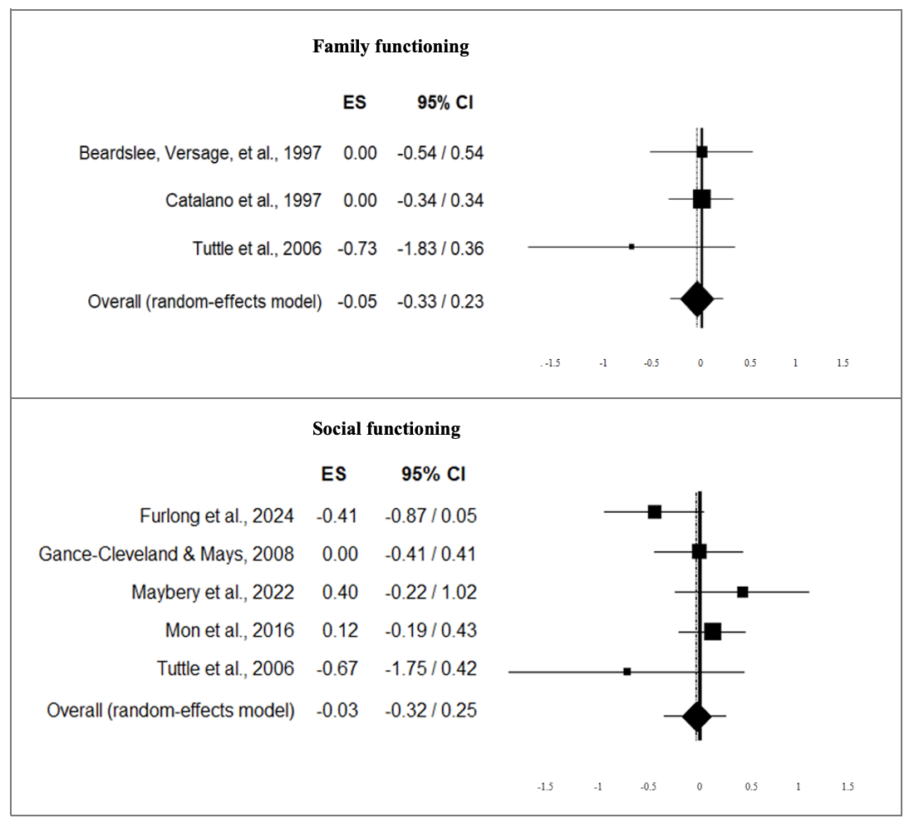

Supplementary Materials 7
Forest Plots of Meta-analyses at Short-term Follow-up.
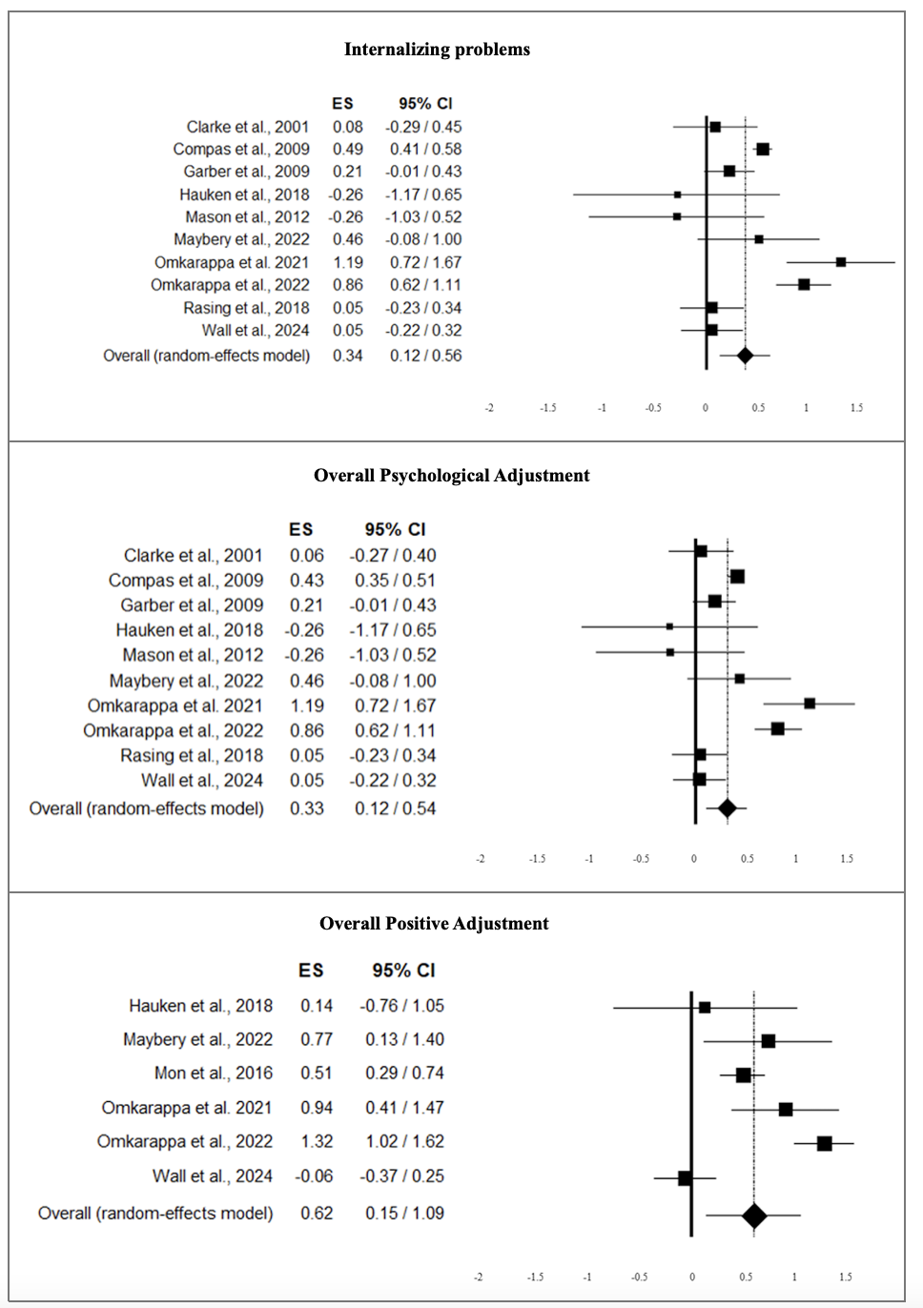

Supplementary Materials 8
Forest Plots of Meta-analyses at Long-term Follow-up.
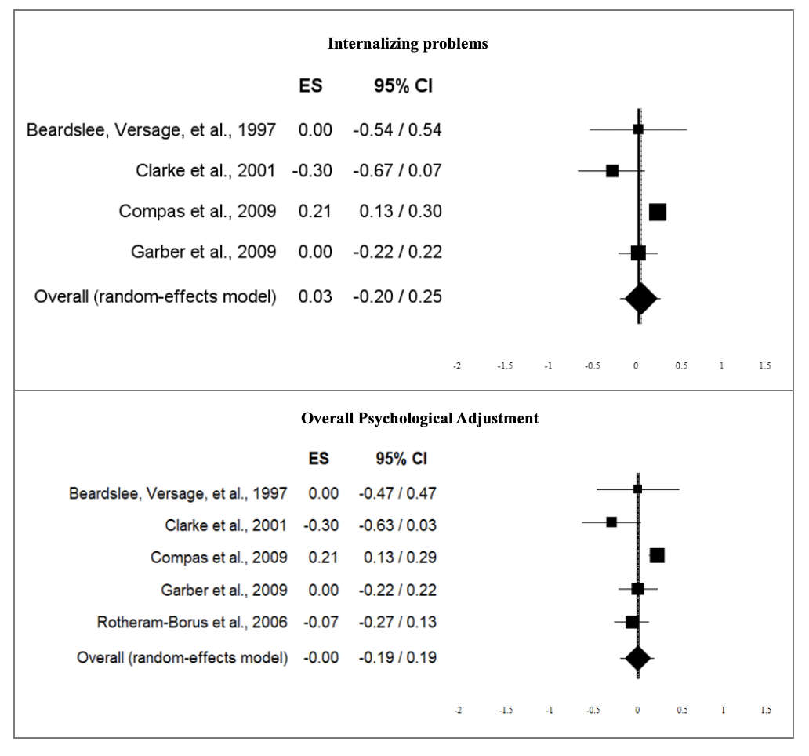

Supplementary Materials 9 A
Results of Moderator Analyses: Subgroup Analyses.

 |  | Summary statistics |  |  |  |  |  |  |  |  |  | Heterogeneity |  |  |  |  |  |  |  | Moderating effects
Outcome | Moderator | k |  | N |  | d |  | [95% CI] |  |  |  | Q |  | T² |  | I² |  | Prediction intervalª |  | Q^{b} |  | p
Post-intervention:
Internalizing problems
 | Type of parental illness: |  |  |  |  |  |  |  |  |  |  |  |  |  |  |  |  |  |  | 0.04 |  | .850
 | Mental illness | 16 |  | 1949 |  | 0.15*** |  | [0.09, 0.22] |  |  |  | 12.97 |  | 0.00 |  | 0.00 |  | [0.07, 0.23]
 | Physical illness | 4 |  | 888 |  | 0.18 |  | [-0.10, 0.47] |  |  |  | 12.29** |  | 0.06 |  | 75.60 |  | [-1.05, 1.41]
 | Intervention setting: |  |  |  |  |  |  |  |  |  |  |  |  |  |  |  |  |  |  | 0.06 |  | .806
 | Group | 13 |  | 2298 |  | 0.15** |  | [0.08, 0.22] |  |  |  | 13.87 |  | 0.00 |  | 13.48 |  | [0.07, 0.23]
 | Individual | 7 |  | 539 |  | 0.11 |  | [-0.13, 0.36] |  |  |  | 11.20 |  | 0.05 |  | 46.44 |  | [-0.55, 0.77]
 | Family member involved: |  |  |  |  |  |  |  |  |  |  |  |  |  |  |  |  |  |  | 1.44 |  | .230
 | Offspring | 9 |  | 1329 |  | 0.19** |  | [0.08, 0.29] |  |  |  | 6.26 |  | 0.00 |  | 0.00 |  | [0.07, 0.31]
 | Offspring + Parents | 11 |  | 1508 |  | 0.09 |  | [-0.03, 0.21] |  |  |  | 18.59* |  | 0.02 |  | 46.20 |  | [-0.26, 0.44]
 | Control group: |  |  |  |  |  |  |  |  |  |  |  |  |  |  |  |  |  |  | 0.01 |  | .942
 | Active | 8 |  | 1456 |  | 0.14 |  | [-0.03, 0.31] |  |  |  | 16.55* |  | 0.03 |  | 57.71 |  | [-0.33, 0.61]
 | Non-active | 12 |  | 1381 |  | 0.15*** |  | [0.08, 0.21] |  |  |  | 9.09 |  | 0.00 |  | 0.00 |  | [0.08, 0.22]
 | Country: |  |  |  |  |  |  |  |  |  |  |  |  |  |  |  |  |  |  | 4.26 |  | .119
 | USA | 11 |  | 1967 |  | 0.11* |  | [0.02, 0.20] |  |  |  | 13.92 |  | 0.01 |  | 28,15 |  | [-0.14, 0.36]
 | Europe | 5 |  | 540 |  | 0.12 |  | [-0.10, 0.34] |  |  |  | 6.95 |  | 0.03 |  | 42.48 |  | [-0.54, 0.78]
 | Others | 4 |  | 329 |  | 0.33** |  | [0.14, 0.52] |  |  |  | 0.56 |  | 0.00 |  | 0.00 |  | [-0.09, 0.75]
Overall Psychological Adjustment
 | Type of parental illness: |  |  |  |  |  |  |  |  |  |  |  |  |  |  |  |  |  |  | 1.77 |  | .183
 | Mental illness | 17 |  | 1963 |  | 0.12*** |  | [0.07, 0.18] |  |  |  | 13.90 |  | 0.00 |  | 0.00 |  | [0.05, 0.19]
 | Physical illness | 5 |  | 1048 |  | 0.45 |  | [-0.02, 0.91] |  |  |  | 67.26*** |  | 0.25 |  | 94.05 |  | [-1.31, 2.21]
 | Intervention setting: |  |  |  |  |  |  |  |  |  |  |  |  |  |  |  |  |  |  | 0.29 |  | .590
 | Group | 15 |  | 2472 |  | 0.19** |  | [0.05, 0.34] |  |  |  | 70.63*** |  | 0.06 |  | 80.18 |  | [-0.36, 0.74]
 | Individual | 7 |  | 539 |  | 0.11 |  | [-0.13, 0.36] |  |  |  | 11.60 |  | 0.05 |  | 48.30 |  | [-0.55, 0.77]
 | Family member involved: |  |  |  |  |  |  |  |  |  |  |  |  |  |  |  |  |  |  | 3.14 |  | .076
 | Offspring | 11 |  | 1503 |  | 0.29* |  | [0.05, 0.54] |  |  |  | 57.98*** |  | 0.13 |  | 82.75 |  | [-0.51, 1.23]
 | Offspring + Parents | 11 |  | 1508 |  | 0.06 |  | [-0.04, 0.15] |  |  |  | 14.26 |  | 0.01 |  | 29.87 |  | [-0.18, 0.31]
 | Intervention approach: |  |  |  |  |  |  |  |  |  |  |  |  |  |  |  |  |  |  | 4.98 |  | .173
 | CBT | 9 |  | 1304 |  | 0.14*** |  | [0.08, 0.21] |  |  |  | 6.99 |  | 0.00 |  | 0.00 |  | [0.06, 0.22]
 | Psychoeducation | 4 |  | 281 |  | 0.18 |  | [-0.17, 0.53] |  |  |  | 6.66 |  | 0.07 |  | 54.97 |  | [-1.19, 1.55]
 | Relational | 5 |  | 930 |  | 0.02 |  | [-0.10, 0.12] |  |  |  | 4.11 |  | 0.00 |  | 2.60 |  | [-0.14, 0.18]
 | Resource enhancement | 4 |  | 496 |  | 0.45 |  | [-0.24, 1.13] |  |  |  | 44.37*** |  | 0.45 |  | 93.24 |  | [-0.51, 1.23]
 | Control group: |  |  |  |  |  |  |  |  |  |  |  |  |  |  |  |  |  |  | 1.41 |  | .236
 | Active | 9 |  | 1470 |  | 0.09 |  | [-0.05, 0.23] |  |  |  | 14.57 |  | 0.02 |  | 45.08 |  | [-0.28, 0.46]
 | Non-active | 13 |  | 1541 |  | 0.23* |  | [0.04, 0.42] |  |  |  | 66.24*** |  | 0.08 |  | 81.88 |  | [-0.36, 0.76]
 | Risk of bias: |  |  |  |  |  |  |  |  |  |  |  |  |  |  |  |  |  |  | 2.13 |  | .145
 | High risk of bias | 8 |  | 952 |  | 0.36* |  | [0.01, 0.71] |  |  |  | 57.94*** |  | 0.22 |  | 87.92 |  | [-0.87, 1.59]
 | Low risk or some concerns | 14 |  | 2059 |  | 0.09* |  | [0.02, 0.17] |  |  |  | 15.49 |  | 0.00 |  | 16.05 |  | [0.00, 0.18]
 | Country: |  |  |  |  |  |  |  |  |  |  |  |  |  |  |  |  |  |  | 3.98 |  | .137
 | USA | 12 |  | 1981 |  | 0.09** |  | [0.04, 0.15] |  |  |  | 10.65 |  | 0.00 |  | 0.00 |  | [0.02, 0.16]
 | Europe | 5 |  | 540 |  | 0.11 |  | [-0.10, 0.32] |  |  |  | 6.92 |  | 0.02 |  | 42.16 |  | [-0.45, 0.67]
 | Others | 5 |  | 490 |  | 0.58* |  | [0.11, 1.06] |  |  |  | 29.03*** |  | 0.24 |  | 86.22 |  | [-1.16, 2.32]
Overall Positive Adjustment
 | Type of parental illness: |  |  |  |  |  |  |  |  |  |  |  |  |  |  |  |  |  |  | 0.02 |  | .890
 | Mental illness | 8 |  | 671 |  | 0.35* |  | [0.07, 0.63] |  |  |  | 19.65** |  | 0.10 |  | 64.37 |  | [-0.50, 1.20]
 | Physical illness | 3 |  | 276 |  | 0.30 |  | [-0.37, 0.96] |  |  |  | 11.58** |  | 0.27 |  | 82.73 |  | [-7.57, 8.17]
 | Intervention setting: |  |  |  |  |  |  |  |  |  |  |  |  |  |  |  |  |  |  | 0.47 |  | .491
 | Group | 7 |  | 638 |  | 0.43** |  | [0.16, 0.70] |  |  |  | 16.22* |  | 0.08 |  | 63.00 |  | [-0.38, 1.24]
 | Individual | 4 |  | 309 |  | 0.20 |  | [-0.39, 0.80] |  |  |  | 12.92** |  | 0.27 |  | 76.78 |  | [-2.39, 2.79]
 | Risk of bias: |  |  |  |  |  |  |  |  |  |  |  |  |  |  |  |  |  |  | 0.92 |  | .337
 | High risk of bias | 8 |  | 627 |  | 0.44** |  | [0.17, 0.71] |  |  |  | 18.30** |  | 0.09 |  | 61.74 |  | [-0.36, 1.25]
 | Low risk or some concerns | 3 |  | 320 |  | 0.09 |  | [-0.57, 0.75] |  |  |  | 11.76** |  | 0.27 |  | 83.00 |  | [-7.78, 7.96]
Overall Interpersonal Adjustment
 | Family member involved: |  |  |  |  |  |  |  |  |  |  |  |  |  |  |  |  |  |  | 0.95 |  | .330
 | Offspring | 4 |  | 306 |  | 0.07 |  | [-0.21, 0.34] |  |  |  | 3.85 |  | 0.02 |  | 22.07 |  | [-0.78, 0.92]
 | Offspring + Parents | 3 |  | 271 |  | -0.12 |  | [-0.38, 0.14] |  |  |  | 2.24 |  | 0.01 |  | 10.77 |  | [-2.23, 1.99]
 | Control group: |  |  |  |  |  |  |  |  |  |  |  |  |  |  |  |  |  |  | 2.57 |  | .109
 | Active | 3 |  | 232 |  | -0.25 |  | [-0.62, 0.13] |  |  |  | 3.23 |  | 0.04 |  | 38.07 |  | [-3.79, 3.29]
 | Non-active | 4 |  | 345 |  | 0.10 |  | [-0.11, 0.32] |  |  |  | 1.26 |  | 0.00 |  | 0.00 |  | [-0.38, 0.58]
 | Risk of bias: |  |  |  |  |  |  |  |  |  |  |  |  |  |  |  |  |  |  | 0.11 |  | .737
 | High risk of bias | 4 |  | 375 |  | 0.01 |  | [-0.28, 0.29] |  |  |  | 5.29 |  | 0.04 |  | 43.33 |  | [-1.05, 1.07]
 | Low risk or some concerns | 3 |  | 202 |  | -0.06 |  | [-0.34, 0.22] |  |  |  | 1.93 |  | 0.00 |  | 0.00 |  | [-1.88, 1.76]
Short-term Follow-up:
Internalizing problems
 | Intervention setting: |  |  |  |  |  |  |  |  |  |  |  |  |  |  |  |  |  |  | 4.26* |  | .039
 | Group | 6 |  | 971 |  | 0.46*** |  | [0.20, 0.72] |  |  |  | 36.89*** |  | 0.08 |  | 86.44 |  | [-0.39, 1.33]
 | Individual | 4 |  | 292 |  | 0.08 |  | [-0.17, 0.33] |  |  |  | 3.24 |  | 0.01 |  | 7.55 |  | [-0.60, 0.76]
 | Family member involved: |  |  |  |  |  |  |  |  |  |  |  |  |  |  |  |  |  |  | 1.42 |  | .233
 | Offspring | 6 |  | 919 |  | 0.46* |  | [0.11, 0.81] |  |  |  | 36.49*** |  | 0.16 |  | 86.30 |  | [-0.76, 1.68]
 | Offspring + Parents | 4 |  | 344 |  | 0.14 |  | [-0.26, 0.53] |  |  |  | 13.94** |  | 0.10 |  | 78.48 |  | [-1.47, 1.75]
 | Control group: |  |  |  |  |  |  |  |  |  |  |  |  |  |  |  |  |  |  | 2.75 |  | .097
 | Active | 3 |  | 424 |  | 0.16 |  | [-0.03, 0.34] |  |  |  | 1.16 |  | 0.00 |  | 0.00 |  | [-1.01, 1.33]
 | Non-active | 7 |  | 839 |  | 0.44** |  | [0.16, 0.71] |  |  |  | 39.63*** |  | 0.10 |  | 84.86 |  | [-0.47, 1.33]
Overall Psychological Adjustment
 | Intervention setting: |  |  |  |  |  |  |  |  |  |  |  |  |  |  |  |  |  |  | 3.93* |  | .048
 | Group | 6 |  | 971 |  | 0.44** |  | [0.19, 0.69] |  |  |  | 36.97*** |  | 0.08 |  | 86.47 |  | [-0.42, 1.30]
 | Individual | 4 |  | 292 |  | 0.08 |  | [-0.17, 0.33] |  |  |  | 3.24 |  | 0.01 |  | 7.55 |  | [-0.62, 0.78]
 | Family member involved: |  |  |  |  |  |  |  |  |  |  |  |  |  |  |  |  |  |  | 1.58 |  | .209
 | Offspring | 6 |  | 919 |  | 0.45* |  | [0.10, 0.81] |  |  |  | 37.49*** |  | 0.16 |  | 86.66 |  | [-0.77, 1.67]
 | Offspring + Parents | 4 |  | 344 |  | 0.14 |  | [-0.21, 0.49] |  |  |  | 11.03* |  | 0.07 |  | 72.79 |  | [-1.23, 1.51]
 | Control group: |  |  |  |  |  |  |  |  |  |  |  |  |  |  |  |  |  |  | 2.80 |  | .094
 | Active | 3 |  | 424 |  | 0.15 |  | [-0.03, 0.33] |  |  |  | 1.28 |  | 0.00 |  | 0.00 |  | [-1.02, 1.32]
 | Non-active | 7 |  | 839 |  | 0.43** |  | [0.15, 0.70] |  |  |  | 38.98 |  | 0.10 |  | 84.61 |  | [-0.46, 1.32]
Note. k = number of studies; N = total number of participants; d = Cohen’s d; CI = confidence interval. Q = statistic used in heterogeneity test; T² = between-study variance; I² = percent of the observed variance reflecting differences in true effect sizes, rather than sampling error. ªPrediction intervals were computed with the adjusted formula provided by Borenstein et al. (2017, p. 17). Q^{b} = contrast between subset of studies. *p < .050, **p < .010, ***p < .001.

Supplementary Materials 9 B
Results of Moderator Analyses: Meta-regressions.
 | Gender balance |  |  |  |  | Age |  |  |  |  | Intervention Duration
 | k | I | B | p |  | k | I | B | p |  | k | I | B | p
Post-intervention:
Internalizing problems | 20 | 0.30 | -0.00 | .241 |  | 20 | 0.08 | 0.00 | .853 |  | 17 | 0.43 | -0.12** | .003
Externalizing problems | 5 | -0.08 | 0.02 | .850 |  | 4 | 1.07 | -0.06 | .751 |  | 5 | 0.28 | -0.03 | .868
Overall Psychological Adjustment | 22 | 0.30 | -0.00 | .606 |  | 21 | 0.35 | -0.01 | .761 |  | 19 | 0.50 | -0.11 | .080
Global well-being | 5 | -0.21 | 0.01 | .725 |  | 5 | -0.34 | 0.04 | .724 |  | 5 | -0.20 | 0.37 | .447
Resilience | 4 | 0.04 | 0.01 | .723 |  | 4 | 1.59 | -0.09 | .834 |  | 4 | -0.42 | 0.20 | .217
Self-esteem | 4 | 0.75 | -0.01 | .447 |  | 4 | 3.75 | -0.24 | .499 |  | 4 | 0.52 | -0.16 | .764
Overall Positive Adjustment | 11 | 0.37 | -0.00 | .973 |  | 11 | 0.40 | -0.00 | .969 |  | 11 | 0.11 | 0.12 | .155
Family functioning | 3 | -0.66 | 0.01 | .696 |  | n/a | n/a | n/a | n/a |  | 3 | 0.84 | -0.21*** | .000
Social functioning | 5 | -0.96 | 0.01 | .218 |  | 4 | -0.72 | 0.05 | .442 |  | 4 | 0.27 | -0.12 | .461
Overall Interpersonal Adjustment | 7 | -0.60 | 0.01 | .245 |  | 6 | -0.39 | 0.03 | .434 |  | 6 | 0.25 | -0.09 | .409
Short-term Follow-up:

Internalizing problems | 10 | 0.96 | -0.01 | .122 |  | 10 | 0.24 | 0.01 | .898 |  | 9 | 0.80 | -0.22 | .188
Overall Psychological Adjustment | 10 | 0.93 | -0.01 | .131 |  | 10 | 0.17 | 0.01 | .845 |  | 9 | 0.80 | -0.22 | .168
Global well-being | 3 | -0.52 | 0.01 | .796 |  | 3 | -1.13 | 0.08 | .488 |  | 3 | 0.34 | -0.07 | .909
Overall Positive Adjustment | 6 | 1.55 | -0.01 | .165 |  | 6 | 0.62 | -0.00 | .998 |  | 6 | 0.82 | -0.13 | .639
Long-term Follow-up:
Internalizing problems | 5 | 1.23 | -0.02* | .029 |  | 5 | 1.13 | -0.08 | .122 |  | 5 | 0.50 | -0.17 | .099
Overall Psychological Adjustment | 5 | 1.22 | -0.02* | .032 |  | 5 | 1.11 | -0.08 | .135 |  | 5 | 0.48 | -0.16 | .111
Note. k = number of studies; I = intercept; B = slope. *p < .050, **p < .010, ***p < .001; n/a: not available.

Supplementary Materials 10
Funnel Plots of Overall Adjustment Domains.
