Reply to Mazaheri et al. “Peak alpha frequency as a candidate biomarker of pain sensitivity: the importance of distinguishing slow from slowing”: A constructive rebuttal.

Data analysis strategy
In Valentini et al., 2022 we used a signal decomposition technique that allows us to identify the underlying combination of maximally independent signals that linearly explain the signal recorded from the scalp electroencephalography (EEG). We reasoned that our selection of Independent component analysis (ICA, Bell and Sejnowski, 1995) clusters, obtained with the ISCTEST approach (Hyvärinen, 2011; Hyvärinen and Ramkumar, 2013), could have hampered the discovery of a negative relationship between peak alpha frequency (PAF) at rest and unpleasantness ratings. Therefore, in contrast to our previous approach, we used all the available clusters (i.e., 42) and no scalp regions of interest for the current analyses (see also the main reply).
Bayesian analyses were performed with Jamovi (The Jamovi Project, 2020; v. 2.3.2). Normality was assessed for all the data using Q-Q plots and Shapiro-Wilk test. Because several variables departed from normality, whenever a supported correlation obtained with the Pearson’s Rho coefficient emerged, we also calculated Kendall’s tau. The Bayes Factors (BF10) were calculated with a stretched beta prior width of 1 and reported with their 95% credible intervals.

On the independence between slow and slowing alpha brain oscillations
For this first analysis we used the previously extracted data from Valentini et al., (2022) and simply correlated the ΔPAF (i.e., slowing) and pain-free state PAF (i.e., slow) for both the bilateral centro-parietal (CP) ROI and the bilateral parieto-occipital (PO) ROI, for both eyes-open and eyes-closed conditions. We established a two-tailed hypothesis. All the correlations are reported in Table 1 whereas we will here provide a scatterplot of the only correlation that indicated a credible relationship (Fig. s1) as well as the graphs showing the Bayesian analyses (Figs. s2).

Fig s1. Visualization of the Bayesian Pearson’s Coefficient between ΔPAF and pre-PAF during eyes-open and recorded in the PO ROI. The confidence band around the linear regression line represents the standard error. The side boxplots indicate the distribution for both variables. Note how the higher the baseline eyes-open PAF the greater the change in PAF from this baseline to the hot pain condition when these are measured at the level of the parieto-occipital clusters.

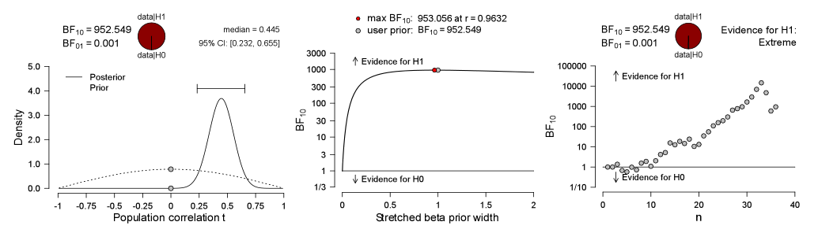
Fig s2. Visualization of the detailed Bayesian results for the relationship between ΔPAF and pre-PAF during eyes-open and recorded in the PO ROI. Note the large BF10 supporting the alternative hypothesis (left). This finding was further corroborated but the BF robustness check (centre) and the sequential analysis (right), showing how the correlation manifested strongly in the majority of the sample.

On the predictivity of slow alpha brain oscillations in the generation of pain
Because different number of ICs and participants contributed to different clusters, we analysed each cluster separately. For each cluster we computed a Bayesian correlation between the eyes-closed pre-PAF and unpleasantness ratings during the hot pain condition (in keeping with our Colleagues’ approach, and to reduce the number of tests, we excluded the eyes-open pre-PAF). We will here provide the graphs showing the Bayesian analyses (Figs. s3).

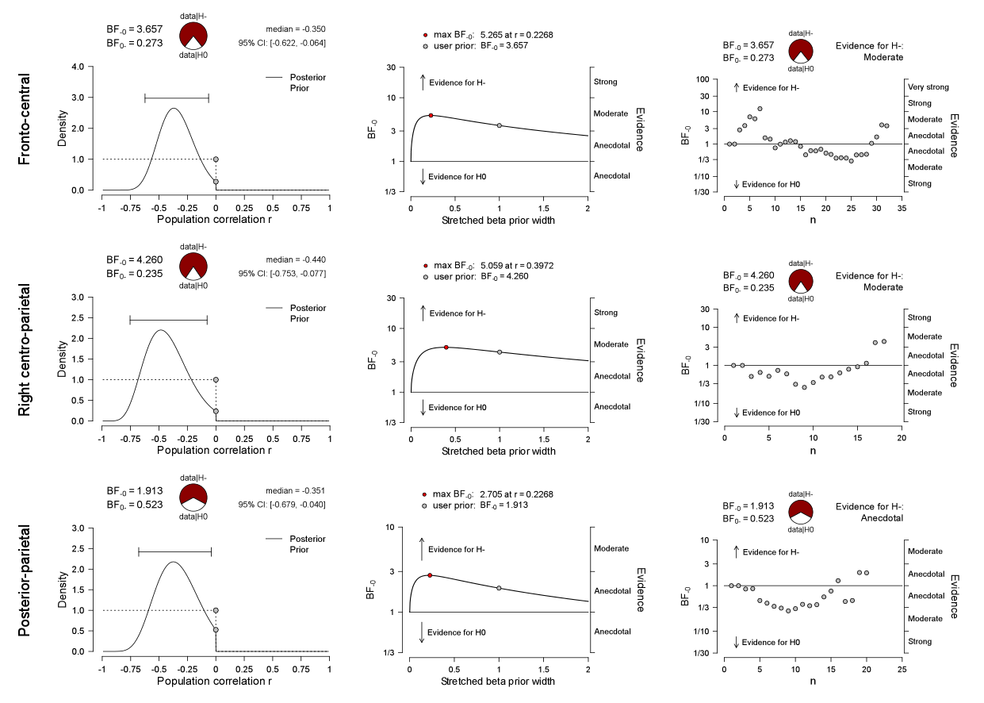
Fig s3. Visualization of the detailed Bayesian correlation between unpleasantness ratings and ΔPAF recorded during the hot painful condition in the only three significant clusters. Note the fronto-central and right centro-parietal clusters associated with moderate BF10 supporting the alternative hypothesis (top and middle), whereas the posterior parietal associated only with anecdotal evidence.

References
Bell, A.J., Sejnowski, T.J., 1995. An information-maximization approach to blind separation and blind deconvolution. Neural Comput 7, 1129–1159.
Hyvärinen, A., 2011. Testing the ICA mixing matrix based on inter-subject or inter-session consistency. Neuroimage 58, 122–136. https://doi.org/10.1016/j.neuroimage.2011.05.086
Hyvärinen, A., Ramkumar, P., 2013. Testing independent component patterns by inter-subject or inter-session consistency. Front Hum Neurosci 7, 94. https://doi.org/10.3389/fnhum.2013.00094
Valentini, E., Halder, S., McInnerney, D., Cooke, J., Gyimes, I.L., Romei, V., 2022. Assessing the specificity of the relationship between brain alpha oscillations and tonic pain. NeuroImage 255, 119143. https://doi.org/10.1016/j.neuroimage.2022.119143

