Supplementary Information

Cryo-compressed CO₂ sorption and diffusion in elastomers for the CO₂ transport chain: examples of FKM, EPDM and HNBR
E. Ghiara, G. Lazzari, V. Signorini, L. Ansaloni, B. Alcock, M. Minelli

- Solubility model
The LF solubility model is an implicit equation with respect to the CO₂ mass fraction. For a rubbery polymer phase, solving the chemical potential equalization involves two interdependent iterative steps: first, the equation of state is solved to determine the density of the solid phase, followed by establishing phase equilibrium [1, 2]. In contrast, for glassy polymers, the NELF solubility model treats the density of the dry glassy polymer phase as an input parameter, making the solid density an explicit equation [3].
While the Lattice Fluid equation of state effectively describes the thermodynamic behaviour of polymeric and polymer+penetrant systems, it has limitations in the representation of CO₂ phase change, often resulting in an overestimation of the vapor pressure. Such discrepancy leads to misleading model predictions for pressures near CO₂ phase transition.

Table S1 - Definition of the different properties and main correlations for the Sanchez–Lacombe LF/NELF solubility model [1, 2, 3].
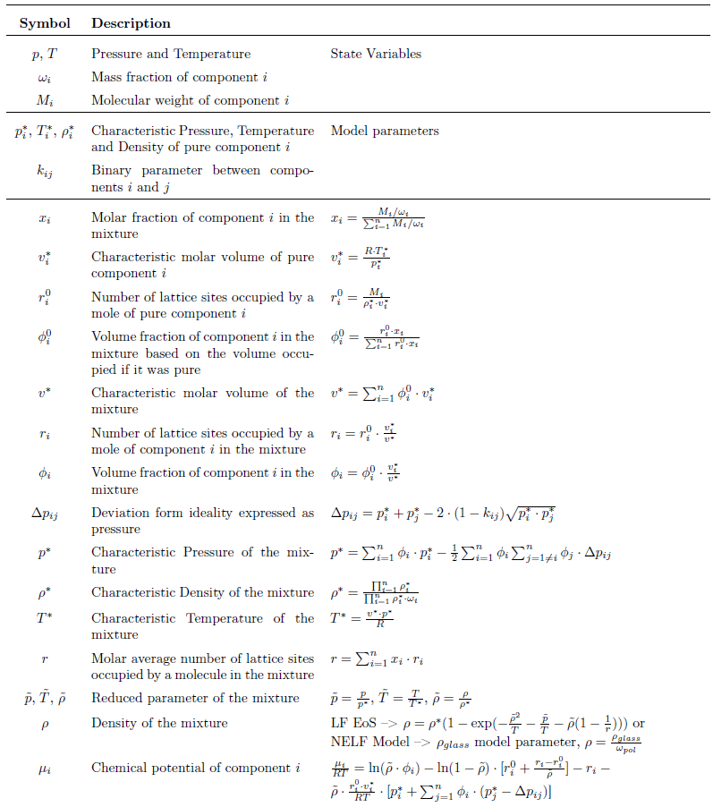

  - Swelling predictions
Using the solubility model, the equilibrium density $ρ$ of the solid phase (polymer+CO₂) is calculated, and the specific volume of the expanded polymer can be evaluated as [1,2]:
$${\tilde{V}}_{pol}=\frac{1}{ρ_{pol}}= \frac{1}{ρ∙ω_{pol}}$$
The dry polymer specific volume refers to the volume of the material at a given temperature, ambient pressure and in absence of CO₂. It is determined by the LF equation of state (EoS) [1,2]:
$${\tilde{V}}_{dry}=\frac{1}{ρ_{dry}}$$
Polymer swelling is then defined as:
$$Swelling=\frac{∆V}{V_{0}}= \frac{{\tilde{V}}_{pol}- {\tilde{V}}_{dry}}{{\tilde{V}}_{dry}}×100$$
Carbon black is assumed to maintain a constant volume in presence of CO₂, so swelling is reduced by CB content. This is accounted for by multiplying the final elastomer swelling by the polymer's volumetric fraction.

Figure S1 presents a comparison between the swelling model predictions and the experimental data obtained from Hertz [4]. The CB content used in the model is based on the values reported in the study, while the binary parameter $k_{ij}$ and the SL characteristic triplet are the same used in this study (Table 2).

a)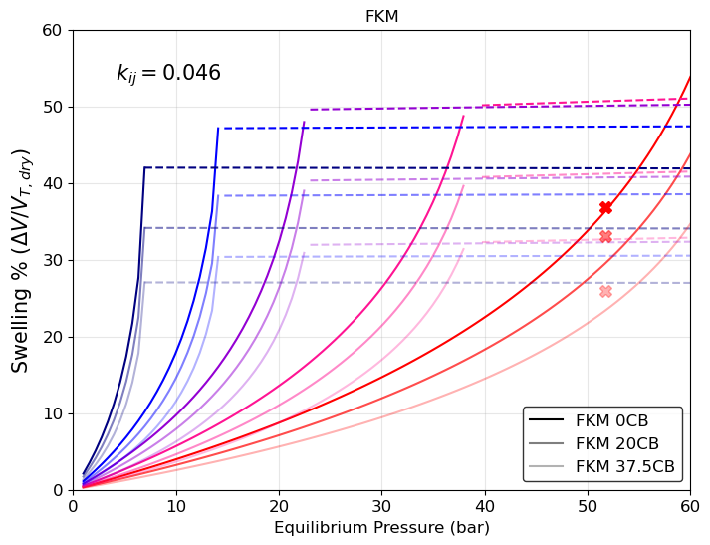
b)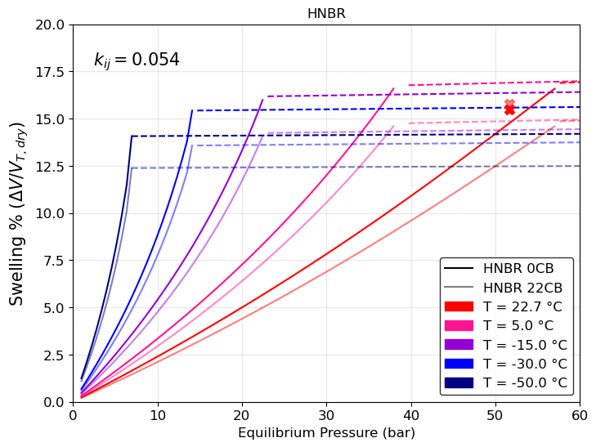
c)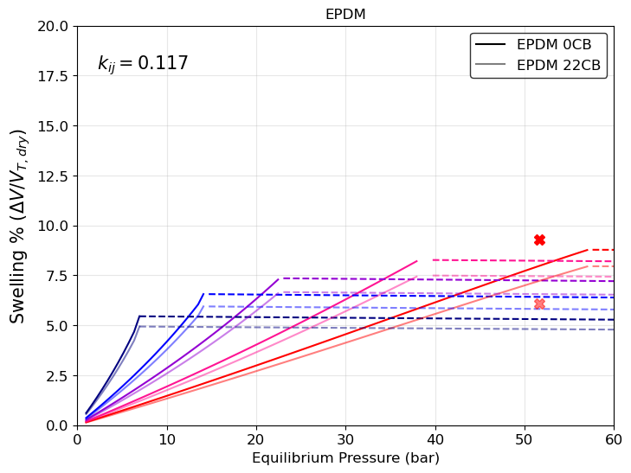
Figure S1 – Elastomer swelling in presence of CO₂ at different temperatures and carbon black content (mass fraction). Symbols: Hertz experimental data [4]. Continuous Lines: LF modeling with CO₂ in vapour phase. Dotted Lines: LF modeling with CO₂ in liquid phase. a) FKM swelling b) HNBR swelling c) EPDM swelling.
  - NELF model
NELF model stands for Non-Equilibrium Lattice Fluid model, it is an extension of the well-established LF model in order to predict also gases’ solubility in a glassy polymer matrix. The modification required to describe non-equilibrium amorphous phases was developed by G. Sarti and F. Doghieri [3]. The only difference between LF Model and NELF Model is how the density of the solid phase is evaluated [3]. When the polymer is in the glassy state, its density cannot be calculated with an equation of state since the polymeric chains did not reach equilibrium. Below the glass transition temperature, the macro-molecules do not have sufficient mobility to reach the configuration with the lowest Gibbs free energy and they remain stuck in a structure with a higher free volume. Thus, the density is lower compared to the one in the equilibrium configuration and it can be evaluated only experimentally [3,5].
If the density of the glassy polymer is known ($ρ_{glass}$), the density of the solid phase composed of polymer and CO₂ molecules can be written as [3,5]:
$$ρ= \frac{ρ_{glass}}{ω_{pol}}$$
The density of the glassy polymer with no absorbents inside ( $ρ_{dry}$ ) is calculated knowing the experimental density at a reference temperature ($ρ_{dry, T_{f}}$) and the thermal expansion coefficient ($γ$) of the glassy configuration [3,5]:
$$ρ_{dry}= ρ_{dry, T_{f}}∙[1-γ\left(T-T_{f}\right)]$$
Once the density of the dry polymer is known, the density of the polymer in the presence of CO₂ ($ρ_{pol}$) can be evaluated in a predictive way, by extrapolating $χ$ from pVT data of the specific polymer.
$$χ= \frac{k_{glass}}{k_{rubber}}$$
$χ$ is the ratio between the isothermal compressibility of the pure polymer above and below T_{g} [5]. With this method, the density of the polymer can be evaluated starting from the dry polymer density plus the addition of a factor that comes from the density of the polymer and of the solid at equilibrium. The non-Equilibrium density of the polymer ($ρ_{glass}$) in the mixture at the designed temperature and pressure is calculated as [5]:
$$\frac{1}{ρ_{glass}}= \frac{1}{ρ_{dry}}+ χ∙(\frac{1}{ρ_{EQ-mix}}-\frac{1}{ρ_{EQ-pol}})$$
Where:
- $ρ_{EQ- mix}$ is the equilibrium density of the polymer in the mixture at the designed temperature and pressure evaluated with LF EoS;
- $ρ_{EQ- pol}$ is the equilibrium density of the pure polymer at the designed temperature and pressure evaluated with LF EoS.
Table S2 summarizes the parameters used to model $ρ_{glass}$ in the case of FKM and HNBR. In this work, EPDM is never considered to be in its glassy state due to its low Tg.
Table S2 – NELF model parameters to determine FKM and HNBR glass density
Polymer | $$ρ_{dry, T_{f}}$$  ($\frac{g}{{cm}^{3}}$) | $$T_{f}$$  ($K$) | $$γ$$  ($\frac{m}{m∙K}$) | $$χ$$ | pVT data
FKM | 1.97 | 253 | 1.24x10⁻⁴ | 0.65 | [6]
HNBR | 1.03 | 243 | 1.32x10⁻⁴ | 0.67 | [7]

- Diffusivity model
The procedure for defining the input parameters for the diffusivity model takes into account the relationship between the diffusion and the mobility coefficients of the gas in the polymer matrix, as reported in Eq. 3 and Eq.4, and it involves the following parameters determination:
- $L_{0}$: the temperature dependence of $L_{0}$ is established from experimental data. At zero CO₂ concentration, the diffusivity $D$ coincides with the kinetic contribution $L$, as $α$ is exactly equal to 1 [8]. By extrapolating the infinite dilution diffusion coefficient $L_{0}$ across different experimental temperatures, $L_{0,T_{inf}}$ and $E_{D}$ are determined for each elastomer sample (Figure S2, Table S3) [8]. The experimental $L_{0}$ values are first rescaled according to the polymer's volumetric fraction in the material to accurately determine the elastomer parameters.
- $β$: the plasticization factor is treated as a fitting parameter.
Each elastomer sample is modeled independently for CO₂ diffusivity, as carbon black is expected to alter the kinetic contribution $L$ by acting as a barrier, thereby increasing the tortuosity of the diffusion path.

a)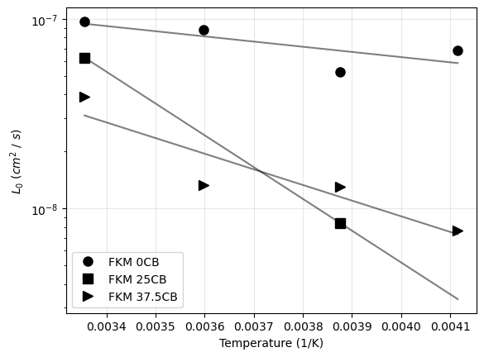 b)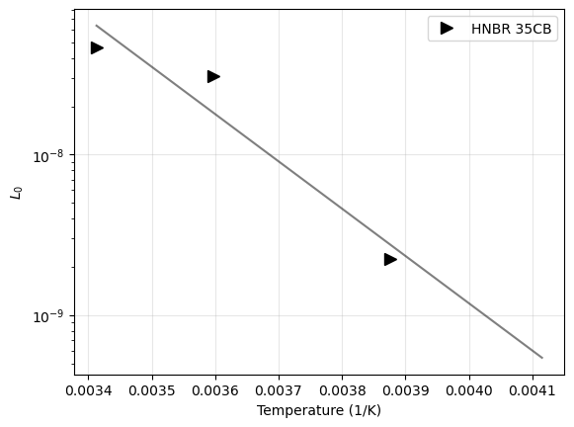c) 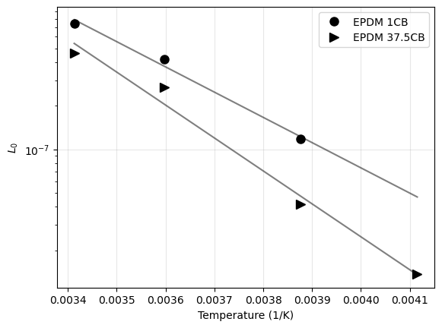
Figure S3 – $L_{0}$ Arrhenius plot. Filled symbols: $L_{0}$ extrapolated from experimental data at each temperature. Lines: best fitting to determine $L_{0,T_{inf}}$ and $E_{D}$ for each elastomer sample. a) FKM samples b) HNBR sample c) EPDM samples.

Table S3 – $L_{0,T_{inf}}$ and $E_{D}$ values extrapolated from Arrhenius plot for each elastomer sample.
Elastomer | $$L_{0,T_{inf}}$$  ($\frac{{cm}^{2}}{s}$) | $$E_{D}$$  ($\frac{kJ}{mol}$)
FKM 0CB | 7.83 x 10⁻⁷ | 5.20
FKM 25CB | 3.53 x 10⁻² | 32.1
FKM 37.5CB | 2.86 x 10⁻⁵ | 15.8
HNBR 35 CB | 7.25 x 10² | 56.4
EPDM 1CB | 7.19 x 10⁻¹ | 33.4
EPDM 37.5CB | 3.98 x 10 | 43.6

- Model uncertainty
The average sMAPE, calculated based on the difference between experimental data and model predictions, is 4.7% for the LF solubility model and 13.0% for the diffusivity model. Table S4 provides the sMAPE values for each tested temperature for both models.
Table S4 – Symmetric Mean Absolute Percentage Error (sMAPE) evaluated both for LF solubility and diffusivity model at each temperature tested.
Sample |  | Solubility Model |  |  | Diffusivity Model
Polymer | CB  (wt %) | $$k_{ij}$$ | T  (°C) | sMAPE  (%) | $$β$$ | $L_{0,T_{inf}}$ ($\frac{{cm}^{2}}{s}$) | $E_{D}$  ($\frac{kJ}{mol}$) | T  (°C) | sMAPE (%)
FKM | 0 | 0.046 | 25 | 0.9 | 50 | 7.83E-07 | 5.2E+03 | 25 | 1.7
FKM | 0 | 0.046 | 5 | 0.1 | 50 | 7.83E-07 | 5.2E+03 | 5 | 4.1
FKM | 0 | 0.046 | -15 | 5.3 | 50 | 7.83E-07 | 5.2E+03 | -15 | 16.9
FKM | 0 | 0.046 | -30 | 7.8 | 50 | 7.83E-07 | 5.2E+03 | -30 | 37.5
FKM | 25 | 0.046 | 25 | 1.5 | 50 | 3.53E-02 | 3.2E+04 | 25 | 9.9
FKM | 25 | 0.046 | -15 | 16.9 | 50 | 3.53E-02 | 3.2E+04 | -15 | 6.8
FKM | 37.5 | 0.046 | 25 | 2.2 | 50 | 2.86E-05 | 1.6E+04 | 25 | 46.9
FKM | 37.5 | 0.046 | 5 | 5.8 | 50 | 2.86E-05 | 1.6E+04 | 5 | 12.1
FKM | 37.5 | 0.046 | -15 | 6.0 | 50 | 2.86E-05 | 1.6E+04 | -15 | 8.6
FKM | 37.5 | 0.046 | -30 | 7.2 | 50 | 2.86E-05 | 1.6E+04 | -30 | 2.0
HNBR | 35 | 0.054 | 20 | 4.8 | 25 | 7.25E+02 | 5.6E+04 | 20 | 11.5
HNBR | 35 | 0.054 | 5 | 3.7 | 25 | 7.25E+02 | 5.6E+04 | 5 | 21.6
HNBR | 35 | 0.054 | -15 | 6.0 | 25 | 7.25E+02 | 5.6E+04 | -15 | 10.7
EPDM | 1 | 0.117 | 20 | 2.4 | 20 | 7.19E-01 | 3.3E+04 | 20 | 5.3
EPDM | 1 | 0.117 | 5 | 2.3 | 20 | 7.19E-01 | 3.3E+04 | 5 | 3.7
EPDM | 1 | 0.117 | -15 | 4.9 | 20 | 7.19E-01 | 3.3E+04 | -15 | 13.8
EPDM | 37.5 | 0.117 | 20 | 2.6 | 20 | 3.98E+01 | 4.4E+04 | 20 | 7.4
EPDM | 37.5 | 0.117 | 5 | 4.6 | 20 | 3.98E+01 | 4.4E+04 | 5 | 7.6
EPDM | 37.5 | 0.117 | -15 | 0.1 | 20 | 3.98E+01 | 4.4E+04 | -15 | 9.6
EPDM | 37.5 | 0.117 | -30 | 8.5 | 20 | 3.98E+01 | 4.4E+04 | -30 | 22.3

References
- I.C. Sanchez, R.H. Lacombe, Statistical thermodynamics of polymer solutions, Macromolecules 11 (1978) 1145–1156.
- I. C. Sanchez, R. H. Lacombe, An elementary molecular theory of classical fluids, Pure fluids, J. Phys. Chem. 80 (1976) 2352–2362.
- F. Doghieri, G. C. Sarti, Nonequilibrium lattice fluids: A predictive model for the solubility in glassy polymers, Macromolecules 29 (1996) 7885–7896.
- Hertz, D. L. "Elastomers in CO₂." Proceedings of the High Performance Elastomers & Polymers for Oil & Gas 2012 International Conference, Aberdeen, UK. 2012.
- Matteo Minelli and Ferruccio Doghieri. “Predictive model for gas and vapor sorption and swelling in glassy polymers: II. Effect of sample previous history”. In: Fluid Phase Equilibria 444 (2017), pp. 47–55.
- Hornig, R., and J. Sunder. "Low-temperature sealing force behaviour of FKM elastomers as a function of the degree of chemical crosslinking and differently restricted geometric deformation in static compression." International Polymer Science and Technology 42.11 (2015): 1-10.
- R. Hornig, J. Sunder, and B. Herr. “Static Cold Sealing Force Behaviour of Amorphous Hnbr Materials”. In: International Polymer Science and Technology 39.11 (2012), pp. 1–14. doi: 10.1177/0307174X1203901101.
- Minelli, Matteo, and Giulio C. Sarti. "Permeability and diffusivity of CO₂ in glassy polymers with and without plasticization." Journal of membrane science 435 (2013): 176-185.

