Supporting Information

Supplementary Table 1. Baseline Characteristics of Patients on Lenvatinib Who Received Concomitant Statins or Not During the Study.
 | Patients With Statins (n = 41) | Patients Without Statins (n = 435)
Median age, years (range) | 67.0 (47.0-82.0) | 62.0 (20.0-88.0)
Sex, n (%)
Male | 35 (85.4) | 368 (84.6)
Female | 6 (14.6) | 67 (15.4)
Race, n (%)
White | 18 (43.9) | 116 (26.7)
Black or African American | 1 (2.4) | 6 (1.4)
Asian | 22 (53.7) | 311 (71.5)
Otherª | 0 (0) | 2 (0.4)
ECOG performance status, n (%)
0 | 29 (70.7) | 275 (63.2)
1 | 12 (29.3) | 160 (36.8)
Child-Pugh score, n (%)
5 | 32 (78.0) | 334 (76.8)
6 | 9 (22.0) | 98 (22.5)
7 | 0 | 3 (0.7)
8 | 0 | 0
9 | 0 | 0
Underlying cirrhosis (IRR),
n (%)
Yes | 28 (68.3) | 327 (75.2)
No | 13 (31.7) | 108 (24.8)
Total Bilirubin (umol/L), median (range) | 10.6 (3.2-32.3) | 10.1 (2.9-50.4)
Albumin (g/L), median (range) | 40.0 (29.0-47.0) | 41.0 (27.0-58.0)
Prothrombin International Normalized Ratio, median (range) | 1.0 (0.8-1.3) | 1.0 (0.8-2.7)
Albumin-Bilirubin, median (range) | -2.8 (-3.5, -1.7) | -2.8 (-4.0, -1.4)
Albumin-Bilirubin grade
Grade 1 (≤ -2.60) | 29 (70.7) | 289 (66.4)
Grade 2 (< -2.60 to -1.39) | 12 (29.3) | 146 (33.6)
Grade 3 (> -1.39) | 0 | 0
ªOther include American Indian or Alaska Native, Native Hawaiian or Other Pacific Islander, and others.
ECOG, eastern cooperative oncology group; INR, international normalized ratio; IRR, independent radiologic review.

Supplementary Table 2. Shift From Baseline to Worst Postbaseline Grade for Treatment-Emergent Hypertension Events.
Lenvatinib
(N = 468^{b})
Worst postbaseline blood pressure stageª, n (%) | Baseline arterial pressure
Worst postbaseline blood pressure stageª, n (%) | Stage 0  (N=158) | Pre-HTN  (N=285) | Stage 1 HTN  (N=23) | Stage 2 HTN  (N=2)
Stage 0 | 11 (7.0) | 5 (1.8) | 0 | 0
Pre-HTN | 95 (60.1) | 111 (38.9) | 4 (17.4) | 0
Stage 1 HTN | 39 (24.7) | 110 (38.6) | 8 (34.8) | 0
Stage 2 HTN | 13 (8.2) | 59 (20.7) | 11 (47.8) | 2 (100)
ªBlood pressure stages: grade 0: SBP <120 mmHg and DBP <80 mmHg; prehypertension (equivalent to grade 1 hypertension according to CTCAE v4.0 criteria¹): SBP 120–139 mmHg or DBP 80–89 mmHg; stage 1 hypertension (equivalent to grade 2 hypertension according to CTCAE v4.0 criteria¹): SBP 140–159 mmHg or DBP 90–99 mmHg; stage 2 hypertension (equivalent to grade ≥3 hypertension according to CTCAE v4.0 criteria¹): SBP ≥160 mmHg or DBP ≥100 mmHg.
^{b}Number of patients with at least one postbaseline blood pressure measurement.
DBP, diastolic blood pressure; SBP, systolic blood pressure.

Supplementary Table 3. Management of Patients With Clinically Significant Treatment-Emergent Hypertension.
Lenvatinib
(N = 476)
Number of patients with CSTE-HTN leading to, n (%)ª
No change | 198 (41.6)
Dose reduction | 16 (3.4)
Dose interruption | 17 (3.6)
Study drug discontinuation | 1 (0.2)
Not applicable | 3 (0.6)
Number of patients with concomitant medications in the full analysis set | Lenvatinib  (N = 478)
Antihypertensive agent^{b}, n (%) | 348 (72.8)
Calcium channel blockers | 204 (42.7)
ACE inhibitors | 95 (19.9)
Beta blockers | 100 (20.9)
Diuretics^{c} | 164 (34.3)
Angiotensin II antagonist | 95 (19.9)
Potassium-sparing agents | 100 (20.9)
ªData on lenvatinib dose management is available for patients who received lenvatinib.
^{b}Includes the most frequently prescribed agents categorized as antihypertensive, but agents may have been prescribed for reasons other than hypertension. Concomitant medications include medications that either (1) started before the first dose of study drug and were continuing at the time of first dose of study drug, or (2) started on or after the date of the first dose of study drug up to 30 days following the last dose.
^{c}Diuretics include high- and low-ceiling diuretics. Low-ceiling diuretics refer to diuretics with a rapidly flattening dose effect curve.² In high-ceiling diuretics, the dose-effect relationship is close to linear.³
CSTE-HTN, clinically significant treatment-emergent hypertension.

Supplementary Table 4. Percentage of Received Dose of Lenvatinib in Patients With and Without Clinically Significant Treatment-Emergent HTN.
 | Patients With CSTE-HTN | Patients Without CSTE-HTN
Received Dose Percentage of Planned Starting Dose, n | 212 | 264
Mean (SD) | 85.2 (19.19) | 89.4 (59.87)
Median | 96.9 | 98.9
Q1, Q3 | 72.8, 100.0 | 75.0, 100.0
Min, Max | 25.8, 100.2 | 14.4, 1000.0
< 60% | 24 (11.3) | 35 (13.3)
60% – < 70% | 21 (9.9) | 21 (8.0)
80% – < 90% | 19 (9.0) | 22 (8.3)
90% – < 100% | 46 (21.7) | 45 (17.0)
= 100% | 74 (34.9) | 121 (45.8)
> 100% | 1 (0.5) | 2 (0.8)
CSTE-HTN, clinically significant treatment-emergent hypertension; Q, quartile; SD, standard deviation.

Supplementary Table 5. Recommended Dose Modifications for Management of Treatment-Emergent Hypertension in Patients Treated With Lenvatinib as Indicated in the Prescribing Information.⁴
Recommended Dosage Reductions of Lenvatinib for Hypertension in unresectable HCC
Indication | First Dosage  Reduction to: |  | Second Dosage Reduction to: | Third Dosage Reduction to:
Bodyweight  ≥ 60 kg | 8 mg once daily |  | 4 mg  once daily | 4 mg  every other day
Bodyweight  < 60 kg | 4 mg once daily |  | 4 mg  every other day | Discontinue
Recommended Dosage Modifications for Lenvatinib for Hypertension
Adverse Reaction | Severityª | Dose Modification for Lenvatinib
Hypertension | Grade 3^{b} | • Withhold for grade 3 that persists despite optimal antihypertensive therapy  • Resume at reduced dose when hypertension is controlled at less than or equal to grade 2
Hypertension | Grade 4^{c} | • Permanently discontinue
ªAdverse event grades are based on Common Terminology Criteria for Adverse Events version 4.0.¹
^{b}Grade 3 hypertension corresponds to stage 2 hypertension (systolic blood pressure ≥160 mmHg or diastolic blood pressure ≥100 mmHg); medical intervention indicated; >1 drug or more-intensive therapy than previously used indicated.
^{c}Grade 4 hypertension is characterized by life-threatening consequences (eg, malignant hypertension, transient or permanent neurologic deficit, hypertensive crisis); urgent intervention indicated.

Supplementary Figure 1. Summary of Different Grades/Classes of Clinically Significant Treatment-Emergent Hypertension and Blood Pressure.

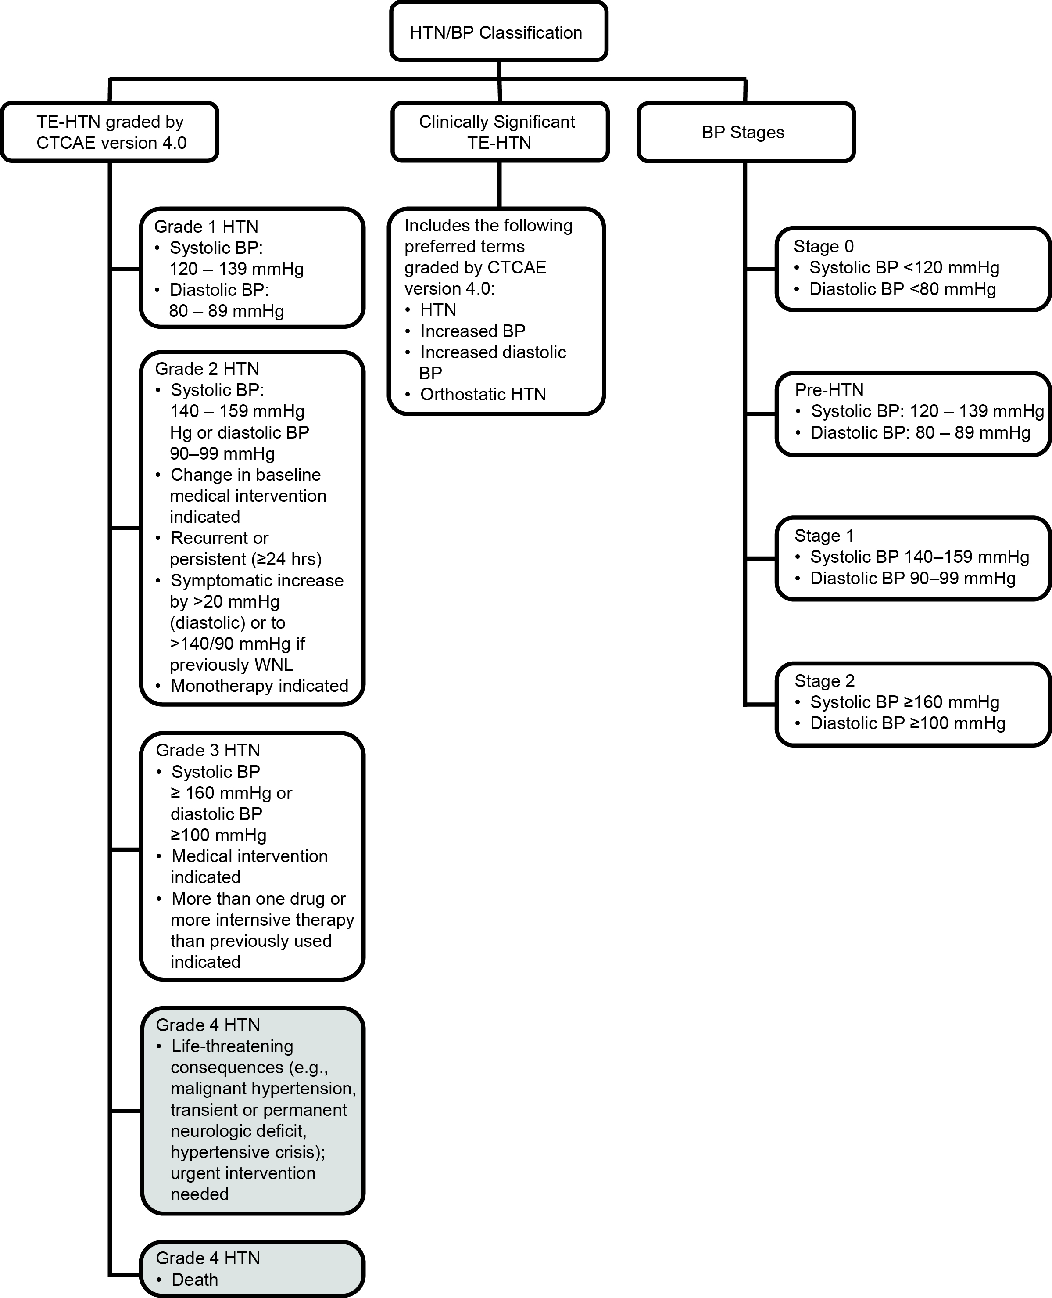

Grades 4–5/Stages 3–4 hypertension were never reached during treatment.
BP, blood pressure; CTCAE, Common Terminology Criteria for Adverse Events; TE-HTN, treatment-emergent hypertension; WNL, within normal limits.

Supplementary Figure 2. 8-Week Landmark Analyses of OS (A) and PFS (B) assessed according to mRECIST by IRR for Lenvatinib-treated Patients With or Without Clinically Significant Hypertension Grade 3.
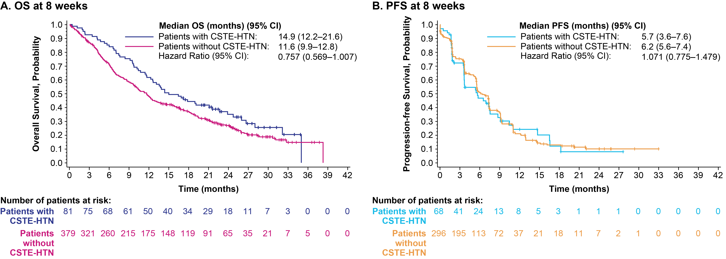
CI, confidence interval; CSTE-HTN, clinically significant treatment-emergent hypertension; IRR, independent radiologic review; mRECIST, modified Response Evaluation Criteria in Solid Tumors; PFS, progression-free survival.

Supplementary Figure 3. OS Analysis of Patients Who Received Lenvatinib With or Without Concomitant Statins.
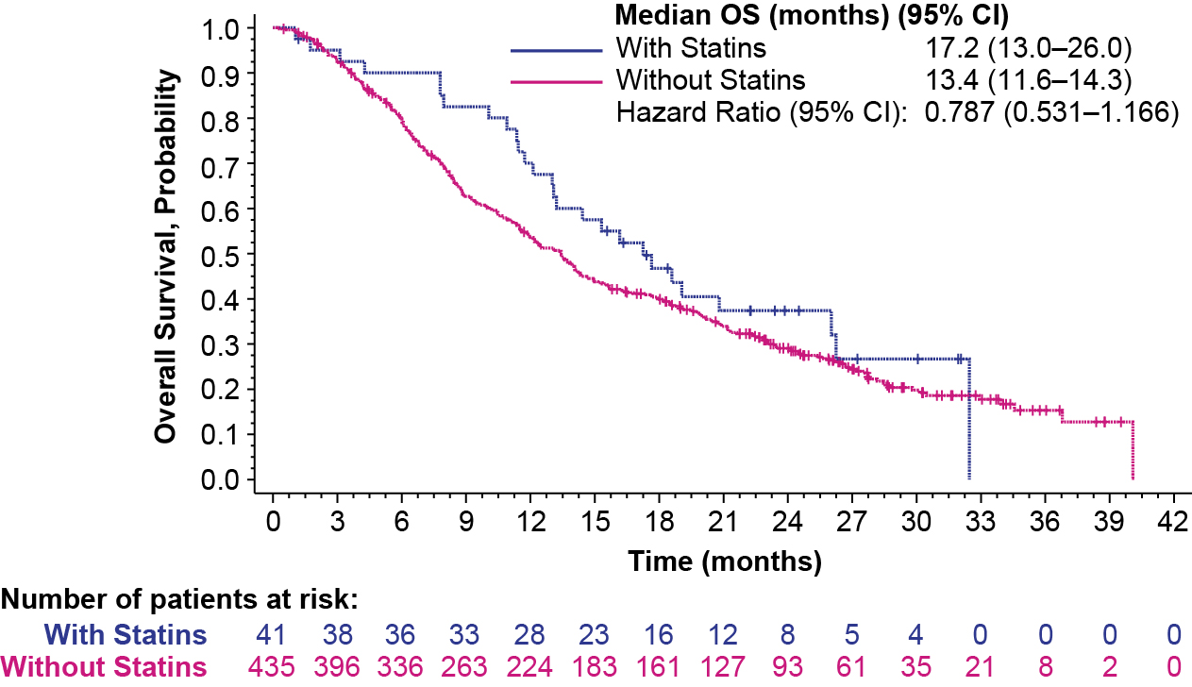
CI, confidence interval; OS, overall survival.

Supplementary Figure 4. OS Analysis of Patients Who Received Lenvatinib With or Without Beta-Blockers.
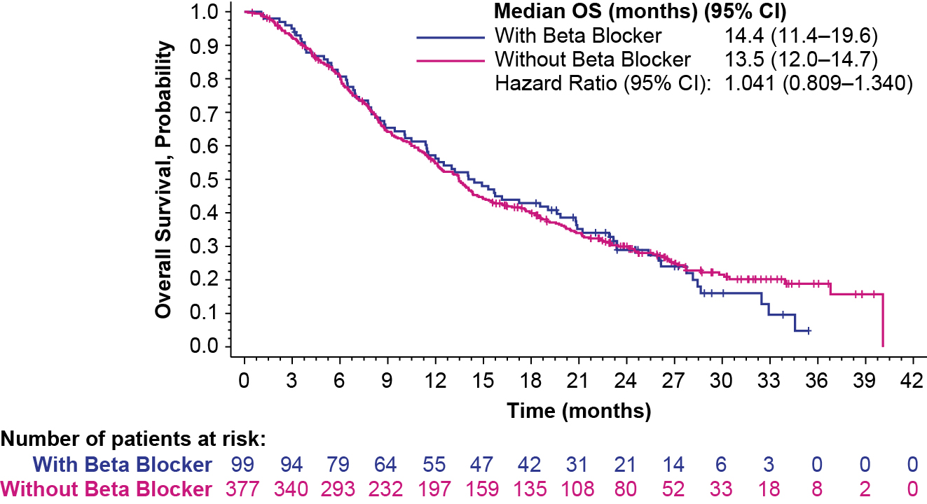
CI, confidence interval; OS, overall survival

Supplemental references:
¹US Department of Health and Human Services. (2009). Common terminology criteria for adverse events (CTCAE) version 4.0. National Institutes of Health, National Cancer Institute, 4(03).
²Knauf H, Mutschler E. Low-dose segmental blockade of the nephron rather than high-dose diuretic monotherapy. European Journal of Clinical Pharmacology. 1993 Jan;44:S63-8.
³Greger, R. (1995). Loop Diuretics. In: Greger, R.F., Knauf, H., Mutschler, E. (eds) Diuretics. Handbook of Experimental Pharmacology, vol 117. Springer, Berlin, Heidelberg. https://doi.org/10.1007/978-3-642-79565-7_7.
⁴Lenvima (lenvatinib) [prescribing information]. Nutley, NJ, USA: Eisai Inc.; 2022.

