Supplementary Table 1
MODIFIED NEWCASTLE - OTTAWA QUALITY ASSESSMENT SCALE
CASE- CONTROL STUDIES (maximum score: 9)
Selection
1) Is the case definition adequate?
a) yes, with independent validation (1)
b) yes, e.g., record linkage (1) or based on self-reports (0.5)
c) no description (0)
2) Representativeness of the cases
a) consecutive or obviously representative series of cases (1)
b) potential for selection biases or not stated (0)
3) Selection of Controls
a) community controls (1)
b) hospital controls (0.5)
c) no description (0)
4) Definition of Controls
a) no history of disease (endpoint) (1)
b) no description of source (0)
Comparability
1) Comparability of cases and controls on the basis of the design or analysis
a) study controls for age, gender, province (0)
b) study controls for age, gender, province +smoking (1)
c) study controls for age, gender, province +smoking + other additional factors (2)
Exposure
1) Ascertainment of exposure
a) secure record (eg surgical records) (1)
b) structured interview where blind to case/control status (1)
c) interview not blinded to case/control status (0.5)
d) written self-report or medical record only (0.5)
e) no description (0)
2) Same method of ascertainment for cases and controls
a) yes (1)
b) no (0)
3) Non-Response rate
a) one or both groups over 90% (1)
b) one or both groups between 60- 90% (0.5)
c) one or both groups under 60% (0)
d) no statemen (0)
NEWCASTLE - OTTAWA QUALITY ASSESSMENT SCALE

COHORT STUDIES (maximum score: 10)

Selection
1) Representativeness of the exposed cohort
a) truly representative of the community (2)
b) somewhat representative of the community (1)
c) selected group of users eg nurses, volunteers (0.5)
d) no description of the derivation of the cohort (0)
2) Selection of the non-exposed cohort
a) drawn from the same community as the exposed cohort (1)
b) drawn from a different source (0.5)
c) no description of the derivation of the non-exposed cohort (0)
3) Ascertainment of exposure
a) secure record (e.g., surgical records) (1)
b) structured interview (1)
c) written self-report (0.5)
d) no description (0)
4) Demonstration that outcome of interest was not present at start of study
a) yes (1)
b) no (0)
Comparability
1) Comparability of cohorts on the basis of the design or analysis
a) study controls for age, gender, province (0)
b) study controls for age, gender, province +smoking (1)
c) study controls for age, gender, province +smoking + other additional factors (2)
Outcome
1) Assessment of outcome
a) independent blind assessment (1)
b) record linkage (1)
c) self-report (0.5)
d) no description (0)
2) Was follow-up long enough for outcomes to occur
a) yes (select an adequate follow- up period for outcome of interest) (1) (average 15 years)
b) no (0)
3) Adequacy of follow- up of cohorts
a) complete follow- up - all subjects accounted for over 90% (1)
b) subjects lost to follow- up unlikely to introduce bias - small number lost between 60- 90% (0.5)
c) follow- up rate < 60% (select an adequate %) and no description of those lost under 60% (0)
d) no statement (0)

Supplementary Table 2. Selected characteristics of the studies included in the review and meta-analysis.

Study reference | First author and year of publication | exposure year | Study population |  | Cancer type | Country | Outcome | Type of acid | Variables adjusted for in the analysis other than gender, age and calendar period
Study reference | First author and year of publication | exposure year | Number of subjects | Gender*
Case- control studies
(48) | Yamaguchi N, (1991) | 1989-1990 | Cases=:144  Controls :676 | Both | Lung cancer | Japan | Incidence | Unspecified | Tobacco Smoking, Asbestos, Dust, Organic Chemicals, Metals, And Other Selected Agents
(21) | Petrauskaite R, (2002) | 1981-1991 | Cases: 277  Controls: 1,108 | Male (100%) | Lung cancer | Lithuania | Incidence | Unspecified | Tobacco Smoking, Other Occupational Exposures
(18) | Grimsrud TK, (2005) | 1952-1995 | Cases: 213  Controls: 525 | Male (100%) | Lung cancer | Norway | Incidence | Sulfuric Acid | Tobacco Smoking
(17) | Soskolne CL, (2007) | 1988-1990 | Cases:  Lung (111)/ sino nasal (22)168  Controls: 247 | Male (100%) | Lung cancer, Sino nasal and nasopharyngeal cancer | Italy | Incidence | Unspecified | Tobacco Smoking, Alcohol Drinking
(22) | d’Errico A, (2009) | 1996-2000 | Cases: 113  Controls: 336 | Both | Sino nasal and nasopharyngeal cancer | Italy | Incidence | Unspecified | Exposure To Wood Dust and Solvents
(20) | Soskolne CL, (2011) | 1981-1985 | Cases: 772  Controls: 772 | Both | Lung cancer | Canada | Incidence | Sulfuric Acid, Hydrochloric Acid, Nitric Acid, Phosphoric Acid | Tobacco Smoking
(16) | ‘t Mannetje A, (2011) | 1998-2001 | Case: 2,852  Control: 3,104 | Male (77%) | Lung cancer | UK, Romania, Hungary, Poland, Russia, Slovakia, Czech Republic | Incidence | Unspecified | Other Occupational Exposures
(19) | Chen Y, (2021) | 2010-2014 | Cases: 2,554  Controls: 2,648 | Both | Nasopharyngeal | China | Incidence | Unspecified | Tobacco Smoking, Family History of Nasopharyngeal Cancer
Cohort Studies
(43) | Weil CS, (1952) | 1928-1950 | Participants :182 | Both | Sino nasal | USA | Mortality | Unspecified | -
(42) | Hueper WC, (1966) | 1927-1950 | Participant:779 | Both | Sino nasal | USA | Incidence | Unspecified | -
(39) | Alderson MR, (1980) | 1959-1975 | Participants: 708  Cases: 6  oral cancer (2),  Sino nasal cancer (1),  Lung cancer (3) | Male (100%) | oral cancer,  Sino nasal cancer,  Lung cancer | UK | Mortality | Unspecified | -
(37) | Enterline PE , (1982) | 1965-1978 | Participants: 2,203  Cases: 31  Lung cancer (7), oral cancer (2) | Both | Lung cancer, oral cancer | USA | Mortality | Unspecified | -
(35) | Cooper WC, (1985) | 1947-1980 | Participants: 6,819  Cases: 109 | Male (100%) | Lung cancer | USA | Mortality | Unspecified | -
(44) | Hilt B, (1985) | 1928-1980 | Participants: 287 | Male (100%) | Lung cancer | Norway | Mortality | Nitric Acid | -
(29) | Stayner LT, (1985) | 1953-1977 | Participants: 3,199  Cases: 10 | Male (93.2%) | Lung cancer | USA | Mortality | Unspecified | -
(30) | Al-Dabbagh S, (1986) | 1946-1981 | Participants: 1,327  Cases: 35 | Male (100%) | Lung cancer | UK | Mortality | Unspecified | -
(28) | Beaumont JJ, (1987) | 1965-1981 | Participants: 1,165  Cases:  Pharyngeal and oral cancer (2), Lung cancer (35) | Male (87%) | Pharyngeal and oral cancer, Lung cancer | USA | Mortality | Unspecified | -
(26) | Forastiere F (1987) | 1969-1983 | Participants: 361  Cases: 5 | Male (100%) | Lung cancer | Italy | Mortality | Sulfuric Acid | -
(27) | Steenland K, (1989) | 1965-1986 | Participants: 1,156  Cases: 41 | Male (100%) | Lung cancer | USA | Mortality | Unspecified | Tobacco Smoking
(34) | Rafnsson V, (1990) | 1954-1985 | Participants: 603  Cases: 4 | Male (100%) | Lung cancer | Iceland | Mortality | Unspecified | -
(47) | Bond GG, (1991.1986) |  | Participants: 19608  Cases: 308 | Male (100%) | Lung cancer | USA | Incidence | Hydrochloric Acid | Tobacco Smoking
(33) | Hagmar L, (1991) | 1963-1986 | Participants: 2,131  Cases: 13 | Male (100%) | Lung cancer | Sweden | Incidence | Unspecified | -
(32) | Fandrem SI, (1993) | 1953-1988 | Participants: 2,023  Cases: 30 | Male (100%) | Lung cancer | Norway | Incidence | Unspecified | -
(38) | Teta MJ, (1995) | 1950-1983 | Participants: 1,031  Cases: 16  Pharyngeal and oral cancer (2), Lung cancer (14) | Male (100%) | Pharyngeal and oral cancer, Lung cancer | UK | Mortality | Unspecified | -
(46) | Coggon D, (1996) | 1950-1990 | Participants :4401 | Male (100%) | Pharyngeal and oral cancer,  Nose,  Lung cancer | UK | Mortality | Unspecified | -
(31) | Bulbulyan MA, (1996) | 1965-1990 | Participants: 4,996  Cases: 22 | Both | Lung cancer | Russia | Mortality | Unspecified | -
(23) | Checkoway H (1996) | 1949-1992 | Participants: 23,012  Cases: 459 | Male (100%) | Lung cancer | USA | Mortality | Sulfuric And Phosphoric Acid | -
(40) | Rapiti E, (1997) | 1970-1991 | Participants: 505  Cases: 26 | Male (100%) | Lung cancer | Italy | Mortality | Unspecified | -
(41) | Block G, (1998) | 1950-1981 | Participants: 3,451  Cases: 50  Oral cancer (4),  Lung cancer (46) | Male (100%) | Oral Cavity,  Lung cancer | USA | Mortality | Unspecified | -
AM15  (25) | Moulin JJ, (2000) | 1968-1991 | Participants: 4,897  Cases: 72  Pharyngeal and oral cancer (18), Lung cancer (54) | Male (87.56%) | Pharyngeal and oral cancer, Lung cancer | France | Mortality | Unspecified | PAH. Silica
(36) | Sorahan T, (2004) | 1947-2000 | Participants: 926  Cases: 49  Lung cancer (45), Pharynx (4) | Male (100%) | Lung cancer, Pharynx | UK | Mortality | Unspecified | -
(24) | Park RM, (2005) | 1992-2001 | Participants: 44,974  Cases: 31 | Male (100%) | Lung cancer | South Korea | Mortality | Unspecified | Tobacco Smoking
(45) | Pesatori AC, (2006) |  | Participants: 1409 | Male (97.3%) | Lung cancer | Italy | Mortality | Sulfuric Acid | -
(7) | Ker YF, (2021) | 1985-1996 | Participants: 10,229  Cases: 17  Pharyngeal and oral cancer (5), Lung cancer (7), Nasopharynx (5) | Male (93.4%) | Pharyngeal and oral cancer, Lung cancer, Nasopharynx | Taiwan | Mortality | Sulfuric Acid | -
* Both indicates that neither gender comprised > 75% of study subjects

Supplementary Table 3. Results of the metanalyses by region, outcome, study design, year of publication, gender, and quality score.

Characteristic | N risk estimates | RR, 95% CI | p heterogeneity
Lung cancer
Region
North America | 9 | 1.18(1.07-1.31) | 0.63
Europe | 15 | 1.21(0.98-1.49) | 0.63
Asia | 4 | 1.79(0.75-4.27) | 0.63
Study design
Case-control | 5 | 1.15(0.76-1.73) | 0.82
Cohort | 23 | 1.21(1.07-1.36) | 0.82
Quality score
Low quality (<7.5) | 15 | 1.10(0.98- 1.23) | 0.31
High quality (>=7.5) | 11 | 1.24(1.01-1.54) | 0.31
Outcome |  |  | 0.22
Incidence | 7 | 1.05(0.83-1.31) | 0.22
Mortality | 21 | 1.23(1.08-1.40) | 0.22
Years of publication
<2000 | 19 | 1.27(1.11-1.46) | 0.05
>=2000 | 9 | 1.00(0.82-1.22) | 0.05
Year of employment start
<1965 | 13 | 1.12(0.99-1.27) | 0.64
>=1965 | 13 | 1.18(1.00-1.40) | 0.64
Gender
Both genders | 4 | 1.39(0.82-2.38) | 0.54
Males only | 24 | 1.18(1.04-1.33) | 0.54
Confounding control
Minimally adjusted* | 18 | 1.22(1.06-1.41) | 0.52
Adjusted for additional factors including smoking | 10 | 1.12(0.90-1.40) | 0.52
Industry type
Chemical industry | 13 | 1.25(1.13-1.38) | 0.08
Inorganic acid production | 4 | 1.13(0.44-2.91) | 0.08
Metal and steel industry | 6 | 1.19(1.04-1.37) | 0.08
Other, mixed | 5 | 0.94(0.78-1.14) | 0.08
Pharyngeal and oral cancer
Region
North America | 4 | 1.39(0.81-2.41) | 0.024
Europe | 4 | 3.27(0.64-16.70) | 0.024
Asia | 1 | 0.39(0.15-0.97) | 0.024
Study design
Case-control | 0 | - | -
Cohort | 9 | 1.58(0.98-2.57) | -
Quality assessment(NOS)
Low quality (<7.5) | 7 | 1.86(1.06-3.28) | 0.038
High quality (>=7.5) | 2 | 0.85(0.53-1.37) | 0.038
Outcome |  |  | -
Incidence | - | - | -
Mortality | 9 | 1.58(0.98-2.57) | -
Years of publication
<2000 | 6 | 1.97(1.11-3.50) | 0.43
>=2000 | 3 | 1.14(0.33-3.93) | 0.43
Year of employment start
<1965 | 6 | 1.97(1.11-3.50) | 0.43
>=1965 | 3 | 1.14(0.33-3.93) | 0.43
Gender
Both genders | 1 | 3.39(0.76-15.05) | 0.32
Males only | 8 | 1.50(0.91-2.48) | 0.32
Confounding control
Minimally adjusted* | 7 | 2.27(1.31-3.93) | 0.004
Adjusted for additional factors including smoking | 2 | 0.63(0.31-1.26) | 0.004
Industry type
Chemical industry | 2 | 1.72(1.57-1.89) | 0.008
Inorganic acid production | 2 | 4.80(0.44-52.75) | 0.008
Metal and steel industry | 4 | 1.25(0.67-2.33) | 0.008
Other, mixed | 1 | 0.39(0.98-2.57) | 0.008
Nasal cavity, sinonasal and nasopharyngeal cancer
Region
North America | 1 | 21.30(7.99-56.76) | <0.001
Europe | 3 | 4.49(0.58-34.47) | <0.001
Asia | 2 | 1.28( 0.71-2.35) | <0.001
Study design
Case- control | 3 | 1.56(1.31-1.87) | 0.21
Cohort | 3 | 8.43(0.59-118.96) | 0.21
Quality assessment(NOS)
Low quality (<7.5) | 3 | 2.87(0.51-15.92) | 0.49
High quality (>=7.5) | 2 | 1.56(1.30-1.87) | 0.49
Outcome |  |  | 0.51
Incidence | 4 | 1.40(1.04-1.88) | 0.51
Mortality | 2 | 5.46(0.09-315.27) | 0.51
Years of publication
<2000 | 2 | 24.29( 9.86-59.84) | <0.001
>=2000 | 4 | 1.52(1.28-1.82) | <0.001
Year of employment start
<1965 | 1 | 50 (5.03- 496.97) | 0.003
>=1965 | 4 | 1.52(1.28- 1.82) | 0.003
Gender
Both genders | 3 | 3.70(0.79-17.37) | 0.96
Males only | 3 | 3.45(0.29-40.05) | 0.96
Confounding control
Minimally adjusted* | 2 | 24.29(9.86-59.84) | <0.001
Adjusted for additional factors including smoking | 4 | 1.52(1.28-1.82) | <0.001
Industry type
Chemical industry | 1 | 1.58(0.15-16.52) | <0.001
Inorganic acid production | 2 | 24.29(9.86-59.84) | <0.001
Metal and steel industry | 0 | - | <0.001
Other, mixed | 3 | 1.49(1.16-1.92) | <0.001
* Adjusted for gender, age and calendar period

Table 4. Results of the metanalyses by region, outcome, study design, year of publication, gender, and quality score.

Characteristic | N risk estimates | RR, 95% CI | p heterogeneity
Lung cancer
Region
North America | 9 | 1.18(1.07-1.31) | 0.63
Europe | 15 | 1.21(0.98-1.49) | 0.63
Asia | 4 | 1.79(0.75-4.27) | 0.63
Study design
Case-control | 5 | 1.15(0.76-1.73) | 0.82
Cohort | 23 | 1.21(1.07-1.36) | 0.82
Quality score
Low quality (<7.5) | 15 | 1.10(0.98- 1.23) | 0.31
High quality (>=7.5) | 11 | 1.24(1.01-1.54) | 0.31
Outcome |  |  | 0.22
Incidence | 7 | 1.05(0.83-1.31) | 0.22
Mortality | 21 | 1.23(1.08-1.40) | 0.22
Years of publication
<2000 | 19 | 1.27(1.11-1.46) | 0.05
>=2000 | 9 | 1.00(0.82-1.22) | 0.05
Year of employment start
<1965 | 13 | 1.12(0.99-1.27) | 0.64
>=1965 | 13 | 1.18(1.00-1.40) | 0.64
Gender
Both genders | 4 | 1.39(0.82-2.38) | 0.54
Males only | 24 | 1.18(1.04-1.33) | 0.54
Confounding control
Minimally adjusted* | 18 | 1.22(1.06-1.41) | 0.52
Adjusted for additional factors including smoking | 10 | 1.12(0.90-1.40) | 0.52
Industry type
Chemical industry | 13 | 1.25(1.13-1.38) | 0.08
Inorganic acid production | 4 | 1.13(0.44-2.91) | 0.08
Metal and steel industry | 6 | 1.19(1.04-1.37) | 0.08
Other, mixed | 5 | 0.94(0.78-1.14) | 0.08
Pharyngeal and oral cancer
Region
North America | 4 | 1.39(0.81-2.41) | 0.024
Europe | 4 | 3.27(0.64-16.70) | 0.024
Asia | 1 | 0.39(0.15-0.97) | 0.024
Study design
Case-control | 0 | - | -
Cohort | 9 | 1.58(0.98-2.57) | -
Quality assessment(NOS)
Low quality (<7.5) | 7 | 1.86(1.06-3.28) | 0.038
High quality (>=7.5) | 2 | 0.85(0.53-1.37) | 0.038
Outcome |  |  | -
Incidence | - | - | -
Mortality | 9 | 1.58(0.98-2.57) | -
Years of publication
<2000 | 6 | 1.97(1.11-3.50) | 0.43
>=2000 | 3 | 1.14(0.33-3.93) | 0.43
Year of employment start
<1965 | 6 | 1.97(1.11-3.50) | 0.43
>=1965 | 3 | 1.14(0.33-3.93) | 0.43
Gender
Both genders | 1 | 3.39(0.76-15.05) | 0.32
Males only | 8 | 1.50(0.91-2.48) | 0.32
Confounding control
Minimally adjusted* | 7 | 2.27(1.31-3.93) | 0.004
Adjusted for additional factors including smoking | 2 | 0.63(0.31-1.26) | 0.004
Industry type
Chemical industry | 2 | 1.72(1.57-1.89) | 0.008
Inorganic acid production | 2 | 4.80(0.44-52.75) | 0.008
Metal and steel industry | 4 | 1.25(0.67-2.33) | 0.008
Other, mixed | 1 | 0.39(0.98-2.57) | 0.008
Nasal cavity, sinonasal and nasopharyngeal cancer
Region
North America | 1 | 21.30(7.99-56.76) | <0.001
Europe | 3 | 4.49(0.58-34.47) | <0.001
Asia | 2 | 1.28( 0.71-2.35) | <0.001
Study design
Case- control | 3 | 1.56(1.31-1.87) | 0.21
Cohort | 3 | 8.43(0.59-118.96) | 0.21
Quality assessment(NOS)
Low quality (<7.5) | 3 | 2.87(0.51-15.92) | 0.49
High quality (>=7.5) | 2 | 1.56(1.30-1.87) | 0.49
Outcome |  |  | 0.51
Incidence | 4 | 1.40(1.04-1.88) | 0.51
Mortality | 2 | 5.46(0.09-315.27) | 0.51
Years of publication
<2000 | 2 | 24.29( 9.86-59.84) | <0.001
>=2000 | 4 | 1.52(1.28-1.82) | <0.001
Year of employment start
<1965 | 1 | 50 (5.03- 496.97) | 0.003
>=1965 | 4 | 1.52(1.28- 1.82) | 0.003
Gender
Both genders | 3 | 3.70(0.79-17.37) | 0.96
Males only | 3 | 3.45(0.29-40.05) | 0.96
Confounding control
Minimally adjusted* | 2 | 24.29(9.86-59.84) | <0.001
Adjusted for additional factors including smoking | 4 | 1.52(1.28-1.82) | <0.001
Industry type
Chemical industry | 1 | 1.58(0.15-16.52) | <0.001
Inorganic acid production | 2 | 24.29(9.86-59.84) | <0.001
Metal and steel industry | 0 | - | <0.001
Other, mixed | 3 | 1.49(1.16-1.92) | <0.001
* Adjusted for gender, age and calendar period

Figure 1: Leave-one-out meta-analysis for the association between SIAM occupational exposure a) lung cancer, b) pharyngeal and oral cancers, and c) Sino nasal cancer incidence and mortality combined.
- Lung cancer
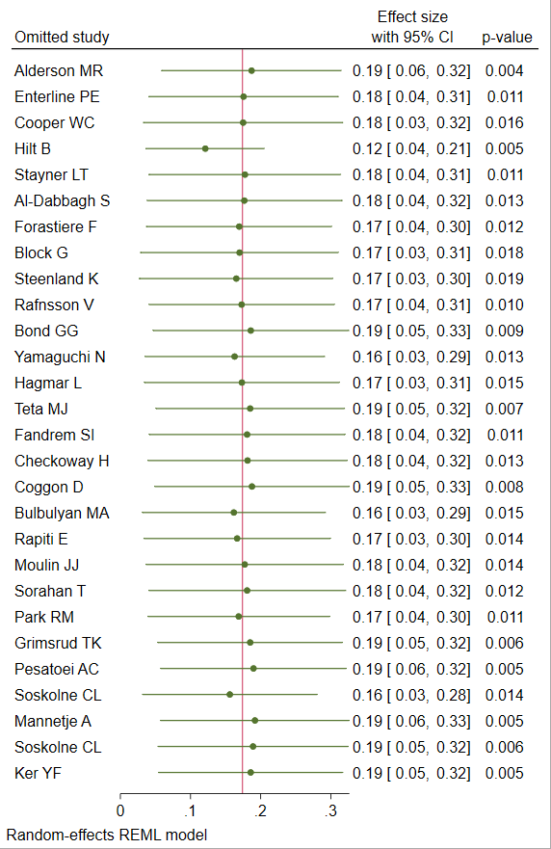

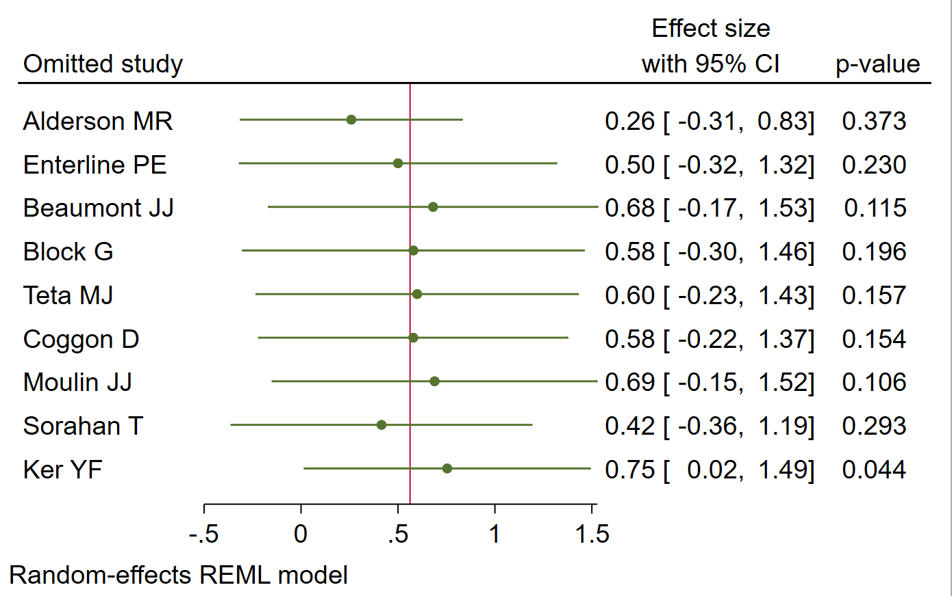
- pharyngeal and oral cancers

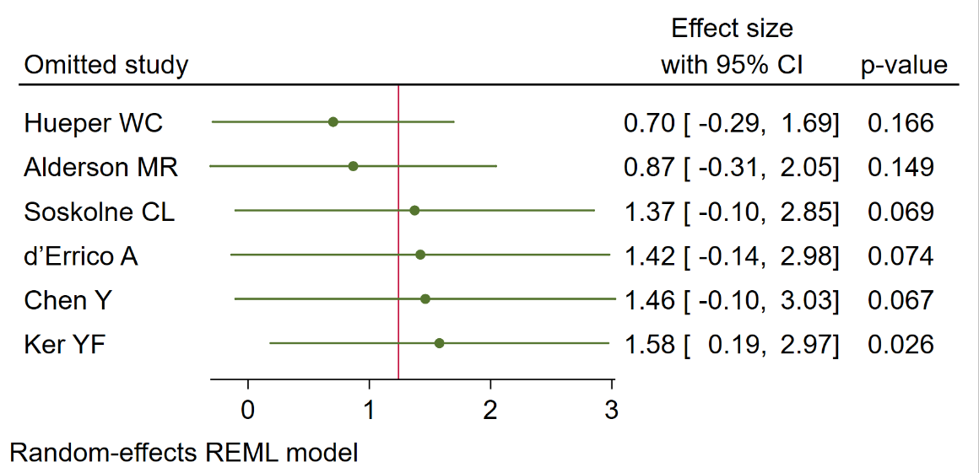
- Sino nasal cancer

Figure 2: Forest plot (random-effects model) of results on the association between SIAM occupational exposure and lung cancer.
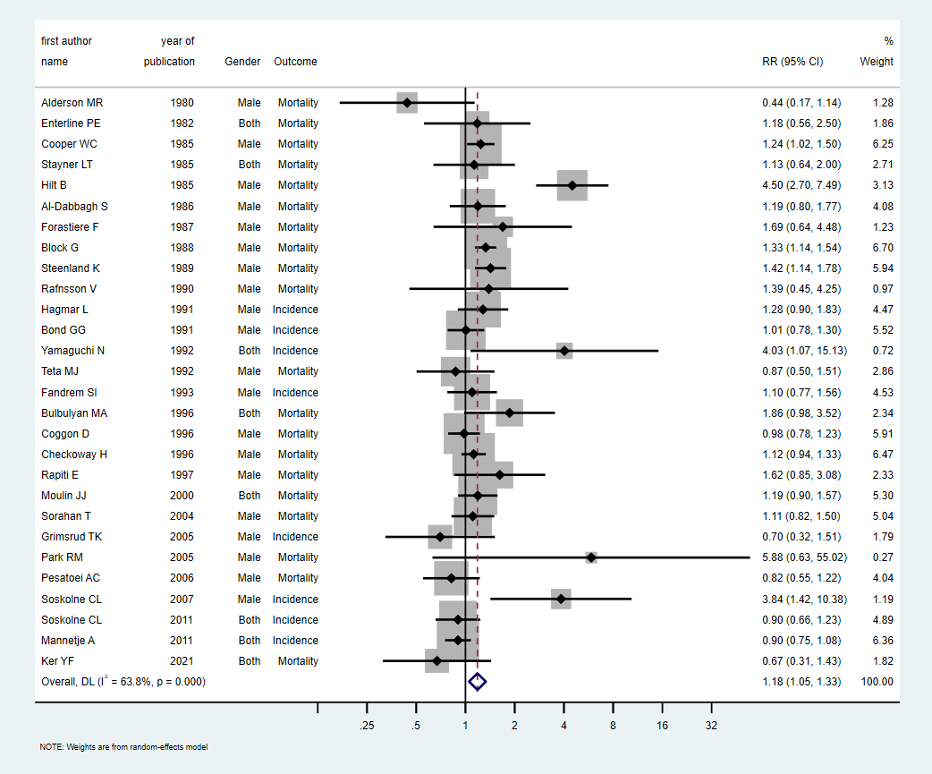

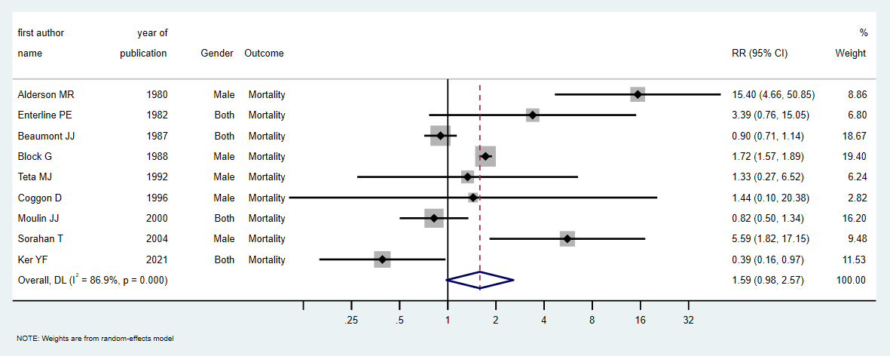
Figure 3: Forest plot (random-effects model) of results on the association between SIAM occupational exposure and pharyngeal and oral cancer.

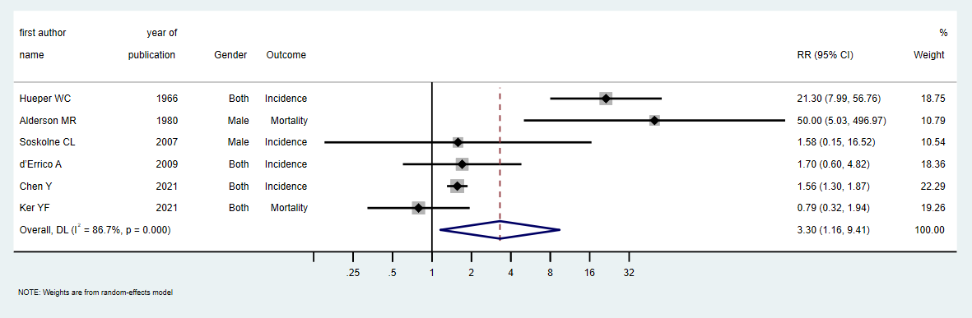
Figure 4: Forest plot (random-effects model) of results on the association between SIAM occupational exposure and cancers of nasal cavity, sinuses and nasopharynx.

Figure 5: Funnel plot of results on the association between SIAM occupational exposure and respiratory tract cancer other than laryngeal cancer ( a. lung cancer, b. pharyngeal and oral cancer, c. nasal cavity, sinuses and nasopharynx)
A  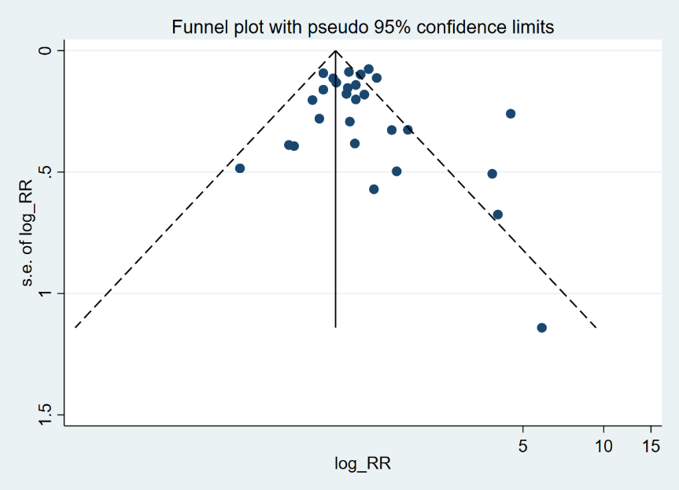 | 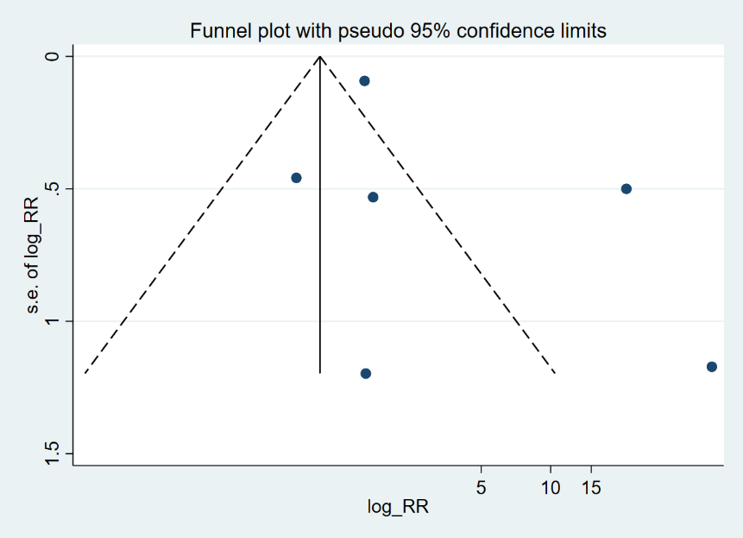  C
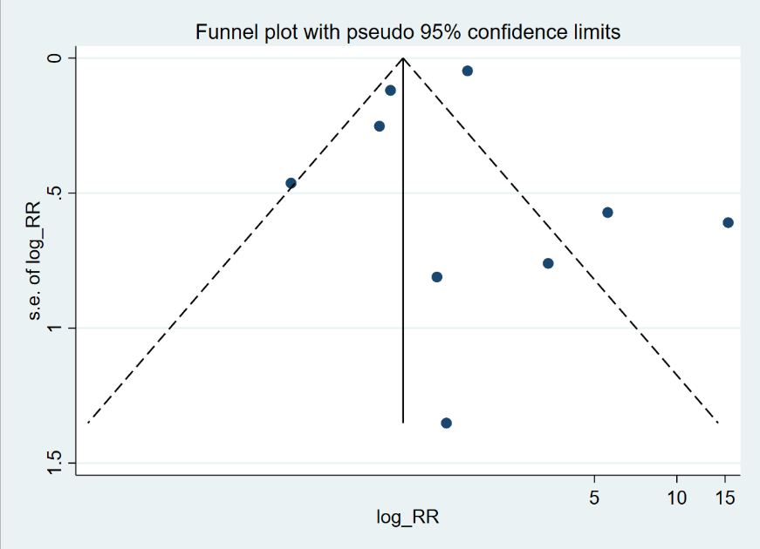
B

