APPENDIX S1
SUPPLEMENTARY MATERIAL
Supplementary methods
We assessed the diagnostic performance for acute kidney injury (AKI) diagnosis of estimated basal serum creatinine (ebSCr), calculated using the Hoste equation, in comparison to measured basal serum creatinine (mbSCr).
The diagnosis of AKI follows the KDIGO criteria, which define AKI as a ratio between the maximum creatinine and basal creatinine ≥1.5.¹ Unfortunately, basal creatinine measurements were only available for a subgroup of our patients. Therefore, in patients without mbSCr, we utilized ebSCr, calculated according to the Hoste (age) equation,² as previously done in various pediatric cohorts.^{3–6} As this method was primarily validated in children with median age of 3.9 years,⁷ we conducted a special sub-analysis within the subgroup of patients with mbSCr to evaluate its validity in younger children enrolled in our study. We uses the mbSCr as the gold standard for accuracy assessment of the ebSCr.
How to use the Hoste (age) equation to back-calculate the basal serum creatinine
We used the Hoste (age) equation to back-calculate basal serum creatinine,⁸ assuming that basal estimated glomerular filtration rate (eGFR) corresponded the median age-based eGFR normative values.⁹
More in detail:
bSCr (mg/dL) = 107.3 x Q/eGFR, where,
Q = 0.21 + 0.057*age – 0.0075*age² + 0.00064*age³ – 0.000016*age⁴ for boys, and
Q = 0.23 + 0.034*age – 0.0018*age² + 0.00017*age³ – 0.0000051*age⁴ for girls (age in years).

Supplementary results
Among the 849 patients enrolled in our study, 169 had a known mbSCr, excluding 35 patients with pre-existing chronic kidney disease (CKD), for whom any estimation of basal creatinine would be meaningless. These 169 patients had a median age of 0.55 years (interquartile range, IQR: 1.75) while the median age of the overall population was 0.5 years (IQR=1.8).
Using mbSCr as the gold standard in that subset, AKI was diagnosed in 26 out of 169 (15.4%) patients. AKI prevalence diagnosed using ebSCr in the same subgroup was 16.0% (27/169 patients) (p=0.88).
The analysis of the confusion matrix is presented in the Supplementary Table S1. The correlation between the two methods was very high, with the ebSCr demonstrating a very high accuracy (94.7%), and very good values of sensitivity, specificity, positive predictive value, negative predictive value, positive likelihood ratio and negative likelihood ratio (Supplementary Table S1). Cohen kappa was 0.79.

Supplementary Table S1. Confusion matrix analysis of ebSCr diagnostic performance for AKI compared with mbSCr
 | AKI + | AKI – | Total
Test + | 22 | 5 | 27
Test – | 4 | 138 | 142
Total | 26 | 143 | 169
Point estimates and 95% Confidence Intervals (CIs):
--------------------------------------------------------------
Apparent prevalence * 0.160 (0.108, 0.224)
True prevalence * 0.154 (0.103, 0.217)
Sensitivity * 0.846 (0.651, 0.956)
Specificity * 0.965 (0.920, 0.989)
Positive predictive value * 0.815 (0.619, 0.937)
Negative predictive value * 0.972 (0.929, 0.992)
Positive likelihood ratio 24.200 (10.073, 58.141)
Negative likelihood ratio 0.159 (0.065, 0.393)
False T+ proportion for true D- * 0.035 (0.011, 0.080)
False T- proportion for true D+ * 0.154 (0.044, 0.349)
False T+ proportion for T+ * 0.185 (0.063, 0.381)
False T- proportion for T- * 0.028 (0.008, 0.071)
Correctly classified proportion * 0.947 (0.901, 0.975)
--------------------------------------------------------------
* Exact CIs

p < 2.2e-16

The Bland–Altman graph displays the superior and inferior limits, as well as the average of the differences (bias) in the ratio between maximum creatinine and mbSCr or ebSCr. The bias was -0.14 (with 95% limits of agreement from -0.20 to -0.08) (Supplementary Figure S1).

Supplementary Figure S1. Bland–Altman plots comparing the ratio between the maximum creatinine and mbSCr or ebSCr. Dashed lines represent the limits of agreement and mean difference (bias) in estimations.

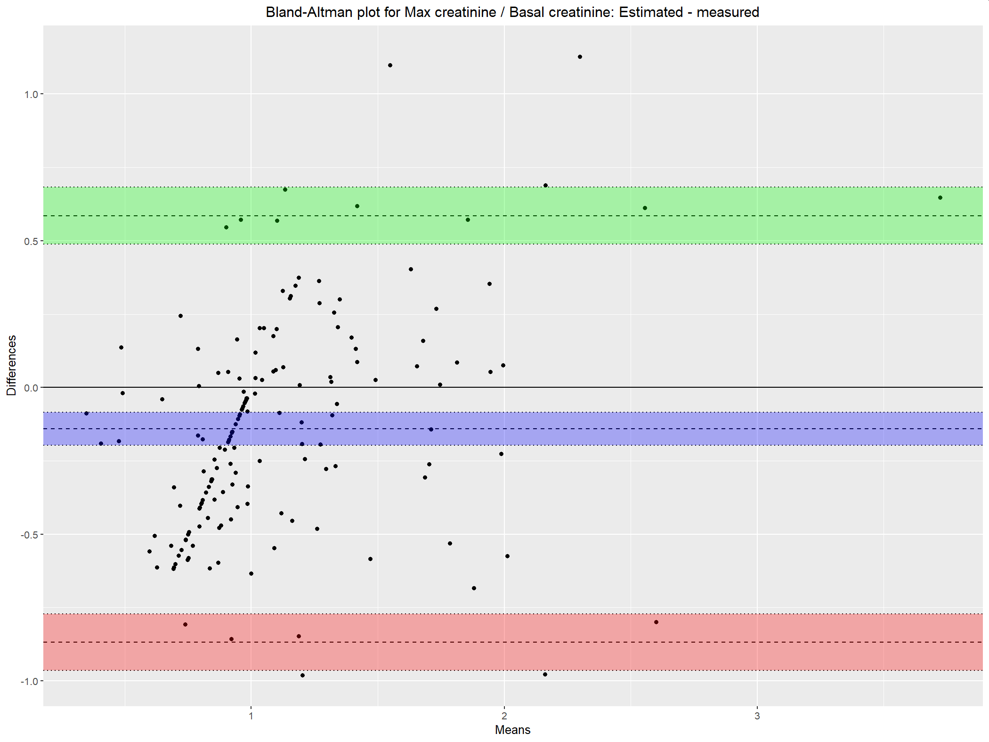
The absolute and relative errors of the ratio between the maximum and basal creatinine, calculated based on the ebSCr, compared with the ratio calculated based on mbSCr, are presented in Supplementary Table S2.

Supplementary Table S2. Absolute and relative errors of the ratio between the maximum and basal creatinine calculated based on the ebSCr compared with the ratio calculated based on mbSCr.

Error | N | Mean | Standard  deviation | Minimum  value | 25th  percentile | 50th  percentile | 75th percentile | Maximum  value
Absolute | 169 | -0.141 | 0.371 | -0.981 | -0.408 | -0.163 | 0.0543 | 1.13
Relative | 169 | -12.1 | 32.8 | -70.6 | -35.5 | -15 | 4.83 | 110

The Supplementary Figure S2 provides a detailed depiction of the results categorized according to the confusion matrix mentioned above (Supplementary Table S1), showcasing a scatterplot of the two ratios (measured and estimated). The regression line of the data is very similar to the identity line. Five false positive patients can be seen in the upper-left quadrant, and 4 false negative patients in the lower-right quadrant. Three of those values, however, are borderline.

Supplementary Figure S2. Diagnosis of AKI using estimated basal creatinine versus measured basal creatinine (gold standard). The brown line is the identity line. The blue line is the linear regression line. The cyan dashed line indicates the 1.5 threshold for the diagnosis of AKI according to the two different axes. Abbreviations: FN, false negative; FP, false positive; TN, true negative; TP, true positive.
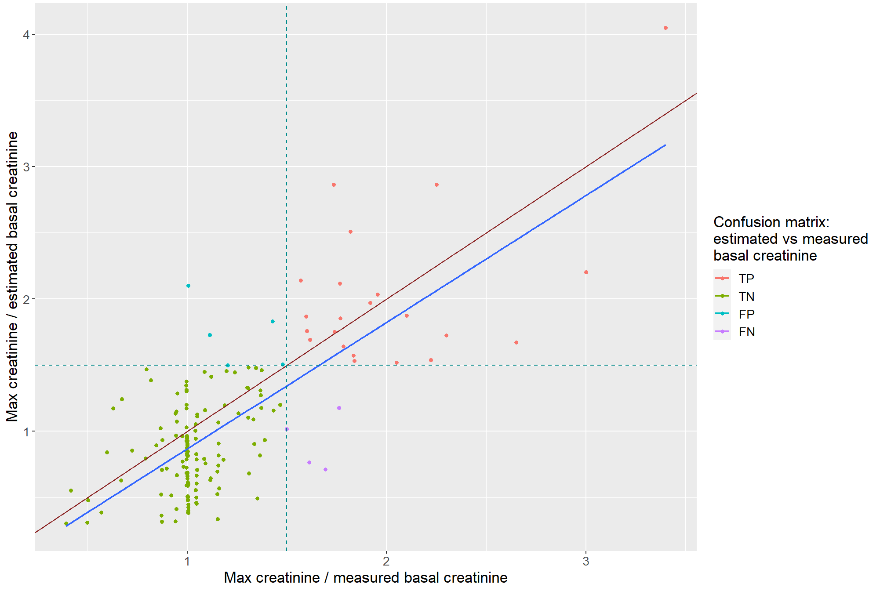

In conclusion, the ebSCr calculated on the basis of the Hoste (age) equation is feasible for AKI diagnosis compared to mbSCr (gold standard), as previously demonstrated in children with median age of 3.9 years.⁷ However, our data further reinforce the reliability of this method in children with a median age of 0.5 months. Therefore, employing ebSCr for AKI diagnosis appears to be a valid alternative to mbSCr when the latter is unavailable.
Supplementary References
1. Kellum JA, Lameire N, Aspelin P, et al. Kidney disease: Improving global outcomes (KDIGO) acute kidney injury work group. KDIGO clinical practice guideline for acute kidney injury. Kidney Int Suppl 2012; 2: 1–138.
2. Pottel H, Hoste L, Dubourg L, et al. An estimated glomerular filtration rate equation for the full age spectrum. Nephrol Dial Transplant 2016; 31: 798–806.
3. Marzuillo P, Baldascino M, Guarino S, et al. Acute Kidney Injury in children hospitalized for acute gastroenteritis: prevalence and risk factors. Pediatric Nephrology 2021; 36: 1627–1635.
4. Marzuillo P, Pezzella V, Guarino S, et al. Acute Kidney Injury in children hospitalized for community acquired pneumonia. Pediatric Nephrology 2021; 36: 2883–2890.
5. Marzuillo P, Coppola C, Caiazzo R, et al. Acute Kidney Injury in Children with Acute Appendicitis. Children 2022; 9: 620.
6. Marzuillo P, Di Sessa A, Golino R, et al. Acute kidney injury in infants hospitalized for viral bronchiolitis. Eur J Pediatr 2023; 182: 3569-3576.
7. Hessey E, Ali R, Dorais M, et al. Evaluation of height-dependent and height-independent methods of estimating baseline serum creatinine in critically ill children. Pediatric Nephrology 2017; 32: 1953–1962.
8. Hoste L, Dubourg L, Selistre L, et al. A new equation to estimate the glomerular filtration rate in children, adolescents and young adults. Nephrology Dialysis Transplantation 2014; 29: 1082–1091.
9. Piepsz A, Tondeur M, Ham H. Revisiting normal 51Cr-ethylenediaminetetraacetic acid clearance values in children. Eur J Nucl Med Mol Imaging 2006; 33: 1477–1482.

