Supplementary Material

Positive effects of two decades of passive ecological restoration in a historically polluted marine site
Fanelli Emanuela^{1,2}, Dell'Anno Antonio^{1,2}, Nepote Ettore¹, Lo Martire Marco¹, Musco Luigi ^{2,3}, Bianchelli Silvia^{1,2}, Gambi Cristina^{1,2}, Falco Pierpaolo¹, Memmola Francesco¹, Coluccelli Alessandro¹, Meola Martina¹, Varrella Stefano^{1,2}, Danovaro Roberto^{1,2}, Corinaldesi Cinzia ^{2,4}*

¹ Department of Life and Environmental Sciences, Polytechnic University of Marche, Via Brecce Bianche, Ancona, Italy
² National Biodiversity Future Centre, Italy
³ Department of Biological and Environmental Sciences and Technologies, University of Salento, Lecce, Italy
⁴ Department of Materials, Environmental Sciences and Urban Planning, Polytechnic University of Marche, Ancona, Italy

*Corresponding author: c.corinaldesi@staff.univpm.it

Table S1. List of the taxa identified at each transect within the control (C1-C3) and SNI (M1-M3) condition off Falconara (Central Adriatic Sea) across the 3-12 m depth range.

Table S2. Results of the environmental variables, chemical contaminants, and biochemical components of the sediment organic matter in the investigated sediments (see Corinaldesi et al., 2022 for additional information)
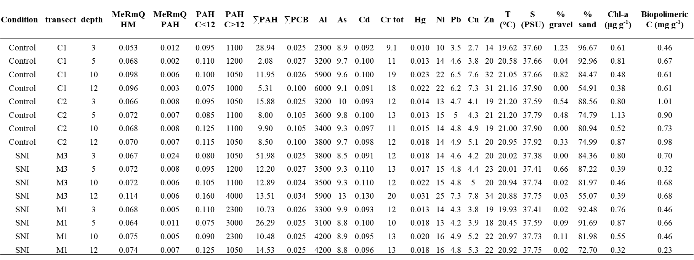

Table S3. Results of the univariate PERMANOVA test for all the environmental variables analysed in the SNI and control transects off Falconara.
 |  | PAH C<12 |  |  |  | PAH C>12 |  |  |  | ΣPAH |  |  |  | ΣPCB
Source | df | MS | Pseudo-F | P(perm) |  | MS | Pseudo-F | P(perm) |  | MS | Pseudo-F | P(perm) |  | MS | Pseudo-F | P(perm)
Condition | 1 | 0.0001 | 0.50 | 0.67 |  | 3.38E+06 | 31.92 | 0.34 |  | 240.64 | 4.52 | 0.32 |  | 0.006 | 3.64 | 0.33
depth | 3 | 0.0006 | 1.51 | 0.30 |  | 1.51E+05 | 0.12 | 0.94 |  | 244.59 | 1.53 | 0.27 |  | 0.001 | 1.99 | 0.23
transect(Condition) | 2 | 0.0002 | 0.50 | 0.62 |  | 1.06E+05 | 0.09 | 0.92 |  | 53.194 | 0.33 | 0.73 |  | 0.002 | 3.01 | 0.13
Conditionxdepth | 3 | 0.0008 | 2.11 | 0.19 |  | 1.76E+05 | 0.14 | 0.94 |  | 30.786 | 0.19 | 0.90 |  | 0.001 | 1.65 | 0.27
Residuals | 6 | 0.0004 |  |  |  | 1.21E+06 |  |  |  | 159.51 |  |  |  | 0.001
Total | 15
 |  | Al |  |  |  | As |  |  |  | Cd |  |  |  | Cr
 |  | MS | Pseudo-F | P(perm) |  | MS | Pseudo-F | P(perm) |  | MS | Pseudo-F | P(perm) |  | MS | Pseudo-F | P(perm)
Condition | 1 | 625 | 0.00 | 1.00 |  | 0.01 | 0.01 | 1.00 |  | 0.0002 | 0.89 | 0.68 |  | 0.00 | 0.00 | 1.00
depth | 3 | 2.85E+06 | 2.84 | 0.14 |  | 0.68 | 0.46 | 0.73 |  | 0.0001 | 1.77 | 0.25 |  | 16.79 | 1.54 | 0.30
transect(Condition) | 2 | 9.48E+05 | 0.94 | 0.44 |  | 1.00 | 0.68 | 0.58 |  | 0.0002 | 3.38 | 0.08 |  | 10.24 | 0.94 | 0.43
Conditionxdepth | 3 | 4.37E+05 | 0.44 | 0.74 |  | 0.97 | 0.66 | 0.61 |  | 0.0001 | 1.11 | 0.43 |  | 3.62 | 0.33 | 0.81
Residuals | 6 | 1.00E+06 |  |  |  | 1.47 |  |  |  | 0.0001 |  |  |  | 10.87
Total | 15
 |  | Hg |  |  |  | Ni |  |  |  | Pb |  |  |  | Cu
 | df | MS | Pseudo-F | P(perm) |  | MS | Pseudo-F | P(perm) |  | MS | Pseudo-F | P(perm) |  | MS | Pseudo-F | P(perm)
Condition | 1 | 5.26E-05 | 1.98 | 0.33 |  | 1 | 0.07 | 0.67 |  | 0.02 | 0.02 | 1.00 |  | 0.00 | 0.00 | 1.00
depth | 3 | 6.34E-05 | 4.03 | 0.06 |  | 32.667 | 2.40 | 0.18 |  | 1.80 | 2.23 | 0.17 |  | 6.45 | 4.77 | 0.05
transect(Condition) | 2 | 2.66E-05 | 1.69 | 0.26 |  | 15.25 | 1.12 | 0.37 |  | 0.80 | 1.00 | 0.42 |  | 1.20 | 0.89 | 0.47
Conditionxdepth | 3 | 1.40E-06 | 0.09 | 0.96 |  | 6 | 0.44 | 0.74 |  | 0.36 | 0.45 | 0.74 |  | 0.60 | 0.45 | 0.75
Residuals | 6 | 1.57E-05 |  |  |  | 13.583 |  |  |  | 0.81 |  |  |  | 1.35
Total | 15
 |  | Zn |  |  |  | T |  |  |  | S |  |  |  | % gravel
 | df | MS | Pseudo-F | P(perm) |  | MS | Pseudo-F | P(perm) |  | MS | Pseudo-F | P(perm) |  | MS | Pseudo-F | P(perm)
Condition | 1 | 0.25 | 0.01 | 1.00 |  | 0.43 | 1.77 | 0.37 |  | 0.10 | 8.48 | 0.34 |  | 0.39 | 7.86 | 0.33
depth | 3 | 56.42 | 1.96 | 0.22 |  | 0.58 | 3.24 | 0.11 |  | 0.09 | 18.11 | 0.01 |  | 0.09 | 0.66 | 0.61
transect(Condition) | 2 | 36.25 | 1.26 | 0.36 |  | 0.24 | 1.36 | 0.32 |  | 0.01 | 2.40 | 0.16 |  | 0.05 | 0.37 | 0.68
Conditionxdepth | 3 | 11.75 | 0.41 | 0.74 |  | 0.07 | 0.40 | 0.74 |  | 0.01 | 1.19 | 0.40 |  | 0.18 | 1.32 | 0.36
Residuals | 6 | 28.75 |  |  |  | 0.18 |  |  |  | 0.01 |  |  |  | 0.13
Total | 15
 |  | % sand |  |  |  | Chla |  |  |  | Biopolimeric C
 | df | MS | Pseudo-F | P(perm) |  | MS | Pseudo-F | P(perm) |  | MS | Pseudo-F | P(perm)
Condition | 1 | 0.04 | 0.00 | 1.00 |  | 0.07 | 0.85 | 0.66 |  | 0.20 | 1.70 | 0.69
depth | 3 | 532.66 | 6.68 | 0.03 |  | 0.10 | 4.04 | 0.06 |  | 0.00 | 0.03 | 0.99
transect(Condition) | 2 | 63.03 | 0.79 | 0.50 |  | 0.08 | 3.16 | 0.11 |  | 0.12 | 3.13 | 0.12
Conditionxdepth | 3 | 16.78 | 0.21 | 0.89 |  | 0.04 | 1.65 | 0.27 |  | 0.01 | 0.35 | 0.78
Residuals | 6 | 79.69 |  |  |  | 0.03 |  |  |  | 0.04
Total | 15

Table S4. Results of univariate PERMANOVA tests carried out on abundance, Biomass, and number of taxa (richness) of macrofauna, according to the experimental design described in the text: a) main test. b) pairwise comparisons for factor depth and factor “condition x depth” for pairs of levels of factor “condition” and ‘transect (condition) for pairs of levels of factor “condition”.
a) Main test |  | Abundance |  |  | Biomass |  |  | Richness of taxa
Source | df | MS | Pseudo-F | P | MS | Pseudo-F | P | MS | Pseudo-F | P
Condition | 1 | 1.77 | 2.63 | 0.20 | 0.13 | 0.52 | 0.60 | 71.70 | 3.32 | 0.20
depth | 5 | 0.35 | 0.52 | 0.76 | 2.18 | 7.23 | 0.001 | 97.73 | 6.75 | 0.0004
transect(Condition) | 4 | 0.67 | 2.14 | 0.09 | 0.24 | 4.27 | 0.004 | 21.59 | 2.37 | 0.06
Conditionxdepth | 5 | 0.51 | 0.75 | 0.60 | 0.93 | 3.09 | 0.03 | 11.82 | 0.82 | 0.55
transect(Condition)xdepth | 20 | 0.68 | 2.18 | 0.01 | 0.30 | 5.30 | 0.0001 | 14.47 | 1.59 | 0.08
Residuals | 72 | 0.31 |  |  | 0.06 |  |  | 9.10
Total | 107
b) Pair-wise test on term ‘depth’
 |  |  |  |  | Groups | t | P | Groups | t | P
 |  |  |  |  | 3, 4 | 4.92 | 0.009 | 3, 4 | 0.93 | 0.40
 |  |  |  |  | 4, 5 | 0.75 | 0.49 | 4, 5 | 1.10 | 0.32
 |  |  |  |  | 5, 6 | 0.32 | 0.77 | 5, 6 | 1.39 | 0.23
 |  |  |  |  | 6, 10 | 1.51 | 0.21 | 6, 10 | 2.56 | 0.06
 |  |  |  |  | 10, 12 | 1.91 | 0.13 | 10, 12 | 1.12 | 0.32
c) Pair-wise test Term 'Conditionxdepth' for pairs of levels of factor 'depth'
 |  |  |  |  | Within level 'Control' of factor 'Condition'
 |  |  |  |  | Groups | t | P
 |  |  |  |  | 3, 4 | 72.47 | 0.10
 |  |  |  |  | 4, 5 | 3.39 | 0.16
 |  |  |  |  | 5, 6 | 0.29 | 0.80
 |  |  |  |  | 6, 10 | 0.03 | 1.00
 |  |  |  |  | 10, 12 | 1.33 | 0.28
 |  |  |  |  | Within level 'SNI' of factor 'Condition'
 |  |  |  |  | Groups | t | P
 |  |  |  |  | 3, 4 | 1.90 | 0.29
 |  |  |  |  | 4, 5 | 0.27 | 0.79
 |  |  |  |  | 5, 6 | 0.18 | 1.00
 |  |  |  |  | 6, 10 | 2.58 | 0.17
 |  |  |  |  | 10, 12 | 1.59 | 0.29
 |  |  |  |  | Term 'transect(Condition)'
 |  |  |  |  | Within level 'Control' of factor 'Condition'
 |  |  |  |  | Groups | t | P
 |  |  |  |  | C1, C2 | 3.24 | 0.004
 |  |  |  |  | C1, C3 | 0.07 | 0.94
 |  |  |  |  | C2, C3 | 3.17 | 0.004
 |  |  |  |  | Within level 'SNI' of factor 'Condition'
 |  |  |  |  | Groups | t | P
 |  |  |  |  | M1, M2 | 0.70 | 0.49
 |  |  |  |  | M1, M3 | 1.80 | 0.08
 |  |  |  |  | M2, M3 | 1.06 | 0.30

Table S5. Results of multivariate PERMANOVA tests carried out on macrofauna assemblage composition and relative abundance. according to the experimental design described in the text: a) main test; b) pairwise comparisons for term ‘depth’; c) ‘transect(Condition) within level ‘Control’ of factor ‘Condition’ and c) pairwise comparisons for term ‘depth’.
- Source | df | MS | Pseudo-F | P(perm)
Condition | 1 | 2471.70 | 1.43 | 0.09
depth | 5 | 8262.40 | 8.10 | 0.0001
transect(Condition) | 4 | 1723.60 | 2.77 | 0.0001
Conditionxdepth | 5 | 1474.60 | 1.45 | 0.03
transect(Condition)xdepth | 20 | 1020.10 | 1.64 | 0.0001
Residuals | 72 | 621.48
Total | 107
b) Term 'depth'
Groups | t | P(perm)
3, 4 | 1.83 | 0.04
4, 5 | 1.01 | 0.42
5, 6 | 1.27 | 0.21
6, 10 | 2.69 | 0.01
10, 12 | 1.59 | 0.09
- Term 'Conditionxdepth' for pairs of levels of factor 'depth' | Within level 'control' of factor 'Condition' |  | Within level 'SNI' of factor 'Condition'
Groups | t | P(perm) | t | P(perm)
3, 4 | 1.48 | 0.20 | 1.52 | 0.18
4, 5 | 1.28 | 0.25 | 0.84 | 0.48
5, 6 | 0.90 | 0.44 | 1.28 | 0.27
6, 10 | 1.78 | 0.17 | 2.41 | 0.10
10, 12 | 1.40 | 0.25 | 1.37 | 0.21
- Term 'transect(Condition)' | Within level 'control' of factor 'Condition' |  |  | Within level 'SNI' of factor 'Condition'
Groups | t | P(perm) | Groups | t | P(perm)
C1, C2 | 1.91 | 0.001 | M1, M2 | 1.31 | 0.08
C1, C3 | 2.11 | 0.0001 | M1, M3 | 1.55 | 0.01
C2, C3 | 1.77 | 0.002 | M2, M3 | 1.25 | 0.13

Table S6. Output of SIMPER test carried out on the macrofaunal assemblage composition. Reported here are % of dissimilarity among Control. SNI. Control vs. SNI transects at each investigated water depth and among depths along Control and SNI transects.
 | 3m | 4m | 5m | 6m | 10m | 12m | Along bathymetric transects
Among control transects | 33.13 | 32.86 | 34.97 | 39.33 | 42.8 | 47.32 | 57.75
Among SNI transects | 34.77 | 33.54 | 37.7 | 30.53 | 39.98 | 43.83 | 53.4
Control vs. SNI transects | 62.78 | 62.2 | 64.04 | 61.17 | 56.28 | 52.21

Table S7. Outputs (sequential tests) of the DISTLM stepwise models testing for environmental parameters. contaminants. and trophic resources as drivers of macrofaunal composition variance. carried out for the whole dataset. and separately for control and SNI communities. F= F statistic. P=probability. Prop= proportion of explained variance. Cumul.= Cumulative proportion of explained variance. AIC=Akaike Information Criterion.

Variable | AIC | SS(trace) | Pseudo-F | P | Prop. | Cumul. | res.df
whole dataset
% sand | 102.66 | 2686.1 | 4.94 | 0.004 | 0.26 | 0.26 | 14
Control
salinity | 851.53 | 2013.4 | 3.97 | 0.030 | 0.40 | 0.40 | 6
% sand | 49.85 | 1724.3 | 3.11 | 0.032 | 0.34 | 0.74 | 6
SNI
salinity | 49.97 | 2272 | 5.45 | 0.005 | 0.48 | 0.48 | 6

Table S8. Mean δ¹⁵N and δ¹³C values (SD) per taxon and depth range in control and SNI transects. The trophic group (TG) of each taxon is also reported; Ca= carnivore; OS= opportunistic scavenger; DF= deposit feeder; SF= suspension feeder.
 | Controls
 |  | depth 1 (1-3 m) |  |  |  | depth 2 (4-6 m) |  |  |  | depth 3 (10-12 m)
Taxon | TG | δ¹⁵N | SD | δ¹³C | SD | δ¹⁵N | SD | δ¹³C | SD | δ¹⁵N | SD | δ¹³C | SD | mean TL
Ampelisca sp. | DF | 7.39 | 0.32 | -15.94 | 0.55 | 7.65 | 0.22 | -16.88 | 0.42 |  |  |  |  | 3
Anadara trasversa | SF
Apseudopsis latreillii | DF | 6.92 | 0.32 | -16.44 | 2.26 | 7.28 | 0.17 | -14.78 | 0.36 |  |  |  |  | 2
Chamalea gallina | SF | 8.67 | 0.24 | -19.12 | 0.14 | 8.68 | 0.45 | -19.10 | 0.09 | 7.09 | 0.24 | -19.14 | 0.27 | 3
Donax spp. | SF | 7.48 | 0.01 | -18.76 | 0.25 | 7.83 | 0.36 | -15.83 | 1.35 | 5.05 | 0.11 | -15.72 | 0.40 | 2
Flabelligeridae | DF | 6.47 | 0.05 | -16.36 | 0.17 | 7.43 | 0.02 | -14.91 | 0.22 |  |  |  |  | 2
Nephthyidae | Ca | 9.52 | 0.03 | -17.10 | 0.12 | 10.63 | 0.10 | -14.99 | 0.82 | 10.48 | 0.65 | -16.93 | 1.45 | 4
Oweniia fusiformis | DF | 7.88 | 0.19 | -15.61 | 0.23 | 8.29 | 0.26 | -17.00 | 0.61 |  |  |  |  | 3
Phoronida | SF | 8.34 | 0.07 | -18.49 | 0.21 | 8.19 | 0.63 | -18.95 | 0.39 |  |  |  |  | 3
Spionidae | SF | 8.10 | 1.61 | -17.29 | 1.53 | 8.34 | 0.30 | -17.74 | 0.27 | 7.73 | 0.12 | -18.15 | 0.37 | 3
Spisula sp. | SF | 10.18 | 0.05 | -16.50 | 0.11 |  |  |  |  | 6.67 | 1.05 | -18.06 | 0.88 | 3
Ruditapes philippinarum | SF |  |  |  |  | 6.66 | 0.04 | -19.07 | 0.06 |  |  |  |  | 2
Tellina spp | DF |  |  |  |  | 7.41 | 0.19 | -14.22 | 0.35 | 4.29 | 0.12 | -15.82 | 0.85 | 2
Tritia neritea | OS | 10.10 | 0.08 | -16.61 | 0.05 | 10.16 | 0.12 | -16.04 | 0.27 |  |  |  |  | 4
Tritia sp. | OS |  |  |  |  | 10.59 | 0.12 | -16.86 | 0.38 | 9.56 | 0.07 | -17.00 | 0.28 | 4
 | SNI
 |  | depth 1 (1-3 m) |  |  |  | depth 2 (4-6 m) |  |  |  | depth 3 (10-12 m)
Ampelisca sp. | DF | 7.78 | 0.06 | -15.92 | 0.06 | 8.95 | 0.69 | -17.95 | 2.06 |  |  |  |  | 3
Anadara trasversa | SF |  |  |  |  | 6.98 | 0.13 | -19.20 | 2.00 | 6.22 | 0.04 | -18.54 | 0.08 | 2
Apseudopsis latreillii | DF | 6.91 | 0.30 | -16.63 | 0.47 | 7.13 | 0.09 | -16.11 | 0.81 |  |  |  |  | 2
Chamelea gallina | SF | 7.99 | 0.19 | -19.16 | 0.16 | 8.38 | 0.06 | -19.09 | 0.61 | 6.88 | 0.05 | -18.74 | 0.18 | 3
Donax spp. | SF | 6.47 | 0.09 | -19.32 | 0.18 | 6.78 | 0.11 | -18.88 | 0.11 | 6.03 | 0.05 | -19.14 | 0.04 | 2
Flabelligeridae | DF | 6.47 | 0.02 | -16.42 | 0.31 |  |  |  |  | 5.36 | 0.06 | -17.26 | 0.30 | 2
Nephthyidae | Ca | 9.62 | 0.14 | -15.91 | 0.43 | 10.74 | 0.36 | -16.23 | 0.24 | 9.40 | 0.96 | -16.12 | 0.64 | 4
Oweniia fusiformis | SF | 8.05 | 0.14 | -17.71 | 0.12 | 7.80 | 0.29 | -16.48 | 0.27 |  |  |  |  | 3
Phoronida | SF | 7.10 | 0.05 | -18.87 | 0.64 | 7.47 | 1.00 | -17.79 | 1.85 |  |  |  |  | 3
Spionidae | SF | 7.82 | 0.22 | -18.20 | 0.17 | 7.59 | 0.93 | -17.42 | 1.20 | 7.74 | 0.27 | -18.57 | 0.23 | 3
Spisula sp. | SF | 7.11 | 0.12 | -18.60 | 0.06 |  |  |  |  | 7.31 | 0.13 | -18.80 | 0.18 | 2
Ruditapes philippinarum | SF |  |  |  |  | 6.35 | 0.03 | -18.84 | 0.18 |  |  |  |  | 2
Tellina spp. | DF | 6.61 | 0.23 | -14.02 | 0.45 | 7.20 | 0.16 | -14.37 | 0.11 | 4.58 | 0.03 | -16.57 | 0.10 | 2
Tritia neritea | OS |  |  |  |  | 8.30 | 0.07 | -15.29 | 0.07 |  |  |  |  | 3
Tritia sp. | OS | 10.60 | 0.18 | -16.98 | 0.19 | 10.48 | 0.02 | -16.86 | 1.67 | 9.78 | 0.13 | -16.40 | 0.68 | 4

Table S9. The output of the PERMANOVA tests carried out on δ¹³C-δ¹⁵N and δ¹⁵N and δ¹³C separately. Condition: Controls -C- vs. SNI. Depth: 1=3 m. 2=4-6 m. 3=10-12 m. TG=Trophic Group (Ca=carnivores. OS=opportunistic scavengers. DF= deposit feeders. SF=suspension feeders). a) main test. b) pairwise comparisons on factor depth. TG. and on factor condition x TG for pairs of the level of factor condition.
a) |  | δ¹³C-δ¹⁵N |  |  | δ¹⁵N |  |  | δ¹³C
Source | df | MS | Pseudo-F | P(perm) | MS | Pseudo-F | P(perm) | MS | Pseudo-F | P(perm)
Condition | 1 | 3.65 | 2.46 | 0.09 | 2.55 | 6.02 | 0.01 | 1.11 | 1.05 | 0.30
Depth | 2 | 18.37 | 12.37 | 0.0001 | 16.40 | 38.78 | 0.0001 | 1.97 | 1.86 | 0.15
TG | 3 | 202.38 | 136..22 | 0.0001 | 109.53 | 259.07 | 0.0001 | 92.85 | 87.36 | 0.0001
ConditionxDepth | 2 | 1..75 | 1.18 | 0.31 | 0.24 | 0.57 | 0.56 | 1.51 | 1.42 | 0.24
ConditionxTG | 3 | 4.66 | 3.13 | 0.01 | 3.77 | 8.91 | 0.0001 | 0.89 | 0.84 | 0.47
DepthxTG | 6 | 7.83 | 5.27 | 0.0001 | 7.34 | 17.36 | 0.0001 | 0.49 | 0.46 | 0.83
ConditionxDepthxTG | 6 | 2.42 | 1.63 | 0.10 | 0.67 | 1.59 | 0.16 | 1.75 | 1.64 | 0.13
Residuals | 220 | 1.49 |  |  | 0.42 |  |  | 1.06
Total | 243
b)
 |  | Groups | t | P(perm) | Groups | t | P(perm)
 |  | 1, 2 | 1.43 | 0.13 | 1, 2 | 1.58 | 0.11
 |  | 2, 3 | 4.89 | 0,0001 | 2, 3 | 8.43 | 0.0001
 |  | Groups | t | P(perm) | Groups | t | P(perm) | Groups | t | P(perm)
 |  | Ca, DF | 10.28 | 0.0001 | Ca, DF | 22.63 | 0.0001 | Ca, DF | 0.17 | 0.86
 |  | Ca, SF | 11.61 | 0.0001 | Ca, SF | 13.41 | 0.0001 | Ca, SF | 10.34 | 0.0001
 |  | Ca, OS | 2.09 | 0.02 | Ca, OS | 1.43 | 0.16 | Ca, OS | 2.41 | 0.02
 |  | DF, SF | 13.01 | 0.0001 | DF, SF | 9.62 | 0.0001 | DF, SF | 14.09 | 0.0001
 |  | DF, OS | 11.95 | 0.0001 | DF, OS | 28.59 | 0.0001 | DF, OS | 2.05 | 0.04
 |  | SF, OS | 11.90 | 0.0001 | SF, OS | 16.03 | 0.0001 | SF, OS | 8.53 | 0.0001
 |  |  |  |  | Term 'ConditionxTG' for pairs of levels of factor 'Condition'
 |  |  |  |  | Within level 'Ca' of factor 'TG'
 |  |  |  |  | Groups | t | P(perm)
 |  |  |  |  | C, SNI | 1.92 | 0.07
 |  |  |  |  | Within level 'DF' of factor 'TG'
 |  |  |  |  | C, SNI | 0.76 | 0.45
 |  |  |  |  | Within level 'SF' of factor 'TG'
 |  |  |  |  | C, SNI | 5.58 | 0.0001
 |  |  |  |  | Within level 'OS' of factor 'TG'
 |  |  |  |  | C, SNI | 3.47 | 0.004

Figure S1. Polar diagram of the current measured at 2.5 m from the sea floor (top-left panel). 4.5 m from the sea floor (top-right panel). 6.5 m from the sea floor (bottom-left panel). and depth-averaged current (bottom-right panel). The colour map represents the speed in cm s⁻¹.
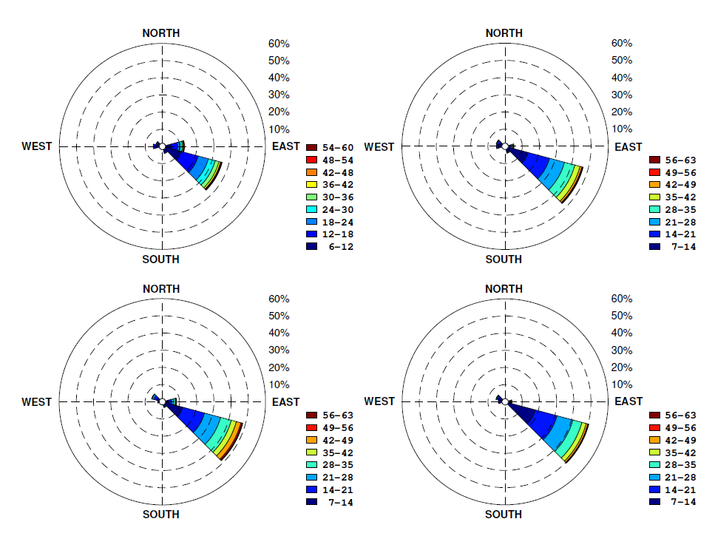

Figure S2. Stick plots of the hourly averaged measured current at different distances from the sea
floor.
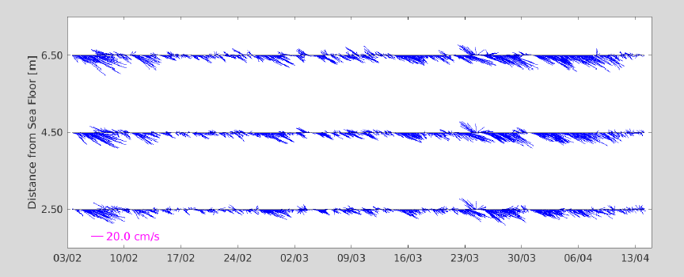

Figure S3. Spatial distribution of abundance (N individual/m²) of the different families of Polychaeta (a). Mollusca (b) and Crustacea (c) along transects and depths. C1. C2 and C3 are the Control transects. M1. M2 and M3 are the SNI transects.
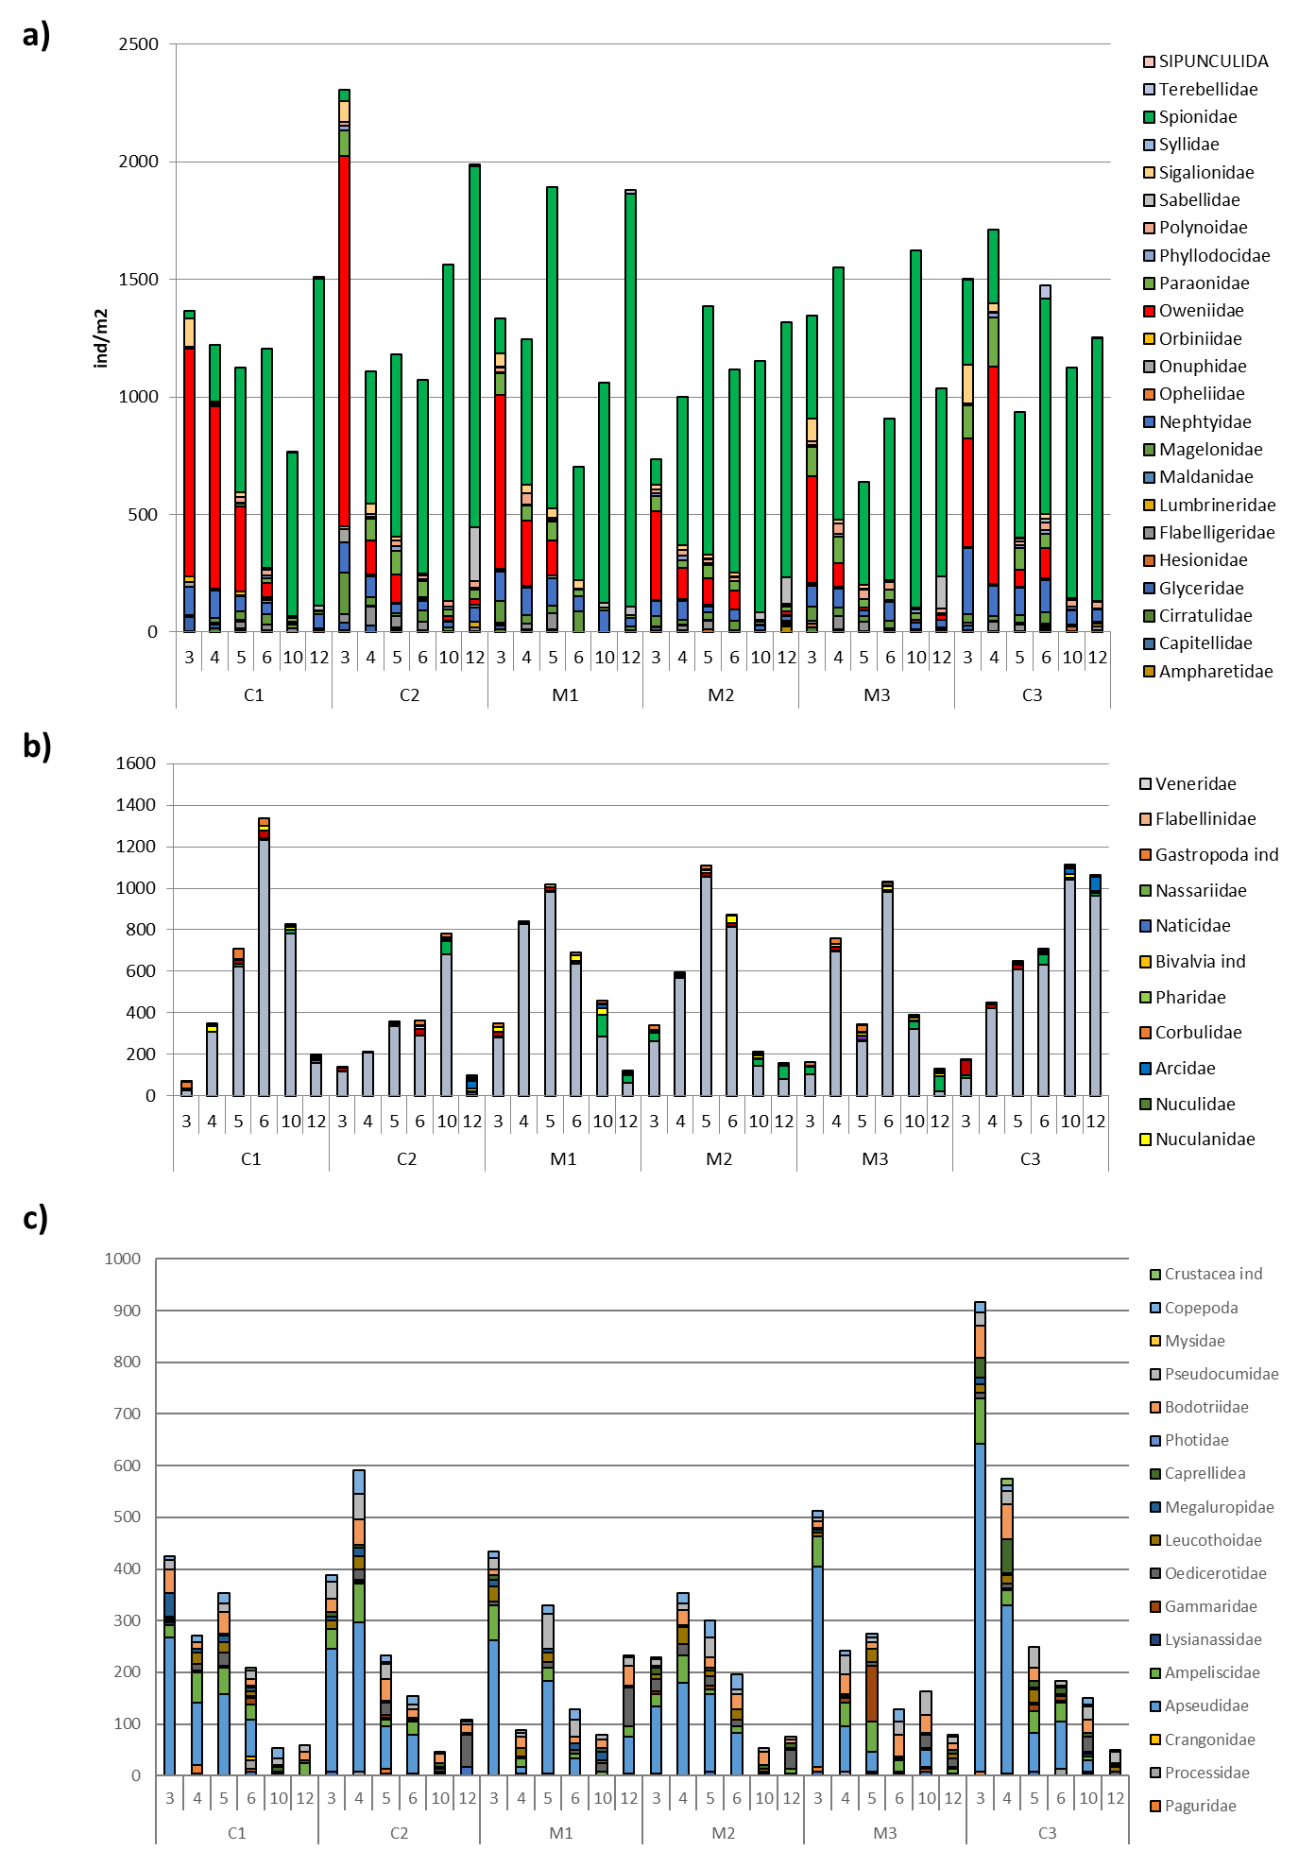
Figure S4. Plot of AMBI index per station (blue dots) in the study area. colours indicate the ecological status of each sample from dark blue corresponding to undisturbed community to red indicating extremely disturbed community. C1. C2 and C3 are the Control transects. M1. M2 and M3 are the SNI transects. Numbers indicate the depth (in m) of each station.
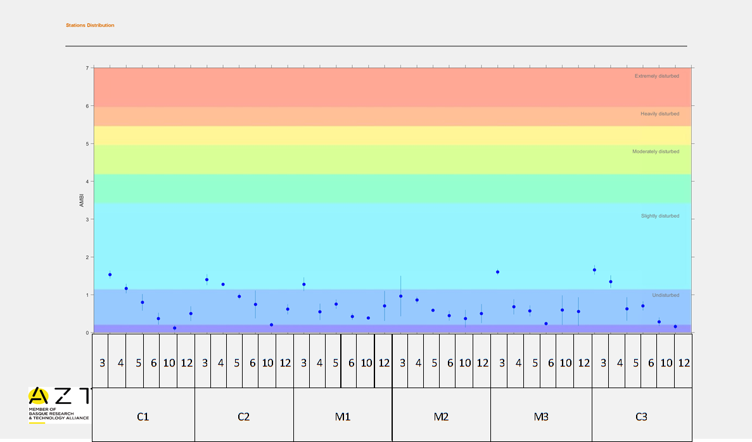

Figure S5. Plot of M-AMBI index per station in the study area. colours indicate the ecological status of each sample from blue corresponding to high ecological status to red indicating communities in bad ecological conditions. C1. C2 and C3 are the Control transects. M1. M2 and M3 are the SNI transects. Numbers indicate the depth (in m) of each station.

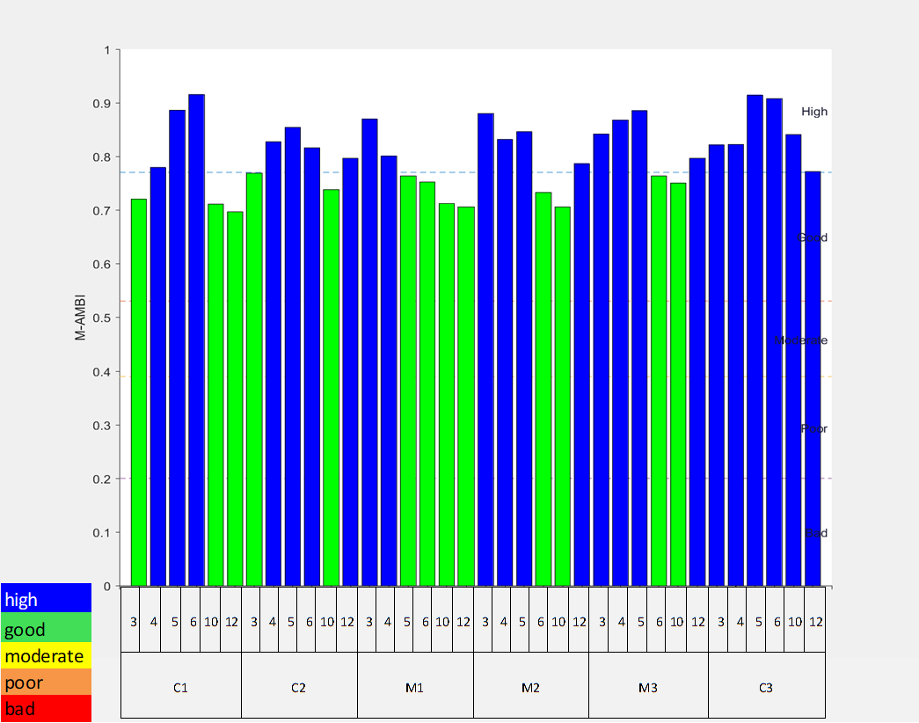

Figure S6. Photomosaic of the Sabellaria spinulosa reefs in the Site of National Interest (SNI) area.
