Supplementary Material

Supplementary Tables

Table S1. Baseline patient characteristics.

 | D group  N=44 | VTd group  N=50
Male sex, n (%) | 24 (54) | 24 (48)
Age, yrs, median (range) | 61 (36-73) | 60 (41-72)
Age >65 yrs, n (%) | 7 (16) | 9 (18)
Hb <10 g/dL, n (%) | 10 (23) | 10 (20)
Ca >11 mg/dL, n (%) | 6 (14) | 2(4)
Bone lesions, n (%) | 33 (75) | 37 (74)
CrCl <40 mL/min, n (%) | 5 (11) | 2 (4)
ISS
I, n (%) | 19 (43) | 28 (56)
II, n (%) | 9 (20) | 12 (24)
III, n (%) | 13 (29) | 6 (12)
unknown, n (%) | 3 (7) | 4 (8)
R-ISS
I, n (%) | 10 (23) | 17 (34)
II, n (%) | 19 (43) | 23 (46)
III, n (%) | 5 (11) | 1 (2)
unknown, n (%) | 10 (23) | 9 (18)
Cytogenetic risk
standard, n (%) | 25 (57) | 28 (56)
high*, n (%) | 12 (27) | 15 (30)
unknown, n (%) | 7 (16) | 7 (14)
BMPC >60%, n (%) | 22 (50) | 12 (24)

*Cytogenetic high risk: any of t(4;14), t(14;16), t(14;20), del(17p).

Abbreviations: BMPC, bone marrow plasma cells; Ca, serum calcium; CrCl, creatinine clearance; D, daratumumab; Hb, haemoglobin; ISS, International Staging System; n, number; R-ISS, Revised-International Staging System; yrs, years; VTd, bortezomib-thalidomide-dexamethasone.
Table S2. Induction therapy and mobilization therapy.

 | D group  N=44 | VTd group  N=50
Induction therapy
DVTd, n (%) | 26 (59) | 0 (0)
DVCd, n (%) | 10 (41) | 0 (0)
VTd, n (%) | 0 (0) | 50 (100)
Number of cycles
4, n (%) | 34 (77) | 29 (58)
5, n (%) | 0 (0) | 10 (20)
6, n (%) | 10 (23) | 11 (22)
Best response
less than PR, n (%) | 0 | 0
PR, n (%) | 11 (25) | 15 (30)
VGPR, n (%) | 23 (52) | 21 (42)
CR, n (%) | 9 (20) | 12 (24)
sCR, n (%) | 1 (2) | 2 (4)
End of therapy to CY, days, median (range) | 34 (3-79) | 17 (0-63)
CY dose
2 g/m², n (%) | 26 (59) | 40 (80)
3 g/m², n (%) | 18 (41) | 10 (20)
Collection goal
1 ASCT, n (%) | 23 (52) | 5 (10%)
2 ASCTs, n (%) | 21 (48) | 45 (90)

Abbreviations: ASCT, autologous stem cell transplant; CR, complete response; CY, cyclophosphamide; DVTd, Daratumumab-bortezomib-thalidomide-dexamethasone; DVCd, Daratumumab-bortezomib-cyclophosphamid-dexamethasone; PR, partial response; sCR, stringent complete response; VGPR, very good partial response; VTd, bortezomib-thalidomide-dexamethasone.

Supplementary Figures

Figure S1. Total CD34+ cell yield in daratumumab-treated patients and VTd-treated patients.

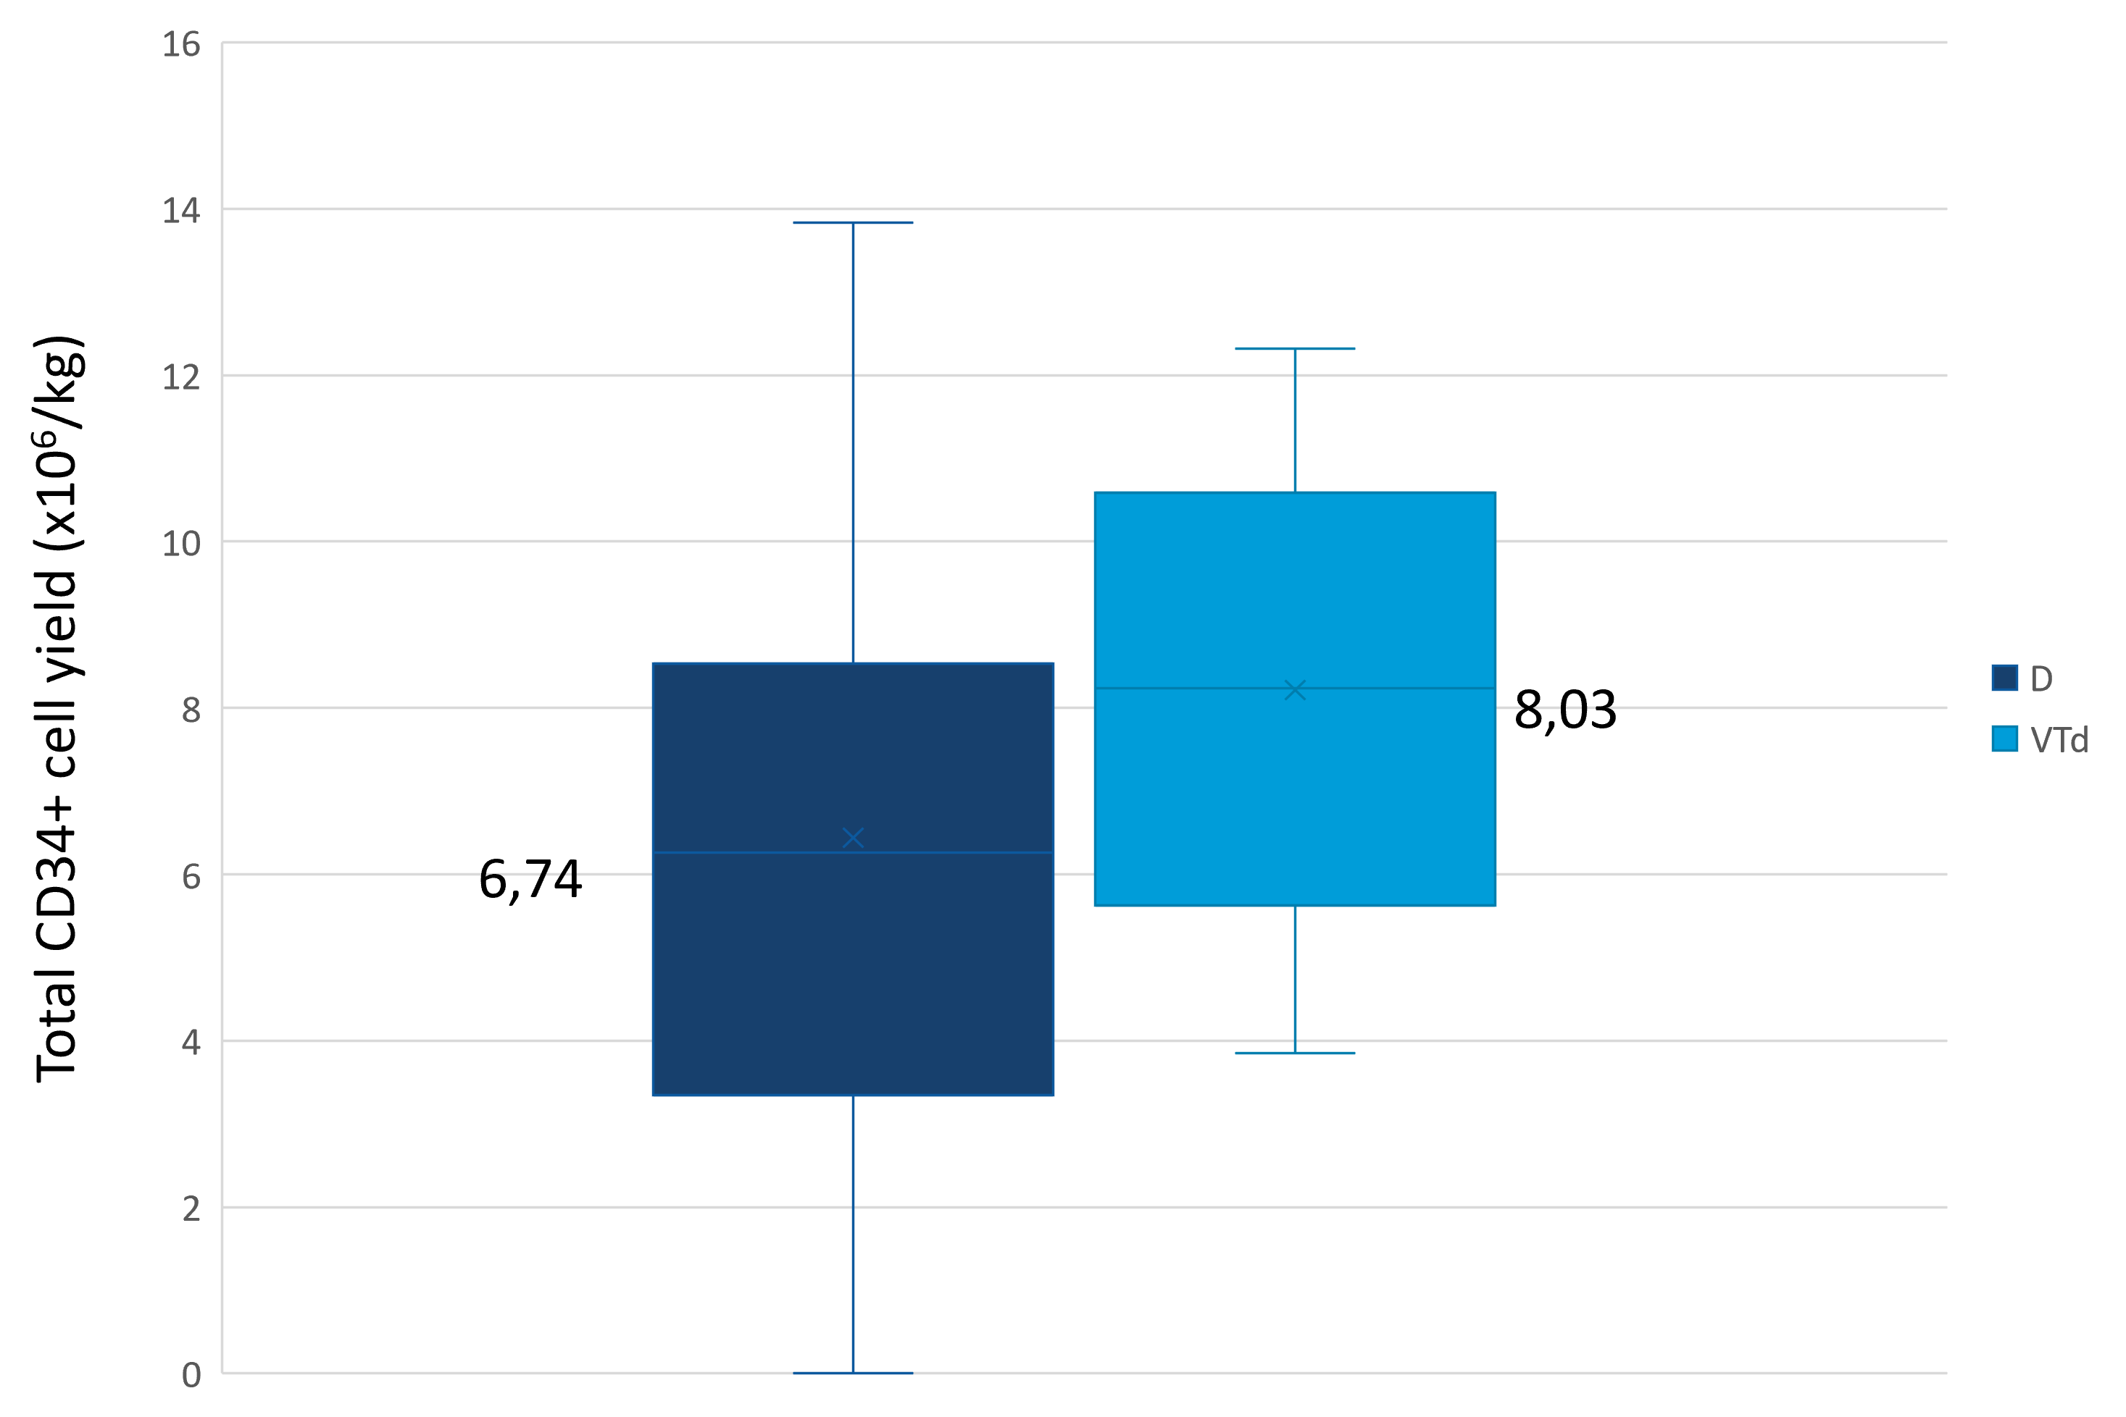

Supplementary Figure 1. A lower level of median CD34+ collected cells was observed in D-treated patients (N=44) compared with controls (VTd-treated pts, N=50) (6.74 vs 8.03 x 10⁶ CD34+ cells/kg, p=0.06).

Figure S2. CD34+ cells collected before and after each dose of plerixafor (PLX) for each D- (daratumumab) treated patient.

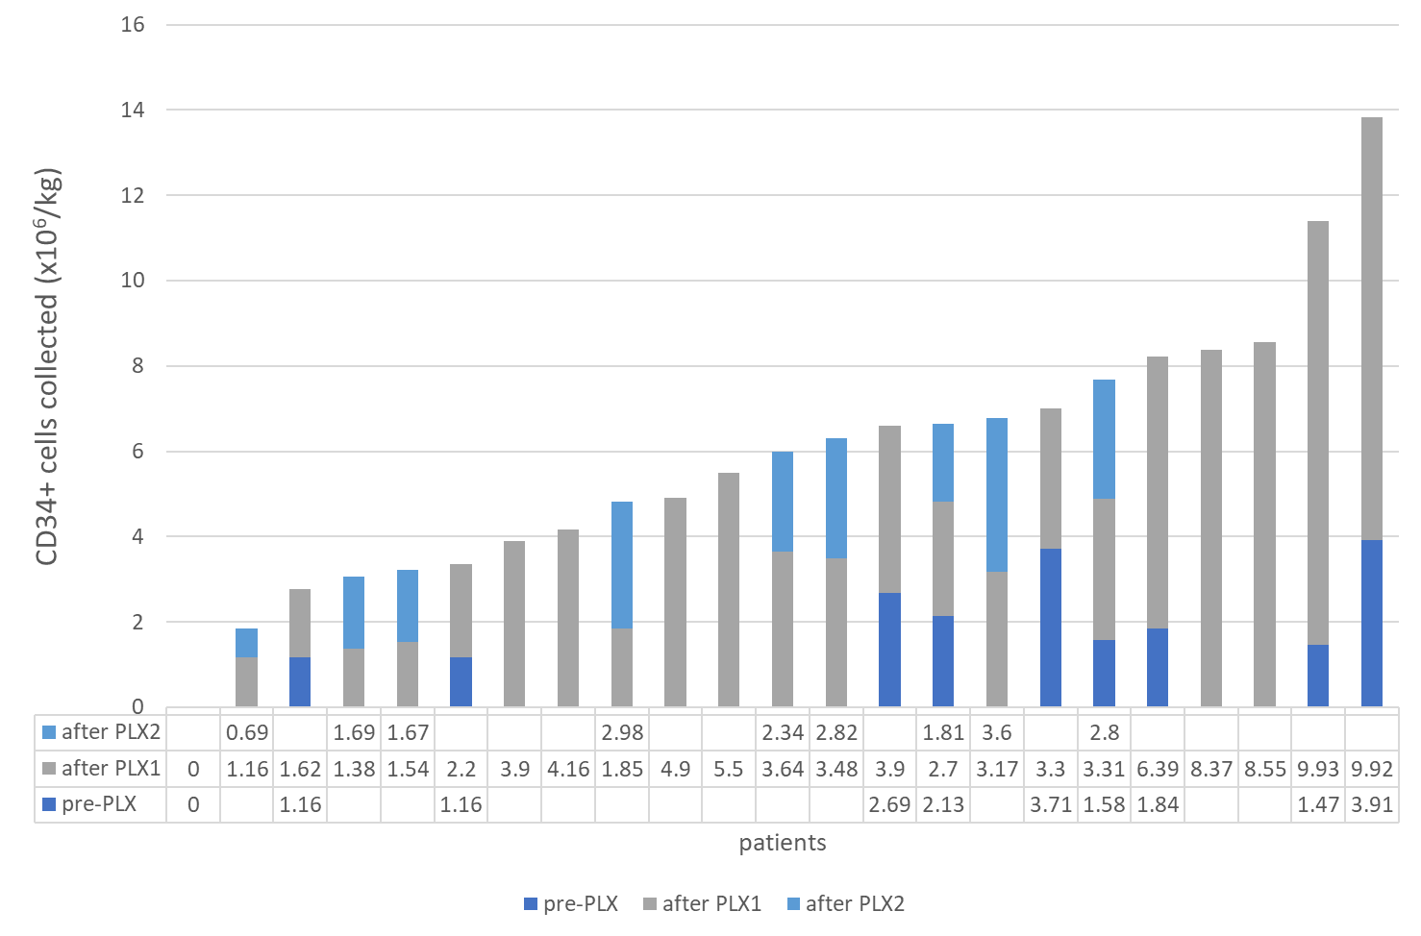
Supplementary Figure 2. PLX, plerixafor; PLX1, first dose of plerixafor; PLX2, second dose of plerixafor.

