A detailed characterization study of Ni/CeO₂ catalysts identifies Ni availability as the primary factor affecting CO₂ methanation performance
Sining Chen^{1,2}, Luke Higgins^{2,3}, Ilenia Giarnieri^{4,5}, Patricia Benito^{4,5}, Andrew M. Beale^{1,2,*}

¹Department of Chemistry, University College London, 20 Gordon Street, WC1H 0AJ, UK
²Research Complex at Harwell, Rutherford Appleton Laboratories, Harwell Science and Innovation Campus, Harwell, Didcot, OX11 0FA, UK
³Diamond Light Source, Rutherford Appleton Laboratories, Harwell Science and Innovation Campus, Harwell, Didcot, OX11 0FA, UK
⁴Department of Industrial Chemistry “Toso Montanari”, Alma Mater Studiorum – Università di Bologna, Viale Risorgimento, 4, 40136, Bologna, Italy
⁵Center for Chemical Catalysis – C3, Alma Mater Studiorum – Università di Bologna, Viale Risorgimento 4, 40136, Bologna, Italy
Supplementary information

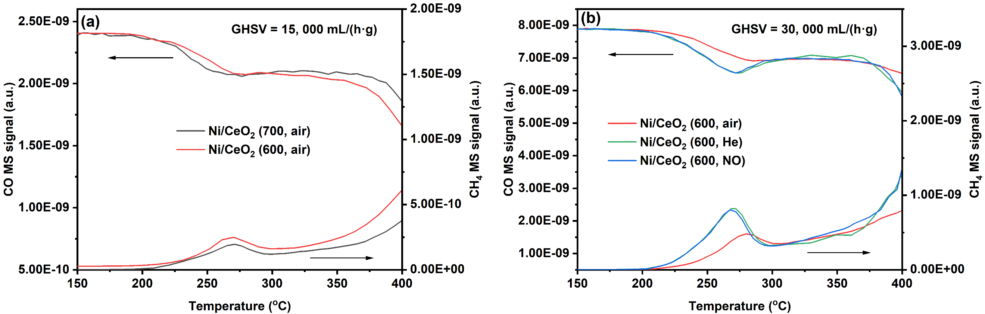
Fig. S1. CO hydrogenation over (a) Ni/CeO₂ (600, air) and Ni/CeO₂ (700, air) at the GHSV = 15, 000 mL/(h·g), and (b) Ni/CeO₂ (600, air), Ni/CeO₂ (600, He) and Ni/CeO₂ (600, NO) at the GHSV = 30, 000 mL/(h·g).

The CO hydrogenation experiments of different catalysts was also carried out to have a better understanding on the role of CO during the reaction, as displayed in Fig. S1. It can be seen that all samples exhibit much worse performance for CO hydrogenation with conversion being less than 20 % at 270 °C. The CO hydrogenation ability over these catalysts can be ranked according to the CH₄ formation, with the order being Ni/CeO₂ (600, He) ~ Ni/CeO₂ (600, NO) ＞Ni/CeO₂ (600, air) ＞Ni/CeO₂ (700, air).
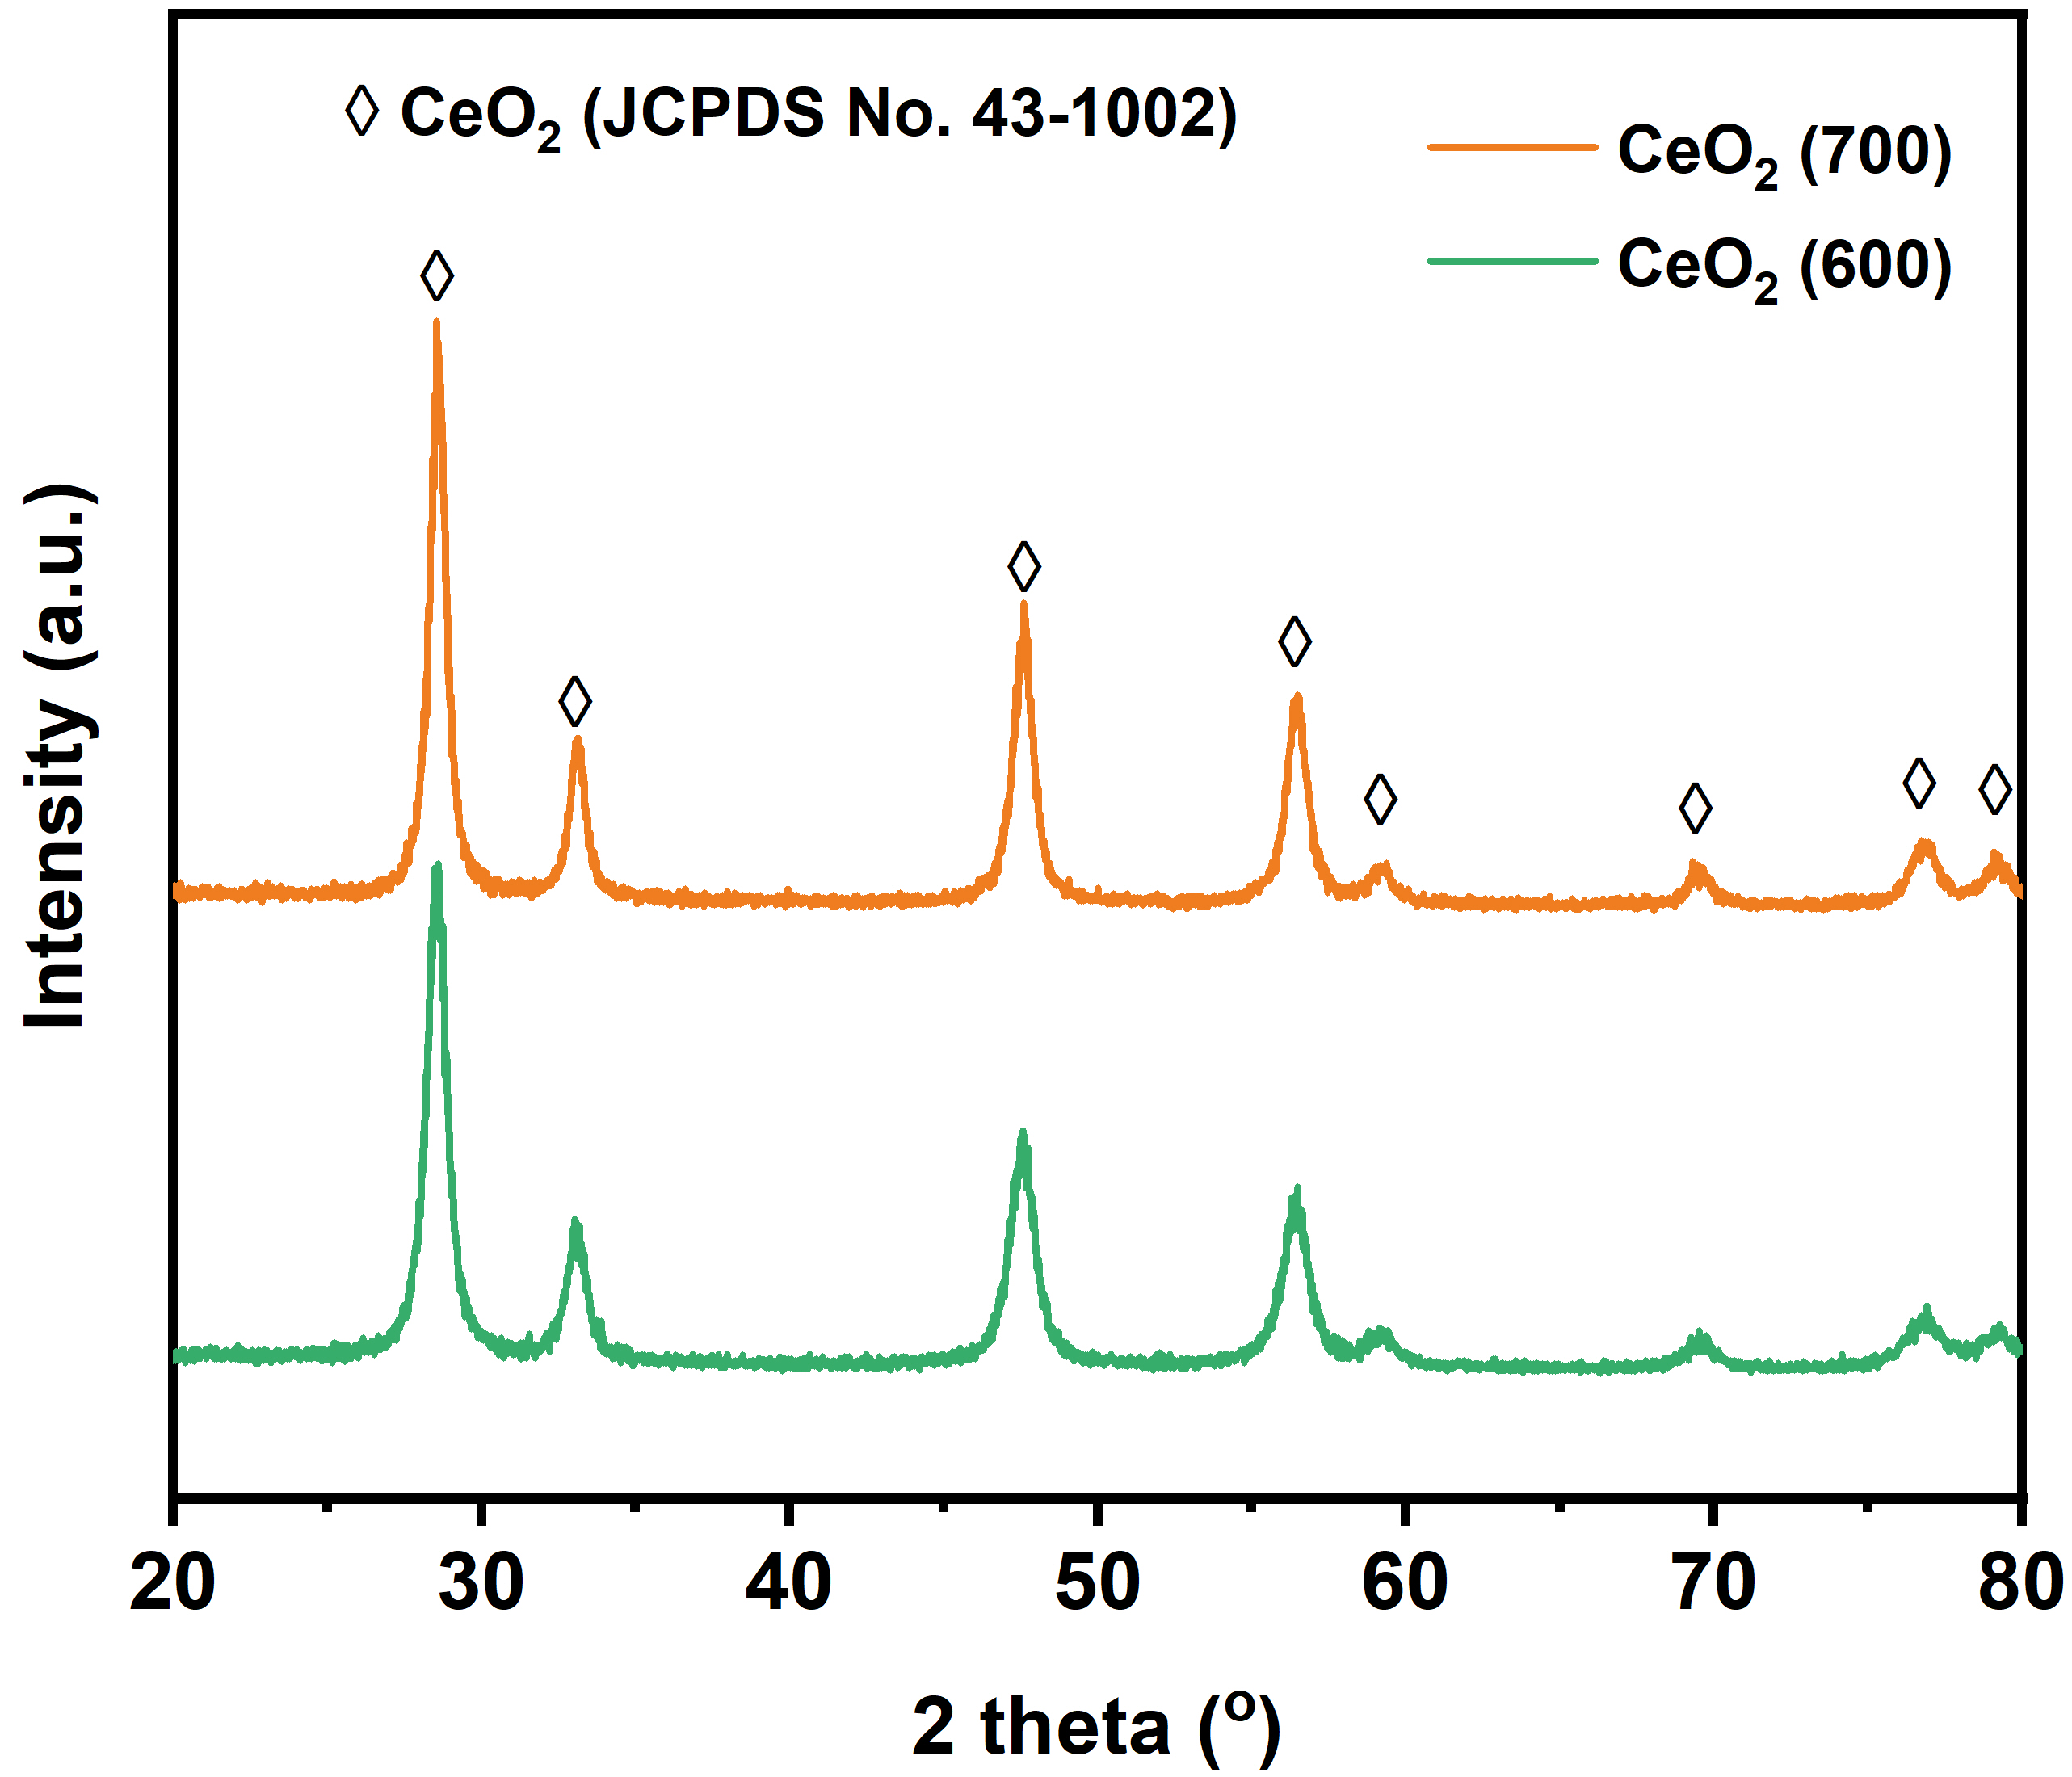
Fig. S2. XRD patterns of CeO₂ (600) and CeO₂ (700) recorded in lab-based Rigaku XRD instrument at the range of 2θ = 20−80°, Phase compositions: CeO₂ (JCPDS No. 43-1002).

The pure CeO₂ supports calcined at 600 and 700 °C were also measured, as seen in Fig. S2. For the pure CeO₂ supports calcined at different temperatures, cerianite-styled CeO₂ (JCPDS No. 43-1002) were formed with the 2θ diffraction peaks at 28.55, 33.08, 47.48, 56.34, 59.09, 69.40º, 76.70 and 79.04 °. The intensity of these diffraction peaks indicates an obvious increase in the crystallinity of CeO₂ calcined at higher temperatures.

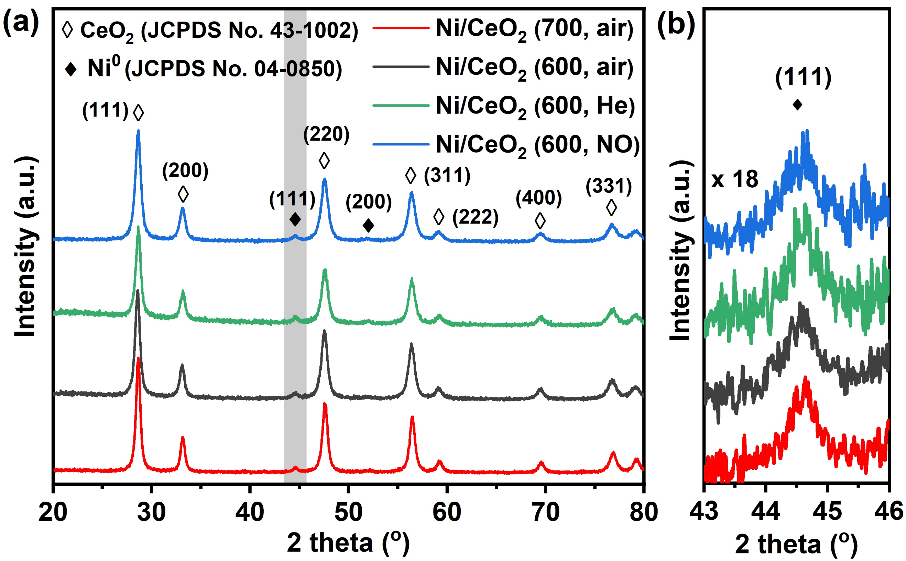
Fig. S3. XRD patterns of Ni/CeO₂ (600, air), Ni/CeO₂ (700, air), Ni/CeO₂ (600, He) and Ni/CeO₂ (600, NO) recorded in Rigaku XRD instrument at the range of (a) 2θ = 20−80° and (b) 2θ = 43−46°, Phase compositions: CeO₂ (JCPDS No. 43-1002), Ni0 (JCPDS No. 04-0850).
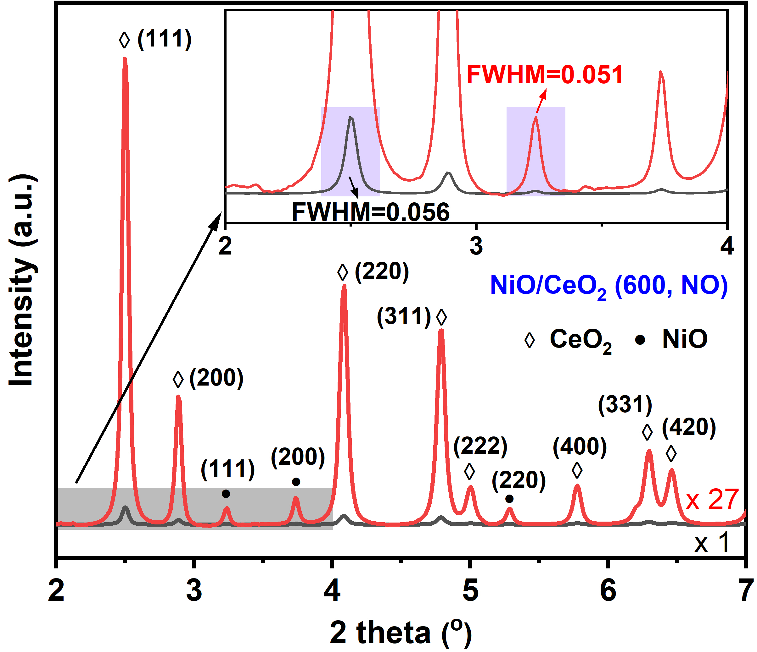
Fig. S4. Synchrotron XRD profiles of NiO/CeO₂ (600, NO) at different Y-axis magnifications (×1 and ×27)

Table S1. Position and full width at half maximum (FWHM) of CeO₂ (111) and Ni(O) (111) in synchrotron XRD profiles
Samples | CeO₂ (111) |  | NiO (111) |  | Ni (111)
Samples | Position | FWHM | Position | FWHM | Position | FWHM
NiO/CeO₂ (600, air) | 2.4979(1) | 0.056(1) | 3.231(2) | 0.052(8) | / | /
NiO/CeO₂ (700, air) | 2.4978(9) | 0.043(3) | 3.231(1) | 0.044(5) | / | /
NiO/CeO₂ (600, He) | 2.4988(2) | 0.056(1) | 3.232(3) | 0.047(9) | / | /
NiO/CeO₂ (600, NO) | 2.4989(1) | 0.056(1) | 3.231(2) | 0.051(8) | / | /
Ni/CeO₂ (600, air) | 2.4962(1) | 0.049(1) | / | / | 3.834(2) | 0.058(7)
Ni/CeO₂ (700, air) | 2.4965(1) | 0.041(1) | / | / | 3.833(1) | 0.050(4)
Ni/CeO₂ (600, He) | 2.4962(1) | 0.050 (1) | / | / | 3.834(1) | 0.056(5)
Ni/CeO₂ (600, NO) | 2.4961(1) | 0.053(1) | / | / | 3.833(1) | 0.055(6)
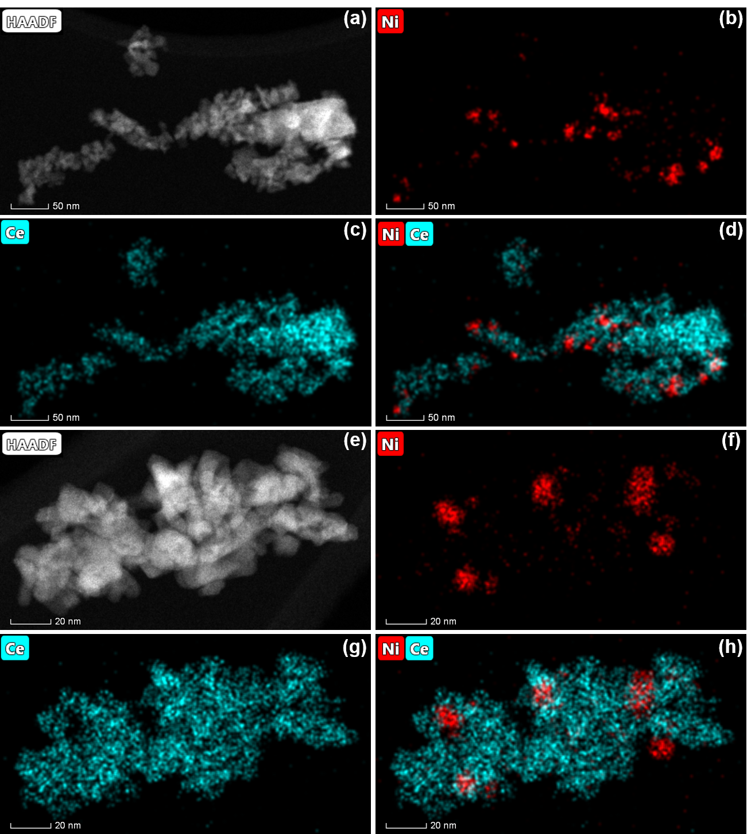
Fig. S5. HAADF images and EDX maps (Ni and Ce) of Ni/CeO₂ (600, air)

Table S2. Atomic percentage of the surface Ni, Ce and O over different samples
Sample | Ni (at %) | Ce (at %) | O (at %) | Ni/Ce (at/at %)
NiO/CeO₂ (600, air) | 7.6 | 14.41 | 78.0 | 0.52
NiO/CeO₂ (700, air) | 9.3 | 13.78 | 76.9 | 0.68
NiO/CeO₂ (600, He) | 5.7 | 11.50 | 82.8 | 0.49
NiO/CeO₂ (600, NO) | 9.2 | 19.58 | 71.3 | 0.47
Ni/CeO₂ (600, air) | 5.7 | 26.8 | 67.5 | 0.21
Ni/CeO₂ (700, air) | 6.9 | 23.2 | 69.9 | 0.30
Ni/CeO₂ (600, He) | 5.5 | 44.0 | 50.5 | 0.13
Ni/CeO₂ (600, NO) | 3.9 | 47.1 | 49.0 | 0.08

The survey spectra were scanned up to 1100 eV, with the relative percentage of each element is given in Table S2. The inelastic mean free paths (IMFP) of the photoelectrons from Ni 2p and Ce 3d are respectively 11.1 and 13.6 Å, suggesting that the mean escape depth of electrons and the probing depth in the Ni(O)/CeO₂ are within 20 % of each other [1]. It is therefore reasonable to evaluate the surface element composition over the different samples from the results given in Table S2. For the NiO/CeO₂, it can be observed that the Ni/Ce ratio is in the following order: NiO/CeO₂ (600, NO) < NiO/CeO₂ (600, He) < NiO/CeO₂ (600, air) < NiO/CeO₂ (700, air), respectively. The lower surface Ni/Ce ratio can be achieved on the catalyst with smaller Ni crystallite size, suggesting the presence of ultra-small nanoparticles which cannot be detected by XPS. A slightly decreased Ni/Ce ratio over the NO calcined sample could explain its highest Ni dispersion to some extent, as the presence of ultrasmall Ni species can go into the CeO₂ structure more easily. The surface Ni/Ce ratio on the reduced catalysts are also given in Table S2, which are around 0.21, 0.30, 0.13 and 0.08 on the Ni/CeO₂ (600, air), Ni/CeO₂ (700, air), Ni/CeO₂ (600, He) and Ni/CeO₂ (600, NO), respectively. We propose that the decrease in surface Ni over all the Ni/CeO₂ can be explained by the encapsulation of Ni by the coverage of CeO_{x} layers after the reduction, due to the formation of a strong metal-support interaction (SMSI) over the Ni/CeO₂ [2-4]. However, the extent of SMSI over these Ni/CeO₂ catalysts are difficult to estimate and compare based on the Ni/Ce ratio as the Ni/Ce ratio can be significantly affected by the Ni NP size, SMSI and the NiO film formed during O₂ passivation etc.

Table S3. Number of Ni sites (mmol/g) and Ni coverage (%) over different Ni/CeO₂ catalysts
Sample | N_{Ni-sites, expected} (mmol/g)ª | H₂-TPD |  | CO chemisorption
Sample | N_{Ni-sites, expected} (mmol/g)ª | N_{Ni-sites, H2} (mmol/g)^{b} | Ni coverage (%)^{b} |  | N_{Ni-sites, CO} (mmol/g)^{c} | Ni coverage (%)^{c}
Ni/CeO₂ (600, air) | 0.250 | 0.095 | 61.8 |  | 0.049 | 80.3
Ni/CeO₂ (700, air) | 0.199 | 0.057 | 71.3 |  | 0.025 | 87.5
Ni/CeO₂ (600, He) | 0.265 | 0.080 | 69.7 |  | 0.039 | 85.3
Ni/CeO₂ (600, NO) | 0.330 | 0.115 | 65.0 |  | 0.058 | 82.4
ª Estimated from Ni dispersion D_{Ni} ^{b} Estimated from H₂-TPD ^{c} Estimated from CO chemisorption
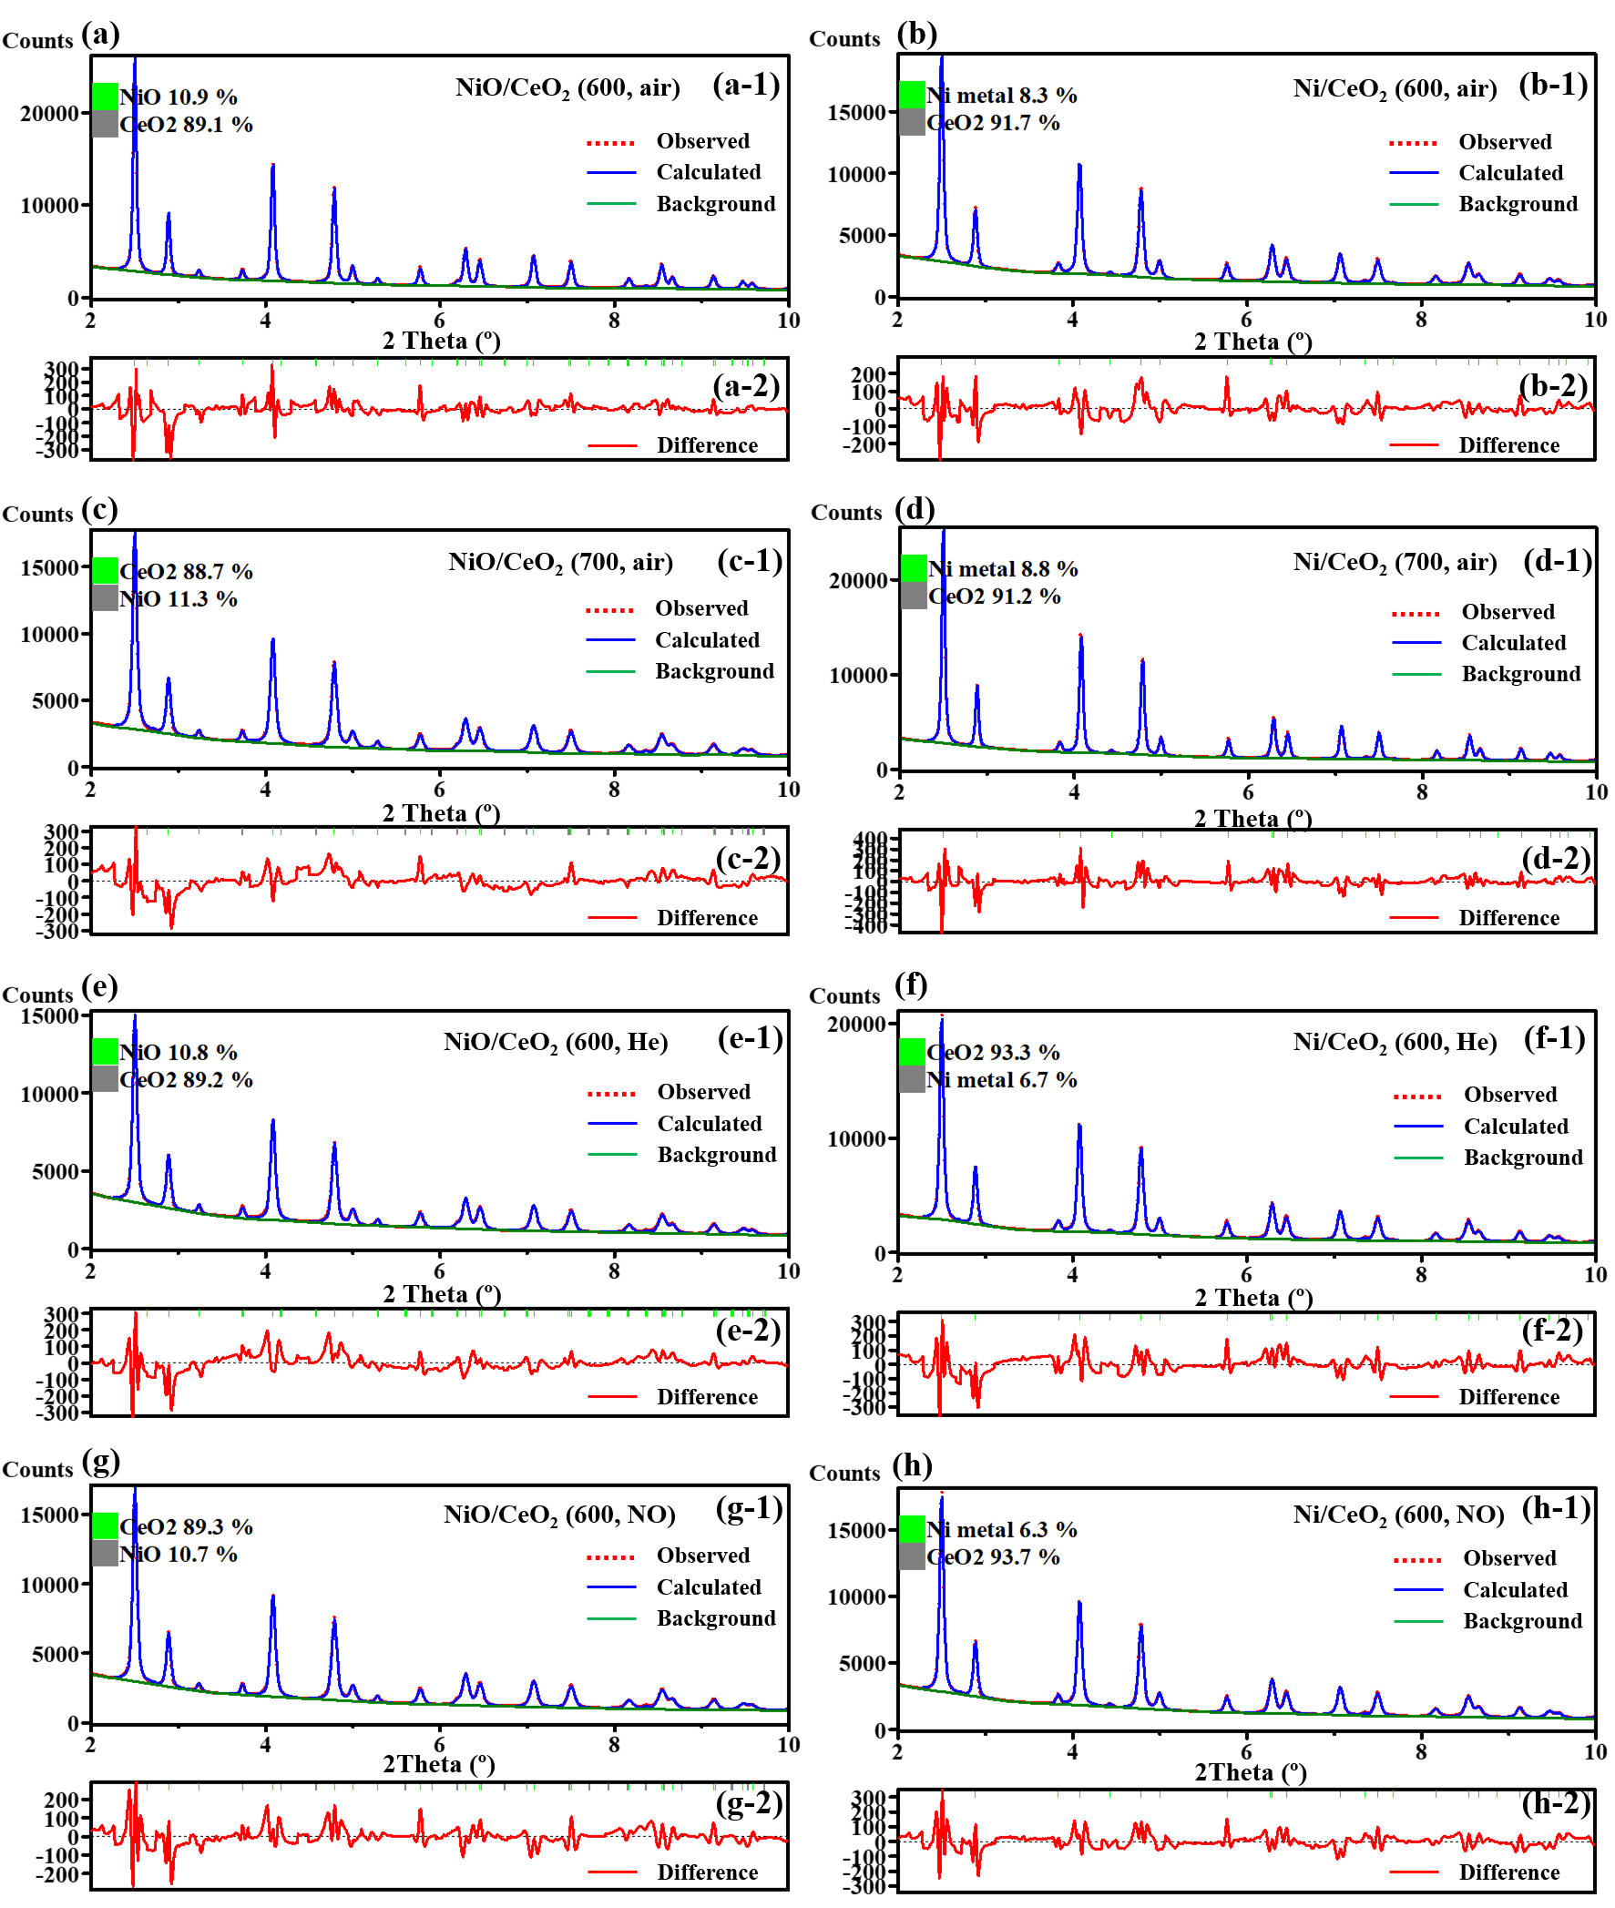
Fig. S6. Results (background, observed data, calculated data and differences) of Rietveld refinement over various NiO/CeO₂ and Ni/CeO₂. (a) NiO/CeO₂ (600, air), (b) Ni/CeO₂ (600, air), (c) NiO/CeO₂ (700, air), (d) Ni/CeO₂ (700, air), (e) NiO/CeO₂ (600, He), (f) Ni/CeO₂ (600, He), (g) NiO/CeO₂ (600, NO) and (h) Ni/CeO₂ (600, NO)
Table S4. Crystalline (NiO, Ni and CeO₂) weight percentages and Ni loadings over the NiO/CeO₂ and Ni/CeO₂ estimated by the Rietveld refinement.
Samples | Crystalline percentage (wt%) |  |  | Ni loadings (wt. %) | Weighed profile R-factor (Rwp) | Goodness of fitting
Samples | CeO₂ | NiO | Ni⁰ | Ni loadings (wt. %) | Weighed profile R-factor (Rwp) | Goodness of fitting
NiO/CeO₂ (600, air) | 89.1 | 10.9 | / | 9.6 | 2.79 | 1.74
NiO/CeO₂ (700, air) | 88.7 | 11.3 | / | 10.0 | 2.41 | 1.38
NiO/CeO₂ (600, He) | 89.2 | 10.8 | / | 9.5 | 2.24 | 1.07
NiO/CeO₂ (600, NO) | 89.3 | 10.7 | / | 9.4 | 2.77 | 1.68
Ni/CeO₂ (600, air) | 91.7 | / | 8.3 | 9.1 | 2.48 | 1.29
Ni/CeO₂ (700, air) | 91.2 | / | 8.8 | 9.6 | 2.54 | 1.31
Ni/CeO₂ (600, He) | 93.3 | / | 6.7 | 7.2 | 2.43 | 1.35
Ni/CeO₂ (600, NO) | 93.7 | / | 6.3 | 6.7 | 2.16 | 1.03

Table S5. Liner composition fitting results of the Ni/CeO₂ sample calcined at different atmospheres (air, He and NO)
Sample | NiO (%) | Ni⁰ (%) | χ²
Ni/CeO₂ (600, air) | 20.5 | 79.5 | 0.026
Ni/CeO₂ (700, air) | 39.3 | 60.7 | 0.070
Ni/CeO₂ (600, He) | 30.0 | 70.0 | 0.084
Ni/CeO₂ (600, NO) | 32.4 | 67.6 | 0.059

Table S6. EXAFS fitting information of the first shell of the Ni/CeO₂ samples
Sample | 1st Shell | R (Å) | C.N. | σ² (Å²) | ΔE₀ (eV)
Ni/CeO₂ (600, air) | Ni−Ni (Ni⁰) | 2.485 ± 0.003 | 8.7 ± 0.9 | 0.006 ± 0.003 | 1.15
Ni/CeO₂ (700, air) | Ni−Ni (Ni⁰) | 2.493 ± 0.007 | 7.7 ± 1.7 | 0.006 ± 0.002 | 2.58
Ni/CeO₂ (600, He) | Ni−Ni (Ni⁰) | 2.486 ± 0.004 | 8.1 ± 1.1 | 0.006 ± 0.001 | 1.35
Ni/CeO₂ (600, NO) | Ni−Ni (Ni⁰) | 2.489 ± 0.005 | 7.7 ± 1.3 | 0.006 ± 0.001 | 1.83
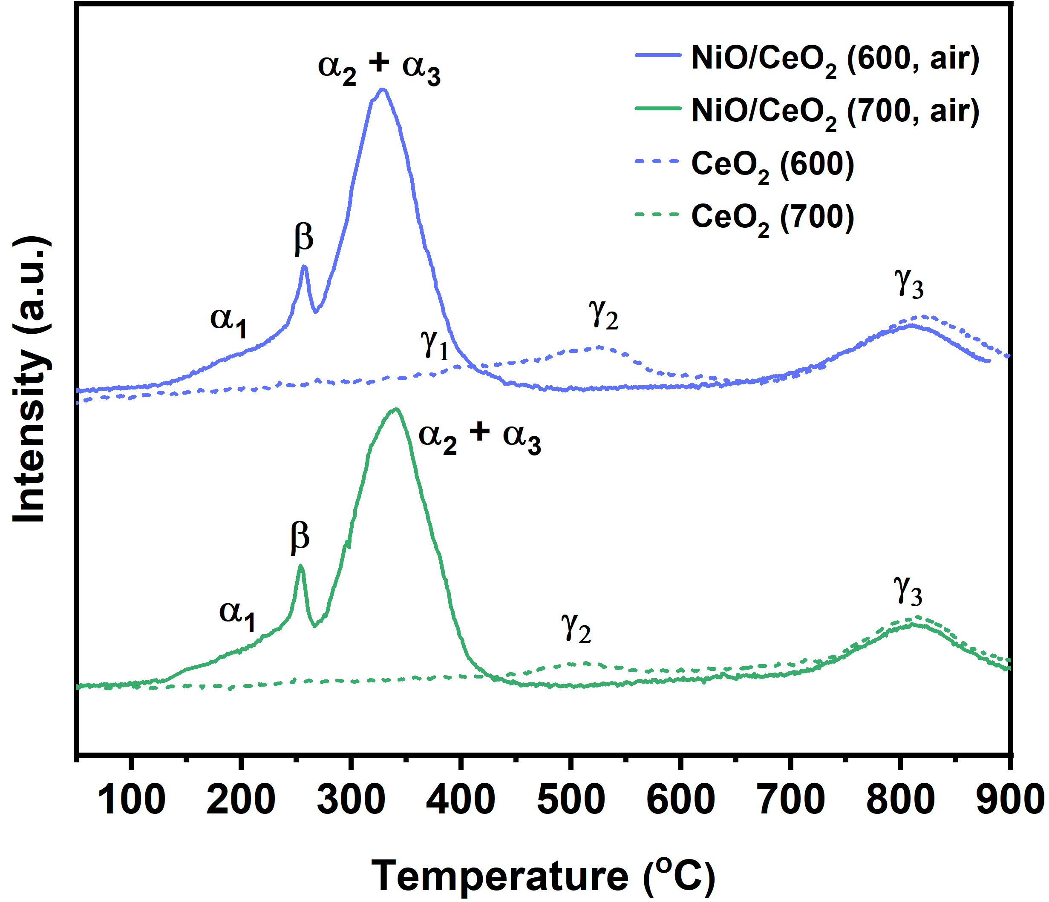
Fig. S7. TPR profiles of the NiO/CeO₂ (600, air), NiO/CeO₂ (700, air) and their supports CeO₂

In order to clearly investigate the reduction performance of surface CeO₂ species, the H₂-TPR analysis were also carried out over the pure CeO₂ (600) and CeO₂ (700), the results of which are displayed in Fig. S7. For the pure CeO₂, apart from the reduction process of bulk CeO₂ (γ₃) at around 800 °C, two reduction peaks (γ₁ and γ₂) attributed to be the reduction of surface oxygen on CeO₂ are also detected at low temperatures (300−600 °C). The intensities of peaks γ₁ and γ₂ decrease at a higher calcination temperature of CeO₂, most likely as a consequence of decreased surface area with increased calcination temperature.

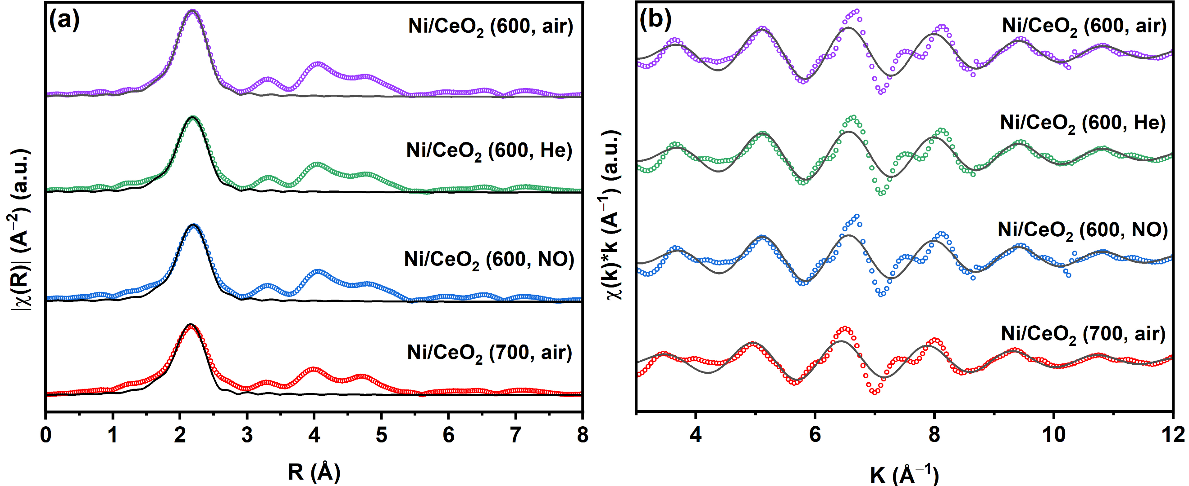
Fig. S8. Ni K-edge EXAFS fitting results of the (c) R and (d) k space based on the Ni−Ni (Ni⁰) path over the Ni/CeO₂. Short dots: raw data. Solid line: fitting data.
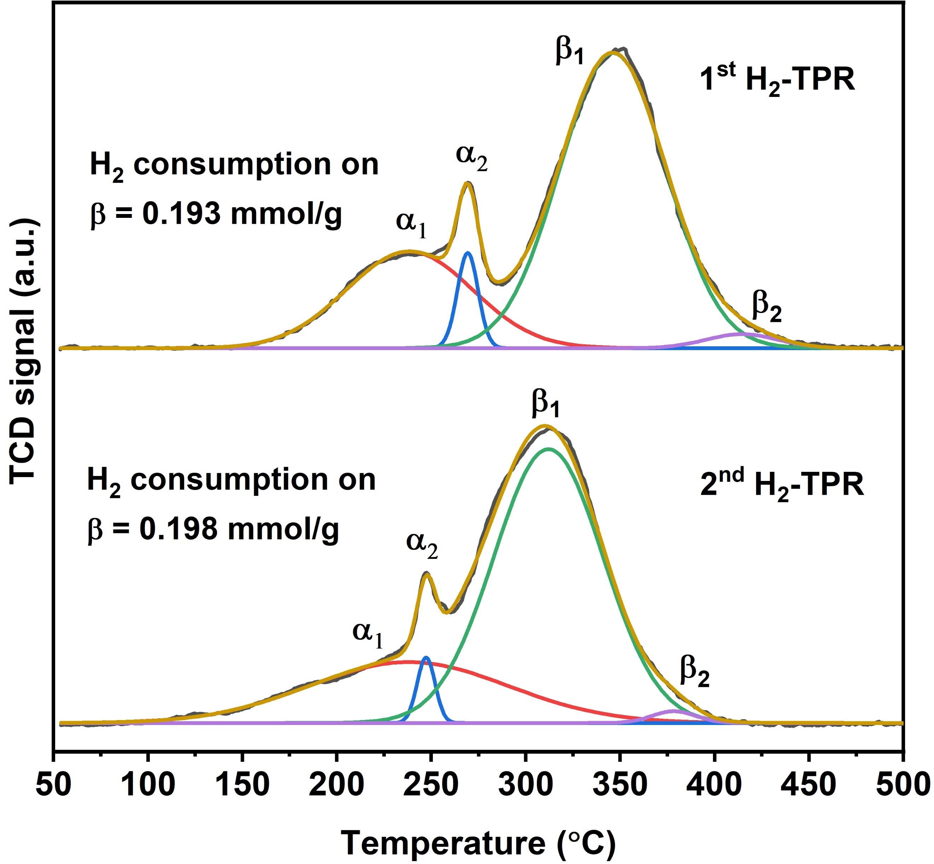
Fig. S9. 1st H₂-TPR profile of the NiO/CeO₂ (600, air) and 2nd H₂-TPR profile after the in situ oxidisation (O₂ pulse) of the reduced sample
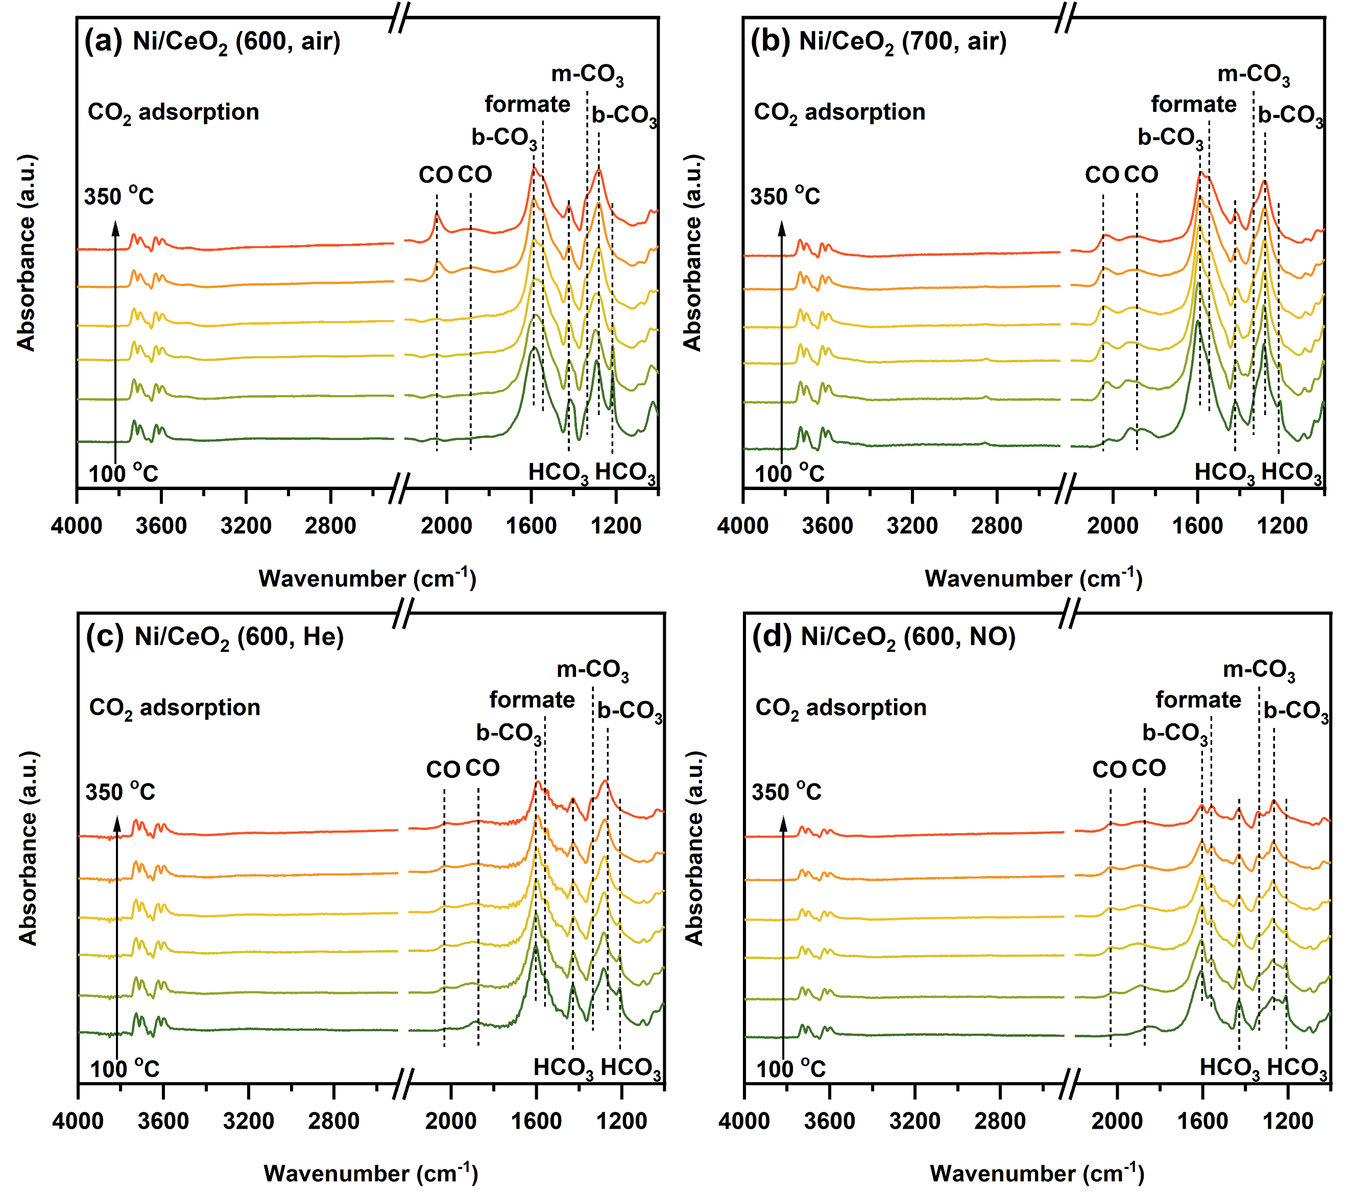
Fig. S10. In situ DRIFTS profiles of CO₂ adsorption at different temperatures over (a) Ni/CeO₂ (600, air), (b) Ni/CeO₂ (700, air), (c) Ni/CeO₂ (600, He) and (d) Ni/CeO₂ (600, NO). Each spetrum was collected from 100 to 400 °C with the interval of 50 °C. The wavelength region is 4000−1000 cm⁻¹.

The CO₂ adsorption performance over different reduced samples is displayed in Fig. S10. For all the samples, the typical CO₂ association species (carbonates and bicarbonates) are observed on all the samples in the region of 2250−1000 cm⁻¹ after the introduction of 20% CO₂ flowing gas. Carbonate species can be divided as two main types, including bidentate carbonates (~1590 cm⁻¹) and monodentate carbonates (~1336 cm⁻¹) [5, 6]. Bicarbonates, generated from monodentate carbonate and surface OH groups on Ce sites, can also be seen at around 1480 cm⁻¹, 1428 cm⁻¹, and 1212 cm⁻¹ [6, 7]. The adsorbed CO₂ on the Ni⁰ active sites also benefit the CO formation with the linear CO (2100−1950 cm⁻¹) and bridge CO (1950−1750 cm⁻¹) seen in the spectra [8]. The reaction process is regarded as the CO₂ dissociation (CO_{2(ads)} → CO_{(ads)} + O_{(ads)}). In addition, the bands at 1550 and 1290 cm⁻¹ assigned as the formate are observed, indicating the reaction between chemisorbed CO₂ and dissociated H on the Ni⁰ sites after reduction [9, 10]. It can be seen that the reaction between surface OH groups and CO₂ occur more easily at high temperatures over all the samples, accompanied by a slightly increase in bicarbonate species (1490−1420 cm⁻¹). However, the formate species at around 1550 cm⁻¹ and 1290 cm⁻¹ decrease significantly with the increasing temperature over the different Ni/CeO₂ samples, which implicit the thermal unstable properties of the formate species. The thermal instability of carbonates and formate over the Ni/CeO₂ (600, NO) could indicate its highest reactivity of these species, thereby leading to its highest catalytic performance in CO₂ methanation. The CO₂ dissociation is similar to the reverse water gas shift (RWGS) reaction which produces CO from CO₂ and H₂ (CO₂ + H₂ → CO + H₂O). One possible mechanism of RWGS is regarded as the oxidation of oxygen vacancies over the support by CO₂, followed by the formation of Ni-carboxyl species [11]. Therefore, the CO formation route by CO₂ dissociation over the Ni/CeO₂ catalysts can be proposed. One of the O atoms of CO₂ can go into the oxygen vacancies on Ce³⁺ sites, and then dissociated CO* moves to active Ni⁰ sites. The role of oxygen vacancies in CO₂ dissociation was also studied over the CeO₂ [12]. It should be noted in Fig. S10 that the intensities of CO bands over Ni/CeO₂ (600, air) gradually increase with the adsorption temperature getting higher, indicating its higher dissociation ability of CO₂ at the higher temperature [13].
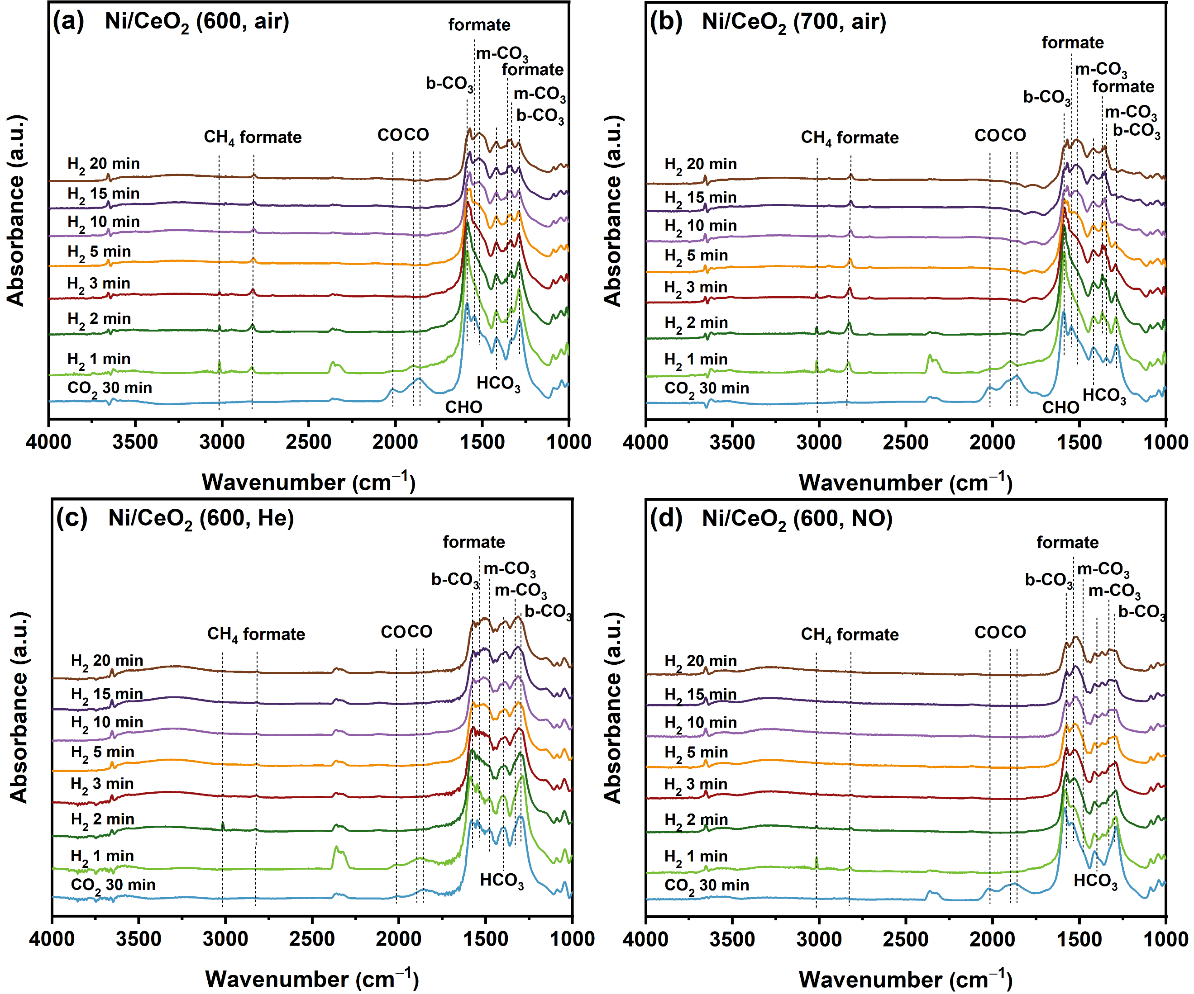
Fig. S11. In situ DRIFTS spectra of transient CO₂ methanation at 250 °C over CO₂ adsorbed (a) Ni/CeO₂ (600, air), (b) Ni/CeO₂ (700, air), (c) Ni/CeO₂ (600, He) and (d) Ni/CeO₂ (600, NO).

The transient reaction over the CO₂ adsorbed catalysts were also performed for the investigation of active intermediates during CO₂ hydrogenation with the gas switch in the process of H₂ (reduction) → He (purge and background collection) → CO₂ (adsorption) → He (removal of physically adsorbed species) → H₂ (reaction between H₂ and chemisorbed CO_{2(ads)}). Firstly, the lower reaction temperature of 250 °C was applied, the results of which can be seen in Fig. S11. All Ni/CeO₂ samples see a similar CO₂ adsorption and transient performance at this temperature. After CO₂ adsorption for 30 min followed by He purge, the presence of monodentate carbonates, bidentate carbonates and bicarbonates are observed in all Ni/CeO₂ samples, denoted as the spectra named “CO₂ 30 min” [5]. As seen in Fig. S11, when H₂ is introduced into the system, the gas phase CO₂ shows up immediately at the spectra collected at 1 min on all Ni/CeO₂ samples, suggesting the competitive adsorption sites of CO₂ and H₂ species. Expect for Ni/CeO₂ (600, NO), the intensities of formate species (~1550 and 1370 cm⁻¹) significantly increase at 1 min over the Ni/CeO₂. This could be due to the highest reaction rate on Ni/CeO₂ (600, NO). Furthermore, the adsorbed CO species from CO₂ dissociation disappears rapidly after the H₂ introduction, exhibiting the role of CO as the intermediate in CO₂ methanation reaction. For the spectra collected at 1 minute, the intensities of gas phase CH₄ (~3016 cm⁻¹) over different samples reach to the maximal, resulting from the largest concentration of adsorbed carbonates after CO₂ adsorption. Afterwards, the CH₄ formation amount significantly decreases with the reaction time and eventually disappears at around 5 min, accompanied by the continuous consumption of surface adsorbed carbonate and formate species. Therefore, the reactivity of formate species as the intermediate can be proposed. Interestingly, the consumption of surface carbonates and formate species still takes place continuously with no CH₄ peak observed. It could be due to the low formation rate of CH₄ or the generation of adsorbed CO on Ce³⁺ sites observed at ~2100 cm⁻¹. Unlike the CO_{(ads)} on Ni⁰ sites, the CO_{(ads)} on Ce³⁺ sites cannot be hydrogenated for CH₄ formation [7].
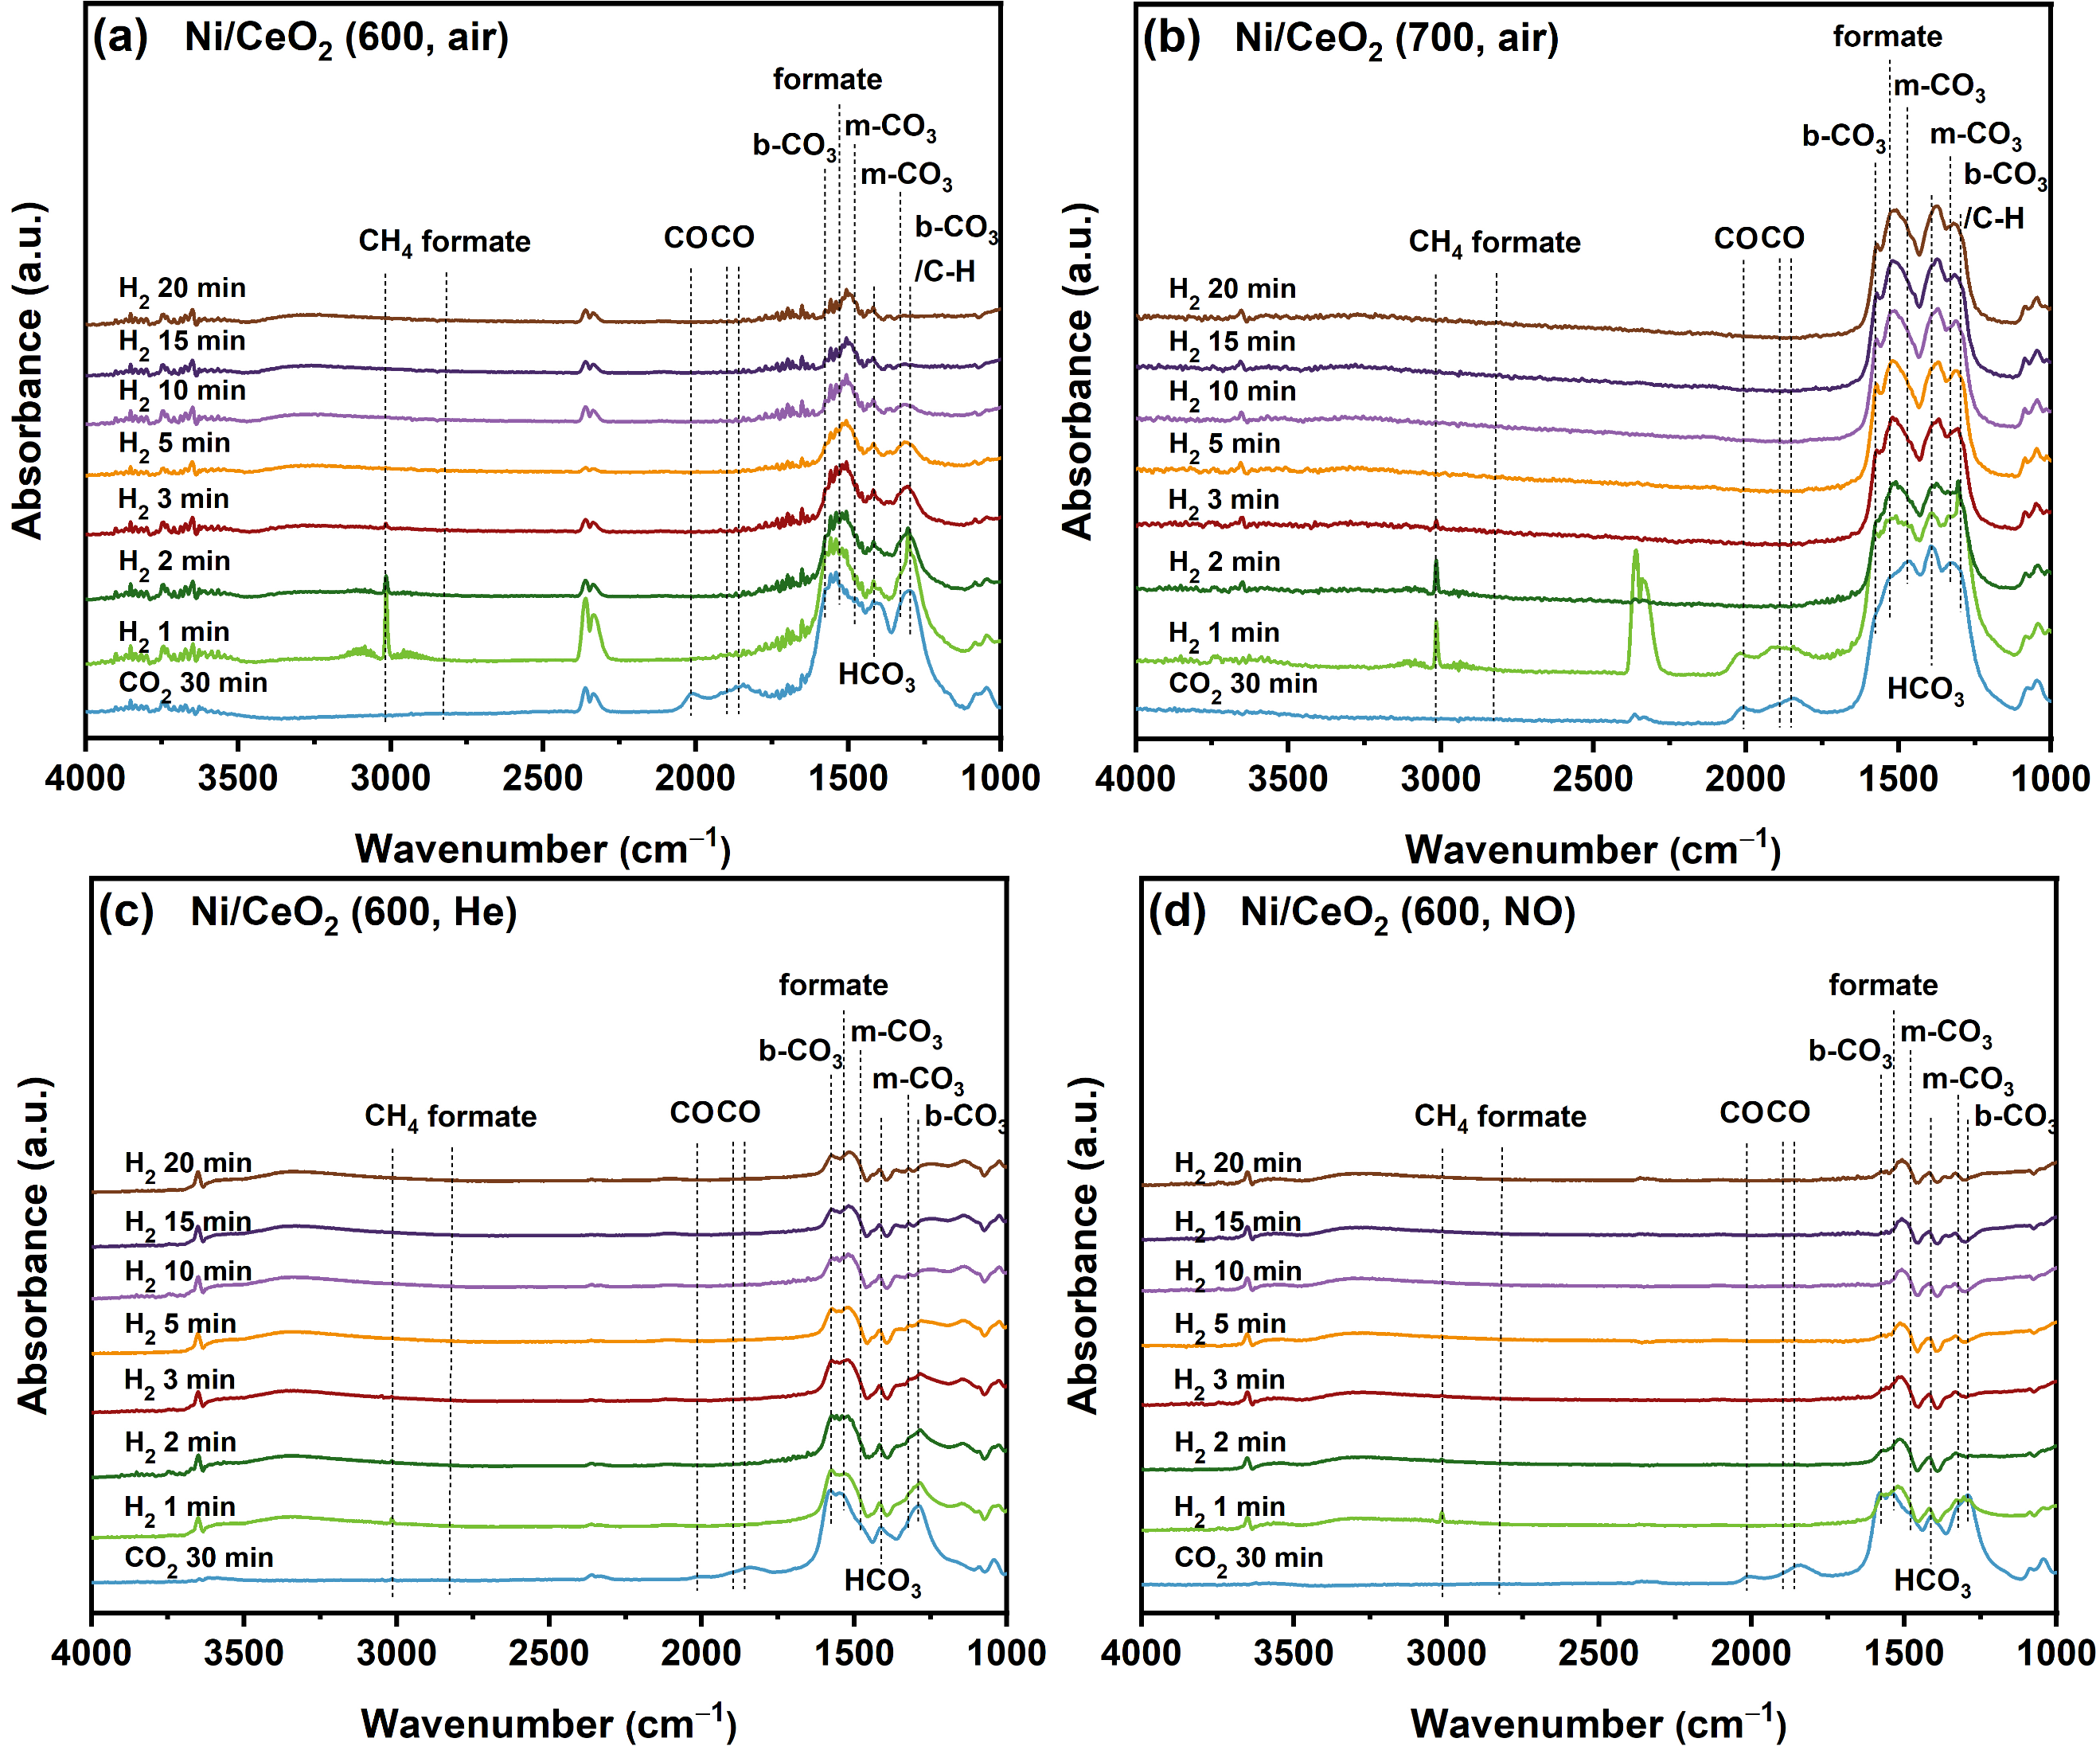
Fig. S12. In situ DRIFTS spectra of transient CO₂ methanation at 350 °C over CO₂ adsorbed (a) Ni/CeO₂ (600, air), (b) Ni/CeO₂ (700, air), (c) Ni/CeO₂ (600, He) and (d) Ni/CeO₂ (600, NO).

A similar transient reaction was also conducted over the Ni/CeO₂ at 350 °C, as exhibited in Fig. S12. Similarly, after CO₂ adsorption, all carbonate (bidentate carbonate, monodentate carbonate and bicarbonate) and formate species are formed. Moreover, the bands at the region of 2100−1800 cm⁻¹ belonging to the adsorbed CO species are also clearly observed. Upon the introduction of H₂, the hydrogenation of active species also take place rapidly on all Ni/CeO₂ samples, and the highest CH₄ formation rate can be obtained at 1 min. Besides, the band of C−H methane (1305 cm⁻¹) is also observed as the formation of CH₄ [9]. At this reaction temperature, the increases of formate species observed at 1 min in the previous experiment (Fig. S8) are not seen at 350 °C, demonstrating the higher reaction rate at a higher temperature. Moreover, unlike other samples, Fig. S12 shows that the CO species over the Ni/CeO₂ (700, air) are much more stable than others at 1 min, although they can be totally consumed in the next 1 min. The poor reactivity of surface formate and CO species over the Ni/CeO₂ (700, air) then demonstrate its low reaction rate of intermediates, indicating the poor activity of Ni/CeO₂ (700, air) during the CO₂ methanation. The consumption amount of the adsorbed CO₂ species at 350 °C in all the catalysts are then roughly calculated by the integration of curves collected before H₂ and after H₂ for 20 min in the range of 2200−1000 cm⁻¹. It can be seen that the Ni/CeO₂ (600, NO) displays the highest utilization efficiency of adsorbed CO₂ species (ca. 95 %), followed by the Ni/CeO₂ (600, air) (ca. 80 %), Ni/CeO₂ (600, He) (ca. 74 %) and Ni/CeO₂ (700, air) (ca. 56%), demonstrating the outstanding catalytic ability of the Ni/CeO₂ (600, NO) under CO₂ methanation condition.

Based on the discussion of the transient reaction above, both of the CO_{(ads)} and formate species can be regarded as the active intermediates in CO₂ methanation over these Ni/CeO₂ catalysts. The ‘CO route’ takes place with the roughly process of CO₂ → CO → CH₄, while the ‘formate route’ occur in the process of CO₂ → (bi)carbonates → formate → CH₄ [14]. By comparing the consumption performance of formate species after H₂ introduction at different temperatures (Figs. S11 and S12), we see that the bands of formate species (2840 and 1580 cm⁻¹) on all samples are much more stable during the hydrogenation reaction at 250 °C than those at 350 °C. Combining the higher intensity of methane (3014 and 1304 cm⁻¹) in Fig. S12 and the enhanced catalytic activity of all Ni/CeO₂ at higher temperatures displayed in Fig. 1, we note that the increase in methane formation comes at the expense of the formate species, suggesting that the formate species are key intermediates and the formate hydrogenation is the rate-determined step during the CO₂ methanation. This is consistent with the activity assessment of all catalysts during the CO hydrogenation reaction shown in Fig. S1, which points out that the CO is not the main active species for CH₄ formation.
Reference
[1] W.T. Figueiredo, R. Prakash, C.G. Vieira, D.S. Lima, V.E. Carvalho, E.A. Soares, S. Buchner, H. Raschke, O.W. Perez-Lopez, D.L. Baptista, R. Hergenröder, M. Segala, F. Bernardi, New insights on the electronic factor of the SMSI effect in Pd/TiO₂ nanoparticles, Appl. Surf. Sci., 574 (2022) 151647, https://doi.org/10.1016/j.apsusc.2021.151647.
[2] Y. Guo, S. Mei, K. Yuan, D. Wang, H. Liu, C. Yan, Y. Zhang, Low-temperature CO₂ methanation over CeO₂-supported Ru single atoms, nanoclusters, and nanoparticles competitively tuned by strong metal–support interactions and H-spillover effect, ACS Catal., 8 (2018) 6203-6215, https://doi.org/10.1021/acscatal.7b04469.
[3] J. Li, Y. Lin, X. Pan, D. Miao, D. Ding, Y. Cui, J. Dong, X. Bao, Enhanced CO₂ methanation activity of Ni/Anatase catalyst by tuning strong metal–support Interactions, ACS Catal., 9 (2019) 6342-6348, https://doi.org/10.1021/acscatal.9b00401.
[4] L.P. Matte, A.S. Kilian, L. Luza, M.C.M. Alves, J. Morais, D.L. Baptista, J. Dupont, F. Bernardi, Influence of the CeO₂ support on the reduction properties of Cu/CeO₂ and Ni/CeO₂ nanoparticles, J. Phys. Chem. C, 119 (2015) 26459-26470, https://doi.org/10.1021/acs.jpcc.5b07654.
[5] A. Cárdenas-Arenas, A. Quindimil, A. Davó-Quiñonero, E. Bailón-García, D. Lozano-Castelló, U. De-La-Torre, B. Pereda-Ayo, J.A. González-Marcos, J.R. González-Velasco, A. Bueno-López, Isotopic and in situ DRIFTS study of the CO₂ methanation mechanism using Ni/CeO₂ and Ni/Al₂O₃ catalysts, Appl. Catal. B: Environ., 265 (2020) 118538, https://doi.org/10.1016/j.apcatb.2019.118538.
[6] S. Collins, M. Baltanas, A. Bonivardi, An infrared study of the intermediates of methanol synthesis from carbon dioxide over Pd/β-Ga₂O₃, J. Catal., 226 (2004) 410-421, https://doi.org/10.1016/j.jcat.2004.06.012.
[7] Y. Yu, Y.M. Chan, Z. Bian, F. Song, J. Wang, Q. Zhong, S. Kawi, Enhanced performance and selectivity of CO₂ methanation over g-C₃N₄ assisted synthesis of Ni-CeO₂ catalyst: kinetics and DRIFTS studies, Int. J. Hydrog. Energy, 43 (2018) 15191-15204, https://doi.org/10.1016/j.ijhydene.2018.06.090.
[8] S. Ewald, M. Kolbeck, T. Kratky, M. Wolf, O. Hinrichsen, On the deactivation of Ni-Al catalysts in CO₂ methanation, Appl. Catal. A: Gen., 570 (2019) 376-386, https://doi.org/10.1016/j.apcata.2018.10.033.
[9] P.H. Ho, G.S. de Luna, S. Angelucci, A. Canciani, W. Jones, D. Decarolis, F. Ospitali, E.R. Aguado, E. Rodríguez-Castellón, G. Fornasari, A. Vaccari, A.M. Beale, P. Benito, Understanding structure-activity relationships in highly active La promoted Ni catalysts for CO₂ methanation, Appl. Catal. B: Environ., 278 (2020) 119256, https://doi.org/10.1016/j.apcatb.2020.119256.
[10] R. Ye, Q. Li, W. Gong, T. Wang, J.J. Razink, L. Lin, Y.-Y. Qin, Z. Zhou, H. Adidharma, J. Tang, A.G. Russell, M. Fan, Y.-G. Yao, High-performance of nanostructured Ni/CeO₂ catalyst on CO₂ methanation, Appl. Catal. B: Environ., 268 (2020) 118474, https://doi.org/10.1016/j.apcatb.2019.118474.
[11] A. Goguet, S. Shekhtman, R. Burch, C. Hardacre, F. Meunier, G. Yablonsky, Pulse-response TAP studies of the reverse water–gas shift reaction over a Pt/CeO₂ catalyst, J. Catal., 237 (2006) 102-110, https://doi.org/10.1016/j.jcat.2005.10.020.
[12] B. Dai, S. Cao, H. Xie, G. Zhou, S. Chen, Reduction of CO₂ to CO via reverse water-gas shift reaction over CeO₂ catalyst, Korean J. Chem. Eng., 35 (2017) 421-427, https://doi.org/10.1007/s11814-017-0267-y.
[13] C. Heine, B.A. Lechner, H. Bluhm, M. Salmeron, Recycling of CO₂: probing the chemical state of the Ni(111) surface during the methanation reaction with ambient-pressure X-Ray photoelectron spectroscopy, J. Am. Chem. Soc., 138 (2016) 13246-13252, https://doi.org/10.1021/jacs.6b06939.
[14] P. Hongmanorom, J. Ashok, P. Chirawatkul, S. Kawi, Interfacial synergistic catalysis over Ni nanoparticles encapsulated in mesoporous ceria for CO₂ methanation, Appl. Catal. B: Environ., 297 (2021) 120454, https://doi.org/10.1016/j.apcatb.2021.120454.

