The clinical meaning of the UIP pattern in fibrotic Hypersensitivity Pneumonitis on cryobiopsy: a multicenter retrospective study

Simone Petrarulo (M.D.)¹, Claudia Ravaglia (M.D.) ^{1,2}, Sissel Kronborg White (M.D., PhD)³, Line Bille Madsen (M.D. Ph.D.) ⁴, Frederik Lex (M.D.) ⁵, Alessandra Dubini (M.D.)⁶, Elisabetta Fabbri (Biostat)⁷, Elisabeth Bendstrup (M.D., Ph.D.)^{3,5}, Sara Piciucchi (M.D.)⁸, Paolo Spagnolo (M.D., Ph.D.)⁹, Venerino Poletti (M.D., Ph.D.)^{1,2,3}

Supplementary material

 |  | Total cohort |  | Aarhus coohort |  | Forlì cohort
 | UIP-like |  | Non UIP-like | UIP-like | Non UIP-like | UIP-like | Non UIP-like
Sample size | 59 |  | 136 | 17 | 90 | 42 | 46
Death | 13 (22%) |  | 11 (8%) | 2 (11%) | 4 (4%) | 11 (26%) | 7 (15%)
Lung transplants | 4 (6%) |  | 3 (2%) | 0 | 2 (2%) | 4 (9%) | 1 (2%)
Transplant-free survival (95% CI)  1 year  3 years  5 years  10 years | 96% (86-99)  90% (77-95)  70% (53-82)  33% (7-62) |  | 99% (94-99)  94% (87-97)  87% (93-76)  54% (23-77) | 93% (63-99)  93% (63-99)  93% (63-99)  - | 98% (91-99)  94% (85-97)  91% (79-96)  - | 97% (82-99)  88% (72-95)  59% (37-75)  17% (1-50) | 100%  94% (80-98)  83% (64-93)  52% (20-76)

Table 4 Survival analysis for patients with fibrotic hypersensitivity pneumonitis: entire cohort and Aarhus and Forlì cohort.

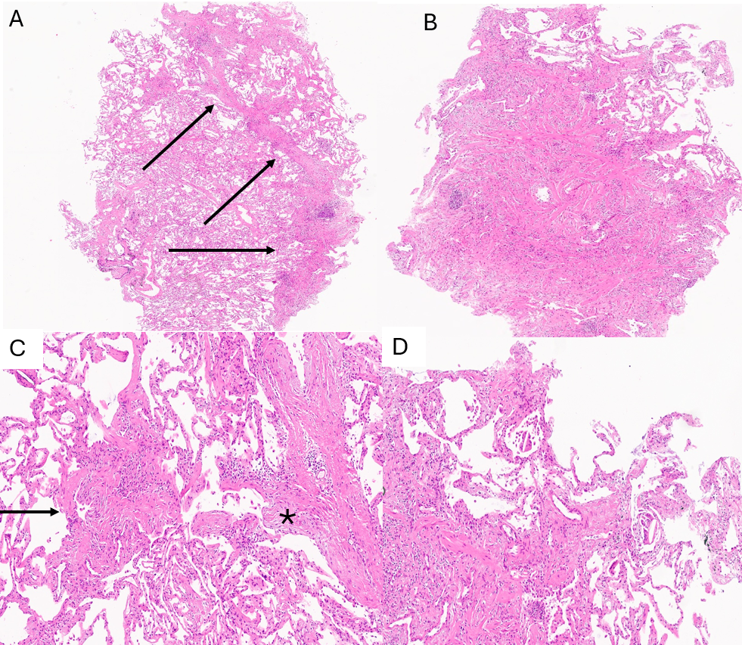

Figure 2 Transbronchial lung cryobiopsy: fibrotic-HP with UIP-like pattern. A Areas of patchy fibrosis with a distribution defined as 'bridging fibrosis’ (arrows) (H&E 4x). B Area of fibrosis with complete architectural disruption of the alveolar structure that borders directly with normal lung parenchyma without intermediate areas. C Centrilobular fibrosis area with features of constrictive bronchiolitis (arrow). Dense fibrotic area with some fibroblastic foci (*) (H&E 10x) D At the border between the fibrotic area and normal lung parenchyma, giant cells with cytoplasm containing 'cholesterol crystals' are recognizable (H&E 10x)

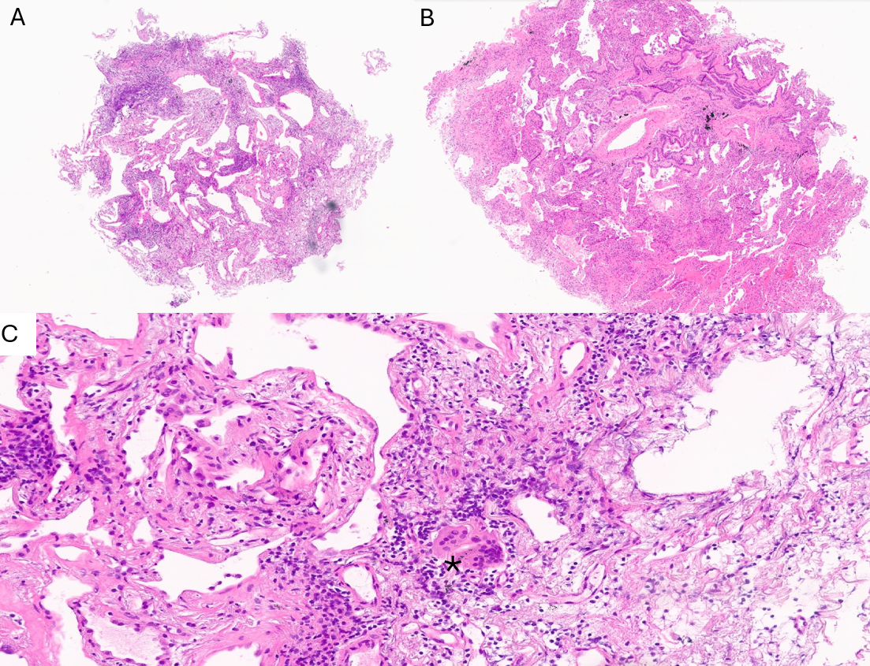

Figure 3 Transbronchial lung cryobiopsy: fibrotic-HP with nonUIP-like pattern. A Non specific interstitial pneumonia (NSIP) pattern with fibrosis and chronic interstitial inflammation (H&E 4x). B. Centrolobular damage is characterized by peribronchiolar metaplasia, fibrosis, and chronic peribronchiolar inflammation (H&E 4x). C Giant cells in lymphocytic background (*) (H&E 20x)

