Supplementary Material

Supplementary Figures and Tables
Table 1 Supplementary. Agreement between questionnaires on calcium intake.
IOF and LOC questionnarire |  | IOF and NOF questionnarire |  | NOF and LOC questionnarire
Cohen’s K | P Value | Cohen’s K | P Value | Cohen’s K | P Value
0.384 | <.001 | 0.675 | <.001 | 0.451 | <.001
Abbreviations: IOF, International Osteoporosis Foundation; LOC, Local; NOF, National Osteoporosis Foundation.
Specifications: Patients were divided into three categories according to calcium intake: very low (≤ 500 mg/die), low (500-1000 mg/die), sufficient (≥ 1000 mg/die).

Table 2 Supplementary. International Osteoporosis Foundation (IOF) Questionnaire
First name
Surname
Date of birth
Questionnaire delivery date
FOOD | QUANTITY
 |  | BRAND OF SUPPLEMENT AND NUMBER OF DOSES (sachets, tablets.. )
Calcium supplements | 500mg
 |  | NUMBER OF PORTIONS PER WEEK
Types of Milk
Milk | 200ml
Milkshake | 300ml
Sheep's milk | 200ml
Coconut milk | 200ml
Soya drink ( enriched ) | 200ml
Soya milk | 200ml
Rice milk | 200ml
Avena's milk | 200ml
Almond milk | 200ml
Yogurt
Flavored yogurt | 150mg
Yogurt with fruit pieces | 150mg
Plain yogurt | 150mg
Cheese
Hard cheese (e.g. Cheddar, Gruyere, Emmental, Parmesan) | 30g
Soft cheese (e.g. Camembert, Brie) | 60g
Feta | 60g
Mozzarella cheese | 60g
Fresh cheese (e.g. cottage cheese, ricotta, mascarpone) | 200g
Cheese cream | 30g
Cream, sweets
Whipped Cream | 30ml
Cooking cream | 30ml
Vanilla custard | 120g
Vanilla ice cream | 100g
Vanilla pudding | 120g
Rice pudding | 200g
Pancake | 80g
cheesecake | 200g
Waffle | 80g
Meat, Fish, Eggs
Egg | 50g
Red meat | 120mg
Chicken | 120mg
Fish (e.g. cod, trout, herring, whitebait) | 120mg
Canned tuna | 120mg
Sardines in oil (canned) | 60mg
Smoked salmon | 60mg
Shrimps | 150mg
Legumes
Lentils | 80g raw, 200g cooked
Chickpeas | 80g raw, 200g cooked
Beans | 80g raw, 200g cooked
Red beans | 80g raw, 200g cooked
Farinaceous
Pasta (cooked) | 180g
Boiled rice) | 180g
Boiled potatoes) | 240g
White bread (1 slice) | 40g
Wholemeal bread (1 slice) | 40g
Muesli (cereals) | 50g
Naan | 60g
Fruit
Orange | 150g
Apple | 120g
Banana | 150g
Apricots (3 fruits) | 120g
Dried currants or gooseberries | 120g
Dried figs | 60g
Raisins | 40g
Vegetables
Lettuce | 50g
Cabbage | 50g raw
Chinese cabbage | 50g raw
Broccoli | 120g raw
Okra/ Okra | 120g raw
Watercress | 120g
Rhubarb | 120g raw
Carrots | 120g raw
Tomatoes | 120g raw
Dried fruit and seeds
Almonds | 30g
Nuts | 30g
Hazelnuts | 30g
Brazil nuts | 30g
Sesame | 15g
Tahini | 30g
Cooked dishes
Quiche (with eggs and cheese) | 200g
Cheese omelette | 120g
Pasta with “Alfredo” cheese | 330g
Pizza | 300g
lasagna | 300g
Cheeseburger | 200g
Other foods
Tofu | 120g
Algae | 100g
Wakame | 100g

Figure 1 Supplementary. Italian calcium intake (LOC) questionnaire
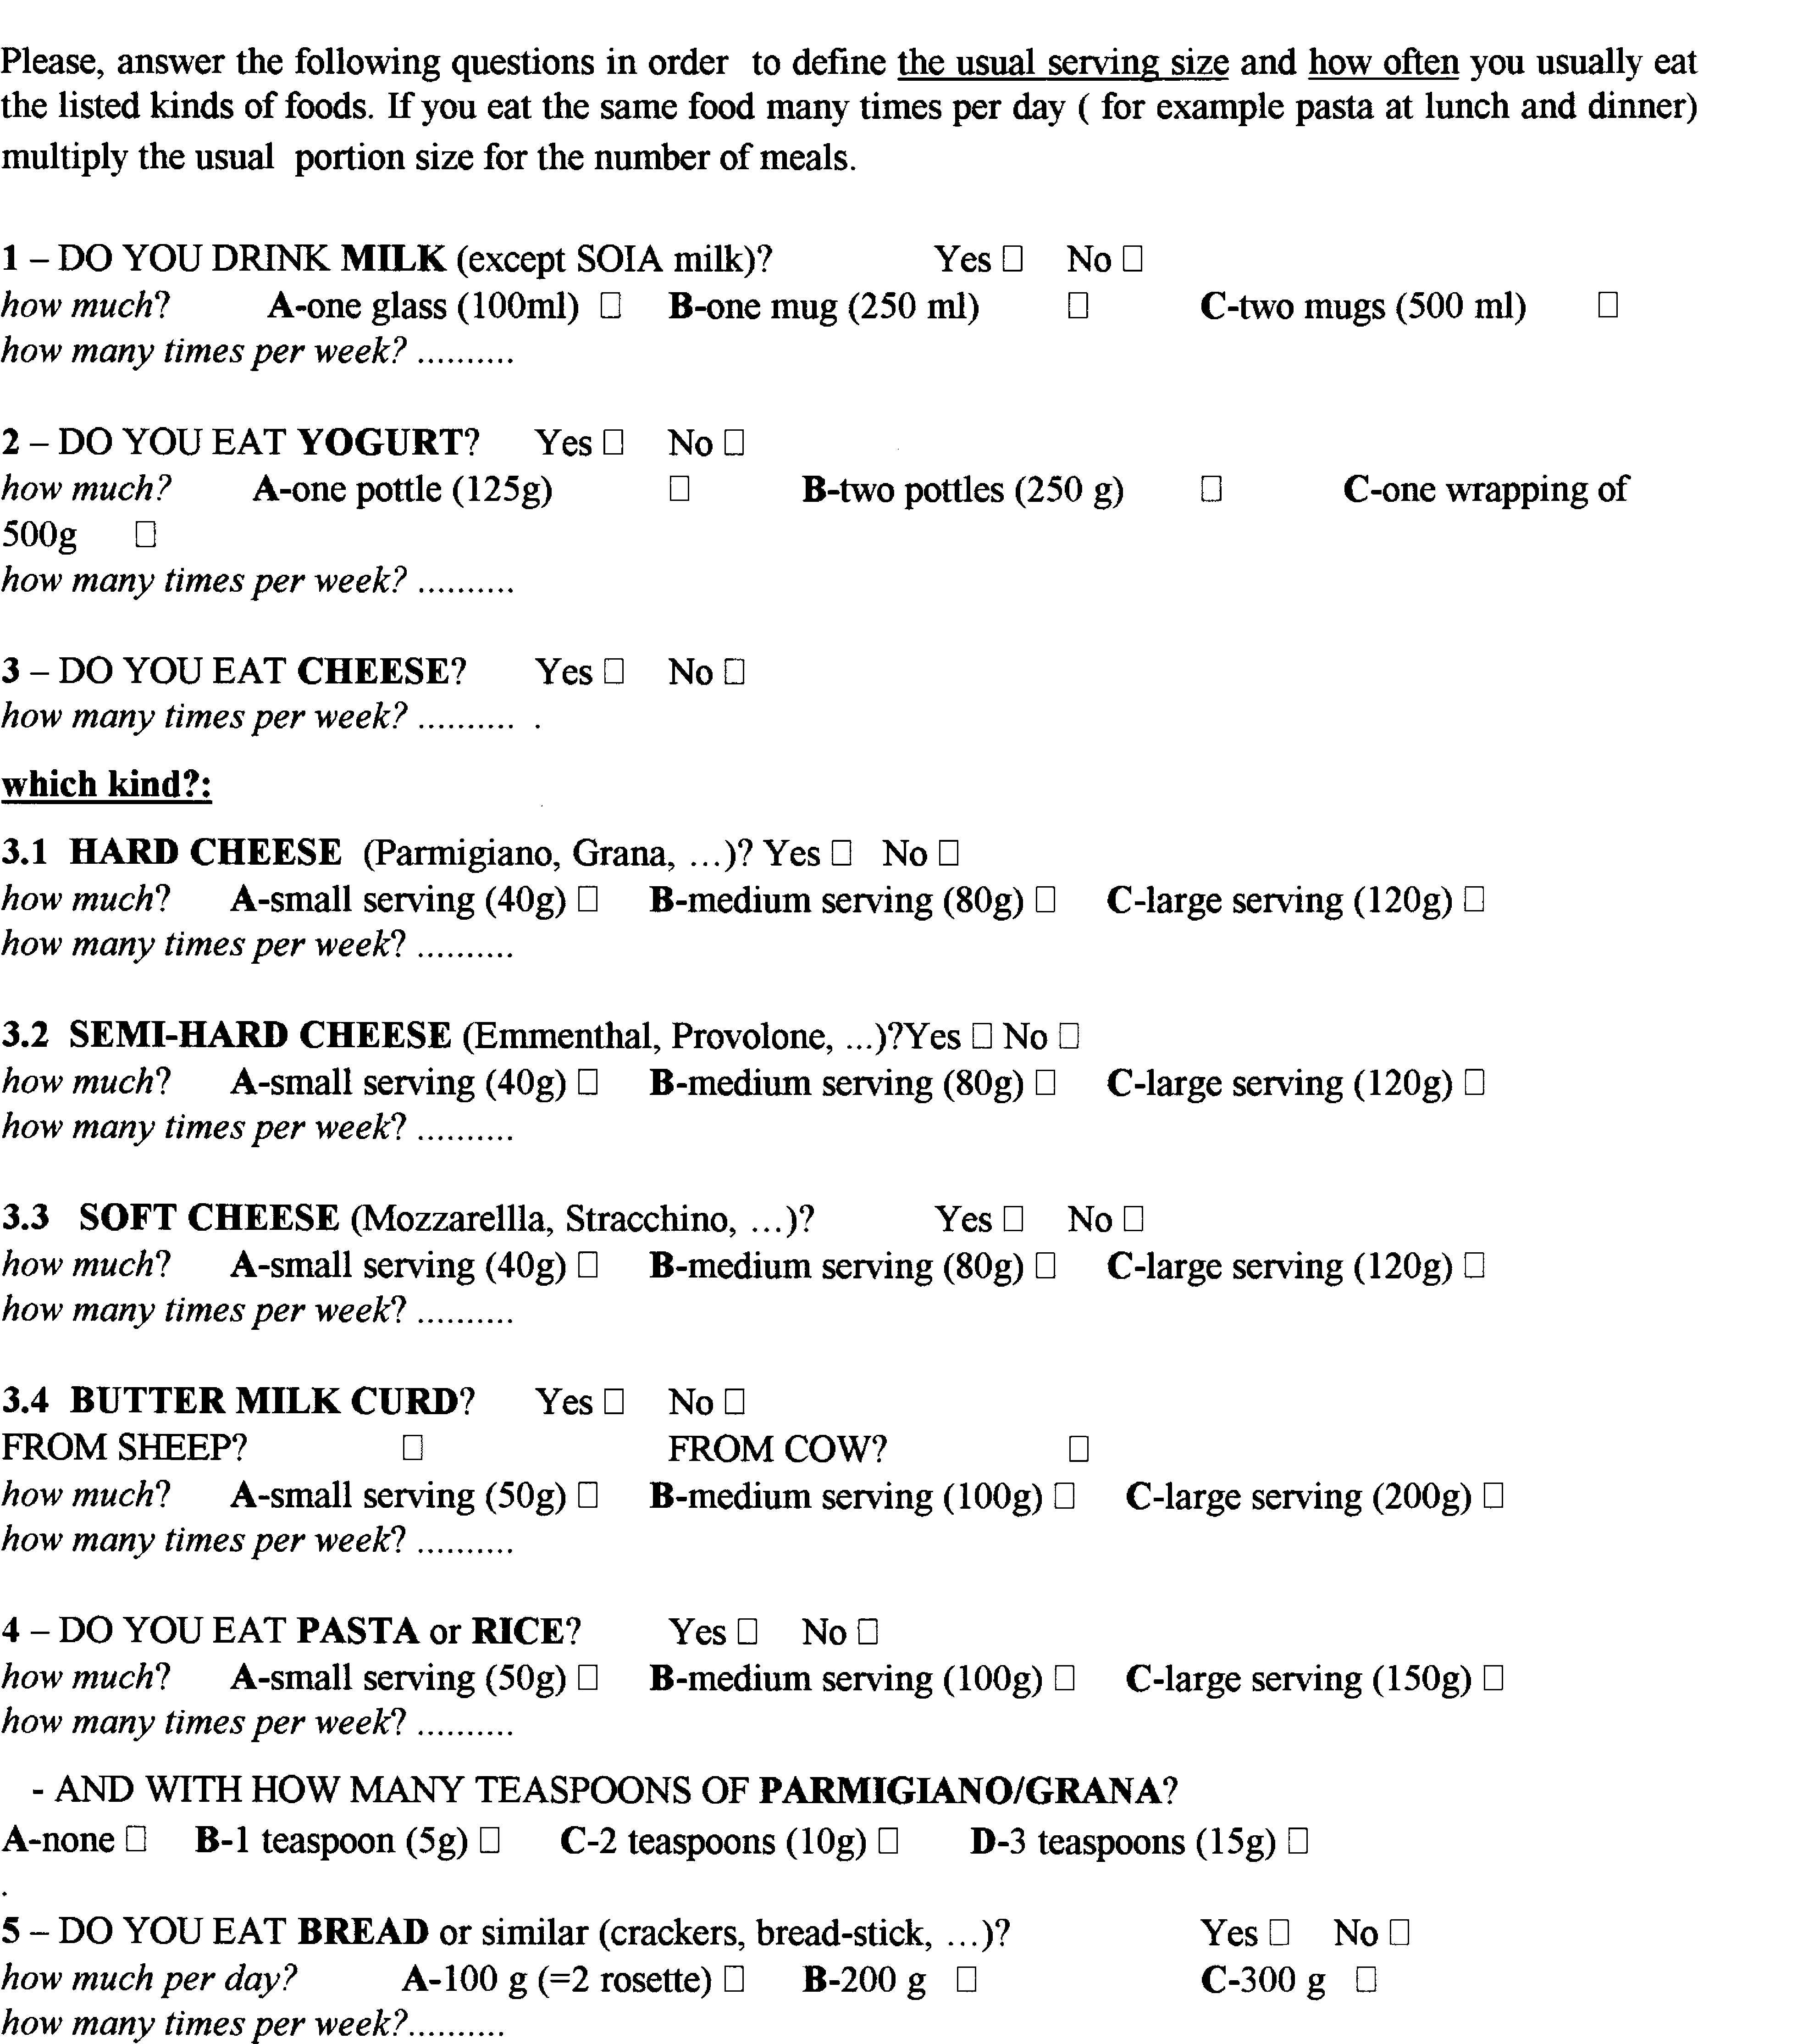
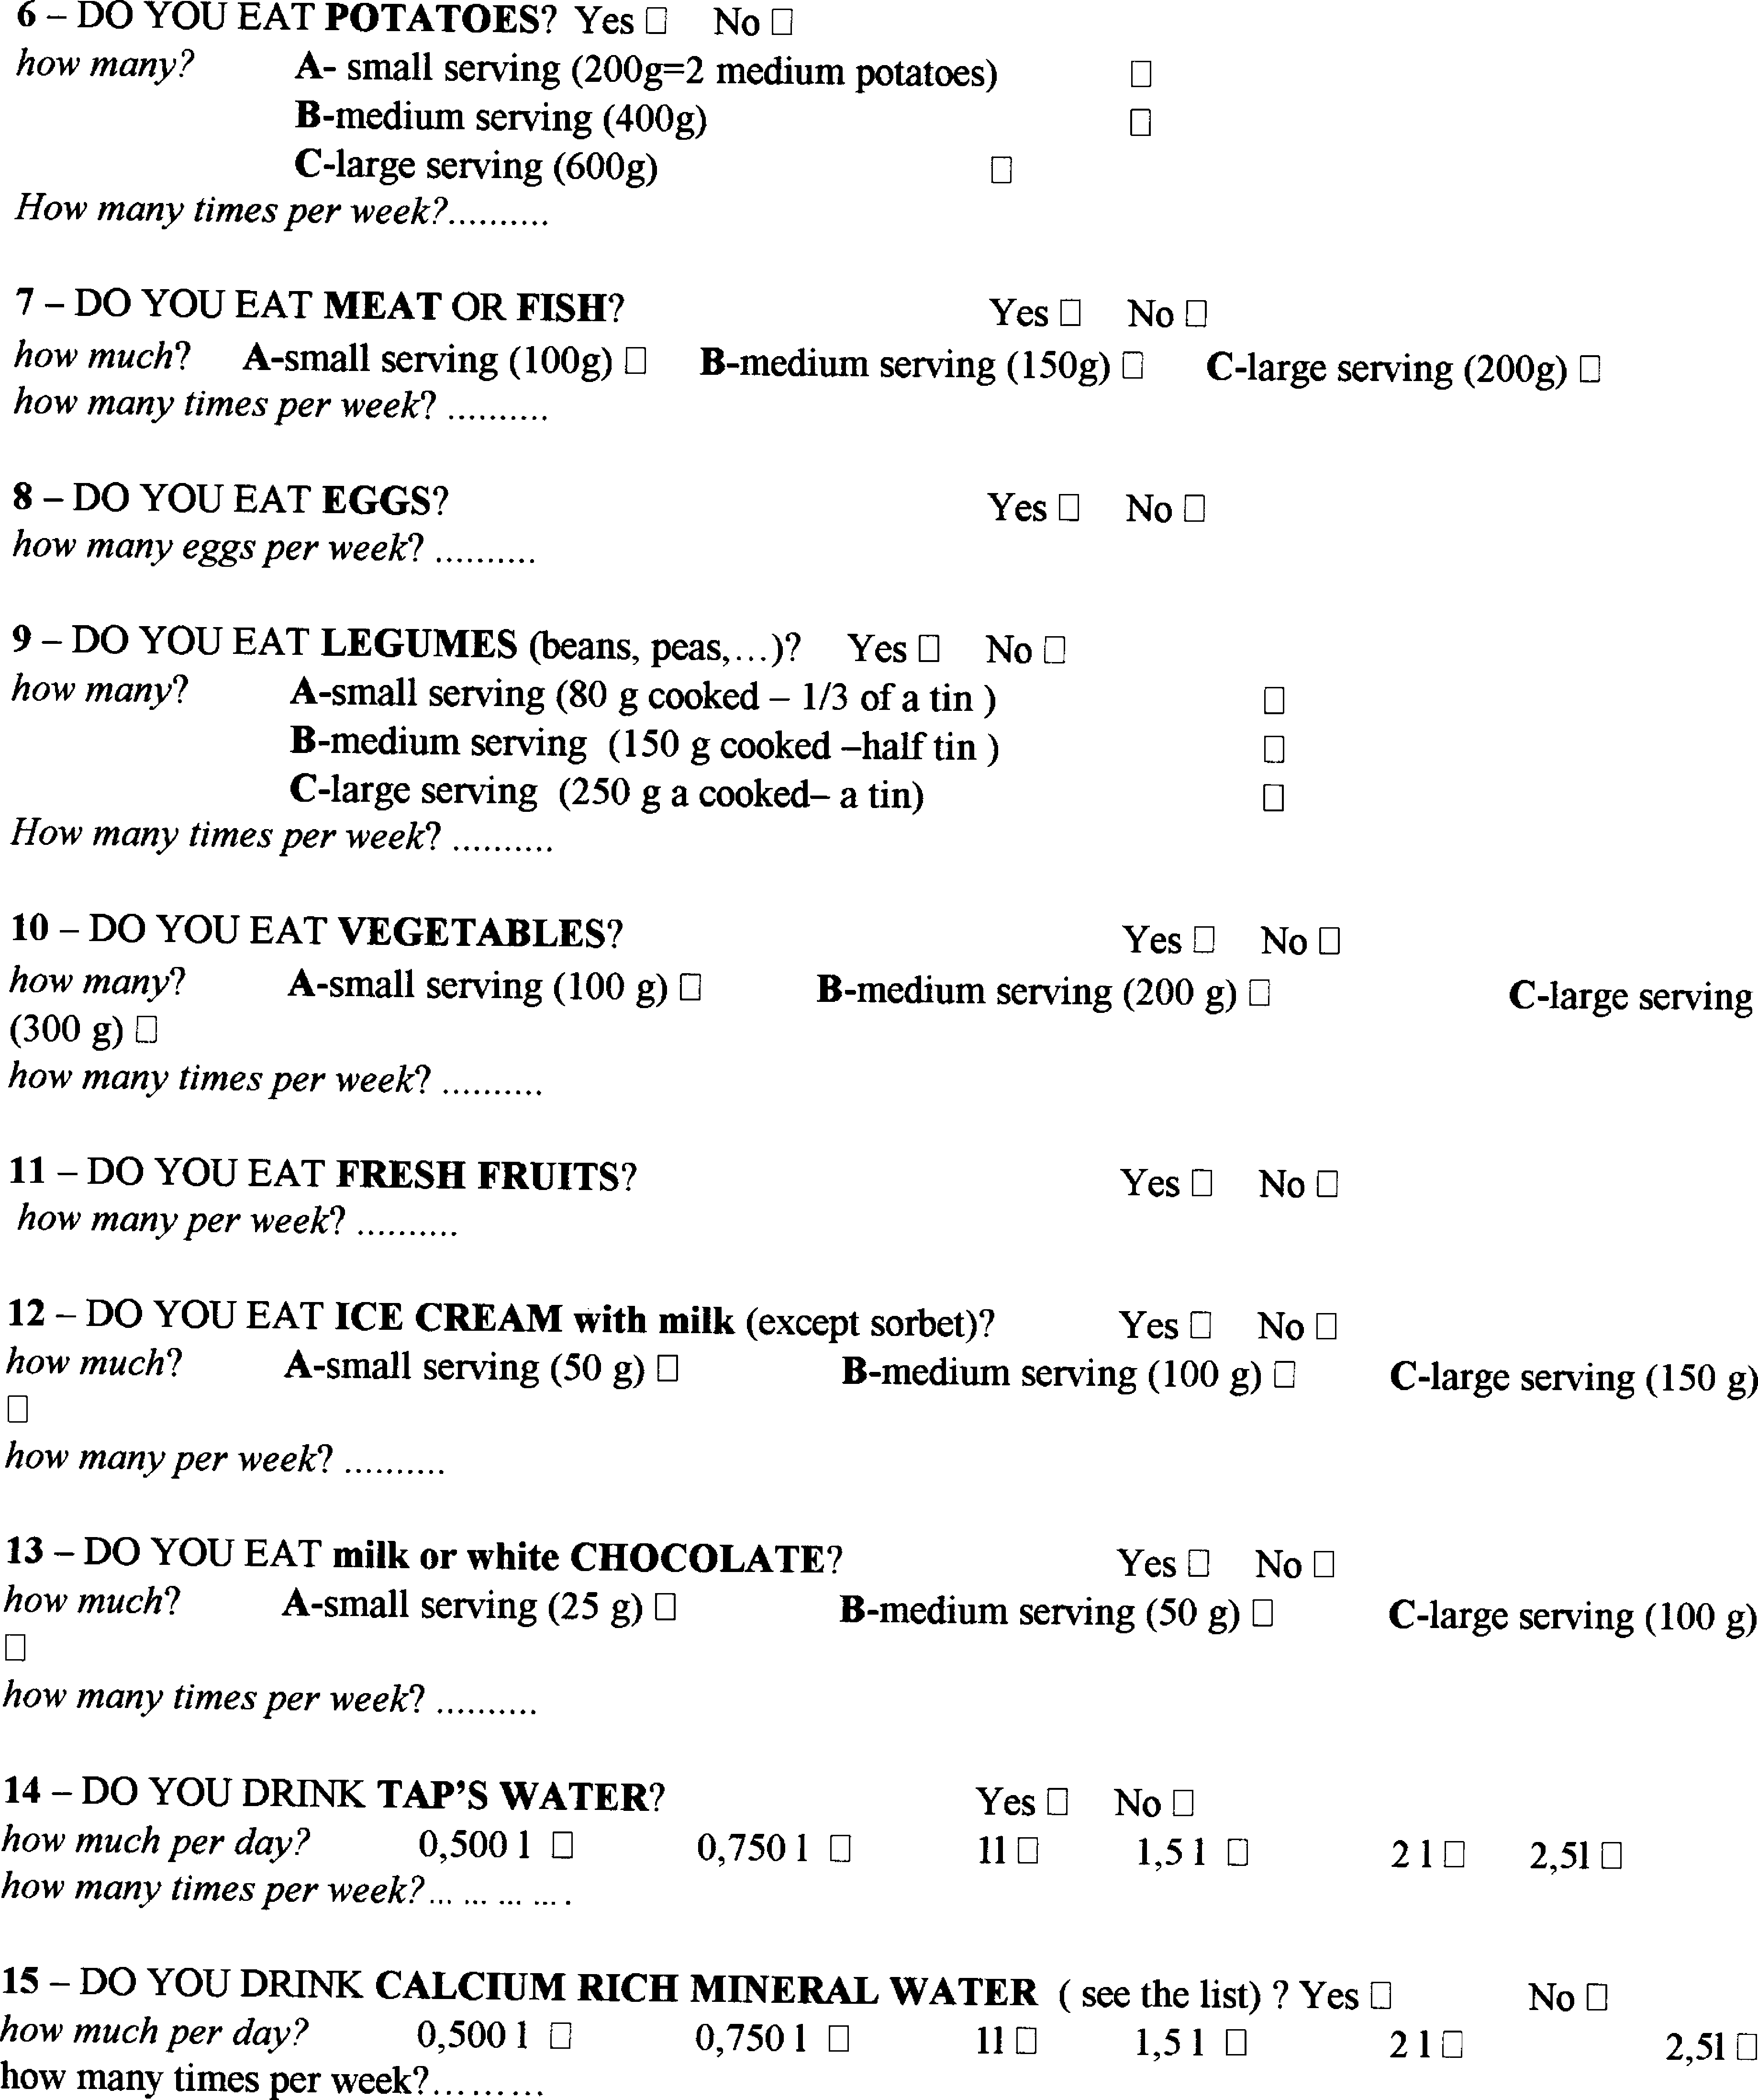
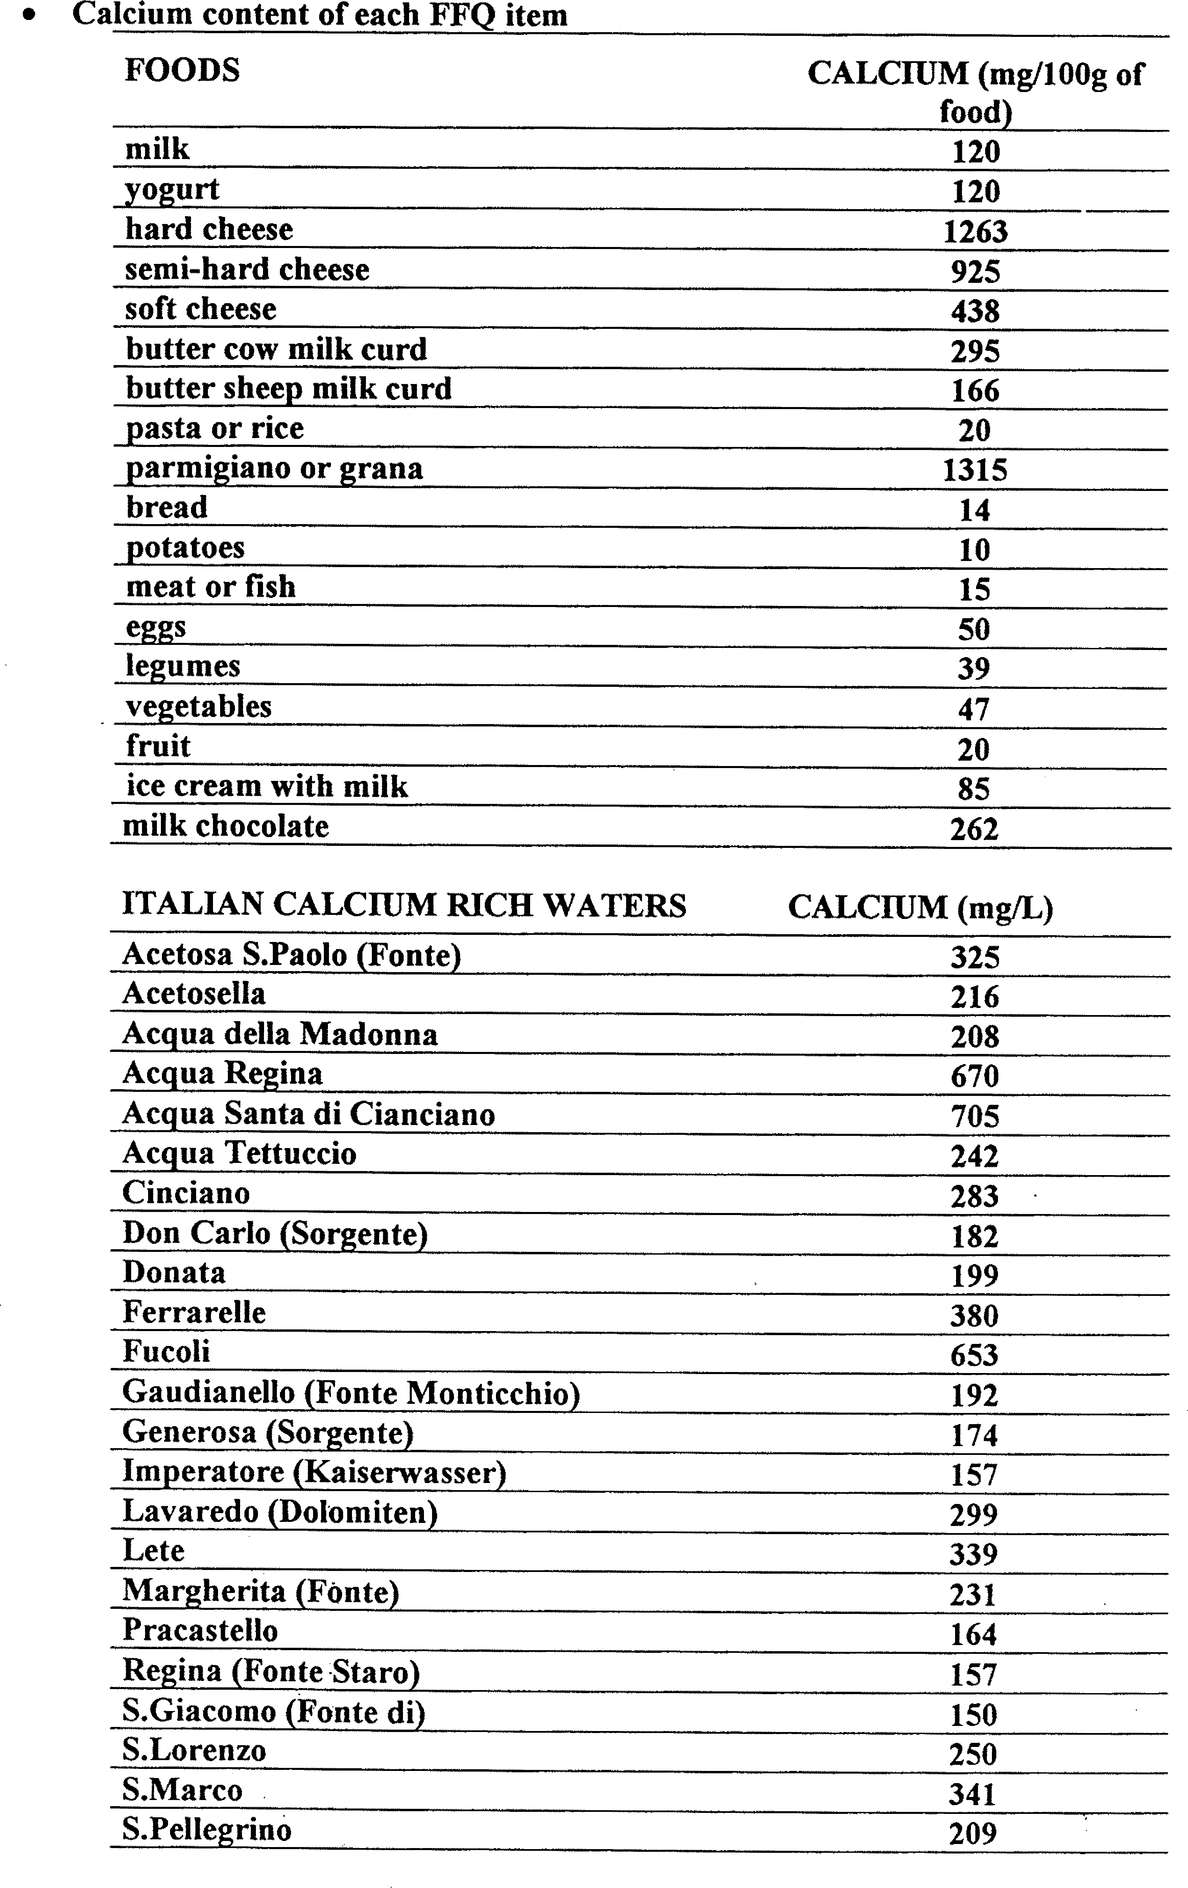
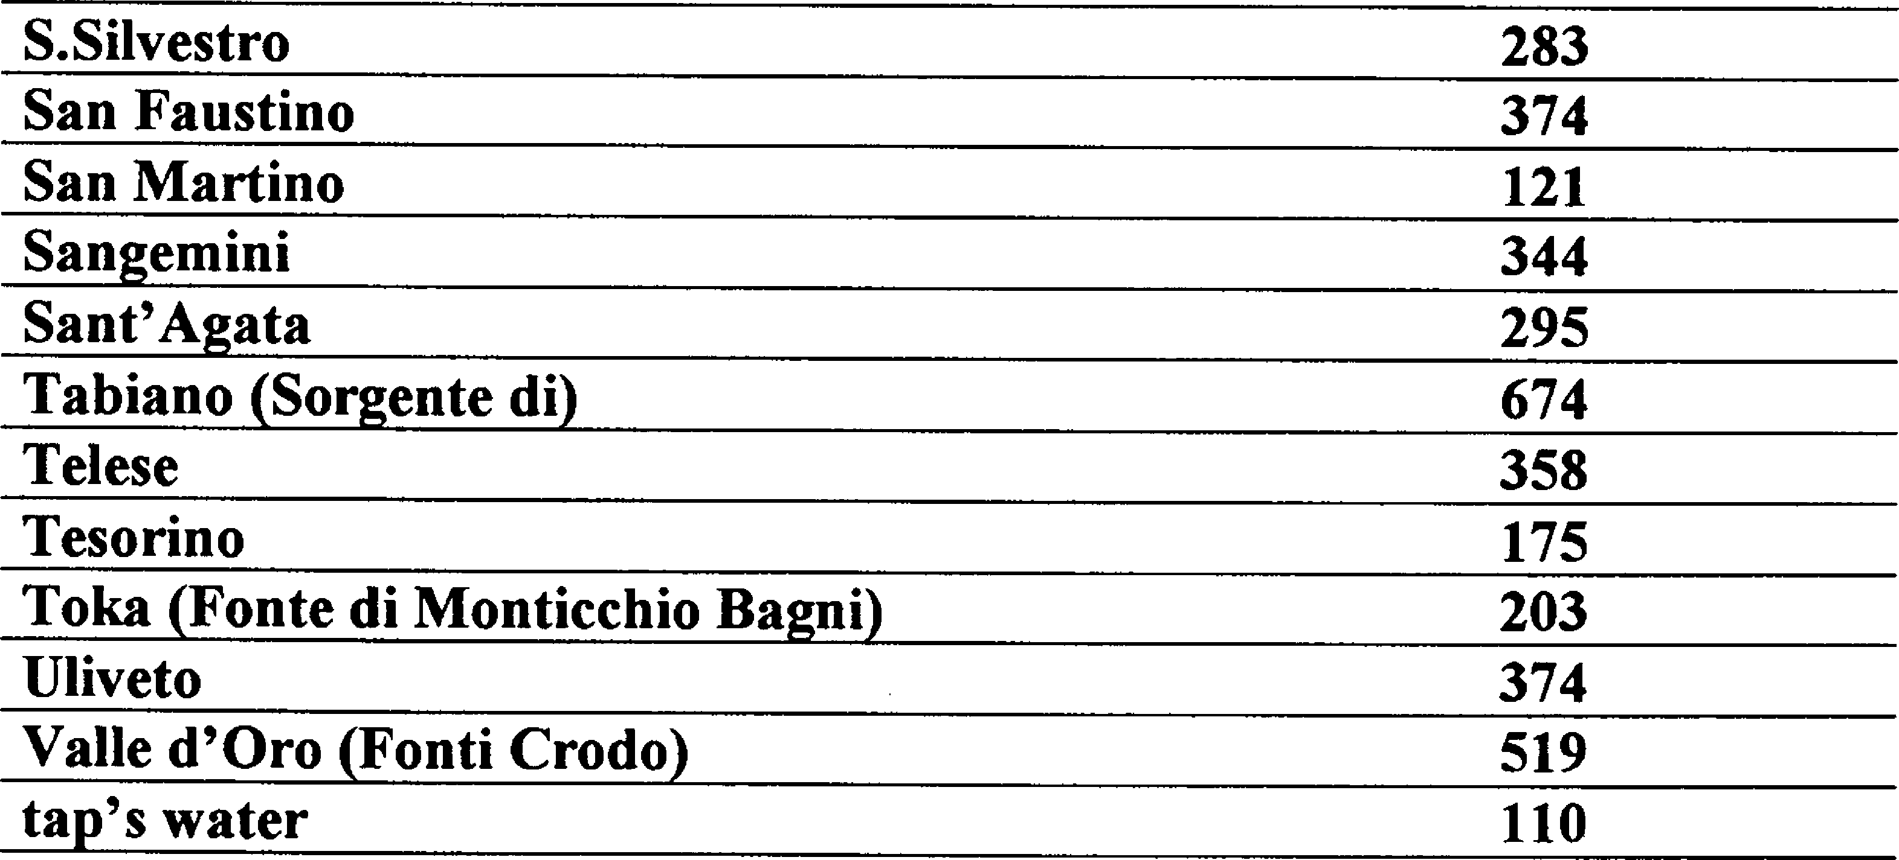

Table 3 Supplementary. National Osteoporosis Foundation (NOF) questionnaire
Food | How many portions do you take per day?
Milk (220 ml) | .................................................. ........................................
Yogurt (170 g) | …………………............................................................................
Cheese (30 g) | .................................................. .......................................
Estimate from other foods (increase this value if the patient eats more than 250g from other foods) | 250 g

