Supplementary Material
Supplementary material includes a more detailed description and interpretation of Borehole 7517/12-U-01 and 7418/01-U-01. This supplementary material also shows supplementary core photos from these boreholes, core photos from Ryseth et al. (2003) and seismic profiles showing parts of a volcanic complex in the Vestbakken Volcanic Province and uninterpreted seismic data discussed in the main text.
Borehole 7517/12-U-01
Borehole 7517/12-U-01 (depth 200–110.75 m) penetrates upper Paleocene strata and shows a stack of siltstone to fine-grained sandstones with a coarsening upwards trend.
The coarsening upward intervals consist of light grey sandstones that gradually coarsen from silt to fine sand e.g., 193–190.6 m, 189–187.5 m, 174–172 m, 168–162.5 m. These segments often show some bioturbation in the lower finer-grained parts. In the sandier parts, trough cross-stratification and plane parallel lamination can be observed (Supplementary Fig. 1a and b). These segments terminate in a sharp boundary followed by a siltstone succession (Supplementary Fig. 1a). The coarsening-upward trend of the segment suggests shallowing and an increase in the energy of the depositional environment.
Another segment of this core consists of siltstones that have been heavily bioturbated e.g., 200–196 m, 120–115.4 m (see below). Trace fossils can be seen in the core photos (e.g., Supplementary Figs. 1c). These segments are generally intensely bioturbated to the point where it becomes difficult to determine primary sedimentary structures (e.g., Supplementary Figs. 1d). Fine-grained and intensely bioturbated deposits are indicators of low energy environments with low depositional rates (e.g., Miall, 2016).
Some sandstone intervals exhibit fining upwards at the end of the interval instead of abruptly ending in a sharp transition as the other coarsening upward sandstones do. These sandstones are observed at depths 180–178.8 m, 172–169 m, and 136–134.8 m. There are other features observed in the cores, for example, displacements/micro faults, loading structure, and mudstone clasts with internal burrows (Supplementary Fig. 1a and c). Overall, the observation indicates a shallow marine setting for the deposits present in borehole 7517/12-U-1 (i.e., lower to upper shoreface).
Borehole 7418/1-U-01
Borehole 7418/1-U-01 (depth 126.15–8.4 m) penetrates upper Paleocene to lower Eocene strata and shows overall a predominantly claystone to siltstone succession with a fine-grained sandstone interval and some conglomerates (Supplementary Fig. 1e and f). Intense bioturbations and shell fragments are primarily observed from the base to a depth of 70.8 m, from which the intensity is reduced towards the top (Supplementary Fig. 1f).
The lower section (126.15–89.2 m) has been dated to be of late Paleocene age based on the occurrence of Reticulophragmium Pauperva and consists of mainly dark grey siltstones, with occasional conglomerates and some dark fibrous intervals (Supplementary Fig. 1e). Within the section there are two conglomeratic layers both of which are matrix-supported, as well as two sandy layers at 100 m (Fig. 3). The intensity of bioturbation indicates that the depositional environment was suitable for organisms to thrive. The siltstone-dominated lithology and bioturbation suggest low energy conditions and an outer shelf environment.
The middle section of the core (89.2 to 70.8 m), which is dated be of late Paleocene – early Eocene age based on the occurrence of Haplophragmoides Excavatus, comprises a structureless fine-grained sandstone package and is bounded by conglomeratic layers at depth 89.2 and 70.8 (Supplementary Figs. 1e and f). The entire section consists of fine-grained dark grey sandstone with lighter grey and darker grey to black laminations. The lower conglomerate shows clasts with size varies from pebble size down to finer clast (Supplementary Fig. 1e). The topmost conglomerate of this section is a matrix-supported polymictic conglomerate, with sub-rounded to rounded clasts (Supplementary Fig. 1f). Some parts of the section are heavily bioturbated indicating low sedimentation rates. Overall, this section represents an inner shelf deposit.
The upper section (70.8–8.4 m), with an age ranging from late Paleocene to middle Eocene (based on the occurrence of Karrerulina Coniformis), shows predominantly mudstone and a conglomerate unit at 12.8 m (Fig. 3). The dominating lithology of this section is light grey mudstone exhibiting dark grey laminations. At 61.2 m, there is a 14 cm interval of greyish-orange sediments showing no primary structures. Both upper and lower boundaries are sharp. At 25.9 m, there is a 30 cm interval of dark yellowish orange and moderate yellowish brown (siderite?), with sharp boundaries at both the start and termination of the layer (Supplementary Fig. 1g).
Green minerals occur in thin units at 34.8m and 36.3m both without any distinct boundaries, suggesting no facies change (e.g., Supplementary Fig. 1h). In both cases, which are conglomeratic, there is a large variance in clast size, and all clasts show very angular in shape. These clasts are likely reworked(?) glauconitic clasts, which are common in condensed marine successions. The lack of bioturbation in the upper section indicates inhospitable conditions for fauna during deposition. This could point to high sedimentation rates (unlikely given the presence of glauconite, which is typical of low sedimentation rates) and a low supply of food. Overall, the observation in core 7418/1-U-1 indicates a sediment-starved shelf environment.

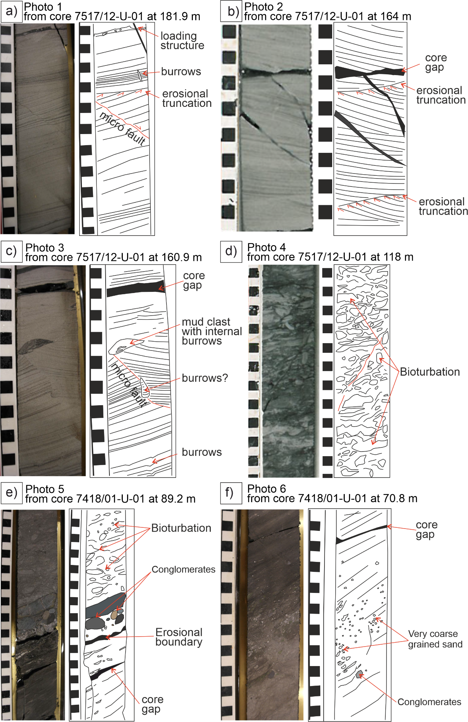
Supplementary Fig. 1. Core photos and interpretations. See the location of the photos on the cores in Figure 3.
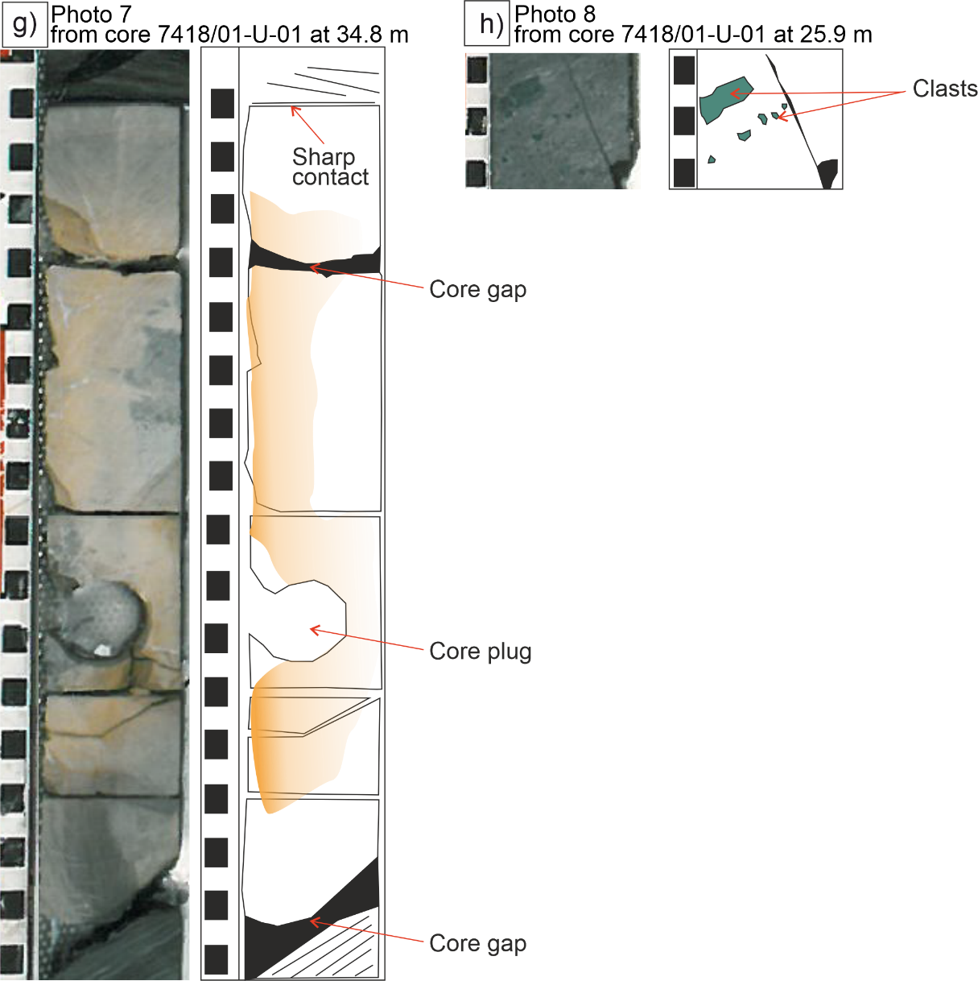
Supplementary Fig. 1. (Continued)

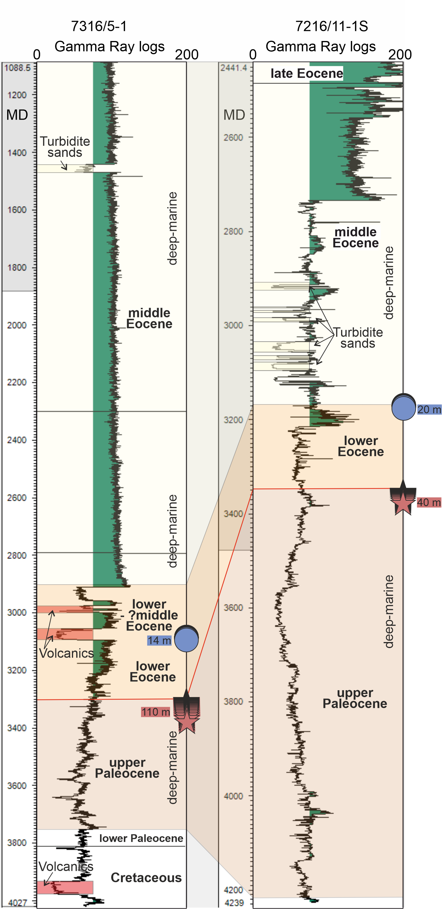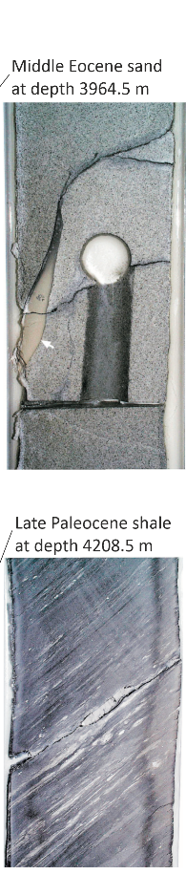
Supplementary Fig. 2. Gamma Ray logs and core photos. a) 7316/5-1 and 7216/11-1S Gamma Ray logs. Low Gamma Ray (GR) values are defined as sand (with a cut-off of 75 API), while high GR values are interpreted as shale. Note that although Paleocene strata here show predominantly low GR values, the completion reports (including drill cuttings) state proven shale successions (NPD, 2023). The Apectodinium Augustum indicating the PETM event is shown as a red star, i.e. depth of 3300 to 3410 m comprising a thickness of 110 m in well 7316/5-1 and depth of 3370 to 3410 comprising a thickness of 40 m in well 7216/11-1S. The Azolla Acme indicating the EECO is shown as a blue circle, i.e. depth of 3100 to 3114 m comprising a thickness of 14 m in well 7316/5-1 and depth of 3170 to 3190 m comprising a thickness of 20 m in well 7216/11-1S (Internal report of Equinor). b) Core photos are taken from Ryseth et al. (2003). Late Paleocene dark grey mudrock with silty/sandy laminated lenses taken from a depth of 4208.5 m. Burrows are low to moderate. Middle Eocene massive sandstones were recorded at a depth of 3964.5 m. Core width is approx. 10 cm. The red line represents the base Eocene succession.

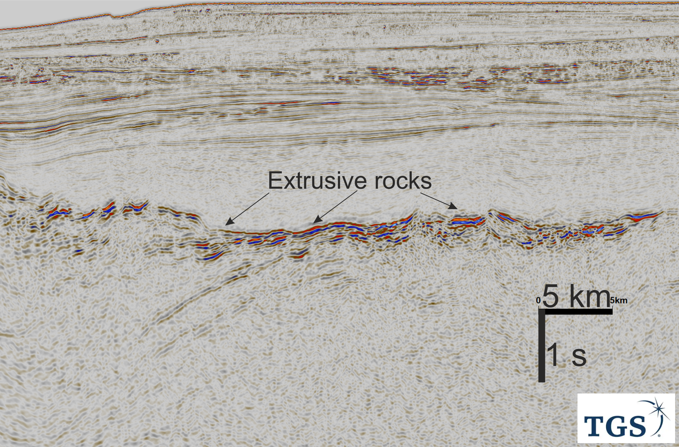
Supplementary Fig. 3. Volcanics in the Vestbakken Volcanic Province. Uninterpreted NW-SE seismic profile NBR11-223165 showing the early Eocene volcanics. The seismic profile is courtesy of TGS.

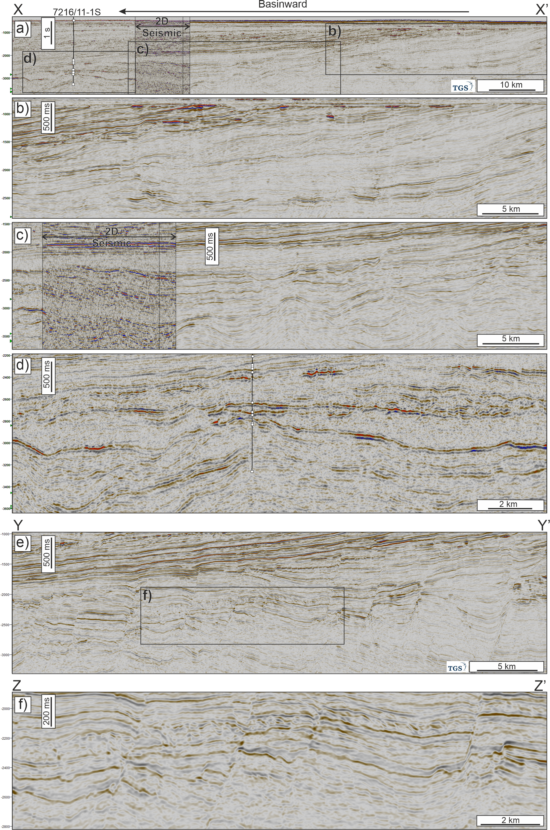
Supplementary Fig. 4 Uninterpreted seismic profiles.
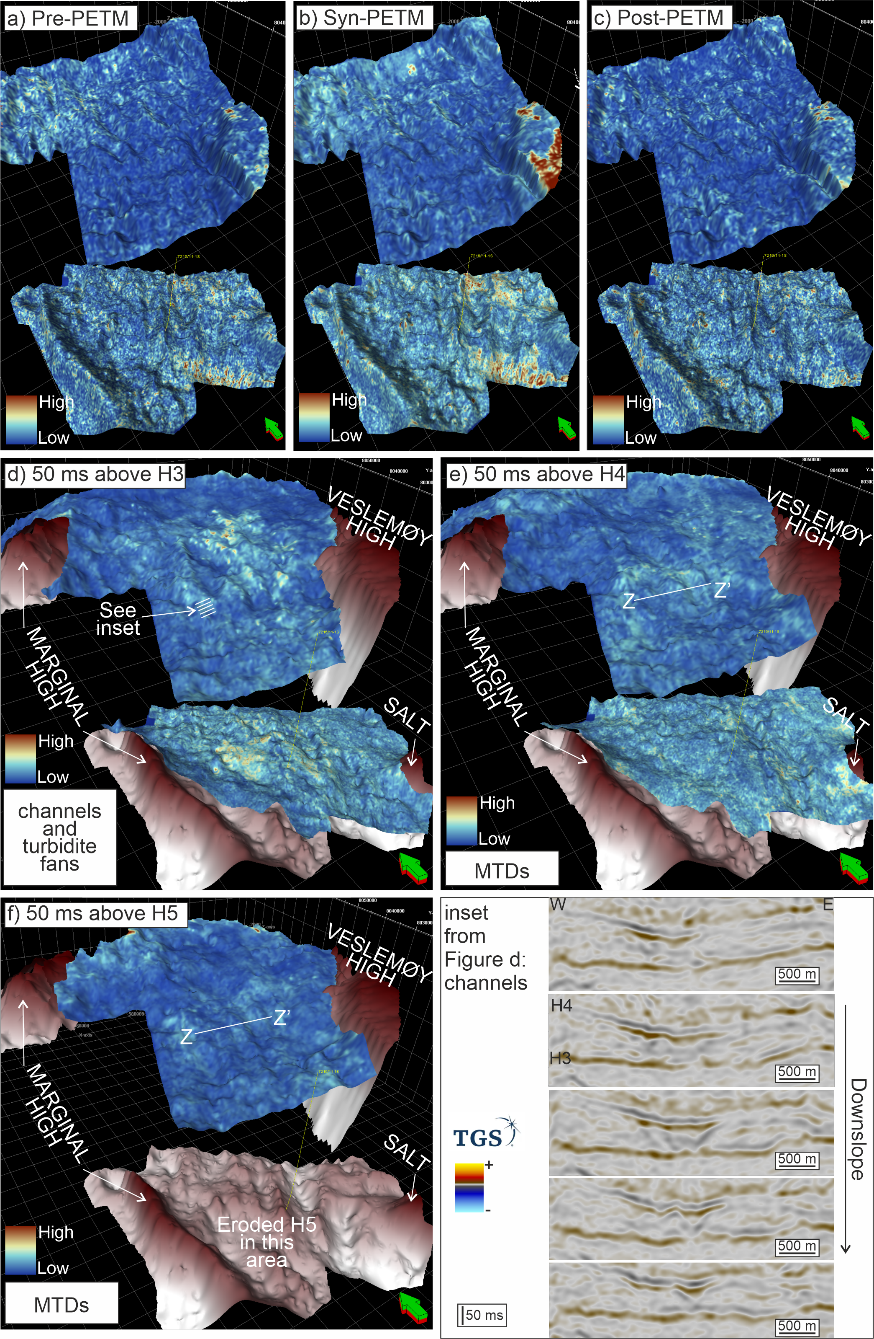
Supplementary Fig. 5. Uninterpreted RMS Amplitude maps and seismic profiles.
References for Supplementary Materials
Miall, A.D., 2016. The valuation of unconformities. Earth-Science Reviews, 163: 22-71.
NPD, 2023. https://factpages.npd.no/en/wellbore/PageView/Exploration/All/4129.
Ryseth, A., Augustson, J.H., Charnock, M., Haugerud, O., Knutsen, S.-M., Midbøe, P.S., Opsal, J.G. and Sundsbø, G., 2003. Cenozoic stratigraphy and evolution of the Sørvestsnaget Basin, southwestern Barents Sea. Norwegian Journal of Geology, 83(2): 107-130.

