Supplementary 1. RSL reconstructions and EIV-IGP model predictions in the 15 regions of Atlantic Africa compared to GIA predictions
Figure S1_1. RSL reconstructions and EIV-IGP model predictions in northern Morocco (#1), Canary Islands (#2), northern Atlantic Sahara (#3) southern Atlantic Sahara (#4) and Mauritania (#5). SLIPs (boxes) are plotted as calibrated age against change in sea level relative to present. Limiting points are plotted as terrestrial or marine horizontal lines. Dimensions of boxes and lines for each point based on 2σ elevation and age errors. The RSL data are compared to the ICE-6G (grey line) and ANUhv (yellow line) predictions for the region. The blue solid line and shaded envelope denote the EIV-IGP model mean and the ±1σ uncertainty. Maps data: Google, ©2024 SIO, Landsat/Copernicus, NOAA, GEBCO.

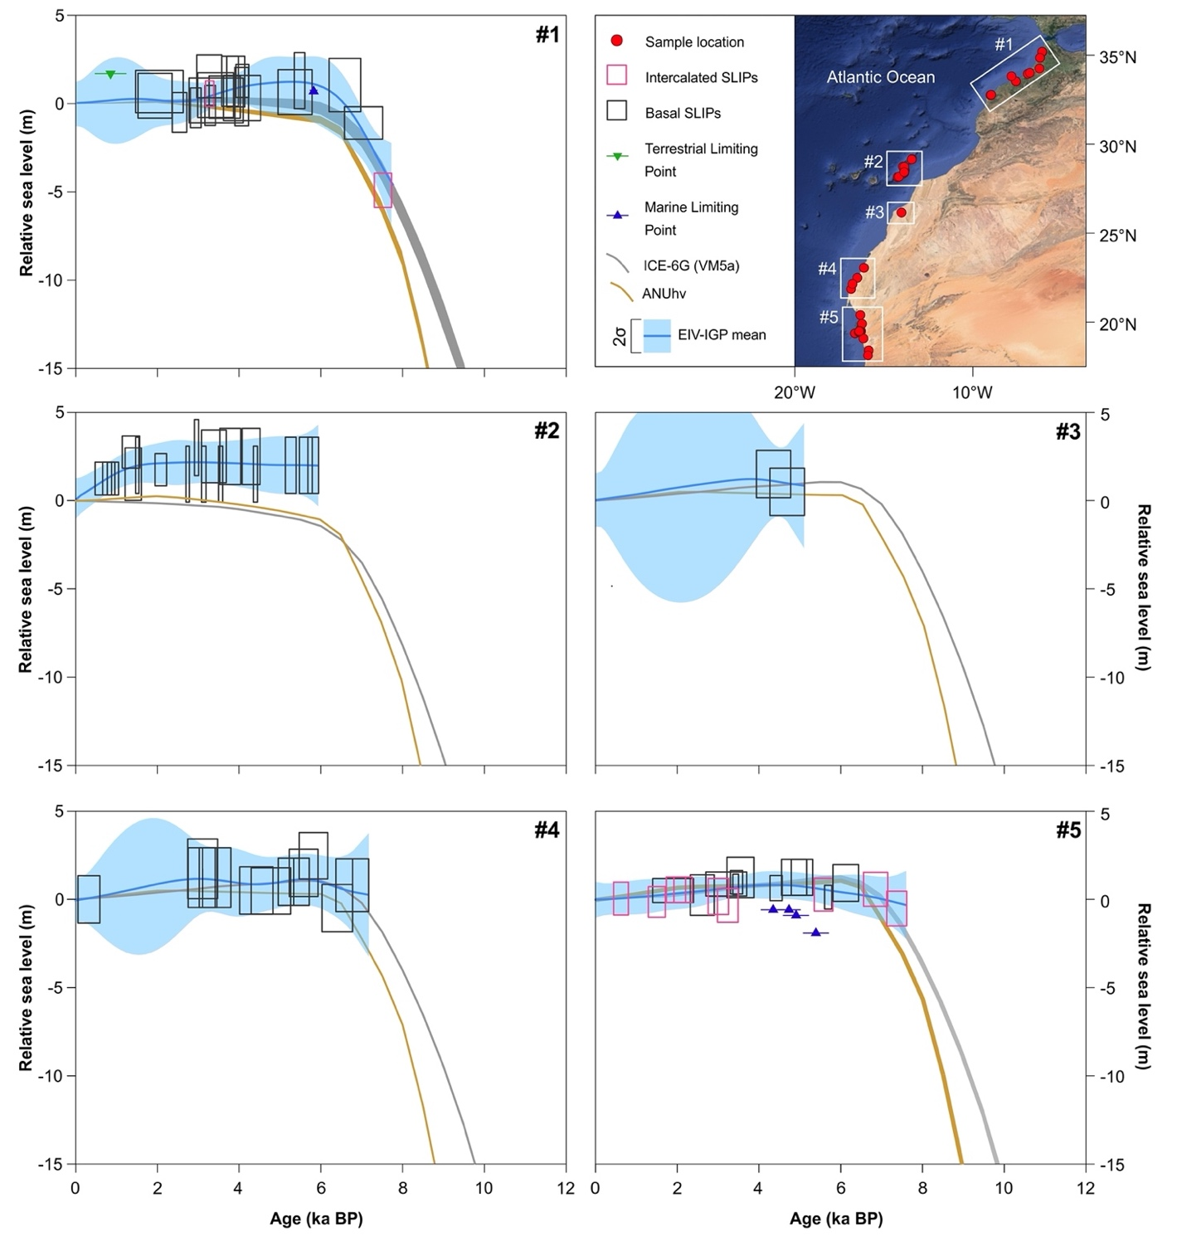

Figure S1_2. RSL reconstructions and EIV-IGP model predictions in Cape Verde islands (#6), Senegal (#7), Sierra Leone (#8) northern Gulf of Guinea (#9) and Cameroon-northern Gabon (#10). SLIPs (boxes) are plotted as calibrated age against change in sea level relative to present. Limiting points are plotted as terrestrial or marine horizontal lines. Dimensions of boxes and lines for each point based on 2σ elevation and age errors. The RSL data are compared to the ICE-6G (grey line) and ANUhv (yellow line) predictions for the region. The blue solid line and shaded envelope denote the EIV-IGP model mean and the ±1σ uncertainty. Maps data: Google, ©2024 SIO, Landsat/Copernicus, NOAA, GEBCO.

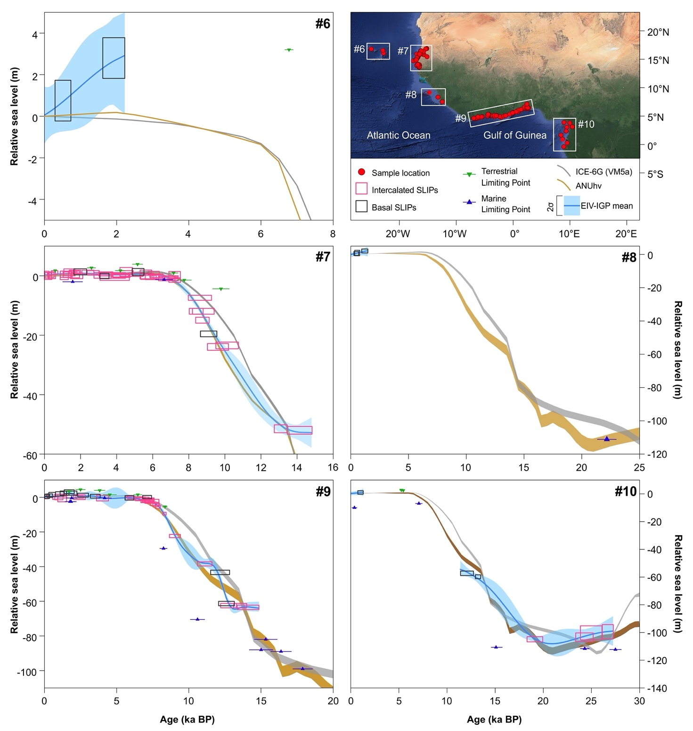
Figure S1_3. RSL reconstructions and EIV-IGP model predictions in southern Gabon-Congo (#11), northern Angola (#12), mid-southern Angola (#13) southern Namibia (#14) and western South Africa (#15). SLIPs (boxes) are plotted as calibrated age against change in sea level relative to present. Limiting points are plotted as terrestrial or marine horizontal lines. Dimensions of boxes and lines for each point based on 2σ elevation and age errors. Predictions are not shown for a region before the earliest SLIP in the region. The RSL data are compared to the ICE-6G (grey line) and ANUhv (yellow line) predictions for the region. The blue solid line and shaded envelope denote the EIV-IGP model mean and the ±1σ uncertainty. Maps data: Google, ©2024 SIO, Landsat/Copernicus, NOAA, GEBCO.

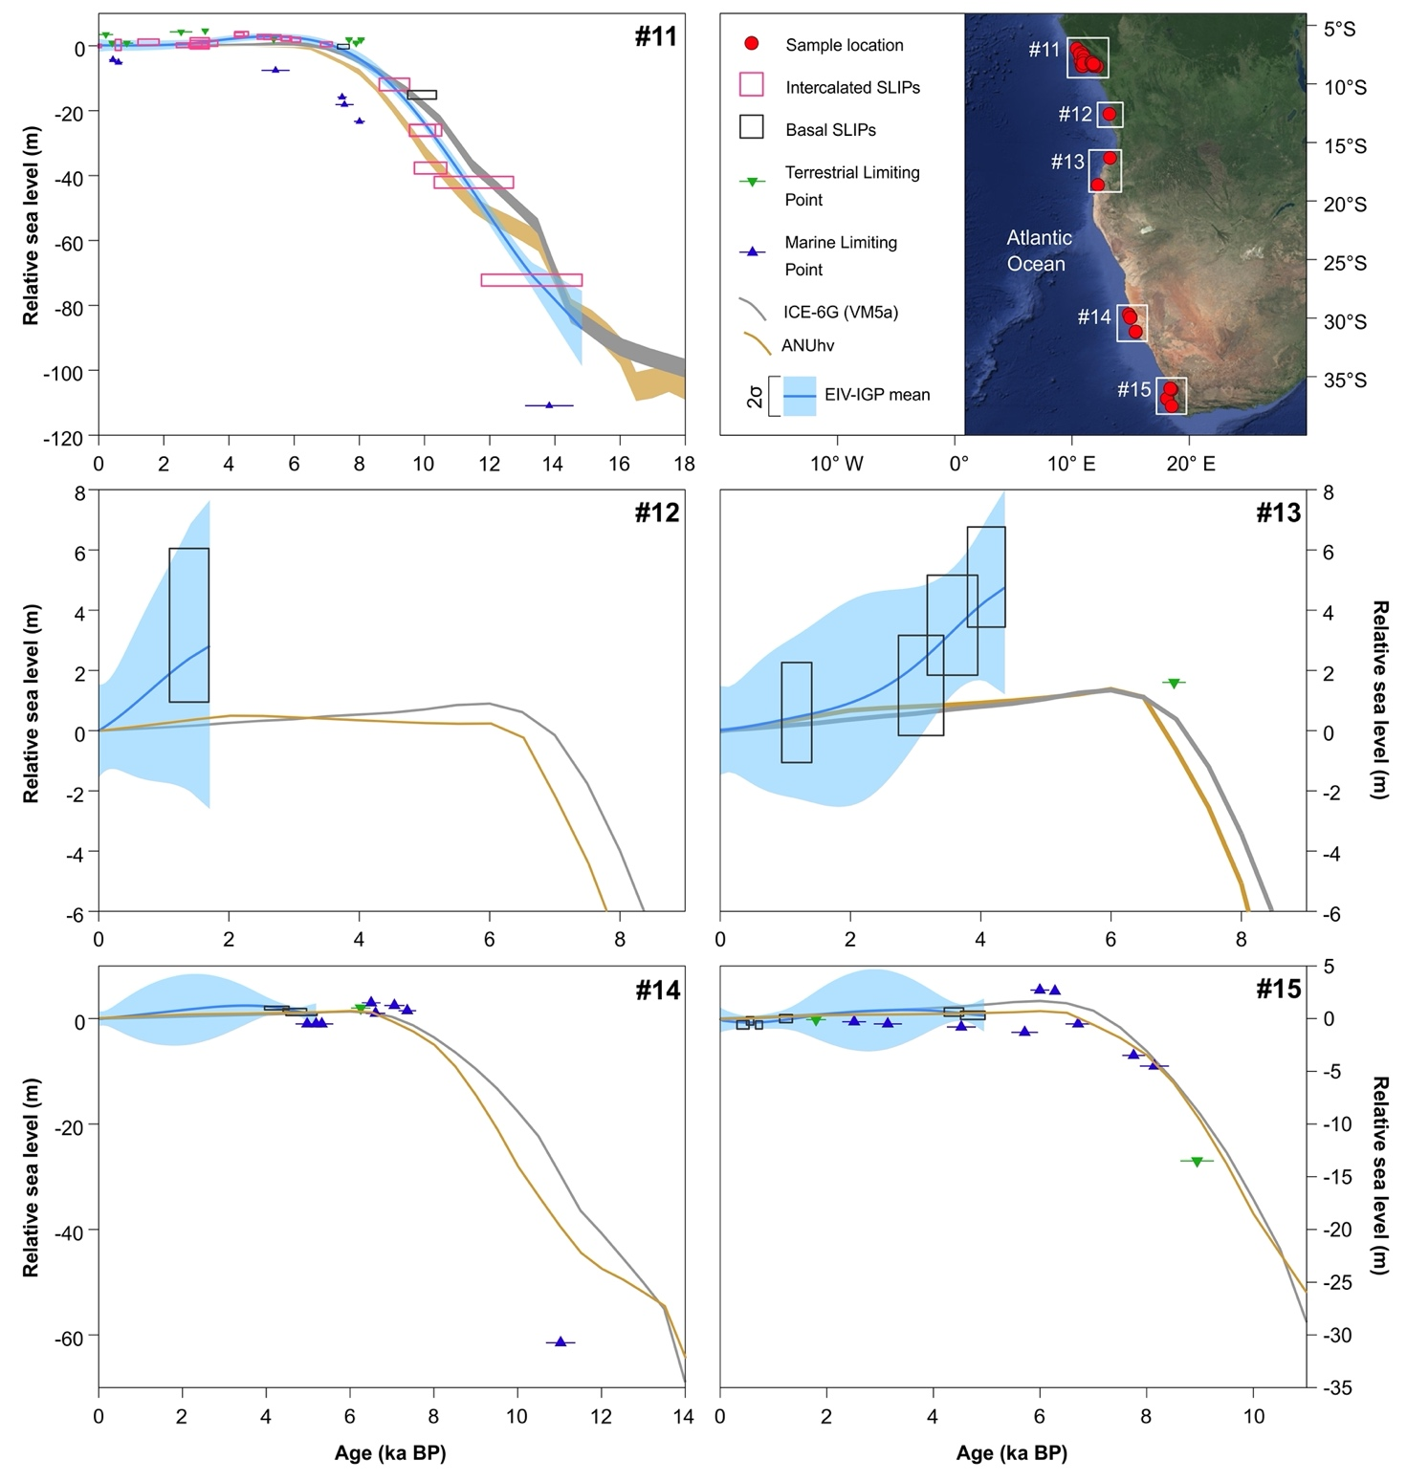

Supplementary 2. Separation of the different ice-sheet contributions to the GIA predictions for the 15 regions of Atlantic Africa

Figure S2_1. Separation of the different ice-sheet contributions to the ICE-6G prediction for the 15 regions in the last 8 ka. Black line indicates the ICE-6G prediction; NH is the northern hemisphere contribution; ANT is the Southern Hemisphere contribution (Antarctic Ice-sheet); NAM is the North America contribution; NEU is the North European contribution. NAM+NEU is the entire Northern Hemisphere contribution (North America+North Europe ice sheets).
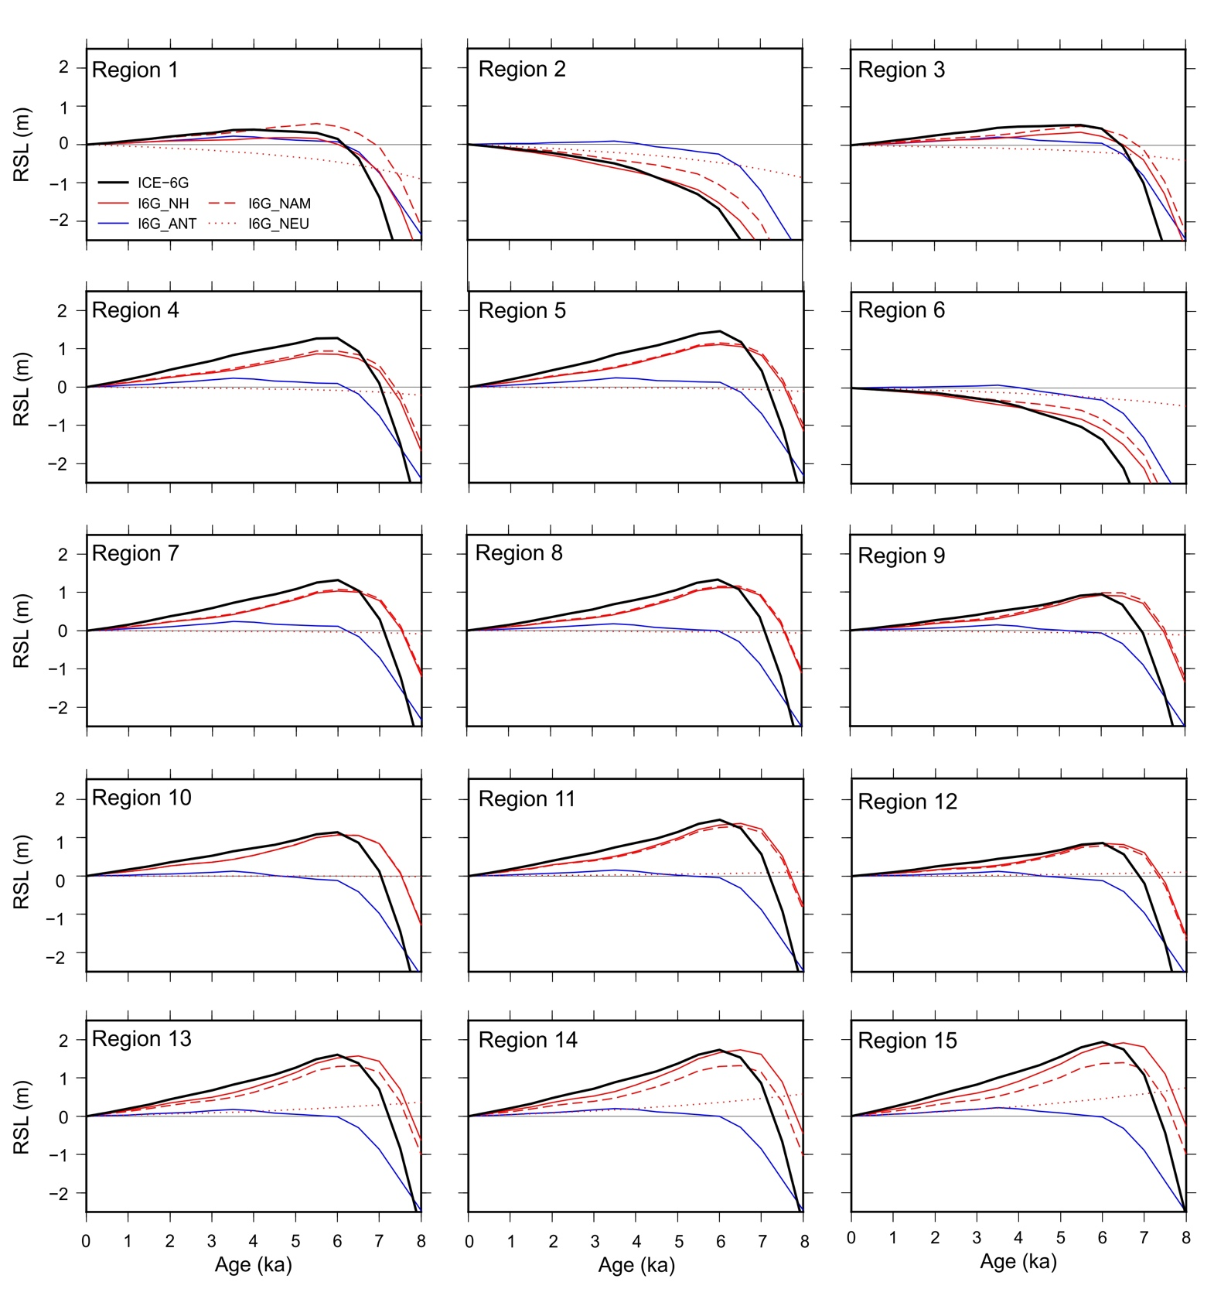

Figure S2_2. Separation of the different ice-sheet contributions to the ANUhv prediction for the 15 regions in the last 8 ka. Black line indicates the ANUhv prediction; NH is the northern hemisphere contribution; ANT is the Southern Hemisphere contribution (Antarctic Ice-sheet); NAM is the North America contribution; NEU is the North European contribution. NAM+NEU is the entire Northern Emisphere contribution (North America+North Europe ice sheets).
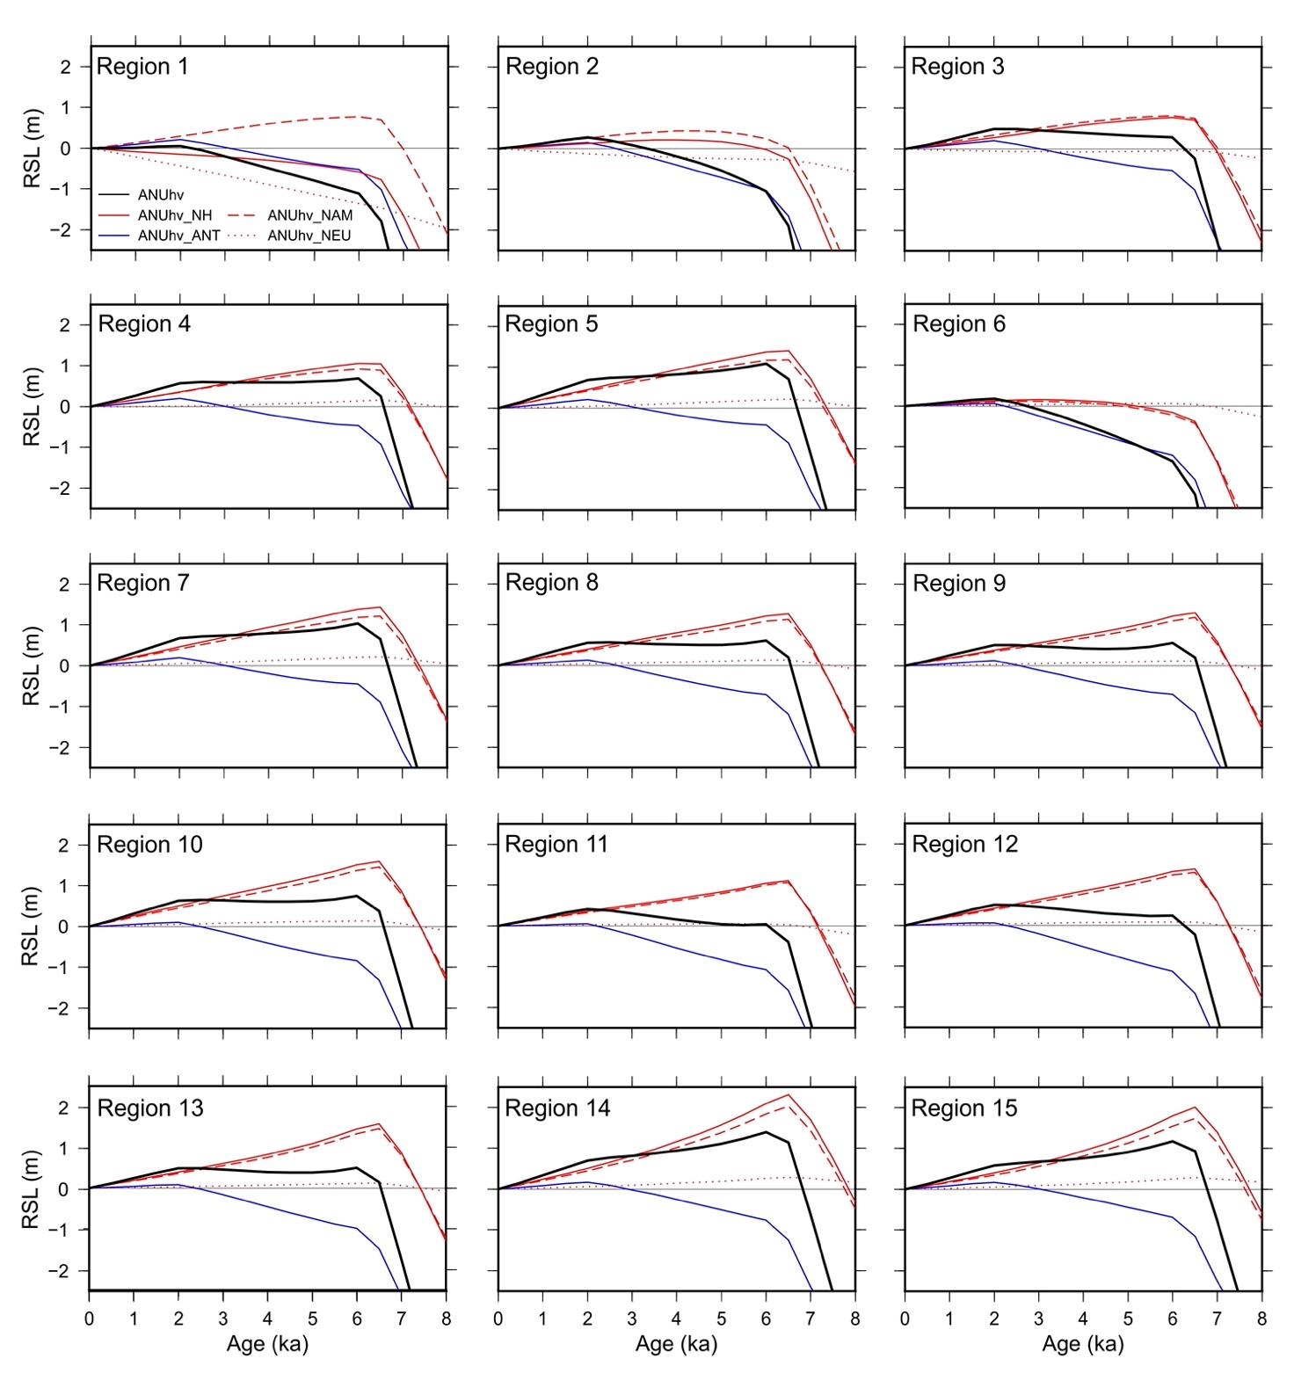

Figure S2_3. Modelled regional contributions of both northern (North America, Northern Europe and Greenland) and southern (Antarctica) hemisphere ice-sheets to meltwater input since 10ka BP according to the ICE-6G and ANUhv GIA models. ESL is the ice-volume equivalent sea-level change.

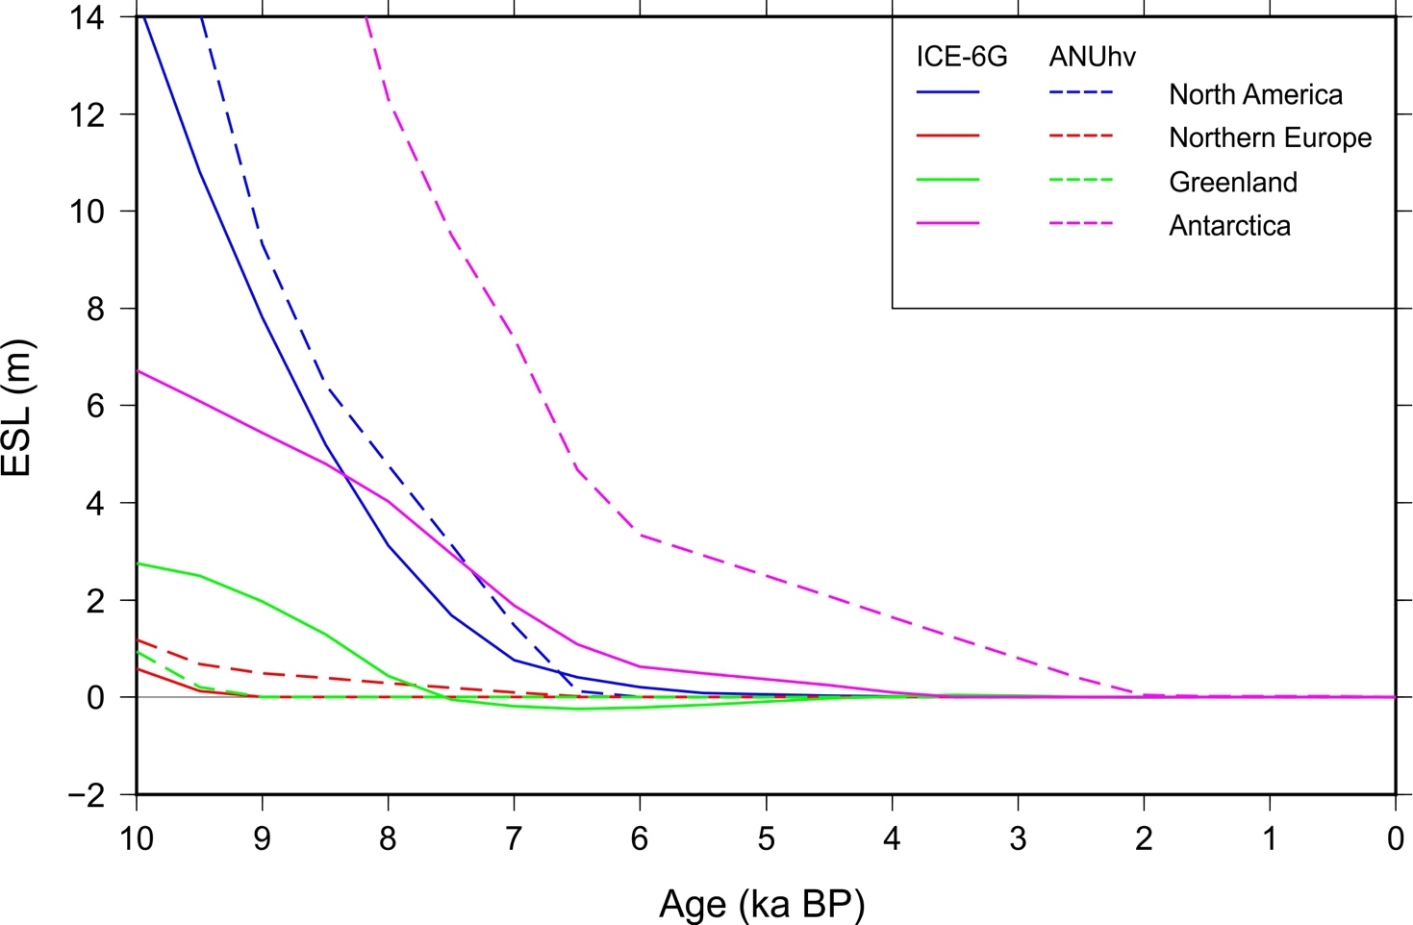

Supplementary 3. Study area description and additional methodological information

Tectonic, geographic and climatic setting of the Atlantic coast of Africa
The Atlantic coast of Africa is a passive margin and most of its coast is considered as affected by negligible tectonic movements within the Quaternary¹. The coastline between Mauritania and Niger delta is considered as tectonically stable^{1,2}. More tectonically active areas are found along the Moroccan coast, in alignment with the Cameroon volcanic line as well as in the Canary and Cabo Verde archipelagos². Despite the mild historical seismicity, Quaternary uplift trends have been recently reported along the Angola coast³, while substantial neotectonic stability is reported for the Namibian and South African coasts^{4,5}. The Atlantic coast of Africa has a N-S orientation except for the northern side of the Gulf of Guinea (e.g., from Ivory Coast to the Niger delta), which runs W-E.
We subdivided the database into 15 regions (Table 1) based on their distance from the palaeo-ice sheets⁶. These 15 regions show a large range of geographic and climatic settings⁷ and are characterized by micro to mesotidal conditions (see Table S3_1). The northern part of the Atlantic coast of Africa extending from Morocco to Mauritania (regions 1 to 5) is characterized by temperate to arid conditions. The coast is generally composed of wave-dominated beaches alternating with rocky coasts⁸. Large coastal lagoons and saltmarshes occur at the mouths of the major rivers^{9,10}. In Atlantic Sahara (also known as Western Sahara or Southern Morocco, a disputed territory on the northwest coast of Africa) and in Mauritania (regions 3 to 5), the dominantly arid conditions significantly reduce the presence of rivers and streams and have favored the development of large evaporitic lagoons¹¹ (sebkhas). Here, saltmarshes only develop in the sheltered bays and in the wide Banc d’Arguin wetlands which stretches for ~180 km along the coast of central Mauritania¹². This area also corresponds to the northernmost extent of African mangrove forests^{13,14}.

Map n. | Region | Latitude | Tidal range
 | North-Atlantic coast of Africa
1 | Mid-northern Morocco | 35.1° to 32.6 N | 3 to 3.7 m
2 | Canary Islands | 29.1° to 28.0° N | 3 m
3 | Northern Atlantic Sahara | 26.1° to 26.1° N | 2.1 m
4 | Southern Atlantic Sahara | 23,0° to 21.8° N | 1.7 to 2.3 m
5 | Mid-northern Mauritania | 20.3° to 18.1° N | 1.5 to 1.6 m
 | Mid-Atlantic coast of Africa
6 | Cabo verde Islands | 16.8° to 16.0° N | 1.1 to 1.2 m
7 | Senegal | 16.9° to 14.6° N | 1.7 to 1.9 m
8 | Sierra Leone- GuineaConakry | 9.3° to 7.5° N | 3.5 to 3.8 m
9 | Northern Gulf of Guinea | 7.0° to 4.5° N | 1.2 to 2.1 m
10 | Cameroon and Northern Gabon | 3.8° to 0.7° S | 2.2 to 2.6 m
 | South-Atlantic coast of Africa
11 | Congo | 3.4° to 4.9° S | 1.8m
12 | Northern Angola | 8.9° to 8.9° S | 1.9 m
13 | mid to southern Angola | 12.6° to 15.1° S | 1.9 m
14 | southern Namibia | 25.9° to 27.5° S | 2 m
15 | western South Africa | 32.4° to 33.8° S | 2 m
Table S3_1. Data subdivision in the 15 regions of Atlantic Africa. Please refer to Figure 1 for the location of the regions

The geomorphological setting changes south of 16° N along the Atlantic coast of Africa (regions 6 to 10), where humid tropical conditions have favoured the development of large mangrove stands dominated by Rhizophora racemosa, Rhizophora mangle, Rhizophora harrissonii, Avicennia africana, Laguncularia racemosa, and Conocarpus erectus15,16. These mangrove forests are widespread between Senegal and Sierra Leone alternating with coastal sectors characterized by eroding cliffs associated with sandy beaches, and cheniers, whereas in the Gulf of Guinea they largely occur in the Volta and Niger river deltas as well as in shore-parallel coastal lagoons along the wave-dominated beach-ridge sand barrier coast stretching from the Ivory Coast to Benin¹⁷.
The southern Atlantic coast of Africa (regions 11 to 15) is mainly characterized by wave-dominated beaches alternating with swampy coasts rich in mangrove forests from Gabon to the Rio Longa estuary in Angola (-10.2° N of latitude)^{14,18}. In southern Angola and Namibia, an important change in the coastal setting corresponds to a major transition from tropical to semi-arid conditions associated with the vast Kalahari Desert. This coastline is characterized by widespread dune fields often developing very close to the shoreline and by low-elevation rocky coasts¹⁹. In South Africa, rocky cliffs and long sandy beaches dominate along much of the coastline. The progressive transition towards temperate climatic conditions has favored the development of coastal marshes, notably at the mouths of the major rivers.

Definition of the indicative meaning
The database of Sea-Level Index Points (SLIPs) and marine and terrestrial limiting points was assembled following the protocol described by International Geoscience Programme (IGCP) projects 61, 200, 495, 588, and 639 and by the recent Holsea Inqua project^{20,21}. Table S3_2 summarizes the typologies of SLIPs and limiting points which characterize the sea-level database of the Atlantic coast of Africa.

Table S3_2. Summary of the indicative meanings used to estimate the relative elevation of the sea-level index points and limiting points for the database. HAT-Highest Astronomical Tide; MHHW-Mean Higher High Water; MHW-Mean High Water; and MTL-Mean Tide Level.

Indicator Type | Evidence | Reference Water Level | Indicative Range
SLIPs  Mangrove and salt-marsh environment | Intertidal sediments with mangrove plant macrofossils^{22,23}. Foraminiferal and pollen assemblages dominated by mangrove taxa^{24,25,26}. | (HAT to MSL)/2 | HAT to MSL
Intertidal environment | Intertidal sediments dominated by foraminiferal and macrofaunal assemblages dominated by intertidal taxa^{22,27,28}. | (HAT to MLLW)/2 | HAT to MLLW
Lower intertidal environment | Intertidal sediments with faunal assemblages typical of the lower intertidal (slikke) facies^{29,30}. | (MSL to MLLW)/2 | MSL to MLLW
Shallow lagoon environment | Lagoonal and estuarine sediments dominated by macrofaunal and microfaunal assemblages typical of brackish environment and with presence of freshwater taxa^{22, 29,31,32}. | (MSL to -1 m)/2 | MTL to -1 m
Open lagoon environment | Lagoonal sediments dominated by marine to brackish macrofaunal assemblages^{11,32,34}. | (MSL to -2 m)/2 | MSL to -2 m
Beach ridges | Sandy to gravelly high energy deposits with mixed shell debris^{35,36}. | (3 m + HAT to MLLW)/2 | 3 m + HAT to MLLW
Upper beach | Sandy deposits characterized by low angle seaward dipping tabular cross bedding and with presence of littoral macrofaunal assemblage^{35,36}. | (HAT to MSL)/2 | HAT to MSL
Intertidal to shallow subtidal environment | Sandy to muddy deposits characterized by the presence of coastal macrofaunal associations, ooids (sometimes oxidated) and milioids^{37,38} . | (HAT to -4 m)/2 | HAT to -4 m
Vermetid reef | Identifiable Vermetid reefs found in living position³⁹. | (MHHW to MLLW)/2 | MHHW to MLLW
Beachrock | Littoral conglomerates showing intergranular intertidal cements and/or sediment bedding showing seaward dipping planar cross beds^{5,40,41} | (HAT to MLLW)/2 | HAT to MLLW
Littoral deposits | Muddy deposits rich in littoral fauna^{37,38} . | (MSL to -10 m)/2 | MLLW to -10 m
Limiting Points  Marine limiting | Marine sands dominated by macrofaunal and microfaunal assemblages typical of infralittoral environment^{29,37,42,43}. | MSL | Below MSL
Freshwater limiting | Peat and organic soils dominated by freshwater plant macrofossil^{11,44,45}, archaeological shell midden deposits^{11,46} . | MSL | Above MSL

Supplementary bibliography
1- Potrel, A., Peucat, J. J., & Fanning, C. M. (1998). Archean crustal evolution of the West African Craton: example of the Amsaga Area (Reguibat Rise). U/Pb and Sm/Nd evidence for crustal growth and recycling. Precambrian Research, 90(3-4), 107-117.
2- Meghraoui, M., & IGCP-601 Working Group. (2016). The seismotectonic map of Africa. Episodes Journal of International Geoscience, 39(1), 9-18.
3- Walker, R. T., Telfer, M., Kahle, R. L., Dee, M. W., Kahle, B., Schwenninger, J. L., ... & Watts, A. B. (2016). Rapid mantle-driven uplift along the Angolan margin in the late Quaternary. Nature Geoscience, 9(12), 909-
4- Partridge, T. C., & Maud, R. R. (2000). Macro-scale geomorphic evolution of southern Africa. Oxford Monographs on Geology and Geophysics, 40, 3-18.
5- Cooper, J. A. G., Green, A. N., & Compton, J. S. (2018). Sea-level change in southern Africa since the Last Glacial Maximum. Quaternary Science Reviews, 201, 303-318.
6- Engelhart, S. E., Horton, B. P., Douglas, B. C., Peltier, W. R., & Törnqvist, T. E. (2009). Spatial variability of late Holocene and 20th century sea-level rise along the Atlantic coast of the United States. Geology, 37(12), 1115-1118.
7- Beck, H., Zimmermann, N., McVicar, T. et al. (2018) Present and future Köppen-Geiger climate classification maps at 1-km resolution. Scientific Data 5, 180214.
8- Sedrati, M., Morales, J. A., El M’rini, A., Anthony, E. J., Bulot, G., Le Gall, R., & Tadibaght, A. (2022). Using UAV and Structure-From-Motion Photogrammetry for the Detection of Boulder Movement by Storms on a Rocky Shore Platform in Laghdira, Northwest Morocco. Remote Sensing, 14(16), 4102.
9-Balloche, A., & Carruesco, C. (1986). Evolution holocène d’un écosystème lagunaire: la lagune de Oualidia (Maroc atlantique). Revue de géologie dynamique et de géographie physique, 27(2), 113-118.
10- Carmona, P., & Ruiz, J. M. (2009). Geomorphological evolution of the River Loukkos estuary around the Phoenician city of Lixus on the Atlantic Littoral of Morocco. Geoarchaeology: An International Journal, 24(6), 821-845.
11- Ortlieb, L. (1975). Recherches sur les formations plio-quaternaires du littoral Ouest-saharien: 28030ʹ-20040ʹ lat. N (Vol. 48). IRD Editions.
12- Barusseau, J. P., Certain, R., Vernet, R., & Saliège, J. F. (2010). Late Holocene morphodynamics in the littoral zone of the Iwik Peninsula area (Banc d'Arguin—Mauritania). Geomorphology, 121(3-4), 358-369.
13- Dahdouh-Guebas, F., & Koedam, N. (2001). Are the northernmost mangroves of West Africa viable?–A case study in Banc d'Arguin National Park, Mauritania. Hydrobiologia, 458(1), 241-253.
14- Diop, E. S., Gordon, C., Semesi, A. K., Soumaré, A., Diallo, N., Guissé, A., ... & Ayivor, J. S. (2002). Mangroves of Africa. In Mangrove ecosystems (pp. 63-121). Springer, Berlin, Heidelberg.
15- Debenay, J. P., Pages, J., & Guillou, J. J. (1994). Transformation of a subtropical river into a hyperhaline estuary: the Casamance River (Senegal)—paleogeographical implications. Palaeogeography, Palaeoclimatology, Palaeoecology, 107(1-2), 103-119.
16-Anthony, E. J. (2004). Sediment dynamics and morphological stability of estuarine mangrove swamps in Sherbro Bay, West Africa. Marine Geology, 208(2-4), 207-224.
17-Anthony, E. J., Oyédé, L. M., & Lang, J. (2002). Sedimentation in a fluvially infilling, barrier‐bound estuary on a wave‐dominated, microtidal coast: the Ouémé River estuary, Benin, west Africa. Sedimentology, 49(5), 1095-1112.
18- Giresse, P., Hoang, C. T., & Kouyoumontzakis, G. (1984). Analysis of vertical movements deduced from a geochronological study of marine Pleistocene deposits, southern coast of Angola. Journal of African Earth Sciences (1983), 2(2), 177-187.
19- Garzanti, E., Vermeesch, P., Andò, S., Lustrino, M., Padoan, M., & Vezzoli, G. (2014). Ultra-longdistance littoral transport of Orange sand and provenance of the Skeleton Coast Erg (Namibia). Marine Geology, 357, 25-36.
20- Shennan, I. (2015). Handbook of sea‐level research: framing research questions. Handbook of sea‐level research, 3-25.
21- Khan, N. S., Horton, B. P., Engelhart, S., Rovere, A., Vacchi, M., Ashe, E. L., ... & Shennan, I. (2019). Inception of a global atlas of sea levels since the Last Glacial Maximum. Quaternary Science Reviews, 220, 359-371.
22- Faure, H., & Elouard, P. (1967). Schéma des variations du niveau de l'Océan Atlantique sur la côte de l'Ouest de l'Afrique depuis 40 000 ans. Compte Rendu de l'Académie des Sciences, Paris, 265, 784-787.
23- Moguedet, G., Bongo-Passi, G., Giresse, P., & Schwartz, D. (1986). Corrélations entre sédiments quaternaires continentaux et marins au Congo. Revue de Géologie dynamique et de Géographie physique, 27(2), 131-40.
24-Lezine, A. M., Turon, J. L., & Buchet, G. (1995). Pollen analyses off Senegal: evolution of the coastal palaeoenvironment during the last deglaciation. Journal of Quaternary Science, 10(2), 95-105.
25- Elenga, H., Vincens, A., Schwartz, D., Fabing, A., Bertaux, J., Wirrmann, D., ... & Servant, M. (2001). Le marais estuarien de la Songolo (Sud Congo) à l'Holocène moyen et récent. Bulletin de la Societe geologique de France, 172(3), 359-366.
26- Tossou, M. G., Akoègninou, A., Ballouche, A., Sowunmi, M. A., & Akpagana, K. (2008). The history of the mangrove vegetation in Bénin during the Holocene: A palynological study. Journal of African Earth Sciences, 52(4-5), 167-174.
27- Ausseil-Badie, J., Barusseau, J. P., Descamps, C., Diop, E. S., Giresse, P., & Pazdur, M. (1991). Holocene deltaic sequence in the Saloum Estuary, Senegal. Quaternary Research, 36(2), 178-194.
28- Barusseau, J. P., Bâ, M., Descamps, C., Diop, E. S., Giresse, P., & Saos, J. L. (1995). Coastal evolution in Senegal and Mauritania at 103, 102 and 101-year scales: natural and human records. Quaternary International, 29, 61-73.
29- Paradis, G. (1978). Interprétation paléoécologique et paléogéographique des Taphocénoses de l'Holocène récent du Sud-Bénin, à partir de la répartition actuelle des mollusques littoraux et lagunaires d'Afrique occidentale. Géobios, 11(6), 867-891.
30- Diara, M., & Barusseau, J. P. (2006). Late Holocene evolution of the Salum-Gambia double delta (Senegal). Geo Eco Marina, 12, 17-28.
31- Delibrias, G., Ortlieb, L., & Petit-Maire, N. (1976). New 14C data for the Atlantic Sahara (Holocene): tentative interpretations. Journal of Human Evolution, 5(6), 535-546.
32- Bidet, J. C., & Carruesco, C. (1982). Etude sédimentologique de la lagune de Oualidia (Maroc). Oceanologica Acta, Special issue.
33- Marius, C., & Lucas, J. (1991). Holocene mangrove swamps of West Africa sedimentology and soils. Journal of African Earth Sciences (and the Middle East), 12(1-2), 41-54.
34- García-Artola, A., Stéphan, P., Cearreta, A., Kopp, R. E., Khan, N. S., & Horton, B. P. (2018). Holocene sea-level database from the Atlantic coast of Europe. Quaternary Science Reviews, 196, 177-192.
35- Giresse, P., Kouyoumontzakis, G., Delibrias, G., (1976). La trangression fini-holocene en Angola, aspects chronologique, eustatique, paleoclimatique et epirogenique. Comptes rendus de l'Académie des sciences 283; 10; 1157-1160;
36- Lefevre, D., Texier, J., Raynal, J. P., Occhietti, S., & Evin, J. (1994). Enregistrements-réponses des variations climatiques du Pléistocène supérieur et de l'Holocène sur le littoral de Casablanca (Maroc)/Upper Pleistocene and Holocene records on the Casablanca coast (Morocco). Quaternaire, 5(3), 173-180.
37- Giresse, P., & Ngueutchoua, G. (1998). Variations des lignes de rivage du plateau continental du Cameroun a la fin du Pleistocene (40 ka a 10 ka BP); chronologie et environnements sedimentaires. Bulletin de la Société Géologique de France, 169(2), 315-325
38- Ngueutchoua, G., & Giresse, P. (2010). Sand bodies and incised valleys within the Late Quaternary Sanaga–Nyong delta complex on the middle continental shelf of Cameroon. Marine and Petroleum Geology, 27(10), 2173-2188
39- Laborel, J and Delibrias, G, 1976, Niveaux marins recents a vermetidae du litoral Ouest Africain, comparaison avec les niveaux homologues des Cotes du Brasil: Asoc Senegal Quaternaire Afr. Liaison Senegal Bul, v47, p97-10.
40- Amieux, P., Bernier, P., & Dalongeville, R. (1989). Cathodoluminescence of carbonate-cemented Holocene beachrock from the Togo coastline (West Africa): an approach to early diagenesis. Sedimentary Geology, 65(3-4), 261-272.
41- Meco, J., Lomoschitz, A., Rodríguez, Á., Ramos, A. J., Betancort, J. F., & Coca, J. (2018). Mid and Late Holocene sea level variations in the Canary Islands. Palaeogeography, Palaeoclimatology, Palaeoecology, 507, 214-22542- Assemien, P., Filleron, J. C., Martin, L., & Tastet, J. P. (1971). Le Quaternaire de la zone littorale de Côte d'Ivoire. Quaternaria, 15, 305-316.
43- McMaster, R. L., Lachance, T. P., & Ashraf, A. (1970). Continental shelf geomorphic features off portuguese guinea, guinea, and sierra leone (west africa). Marine Geology, 9(3), 203-213.
44- Talbot, M. R. (1981). Holocene changes in tropical wind intensity and rainfall: evidence from southeast Ghana. Quaternary Research, 16(2), 201-220.
45- Malounguila-Nganga, D., Giresse, P., Boussafir, M., & Miyouna, T. (2017). Late Holocene swampy forest of Loango Bay (Congo). Sedimentary environments and organic matter deposition. Journal of African Earth Sciences, 134, 419-434.
46- Barusseau, J. P., Vernet, R., Saliège, J. F., & Descamps, C. (2007). Late Holocene sedimentary forcing and human settlements in the Jerf el Oustani-Ras el Sass region (Banc d’Arguin, Mauritania). Géomorphologie: relief, processus, environnement, 13(1).

