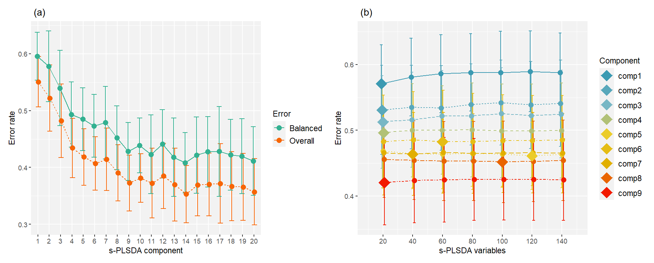
Supplementary Figure 1. Error rate across number of components (a) and number of selected variables (b) for each selected sPLS-DA component for the prediction of fresh semen groups.

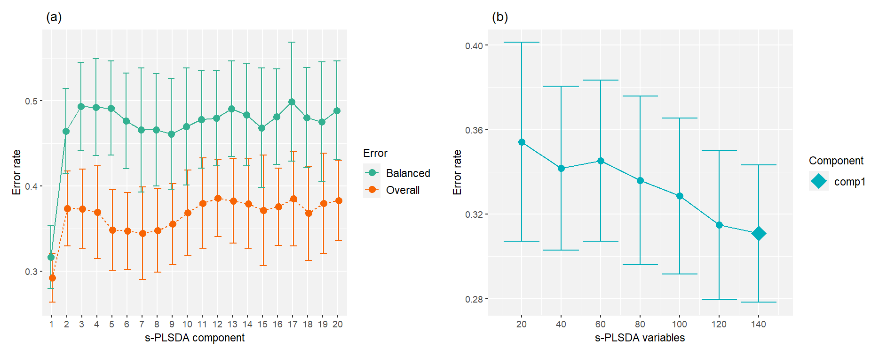

Figure 2. Error rate across number of components (a) and number of selected variables (b) for each selected sPLS-DA component for the prediction of thawed semen groups.

