Supplementary material

Annex 1 – Survey
Figure 1.S1. Survey (English version) used during the study. This survey was completed through EUSurvey system (https://ec.europa.eu/eusurvey).
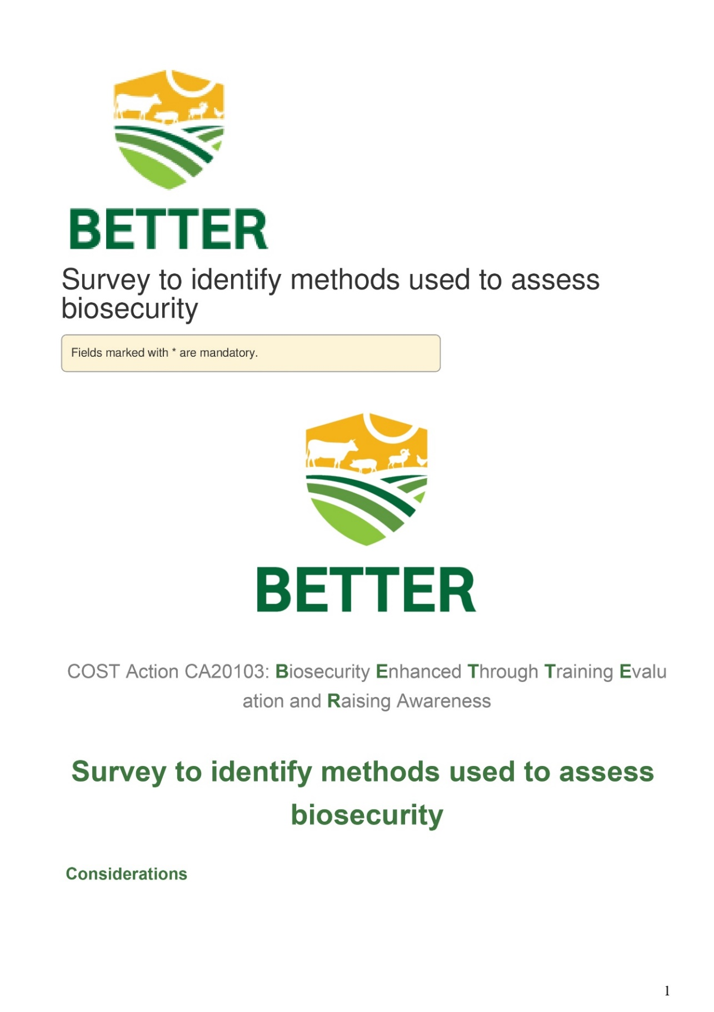
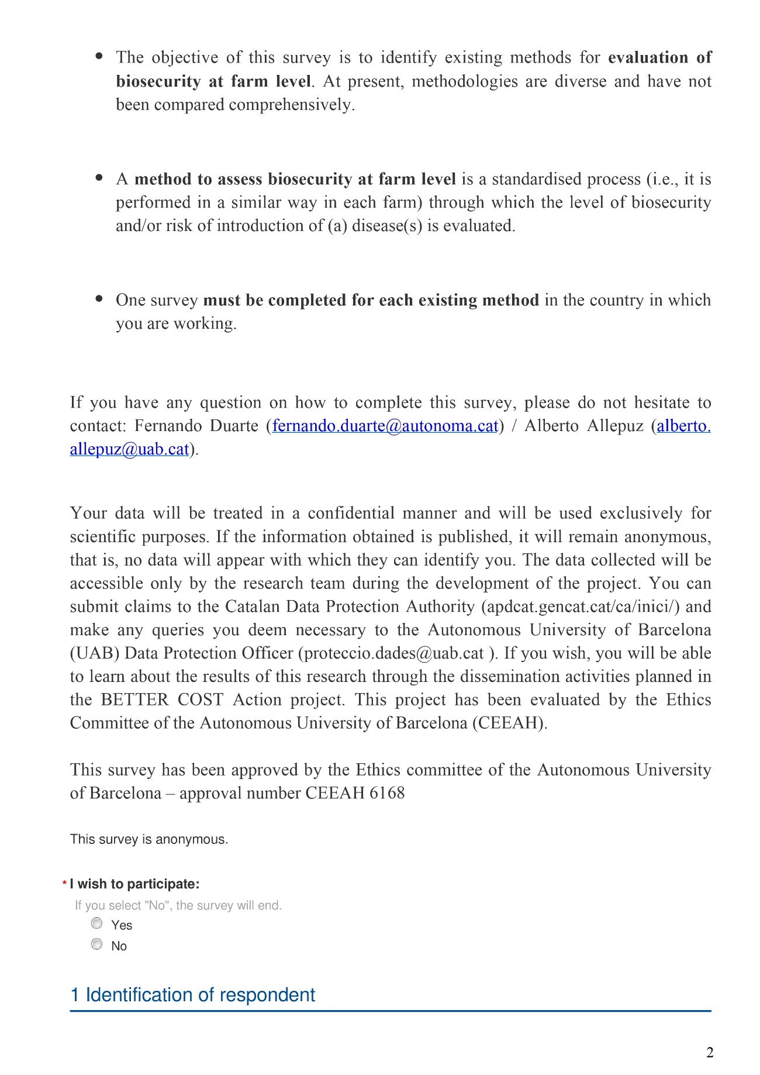

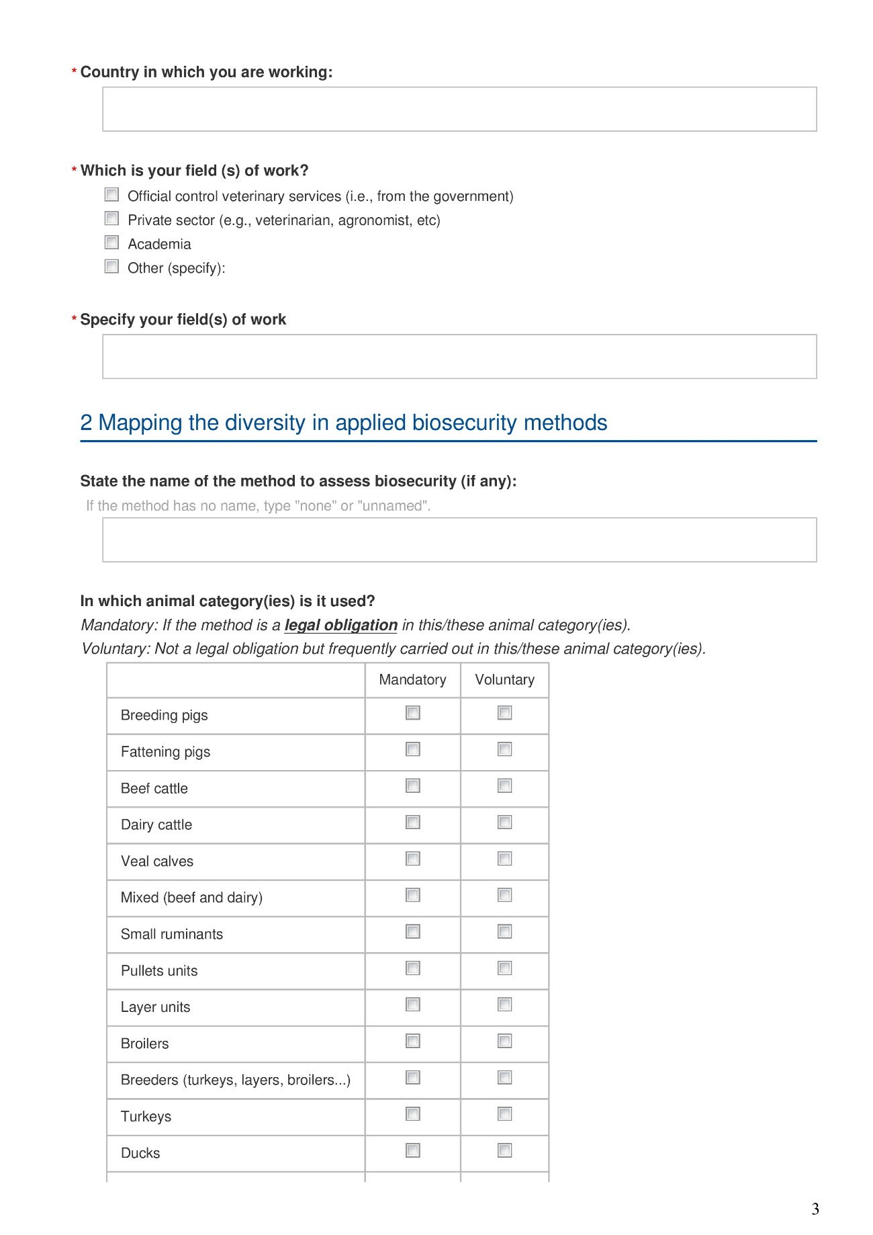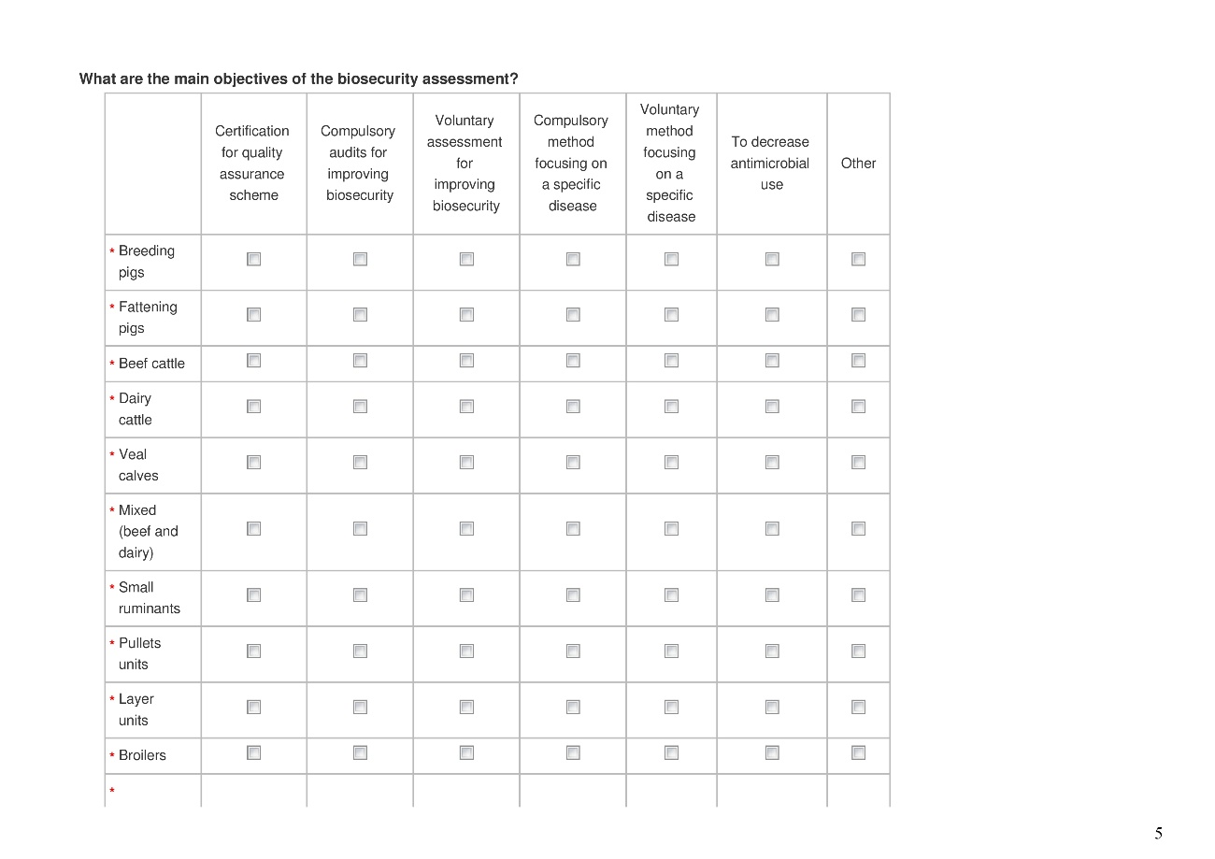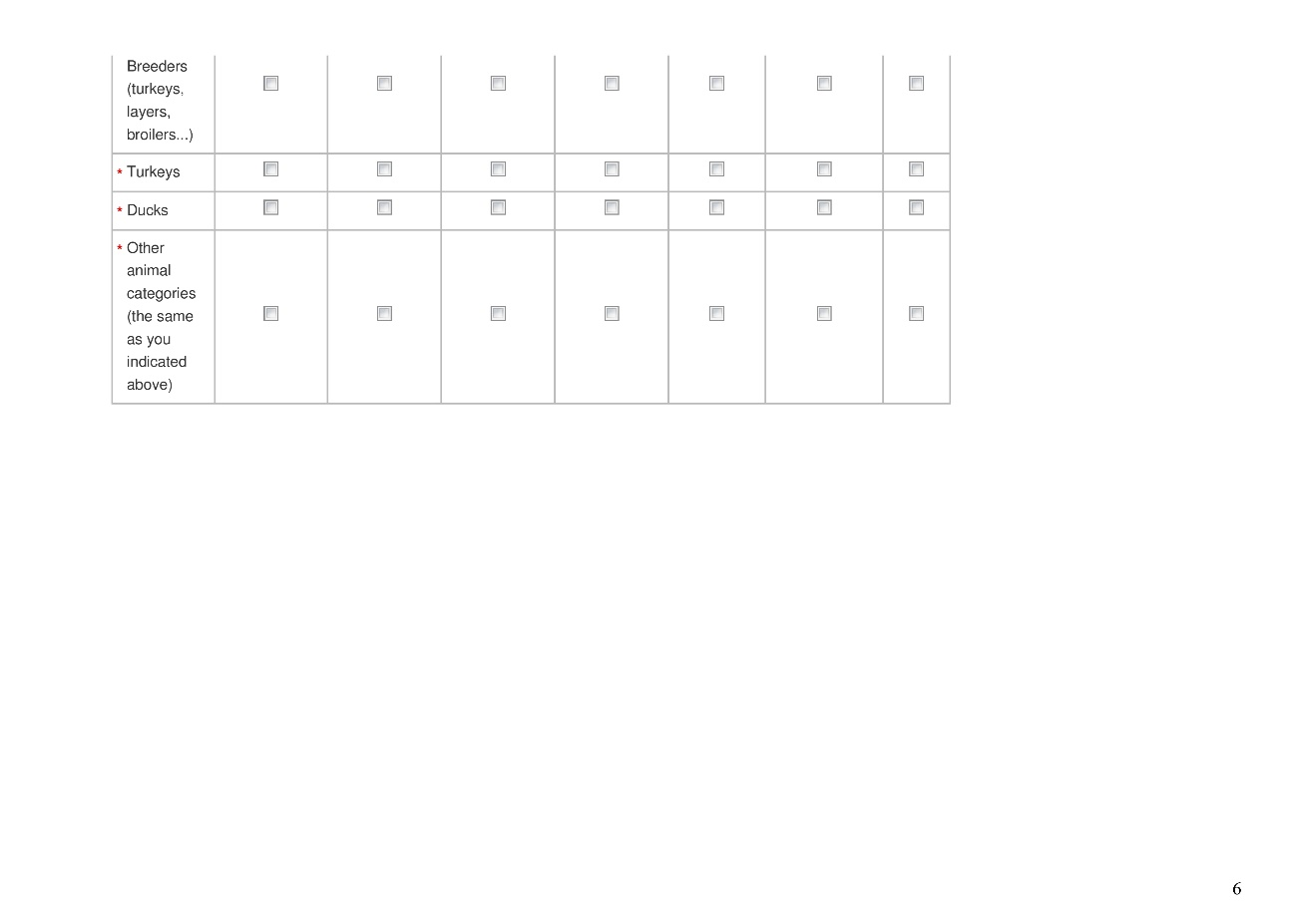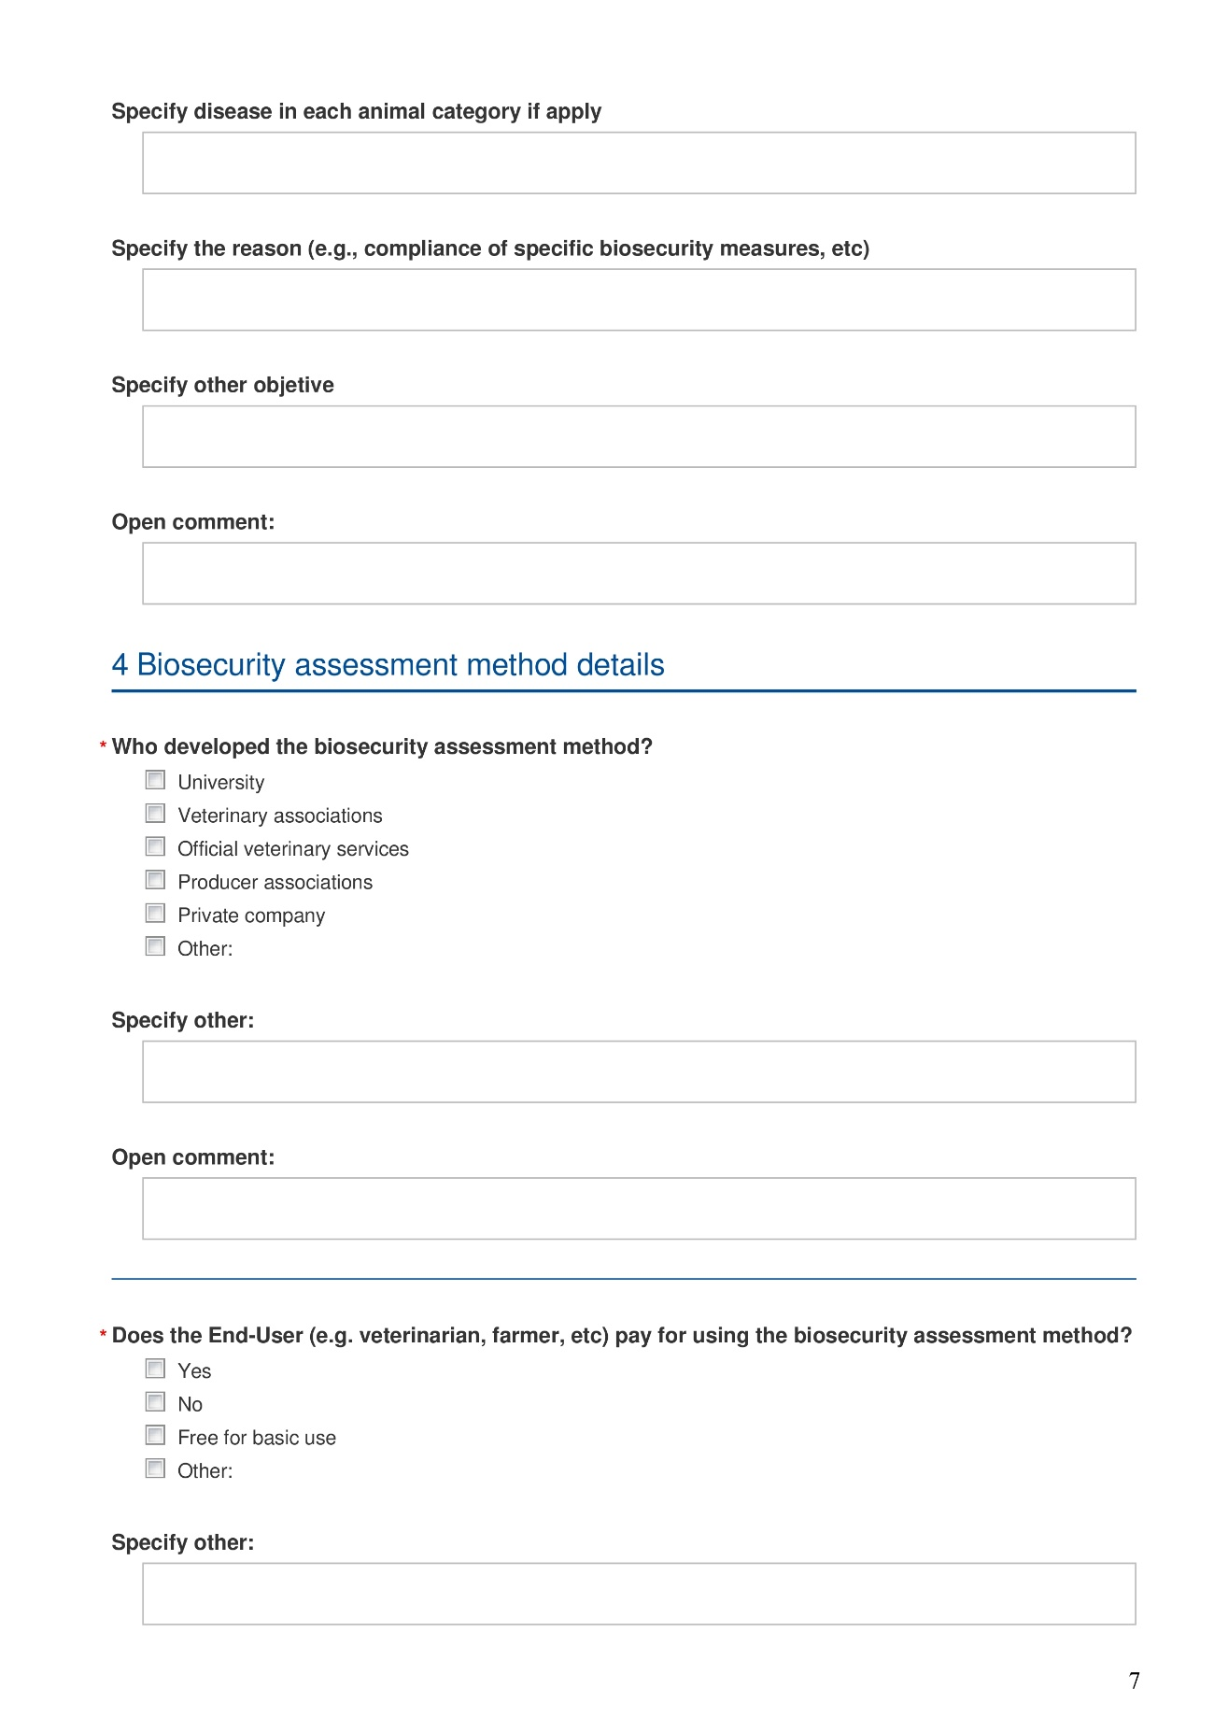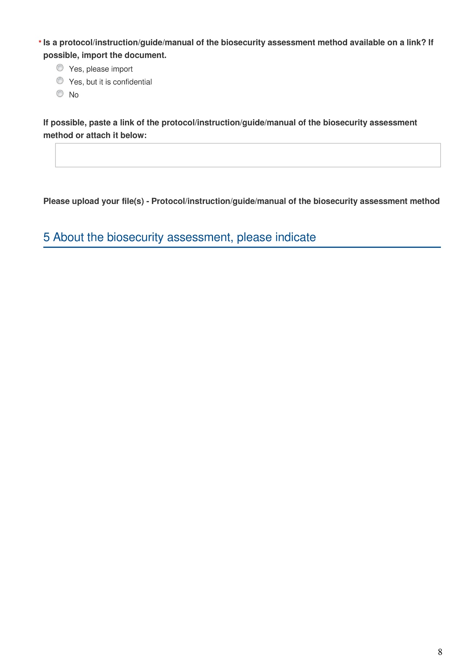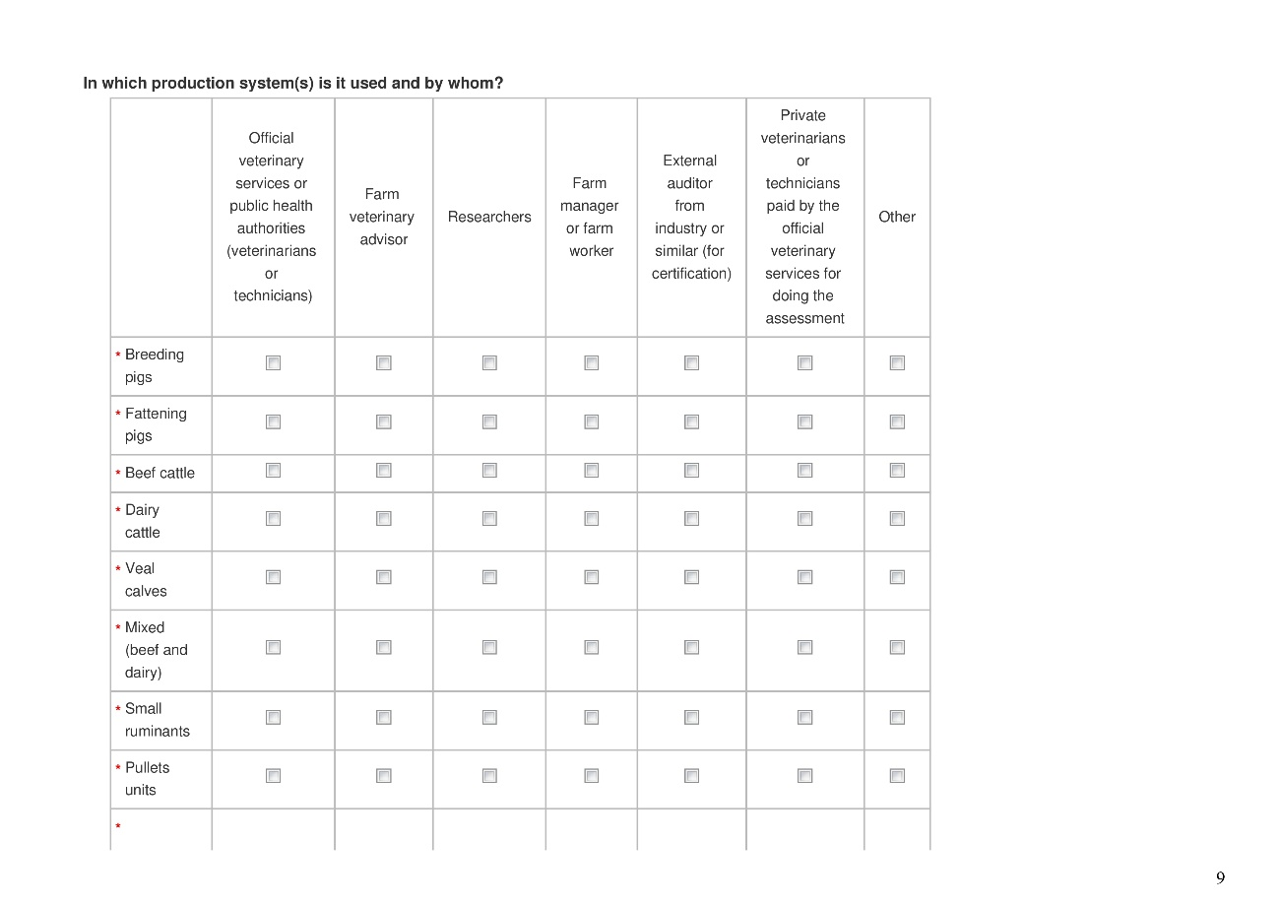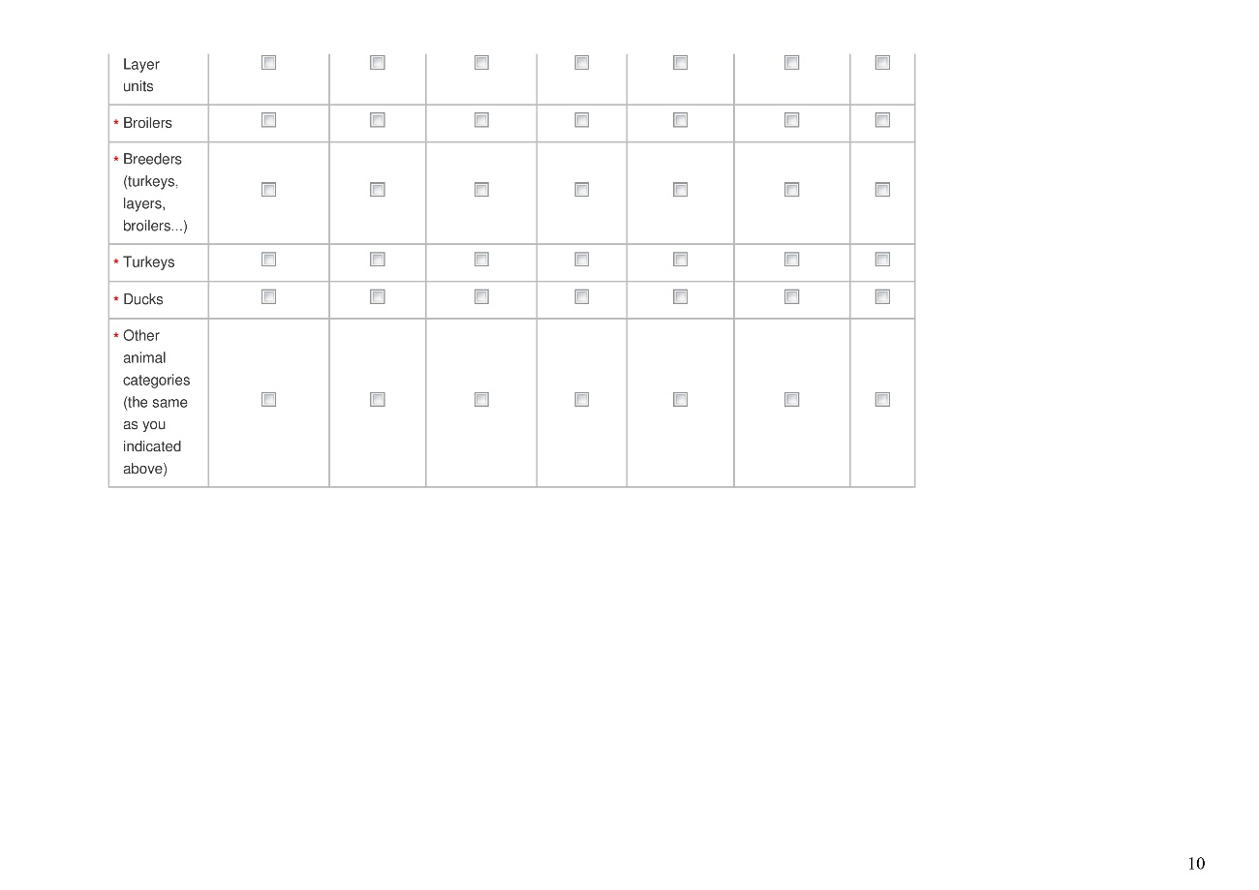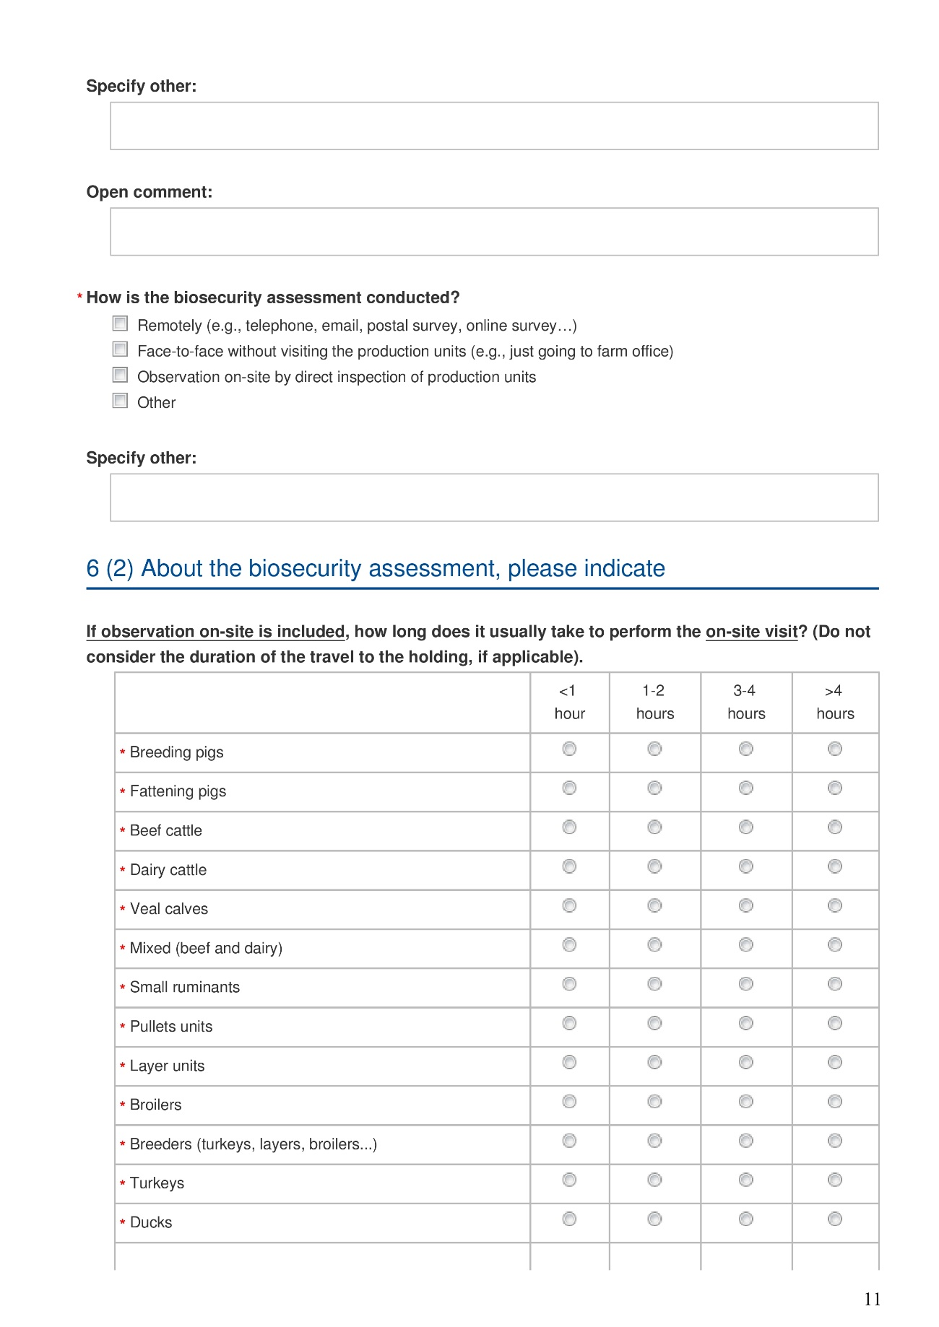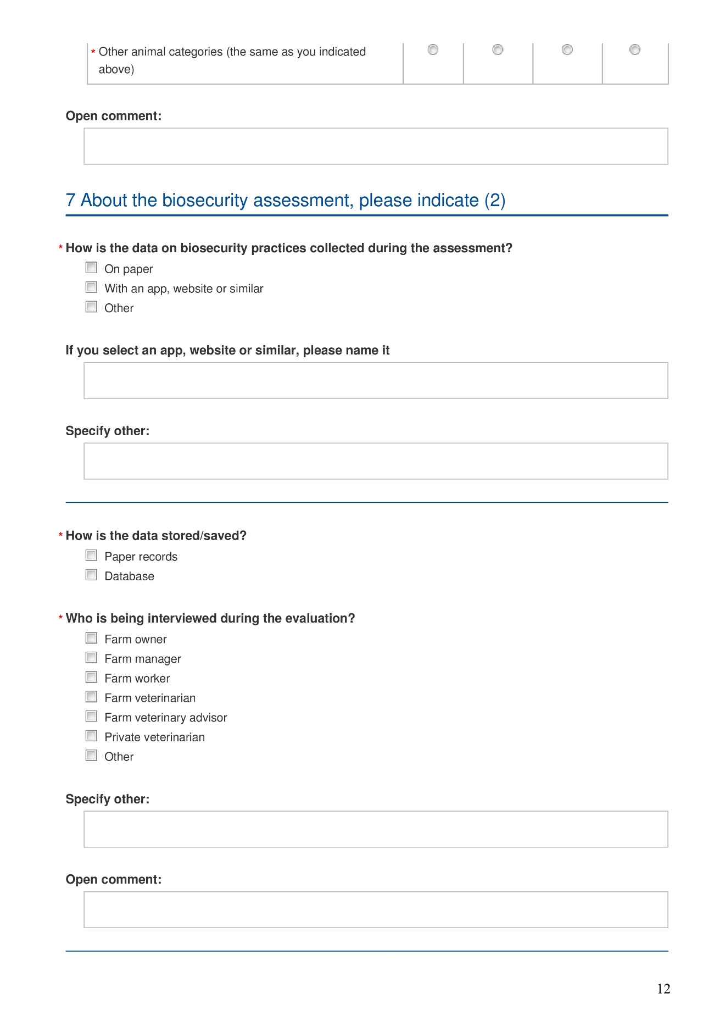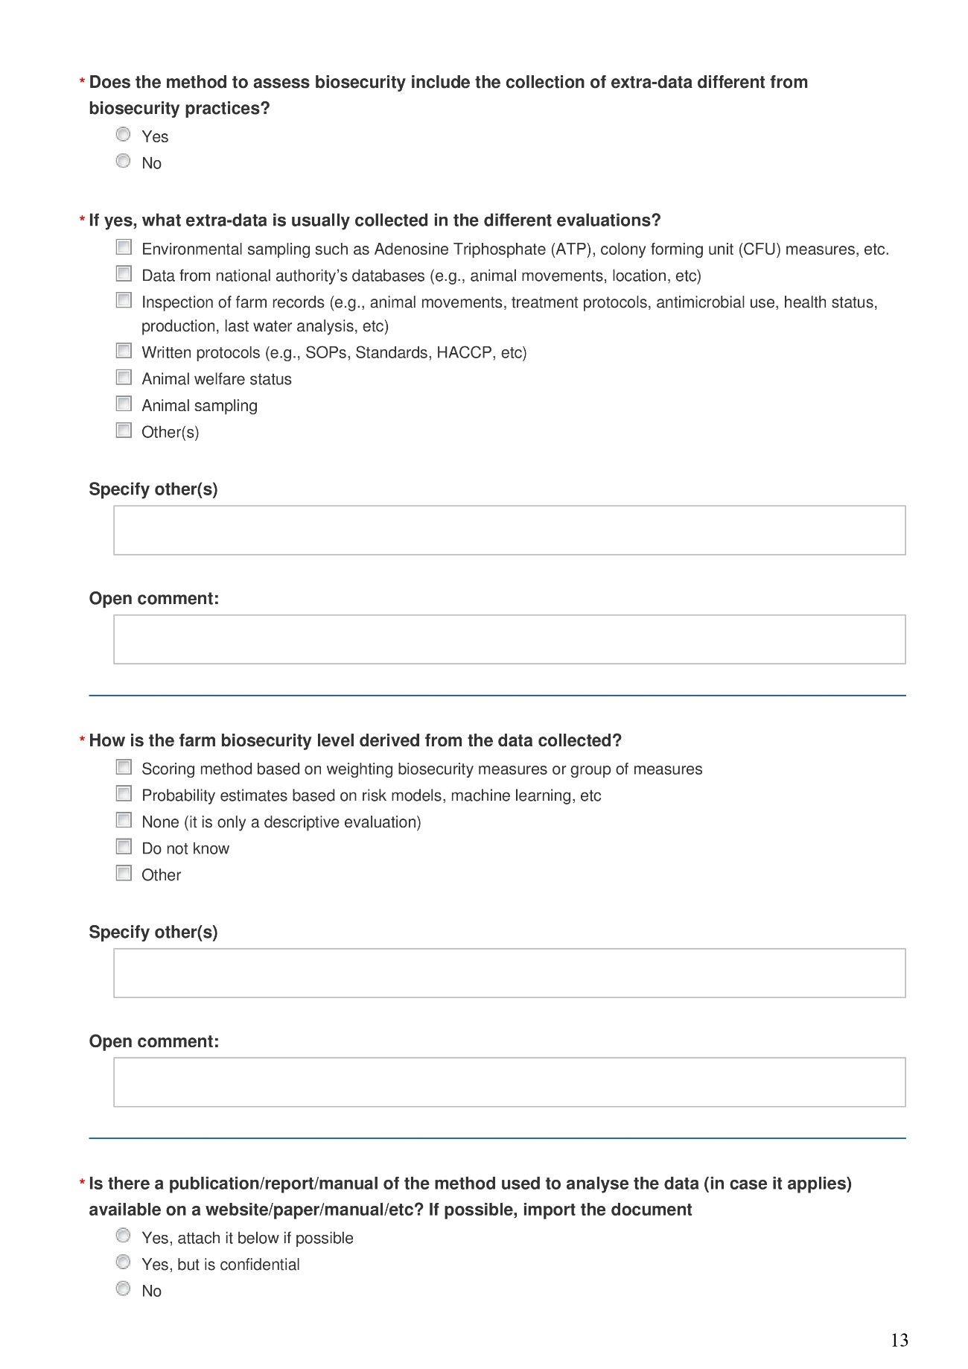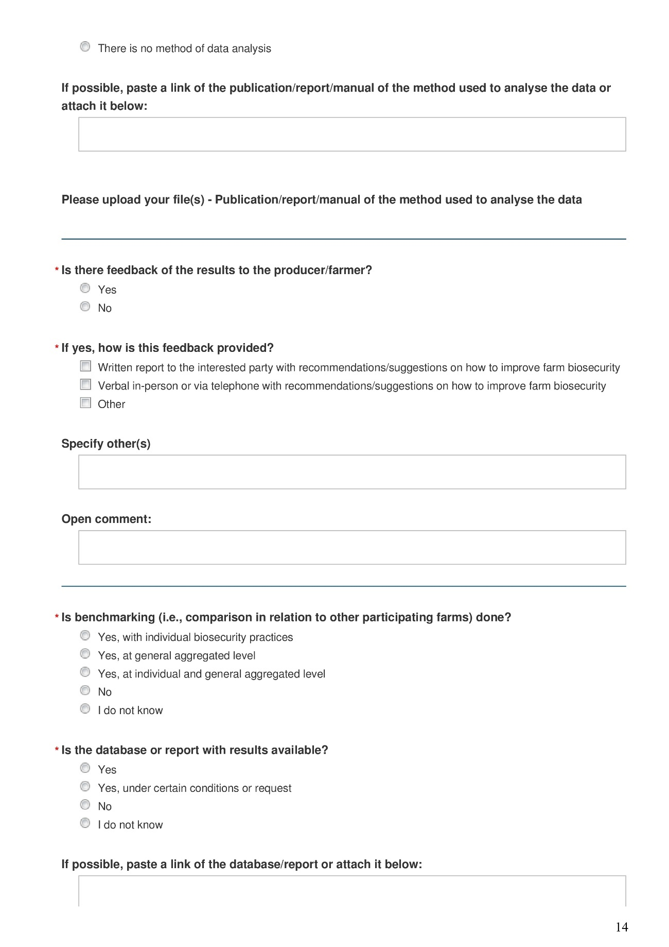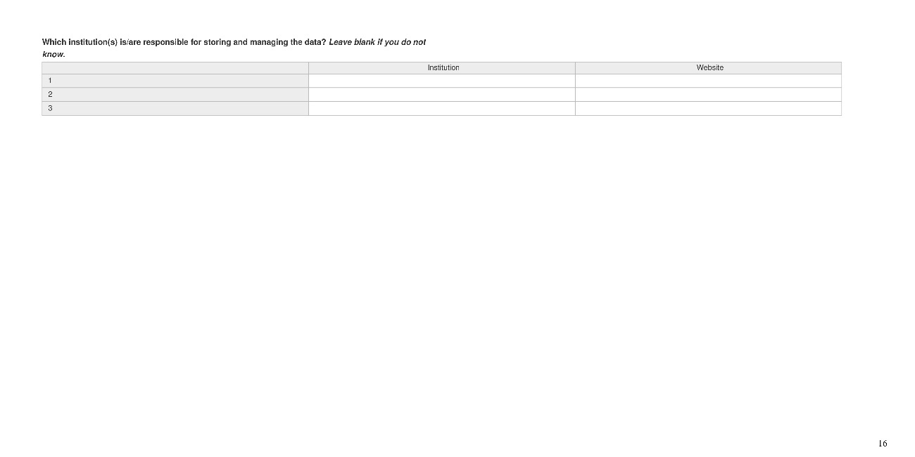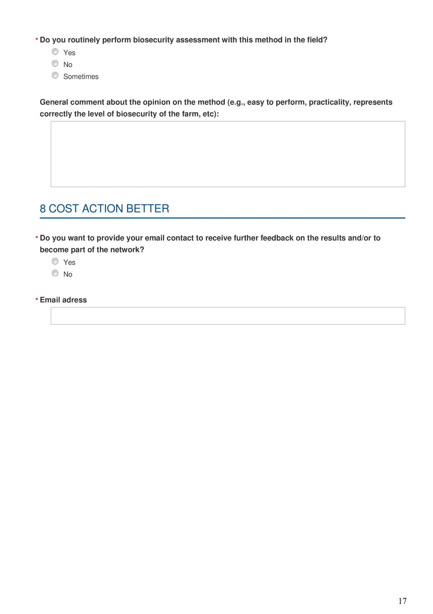

Annex 2
Table 1.S2. List of participating countries and the number of different methods to assess biosecurity on farm reported through the online survey between October and November 2023.
Country | No. of methods
Spain | 15
France | 9
Netherlands | 9
Ukraine | 7
Argentina | 4
Kosovo | 4
Poland | 4
Portugal | 4
Sweden | 4
Chile | 3
Denmark | 2
Finland | 2
Serbia | 2
Albania | 1
Belgium | 1
Bosnia and Herzegovina | 1
Croatia | 1
Estonia | 1
Hungary | 1
Ireland | 1
Israel | 1
Italy | 1
Jordan | 1
Mexico | 1
North Macedonia | 1
Slovenia | 1
Tunisia | 1
Venezuela | 1

Table 2.S2. Number of methods reported to assess biosecurity on farms by number of types of animal production for which the method was designed.
No. of animal production type | No. of methods
No. of animal production type | N | %
One species | 61 | 82%
Two species | 5 | 7%
Three species | 8 | 11%
Total | 74 | 100%

Table 3.S2. Number of methods to assess biosecurity on farms (N=74) animal production type in 28 countries reported between October and November 2023. The reported N represents the number of unique methods received for each type of animal production, with the percentage (%) calculated within each respective production type.

Animal production type | No. of methods (N=74)
Animal production type | N | %
Pigs | 35 | 47%
Ruminants | 27 | 36%
Poultry | 33 | 45%

Table 4.S2. Developers of the biosecurity assessment methods (BAMs) by animal production type in 28 countries reported between October and November 2023. The reported N represents the number of unique methods received for each type of animal production, with the percentage (%) calculated within each respective production type.

Developer | Pigs N=35 |  | Ruminants N=27 |  | Poultry N=33
Developer | N | % | N | % | N | %
Universities | 2 | 6% | 2 | 7% | 1 | 3%
Veterinary associations | 2 | 6% | 1 | 4% | 1 | 3%
Official veterinary services | 8 | 23% | 9 | 33% | 9 | 27%
Producer associations | 2 | 6% | 4 | 15% | 7 | 21%
Private companies | 12 | 34% | 3 | 11% | 7 | 21%
Combinations of the above | 9 | 26% | 8 | 30% | 8 | 24%

Table 5.S2. Implementation of the assessment to collect data from the farm by animal production type in 28 countries reported between October and November 2023. The reported N represents the number of responses received for each type of animal production, with the percentage (%) calculated within each respective production type.

Implementation | Pigs N=45 |  | Ruminants N=30 |  | Poultry N=37
Implementation | N | % | N | % | N | %
On-site | 40 | 89% | 30 | 100% | 37 | 100%
Without visit | 5 | 11% | 0 | 0% | 0 | 0%

Table 6.S2. Duration of on-farm assessment by animal production type in 28 countries reported between October and November 2023. The reported N represents the number of responses received for each type of animal production, with the percentage (%) calculated within each respective production type.

Duration | Pigs N=40ª |  | Ruminants N=30 |  | Poultry N=37
Duration | N | % | N | % | N | %
Up to 1 hour | 3 | 8% | 6 | 20% | 4 | 11%
Up to 2 hours | 17 | 43% | 15 | 50% | 22 | 59%
Up to 3 hours | 10 | 25% | 4 | 13% | 4 | 11%
Up to 4 hours | 6 | 15% | 2 | 7% | 1 | 3%
No data | 4 | 10% | 3 | 10% | 6 | 16%
ª On-site assessments only.

Table 7.S2. Data collection and data storage of the methods by animal production type in 28 countries reported between October and November 2023. The reported N represents the number of responses received for each type of animal production, with the percentage (%) calculated within each respective production type.

 | Pigs N=45 |  | Ruminants N=30 |  | Poultry N=37
 | N | % | N | % | N | %
Data collection
On paper | 23 | 51% | 18 | 60% | 20 | 54%
With an app, website or similar | 17 | 38% | 6 | 20% | 12 | 32%
On paper and / or an app or similar | 5 | 11% | 5 | 17% | 3 | 8%
Other |  |  | 1 | 3% | 2 | 5%
Data storage
Paper records | 7 | 16% | 7 | 23% | 6 | 16%
Database | 25 | 56% | 11 | 37% | 17 | 46%
Paper records & database | 13 | 29% | 12 | 40% | 14 | 38%

Table 8.S2. Respondents who can respond to the on-farm assessment by animal production type in 28 countries reported between October and November 2023. The reported N represents the number of responses received for each type of animal production, with the percentage (%) calculated within each respective production type.

Respondent | Pigs N=45 |  | Ruminants N=30 |  |  | Poultry N=37
Respondent | N | % |  | N | % |  | N | %
Farm owner | 20 | 44% |  | 20 | 63% |  | 26 | 67%
Farm manager | 41 | 77% |  | 25 | 78% |  | 32 | 82%
Farm worker | 18 | 34% |  | 13 | 41% |  | 16 | 41%
Farm veterinarian | 26 | 49% |  | 11 | 34% |  | 12 | 31%
Farm veterinarian advisor | 5 | 9% |  | 2 | 6% |  | 4 | 10%
Private veterinarian | 5 | 9% |  | 3 | 9% |  | 3 | 8%
Other respondent | 1 | 2% |  | 0 | 0% |  | 1 | 3%

Table 9.S2. Outputs of the different of the biosecurity assessment methods (BAMs) by animal production type in 28 countries reported between October and November 2023. The reported N represents the number of unique methods received for each type of animal production, with the percentage (%) calculated within each respective production type.

Output | Pigs N=35 |  | Ruminants N=27 |  | Poultry N=33
Output | N | % | N | % | N | %
Descriptive output | 14 | 40% | 15 | 56% | 19 | 58%
Scoring based on weighting biosecurity measures | 19 | 54% | 12 | 44% | 13 | 39%
Probability estimates (e.g., based on risk models or machine learning) | 1 | 3% |  |  | 1 | 3%
Other methods of calculation ª | 1 | 3%
ª KPIs related to antibiotic use.

Table 10.S2. Benchmarking provided by the method by animal production type in 28 countries reported between October and November 2023. The reported N represents the number of responses received for each type of animal production, with the percentage (%) calculated within each respective production type.

Benchmarking | Pigs N=45 |  | Ruminants N=30 |  | Poultry N=37
Benchmarking | N | % | N | % | N | %
Do not know | 2 | 4% | 4 | 13% | 2 | 5%
No | 14 | 31% | 14 | 47% | 17 | 46%
At general or individual level | 29 | 64% | 12 | 40% | 18 | 49%

Figure 1.S2. Bar plot of the explained variance by dimension obtained by multiple correspondence analysis.
Four dimensions were retained, determined by the number of dimensions yielding the lowest mean square error of prediction (MSEP), collectively explaining 54.3% of the cumulative variance.
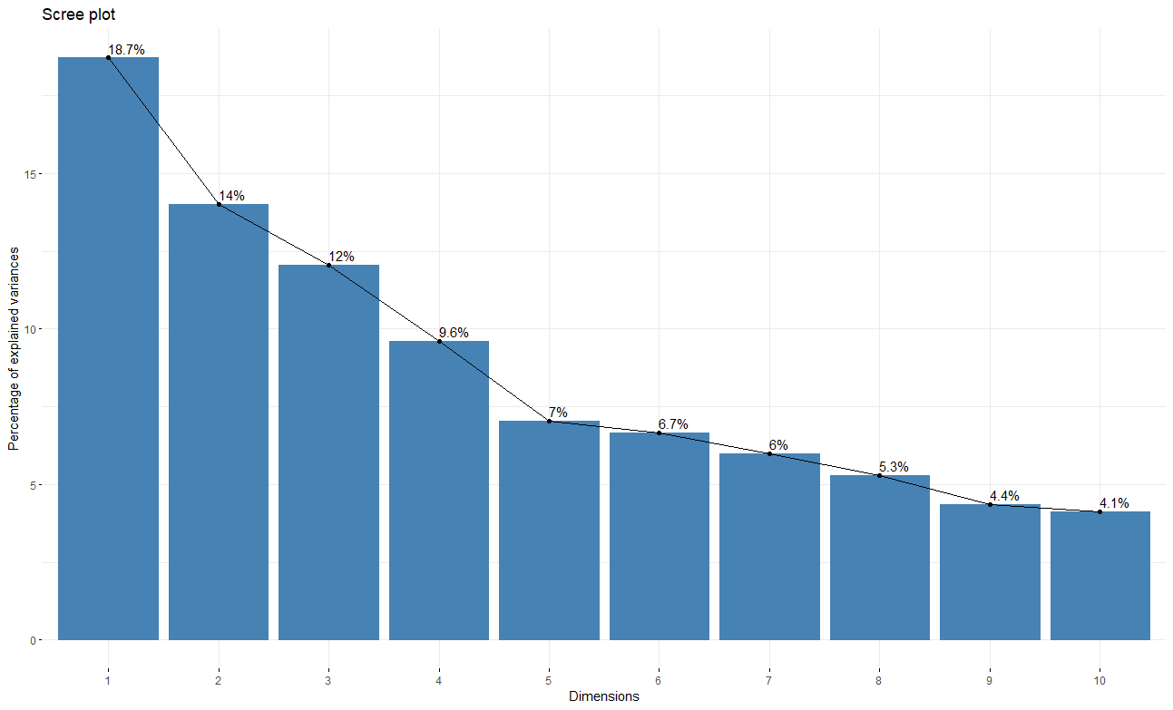

Figure 2.S2. Dendrogram of the Hierarchical Clustering on Principal Components.
Dendrogram illustrating the results of the Hierarchical Clustering on Principal Components (HCPC) analysis. The x-axis displays the various BAMs received, with the initial partitioning determined by cutting the dendrogram according to inertia gains between partitions. The hierarchical classification identified four distinct clusters.

