Supplementary material
Bio-based ester- and ester-imine resins for digital light processing 3D printing: the role of the chemical structure on reprocessability and susceptibility to biodegradation under simulated industrial composting conditions
Anna Liguori*, Naba Kumar Kalita, Grazyna Adamus, Marek Kowalczuk, Maria Letizia Focarete, Minna Hakkarainen*
anna.liguori@unibo.it
minna@kth.se

This supplementary material file contains 1 Table and 9 Figures on 6 pages.
Table S1. Composition and theoretical weight percentage of carbon in each thermoset. The theoretical weight percentage of carbon was calculated as ratio between the weight of all the carbon atoms and the total weight of all the atoms in each thermoset.
Samples | Composition [w/w%] | C%
ME | 100% ME | 72
SB+ME | 50% SB, 50% ME | 69
MOHB+ME | 17% MOHB, 83% ME | 70
SB+MOHB+ME | 41.5% SB, 17% MOHB, 41.5% ME | 67

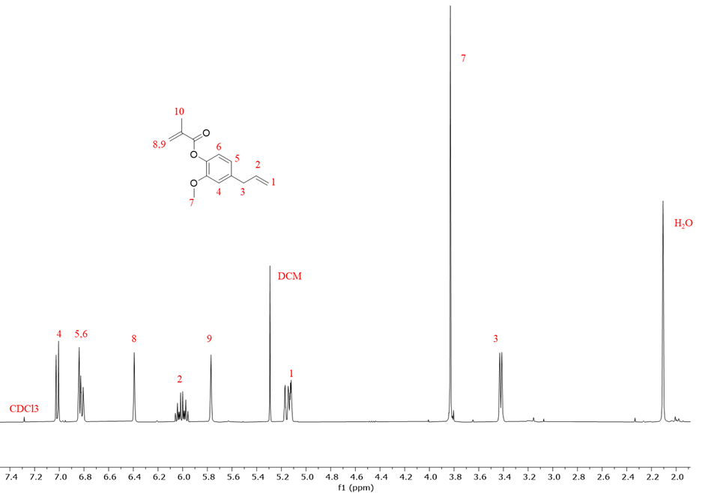
Figure S1. ¹H NMR spectrum of ME resin.
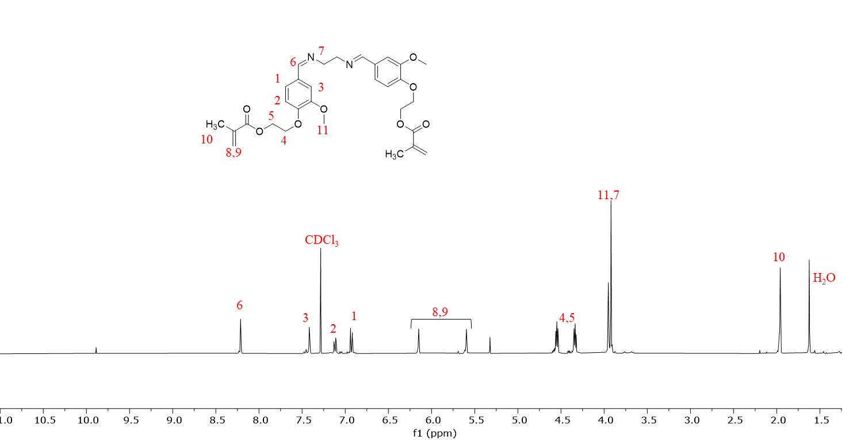
Figure S2. ¹H NMR spectrum of SB resin.

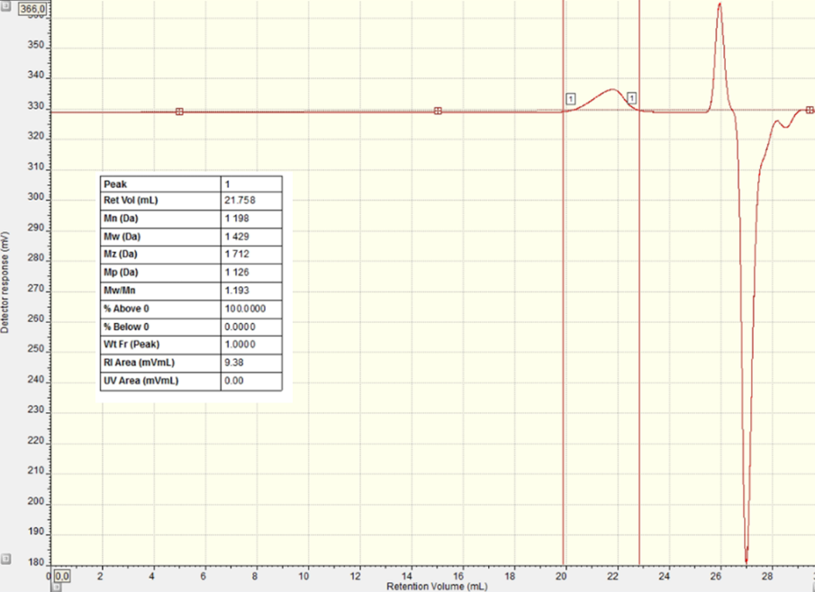
Figure S3. SEC analysis of PHB-diol. M_{w} = 1430 g/mol
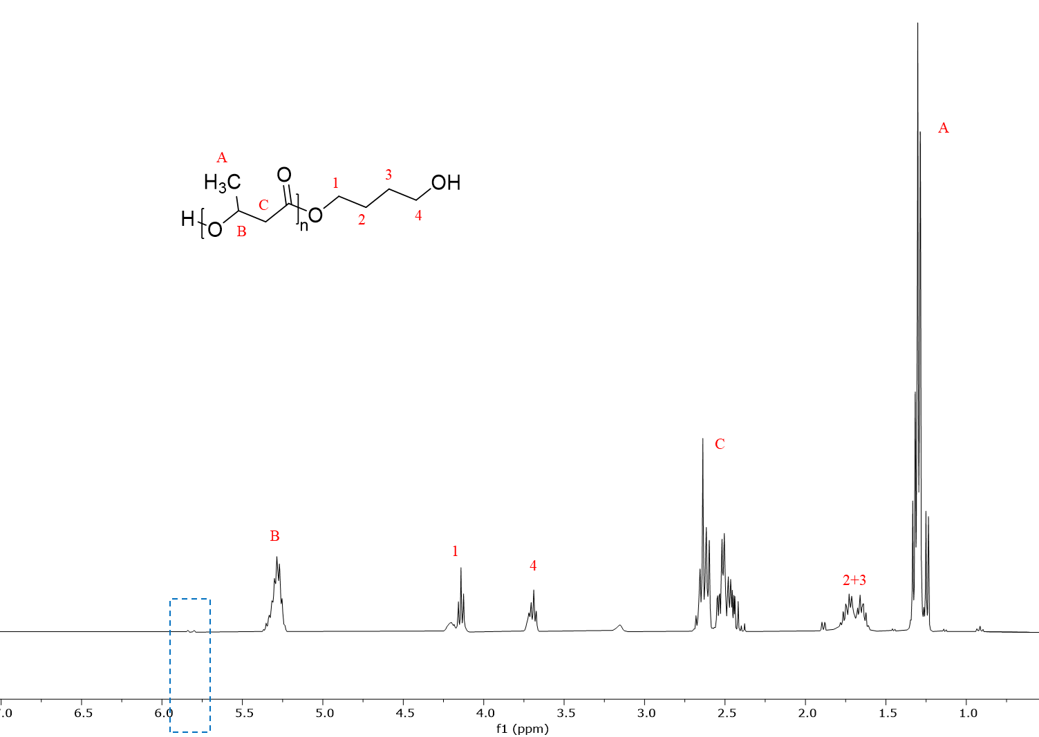
Figure S4. ¹H NMR spectrum of PHB-diol. No significant peaks at 5.8 ppm, indicating crotonate vinylic proton signal, are detected.
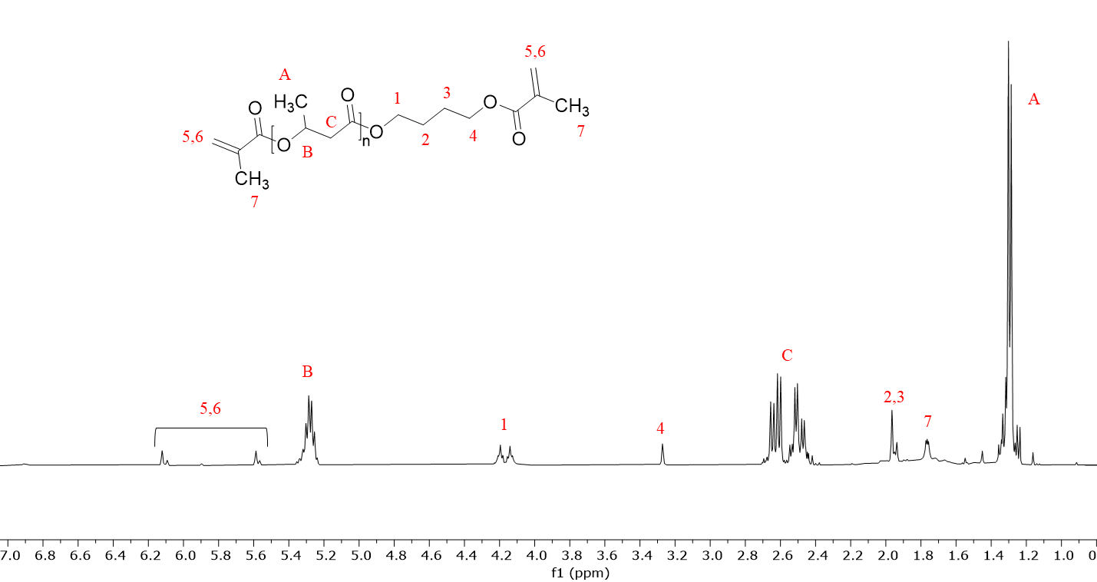
Figure S5. ¹H NMR spectrum of MOHB.

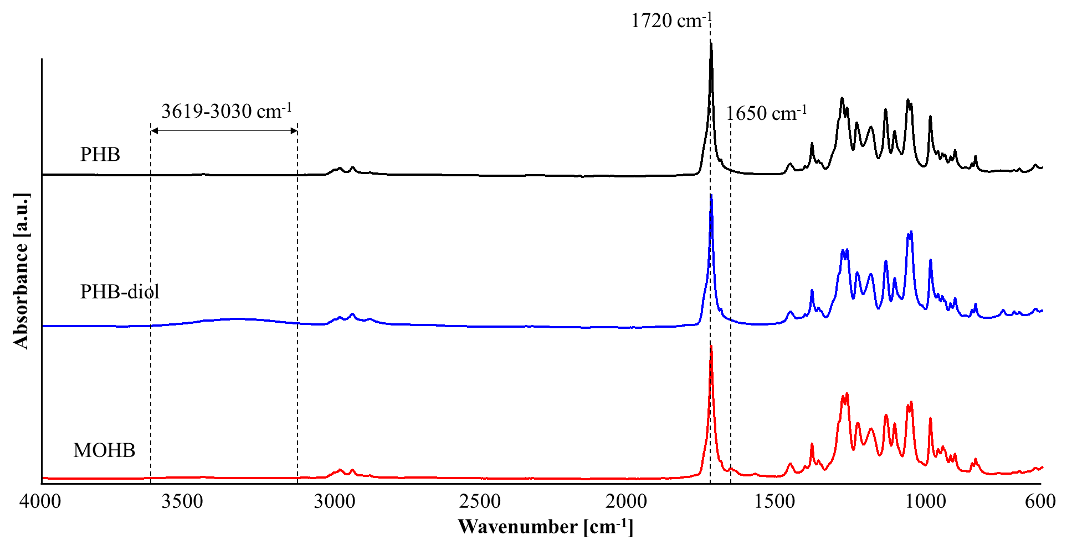
Figure S6. ATR-FTIR spectra of PHB, PHB-diol and MOHB monomer.

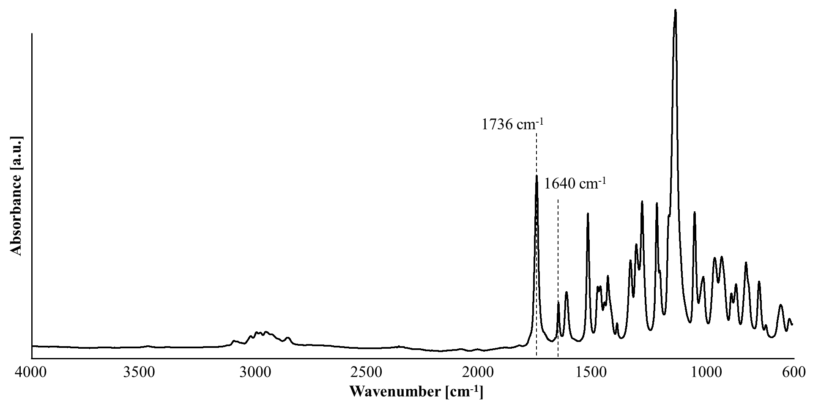
Figure S7. ATR-FTIR spectrum of ME monomer.

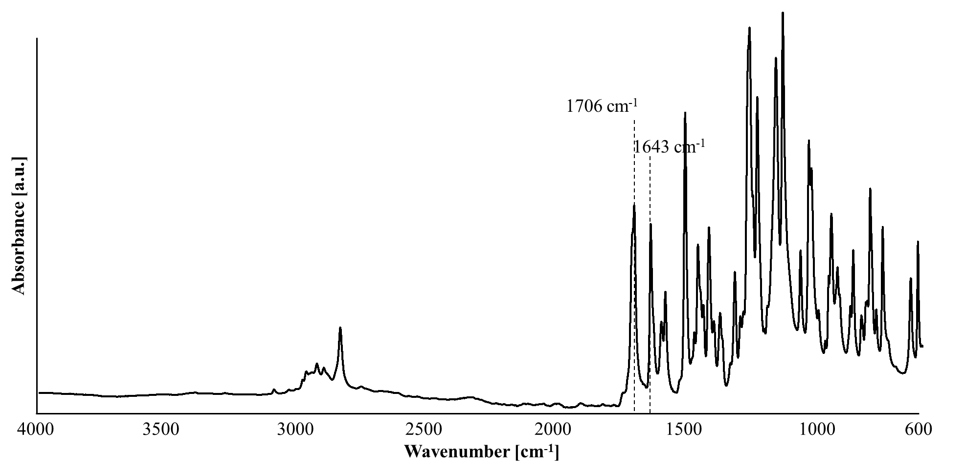
Figure S8. ATR-FTIR spectrum of SB monomer.

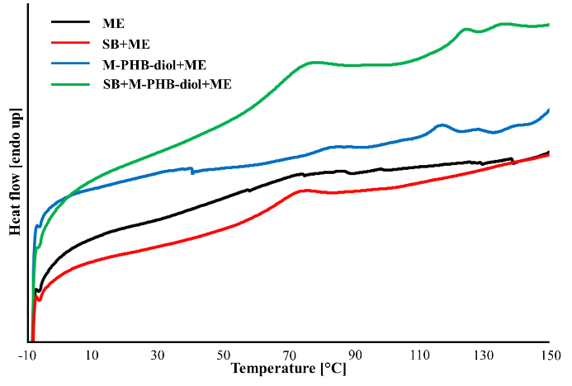
Figure S9. DSC curves of all the thermosets

