Supplementary materials
Table S1. Detail of the samples: ID code related to figure in the manuscript, type of flour, name of the product, Italian origin of the product.
ID code | Type of flour | Name of the product | Origin
F01 | 00 | Molino Mettone | Piemonte region (Italy)
F02 | 00 | Barilla | mixed Italian wheat
F03 | 00 | Molino Rossetto | Veneto region (Italy)
F04 | 00 | Dallari | Emilia-Romagna region (Italy)
F05 | 00 | ItalMill | Lombardia region (Italy)
F06 | 00 | Molino Spadoni | Emilia-Romagna region (Italy)
F07 | 00 | Smart | mixed Italian wheat
F08 | 00 | Molino Pivetti | Emilia-Romagna region (Italy)
F09 | 00 | Esselunga | mixed Italian wheat
F10 | 00 | Molino Chiavazza | Piemonte region (Italy)
F23 | 00 | MD | mixed Italian wheat
F26 | 00 | Molino Fiorilli | Molise region (Italy)
F30 | 00 | Belbake - Agugiaro & Figna | Emilia-Romagna region (Italy)
F32 | 00 | Viviverde Coop BIO | mixed Italian biological wheat
F35 | 00 | Coop | mixed Italian wheat
F36 | 00 | Le tre grazie | Emilia-Romagna region (Italy)
F39 | 00 | Seme | mixed Italian wheat
F44 | 00 | Conad | mixed Italian wheat
F50 | 00 | Molino Verrini | Emilia-Romagna region (Italy)
F72 | 00 | Le Farine Magiche | Campania region (Italy)
F86 | 00 | PAM | mixed Italian wheat
F12 | 0 | Molino Spadoni | Emilia-Romagna region (Italy)
F13 | 0 | Cuore di (Molino Rossetto) | Veneto region (Italy)
F14 | 0 | Le Farine Magiche | Campania region (Italy)
F15 | 0 | Coop BIO | mixed Italian biological wheat
F16 | 0 | Coop | mixed Italian wheat
F18 | 0 | CaSP | Emilia-Romagna region (Italy)
F21 | 0 | Molino Cofelice | Molise region (Italy)
F22 | 0 | Molino Caputo | Campania region (Italy)
F27 | 0 | Molino Casillo | Puglia region (Italy)
F28 | 0 | Molino Cofelice | Molise region (Italy)
F31 | 0 | Viviverde Coop BIO | mixed Italian biological wheat
F34 | 0 | Molino Pivetti | Emilia-Romagna region (Italy)
F37 | 0 | Le tre grazie | Emilia-Romagna region (Italy)
F38 | 0 | Seme | mixed Italian wheat
F43 | 0 | Conad | mixed Italian wheat
F49 | 0 | Molino Rossetto | Veneto region (Italy)
F54 | 0 | Dallari | Emilia-Romagna region (Italy)
F70 | 0 | Frumenta | mixed Italian wheat
F87 | 0 | Molino Sima BIO | Emilia-Romagna region (Italy)
F85 | 0 | PAM | mixed Italian wheat
F20 | 1 | CaSP | Emilia-Romagna region (Italy)
F25 | 1 | Molino Casillo | Puglia region (Italy)
F60 | 1 | Molino Grassi | Emilia-Romagna region (Italy)
F61 | 1 | Molino Pivetti | Emilia-Romagna region (Italy)
F65 | 1 | Molino Verrini | Emilia-Romagna region (Italy)
F66 | 1 | Molino Spadoni | Emilia-Romagna region (Italy)
F82 | 1 | PAM | mixed Italian wheat
F24 | 2 | Molino Casillo | Puglia region (Italy)
F67 | 2 | Molino Spadoni | Emilia-Romagna region (Italy)
F71 | 2 | PAM | mixed Italian wheat
F11 | Whole wheat | Barilla | mixed Italian whole wheat
F17 | Whole wheat | CaSP BIO | Emilia-Romagna region (Italy)
F19 | Whole wheat | CaSP | Emilia-Romagna region (Italy)
F29 | Whole wheat | Conad | mixed Italian whole wheat
F33 | Whole wheat | Viviverde Coop BIO | mixed Italian biological whole wheat
F62 | Whole wheat | Molino Pivetti | Emilia-Romagna region (Italy)
F69 | Whole wheat | Molino Garofalo | Campania region (Italy)
F80 | Whole wheat | Agugiaro & Figna | Emilia-Romagna region (Italy)
F78 | Whole wheat | Frumenta | mixed Italian whole wheat
F40 | Durum wheat | Molino Casillo rimacinata | Puglia region (Italy)
F41 | Durum wheat | La Molisana BIO | Molise region (Italy)
F42 | Durum wheat | Conad | mixed Italian durum wheat
F46 | Durum wheat | La Molisana | Molise region (Italy)
F53 | Durum wheat | De Cecco | mixed Italian durum wheat
F55 | Durum wheat | Molino Rossetto | Veneto region (Italy)
F63 | Durum wheat | Coop | mixed Italian durum wheat
F64 | Durum wheat | Coop rimacinata | mixed Italian durum wheat
F68 | Durum wheat | Sansepolcro | Toscana region (Italy)
F73 | Durum wheat | PAM rimacinata | mixed Italian durum wheat
F81 | Durum wheat | PAM | mixed Italian durum wheat
F84 | Durum wheat | Molino Casillo | Puglia region (Italy)
F88 | Durum wheat | Esselunga | mixed Italian durum wheat
F89 | Durum wheat | Molino Martimucci | Puglia region (Italy)
F94 | Durum wheat | Barilla | mixed Italian durum wheat
F95 | Durum wheat | Esselunga BIO | mixed Italian biological durum wheat
F98 | Corn | Molino di Ferro | Veneto region (Italy)
F99 | Corn | Dallari | Emilia-Romagna region (Italy)
F100 | Corn | Molino Rossetto | Veneto region (Italy)
F101 | Corn | Conad | mixed Italian corn
F102 | Corn | Polenta Valsugana | Trentino-Alto Adige region (Italy)
F109 | Corn | Polenta Valsugana integrale | Trentino-Alto Adige region (Italy)
F57 | Corn | Molino Favero | Veneto region (Italy)
F58 | Corn | PAM | mixed Italian corn
F59 | Corn | Luzi | Marche region (Italy)
F75 | Corn | Molino Peila | Piemonte region (Italy)
F76 | Corn | Molino Moretti | Lombardia region (Italy)
F45 | Corn | Smart | mixed Italian corn
F47 | Corn | Esselunga | mixed Italian corn
F48 | Corn | Molino Rossetto | Veneto region (Italy)
F51 | Corn | Coop | mixed Italian corn
F103 | Oats | Molino Vigevano | Lombardia region (Italy)
F104 | Oats | Molino Rossetto rimacinata | Veneto region (Italy)
F105 | Oats | Le Farine Magiche | Campania region (Italy)
F106 | Oats | Molino Rossetto | Veneto region (Italy)
F107 | Oats | Molino Sarchio | Emilia-Romagna region (Italy)
F108 | Oats | Conad | mixed Italian oats
F75 | Spelt | Esselunga | mixed Italian spelt
F52 | Spelt | Molino Sima | Emilia-Romagna region (Italy)
F56 | Spelt | Coop | mixed Italian spelt
F74 | Spelt | Molino Chiavazza | Piemonte region (Italy)
F77 | Spelt | Luzi | Marche region (Italy)
F79 | Spelt | PAM | mixed Italian spelt
F83 | Rice | Pedon | Veneto region (Italy)
F90 | Rice | Molino Rossetto | Veneto region (Italy)
F91 | Rice | Molino Chiavazza | Piemonte region (Italy)
F92 | Rice | Vital Nature | Emilia-Romagna region (Italy)
F93 | Rice | Molino Filippini | Lombardia region (Italy)
F96 | Rice | Le Farine Magiche | Campania region (Italy)

Table S2. Limit of Detection (LOD) and Limit of Quantification (LOQ) data both for the process (P) and for the instrument (I) for multi-element trace analysis present in the standard solution selected and expressed in µg/kg. In the last column the LODs proposed by Sakai (2015) for ICP-MS-QQQ 8800 model, Agilent Technologies.
 | Instrument |  | Process
 | LOQ (µg/kg) | LOD (µg/kg) | LOQ (µg/kg) | LOD (µg/kg) | LOD Agilent Technologies  (Sakai, 2015)
Al | 8.82198 | 2.64659 | 3.70272 | 1.11081 | 1.000
As | 0.36119 | 0.10836 | 0.44497 | 0.13349 | 0.024
Pb | 0.01819 | 0.00546 | 0.07374 | 0.02212 | 0.009
Cd | 0.02524 | 0.00757 | 0.02261 | 0.00677 | 0.012
Ni | 3.05262 | 0.91579 | 3.68753 | 1.10626 | 0.049
Cr | 0.03120 | 0.00931 | 0.02849 | 0.00814 | 0.040
Co | 0.003458 | 0.00103 | 0.01736 | 0.00521 | 0.051
V | 0.11542 | 0.03462 | 0.02887 | 0.00666 | 0.063
Cs | 0.01337 | 0.00411 | 0.07421 | 0.02101 | -
Mn | 0.05099 | 0.00953 | 0.02377 | 0.00621 | 0.062
Fe | 1.86655 | 0.52066 | 2.62655 | 0.83796 | 0.450
Cu | 0.20019 | 0.06006 | 0.04342 | 0.01302 | 0.021
Zn | 0.13997 | 0.04199 | 0.41161 | 0.12348 | 0.063

Table S3. Comparison of multi-element trace analysis obtained by ICP-MS-QQQ with literature data (Telloli et al., 2024). All the data are expressed in µg/kg.
 | wheat 00 |  | wheat 0 |  | wheat 1 |  | wheat 2 |  | wholewheat
 | Telloli  et al. (2024) | This research | Telloli  et al. (2024) | This research | Telloli  et al. (2024) | This research | Telloli  et al. (2024) | This research | Telloli  et al. (2024) | This research
Al | 1016.644 | 1026.178 | 1435.296 | 1488.909 | 1268.594 | 1274.683 | 1385.312 | 1384.586 | 2672.015 | 2566.535
As | 5.281 | 5.371 | 7.349 | 7.922 | 7.168 | 7.948 | 3.126 | 3.470 | 3.909 | 4.569
Pb | 4.674 | 4.624 | 2.231 | 2.207 | 1.678 | 1.660 | 3.535 | 3.497 | 1.276 | 1.262
Cd | 0.590 | 0.613 | 0.471 | 0.526 | 0.396 | 0.439 | 0.720 | 0.753 | 0.661 | 0.705
Ni | 650.805 | 614.216 | 711.069 | 685.405 | 228.924 | 218.625 | 13.095 | 12.792 | 102.991 | 100.058
Cr | 359.433 | 359.718 | 813.932 | 818.432 | 332.298 | 335.156 | 14.953 | 24.953 | 434.105 | 435.216
Co | 17.392 | 18.117 | 19.410 | 20.229 | 6.091 | 6.455 | 0.468 | 0.488 | 2.609 | 2.778
V | 2.757 | 2.101 | 4.550 | 4.550 | 1.943 | 1.943 | 0.315 | 0.315 | 3.099 | 3.099
Cs | 6.347 | 2.275 | 0.277 | 0.120 | 3.101 | 0.367 | 2.489 | 0.960 | 0.528 | 0.119
Mn | 214.659 | 198.587 | 250.613 | 237.513 | 312.533 | 294.445 | 441.373 | 406.763 | 731.585 | 695.249
Fe | 1216.363 | 1279.692 | 2459.921 | 2431.921 | 1199.120 | 1282.444 | 516.314 | 520.902 | 2244.614 | 2448.079
Cu | 132.022 | 147.557 | 47.227 | 53.429 | 49.508 | 55.705 | 65.936 | 72.438 | 84.137 | 95.248
Zn | 155.521 | 160.899 | 191.600 | 197.428 | 256.769 | 259.186 | 375.337 | 366.268 | 527.109 | 525.737

Table S4. Main components obtained by PCA using the XLSTAT software by Addinsoft.
 | F1 | F2 | F3 | F4 | F5 | F6 | F7 | F8
Eigenvalue | 6.093 | 2.906 | 2.187 | 1.432 | 1.169 | 1.057 | 0.907 | 0.824
Variability (%) | 32.070 | 15.293 | 11.508 | 7.535 | 6.153 | 5.564 | 4.776 | 4.334
Cumulative % | 32.070 | 47.364 | 58.872 | 66.406 | 72.559 | 78.123 | 82.899 | 87.233

Figure S1. Quality Control (QC) for the data reliability, expressed in µg/kg: a) and b) QC 1000 µg/kg; c) and d) QC 5000 µg/kg. Figures b) and d) represent the magnification of figures a) and c) respectively for the elements with lower values.
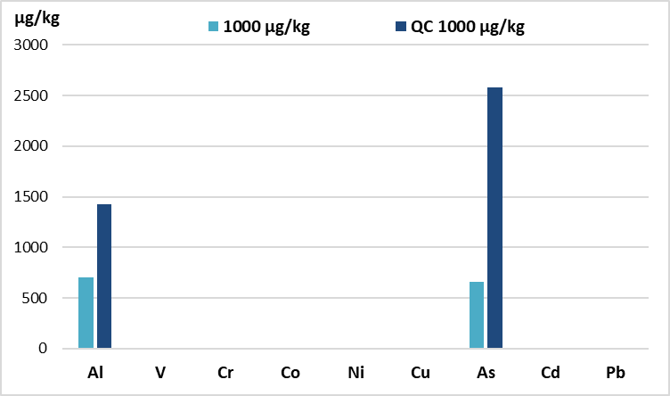a) 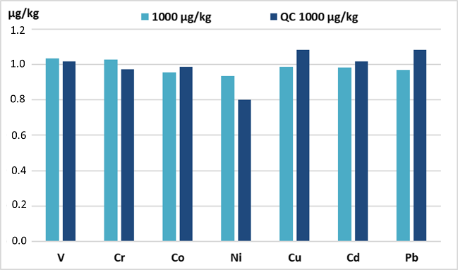b)
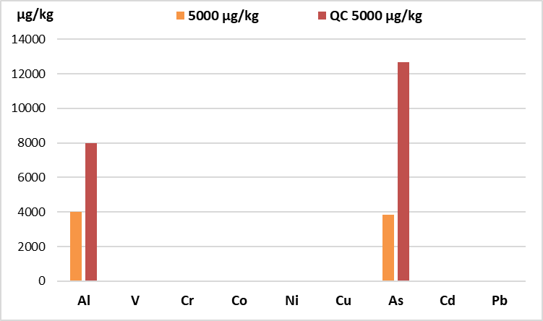c) 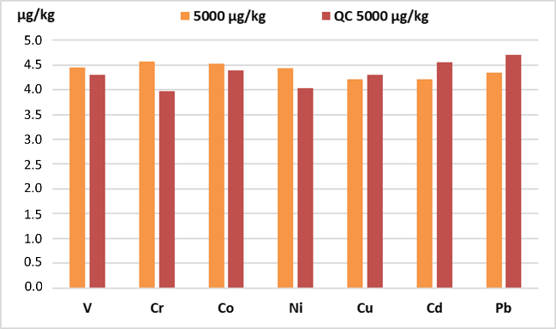d)
Figure S2. Calibration curves of the main toxic trace mentals analysed by ICP-MS-QQQ with the calibration curve 0.1 – 1.00 – 5.00 – 10.00 – 20.00 – 50.00 µg/kg: a) As; b) Pb; c) Cd; d) Ni; e) Cr; f) Co; g) V; h) Cs; i) Mn; j) Fe; k) Cu; l) Zn.
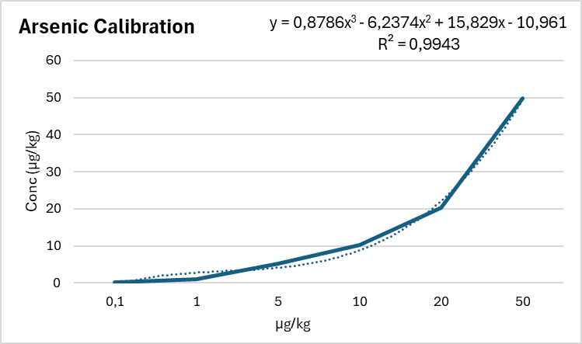a) 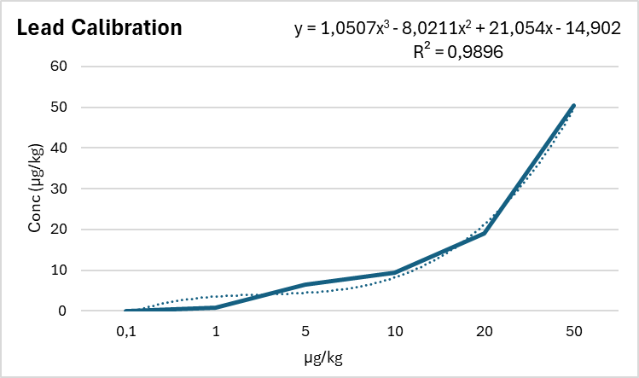b)
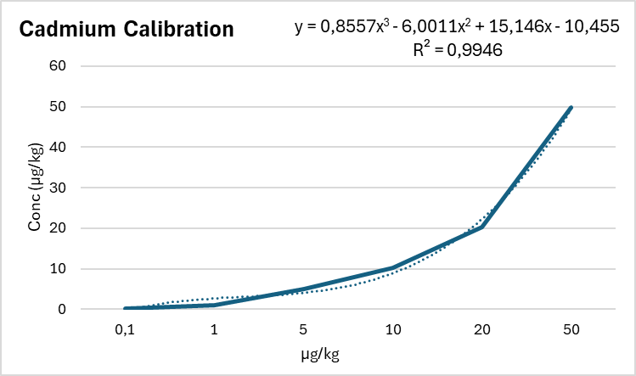c) 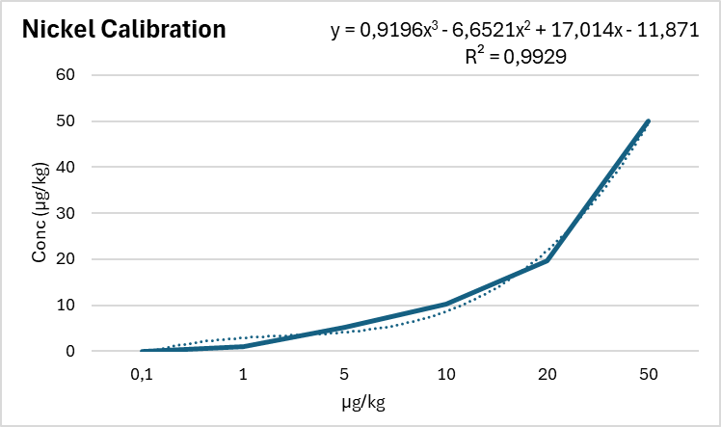d)
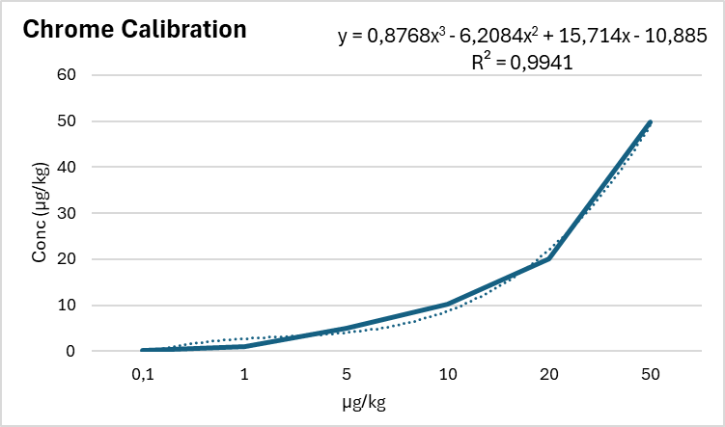e) 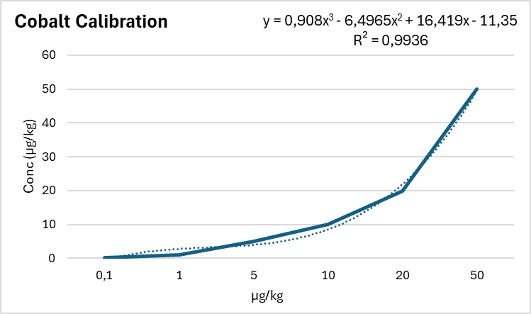f)
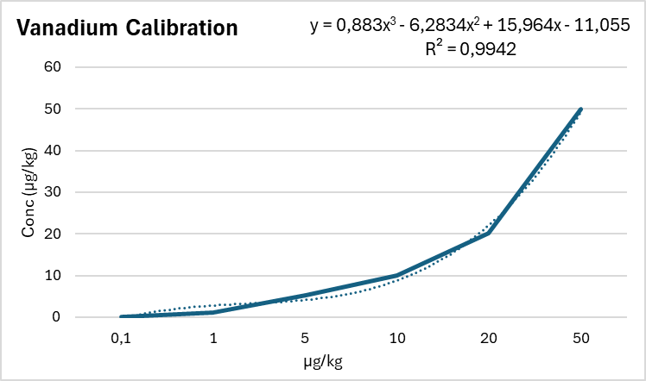g) 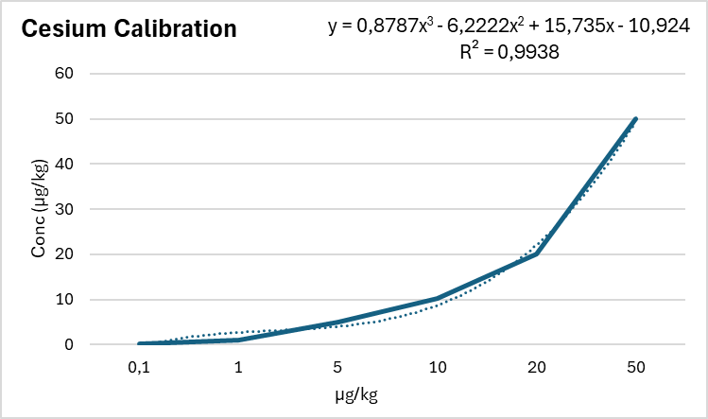h)
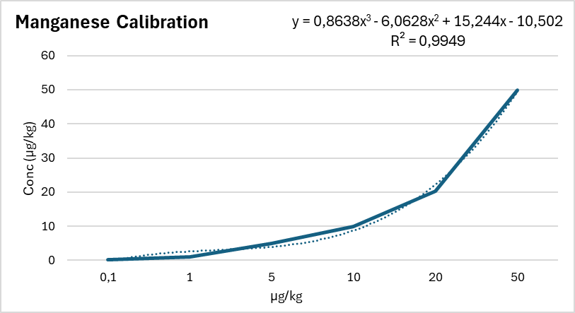i) 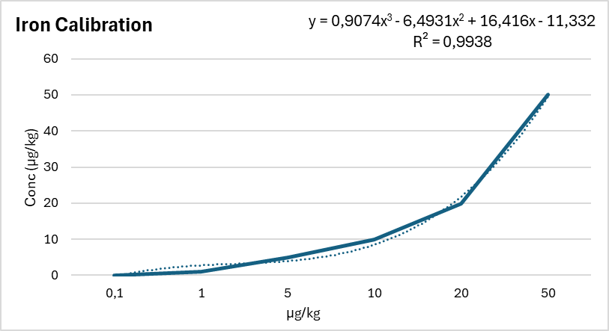j)
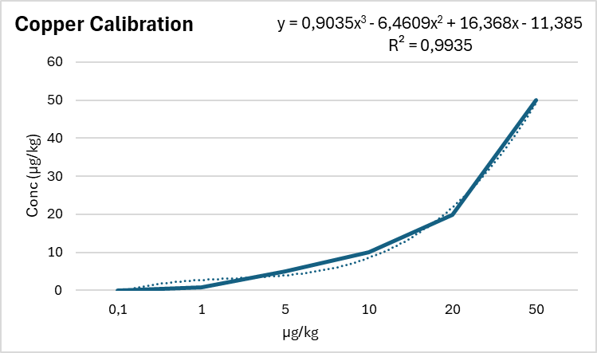k) 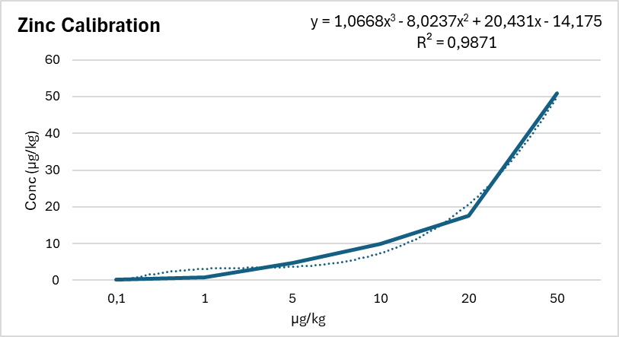l)
Figure S3. Scree plot obtained by PCA using XLSTAT software by Addinsoft, based on the data obtained in table S4.
