(Supplementary Information)

H₂ Production from Photocatalytic Reforming of PET over Pt/TiO₂: The Role of Terephthalic Acid
Luke Roebuck^{1*}, Min Hu¹, Helen Daly¹, Hubertus Warsahartana¹, Louise S. Natrajan², Arthur Garforth¹, Carmine D’Agostino^{1,3}, Marta Falkowska¹, Christopher Hardacre^{1*}
¹ Department of Chemical Engineering, School of Engineering, The University of Manchester, M13 9PL, United Kingdom
²Department of Chemistry, School of Natural Sciences, University of Manchester, Manchester, M13 9PL, United Kingdom
³Dipartimento di Ingegneria Civile, Chimica, Ambientale e dei Materiali (DICAM), Alma Mater Studiorum – Università di Bologna, Via Terracini, 28, 40131 Bologna, Italy

S1. Methods
Figure S1: Photograph of photoreforming reactor setup.

S.2 Catalyst Characterisation
Figure S2: Low temperature N₂ adsorption/desorption isotherm (a) and powder x-ray diffraction pattern (b) of 0.2% Pt supported on TiO₂ (P25).

S.3 PET Photoreforming
Figure S3: Gas evolution rates from the photoreforming of (left to right) direct water splitting, 2 M KOH, 10mM ethylene glycol, 10 mM ethylene glycol in 2 M KOH, 10 mM ethylene glycol in 2 M KCl, 16 mM terephthalic acid in 2 M KOH. Reaction conditions: 30 ml reaction volume, 30 mg Pt/TiO₂ photocatalyst, UV (λ = 365-375 nm) irradiation, 8 hours reaction time.

S.4 PET Steam Hydrolysis

Figure S4: H₂ evolution vs time from the photoreforming of 2 M KOH pretreated PET and PET hydrolysate from Steam Hydrolysis (SH). Reaction conditions: 300 mg PET, 30 ml reaction volume, 30 mg Pt/TiO₂ photocatalyst, UV (λ = 365-375 nm) irradiation, 4 hours reaction time.

Steam hydrolysis of PET was performed as follows. PET (<425 µm, 2.5 g), and deionised water (40 g) were loaded into a 600 ml Hastelloy autoclave reactor (Parr Instruments, USA), which was then sealed and thrice purged with nitrogen at 6 bar, before being charged with 2 bar prior to the start of heating. The reactor was heated to the setpoint of 220 °C, corresponding to an autogenous pressure of 26 bar, and stirred for 1 h. Afterwards, the reactor was air-cooled back to room temperature. Precipitated TPA and unreacted PET was filtered out and the remaining hydrolysate was used as the photoreforming substrate in Figure S4 above. The filtered solids were redispersed in 1 M NaOH solution to dissolve the TPA the mixture was filtered again to separate unreacted PET which was then, washed, dried, and weighed to calculate PET conversion. TPA was finally isolated by precipitation with 2 M HCl and vacuum filtration followed by washing, drying, and weighed to calculate TPA yield. A PET conversion of 99% and a TPA yield of 82% was achieved. H¹ NMR of the isolated TPA was performed to confirm its purity (Figure S6).

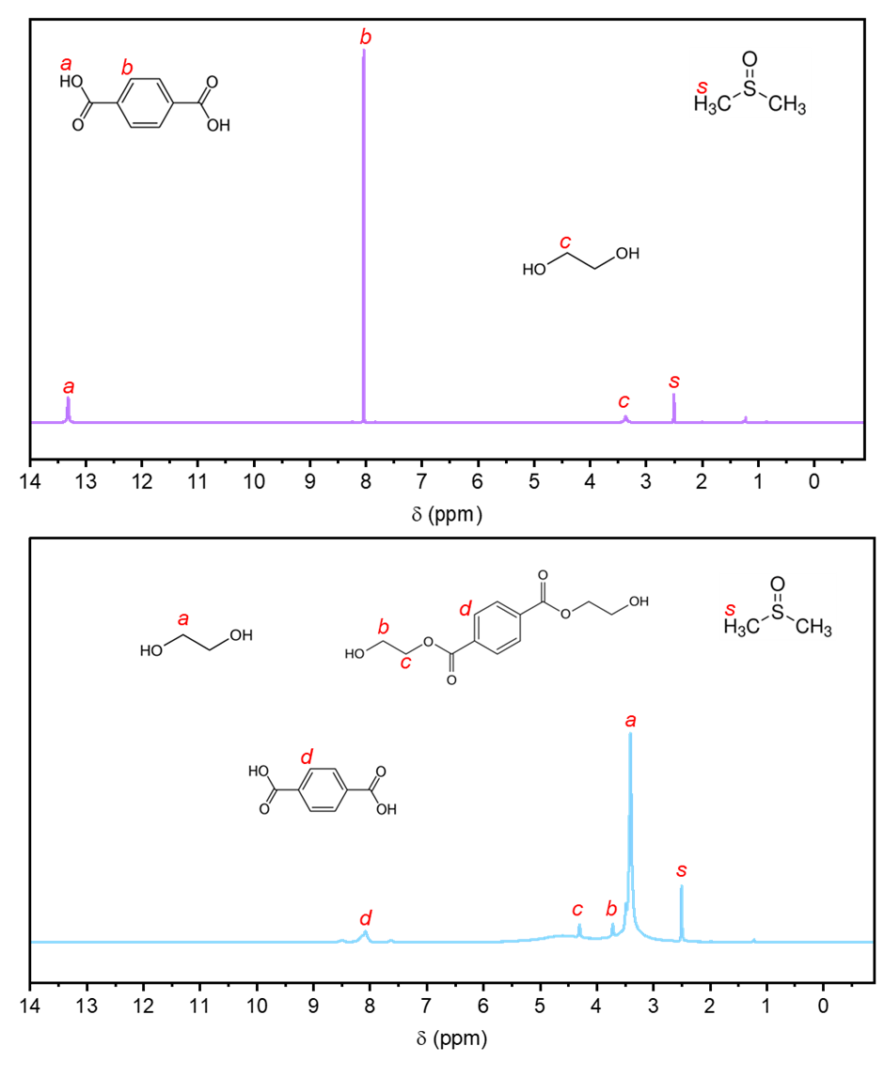

Figure S5: ¹H NMR Spectra of isolated TPA (top) and of remaining hydrolysate (bottom).

